CURRICULUM VITAE

**PERSONAL DETAILS**

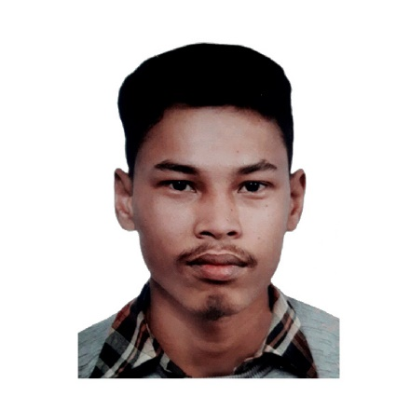Name: Rupesh Mahato

Residential Address: Kalanki, Kathamndu, Nepal

Permanent Address: Madhyabindu-8 Devkotatol, Nawalparasi (East),

Gandaki Provience, Nepal

Mobile: **9865431460**

**9811583617**

Email: [**rupeshmahato@gmail.com**](mailto:deependrarajpathak@gmail.com)

Date of Birth: 12th May, 1998

Nationality: Nepali

**CAREER OBJECTIVE**

Self-motivated and hardworking fresher seeking for an opportunity to work in a challenging environment to prove my skill and utilize my knowledge and intelligence in the growth of organisation.

**EDUCATION HISTORY**

|  |  |  |  |  |  |
| --- | --- | --- | --- | --- | --- |
| **S.N.** | **Qualification** | **Institute Name** | **University / Board** | **Percentage/Grade** | **Year of Graduation** |
| 1. | Intermediate (Commerce) | Nawajagaran Multiple Campus  (Madhyabindu-7,Chormara, Nawalparasi, Nepal) | NEB | 60.30% | 2073 B.S.  (2016 AD) |
| 2. | S.L.C | Nawajagaran Higher Secondary School  (Madhyabindu-7,Chormara, Nawalparasi, Nepal) | Nepal Government | 63% | 2070 B.S.  (2014 AD) |

**SKILLS AND CERTIFICATES**

**TRAININGS**

* Basic Trainings of HTML, CSS, JavaScript and other from Nawajagaran Multiple Campus.

**PROGRAMMING AND COMPUTER SKILLS:**

* C and C++ (Basic programming concepts according to the course of Tribhuban University).
* .Net Framework and C#
* VB.NET (Basic Knowledge acquired during work)
* Basic SQL Server
* Basic HTML,CSS, JavaScript, PHOTOSHOP.
* Microsoft Office applications (Word, Excel, PowerPoint) – Advanced

**EXPERIENCE DETAIL:**

* Worked for Local Primary School "Shree Lohasedhara Primary School (Madhyabindu-8, Bhagra, Nawalparasi)" as teacher and accountant.

**LANGUAGE SKILLS:**

* Nepali
* English
* Hindi

**PERSONAL COMPETENCIES**

* Ability to work in a fast-paced environment.
* Enthusiastic self-starter who contributes well to the team
* Dedicated
* Honest and responsible
* Eagerness to learn new things

**DECLARATION**

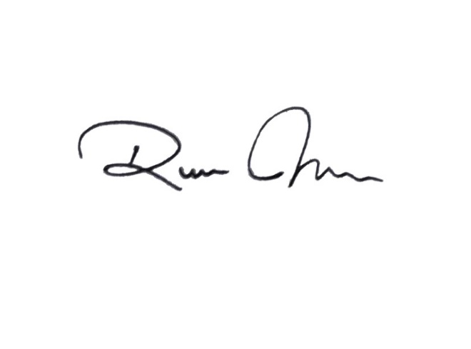I hereby declare that the above written particulars are true to the best of my knowledge and belief.

------------------------------------------ (Rupesh Mahato)