Current Mirror using Skywater 130nm PDK

1st Rupesh D. Kadam

*dept. of Electronics & telecommunication engineering* Vishwakarma Institute of Technology Pune, India [rupesh.kadam20@vit.edu](mailto:rupesh.kadam20@vit.edu)

***Abstract*—This paper presents the design and implementation of a current mirror circuit using the Sky-water 130nm PDK. Current mirrors are fundamental building blocks in analog integrated circuits, enabling precise current replication and biasing. The proposed design employs a differential pair topology with active load to achieve high accuracy and wide output voltage range.**

***Keywords—component, formatting, style, styling, insert (****key words****)***

1. INTRODUCTION (*HEADING 1*)

A current mirror is a fundamental building block in analog integrated circuit design. It serves to replicate a reference current at its output, enabling precise current biasing and amplification. This circuit is widely used in various applications, including operational amplifiers, voltage regulators, and data converters.

1. Principle

A current mirror is a fundamental analog circuit that replicates a reference current at its output. This circuit relies on the principle of current sharing between two transistors connected in parallel.

Basic Current Mirror:

The simplest form consists of two identical transistors, Q1 and Q2, connected in parallel. The emitter terminals of both transistors are connected to a common node, while the base terminals are connected together. The collector of Q1 is connected to a constant voltage source, and the collector of Q2 is connected to the load.

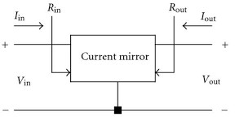

When a current, Iref, is injected into the base of Q1, it creates a voltage drop across the base-emitter junction. This voltage drop forces a current, Iout, to flow through Q2. Due to the identical nature of the transistors and the matched base-emitter voltages, the output current Iout will be approximately equal to the input current Iref.

There are several types of current mirrors, each with its own characteristics and applications:

Simple Current Mirror: This is the most basic type, consisting of two transistors connected in parallel. The input current is mirrored to the output, but it suffers from limitations in output voltage range and output impedance.

Wilson Current Mirror: This configuration improves the output impedance and voltage range compared to the simple

current mirror. It uses an additional transistor to boost the output impedance.

Widlar Current Mirror: This type allows for precise current scaling by introducing a resistor in the emitter of one of the transistors. It's useful for generating reference currents that are significantly smaller or larger than the input current.

Cascode Current Mirror: This configuration further enhances the output impedance by adding a cascode transistor to each branch of the current mirror. It is commonly used in high- performance circuits where high output impedance is critical.

1. IMPLEMENTATION

*A.* *Circuit Diagram*

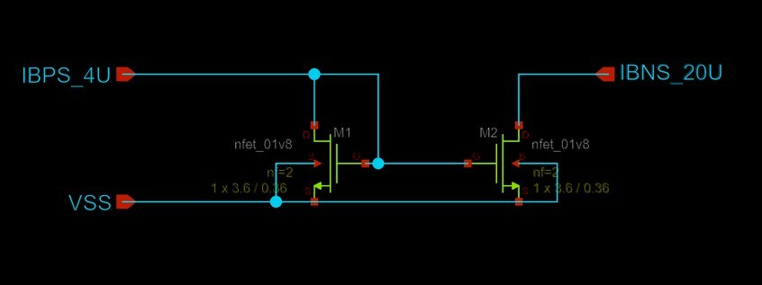

M1 and M2: These are identical nmos transistors,

IBPS: This is the reference current flowing into the base of M1.

IBNS: This is the output current flowing through the collector of M2.

Reference Current: A reference current, IBPS, is injected into the gate of M1.

Voltage Drop: This current creates a voltage drop across the gate-source junction of M1.

Current Mirroring: Due to the identical nature of M1 and M2, a similar voltage drop is created across the gate-source junction of M2.

Output Current: This voltage drop forces a current, Iout, to flow through the source of M2.

Current Matching: Ideally, if M1 and M22 are perfectly matched, IBNS will be almost equal to IBPS.

REFERENCES

1. *Li, Yuping, Haihua Wang, and Mohammad Trik. "Design and simulation of a new current mirror circuit with low power consumption and high performance and output impedance." Analog Integrated Circuits and Signal Processing 119.1 (2024): 29-41.*
2. Bertemes-Filho, P., B. H. Brown, and A. J. Wilson. "A comparison of modified Howland circuits as current generators with current mirror type circuits." Physiological measurement 21.1 (2000): 1.
3. Ramirez-Angulo, J., et al. "Compact implementation of high- performance CMOS current mirror." Electronics letters 41.10 (2005): 3-4.