**Title:**  Using suitable data visualization tools (minimum 2) compare data of 5 appropriately contrasting countries

**Statement**: Data Visualization of capital of GDP and GDP per capita data of 5 appropriately contrasting countries using box plot, bar plot and pie chart.

**Metadata**:

**Name of creator of data**: United Nations Statistics Division, New York, National Accounts Statistics: Analysis of Main Aggregates (AMA) database

**Set Name of author of document**: Unknown

**Title of document**: SYB63_230_202009_GDP and GDP Per Capita

**Location of file**: data.un.org

**Size of file**: 1.40 MB

**Format**: csv (comma separated values)

**Descriptions of column:**

**Region/Country/Area No:** contains unique id given to each observation.

**Region/Country/Area**: Names of the countries.

**Year**: Year in which data was observed.

**Series:** type of data

**Value:** values as per series

**Footnotes:** Blank

**R-Code:**

|  |
| --- |
| #1. Reference http: data.un.org. Data of GDP and GDP per capita #2. Use suitable data visualization tools (minimum 2) to compare data of 5 appropriately contrasting countries. #The assignment is to be implemented in R  data <- read.csv("SYB63_230_202009_GDP and GDP Per Capita.csv") library("highcharter") library(dplyr) library(tidyverse) library(ggplot2) data <- data[-c(1),]  names(data)[1] <- "Region/Country/Area No" names(data)[2] <- "Region/Country/Area" names(data)[3] <- "Year" names(data)[4] <- "Series" names(data)[5] <- "Value" names(data)[6] <- "Footnotes" names(data)[7] <- "Source"   data[,c(3,5)] <- sapply(data[,c(3,5)], as.numeric) summary(data)  #-----------------------------GDP Growth of INDIA-------------------------- highchart() %>%   hc_chart(type = "column") %>%   hc_xAxis(     title = list(text = "Annual Year"),     alternateGridColor = "#FDFFD5",     plotLines = list(       list(         label = list(text = "This is a plotLine"),         color = "#FF0000",         width = 2,         value = 5.5       )     )   ) %>%   hc_title(text = "Data of GDP Growth in India") %>%   hc_plotOptions(column = list(enableMouseTracking = TRUE)   ) %>%   hc_add_series(name="1985",data=data$Value[data$Series == "GDP in current prices (millions of US dollars)" & data$`Region/Country/Area` == "India" & data$Year == "1985"]) %>%   hc_add_series(name="1995",data=data$Value[data$Series == "GDP in current prices (millions of US dollars)" & data$`Region/Country/Area` == "India" & data$Year == "1995"]) %>%   hc_add_series(name="2005",data=data$Value[data$Series == "GDP in current prices (millions of US dollars)" & data$`Region/Country/Area` == "India" & data$Year == "2005"]) %>%   hc_add_series(name="2010",data=data$Value[data$Series == "GDP in current prices (millions of US dollars)" & data$`Region/Country/Area` == "India" & data$Year == "2010"]) %>%   hc_add_series(name="2015",data=data$Value[data$Series == "GDP in current prices (millions of US dollars)" & data$`Region/Country/Area` == "India" & data$Year == "2015"]) %>%   hc_add_series(name="2017",data=data$Value[data$Series == "GDP in current prices (millions of US dollars)" & data$`Region/Country/Area` == "India" & data$Year == "2017"]) %>%   hc_add_series(name="2018",data=data$Value[data$Series == "GDP in current prices (millions of US dollars)" & data$`Region/Country/Area` == "India" & data$Year == "2018"])  #---------------------Data of GDP in 2018--------------------------- pc <- mean(data$Value[data$Series == "GDP in current prices (millions of US dollars)" & data$`Region/Country/Area` == "China"]) print(pc) highchart() %>%   hc_chart(type = "column") %>%   hc_xAxis(     title = list(text = "5 appropriately contrasting countries"),     alternateGridColor = "#FDFFD5",     plotLines = list(       list(         label = list(text = "This is a plotLine"),         color = "#FF0000",         width = 2,         value = 5.5       )     )   ) %>%   hc_title(text = "Data of GDP in 2018") %>%   hc_plotOptions(column = list(enableMouseTracking = TRUE)   ) %>%   hc_add_series(name="India",data=tail(data$Value[data$Series == "GDP in current prices (millions of US dollars)" & data$`Region/Country/Area` == "India"], n=1))%>%   hc_add_series(name="Germany",data=tail(data$Value[data$Series == "GDP in current prices (millions of US dollars)" & data$`Region/Country/Area` == "Germany"], n=1))%>%   hc_add_series(name="Japan",data=tail(data$Value[data$Series == "GDP in current prices (millions of US dollars)" & data$`Region/Country/Area` == "Japan"], n=1))%>%   hc_add_series(name="China",data=tail(data$Value[data$Series == "GDP in current prices (millions of US dollars)" & data$`Region/Country/Area` == "China"], n=1))%>%   hc_add_series(name="USA",data=tail(data$Value[data$Series == "GDP in current prices (millions of US dollars)" & data$`Region/Country/Area` == "United States of America"], n=1))  #-------------------Data of GDP Growth rate in 2018-------------------- pc <- mean(data$Value[data$Series == "GDP real rates of growth (percent)" & data$`Region/Country/Area` == "China"]) print(pc) highchart() %>%   hc_chart(type = "column") %>%   hc_xAxis(     title = list(text = "5 appropriately contrasting countries"),     alternateGridColor = "#FDFFD5",     plotLines = list(       list(         label = list(text = "This is a plotLine"),         color = "#FF0000",         width = 2,         value = 5.5       )     )   ) %>%   hc_title(text = "Data of GDP Growth Rate in 2018") %>%   hc_plotOptions(column = list(enableMouseTracking = TRUE)   ) %>%   hc_add_series(name="Japan",data=tail(data$Value[data$Series == "GDP real rates of growth (percent)" & data$`Region/Country/Area` == "Japan"], n=1))%>%   hc_add_series(name="Germany",data=tail(data$Value[data$Series == "GDP real rates of growth (percent)" & data$`Region/Country/Area` == "Germany"], n=1))%>%   hc_add_series(name="USA",data=tail(data$Value[data$Series == "GDP real rates of growth (percent)" & data$`Region/Country/Area` == "United States of America"], n=1))%>%   hc_add_series(name="China",data=tail(data$Value[data$Series == "GDP real rates of growth (percent)" & data$`Region/Country/Area` == "China"], n=1))%>%   hc_add_series(name="India",data=tail(data$Value[data$Series == "GDP real rates of growth (percent)" & data$`Region/Country/Area` == "India"], n=1))  #------------------Data of GDP Per Capita in 2018------------------------ pc <- mean(data$Value[data$Series == "GDP real rates of growth (percent)" & data$`Region/Country/Area` == "China"]) print(pc) highchart() %>%   hc_chart(type = "column") %>%   hc_xAxis(     title = list(text = "5 appropriately contrasting countries"),     alternateGridColor = "#FDFFD5",     plotLines = list(       list(         label = list(text = "This is a plotLine"),         color = "#FF0000",         width = 2,         value = 5.5       )     )   ) %>%   hc_title(text = "Data of GDP Per Capita in 2018") %>%   hc_plotOptions(column = list(enableMouseTracking = TRUE)   ) %>%   hc_add_series(name="India",data=tail(data$Value[data$Series == "GDP per capita (US dollars)" & data$`Region/Country/Area` == "India"], n=1))%>%   hc_add_series(name="China",data=tail(data$Value[data$Series == "GDP per capita (US dollars)" & data$`Region/Country/Area` == "China"], n=1))%>%   hc_add_series(name="Japan",data=tail(data$Value[data$Series == "GDP per capita (US dollars)" & data$`Region/Country/Area` == "Japan"], n=1))%>%   hc_add_series(name="Germany",data=tail(data$Value[data$Series == "GDP per capita (US dollars)" & data$`Region/Country/Area` == "Germany"], n=1))%>%   hc_add_series(name="USA",data=tail(data$Value[data$Series == "GDP per capita (US dollars)" & data$`Region/Country/Area` == "United States of America"], n=1))  #sub-setting data for line plots Region <- data$`Region/Country/Area`[data$`Region/Country/Area` == "India" | data$`Region/Country/Area` == "China" | data$`Region/Country/Area` == "Germany" | data$`Region/Country/Area` == "United States of America" | data$`Region/Country/Area` == "Japan"] Year <-data$Year[data$`Region/Country/Area` == "India" | data$`Region/Country/Area` == "China" | data$`Region/Country/Area` == "Germany" | data$`Region/Country/Area` == "United States of America" | data$`Region/Country/Area` == "Japan"] Series <-data$Series[data$`Region/Country/Area` == "India" | data$`Region/Country/Area` == "China" | data$`Region/Country/Area` == "Germany" | data$`Region/Country/Area` == "United States of America" | data$`Region/Country/Area` == "Japan"] Value <-data$Value[data$`Region/Country/Area` == "India" | data$`Region/Country/Area` == "China" | data$`Region/Country/Area` == "Germany" | data$`Region/Country/Area` == "United States of America" | data$`Region/Country/Area` == "Japan"] df <- data.frame(Region, Year, Series, Value)  #----------------------Data of GDP Growth Rate--------------------------- growth <- subset(df, data$Series == "GDP real rates of growth (percent)") ggplot(data=growth, aes(x=Year, y=Value, group=Region)) +   geom_line(aes( color=Region), size = 1)+   geom_point(aes(color = Region, size = 0.1))+   theme(legend.position = "top")+   labs(y = "Growth Rate", title = "GDP Growth Rate", subtitle = "from 1985 to 2018")  #-------------------------GDP Per Capita------------------------------------ gdp_capita <- subset(df, data$Series == "GDP per capita (US dollars)") ggplot(data=gdp_capita, aes(x=Year, y=Value, group=Region)) +   geom_line(aes( color=Region), size = 1)+   geom_point(aes(color = Region, size = 0.1))+   theme(legend.position = "top")+   labs(y = "GDP Per Capita", title = "GDP Per Capita (in US dollars)", subtitle = "from 1985 to 2018")  #-------------------GDP in constant 2010 Prices---------------------------- gdp_2010 <- subset(df, data$Series == "GDP in constant 2010 prices (millions of US dollars)") ggplot(data=gdp_2010, aes(x=Year, y=Value, group=Region)) +   geom_line(aes( color=Region), size = 1)+   geom_point(aes(color = Region, size = 0.1))+   theme(legend.position = "top")+   labs(y = "GDP in constant 2010 prices (millions of US dollars)", title = "GDP in constant 2010 prices (millions of US dollars)", subtitle = "from 1985 to 2018") |

**Outputs:**

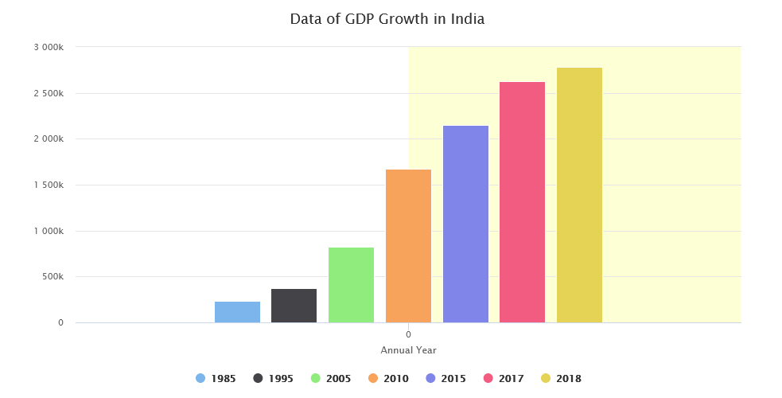

**Fig 1: Data of GDP Growth in India**

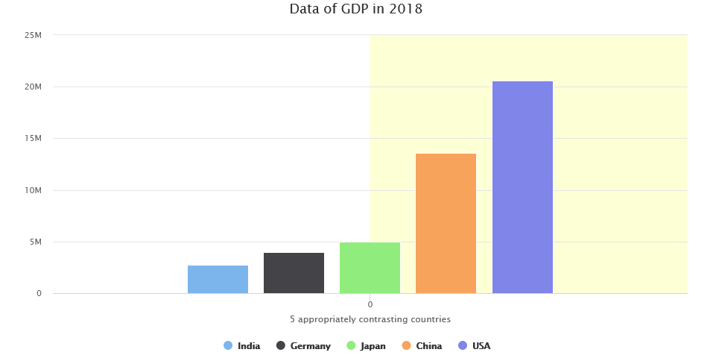

**Fig 2: Data of GDP in 2018**

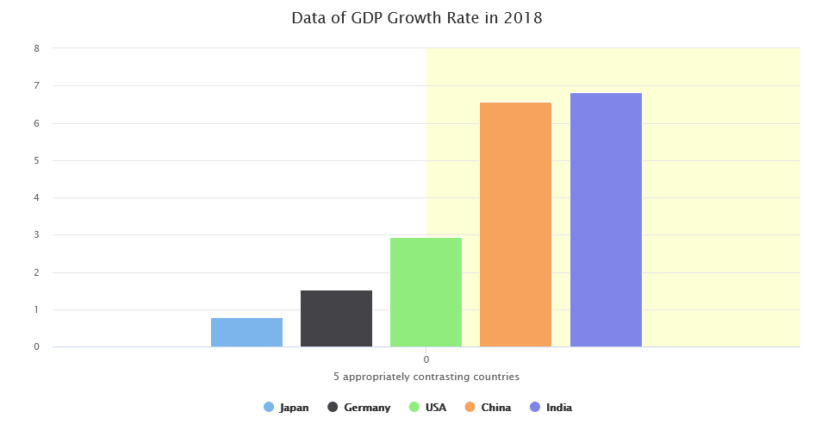

**Fig 3: Data of GDP Growth Rate in 2018**

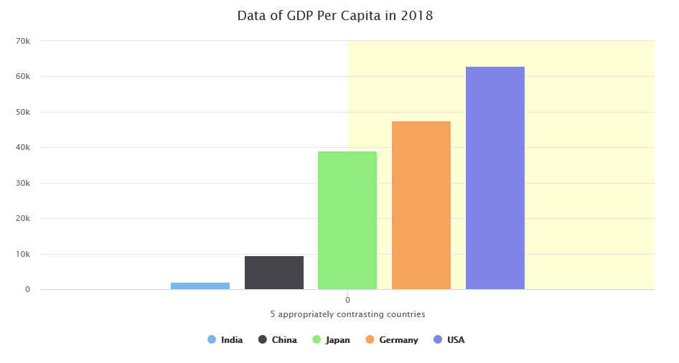

**Fig 4: Data of GDP Per Capita in 2018**

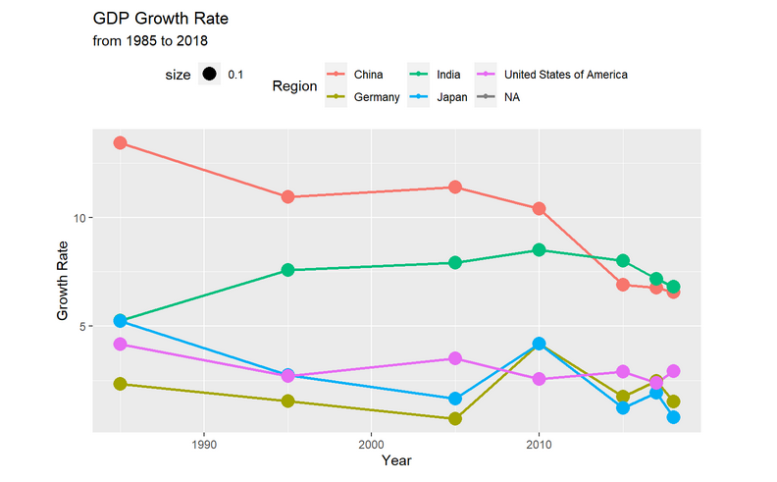

**Fig 5: GDP Growth Rate**

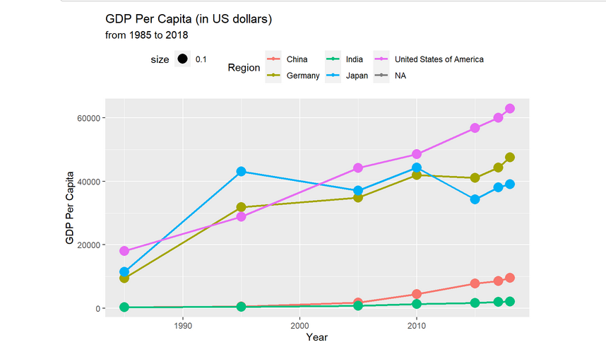

**Fig 6: GDP Per Capita (in US Dollars)**

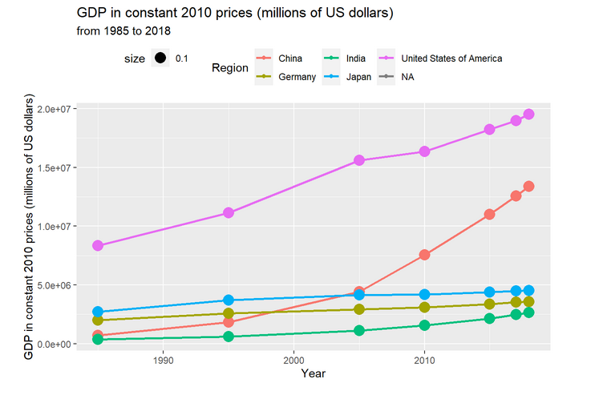

**Fig 7: GDP in constant 2010 prices (millions of US dollars)**

**Conclusion**:

* Top-5 countries according to Gross Domestic Product
* China and India are growing at very fast rate
* Although USA, Japan, and Germany are currently growing at slow rate most of their GDP growth lies in 20th Century
* China has made very remarkable growth over small period of time
* There is very greater need to increase GDP growth rate for India
* India is quite far from becoming a developed country.