Predicting Students’ Final Grades With Different Grade Availability
Venkaiah Chowdary Jampani, Dushyanth SaiKumar Yepuri, Enose Katti, Rupesh Sai Yadala and Sai Kiran Reddy Gaddam.
School of Computer and Information Sciences, University of the Cumberlands
ITS836: Data Science in Big Data Analytics
Dr. Jess Schwartz
October 24, 2026

Predicting Students’ Final Grades With Different Grade Availability
Every school year, some students finish a course with a failing grade even though the warning signs were there months earlier. In most schools, those signs only become visible when report cards come out, and by then much of the year is gone, leaving less room to help through tutoring, extra support, or a conversation with the family. This is a big part of why predicting student performance is one of the most studied problems in educational data mining.
Earlier achievement is a common predictor in educational data mining. Shahiri et al. (2015) reviewed student-performance prediction studies and identified academic achievement measures as recurring inputs. Cortez and Silva (2008) studied the two Portuguese school datasets used here, including experiments with and without period grades. Online learning research also illustrates the potential of educational data for student support (Kuzilek et al., 2017; Macfadyen & Dawson, 2010). These contexts differ, so predictive performance should not be assumed to transfer between them.
Prediction with more grade information can be more accurate, but this alone does not establish how early a model could operate. Dated measurements are needed to validate a prospective warning system. A second concern is evaluation: when most students pass, overall accuracy can conceal low recall among students who fail. Useful reporting therefore needs regression error, class-specific metrics, and explicit limits on interpretation.
This retrospective study compares three feature sets: non-grade variables only, those variables plus the first period grade (G1), and those variables plus G1 and the second period grade (G2). We exclude absences because attendance totals are not available separately for each prediction stage. Questionnaire collection times are not established, so the no-grade experiment must not be interpreted as a validated first-day-of-school forecast. Three research questions guide the comparison:
RQ1: How does final-grade prediction change when no period grades, G1, or G1 and G2 are supplied?
RQ2: Which non-grade variables does a no-grade random forest rely on most?
RQ3: How well does a classifier identify students with a final grade below 10 under each feature set?
H1 predicts substantially lower prediction error when G1 is added. H2 predicts that non-grade variables improve on simple constant baselines. We assess these hypotheses descriptively rather than claiming statistical significance or intervention effectiveness.
Methods
Data Source
We used the Student Performance dataset from the UCI Machine Learning Repository (Cortez, 2008), which was originally collected and described by Cortez and Silva (2008). The data comes from two public secondary schools in Portugal and was gathered from school reports and student questionnaires. It is provided as two files: student-mat.csv with 395 students in a mathematics course and student-por.csv with 649 students in a Portuguese language course. Both files have the same 33 columns. Three of these are grades: G1 and G2 are the first and second period grades, and G3 is the final grade, which is the target we predict. All grades range from 0 to 20, and 10 is the passing mark. The other 30 columns describe the student's background: demographics, family (such as parents' education and jobs), study habits (weekly study time, past failures, absences, plans for higher education), support (school, family, and paid classes), and social life (going out, free time, alcohol use). The dataset was downloaded from the repository and is released under a CC BY 4.0 license. About 382 students appear in both files because they took both courses, so we analyzed the two courses separately rather than combining them.
Data Wrangling and Preprocessing
Both semicolon-separated files were loaded with pandas and checked for missing values; neither contained missing entries. The primary analysis retains all 395 mathematics and 649 Portuguese records, including 38 and 15 zero final grades. Earlier nonzero grades do not establish whether a zero reflects dropout, absence, or another outcome. Excluding these records would restrict the population using the target itself. A secondary sensitivity analysis repeats evaluation on records with G3 > 0 without treating this restriction as a verified dropout definition.
The 17 categorical variables are one-hot encoded using OneHotEncoder(drop="first", handle_unknown="ignore") inside a scikit-learn pipeline. The encoder is fitted only on the training portion of each fold, then applied to validation or test data. Numeric variables pass through without scaling. Ordinal variables retain their recorded integer codes, so linear regression assumes equally spaced increments. The two courses are modeled independently with their own encoders.
Stage Design and Data Splitting
The primary no-grade feature set contains 29 original variables: all predictors except absences and the three grades. The G1 and G1-plus-G2 sets contain 30 and 31 original variables. One-hot encoding expands categorical inputs internally. Each course receives one 80/20 split stratified by G3 < 10, with random_state=42. The same students are used across feature sets and tasks. Mathematics has 316 training and 79 test records; Portuguese has 519 training and 130 test records. Test outcomes are reserved for final evaluation, not model selection.
Analytical Techniques
Regression candidates are linear regression, random forest with 300 trees (Breiman, 2001), and gradient boosting with 100 trees, learning rate .1, and maximum depth 3 (Friedman, 2001). For each course and feature set, five-fold shuffled cross-validation within the training set selects the candidate with the lowest mean absolute error (MAE). The selected pipeline is refitted on all training records and evaluated once on the held-out test set using MAE and R². Training-mean and training-median constant baselines are both evaluated; the median is the optimal constant for absolute error. Randomized operations use seed 42. Unrounded scores are retained for calculations.
For RQ2, a prespecified 300-tree random forest is fitted to each no-grade training set, independently of regression model selection. Permutation importance shuffles each original variable in the held-out data 20 times and measures the increase in MAE. The entire preprocessing pipeline is evaluated, so categories from the same original variable remain grouped. Error bars show shuffle standard deviations, not population confidence intervals. Importance reflects model reliance, neither effect direction nor causation; correlated variables may divide importance.
At risk is defined as G3 < 10. A prespecified random forest classifier uses 300 trees, balanced class weights, and its default decision threshold. Training-only stratified five-fold cross-validation estimates recall, after which the classifier is refitted on all training records. Held-out reporting includes accuracy, precision, recall, F1, confusion matrices, and 95% Wilson intervals for recall. An always-pass classifier supplies an accuracy baseline. Recall intervals describe finite test-sample uncertainty and do not include all uncertainty from training or model choice. No threshold is tuned on test outcomes.
Tools and Reproducibility
The supplied README and requirements.txt describe installation and execution. The notebook contains Markdown instructions and runs from top to bottom with the CSV files beside it. The verified environment uses pandas 2.2.3, NumPy 2.1.3, scikit-learn 1.6.1, matplotlib 3.10.0, and seaborn 0.13.2; exact Python and notebook versions are recorded in review_outputs/environment.json. pandas supports tabular processing (McKinney, 2010), scikit-learn modeling (Pedregosa et al., 2011), and matplotlib and seaborn visualization (Hunter, 2007; Waskom, 2021). Each run exports full-precision tables and figures. Fixed seeds support repeatability within the recorded environment, not guaranteed equality across software versions.
Results
Final Grade Distribution
Table 1 summarizes the complete datasets used in the primary analysis. Mathematics has lower average recorded grades and a lower observed pass rate than Portuguese; this descriptive difference does not establish that one course is intrinsically harder. Figure 1 retains the zero-grade groups rather than assigning an unverified dropout meaning to them.
Table 1
Summary of Final Grades (G3), Including Zero Grades
Course | N | Mean | SD | Pass rate | Zeros
Math | 395 | 10.42 | 4.58 | 67.1% | 38
Portuguese | 649 | 11.91 | 3.23 | 84.6% | 15
Note. Grades range from 0 to 20. All records are retained in the primary analysis; pass rate is the proportion with G3 ≥ 10.
Figure 1
Distribution of Final Grades (G3) by Course
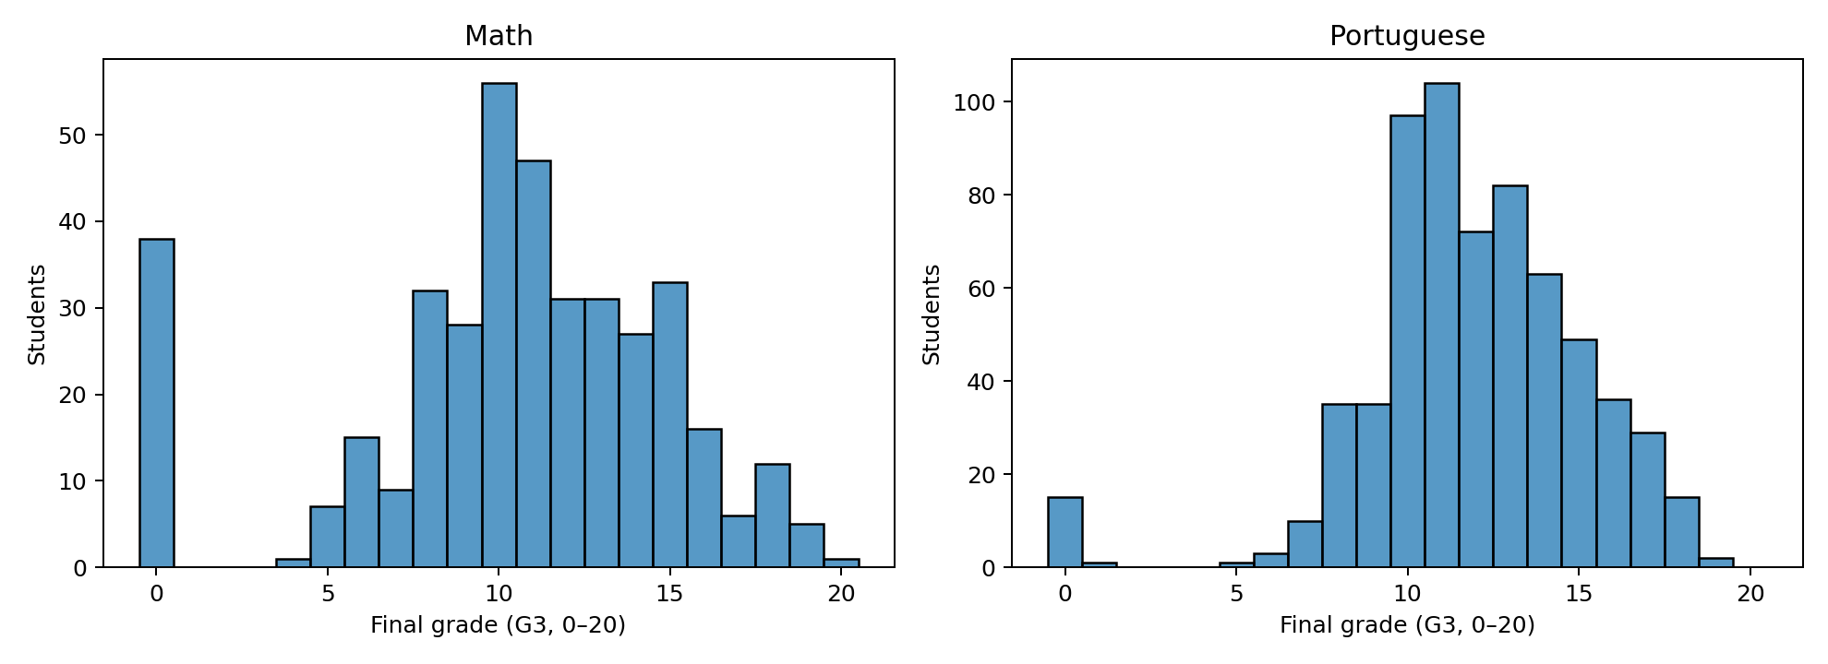
Note. Integer-aligned bins show all recorded final grades. Zero grades are not confirmed dropout labels.
Regression Findings
The tables distinguish training cross-validation from held-out evaluation. MAE is measured in grade points and R² is relative to a constant predictor on the test sample. A negative R², if observed, means worse squared-error performance than that reference; R² is not classification accuracy. The exported cross_validation.csv contains results for all candidate regressors, including fold variability.
Regression Results by Stage
Table 2 reports only the regression model selected using training cross-validation for each course and feature set. Figure 2 compares held-out R² for those selections. Math test MAE was 3.23, 2.04, and 1.27 grade points for no grades, G1, and G1 plus G2, respectively; R² was 0.109, 0.608, and 0.813. Portuguese test MAE was 2.25, 1.42, and 0.94 grade points for no grades, G1, and G1 plus G2, respectively; R² was 0.220, 0.652, and 0.806.
Table 2
Training-Selected Regression Models and Held-Out Performance
Course / inputs | Selected model | CV MAE | Test MAE | Test R²
Math: No grades | Random forest | 3.35 | 3.23 | 0.109
Math: + G1 | Random forest | 2.02 | 2.04 | 0.608
Math: + G1 + G2 | Random forest | 1.26 | 1.27 | 0.813
Portuguese: No grades | Random forest | 1.96 | 2.25 | 0.220
Portuguese: + G1 | Random forest | 1.22 | 1.42 | 0.652
Portuguese: + G1 + G2 | Random forest | 0.80 | 0.94 | 0.806
Note. CV MAE is the five-fold training estimate used for selection. Test MAE and R² use 79 mathematics and 130 Portuguese records. MAE is in grade points.
Figure 2
Held-Out R² by Grade Information and Course
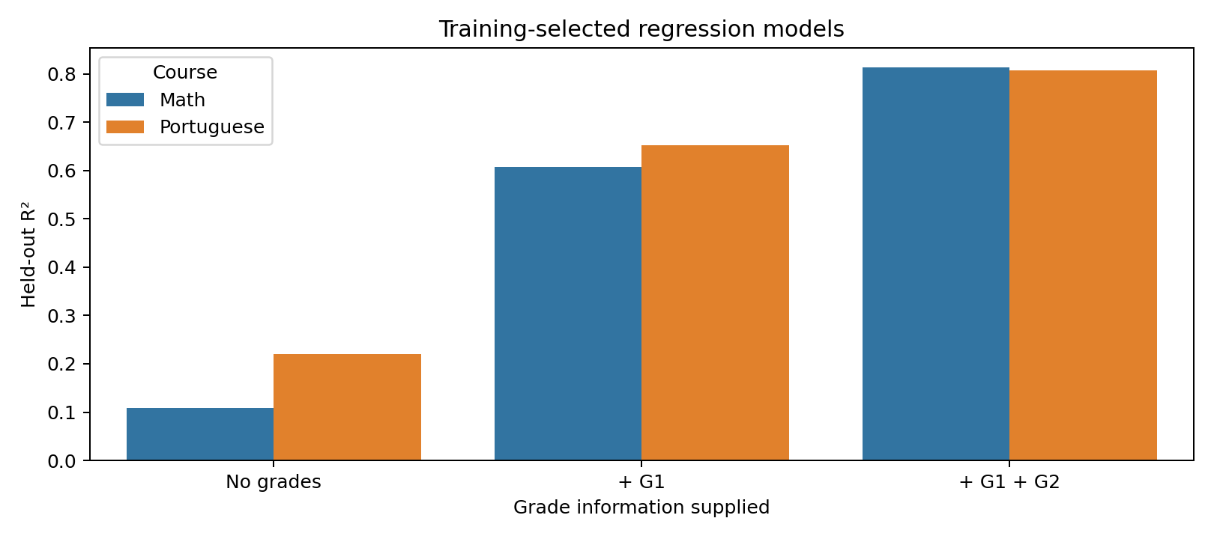
Note. Each bar represents the candidate selected by training-only cross-validation for that course and feature set.
Comparison with constant predictions addresses H2. Math: no-grade MAE 3.23; training-mean baseline 3.42; training-median baseline 3.37. Portuguese: no-grade MAE 2.25; training-mean baseline 2.60; training-median baseline 2.59. Improvements over these baselines are descriptive estimates on one held-out split, not proof of reliable operational warning performance.
Important Factors at Stage 0
The largest no-grade permutation importance values, expressed as increases in MAE, were as follows. Math: failures (0.533), schoolsup (0.142), guardian (0.099). Portuguese: failures (0.229), higher (0.094), Fedu (0.080). Figure 3 shows the ten largest values for each course. Rankings characterize these fitted models; they are not estimates of the effect of changing a student’s circumstances.
Figure 3
No-Grade Random Forest Permutation Importance
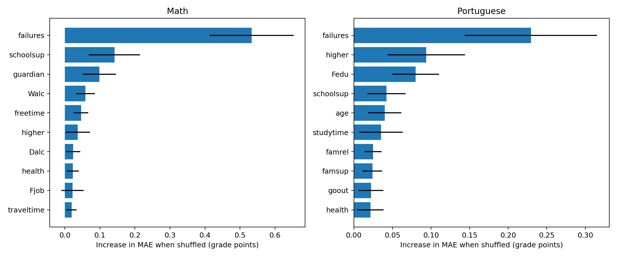
Note. Bars show mean increases in test MAE across 20 shuffles of an original variable. Error bars are shuffle standard deviations, not confidence intervals.
Identifying At-Risk Students
Table 3 and Figure 4 summarize the prespecified classifier on the held-out records. Math recall was 26.9%, 69.2%, and 88.5% across the three feature sets. With G1, precision was 72.0%, and the 95% Wilson recall interval was 50.0%–83.5%. Portuguese recall was 10.0%, 30.0%, and 70.0% across the three feature sets. With G1, precision was 66.7%, and the 95% Wilson recall interval was 14.5%–51.9%. Accuracy must be read alongside recall, precision, and false alarms. The exported classification.csv also contains F1, confusion counts, training cross-validation recall, and always-pass accuracy.
Table 3
Held-Out At-Risk Classification Performance
Course / inputs | Accuracy | Precision | Recall (95% CI) | F1
Math: No grades | 72.2% | 70.0% | 26.9% (13.7%–46.1%) | 0.389
Math: + G1 | 81.0% | 72.0% | 69.2% (50.0%–83.5%) | 0.706
Math: + G1 + G2 | 91.1% | 85.2% | 88.5% (71.0%–96.0%) | 0.868
Portuguese: No grades | 83.1% | 33.3% | 10.0% (2.8%–30.1%) | 0.154
Portuguese: + G1 | 86.9% | 66.7% | 30.0% (14.5%–51.9%) | 0.414
Portuguese: + G1 + G2 | 91.5% | 73.7% | 70.0% (48.1%–85.5%) | 0.718
Note. At risk means G3 < 10. Precision is the share of warnings that identify at-risk students; recall is the share of at-risk students caught. Recall intervals are 95% Wilson intervals.
Figure 4
Confusion Matrices for Pass/Fail Prediction at Each Stage
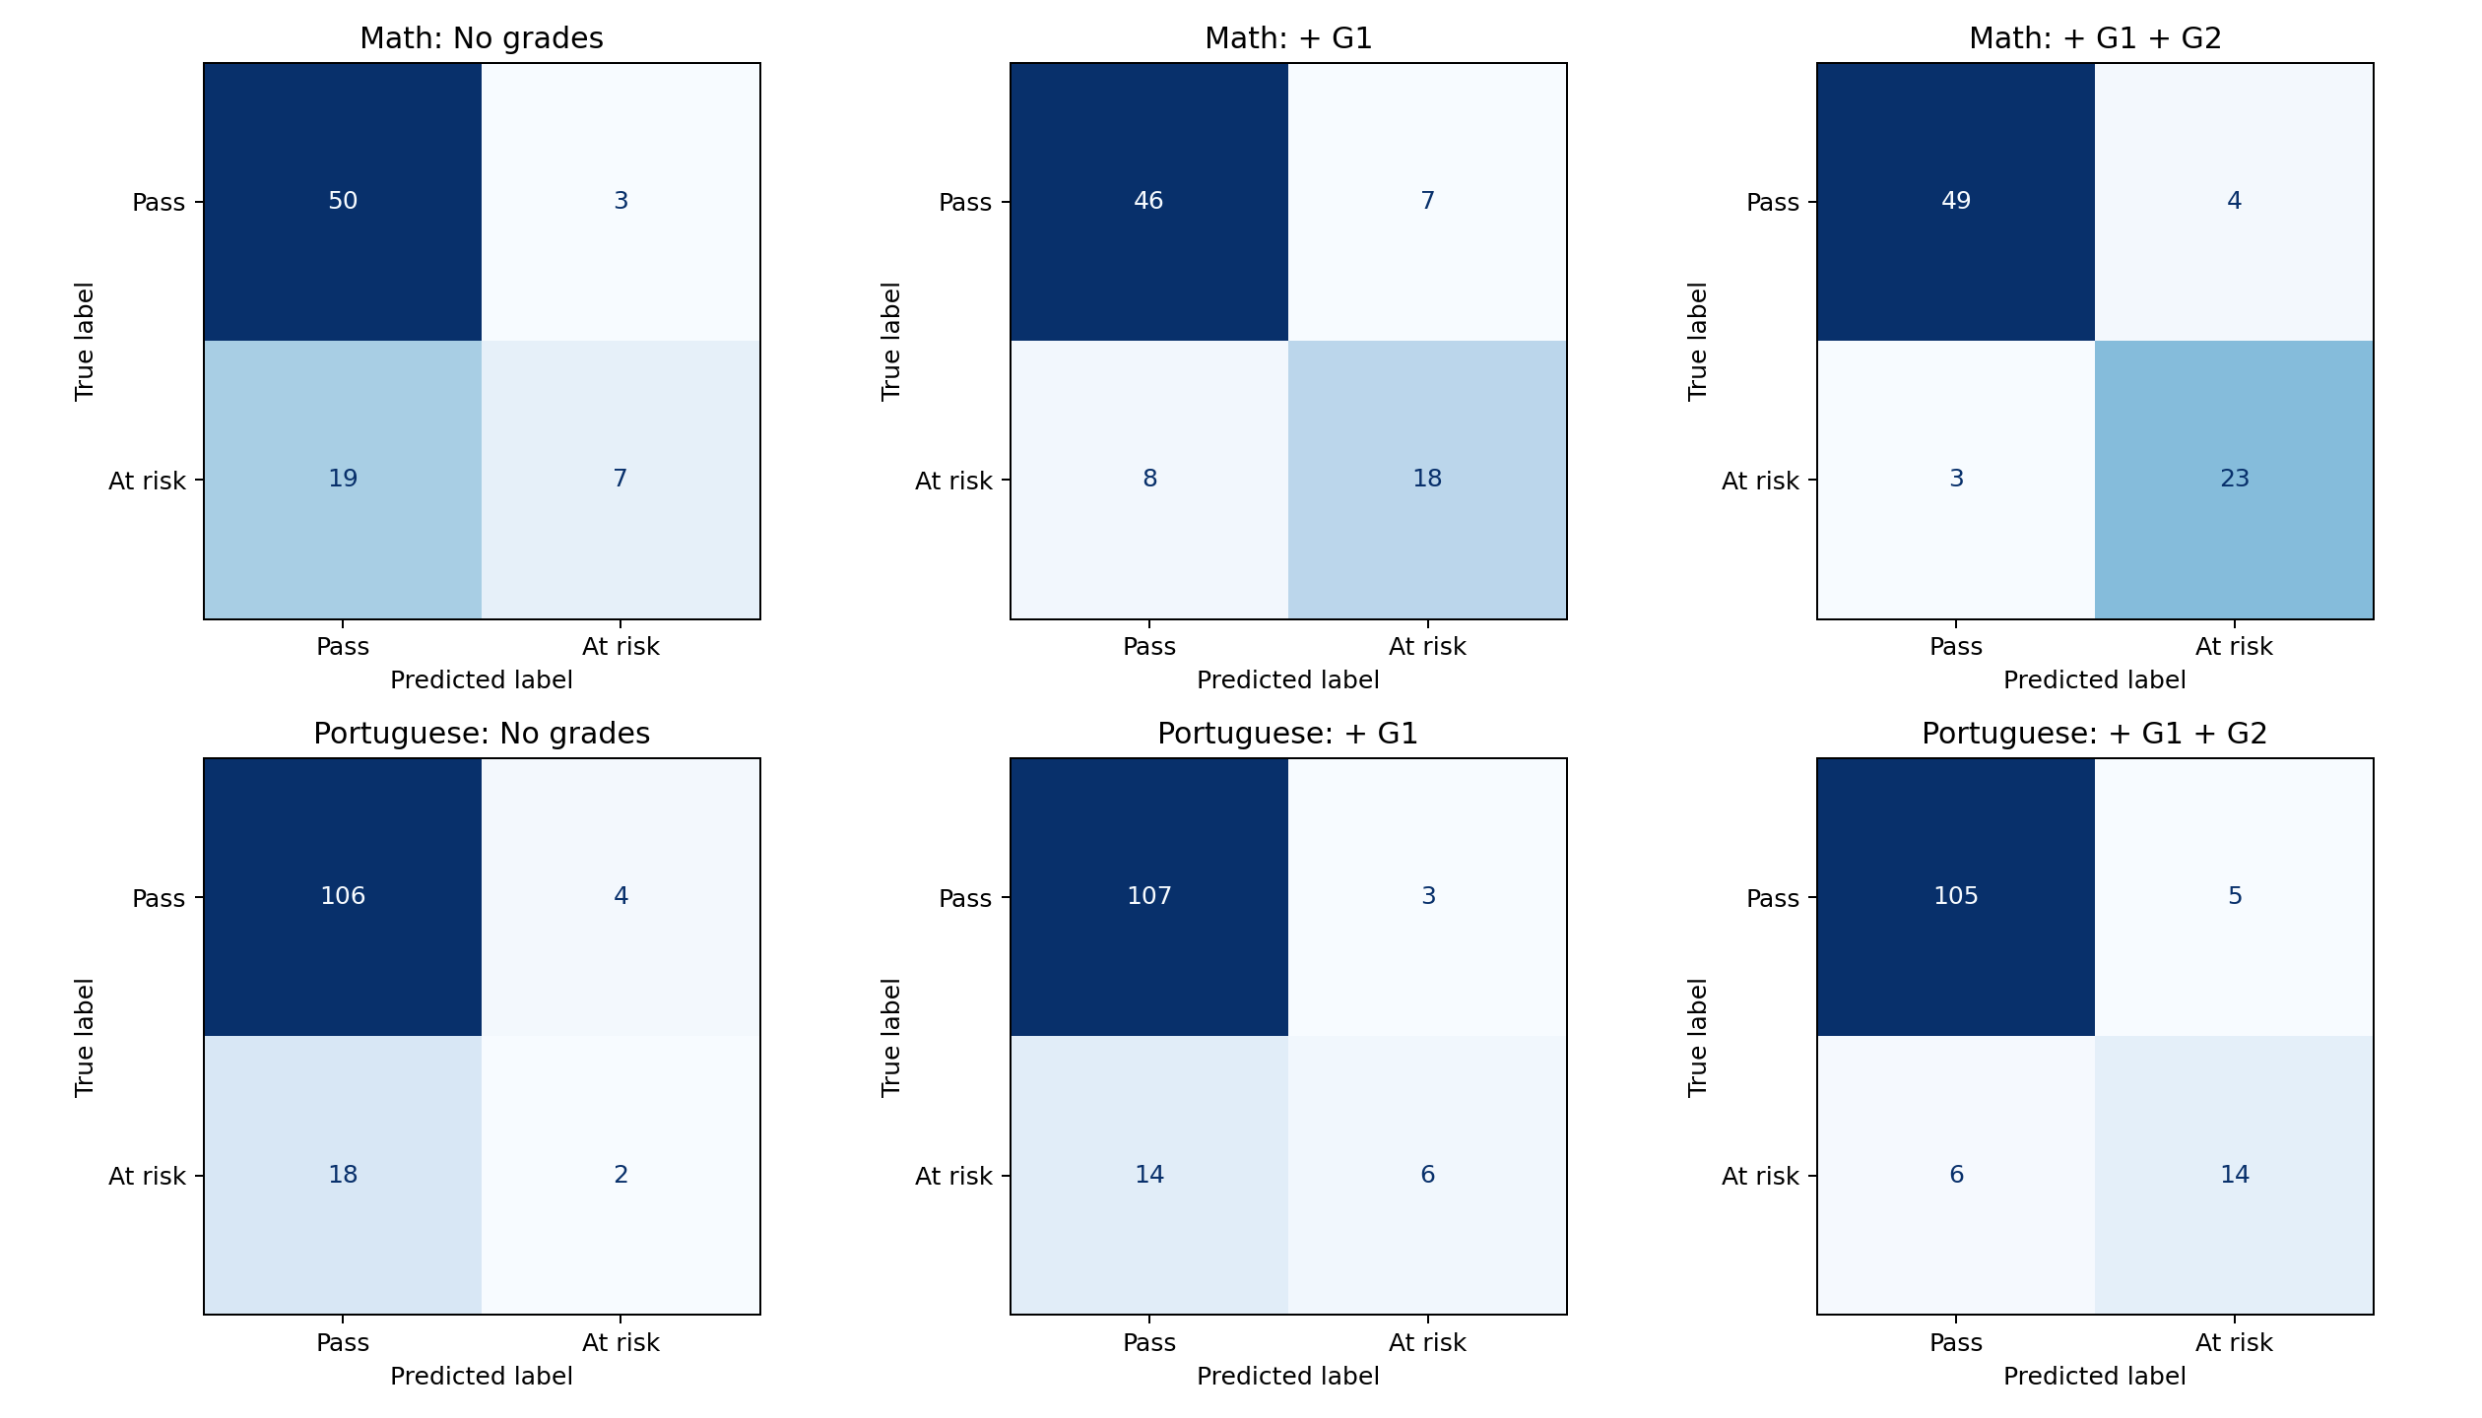
Note. Rows show the true outcome and columns show the predicted outcome. The bottom-right cell of each matrix counts at-risk students the model correctly identified.
Discussion
RQ1 concerns the predictive contribution of period grades. Math test MAE was 3.23, 2.04, and 1.27 grade points for no grades, G1, and G1 plus G2, respectively; R² was 0.109, 0.608, and 0.813. Portuguese test MAE was 2.25, 1.42, and 0.94 grade points for no grades, G1, and G1 plus G2, respectively; R² was 0.220, 0.652, and 0.806. These comparisons use the same test students within each course, while allowing the model type to be selected within training data. They measure retrospective predictive performance; measurement timing remains a separate requirement for a prospective application.
RQ2 concerns model reliance on non-grade inputs. Math: failures (0.533), schoolsup (0.142), guardian (0.099). Portuguese: failures (0.229), higher (0.094), Fedu (0.080). These variables may proxy prior achievement, existing responses to difficulty, or social circumstances. For example, an importance score for school support does not establish that support lowers grades. Establishing direction requires additional analysis, and establishing intervention effects requires an appropriate causal design.
RQ3 concerns identification of at-risk students. Math recall was 26.9%, 69.2%, and 88.5% across the three feature sets. With G1, precision was 72.0%, and the 95% Wilson recall interval was 50.0%–83.5%. Portuguese recall was 10.0%, 30.0%, and 70.0% across the three feature sets. With G1, precision was 66.7%, and the 95% Wilson recall interval was 14.5%–51.9%. Recall alone does not establish usefulness: schools must also consider precision, false alarms, support capacity, and the consequences of missed warnings. Small class-specific test counts make point estimates uncertain. Cross-validation recall and test intervals provide complementary evidence, but neither substitutes for external validation.
The broad question follows Cortez and Silva (2008), who examined student-performance prediction with differing grade inputs. Shahiri et al. (2015) also place prior achievement within the wider educational prediction literature. Direct numerical comparisons require matching populations, splits, metrics, preprocessing, and validation procedures. We therefore do not compare our MAE directly with published RMSE or interpret differences as algorithm superiority. This project contributes a reproducible within-dataset comparison with training-only model selection and explicit class-specific evaluation.
The practical implication is to investigate whether information available at a documented decision time can improve support planning. These models are research prototypes, not validated tools for assigning interventions. A prospective pilot would need dated predictors, an agreed warning threshold, assessment of false alarms and missed cases, and evidence that support benefits students. Predictions should supplement educator judgment rather than determine student opportunities.
Limitations include historical data from two schools, modest sample sizes, self-reported variables, uncertain collection times, and students appearing in both course datasets. Separate course analyses avoid pooling repeated records but do not create independent replications. One stratified held-out split leaves sensitivity to the chosen sample. Ordinal coding imposes assumptions, permutation importance depends on correlated predictors, and balanced class weights do not guarantee high recall. Zero outcomes have uncertain meanings, and a restricted G3 > 0 analysis changes the population.
Future work should validate using dated attendance, assignment, and questionnaire records; repeat evaluation across splits or schools; examine subgroup performance; and select thresholds using training data and intervention costs. The supplied sensitivity.csv reports G3 > 0 results using the primary selected regression model types and fresh stratified splits. Because restricted and full test populations differ, these estimates describe sensitivity to population definition rather than the causal effect of excluding zeros. Confirmed dropout labels would support a separate dropout task.
Conclusion
This study compares final-grade prediction with no period grades, G1, and G1 plus G2 while retaining zero outcomes and excluding undated absences. Math test MAE was 3.23, 2.04, and 1.27 grade points for no grades, G1, and G1 plus G2, respectively; R² was 0.109, 0.608, and 0.813. Portuguese test MAE was 2.25, 1.42, and 0.94 grade points for no grades, G1, and G1 plus G2, respectively; R² was 0.220, 0.652, and 0.806.
H1 was supported descriptively: compare the no-grade and G1 MAEs above. H2 was supported against both constant baselines on these held-out samples. These statements concern predictive estimates rather than statistical significance. The sample sizes, software dependence, population definition, and unknown predictor times limit broader conclusions.
The value of the work is a transparent distinction between grade prediction, identification of at-risk students, and evidence needed for real-world use. Training-only preprocessing and selection preserve the test set for evaluation, while precision, recall, and uncertainty make the limits of warning performance visible. Prospective validation is required before conclusions about how early these predictions can support a school.
References
Breiman, L. (2001). Random forests. Machine Learning, 45(1), 5–32. https://doi.org/10.1023/A:1010933404324
Cortez, P. (2008). Student performance [Data set]. UCI Machine Learning Repository. https://doi.org/10.24432/C5TG7T
Cortez, P., & Silva, A. M. G. (2008). Using data mining to predict secondary school student performance. In A. Brito & J. Teixeira (Eds.), Proceedings of the 5th Future Business Technology Conference (FUBUTEC 2008) (pp. 5–12). EUROSIS.
Friedman, J. H. (2001). Greedy function approximation: A gradient boosting machine. The Annals of Statistics, 29(5), 1189–1232. https://doi.org/10.1214/aos/1013203451
Hunter, J. D. (2007). Matplotlib: A 2D graphics environment. Computing in Science & Engineering, 9(3), 90–95. https://doi.org/10.1109/MCSE.2007.55
Kuzilek, J., Hlosta, M., & Zdrahal, Z. (2017). Open University Learning Analytics dataset. Scientific Data, 4, Article 170171. https://doi.org/10.1038/sdata.2017.171
Macfadyen, L. P., & Dawson, S. (2010). Mining LMS data to develop an "early warning system" for educators: A proof of concept. Computers & Education, 54(2), 588–599. https://doi.org/10.1016/j.compedu.2009.09.008
McKinney, W. (2010). Data structures for statistical computing in Python. In S. van der Walt & J. Millman (Eds.), Proceedings of the 9th Python in Science Conference (pp. 56–61). https://doi.org/10.25080/Majora-92bf1922-00a
Pedregosa, F., Varoquaux, G., Gramfort, A., Michel, V., Thirion, B., Grisel, O., Blondel, M., Prettenhofer, P., Weiss, R., Dubourg, V., Vanderplas, J., Passos, A., Cournapeau, D., Brucher, M., Perrot, M., & Duchesnay, É. (2011). Scikit-learn: Machine learning in Python. Journal of Machine Learning Research, 12, 2825–2830.
Shahiri, A. M., Husain, W., & Rashid, N. A. (2015). A review on predicting student's performance using data mining techniques. Procedia Computer Science, 72, 414–422. https://doi.org/10.1016/j.procs.2015.12.157
Waskom, M. L. (2021). seaborn: Statistical data visualization. Journal of Open Source Software, 6(60), Article 3021. https://doi.org/10.21105/joss.03021

