Predicting Students' Final Grades Across the School Year: How Early Can At-Risk Students Be Identified?

Venkaiah Chowdary Jampani, Dushyanth SaiKumar Yepuri, Enose Katti, Rupesh Sai Yadala and Sai Kiran Reddy Gaddam.
School of Computer and Information Sciences, University of the Cumberlands
ITS836: Data Science in Big Data Analytics
Dr. Jess Schwartz
10-24-2026

Predicting Students' Final Grades Across the School Year: How Early Can At-Risk Students Be Identified?
Every school year, some students finish a course with a failing grade even though the warning signs were there months earlier. In most schools, those signs only become visible when report cards come out, and by then much of the year is gone, leaving less room to help through tutoring, extra support, or a conversation with the family. This is a big part of why predicting student performance is one of the most studied problems in educational data mining.
Most of what is known so far points in the same direction: a student's earlier academic results are the best predictor of later ones. In a review of studies on predicting student performance, Shahiri et al. (2015) found that cumulative grade point average and internal assessment marks were the attributes used most often and with the most influence. Cortez and Silva (2008), who collected the dataset used in this project from two secondary schools in Portugal, reached a similar conclusion. Their models were highly accurate when the first and second period grades were included, and prediction became much harder once those grades were removed. More recent work on the same data still lists the period grades, past failures, and parents' education among the strongest predictors (Guo et al., 2026). Other studies have looked beyond grades, pointing to study hours, attendance, and tutoring (Yin, 2026) or to activity logs from online learning platforms (Kuzilek et al., 2017; Macfadyen & Dawson, 2010).
The challenge is that accuracy and timing pull in opposite directions. A model that uses the second period grade can predict the final grade very well, but by the time that grade exists, most of the year has passed. A model that uses only background information, such as study habits, family situation, and past failures, could be run on the first day of school, but it will likely be much less accurate. Many published models report results using every grade available, which says little about how useful they would be earlier in the year. How models are judged is a second problem. Since most students pass, a model can report high overall accuracy while still missing most of the students who fail, and those are the students an early warning system exists to find.
This project looks at that trade-off directly. Instead of building a single model, we predict each student's final grade at three points in the school year: at the start, before any grades exist (Stage 0); after the first period grade (Stage 1); and after the second period grade (Stage 2). Comparing the stages shows how much accuracy is gained with each new piece of information and how early a useful prediction becomes possible. The analysis is guided by three research questions:
RQ1: How accurately can a student's final grade be predicted at the start of the year, after the first period, and after the second period?
RQ2: Which background factors contribute most to the prediction before any grades are available?
RQ3: How well can a model identify at-risk students, meaning those who will finish below the passing grade, at each stage?
We expected prediction accuracy to rise sharply once the first period grade was added (H1). We also expected background factors, especially past failures, study time, and absences, to still produce a prediction that is meaningfully better than simply guessing the class average at Stage 0 (H2).
Methods
Data Source
We used the Student Performance dataset from the UCI Machine Learning Repository (Cortez, 2008), which was originally collected and described by Cortez and Silva (2008). The data comes from two public secondary schools in Portugal and was gathered from school reports and student questionnaires. It is provided as two files: student-mat.csv with 395 students in a mathematics course and student-por.csv with 649 students in a Portuguese language course. Both files have the same 33 columns. Three of these are grades: G1 and G2 are the first and second period grades, and G3 is the final grade, which is the target we predict. All grades range from 0 to 20, and 10 is the passing mark. The other 30 columns describe the student's background: demographics, family (such as parents' education and jobs), study habits (weekly study time, past failures, absences, plans for higher education), support (school, family, and paid classes), and social life (going out, free time, alcohol use). The dataset was downloaded from the repository and is released under a CC BY 4.0 license. About 382 students appear in both files because they took both courses, so we analyzed the two courses separately rather than combining them.
Data Wrangling and Preprocessing
Both files were loaded with pandas using a semicolon as the separator. Neither file had missing values. The final grade distribution showed a separate group of students with a final grade of exactly 0 (38 in mathematics and 15 in Portuguese), with almost no students between 1 and 4, so we checked their earlier grades. Their average first period grade was 7.53 in mathematics and 7.07 in Portuguese, so they had been attending class and earning grades. In addition, 13 of the 38 mathematics students and 7 of the 15 Portuguese students already had a second period grade of 0. This pattern suggests these students dropped out or did not sit the final exam rather than scoring zero. Because this project is about predicting grades and not predicting dropout, we removed them. This left 357 students in mathematics and 634 in Portuguese.
Next, the 17 text columns were converted to numbers using one-hot encoding (pandas get_dummies with drop_first=True), which creates a 0/1 column for each category and drops one category per variable to avoid redundancy. For example, higher became higher_yes, where 1 means the student plans to pursue higher education. Each dataset then had 42 numeric columns.
Stage Design and Data Splitting
We defined three feature sets. Stage 0 uses the 39 background columns only. Stage 1 adds G1 for a total of 40 columns, and Stage 2 adds both G1 and G2 for 41 columns. Each dataset was split once into a training set (80%) and a test set (20%) using scikit-learn's train_test_split with random_state=42. This produced 285 training and 72 test students in mathematics, and 507 training and 127 test students in Portuguese. The same split was used for every stage and every model, so the only thing that changes between stages is the information the model is allowed to see. All models were trained on the training set and evaluated only on the test set.
Analytical Techniques
For the regression task, we compared three models at each stage. Linear regression served as a simple and interpretable reference. A random forest regressor with 300 trees averages the predictions of many decision trees, each built on a random sample of the data (Breiman, 2001). A gradient boosting regressor, using scikit-learn's default settings of 100 trees, a learning rate of 0.1, and a maximum depth of 3, builds trees one after another, with each tree correcting the errors of the previous ones (Friedman, 2001). Both tree-based models used random_state=42. Each model was evaluated with the coefficient of determination (R²), which shows how much of the variation in final grades the model explains, and the mean absolute error (MAE), which shows how many grade points the predictions are off on average. To judge whether the Stage 0 models were useful, we also compared them to a baseline that predicts the training set's average final grade for every student.
To understand which background factors, drive the Stage 0 predictions, we used permutation importance on the Stage 0 random forest. This method shuffles one column at a time in the test set and measures how much the MAE increases. A large increase means the model relies heavily on that column. Each column was shuffled 20 times (n_repeats=20, random_state=42).
For the classification task, we labeled students with a final grade below 10 as at risk and all others as passing. A random forest classifier with 300 trees was trained at each stage using class_weight="balanced" so that the model would give more weight to the smaller at-risk group, along with random_state=42. We report accuracy, recall for the at-risk class, and a confusion matrix for every stage. Recall was the main measure here, because it shows the share of at-risk students the model catches.
Tools and Reproducibility
The analysis was done in Python 3 using Jupyter Notebook through the Anaconda distribution. Data handling used pandas (McKinney, 2010) and NumPy, modeling and evaluation used scikit-learn (Pedregosa et al., 2011), and charts were created with matplotlib (Hunter, 2007) and seaborn (Waskom, 2021). To replicate the analysis, place the two CSV files in the same folder as the notebook and run all cells from top to bottom. Every random process uses random_state=42, so the splits, models, and results reproduce exactly. The notebook is submitted with this paper and includes a README section and comments explaining each step.
Results
Final Grade Distribution
Table 1 summarizes the final grades before and after removing the students with a final grade of 0. Mathematics was the harder course, with a lower average grade and a lower pass rate than Portuguese. Figure 1 shows the distribution of final grades in both courses. Most grades fall between 8 and 15, with a separate cluster at 0.
Table 1
Summary of Final Grades (G3) Before and After Removing Zero Grades
Measure | Math (before) | Math (after) | Portuguese (before) | Portuguese (after)
Students | 395 | 357 | 649 | 634
Mean | 10.42 | 11.52 | 11.91 | 12.19
Standard deviation | 4.58 | 3.23 | 3.23 | 2.69
Pass rate (G3 ≥ 10) | 67.1% | 74.2% | 84.6% | 86.6%
Students with G3 = 0 | 38 | 0 | 15 | 0
Note. Grades range from 0 to 20. Students with a final grade of 0 were removed because their earlier grades indicated they did not complete the course.
Figure 1
Distribution of Final Grades (G3) by Course
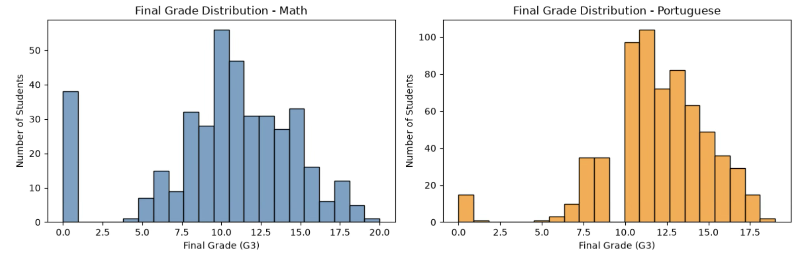

Note. Histograms of final grades before removing zero grades. The isolated bar at 0 represents students who most likely did not complete the course.
Relationships With the Final Grade
As expected, the period grades were very strongly correlated with the final grade. In mathematics, the correlation with G3 was .89 for G1 and .97 for G2. In Portuguese, it was .87 for G1 and .93 for G2. The background factors were much weaker. Past class failures had the strongest relationship in both courses (r = −.29 in mathematics and r = −.39 in Portuguese). Absences (r = −.21) and mother's education (r = .19) followed in mathematics, and mother's education (r = .27) and study time (r = .25) followed in Portuguese. No background factor reached .40, which suggested Stage 0 would be the hardest to predict.
Regression Results by Stage
Table 2 shows the R² and MAE for every model at every stage, and Figure 2 compares the R² values visually. Accuracy improved sharply at each stage. At Stage 0, the best R² was .233 in mathematics and .319 in Portuguese, and both came from the random forest. Adding the first period grade raised the best R² to .766 in mathematics and .762 in Portuguese, and the average prediction error fell from about 2 grade points to just over 1. At Stage 2, the best models explained about 89% to 93% of the variation, and predictions were off by less than one grade point on average. No single model was best everywhere: the random forest led in mathematics, while linear regression did as well or better in Portuguese at Stages 1 and 2.
Table 2
Regression Performance by Stage, Model, and Course
Stage / Model | Math R² | Math MAE | Portuguese R² | Portuguese MAE
Stage 0 (no grades)
Linear regression | .202 | 2.32 | .221 | 2.02
Random forest | .233 | 2.22 | .319 | 1.88
Gradient boosting | .127 | 2.31 | .262 | 1.94
Stage 1 (+ G1)
Linear regression | .708 | 1.34 | .762 | 1.10
Random forest | .766 | 1.14 | .755 | 1.13
Gradient boosting | .743 | 1.22 | .753 | 1.11
Stage 2 (+ G1, G2)
Linear regression | .916 | 0.67 | .891 | 0.77
Random forest | .928 | 0.60 | .871 | 0.77
Gradient boosting | .915 | 0.67 | .874 | 0.76
Note. All results are on the held-out test set (72 students in mathematics, 127 in Portuguese). MAE is in grade points on the 0 to 20 scale.
Figure 2
Prediction Accuracy (R²) by Stage and Model
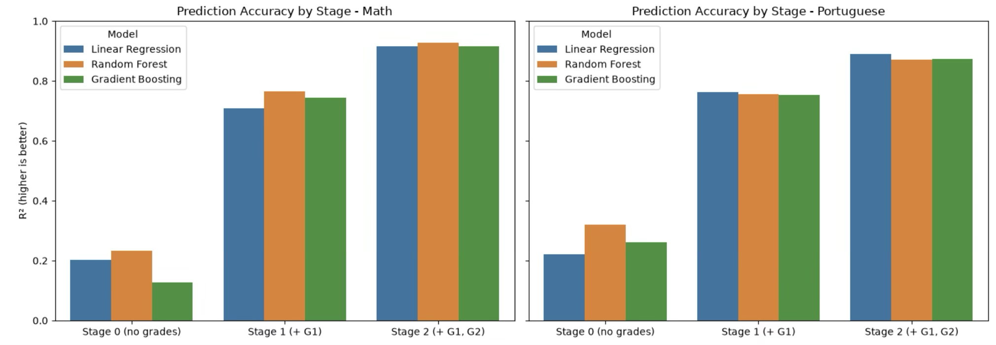

Note. Each group of bars shows the three regression models at one stage. The largest increase in R² occurs when the first period grade (G1) is added.
To check whether the Stage 0 models were useful at all, we compared them with the baseline that predicts the class average for every student. The baseline had an MAE of 2.57 in mathematics and 2.42 in Portuguese. The best Stage 0 models reduced this to 2.22 and 1.88, which is an improvement of 13.7% in mathematics and 22.3% in Portuguese. Background information alone does improve on guessing, but the gain is modest compared with what a single report card provides.
Important Factors at Stage 0
Figure 3 shows the ten background factors with the highest permutation importance in the Stage 0 random forest. In mathematics, receiving extra educational support from the school (0.115) and past failures (0.106) were the most important factors, followed by weekly study time (0.050). In Portuguese, past failures stood out clearly (0.369), followed by plans to pursue higher education (0.173), age (0.057), and mother's education (0.051). Beyond the top few, every value was small, so the Stage 0 prediction comes from many weak signals.
Figure 3
Top 10 Background Factors at Stage 0 by Permutation Importance
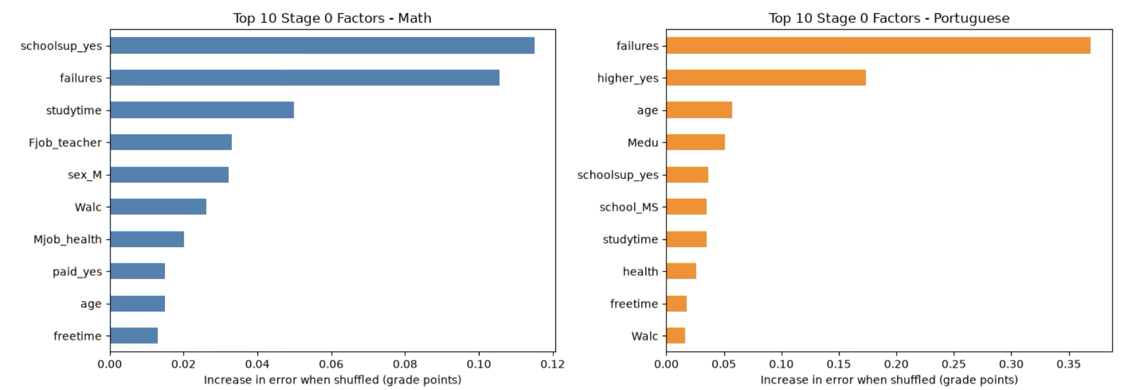

Note. Values show the average increase in mean absolute error (grade points) when each factor is randomly shuffled, across 20 repetitions. Encoded variables ending in _yes represent a "yes" response.
Identifying At-Risk Students
Table 3 reports the classification results, and Figure 4 shows the confusion matrices. The test sets included 19 at-risk students in mathematics and 22 in Portuguese. At Stage 0, accuracy looked reasonable at 77.8% and 83.5%, but recall was low. The model caught only 5 of the 19 at-risk students in mathematics and 6 of the 22 in Portuguese. Adding the first period grade changed this considerably in mathematics, where recall rose from 26.3% to 78.9%, and the model caught 15 of the 19 at-risk students. Portuguese improved more slowly, reaching 50.0% recall at Stage 1 and 68.2% at Stage 2.
Table 3
Pass/Fail Classification Results by Stage and Course
Course / Stage | Accuracy | Recall (at risk) | At-risk caught | False alarms
Math, Stage 0 | 77.8% | 26.3% | 5 of 19 | 2
Math, Stage 1 | 84.7% | 78.9% | 15 of 19 | 7
Math, Stage 2 | 94.4% | 89.5% | 17 of 19 | 2
Portuguese, Stage 0 | 83.5% | 27.3% | 6 of 22 | 5
Portuguese, Stage 1 | 86.6% | 50.0% | 11 of 22 | 6
Portuguese, Stage 2 | 91.3% | 68.2% | 15 of 22 | 4
Note. At risk is defined as a final grade below 10. False alarms are passing students the model labeled as at risk.
Figure 4
Confusion Matrices for Pass/Fail Prediction at Each Stage
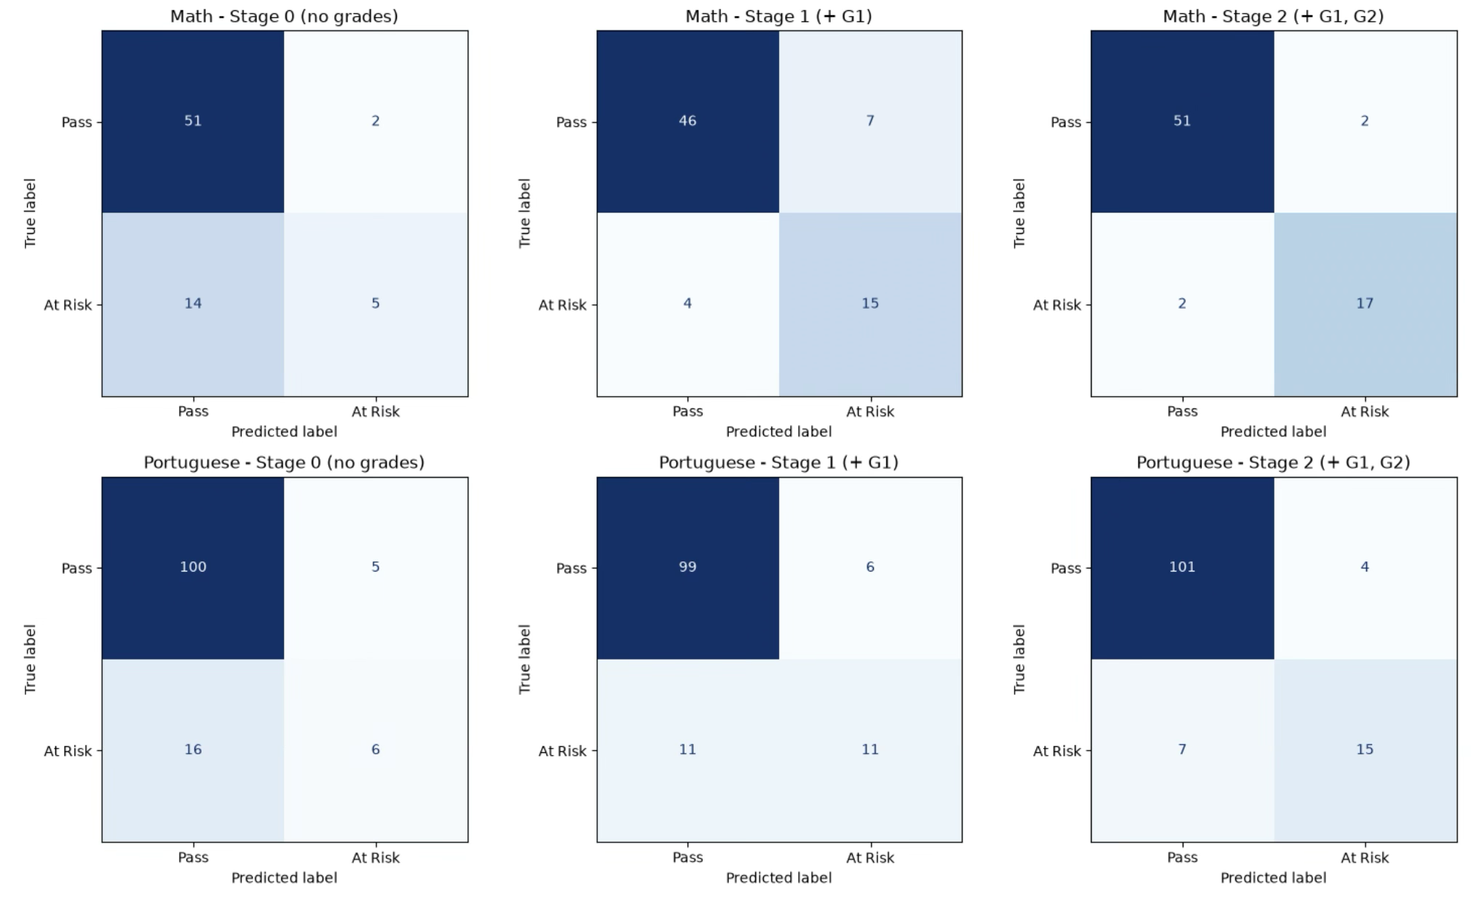

Note. Rows show the true outcome and columns show the predicted outcome. The bottom-right cell of each matrix counts at-risk students the model correctly identified.
Discussion
The first research question asked how accurately the final grade can be predicted at different points in the year. The answer depends heavily on timing. With background information alone, the models explained only about a quarter to a third of the variation in final grades. One additional piece of information, the first period grade, more than tripled that figure. This was the largest change in the analysis, bigger than the gain from adding the second period grade. A single report card told the models more than all 39 background variables combined.
The second research question asked which background factors matter most before grades exist. Past failures was the most consistent signal, ranking first or second in both courses and in both the correlation and permutation analyses. In mathematics, extra school support ranked first. This should not be read as support causing lower grades; the school most likely gave support to students teachers already saw struggling, so the variable works as an existing warning flag. In Portuguese, plans to pursue higher education ranked second, which points to motivation as a meaningful early signal. Weekly study time appeared in both courses, while absences, which we expected to be important, mattered less in the trained models than the correlations suggested.
The third research question asked how well at-risk students can be identified at each stage. At Stage 0, the classifier missed about three out of every four at-risk students, even though its overall accuracy looked acceptable. A model that called every student passing would have reached a similar accuracy without catching anyone, which is why accuracy alone is misleading here. Once G1 was available, the mathematics model caught most at-risk students, while the Portuguese model still missed about half. One likely reason is that fewer students fail Portuguese, leaving fewer at-risk examples to learn from.
These results line up closely with the original study on this dataset. Cortez and Silva (2008) also compared inputs with both period grades, with G1 only, and with no grades, and their best regression error in mathematics rose from 1.75 to 3.90 RMSE as the grades were removed. With no grades, their best model improved on a naive predictor by about 15% in mathematics and 17% in Portuguese, close to our gains of 13.7% and 22.3%. Their best no-grade classifier reached 70.6% accuracy in mathematics, only slightly above the 67.1% pass rate, which matches our finding that background data alone is weak at separating passing and failing students. They also found past failures to be the most important input without grades and listed school support and higher education plans among the other relevant variables, as our permutation results did. Their errors are larger than ours, partly because RMSE penalizes large misses more than MAE and, we suspect, partly because the zero grades remain in their data. Guo et al. (2026) likewise ranked past failures and parents' education among the strongest predictors, fitting the broader pattern described by Shahiri et al. (2015). What this project adds is a side-by-side view of the same models at three points in time, with recall reported alongside accuracy.
The main real-world takeaway is that a school does not have to choose between predicting early and predicting accurately; it can use both in sequence. At the start of the year, past failures, existing school support, and low study time can place students on a watch list without being treated as a firm prediction. Once the first period grades are released, the model becomes reliable enough, especially in mathematics, to flag students for real intervention.
This study has several limitations. The dataset is small and comes from only two schools in one country, so the results may not apply to other school systems. The data is more than fifteen years old, and many variables, such as study time and alcohol use, are self-reported. Removing students with a final grade of 0 also means our models do not cover students who drop out, who may need help the most. Finally, with test sets of 72 and 127 students, one or two students can change recall noticeably, so cross-validation would give more stable estimates.
Future research could build on this work in several ways. Lower decision thresholds at Stage 0 could catch more at-risk students at the cost of more false alarms, which may be acceptable for a watch list. Predicting dropout as its own outcome would cover the students removed here, and a larger, more recent dataset with attendance or assignment data from the first weeks of the term could help close the gap between Stage 0 and Stage 1.
Conclusion
This project set out to find how early a school can tell that a student is likely to struggle. By predicting final grades at three points in the school year, we found that accuracy rises sharply once the first period grade is available. The best R² increased from .23 to .77 in mathematics and from .32 to .76 in Portuguese, and it reached about .89 to .93 by the second period. Before any grades exist, past failures, school support, plans for higher education, and study time carry the most information, but together they only modestly beat guessing the class average.
Our first hypothesis, that accuracy would rise sharply once G1 was added, was strongly supported. Our second hypothesis, that background factors alone would give a meaningfully better prediction than the class average, was only partly supported. The Stage 0 models did beat the baseline by 13.7% and 22.3%, and past failures and study time were among the most important factors as expected. However, absences mattered less than expected, and Stage 0 caught only about one in four at-risk students.
The value of this work lies in showing the trade-off between timing and accuracy, not just the best possible score. For schools, the message is practical: background information helps decide which students to watch from the first day, and the first report card is where early warning becomes dependable, with most of the year still left to help.
References
Breiman, L. (2001). Random forests. Machine Learning, 45(1), 5–32. https://doi.org/10.1023/A:1010933404324

Cortez, P. (2008). Student performance [Data set]. UCI Machine Learning Repository. https://doi.org/10.24432/C5TG7T

Cortez, P., & Silva, A. M. G. (2008). Using data mining to predict secondary school student performance. In A. Brito & J. Teixeira (Eds.), Proceedings of the 5th Future Business Technology Conference (FUBUTEC 2008) (pp. 5–12). EUROSIS.

Friedman, J. H. (2001). Greedy function approximation: A gradient boosting machine. The Annals of Statistics, 29(5), 1189–1232. https://doi.org/10.1214/aos/1013203451

Guo, J., Liu, C., Ji, T., Li, Y., & Zhang, Q. (2026). Student performance prediction using the UCI dataset: A comparison of interpretable and ensemble models. ASEAN Journal of Engineering Education, 10(1), 24–30. https://doi.org/10.11113/ajee2026.10n1.211

Hunter, J. D. (2007). Matplotlib: A 2D graphics environment. Computing in Science & Engineering, 9(3), 90–95. https://doi.org/10.1109/MCSE.2007.55

Kuzilek, J., Hlosta, M., & Zdrahal, Z. (2017). Open University Learning Analytics dataset. Scientific Data, 4, Article 170171. https://doi.org/10.1038/sdata.2017.171

Macfadyen, L. P., & Dawson, S. (2010). Mining LMS data to develop an "early warning system" for educators: A proof of concept. Computers & Education, 54(2), 588–599. https://doi.org/10.1016/j.compedu.2009.09.008

McKinney, W. (2010). Data structures for statistical computing in Python. In S. van der Walt & J. Millman (Eds.), Proceedings of the 9th Python in Science Conference (pp. 56–61). https://doi.org/10.25080/Majora-92bf1922-00a

Pedregosa, F., Varoquaux, G., Gramfort, A., Michel, V., Thirion, B., Grisel, O., Blondel, M., Prettenhofer, P., Weiss, R., Dubourg, V., Vanderplas, J., Passos, A., Cournapeau, D., Brucher, M., Perrot, M., & Duchesnay, É. (2011). Scikit-learn: Machine learning in Python. Journal of Machine Learning Research, 12, 2825–2830.

Shahiri, A. M., Husain, W., & Rashid, N. A. (2015). A review on predicting student's performance using data mining techniques. Procedia Computer Science, 72, 414–422. https://doi.org/10.1016/j.procs.2015.12.157

Waskom, M. L. (2021). seaborn: Statistical data visualization. Journal of Open Source Software, 6(60), Article 3021. https://doi.org/10.21105/joss.03021

Yin, Q. (2026). Predicting student academic performance using TabPFN and SHAP: An interpretable machine learning approach. PLOS ONE. https://doi.org/10.1371/journal.pone.0328634

