**A**

**LAB REPORT**

**ON**

**java PROGRAMMING**

**Phase I**

**By**

**Anup Khatri**

**Exam Roll No: 8627/18**



**Submitted to:**

**Nimesh sir**

**Department of Computer Science**

**Kantipur College of Management and Information Technology**

**In partial fulfillment of the requirements for the Course**

**java Programming**

**Mid Baneshwor, Kathmandu**

**December 1**

# Write program to print hello in java.

## Source Code

class Simple{

public static void main(String args[]){

System.out.println("Hello Java");

}

}

## Output Window

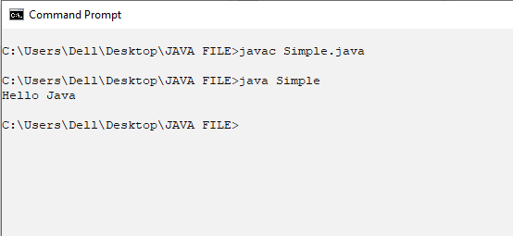

# Write a program to display the sum integers and product of two doubles.

## Source Code:

class Sumofint_Productofdouble

{

public static void main(String [] args)

{

int a = 56, b = 34;

double m = 9.35, n = 6.135;

System.out.println("Sum of integers is: " +a+b);

System.out.println("Product of doubles is: " +m*n);

}

}

## Output window

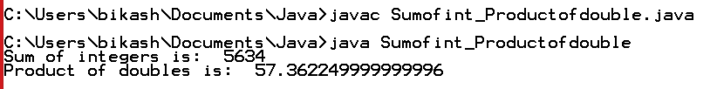

# Write a program to display something.

## Source code

class bim

{

public static void main(String[] args) {

System.out.println("welcome to kcmit");

}

}

## Output Window

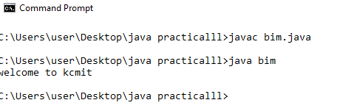

# Write a program to display sum of all the elements of array of size 7.

## Source code

class sum

{

public static void main(String[] args) {

int arr[]={1,2,3,4,5,6,7};

System.out.println("sum is :"+(arr[0]+arr[1]+arr[2]+arr[3]+arr[4]+arr[5]+arr[6]));

}

}

## Output Window

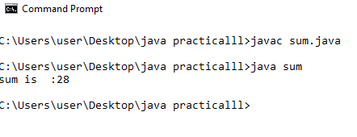

# Write a program to check whether the number is even or odd

## Source code

class evenorodd

{

public static void main(String[] args) {

int a=20;

if(a%2==0)

System.out.println("the given number is even");

else

System.out.println("the given number is odd");

}

}

## Output window

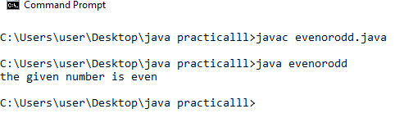

# .Write a program to check whether the number is positive or negative

## 4.1 Source code

class positiveornegative

{

public static void main(String[] args) {

int a=7;

if(a<0)

System.out.println("the given number is negative");

else

System.out.println("the given number is positive");

}

}

## 4.2 Output Window

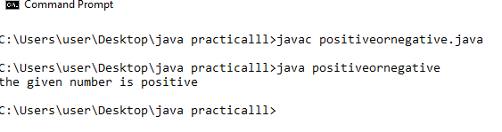

# Write a program to check whether the character is vowel or not

## Source code

class vowelornot

{

public static void main(String[] args) {

char a='j';

if(a=='a'||a=='e'||a=='i'||a=='o'||a=='u'||a=='A'||a=='E'||a=='I'||a=='O'||a=='U')

System.out.println("the given character is vowel");

else

System.out.println("the given character is not vowel");

}

}

## Output Window

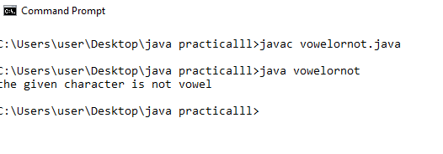

# Write a program to find the greatest number among 3 number

## Source code

class greatest

{

public static void main(String[] args) {

int a=5,b=10,c=15;

if(a>b&&a>c)

System.out.println("greatest number is :"+a);

if(b>a&&b>c)

System.out.println("greatest number is :"+b);

else

System.out.println("greatest number is :"+c);

}

}

## Output Window

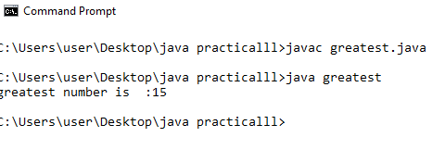

# Write a program to find the second greatest number among 3 number

## Source code

class sgreatest

{

public static void main(String[] args) {

int a=10,b=15,c=20;

if(b>a&&b<c||b>c&&b<a)

System.out.println("second greatest number is :"+b);

else if(a>b&&a<c||a>c&&a<b)

System.out.println("second greatest number is :"+a);

else

System.out.println("second greatest number is :"+c);

}

}

## Output Window

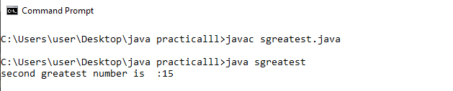

# Write a program to know about switch

## Source code

class switch_demo

{

public static void main(String[] args) {

for(int i=0;i<5;i++)

switch(i)

{

case 0:System.out.println("value is 0"); break;

case 1:System.out.println("value is 1");break;

}

}

}

## Output Window

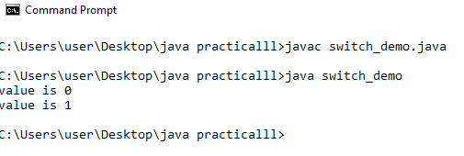

# Write a program to display 7 days name by using switch

## Source code

class switchh_demo

{

public static void main(String[] args) {

for(int i=0;i<7;i++)

switch(i)

{

case 0:System.out.println("sunday");break;

case 1:System.out.println("monday");break;

case 2:System.out.println("tuesday");break;

case 3:System.out.println("wednesday");break;

case 4:System.out.println("thurstday");break;

case 5:System.out.println("friday");break;

case 6:System.out.println("saturday");break;

}

}

}

## Output Window

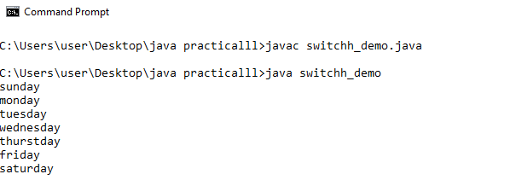

# .Write a program to terminate the loop through break

## Source code

class break_terminateloop

{

public static void main(String[] args) {

int i;

for(i=0;i<100;i++)

{

if(i==10)

break;

System.out.println(i+" ");

}

System.out.println("loop complited");

}

}

## Output Window

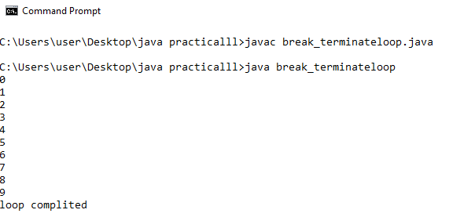

# Write a program to continue the loop through continue

## 11.1 Source code

class continue_example

{

public static void main(String[] args) {

int i;

for(i=0;i<10;i++)

{

System.out.println(i+" ");

if(i%2==0)

continue;

System.out.println();

}

}

}

## Output Window

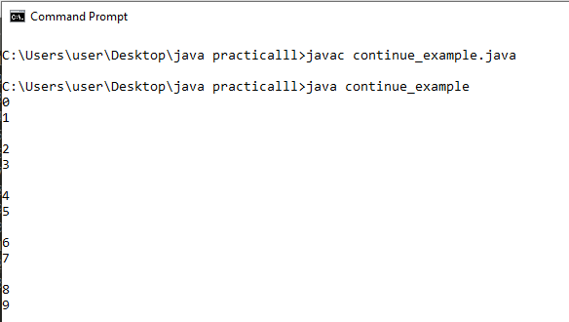

# Write a program to find sum of even num and product of odd number

## Source code

class sandp

{

public static void main(String[] args) {

int i;

int sum=0,product=1;

for(i=1;i<11;i++)

{

if (i%2==0)

sum=sum+i;

else

product=product*i;

}

System.out.println("product of odd number is: "+product);

System.out.println("sum of even number is: "+sum);

}

}

## Output Window

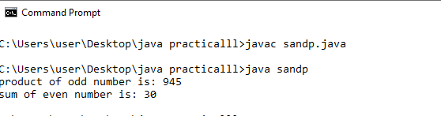

# Write a program to take a character and check if it is an alphabet or not.

## Source Code:

import java.util.Scanner;

class Alphabet

{

public static void main(String [] Args)

{

char x;

Scanner s = new Scanner(System.in);

System.out.println("Enter an alphabet: ");

x = s.next().charAt(0);

if(x>='a'&&x<='z'||x>='A'&&x<='Z')

System.out.println("The character is an alphabet");

else

System.out.println("The character is not an alphabet");

}

}

## Output Window

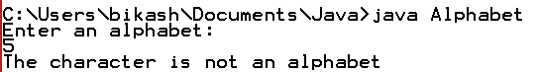

# Write a program to take 3 integers from the user and find the greatest number among them.

## Source Code:

import java.util.Scanner;

class large

{

public static void main(String []args)

{

int x,y,z;

Scanner s = new Scanner(System.in);

System.out.println("Enter 3 integers: ");

x = s.nextInt();

y = s.nextInt();

z = s.nextInt();

if(x>y&&x>z)

System.out.println(x+" is the greatest number.");

else if(y>x&&y>z)

System.out.println(y+" is the greatest number.");

else

System.out.println(z+" is the greatest number.");

}

}

## Output Window

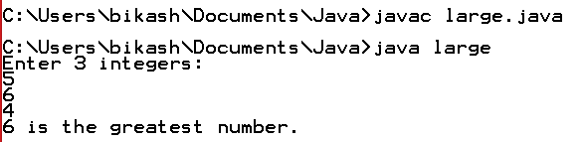

# Write a program to take 3 integers from user and display them in ascending order.

## Source Code:

import java.util.Scanner;

class ascending

{

public static void main(String [] args)

{

int a,b,c;

Scanner s = new Scanner(System.in);

System.out.println("Enter 3 integers: ");

a = s.nextInt();

b = s.nextInt();

c = s.nextInt();

if(a>b&&b>c)

System.out.println(c+" "+b+" "+a);

else if(a>c&&c>b)

System.out.println(b+" "+c+" "+a);

else if(b>c&&c>a)

System.out.println(a+" "+c+" "+b);

else if(b>a&&a>c)

System.out.println(c+" "+a+" "+b);

else if(c>a&&a>b)

System.out.println(b+" "+a+" "+c);

else

System.out.println(a+" "+b+" "+c);

}

}

## Output:

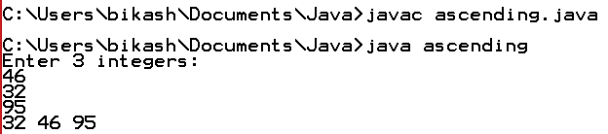

Table of Contents

1 Write program to print hello in java. 1

1.1 Source Code 1

1.2 Output Window 1

2 Write a program to display the sum integers and product of two doubles. 2

2.1 Source Code: 2

2.2 Output window 2

3 Write a program to display something. 3

3.1 Source code 3

3.2 Output Window 3

4 Write a program to display sum of all the elements of array of size 7. 4

4.1 Source code 4

4.2 Output Window 4

5 Write a program to check whether the number is even or odd 5

5.1 Source code 5

5.2 Output window 5

6 .Write a program to check whether the number is positive or negative 6

6.1 4.1 Source code 6

6.2 4.2 Output Window 6

7 Write a program to check whether the character is vowel or not 7

7.1 Source code 7

7.2 Output Window 7

8 Write a program to find the greatest number among 3 number 8

8.1 Source code 8

8.2 Output Window 8

9 Write a program to find the second greatest number among 3 number 9

9.1 Source code 9

9.2 Output Window 9

10 Write a program to know about switch 10

10.1 Source code 10

10.2 Output Window 10

11 Write a program to display 7 days name by using switch 11

11.1 Source code 11

11.2 Output Window 11

12 .Write a program to terminate the loop through break 12

12.1 Source code 12

12.2 Output Window 12

13 Write a program to continue the loop through continue 13

13.1 11.1 Source code 13

13.2 Output Window 13

14 Write a program to find sum of even num and product of odd number 14

14.1 Source code 14

14.2 Output Window 14

15 Write a program to take a character and check if it is an alphabet or not. 15

15.1 Source Code: 15

15.2 Output Window 15

16 Write a program to take 3 integers from the user and find the greatest number among them. 16

16.1 Source Code: 16

16.2 Output Window 16

17 Write a program to take 3 integers from user and display them in ascending order. 17

17.1 Source Code: 17

17.2 Output: 17