BCI S2024 Project   
Part-2 Dataset Visualization

**Group No**. 35

**Student Names:**

Peddineni Rupesh chowdary (S20210010173)

Peta Varun (S20210010176)

**Manuscript Title:**  Emotion Recognition Using Multimodal Deep Learning

**Understanding Dataset:**

**Introduction:**

This Paper utilizes the DEAP dataset, monitoring EEG and physiological signals from 32 participants viewing music videos. Emotional states were evaluated without considering familiarity, with trials categorized for valence, arousal, dominance, and liking, and a 90/10 split for training and testing data.

* The DEAP dataset comprises 32 subjects, each represented by a distinct set of files labelled from 's01.dat' to 's32.dat'.
* Within these files, there are two main components “labels” and “data”.

**Components of Dataset:**

* The labels section provides a structured representation of the subjects' emotional responses during the viewing of 40 one-minute videos.
* This representation takes the form of a 2D matrix, with each row corresponding to a particular trial
* And each column representing one of the four emotional dimensions i.e. valence, arousal, dominance, and liking.
* The data section, on the other hand, presents a three-dimensional matrix.
* The length of this matrix aligns with the 40 trials undertaken by each subject.
* Within this matrix, the data is organized into arrays, corresponding to the 40-channel EEG recordings utilized during the experiment.
* Each array encapsulates the data collected over specific time intervals by individual channels.

**Dataset Visualization:**

* Since there are 40 trails and each trail consisting 40 channels we consider only  
   **4 channels among those 40 channels to visualize**.
* Since **there are 32 subjects** and each subject contains huge data which make the visualization difficult. So **we visualize only 10 Subjects datasets**.

**Subject -01 ( s01.dat)**

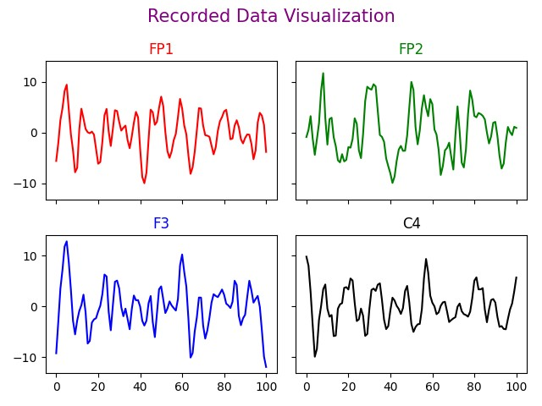 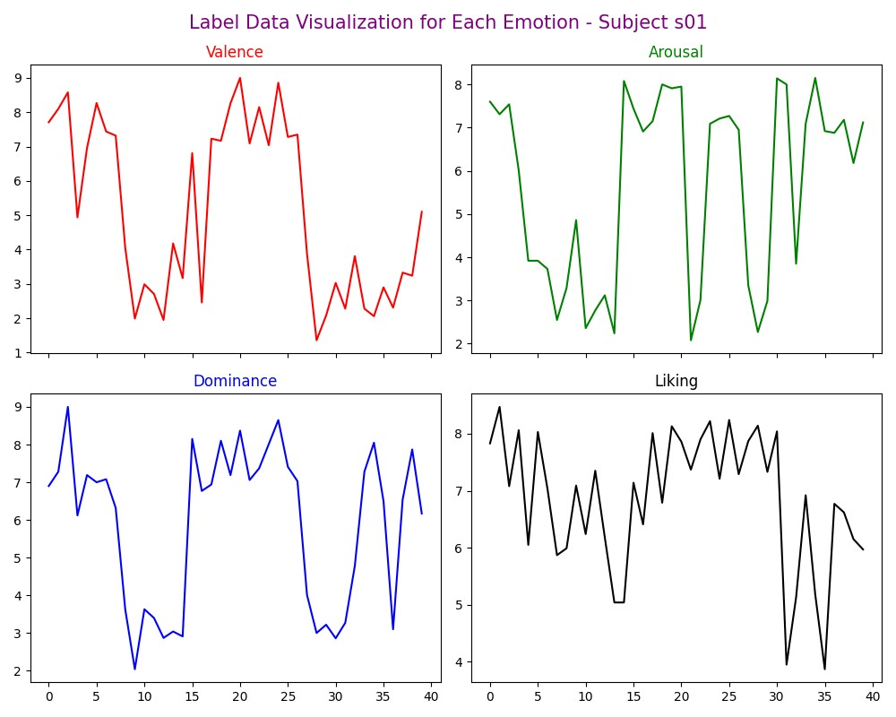

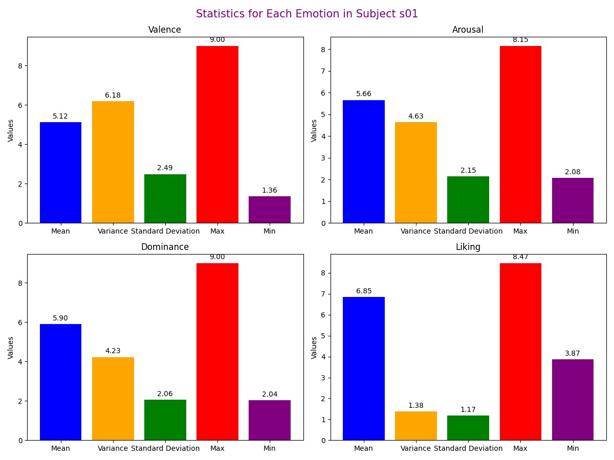

**Subject -02 ( s02.dat)**

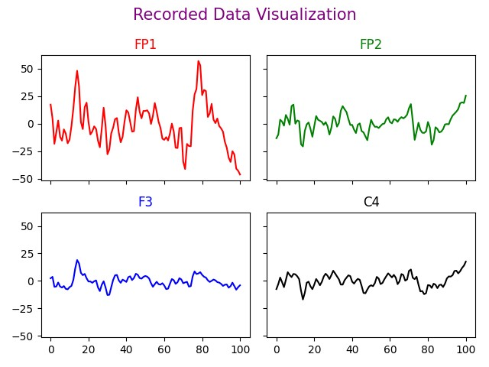 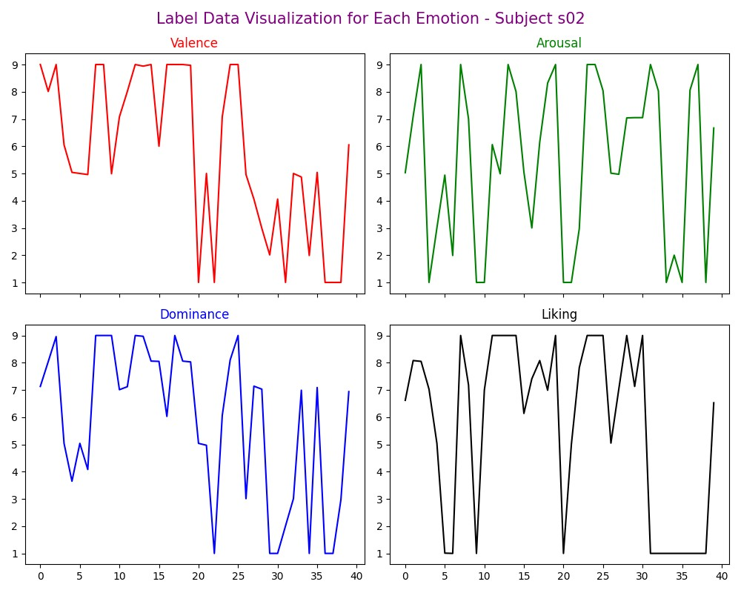

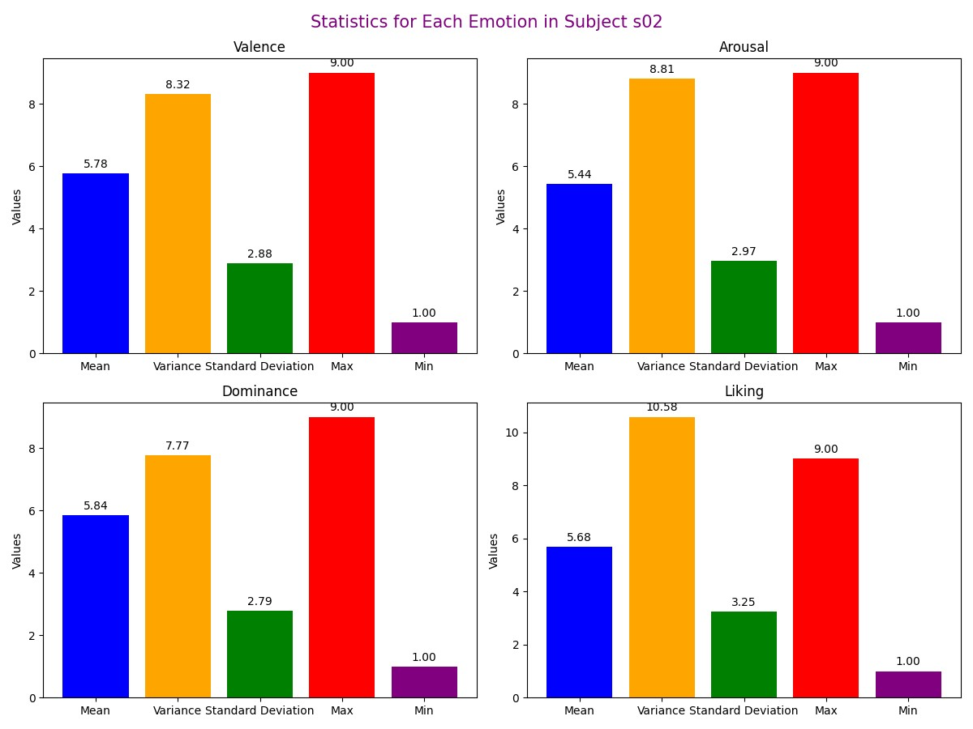

**Subject -03 ( s03.dat)**

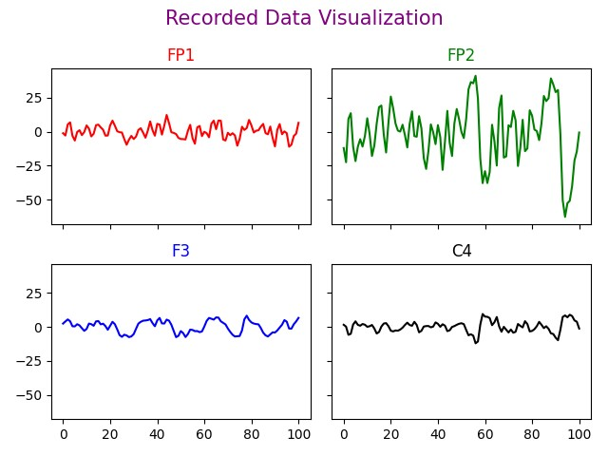 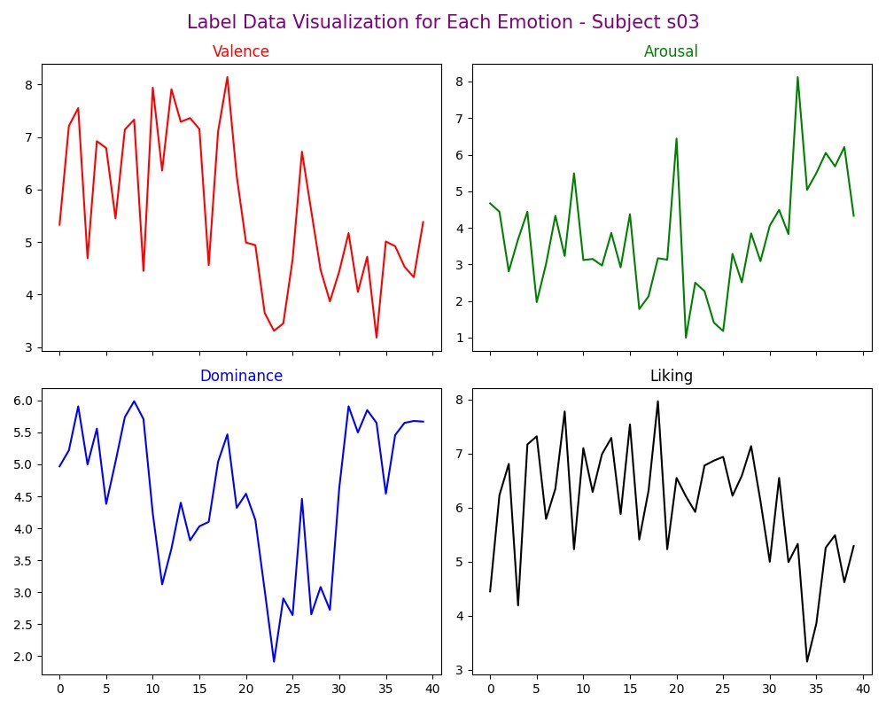

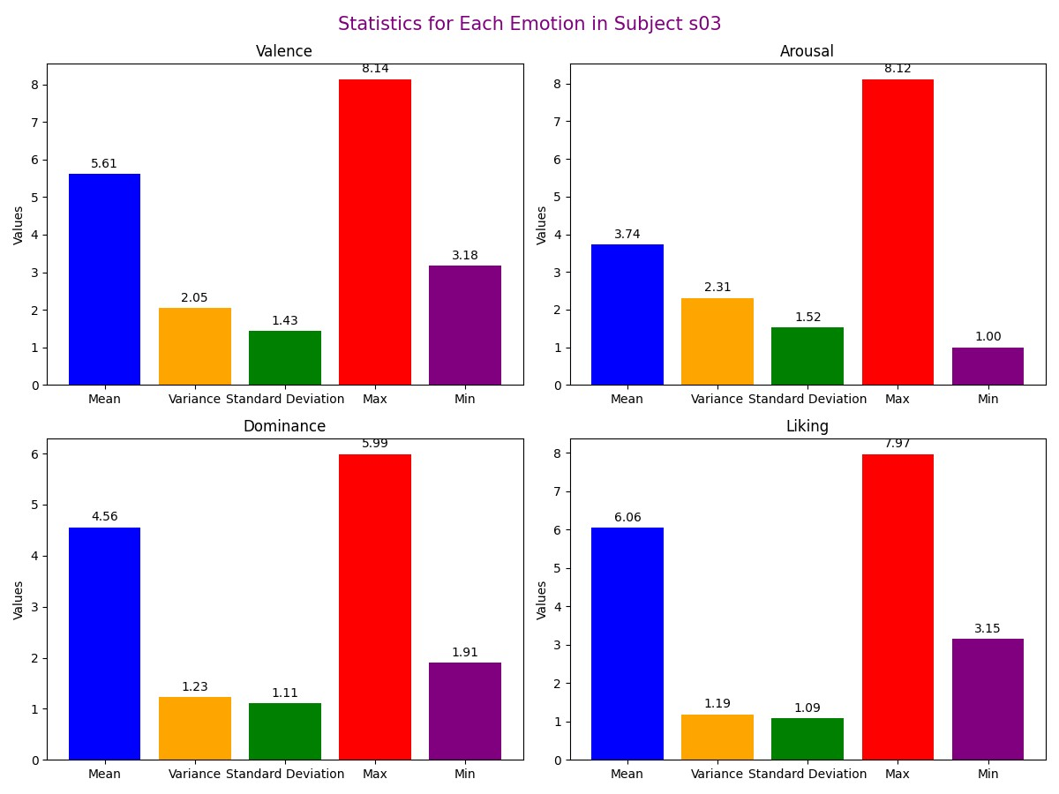

**Subject -04 ( s04.dat)**

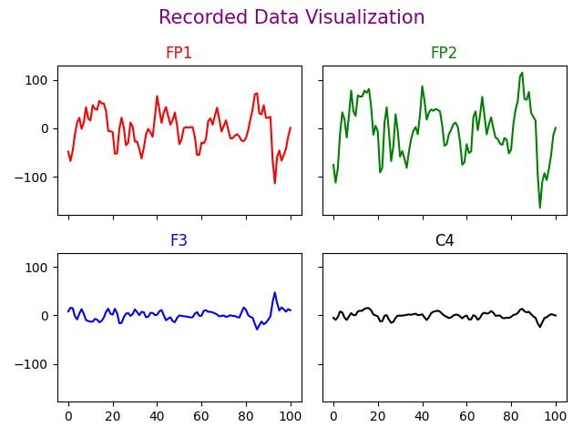 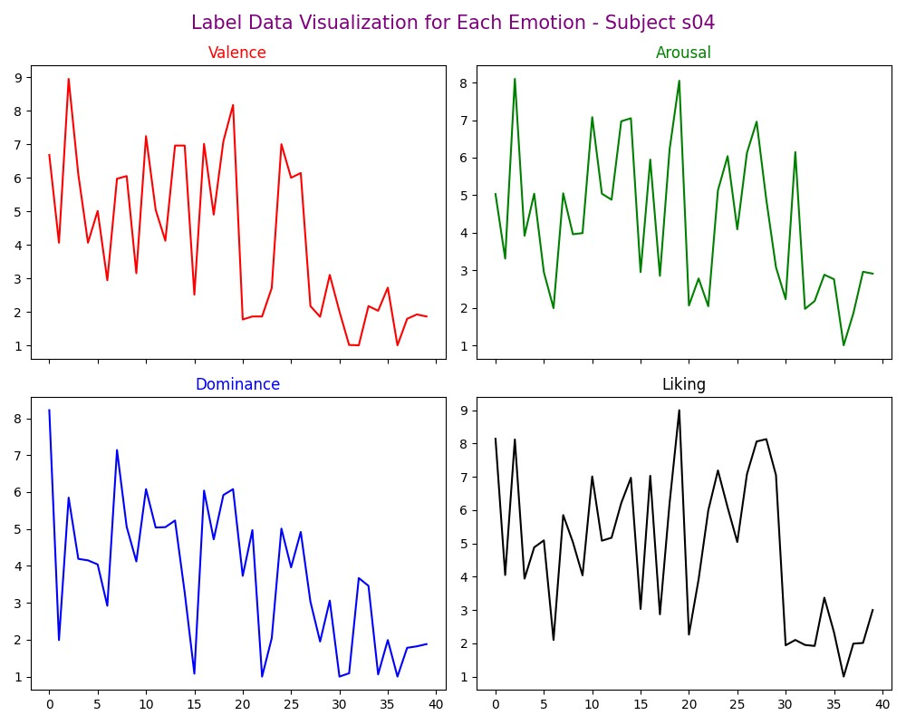

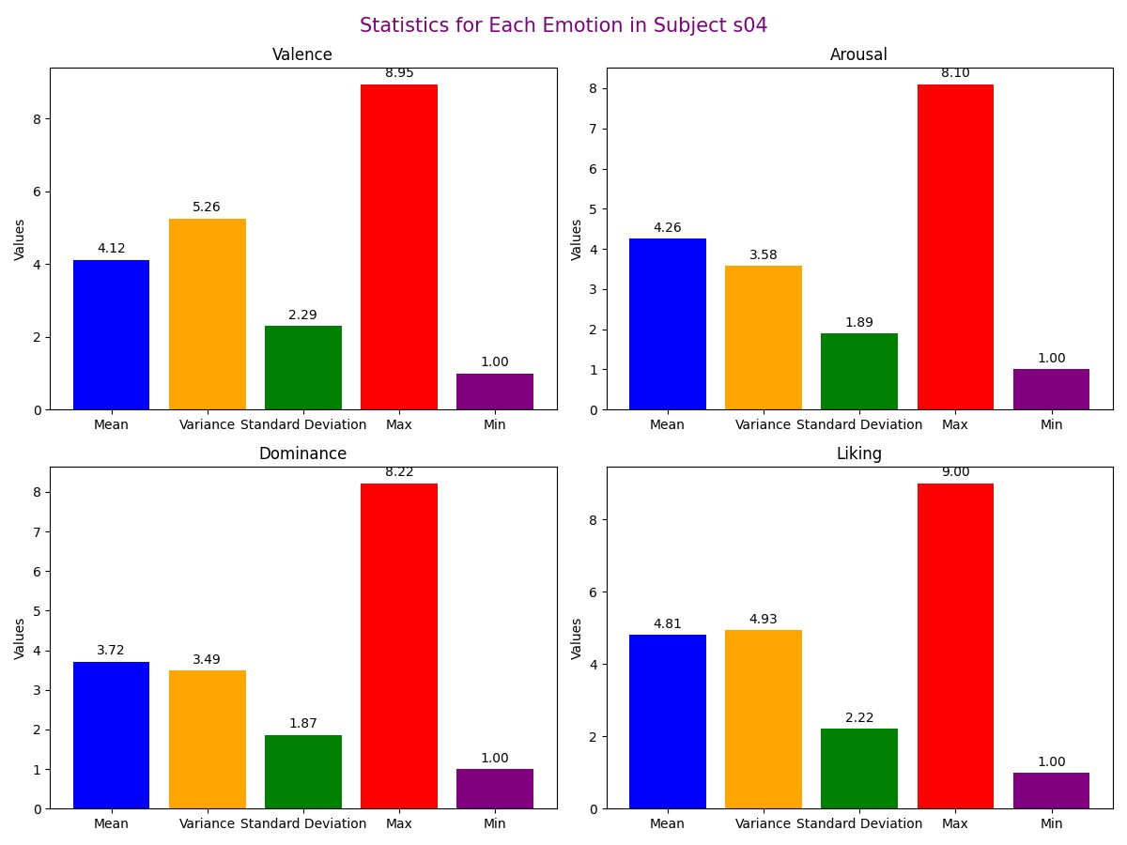

**Subject -05 ( s05.dat)**

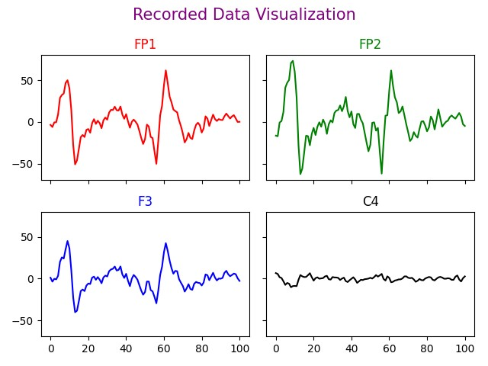 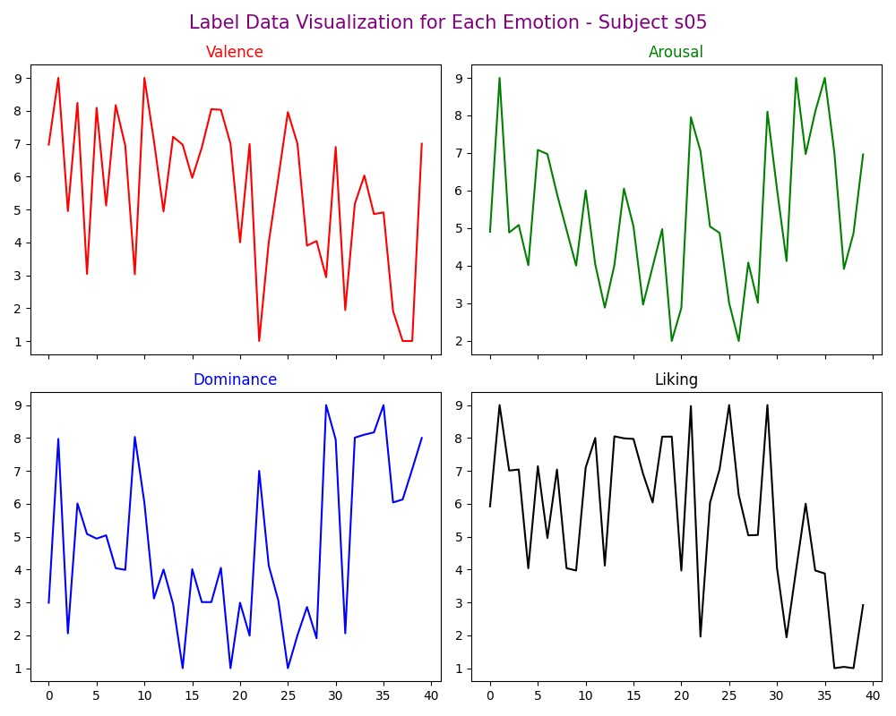

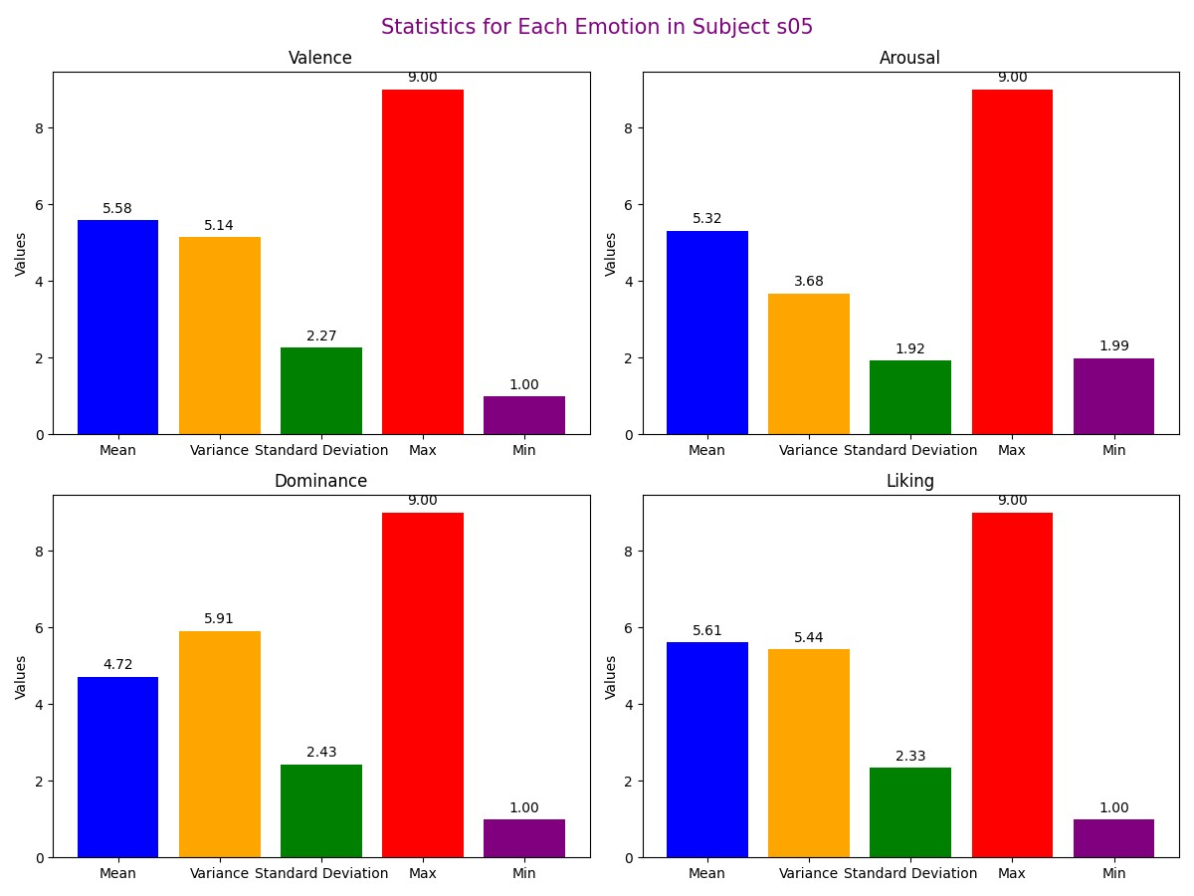

**Subject -06 ( s06.dat)**

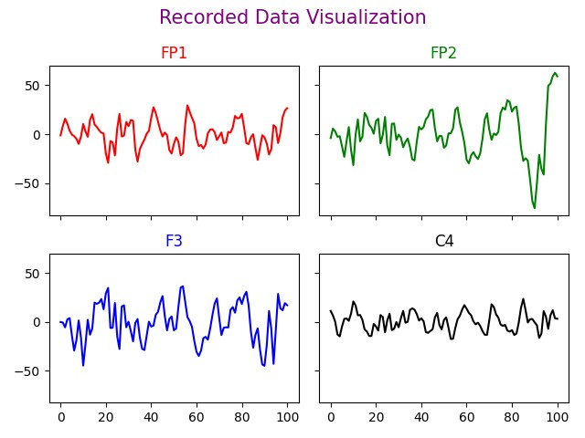 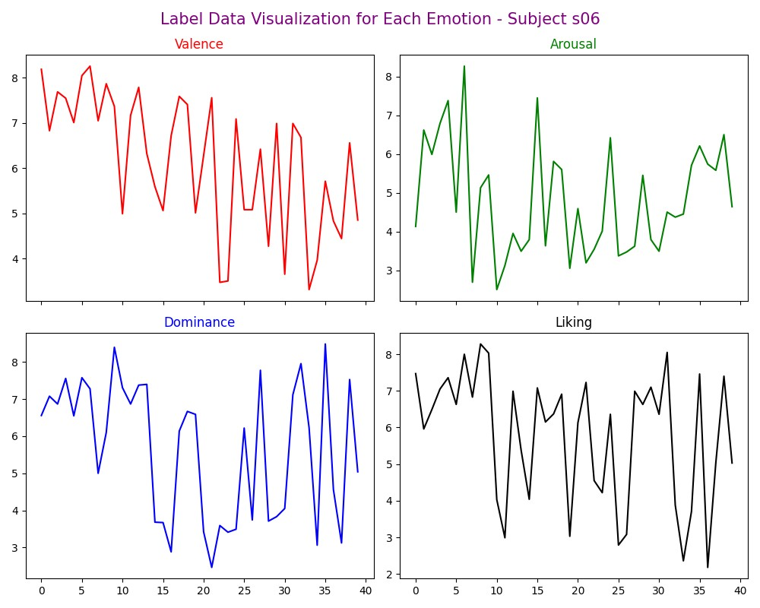

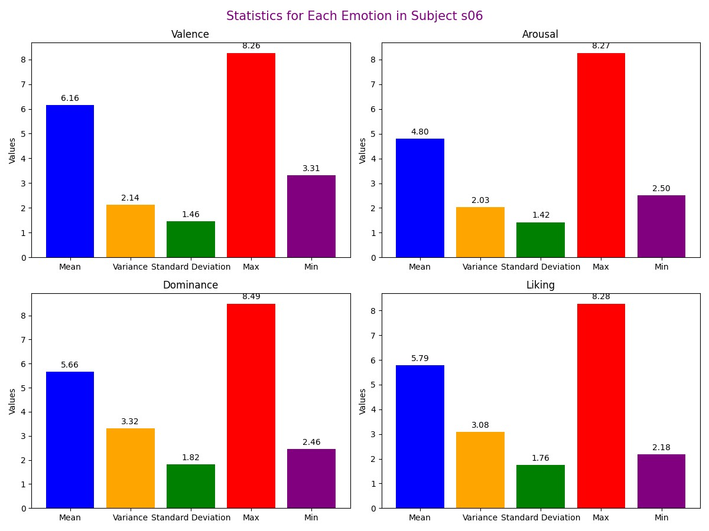

**Subject -07 ( s07.dat)**

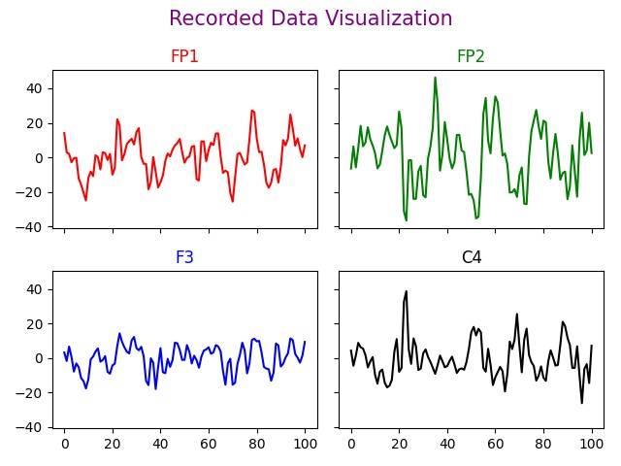 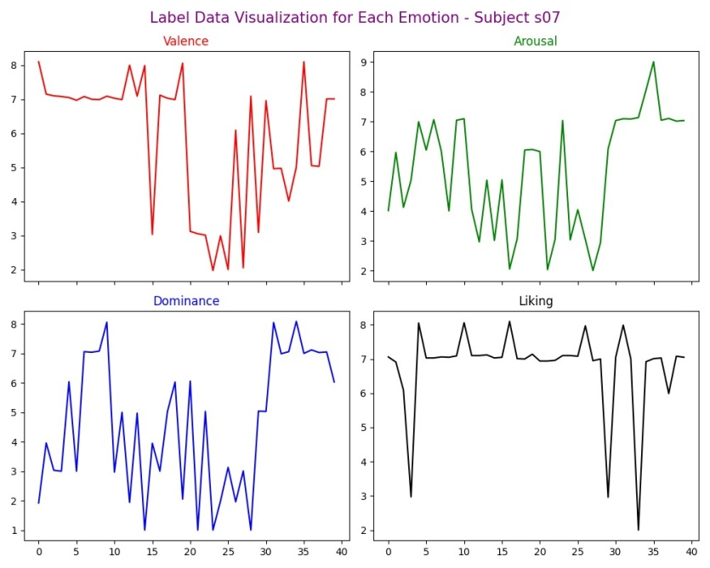

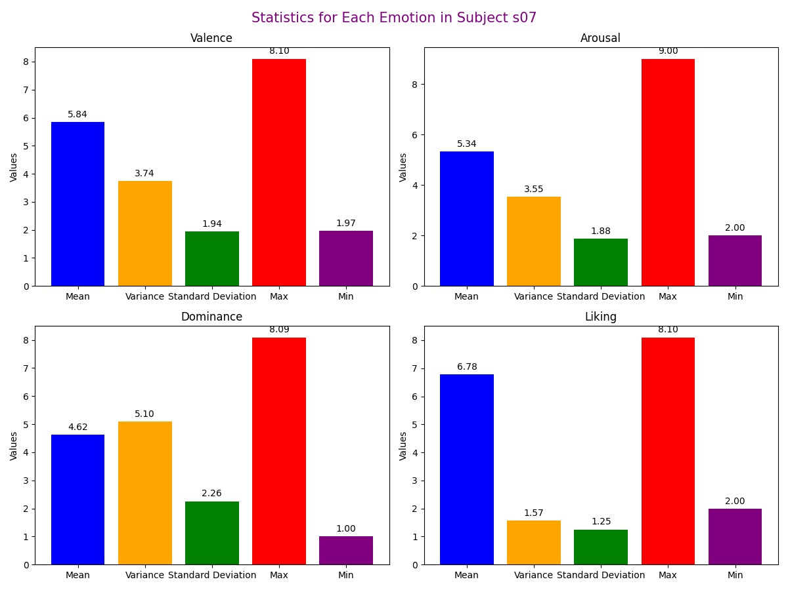

**Subject -08 ( s08.dat)**

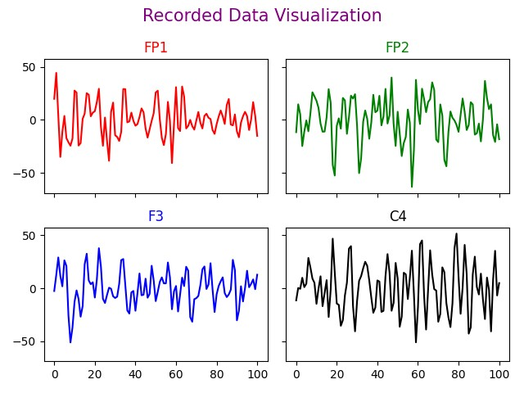 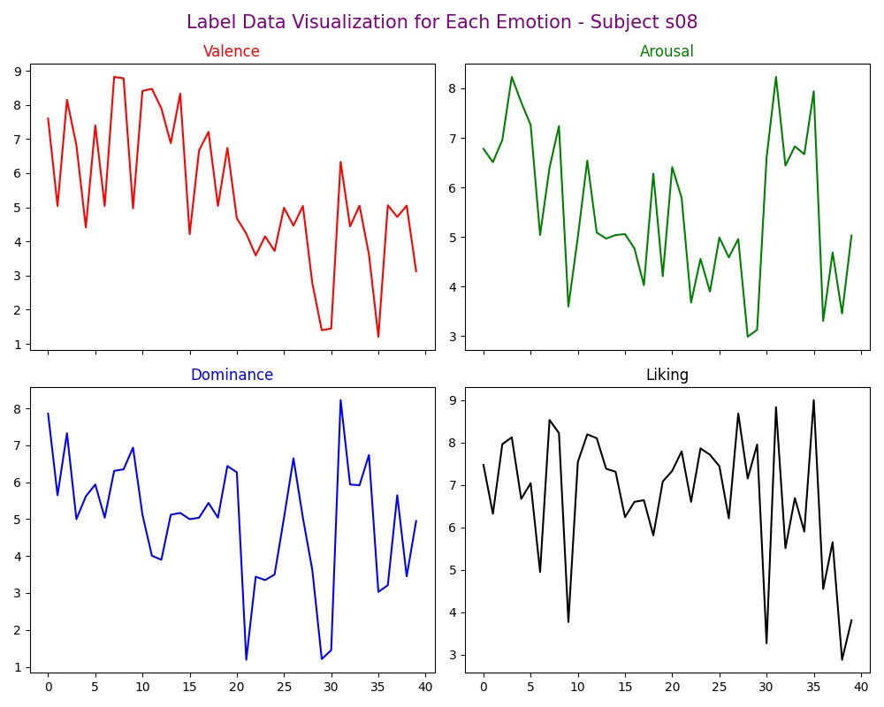

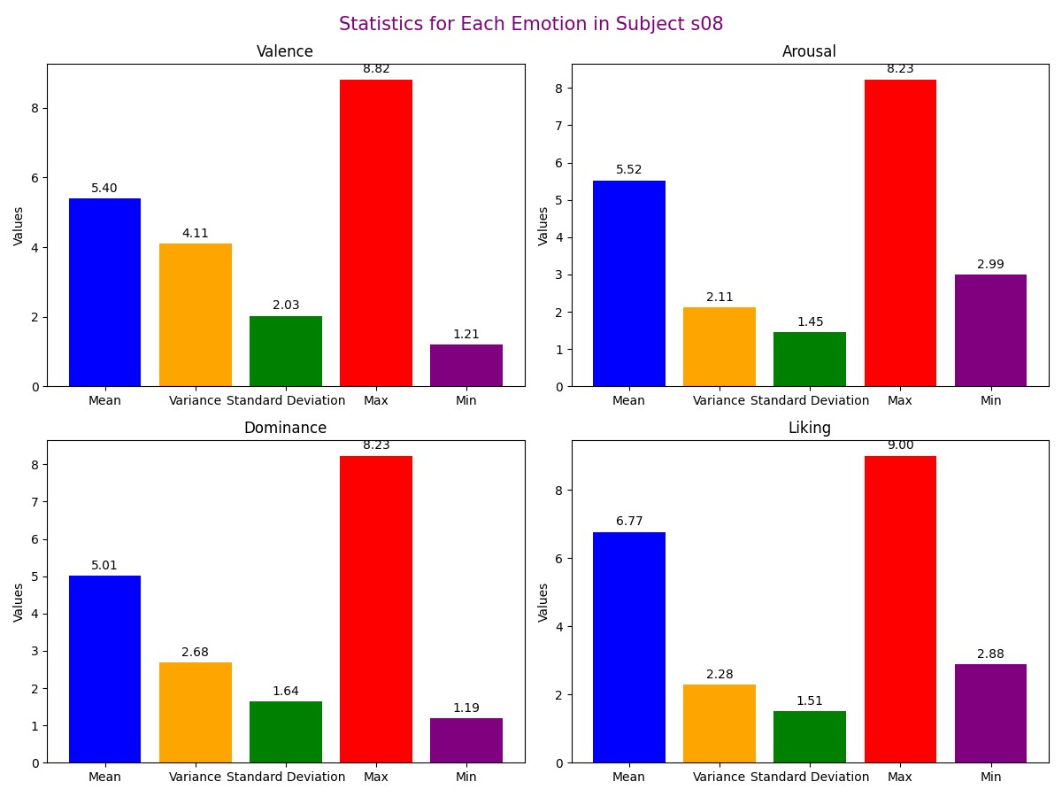

**Subject -09 ( s09.dat)**

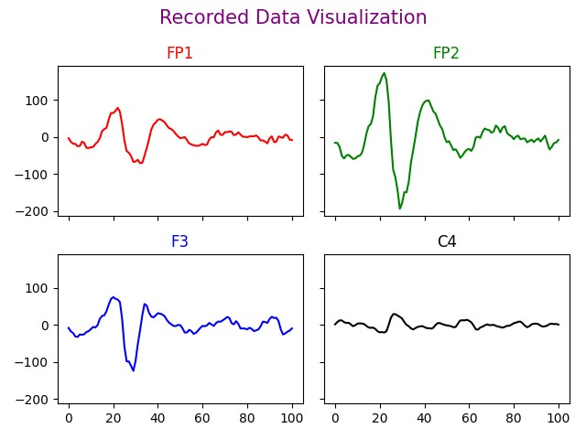 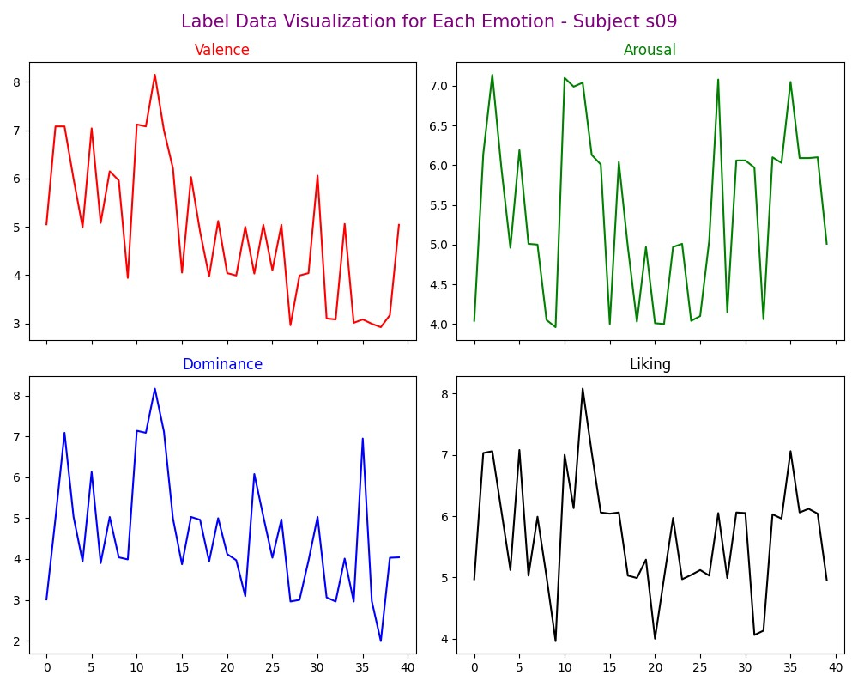

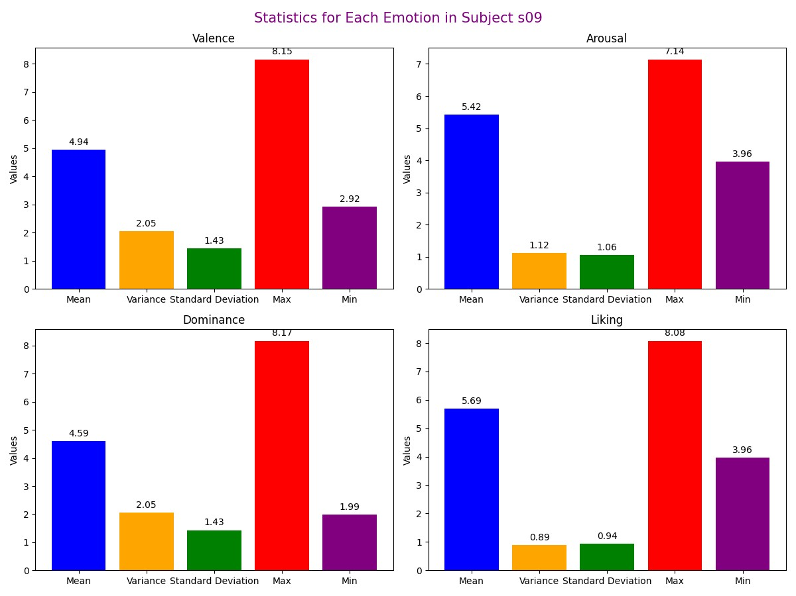

**Subject -10 ( s10.dat)**

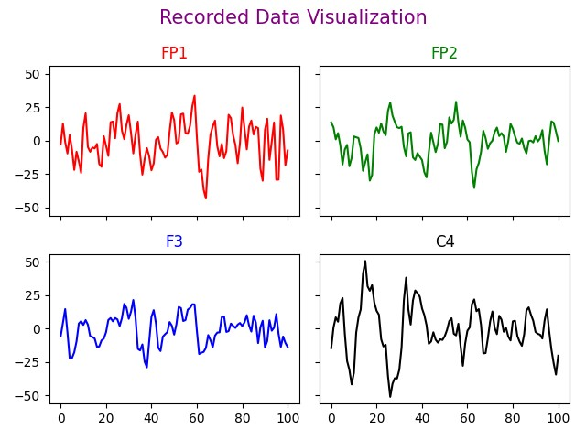 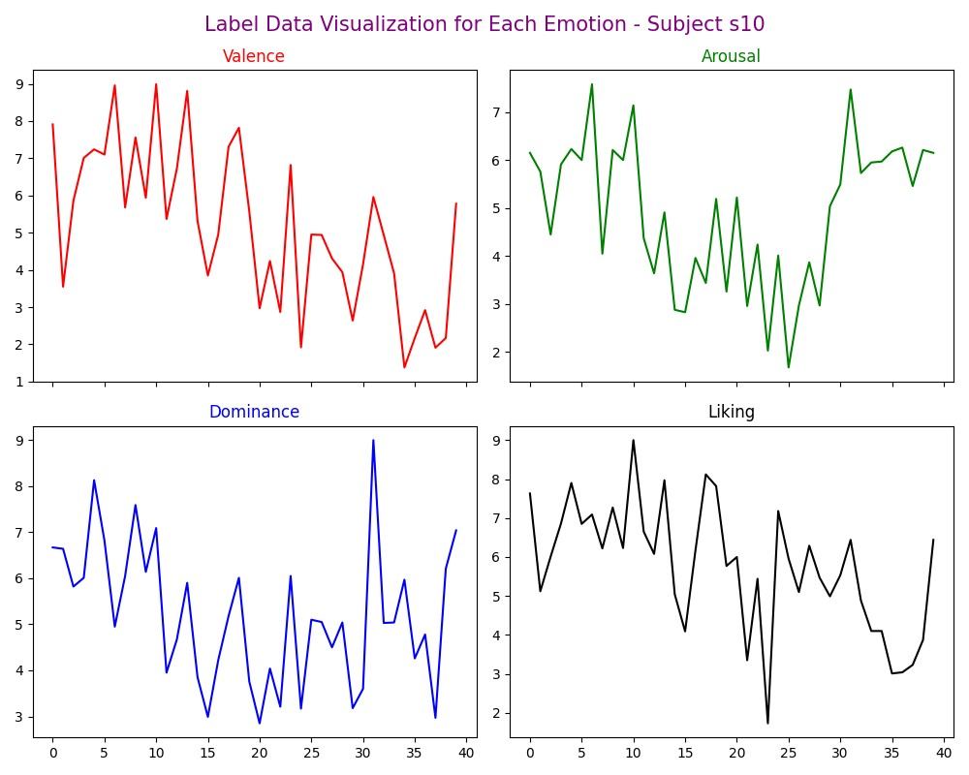

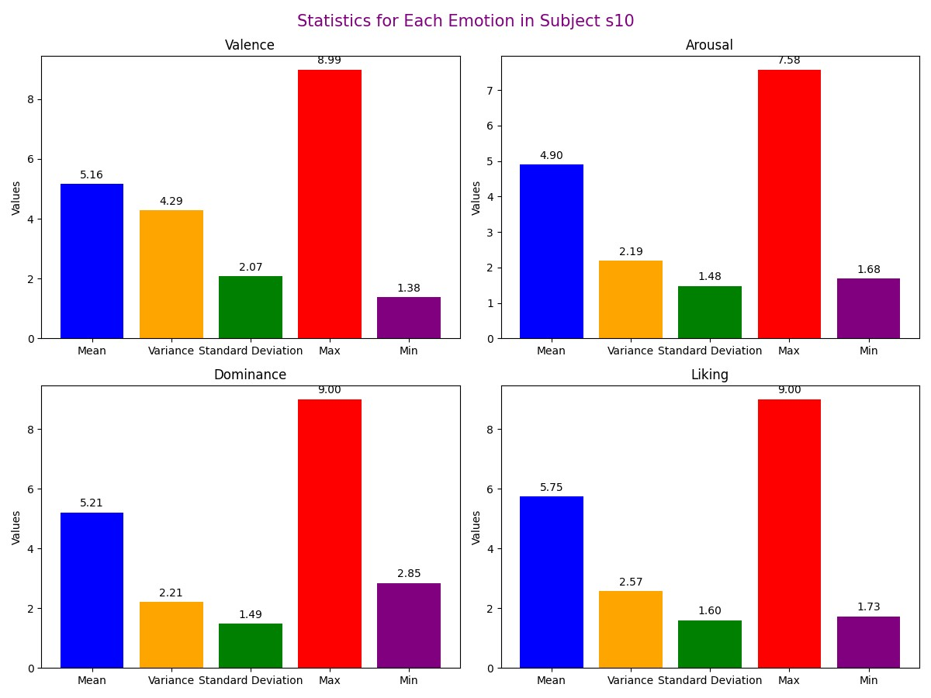

**Summary:**

In summary, the DEAP dataset offers a comprehensive insight into the emotional responses of subjects as they engage with a series of one-minute videos, utilizing EEG recordings to capture the nuanced dynamics of their experiences across multiple emotional dimensions.