Multimedia Systems  
S2024 Project

**Group No**. 15

**Student Names:**

Peddineni Rupesh chowdary (S20210010173)

Somisetty Ramtej (S20210010211)

**Project Title:** *TOM AND JERRY FREE FALL FRENZY*

**Introduction:**

Welcome to ***'Tom and Jerry Free Fall Frenzy'***! Get ready for some high-flying fun as you join Jerry in his quest to escape Tom's clutches. In this game, Jerry falls from the sky, trying to avoid Tom while collecting cheese for extra lives. But watch out! Tom gets faster as you go down. Can you help Jerry escape? Let's dive into this exciting adventure filled with cheese, challenges, and endless excitement!

**How to Play? :**

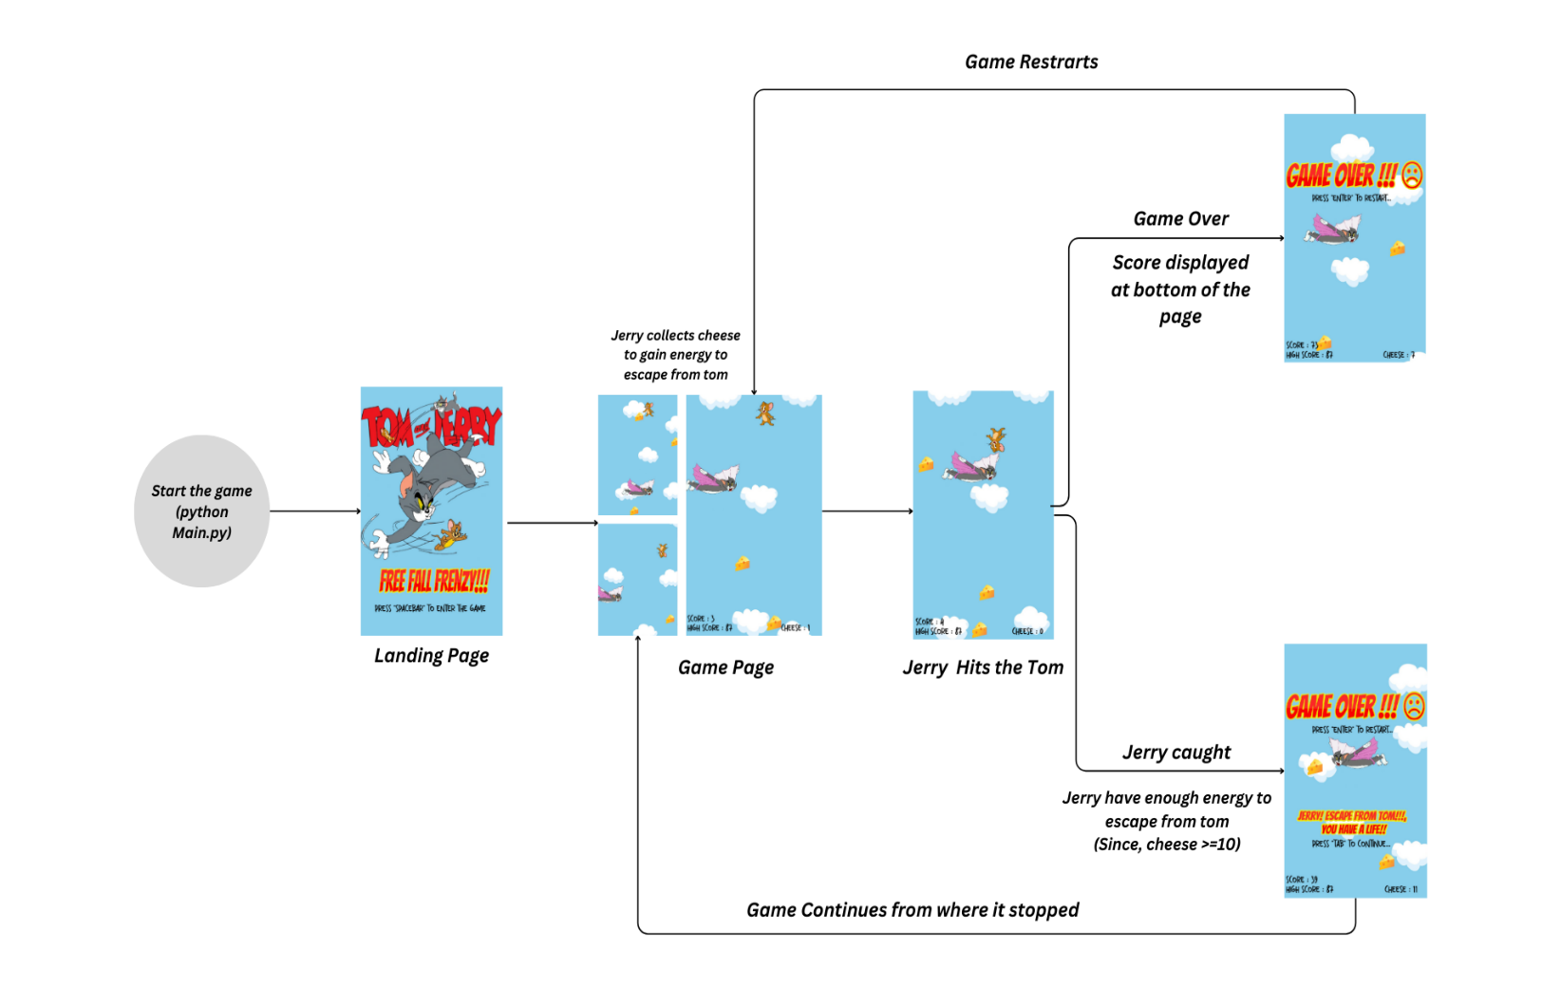

**Packages used :**

* **Pygame Library**

**- Initialization :** “pygame.init()” is called to initialize all imported pygame modules. This is necessary before using any other pygame functions

**-Screen Setup** : “pygame.display.set_mode([WIDTH, HEIGHT])” creates a window with specified width and height for the game.

-**Image Loading** : Various images used in the game (such as clouds, Tom, and Jerry) are loaded using “pygame.image.load()”. These images are scaled and transformed as needed.

-**Rectangles :** “ pygame.rect.Rect()” is used to create rectangles for collision detection and drawing shapes.

**-Sound** : Sound effects and music are loaded and played using “pygame.mixer.Sound()” and “pygame.mixer.music.load()”

**-Event Handling** : The pygame.event.get() function retrieves a list of all the events t that have occurred since the last call. This is used to handle user input, such as keyboard keyboard events for controlling Jerry's movement and for quitting the game.

* **Random Module**

**-Random Number Generation :** “random.randint(a, b)” is used to generate a n random integer between a and b, inclusive. This is used for various purposes such as det determining initial positions of objects, generating random cloud types, and setting enemy spawn positions.

-**Random Choice** : random.choice(seq) is used to choose a random element from a s sequence (seq). This is utilized for selecting cloud images and determining whether to generate one or two clouds

-**Randomized Enemy Movement :** The speed of enemies is determined based on the current score using current_score//15, providing increasing difficulty as the game progresses.

-**Randomized Cloud Placement :** The placement of clouds and cheeses is random within certain constraints. Clouds are positioned at random heights within specified ranges and cheeses are placed randomly within cloud boundaries.

**Screen Shots :**

* **Draw_Clouds :**

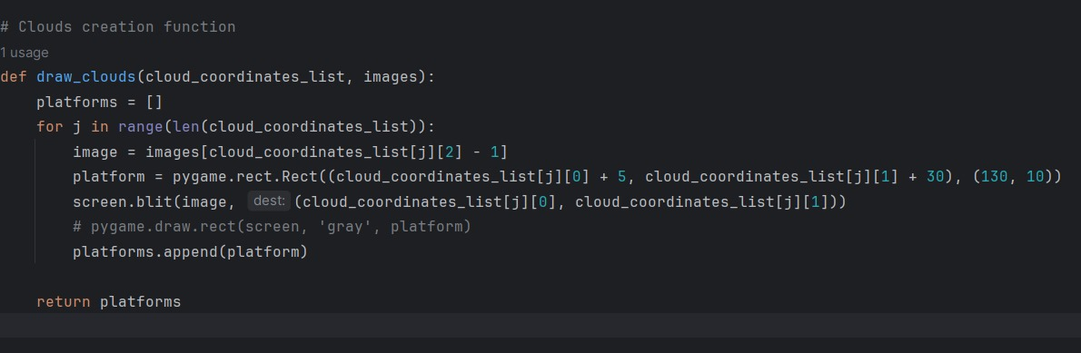

* **Draw_Cheese :**

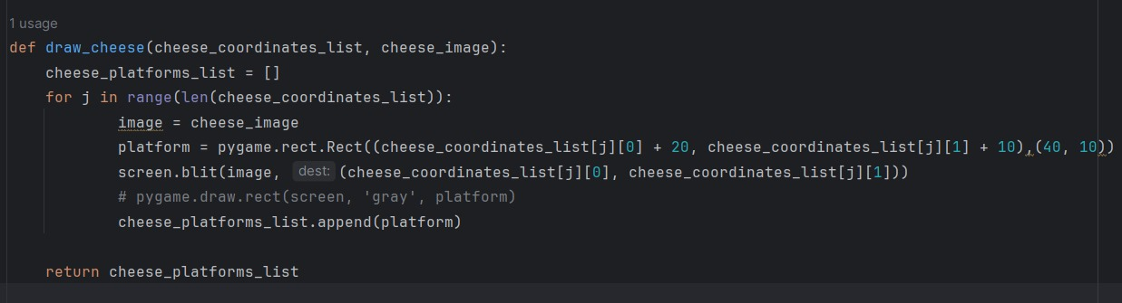

* **Draw_Player :**

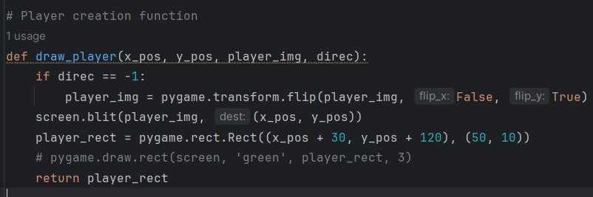

* **Draw_enemies :**

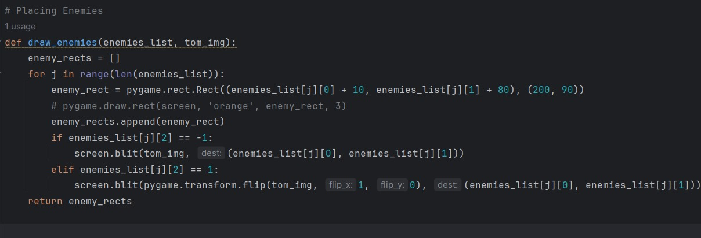

* **Move_enemies :**

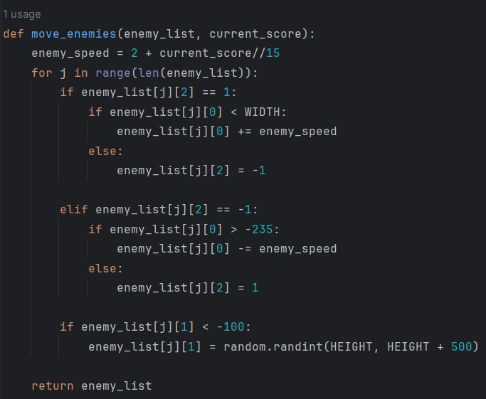

* **Uptade_objects :**

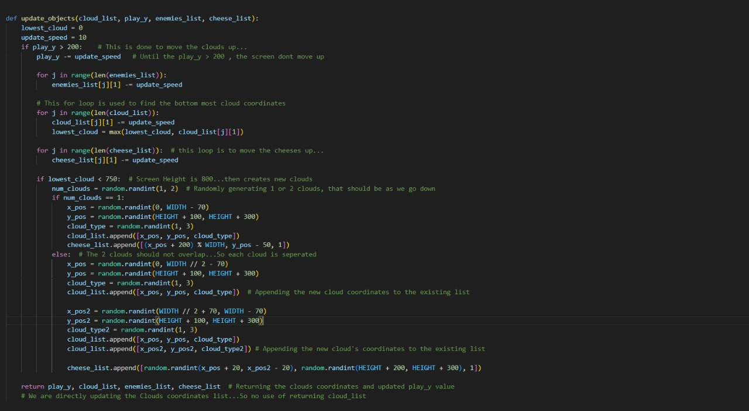

* **Landing_Page(While Loop) :**

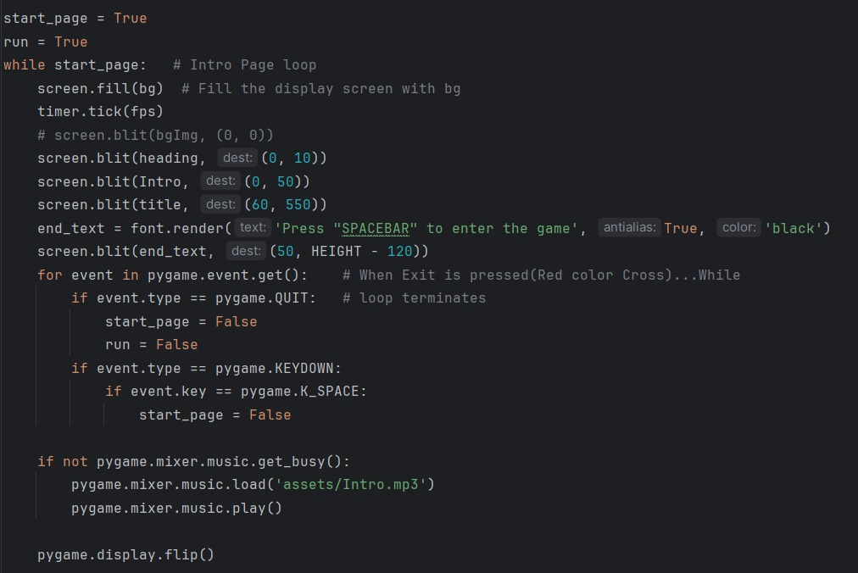

* **Exit_Handler :**

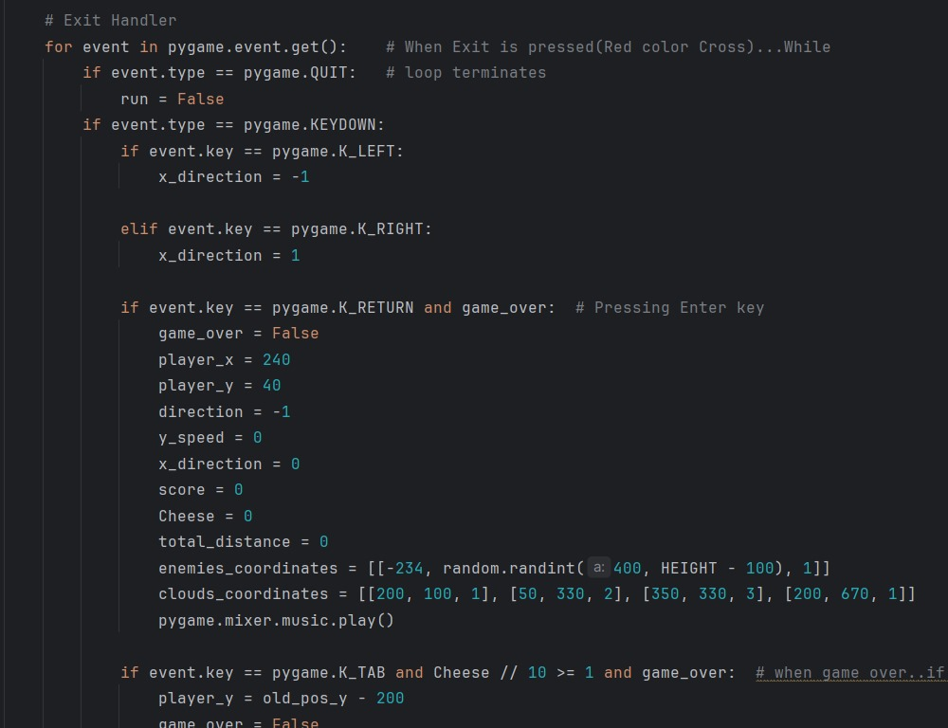

* **Game_page(While Loop) :**

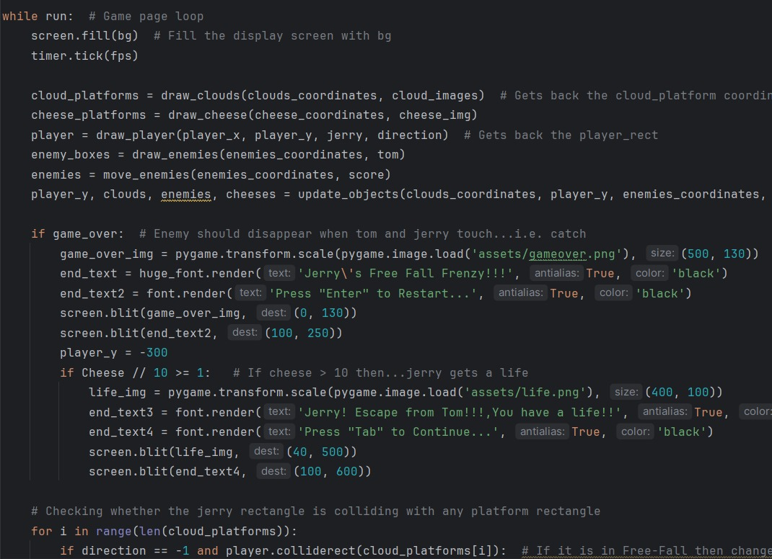



**Overall Work Flow:**

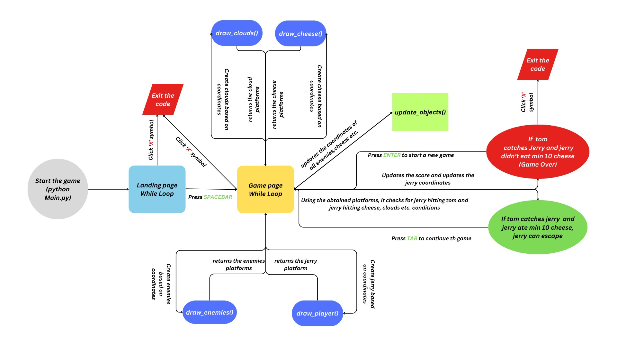

**Conclusion:**

In conclusion, we built a vertical scrolling platformer game where the player controls Jerry, collecting cheese while avoiding obstacles represented by Tom. The game utilizes various features of Pygame such as image loading, collision detection, and event handling to create an interactive gaming experience. Players control Jerry's movement with the left and right arrow keys, aiming to collect cheese and avoid collisions with Tom. The game also includes elements like cloud platforms, score tracking, game over conditions, and a high score system, enhancing its gameplay depth and engagement.

**Possible Future Extensions:**

* **Level Design :**

Create multiple levels with different layouts, obstacles, and challenges, gradually increasing in difficulty as the player progresses.

* **Multiplayer:**

Include a multiplayer mode where players can compete against each other or collaborate in completing objectives.

* **Leader Boards** :

Implement online leaderboards to allow players to compare their scores with others globally and compete for high rankings**.**