M Rupesh kumar yadav

National institute of technology , tadepalligudem

INTERNET OF THINGS

**MAJOR PROJECT**

**Project Statement :**

Building a IOT based system, using thingspeak, IFTTT and Creating a channel to read two different sensor values, create a react trigger and connect it to IFTTT using webhook and send a notification message on your mobile phone through sms.

**Screenshots of work :-**

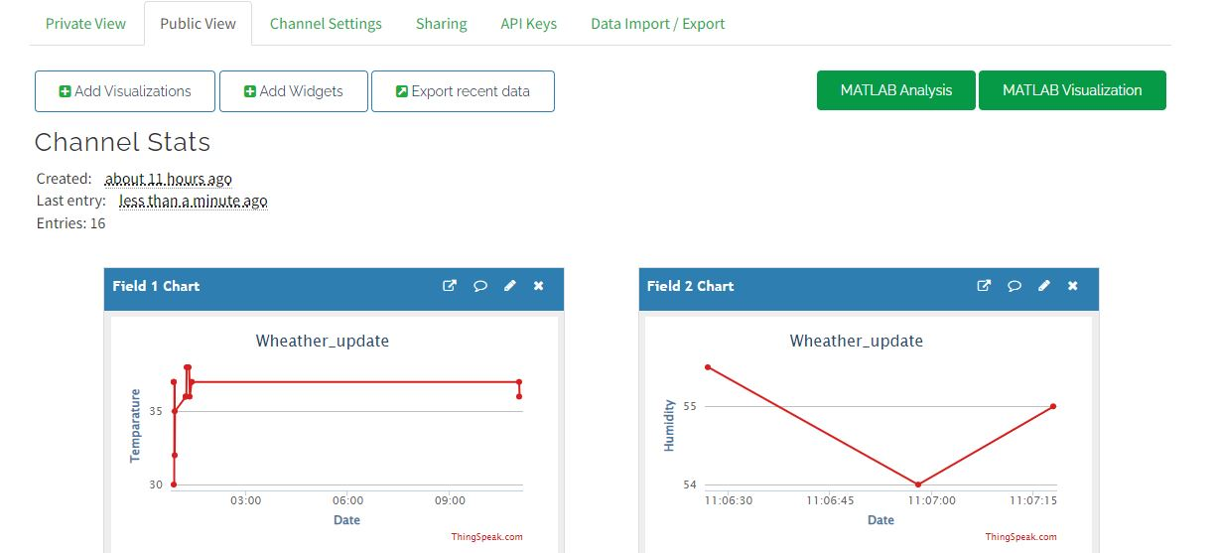

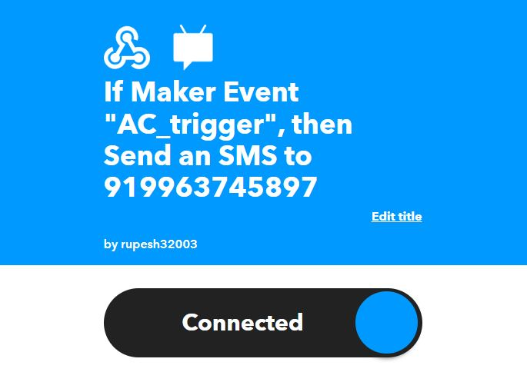

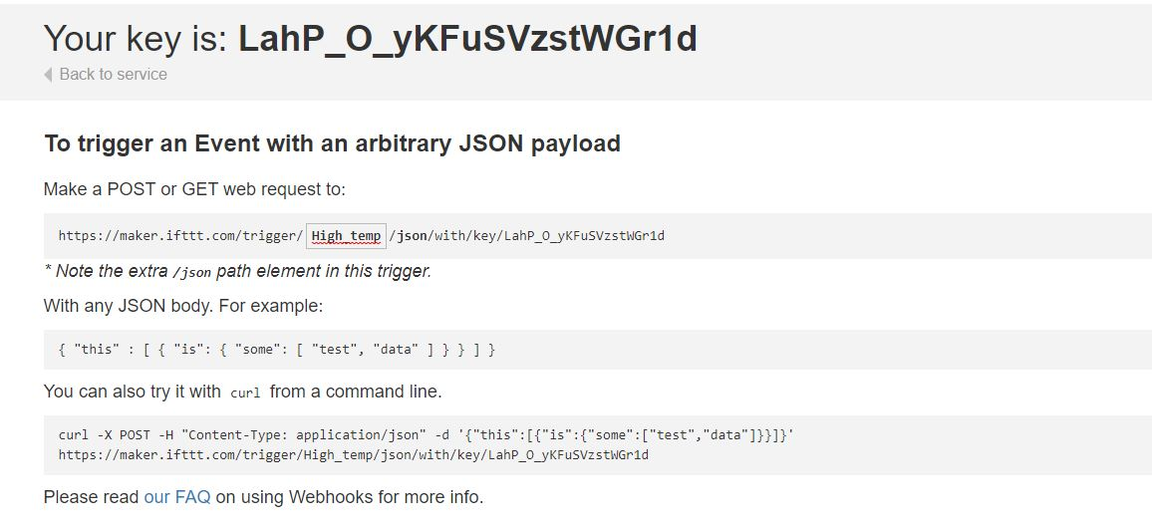

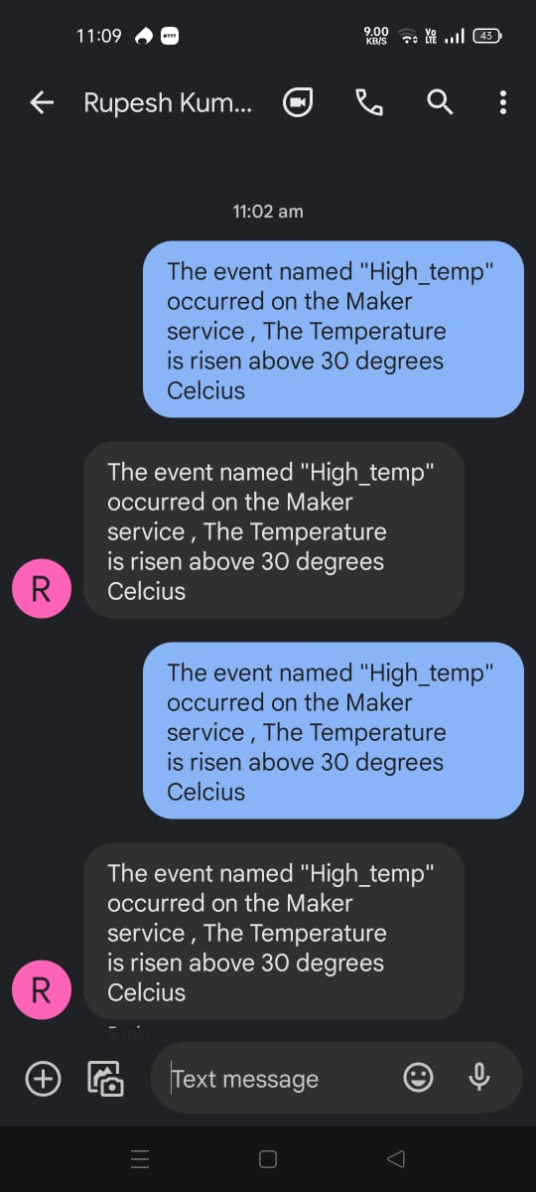

**Project Statement / Task :**

Build a system using 3 servo and 3 sensors, when each sensor activates, the

corresponding servo should operate 45deg.

**Solution :**

**Simulation :**

<https://www.tinkercad.com/things/cC2ZOJYkPAK-copy-of-copy-of-copy-of-motion-sensor-/editel?sharecode=a3GdEaWElg3bgXyYHZcggIKfJSXXWgxawGpFSFDsaiw>

Circuit Diagram :

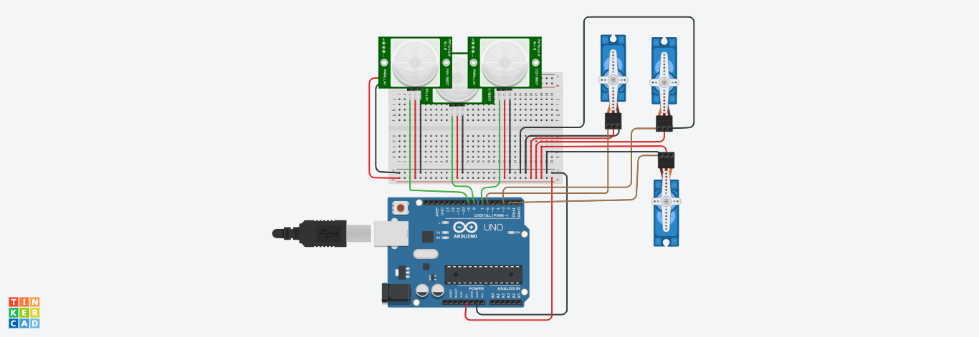

Appartus :

|  |  |  |
| --- | --- | --- |
| Name | Quantity | Component |
| PIR2 | 1 | -152.71125659906397 , -121.2965907628224 , -180.44433730630823 , -216.17633531317588 PIR Sensor |
| U1 | 1 | Arduino Uno R3 |
| PIR1 | 1 | 160.25576246736162 , -241.33737584947792 , -183.66901528879777 PIR Sensor |
| PIR3 | 1 | -236.32273580072322 , 36.64118291834217 , -152.32751498408112 PIR Sensor |
| SERVO1, SERVO2, SERVO3 | 3 | Positional Micro Servo |

Code :

|  |
| --- |
| // C++ code  //  #include <Servo.h>  Servo servo_6;  Servo servo_3;  Servo servo_2;  void setup()  {  pinMode(7, INPUT);  servo_6.attach(6, 500, 2500);  pinMode(8, INPUT);  servo_3.attach(3, 500, 2500);  pinMode(9, INPUT);  servo_2.attach(2, 500, 2500);  }  void loop()  {  if (digitalRead(7) == 1) {  servo_6.write(45);  delay(100); // Wait for 100 millisecond(s)  } else {  servo_6.write(0);  delay(100); // Wait for 100 millisecond(s)  }  if (digitalRead(8) == 1) {  servo_3.write(45);  delay(100); // Wait for 100 millisecond(s)  } else {  servo_3.write(0);  delay(100); // Wait for 100 millisecond(s)  }  if (digitalRead(9) == 1) {  servo_2.write(45);  delay(100); // Wait for 100 millisecond(s)  } else {  servo_2.write(0);  delay(100); // Wait for 100 millisecond(s)  }  } |

**IOT MINOR**

Statement :

Create a thingspeak http request of either a cricket score or share price of any shares

Screenshots :

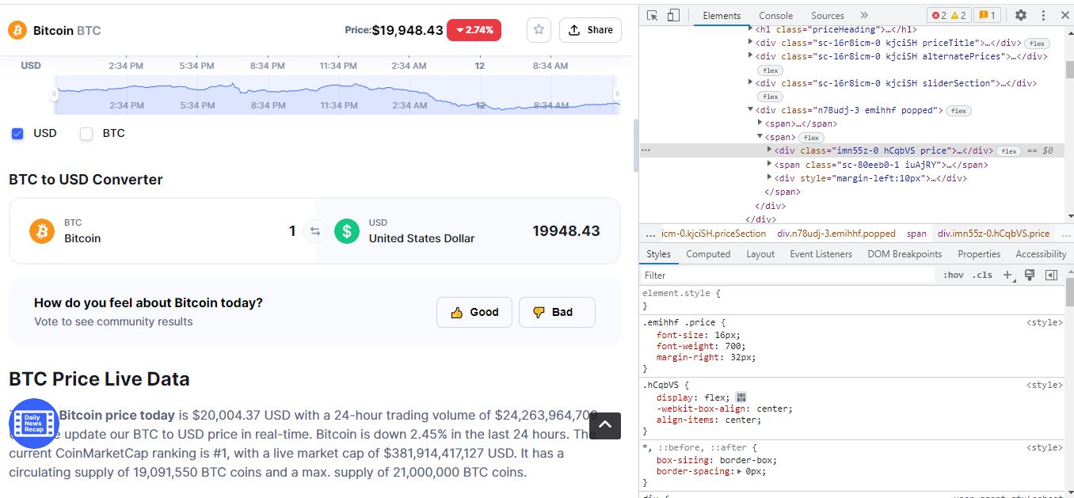

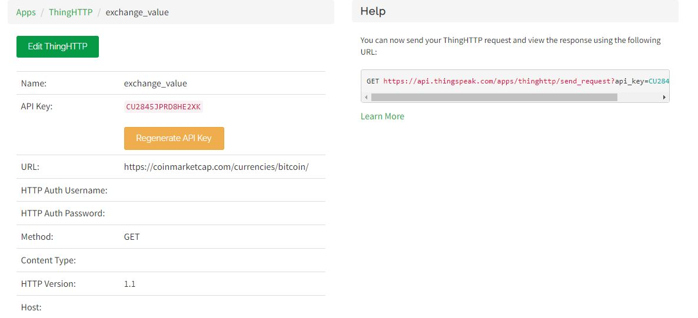

IOT LINKS :

Thinkspeak, IFTTT , webhooks , Teachable Machine ,Trello , Aurdino.cc , aurdio-projects , esp

stepper motor , servo motor

<https://teachablemachine.withgoogle.com/train/image>