# The Sparks Foundation - Data Science & Business Analytics Internship

**TASK 1 - Prediction using Supervised Machine Learning**

### In this task it is required to predict the percentage of a student on the basis of number of hours studied using the Linear Regression supervised machine learning algorithm.

**Steps:**

.Step 1 - Importing the dataset

.Step 2 - Visualizing the dataset

.Step 3 - Data preparation

.Step 4 - Training the algorithm

.Step 5 - Visualizing the model

.Step 6 - Making predcitions

.Step 7 - Evaluating the model

**Author: Rupesh Padature**

**STEP 1 - Importing the dataset**

### In this step, we will import the dataset through the link with the help of pandas library and then we will observe the data

In [3]:

*# Importing all the required libraries*

**import** pandas **as** pd

**import** numpy **as** np

**import** matplotlib.pyplot **as** plt

**%matplotlib** inline

**import** seaborn **as** sns

*# To ignore the warnings*

**import** warnings **as** wg

wg**.**filterwarnings("ignore")

In [4]:

*# Reading data from remote link*

url **=** "https://raw.githubusercontent.com/AdiPersonalWorks/Random/master/student_scores%20-%20student_sc df **=** pd**.**read_csv(url)

In [5]:

*# now let's observe the dataset*

df**.**head()

Out[5]:

**Hours Scores**

**0** 2.5 21

**1** 5.1 47

**2** 3.2 27

**3** 8.5 75

**4** 3.5 30

In [6]:

df**.**tail()

|  |  |  |  |
| --- | --- | --- | --- |
| Out[6]: |  | **Hours** | **Scores** |
|  | **20** | 2.7 | 30 |
|  | **21** | 4.8 | 54 |
|  | **22** | 3.8 | 35 |
|  | **23** | 6.9 | 76 |
|  | **24** | 7.8 | 86 |

In [7]:

*# To find the number of columns and rows*

df**.**shape

Out[7]:

In [8]:

(25, 2)

<class 'pandas.core.frame.DataFrame'> RangeIndex: 25 entries, 0 to 24

*# To find more information about our dataset*

df**.**info()

Data columns (total 2 columns):

# Column Non-Null Count Dtype

1. Hours 25 non-null float64
2. Scores 25 non-null int64 dtypes: float64(1), int64(1)

memory usage: 528.0 bytes

In [9]:

df**.**describe()

|  |  |  |  |
| --- | --- | --- | --- |
| Out[9]: |  | **Hours** | **Scores** |
|  | **count** | 25.000000 | 25.000000 |
|  | **mean** | 5.012000 | 51.480000 |
|  | **std** | 2.525094 | 25.286887 |
|  | **min** | 1.100000 | 17.000000 |
|  | **25%** | 2.700000 | 30.000000 |
|  | **50%** | 4.800000 | 47.000000 |
|  | **75%** | 7.400000 | 75.000000 |
|  | **max** | 9.200000 | 95.000000 |

In [10]:

*# now we will check if our dataset contains null or missings values*

df**.**isnull()**.**sum()

Out[10]:

In [11]:

Hours 0

Scores 0

dtype: int64

## Step 2 - Visualizing the dataset

*# Plotting the dataset*

plt**.**rcParams["figure.figsize"] **=** [16,9]

df**.**plot(x**=**'Hours', y**=**'Scores', style**=**'.', color**=**'Red', markersize**=**10) plt**.**title('Hours vs Percentage')

plt**.**xlabel('Hours Studied')

plt**.**ylabel('Percentage Score') plt**.**grid()

plt**.**show()

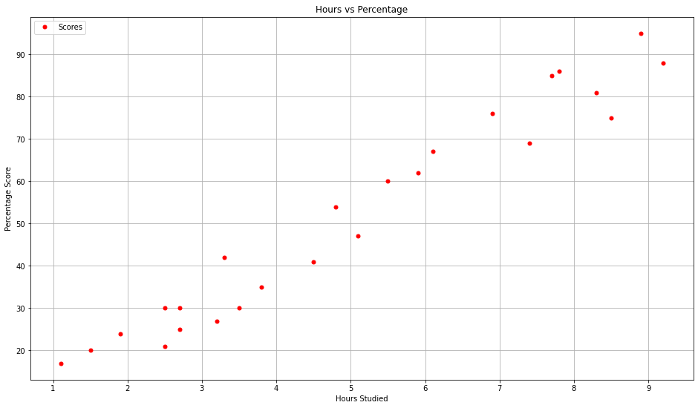

In [12]:

*# we can also use .corr to determine the corelation between the variables*

df**.**corr()

Out[12]:

In [13]:

**Hours Scores**

**Hours** 1.000000 0.976191

**Scores** 0.976191 1.000000

## Step 3 - Data preparation¶

df**.**head()

|  |  |  |  |
| --- | --- | --- | --- |
| Out[13]: |  | **Hours** | **Scores** |
|  | **0** | 2.5 | 21 |
|  | **1** | 5.1 | 47 |
|  | **2** | 3.2 | 27 |
|  | **3** | 8.5 | 75 |
|  | **4** | 3.5 | 30 |

In [14]:

*# using iloc function we will divide the data*

X **=** df**.**iloc[:, :1]**.**values

y **=** df**.**iloc[:, 1:]**.**values

In [15]:

X

Out[15]:

array([[2.5],

[5.1],

[3.2],

[8.5],

[3.5],

[1.5],

[9.2],

[5.5],

[8.3],

[2.7],

[7.7],

[5.9],

[4.5],

[3.3],

[1.1],

[8.9],

[2.5],

[1.9],

[6.1],

[7.4],

[2.7],

[4.8],

[3.8],

[6.9],

[7.8]])

In [16]:

y

Out[16]:

In [17]:

array([[21],

[47],

[27],

[75],

[30],

[20],

[88],

[60],

[81],

[25],

[85],

[62],

[41],

[42],

[17],

[95],

[30],

[24],

[67],

[69],

[30],

[54],

[35],

[76],

[86]], dtype=int64)

*# Splitting data into training and testing data*

**from** sklearn.model_selection **import** train_test_split

X_train, X_test, y_train, y_test **=** train_test_split(X, y,

test_size**=**0.2, random_state**=**0)

## Step 4 - Training the Algorithm

In [18]:

**from** sklearn.linear_model **import** LinearRegression

model **=** LinearRegression() model**.**fit(X_train, y_train)

Out[18]:

In [19]:

LinearRegression()

## Step 5 - Visualizing the model

line **=** model**.**coef_**\***X **+** model**.**intercept_

*# Plotting for the training data*

plt**.**rcParams["figure.figsize"] **=** [16,9]

plt**.**scatter(X_train, y_train, color**=**'blue') plt**.**plot(X, line, color**=**'green');

plt**.**xlabel('Hours Studied')

plt**.**ylabel('Percentage Score') plt**.**grid()

plt**.**show()

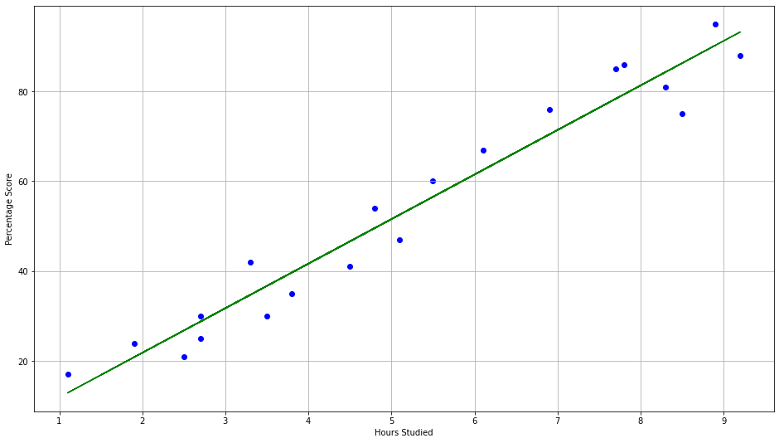

In [20]:

*# Plotting for the testing data*

plt**.**rcParams["figure.figsize"] **=** [16,9]

plt**.**scatter(X_test, y_test, color**=**'blue') plt**.**plot(X, line, color**=**'green');

plt**.**xlabel('Hours Studied')

plt**.**ylabel('Percentage Score') plt**.**grid()

plt**.**show()

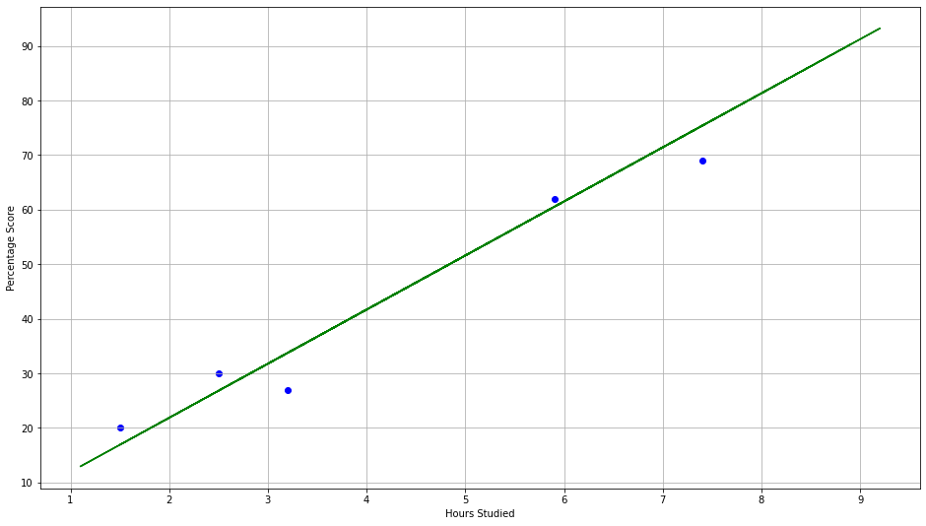

## Step 6 - Making Predictions

In [21]:

print(X_test) *# Testing data - In Hours*

y_pred **=** model**.**predict(X_test) *# Predicting the scores*

[[1.5]

[3.2]

[7.4]

[2.5]

[5.9]]

In [22]:

*# Comparing Actual vs Predicted*

y_test

Out[22]:

In [23]:

array([[20],

[27],

[69],

[30],

[62]], dtype=int64)

y_pred

Out[23]:

In [ ]:

array([[16.88414476],

[33.73226078],

[75.357018 ],

[26.79480124],

[60.49103328]])

*# Comparing Actual vs Predicted*

comp **=** pd

In [28]:

**.**DataFrame({ 'Actual':[y_test],'Predicted':[y_pred] }) comp

Out[28]:

In [25]:

**Actual Predicted**

**0** [[20], [27], [69], [30], [62]] [[16.884144762398037], [33.73226077948984], [7...

The predicted score if a person studies for 9.25 hours is [93.69173249]

*# Testing with your own data*

hours **=** 9.25

own_pred **=** model**.**predict([[hours]])

print("The predicted score if a person studies for",hours,"hours is",own_pred[0])

## Step 7 - Evaluating the model

In [26]:

**from** sklearn **import** metrics

print('Mean Absolute Error:', metrics**.**mean_absolute_error(y_test, y_pred))

Mean Absolute Error: 4.183859899002975