Name: Rupesh Chaudhary

**Action TODO MVVM APP**

**Description**

Action To-do App is an android app that allows a user to build a to-do list including a few basic features like adding new tasks, editing and deleting an existing item, etc. Along with that, this app also includes other extra features like a splash screen, Google's speech to text service, local notification, user experience points, etc.

**Features**

* Speech Recognition for Adding and Updating Task
* Splash Screen
* CRUD functionality

**Framework used to develop this app is:**

* MVVM (Model-View-View-Model)

Model-View-View-Model is an architectural approach used to abstract the state and behavior of a view, which allows us to separate the development of the UI from the business logic. This is accomplished by the introduction of a View Model; whose responsibility is to expose the data objects of a model and handle any of the applications logic involved in the display of a view.

**Database used to develop this app is:**

* SQLite

**Android Components used to develop this app:**

* Fragments
* Adapters
* Recycler View
* Activity

**User Interface Screenshots:**

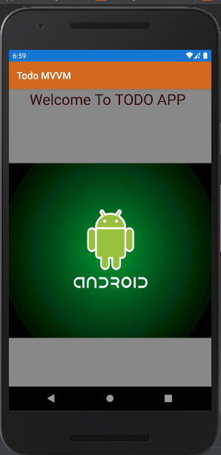 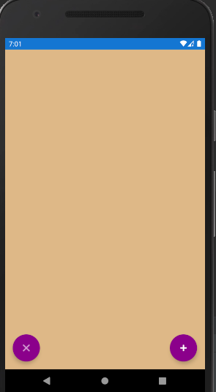

**Clear Add**

