**PROJECT REPORT**

**30TH National Children Science Congress**

**STATE – JHARKHAND CATEGORY-SENIOR**

**DISTRICT- BOKARO**

**SCHOOL- DELHI PUBLIC SCHOOL , SEC-IV, BOKARO**

**PROJECT TITLE**

***“AIDING SOFTWARE FOR MUTE & SPEECH IMPAIRED PEOPLE”***

**By-Rupesh Kumar**

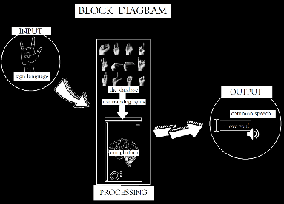

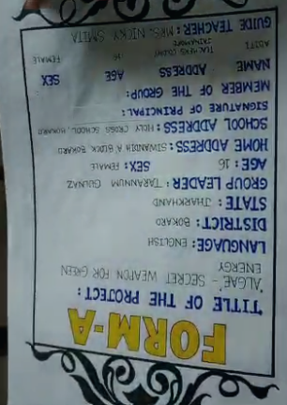

ABSTRACT

Communication is the backbone of human civilization and the basis of our society and the most critical ecosystem , the human ecosystem. For communication there is a need of a common medium which is lacking between general public and the people who use sign language. The 10 million deaf and mute population of the world which is ignored on a daily basis lacks a way to communicate with the general public in situations like shopping, railway stations on a daily basis. This makes them an outcast and promotes inequality in the society. Also, in representation of this huge population , in India there are only about 250 verified sign language interpreters which is very low compared to the wide population. This leads to illiteracy in specially abled children due to the absence of schools and teachers. Therefore, to help them we have proposed to develop a platform in the shape of an app or a website which will translate sign language into common languages like English and hindi and vice versa making way for a two way communication.It uses machine learning and the source code is made in python language using different machine learning libraries like tensorflow and keras.This project is based on convolutional neural network and hand datapoints distribution which understands what the symbol i Not only this, we have created a platform to test one’s grasp on sign language which would certify them and reduce the problem of authorisation in the Indian Sign Language System. Taking the project global we also aim to translate one accent of sign language to another for example Indian SL to American SL. We hope that our project clears these problems and plays its part in making the world a better place and conserve the most precious human ecosystem.

**KEYWORDS –** Sign Language ,Computer Vision ,Image recognition , Neural Networks, Feedback learning, Specially abled, Certification in sign language , Braille Script, Depth analysis,Dataset Generation,Training and testing of ML model.

**PRASTAVNA**

Everyone on this planet isn’t alike and we should celebrate our differences. There is one special group which amongst us which is often neglected and doesn’t easily fit in the common society. The people suffering from audio and speech impairments are not able to communicate and express their thoughts like us due to their inability to properly function these vital organs. They use different ways to convey their messages like sign language. The issue arises that when they want to communicate With common people like during shopping or the hospital, the lack of common medium disallows them and makes them an outcast from the society. To tackle this tissue, we have tried to come up with an initiative to help them mingle in the society by developing tools to translate into English or any other language and vice versa. These tools would also help in verification, testing and certification of people who are skilled in sign language on a digital platform.

**THEME AND HOW IT’S RELATED TO OUR PROJECT**

Main theme -**Understanding Health and Well Being for ecosystem restoration**

Sub theme- **Technological innovation for human ecosystem and health**

Description about the themes-

**What is a healthy ecosystem?**A healthy ecosystem is one that is intact in its physical, chemical, and biological components and their interrelationships, such that it is resilient to withstand change and stressors.

* **Healthy communities rely on well-functioning and healthy ecosystems. They provide clean air, fresh water, medicines and food security. They also limit disease and stabilize the climate.[1]**

**What is biodiversity?**Biodiversity underpins all life on Earth, and refers to biological variety in all its forms, from the genetic make up of plants and animals to cultural diversity.

**What does biodiversity mean for human health?**People depend on biodiversity in their daily lives, in ways that are not always apparent or appreciated. Human health ultimately depends upon ecosystem products and services (such as availability of fresh water, food and fuel sources) which are requisite for good human health and productive livelihoods. Biodiversity loss can have significant direct human health impacts if ecosystem services are no longer adequate to meet social needs. Indirectly, changes in ecosystem services affect livelihoods, income, local migration and, on occasion, may even cause or exacerbate political conflict.

Additionally, biological diversity of microorganisms, flora and fauna provides extensive benefits for biological, health, and pharmacological sciences. Significant medical and pharmacological discoveries are made through greater understanding of the earth's biodiversity. Loss in biodiversity may limit discovery of potential treatments for many diseases and health problems.

**What is meant by human ecosystems?**(2)"Human ecosystem" is the term scientists use to study the way people interact with their ecosystems. The study of human ecosystems considers geography, ecology, technology, economics, politics, and history. The study of urban ecosystems focuses on cities and suburbs

Our project is based on the noble idea of creating a culturable environment for all the people suffering from speech and audio impairments ,thus improving the human ecosystem. We are aiming to create a technological platform to help them lead a better life. It matches with our chosen theme to have a technological invention for human ecosystem and health. Our invention will help assist the most vital ecosystem that is formed by the human beings between them, if applied in an amicable way it can be used widely and improve the overall lifestyle of people and therefore their health.

**PROBLEM IDENTIFICATION**

With people different speaking languages and no common medium for either to understand, it is clear that there are lots of problems present due to absence of successful communication. The person using sign language is not able to perform daily life activities like shopping, buying medicines ,etc because the common vendor doesn’t know sign language and it is near to impossible to teach everyone how to use sign language. This idea was born out of few simple events. In the month of may this year, I was visiting my relatives and at the Bokaro Steel City railway station, when I went to inquire about the position of my train, I saw a deaf and mute man trying to communicate with the lady behind the counter and he was unable to do so. This man knew basic sign language phrases used in ISL but wasn’t able to communicate as the other person didn’t know it. After quite a struggle, he was able to clarify he wanted a ticket to a local train for Ranchi. Then and there I realised that this basic piece of information took so long to transfer due to lack of proper awareness and implementation of sign language.

Another huge problem is the lack of interpreters and teachers in India and especially in Jharkhand as there are a lot of children here who drop out of schooling and opt no special schooling after grade V. Thus , making them an illiterate , an outcast and ineligible for any respected jobs and further studies. This would change radically if there were sign language teachers but unfortunately there is no way to get it as a vocational course here and other courses are very inaccessible.

Analysing data for problem identification

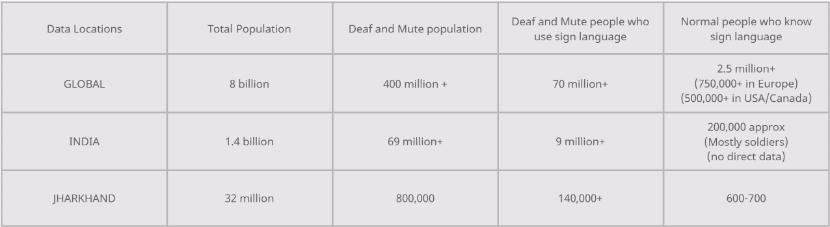

Problems which are evident by this data are

It is clear that a only a meagre population of normal people know or can communicate in sign language due to lack of general awareness and vocational courses or jobs in the sector.

It is also visible that very less percentage of deaf and mute people know sign language and the few which know are the privileged ones. This is due to absence of interpreters and special schools in the world for these people. In India there are no available courses for the underprivileged ones and the ones present are very expensive and inaccessible.

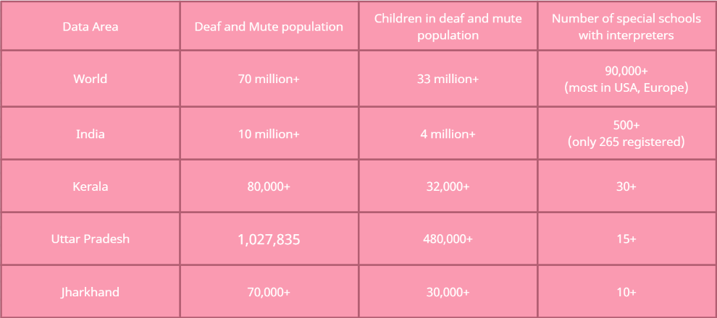

This data clearly shows the absence of schools and thus teachers to teach the special students which contribute to about 50% of the total deaf and mute population creating a big problem of illiteracy.

**HYPOTHESIS**

We hypothesize that if there is a virtual platform which is easily accessible to everyone and converts sign language into English , Hindi or any other language or even another sign language accent , it will be a great help to the people who are speech and audio wise impaired. If it is applied on a large scale it would smoothen out all the communication barriers between the two groups. We also state that certification of people as verified sign language trainers would greatly help improve their scopes to get a job and create awareness about it. We believe that a platform as ours would help create a better human ecosystem.

**AIM**

To create a software/platform to translate sign language into common languages like English and Hindi using machine learning to ease out the communication between normal people and people suffering from speech or auditory impairments.

**NEED STATEMENT**

There is a dire need in the society for the specially abled people to have a common medium to communicate so that they are able to talk to the common people as well easing out their daily life activities and help them from not feeling weird and different in public and help in mingling easily.

* Need of a common medium for communication between people using sign language and people not using sign language.
* Need of a converter to convert sign language into different accents of sign language helping in global communication.
* Need of a verification and certification tool to quicken the long manual of getting verified as a sign language expert.
* Need to increase awareness and introducing it as a vocational course.

ELABORATION OF NEED

The major problem faced by people using sign language is that they aren't able to communicate efficiently with the common public due to lack of a common medium. The public is not able to understand the different signs and symbols used in sign language. This disallows them to mingle in common public and face issue in even basic tasks like communication or shopping.The main objective of this project is to recognize the gestures and displaying the correspondent word. The first phase involves capturing the gesture using a webcam. Over the world wide web, there is no tool for proper verification and certification of sign language readers and practitioners. It is a tedious ,manual method limiting its accessibility highly  to only a few specific people resulting in the nation with twelve point three million sign language practitioners, only and only two hundred and fifty of them are verified and certified. This invention will help develop a tool which will allow people to learn sign language and braille script as well as  get certified and tested. We can add a basic quizzing and testing program into the existing platform which will help in testing the fluency and grasp of your language .

Like the famous app duolingo which teaches a language as well as checks your grasp, we aim to create a similar platform just instead for sign language. This would help authenticate the overall process as well as act as an incentive and a tool for verification for the people. With certificates ,it would also help in employment of the skilled people in various places as an interpreter. It would also limit the slow manual process of certification and give it an digital out look.It will also be extremely useful if the practice is reversed that is translating common text and voice to sign language using our translator to open the communication gateway for the people using common languages to the people using these special languages.

Furthermore, using already present translators like google translate, we can first translate the text into English from any language and then into sign language. This would break all the current boundaries of translating just from English, making this project usable for everyone from anywhere. We hope that these objectives of our project are fulfilled and we can play a little part in making this world a better place to live and coexist without indifferences. The sustainable development goals set by the united nations also mention good health and well being and reducing inequalities as two of the seventeen goals which our project will be focusing on.

**OBJECTIVES**

As it is rightly said that Necessity is the mother of invention, our idea deals with a lot of difficult aspects faced by our specially abled companions in their daily lives.

* TRANSLATION OF SIGN LANGUAGE TO COMMON TEXT OF ANY LANGUAGE ,VOICE AND VICE VERSA.
* PROVIDE A PLATFORM FOR  TESTING ,VERIFICATION AND AUTHENTIFICATION OF SIGN LANGUAGE
* CREATE MORE AWARENESS AND HELP CREATE EMPLOYMENT FROM SIGN LANGUAGE TRANSLATION AND TEACHING.
* TRANSLATION OF ANY GLOBAL SIGN LANGUAGE TO ANOTHER SIGN LANGUAGE TO CREATE A COMMON MEDIUM

**DESCRIPTION OF THE TERMS AND TOOLS USED**

**Sign Language and its description**:  
Sign language is a visual-gestural language used by deaf and hard-hearing people for communication purposes. Three dimensional spaces and the hand movements are used and other parts of the body to convey meanings. It has its own vocabulary and syntax which is purely different from spoken languages/written language. Spoken languages use the oratory faculties to produce sounds mapped against specific words and grammatical combinations to convey meaningful information. Then the oratory elements are received by the auditory faculties and processed accordingly. Sign language uses the visual faculties which is different from spoken language. Spoken language makes use of rules to produce comprehensive messages; similarly sign language is also governed by a complex grammar

**What are neural networks?**

Neural networks, also known as artificial neural networks (ANNs) or simulated neural networks (SNNs), are a subset of machine learning and are at the heart of deep learning algorithms. Their name and structure are inspired by the human brain, mimicking the way that biological neurons signal to one another. Neural networks rely on training data to learn and improve their accuracy over time. However, once these learning algorithms are fine-tuned for accuracy, they are powerful tools in computer science and [artificial intelligence](https://www.ibm.com/in-en/cloud/learn/what-is-artificial-intelligence), allowing us to classify and cluster data at a high velocity. Tasks in speech recognition or image recognition can take minutes versus hours when compared to the manual identification by human experts. One of the most well-known neural networks is Google’s search algorithm.

## What is machine learning?

Machine learning is a branch of [artificial intelligence (AI)](https://www.ibm.com/cloud/learn/what-is-artificial-intelligence) and computer science which focuses on the use of data and algorithms to imitate the way that humans learn, gradually improving its accuracy.

**What is computer vision?**

Computer vision is a field of artificial intelligence (AI) that enables computers and systems to derive meaningful information from digital images, videos and other visual inputs — and take actions or make recommendations based on that information. If AI enables computers to think, computer vision enables them to see, observe and understand.  
Computer vision works much the same as human vision, except humans have a head start. Human sight has the advantage of lifetimes of context to train how to tell objects apart, how far away they are, whether they are moving and whether there is something wrong in an image.

* We have created our project in python language

**What is python?**

Python is a high-level, general-purpose programming language. Its design philosophy emphasizes code readability with the use of significant indentation. Python is dynamically-typed and garbage-collected. It supports multiple programming paradigms, including structured, object-oriented and functional programming.

In python there are several libraries used for machine learning out of which to create neural networks we have used tensorflow, keras and opencv libraries.

**Tensorflow**

TensorFlow is a free and open-source software library for machine learning and artificial intelligence. It can be used across a range of tasks but has a particular focus on training and inference of deep neural networks.

**Keras Module**

-Keras is a high-level, deep learning API developed by Google for implementing neural networks. It is written in Python and is used to make the implementation of neural networks easy. It also supports multiple backend neural network computation.

**OpenCV**-

OPEN CV is an open source computer vision and machine learning software library. OpenCV was built to provide a common infrastructure for computer vision applications and to accelerate the use of machine perception in the commercial products.

**METHODOLOGY**

The research problem that motivated the conduction of this study was to highlight the issues faced by auditory impaired and mute people while communicating with other people. This study reflected the problems, difficulties faced the be specially abled people. The study included taking survey from different people at different locations about their perception and knowledge about sign language. Survey was taken from auditory impaired and mute people about their problems and daily challenges that they face. This study also highlights a deeper understanding of knowledge of sign language of common people. The study highlighted the need for a platform wherein people could translate as well as learn sign language.

Experimentation and project details –

Our project can be distributed into 3 parts, which is when a normal person opts for translating normal speech into sign language for the specially abled person or a disabled person chooses it to translate into normal speech, this part can be classified as the input part. This input is then received by the machine which is the next part, this part can be classified as the processor which understands the input based on the training given by us to the machine and the produces the require output.

The processor can then be classified into different subsets, like the human brain when born ,has no data but learns from the data around it and uses it to take decisions, then see the reviews , repeat the task until it is error free and thus accomplish a task. For example ,the task is of walking. The human brain looks around and takes input that the task is to be done by the legs, then this data is applied and there are attempts to walk. In the first few attempts the child falls and learns that it was wrong. Soon , it learns how to walk, similarly instead of the eyes , our input is given by the us only to the machine/ computer brain. The review until the work is done right is done by us which is called training the machine so that it works error free and when it is able to recognise the sign , it is translated to normal speech and the task is done.Materials required is just a computer with python idle and machine learning modules mentioned in description with a good enough processor and materials required for usage is any device with any processing power good enough to run android and chrome.

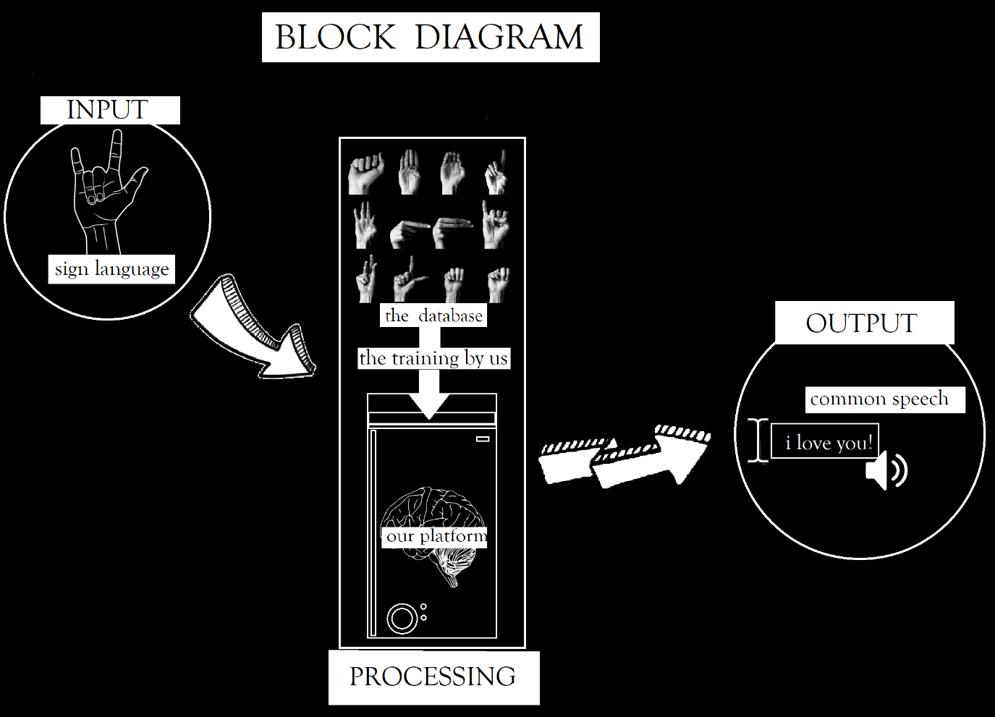

**CASE STUDY**

“Special café in Jamshedpur”

**Brewed with love**

La Gravitea was started in 2016 after its founder Avinash Duggar stumbled upon a sudden and vehement passion for tea. A former Vice President of sales at a steel plant in Jamshedpur, Duggar had spent 17 years in a corporate job that paid well but left little to the imagination. But he loved to travel and the job was good at paying the bills. On one of his trips, he entered a tea shop in England and fell in love.  
“Tea is a wonderful thing. There are so many different varieties of tea with such fancy names and histories, so many different techniques to brew it, so many different ways to serve it. It fascinated me to no end,” Duggar says.  
Soon after that, Duggar decided to quit his job and enter the tea business for good. He set up a small cart and started selling tea. “One day, a little deaf girl and her brother came to me for tea. After drinking a few sips, the girl asked me if I could give her a job. I couldn’t do that because she was a minor. But it got me thinking,” he recalls.  
Duggar’s wife Kajal says that it was as if he was consumed. “All he talked about was the little girl and how he couldn't help her”. That moment changed his life. Duggar started researching the education and employment opportunities for deaf-mute people and eventually reached out to local activists and ISL educators and institutions. Duggar found that despite graduating from special schools, many deaf people still did not get jobs. And a majority never even ended up in schools. “I wanted to do something for the young, unemployed deaf and mute youth. No one wanted to hire them, so I thought, why not hire them myself”.  
That was how La Gravitea started. Today, the cafe employs 11 persons with hearing, learning or speech disabilities including seven deaf persons. Having first trained himself, Duggar personallytrains them in Indian Sign Language (ISL) as well the vocational training required for running a cafe.“We do everything on our own. We have complete freedom to work as we wish and refuse to do the jobs that we don’t like,” Sooraj Thakur, who has been working at the cafe for three years now, says in sign language. After losing four jobs as a carpenter and locksmith, this is Sooraj’s fifth job. Despite not knowing much about the cafe business, Sooraj decided to give it a try. He says he has not regretted it.“In my previous jobs, they paid us less than hearing technicians and often insulted us with ignorant or impatient behaviour”. With his present job, Thakur can pay for his house rent, save for his sister’s wedding and contribute to monthly grocery shopping at home.

Sooraj, however, notes that when it came to finding jobs, the deaf were on their own.  
“The government does not do anything for us. There is a deaf club here. It’s full of youth with hearing impairments. They’re all just waiting. We have all our documents but no jobs, or stipend schemes come to us,” Sooraj signs. He adds that for someone like him, finding a source of livelihood was not easy, especially when no one spoke his language or wanted to teach him skills.

**Discrimination begins early**

The ignorance of the hearing community, says Pragya Singh, a certified ISL teacher trainer and principal of Jamshedpur’s DAV Public School, Bistupur, is one of the main obstacles for deaf people to get lasting employment. “The problem is not that they are not skilled or able. The problem is that the hearing community does little to understand or help them,” she says  
.One day, in 2018, Singh visited La Gravitea and was impressed by the sign language menus and mugs that the cafe used as napkin holders to promote ISL. It gave her the idea to create an ISL wall in her school to promote and normalise the language among children. The wall was put up in 2019. Next, she plans to put these walls in all the classrooms across the school and turn it into a model for inclusion that schools in the rest of the country can follow. In her decade-long reign as the head of the school, Singh has also tried to incorporate several other strategies for inclusion in the way the school curriculum is designed and taught to students.

Two to five per cent of the students in each standard of DAV have some form of speech, hearing and learning disabilities including dyslexia and ADHD, Singh tells Outlook. “Being a little different doesn’t mean your child will not achieve. Achievement is not just in academics. If given the right care, everyone can achieve things in their own way," she adds.For a majority of persons with disabilities in India, however, the picture is not as optimistic. According to a recent UN report, 75 per cent of children with disabilities do not attend any kind of school in India.

For those who can manage to go to school, lack of financial resources and acceptance at home, untrained teachers and lack of proper skill training programs often keep students from achieving optimum results. Take, for instance, the case of deaf and mute siblings Ganga and Sagar. Their father too is deaf and drives a rickshaw. Their mother works at a hotel and has no time to take care of the children’s education. Their tutor, Priya Kumari, tells Outlook that the duo was found selling potatoes.

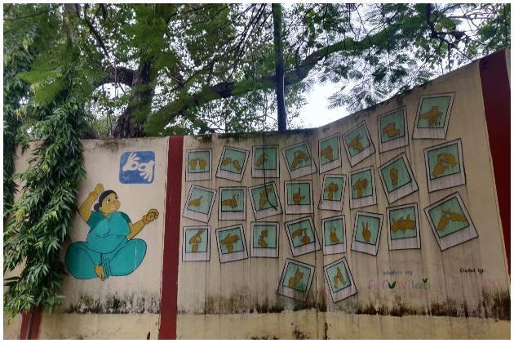

(An ISL wall inside DAV school)

They were rescued and enrolled in the missionary-run Carmel Bal Vidyalay, the only school for deaf children in Jamshedpur. Priya, a student herself, has been learning from sign language books and teaching the kids, who live in the slums on the edges of Sonari. “They are good at studies but their parents have no interest in sending them to school. That’s because despite going to school, deaf youth often find it difficult to find or keep skilled jobs so parents don’t want to invest in their education.”

Duggar hopes to further amplify the employment needs and opportunities of the deaf community in Jamshedpur. “Unemployment is a big issue in the country. We want to replicate the model of our cafe where we learn and also teach while providing livelihood to vulnerable communities. And no better way to promote disability empowerment than by letting the PWD themselves take centre stage and show the world in signs what they can’t say in words.”

<https://www.outlookindia.com/website/story/india-news-a-cafe-in-jharkhand-is-brewing-inclusion-in-a-teapot/405497>

**DATA COLLECTION AND ANALYSIS**

SOURCES OF DATA COLLECTION

The major source for our factual data has been the internet and some research papers and websites given in references.

As it is both a social and technical/machine learning project , the basis of everything here is based on the data we have collected. Drifting away from the technical terms, the data collected from social sources have been scraped from various sites

**SITE 1**

ASHA LATA VIKLANG VIKASH KENDRA , BOKARO STEEL CITY

It has been our most major and fruitful source as it is a school for the specially abled people , the target audience we are aiming this project for.It is a great humanitarian initiative done by Shri B.S Jaiswal Sir( managing director) and managed by Mr Rupesh Kumar Dubey Sir (Acting Principal)

The smiling faces of the children, their self confidence, talent and skills have been a source of inspiration to one and all and we are grateful to the entire institution for their cooperation and this god-like initiative.

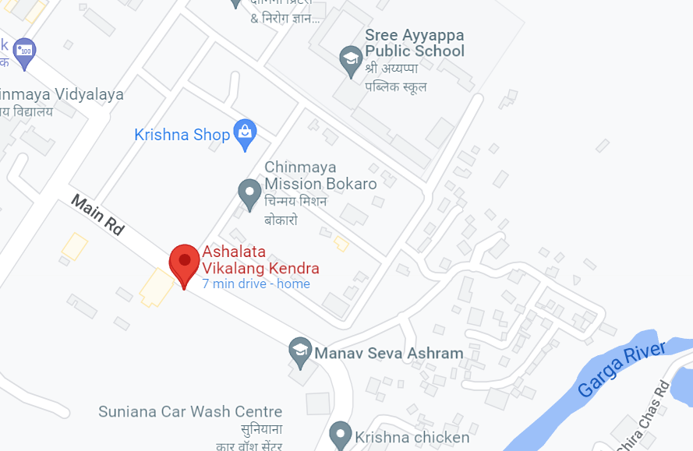

**SITE 2**

BOKARO GENERAL HOSPITAL, BOKARO STEEL CITY

The BGH hospital and the entire BSL institution has been kind enough to us allowing to take survey and ask about the problems faced by people while ordering medicines or describing their problems when , especially when they are specially abled or have speech auditory impairments.

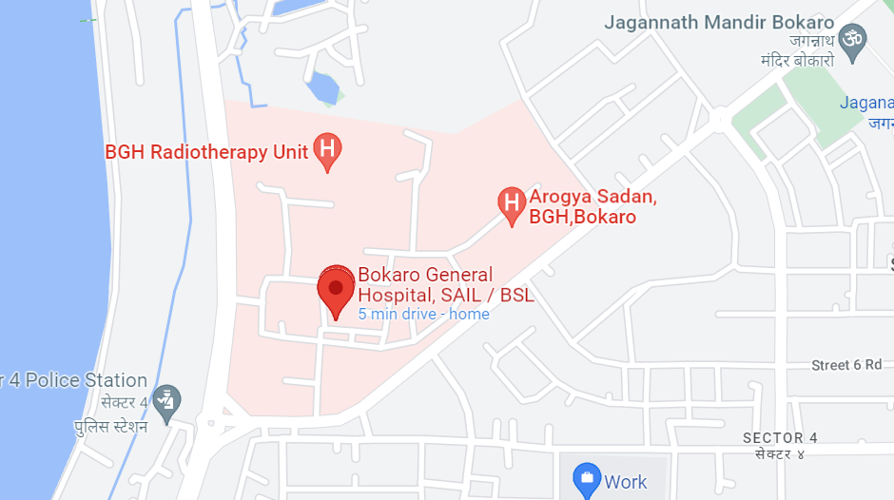

**SITE 3**

BOKARO RAILWAY STATION, BOKARO STEEL CITY

We also surveyed the people at counters available at the railway station and received vital data about how people face issues while buying tickets and raised awareness for them to learn sign language aiding the specially abled

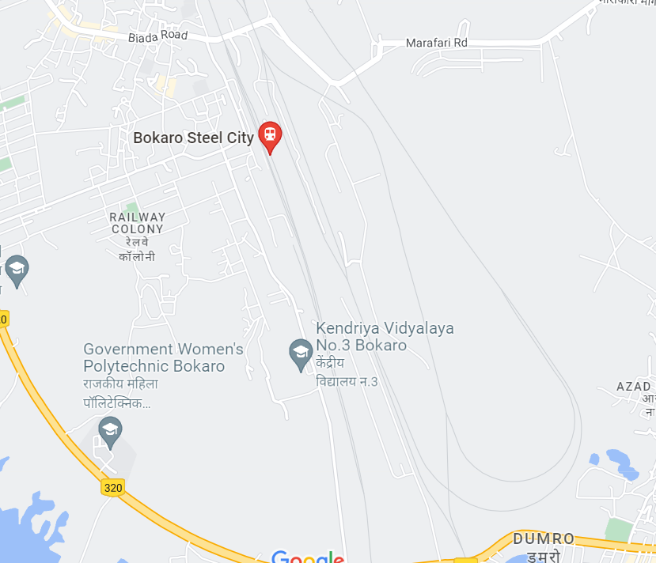

**SITE 4**

DELHI PUBLIC SCHOOL , BOKARO STEEL CITY

Our school was also a survey site and helped collect data from the young minds present .

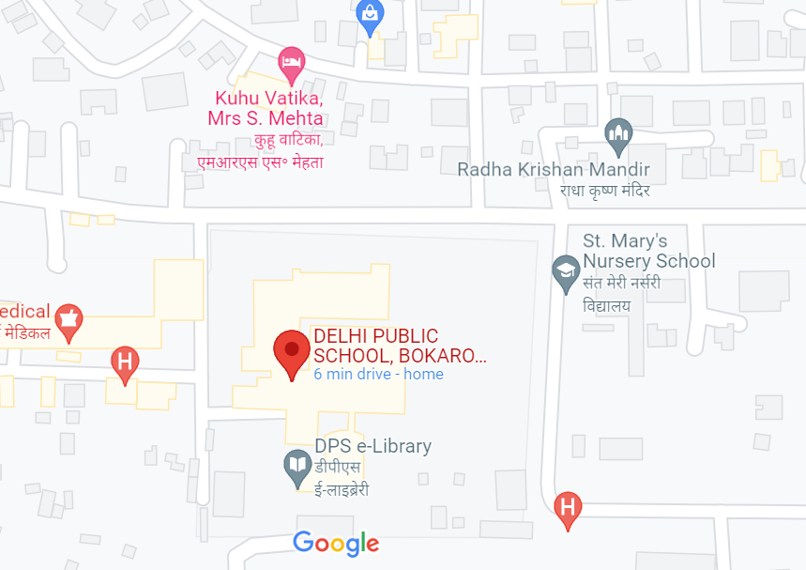

Technological Data collection

For training our model we have created a database in which there are images of different signs which we have created. In computing, a database is an organized collection of data stored and accessed electronically. Small databases can be stored on a file system, while large databases are hosted on computer clusters. We have used American Sign language as our bases for the platform we are creating to translate to English and hindi.

-All the other general figures have been taken from google and other trusted sources who have been mentioned in the bibliography.

**OBSERVATIONS**

In places with well to do people like our school DPS Bokaro, the station master at railway station , doctors and patients in AC wards we observed there was basic general awareness about sign language and basic symbols which are used but in places like Asha Lata and Railway station general waiting rooms, the situation was not so good. Poor people are often so deep in fighting their own daily struggles ,they tend to ignore the major issues like environment, disability and ecosystem conservation.

This is due to lack in education. The biggest correlation we found was that if a person was speech impaired or mute and was not from the crème of society, the only option was for him or her to beg or do very menial jobs to even survive. They are often in the gravest depths of poverty and there seems no hope for them to succeed without easily accessible education and a little kindness.

We observed in asha lata that the students doing well in the classroom had a direct relation with how their parents responded to their education. A lot of such students are often neglected due to their inability to communicate with their parents which would be solved by our platform which would not only translate but teach sign language aswell. The students doing good had continuous support and patience shown by their parents.

DATA ANALYSIS AND INTERPRETATION

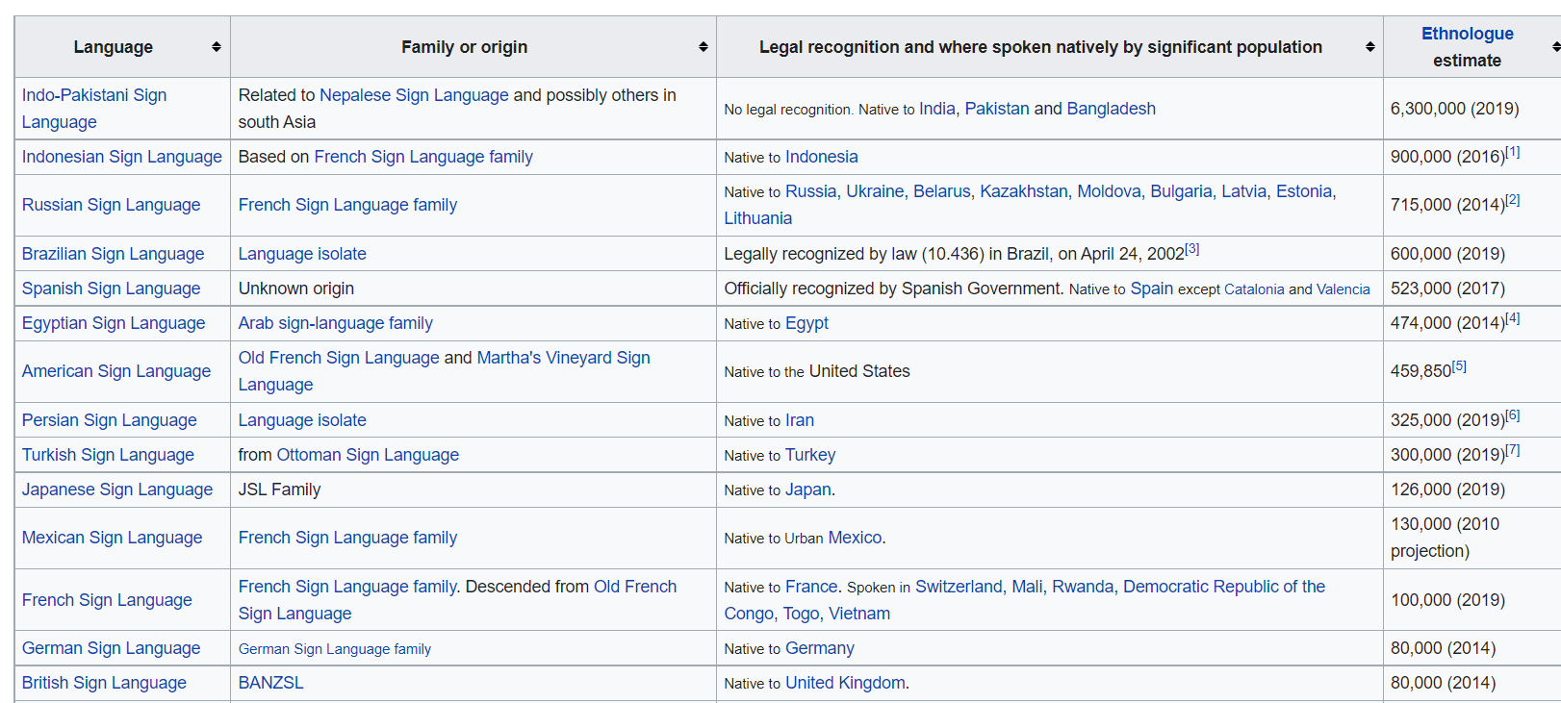

This table depicts the various sign languages and their number of speakers showing us the problem of no common sign language in nations causing a havoc globally.

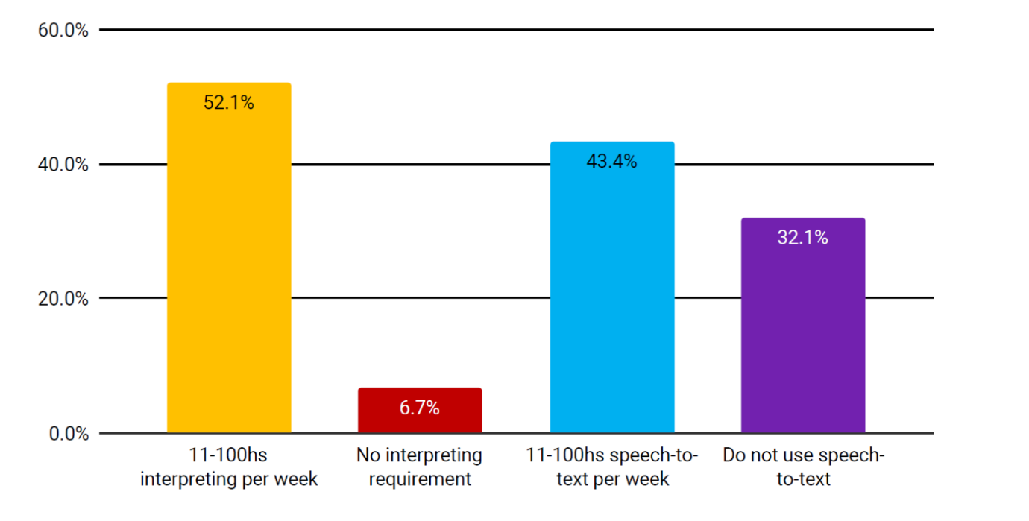

This graphs help show the great untapped economy and job opportunities in interpreting business in the world with about more than 70% of the people don’t use interpreters or use text to speech interpretation.

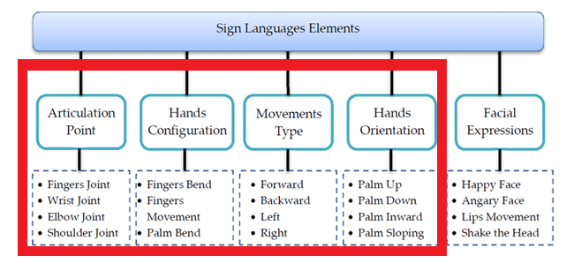

This flow chart shows the various aspects of using a sign language. The parts in red area is interpreted by the current model of our sign language translator.

India with a huge population of more than 18 million deaf people , there are only about 250 verified sign language translators showing the grave lack in certification and verification of our system.

ADD THE PIE CHARTS FROM LOGBOOK AND THE DATA SHEET, create more surveys….

**SOLUTION TO THE PROBLEM**

We believe a platform which translates sign language into common speech of other languages aswell as other sign language and also teaches sign language using machine learning will be the solution to the problems.Also , a verification tool to give authorization to practice sign language will also be of great help to create employment and teach such students.

**WORK PLAN**

Create a database

Feed it to the model

Train the model

Testing the model

Improving the machine

Give a Graphic User interface to it

Make a usable platform like app or website out of it

Finish

**Creating Required Dataset for Training Model:**

We created a python script to capture and store images of different sign languages. We used Open computer vision (OpenCV) library in order to produce our dataset. Firstly, we captured around 303 images of each of the symbol in ASL for training purposes and around 200 images per symbol for testing purpose. First, we capture each frame shown by the webcam of our machine. In each frame the porting including hand is a region of interest (ROI) which is denoted by a purple bounded square as shown in the image below. From the whole image we extracted our ROI which is RGB and apply finger pointers to our image which helps us extracting various features of our image and latter improve the accuracy of the model. The captured images are stored in project directory.

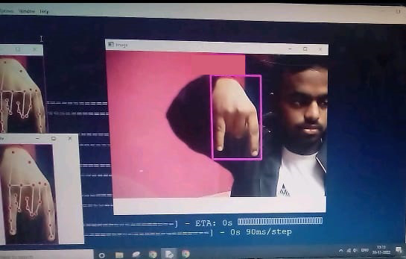 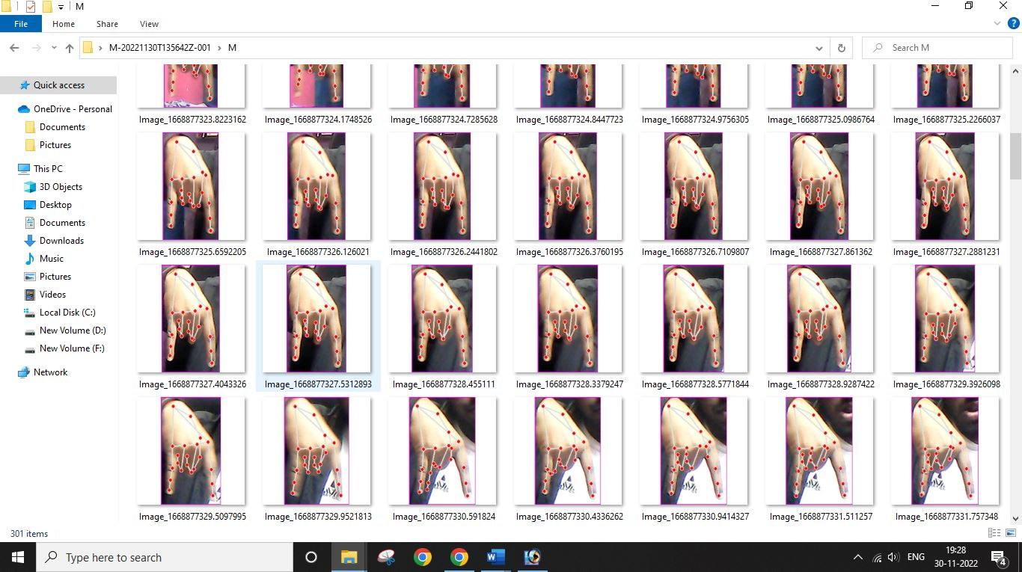

Capturing images for Data set Storing 300-500 images

##---------------------------------Code-------------------------------------##

import cv2

from cvzone.HandTrackingModule import HandDetector

import numpy as np

import math

import time

cap = cv2.VideoCapture(0)

detector = HandDetector(maxHands = 2)

offset = 20

imgSize = 300

folder = "Data/N"

counter = 0

while True:

    success,img = cap.read()

    hands,img = detector.findHands(img)

    if hands:

        hand = hands[0]

        x,y,w,h = hand['bbox']

        imgWhite = np.ones((imgSize,imgSize,3),np.uint8)*255

        imgCrop = img[y-offset:y+h + offset , x - offset:x+w + offset]

        imgCropShape = imgCrop.shape

        aspectRatio = h/w

        if aspectRatio > 1:

            k = imgSize / h

            wCal = math.ceil(k*w)

            imgResize = cv2.resize(imgCrop, (wCal, imgSize))

            imgResizeShape = imgResize.shape

            wGap = math.ceil((imgSize - wCal)/2)

            imgWhite[0:imgResizeShape[0], wGap:wCal + wGap] = imgResize

        else:

            k = imgSize / w

            hCal = math.ceil(k*h)

            imgResize = cv2.resize(imgCrop, (imgSize,hCal))

            imgResizeShape = imgResize.shape

            hGap = math.ceil((imgSize - hCal)/2)

            imgWhite[hGap:hCal + hGap, : ] = imgResize

        cv2.imshow("ImageCrop", imgCrop)

        cv2.imshow("ImageWhite", imgWhite)

    cv2.imshow("Image",img)

    key = cv2.waitKey(1)

    if key == ord("s"):

        counter +=1

        cv2.imwrite(f'{folder}/Image_{time.time()}.jpg',imgWhite)

        print(counter)

**Training Model with the dataset created:**

The data set created is taken up in the training platform Teachable machine (teachablemachine.withgoogle.com) by google To train the AI model with our Data set. The Epochs was set to 55 to obtain a better accuracy. It took around 30-35 minutes to train the model with 13,078 images of sign symbols. Then the trained model along with the label set was downloaded and stored in the project directory.

The data set created is taken up in the training platform and Decision tree algorithm is used to train the machine. The set of values stored for a specific gesture is referred by the machine in its training and makes it possible to predict the gesture when the input is taken. Decision Tree Values The input values will be run through the tree and the final answer will be displayed along with its value and the corresponding label. The corresponding values for labels are then substituted with words and are displayed in the result. Every new gesture has several frames recorded for it and trained using the decision tree algorithm. More the number of frames recorded better the efficiency of the system in predicting the gesture



Training AI model with Data set

**Testing Model:**

The system, when provided with the proper gestures, gives out the corresponding words. The system can provide proper results even when there are some slight variations in gestures. There will be different kinds of variations from different kinds of persons performing the gestures. The system recognizes multiple gestures one after the after and the gives out the respective words.

The model was tested with the help of confusion matrix using the 200 images stored for testing. The model gives **total accuracy of 98.741 % with total F1 score of 99.98.** The system, when provided with the proper gestures, gives out the corresponding words. The system can provide proper results even when there are some slight variations in gestures. There will be different kinds of variations from different kinds of persons performing the gestures.

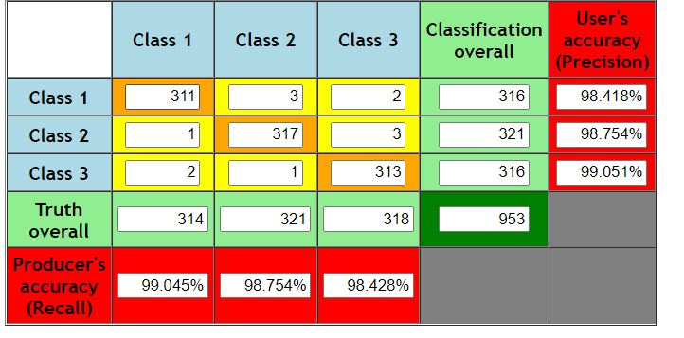

Testing model with Confusion Matrix

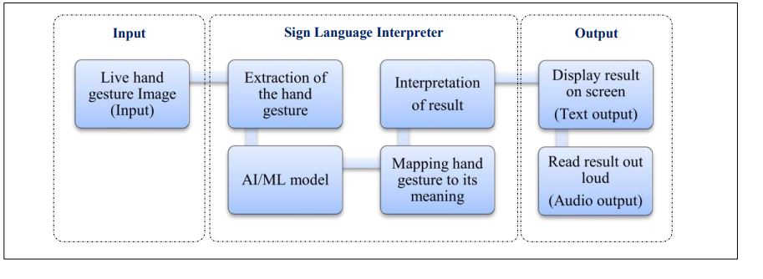

THE system architecture of SLI

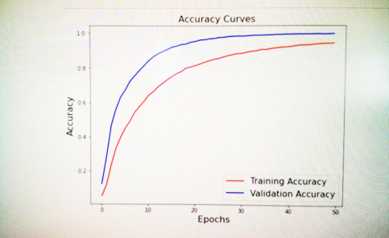

ACCURACY CURVES OF OUR CODE

**IMPLEMENTATION**

The Trained model is used in python script to create a live sign language prediction software. Live input is taken from the web cam and the output is displayed on the screen. The system recognizes multiple gestures one after the after and predicts the expected meaning.

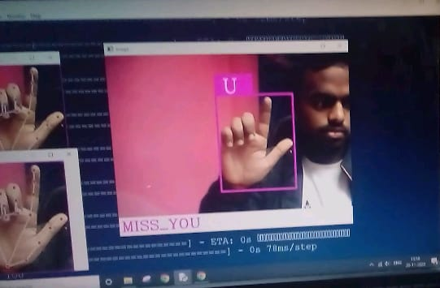

Live Translatoin of Sign language to text

##------------------------------Code----------------------------------------##

import cv2

from cvzone.HandTrackingModule import HandDetector

from cvzone.ClassificationModule import Classifier

import numpy as np

import math

import time

cap = cv2.VideoCapture(0)

detector = HandDetector(maxHands = 1)

classifier = Classifier("Model/keras_model.h5", "Model/labels.txt")

offset = 20

imgSize = 300

folder = "Data/C"

counter = 0

recText = ""

recTime = 0

labels = ["A","B","C","D","E","F","G","H","I","J","K","L","M","N","O","P","Q","R","S","T","U","V","W","X","Y","Z","_"]

while True:

    success,img = cap.read()

    imgOutput = img.copy()

    hands,img = detector.findHands(img)

    if hands:

        hand = hands[0]

        x,y,w,h = hand['bbox']

        imgWhite = np.ones((imgSize,imgSize,3),np.uint8)*255

        imgCrop = img[y-offset:y+h + offset , x - offset:x+w + offset]

        imgCropShape = imgCrop.shape

        aspectRatio = h/w

        if aspectRatio > 1:

            k = imgSize / h

            wCal = math.ceil(k*w)

            imgResize = cv2.resize(imgCrop, (wCal, imgSize))

            imgResizeShape = imgResize.shape

            wGap = math.ceil((imgSize - wCal)/2)

            imgWhite[0:imgResizeShape[0], wGap:wCal + wGap] = imgResize

            prediction, index = classifier.getPrediction(imgWhite,draw =False)

            recTime+=1

            if(recTime % 10 == 0):

                recTime = 0

                recText+=labels[index]

        else:

            k = imgSize / w

            hCal = math.ceil(k*h)

            imgResize = cv2.resize(imgCrop, (imgSize,hCal))

            imgResizeShape = imgResize.shape

            hGap = math.ceil((imgSize - hCal)/2)

            imgWhite[hGap:hCal + hGap, : ] = imgResize

            prediction, index = classifier.getPrediction(imgWhite,draw =False)

            recTime+=1

            if(recTime>=95):

                recTime = 0

                recText+=labels[index]

        cv2.rectangle(imgOutput, (x- offset,y - offset - 55), (x-offset + 100, y- offset ), (255,0,255),cv2.FILLED)

        cv2.putText(imgOutput, labels[index] , (x,y-26),cv2.FONT_HERSHEY_COMPLEX, 1.7, (255,255,255),2)

        cv2.rectangle(imgOutput, (x- offset,y - offset), (x+w + offset, y+h+offset), (255,0,255), 4)

        cv2.rectangle(imgOutput, (0,500), (500, 600), (255,255,255), cv2.FILLED)

        cv2.imshow("ImageCrop", imgCrop)

        cv2.imshow("ImageWhite", imgWhite)

    print(recText)

    cv2.rectangle(imgOutput, (0,430), (640, 480), (255,255,255),cv2.FILLED)

    cv2.putText(imgOutput,recText , (5,467),cv2.FONT_HERSHEY_COMPLEX, 1.3, (255,0,255),2)

    cv2.imshow("Image",imgOutput)

    cv2.waitKey(1)

**Voice to Sign language translator:**

To translate Voice to sign language we used Pillow, matplotlib and Speech recognition in our python script. It first recognizes spoken text, analyses and filters it, then it matches it with the corresponding sign language translation and displays it.

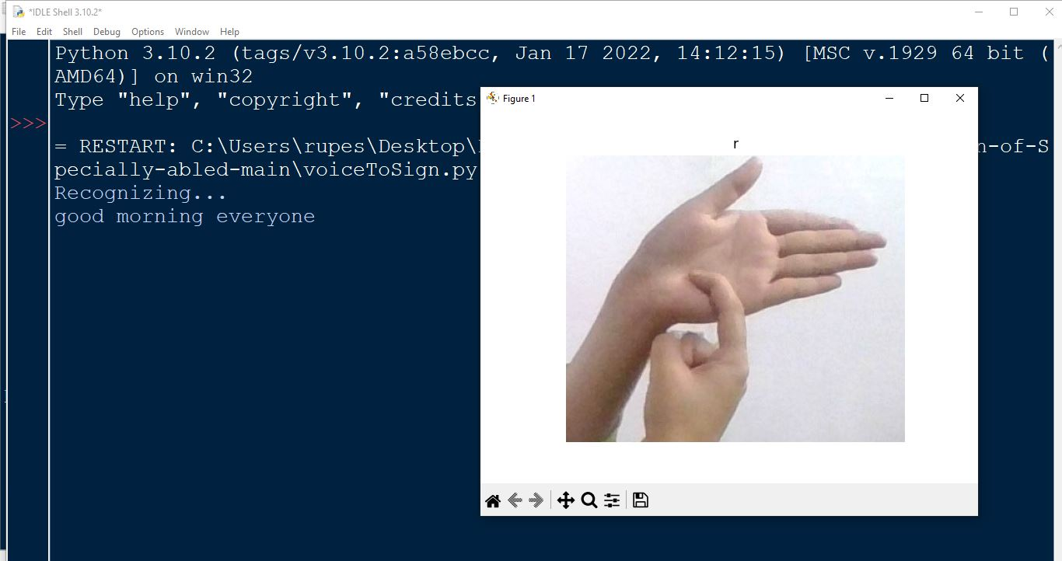

Live Translatoin of Sign language to text

##------------------------------------Code----------------------------------##

import speech_recognition as sr

from PIL import Image

import imageio.v2

import imageio

import matplotlib.pyplot as plt

import os

import skvideo.io

from matplotlib.animation import FuncAnimation

import imageio

r = sr.Recognizer()

Mytext = ""

try:

    with sr.Microphone() as source:

        # read the audio data from the default microphone

        print("Recognizing...")

        audio_data = r.record(source,5)

        # convert speech to text

        Mytext = r.recognize_google(audio_data)

        Mytext = Mytext.lower()

        print(Mytext)

except:

    print("Failed to Recognise, pls try again")

def display(img,title="Original"):

        plt.imshow(img,cmap='gray'),plt.title(title)

        plt.axis('off')

        plt.show(block=False)

        plt.pause(2)

        plt.close

if(Mytext != ""):

    for l in Mytext:

        if l == ' ':

            l = '_'

        img=imageio. v2.imread("SLD/"+l+'.jpg')

        display(img,l)

**UNIQUENESS OF OUR PROJECT**

First of all there are no fully usable apps or platform used by the general public.There are some projects and research papers which are old and faulty with no outcome given. Anyways those research papers use pose estimation model which is a training model different than us as it takes the hand gestures together as a whole and that leads to less accuracy whereas we assign all the joints and points in our hand a specific value and when it moves or makes a symbol, the value of that variable changes and is then matched by our dataset to give output resulting in way more accuracy and usability.

**RESULT**

The result we have received are marvellous and are supporting our work and the code. We are successfully able to translate American Sign Language into English and other languages. We are also able to translate normal speech into American Sign Language thus creating a 2-way communication channel which can be used by both normal people and the specially abled age group. We are also able to translate American Sign Language to Indian Sign Language. We are also able to generate certificates for people learning sign language, For a measure system, we have created a 5 level course and thus have created a testing system for the people to use and learn sign language. We have thus trained our model using database we created and thus have created a proper platform to claim our objectives. Soon we will be able to transform it to an app or add it as a feature in google translate and we believe within a year we would be able to make it as an app and thus make it an open-source platform available to everyone.

**DRAWBACK OF COMPETITION**

Currently there is no proper tool present in the market available to translate sign language into English or Hindi as well as no proper course to learn and test a person’s grasp on sign language. We aim to create a platform for people just like Duolingo {3) which is a very famous app for learning new languages, just instead we would make it for sign language. All the courses which provide certificates are offline and non as convenient and easy as ours.

**FUTURE SCOPE OF IMPROVEMENT**

This device can be implemented at hospitals and railway stations to make it easy for the specially abled people to communicate with other peoples and get their services. It can be embedded with google translate to provide a global sign language translator. This will promote the use of sign language and its importance and will further create a society wherein people are well versed with different modes of communication. With further training this will also recognise and translate different other global sign languages making the usage world widely available. Also, we aim to add it as a feature for google translate which would help us to get this project global.

**COST EFFECTIVENESS.**

One of the best result of our idea is that it is literally investment free. There is literally zero rupees required for its usage as it is a service which could be downloadable from playstore or accessed at a website on the web. We can easily even turn it profitable by adding adsense into the app. Thus ,our idea cost zero rupees of add on investment making it easily usable in already existing resources as smartphone has become a resource which is owned by the unprivileged these days as well due to the advancement in technology.

**IMPLEMENTATION OF OUR SOLUTION**

Our app is still in the developing phase yet the platform we have created has been used to translate several sentences by us and works very efficiently, we have also started sign language classes in our language lab for classes 6-10 with frequency of 1 class a fortnight. Through this practice we have certified few students who with level 1 certificate which acknowledges their ability to recognise and remember all the alphabets of the ASL. We have distributed the course in 10 levels and few students mentioned below have received the level 1 and level 2 certificates for recognising alphabets and basic word formations respectively with their images.

**ACKNOWLEDGEMENT**

This report has not been a solo endeavour and we are deeply indebted to all the people who helped and supported us while the making of the project. First of all I would sincerely like to thank the Principal of our school, Mr A.S Gangwar under whose guidance every journey is a sweet smooth road. We would like to express deepest appreciation to the entire NCSC 22-23 conducting team ,hosting such a wonderful competition to bring out ideas for the betterment of our nation and streamline the youth towards becoming an inventor. We would also like express out gratitude to our science teacher, Mr Obaidullah Ansari and all our headmistresses and vice principals to give us this once in a lifetime opportunity. Last but not the least, getting all first-hand experience wouldn’t have been possible without the support of the Asha Lata Organisation and we would like to thank them for the same.

BIBLIOGRAPHY AND REFRENCING

1. <https://www.ibm.com/in-en/cloud/learn/neural-networks>
2. <https://www.ibm.com/cloud/learn/machine-learning>
3. <https://www.ibm.com/in-en/topics/computer-vision>
4. <https://www.who.int/news-room/fact-sheets/detail/biodiversity-and-health>
5. <https://www.researchgate.net/publication/331931105_Deaf_Education_in_India>
6. <https://www.hrw.org/news/2019/09/23/without-sign-language-deaf-people-are-not-equal>
7. <https://www.ayjnihh.nic.in/special-school-hearning-state-ut-hearing>
8. <http://deafeducationworldwide.weebly.com/deaf-education-programs-around-the-world.html>
9. <http://islrtc.nic.in/sites/default/files/Indian%20Sign%20Language%20Interpreters%20directory.pdf>
10. <https://www.audicus.com/world-wide-hearing-loss-stats-from-around-the-world/>
11. https://www.who.int/news-room/fact-sheets/detail/deafness-and-hearing-losshttps://en.wikipedia.org/wiki/List_of_sign_languages_by_number_of_native_signers
12. <https://www.quora.com/Why-do-normal-people-learn-sign-language>
13. https://www.linkedin.com/pulse/indian-sign-language-facts-amit-gautam#:~:text=They%20are%20not%20less%20intelligent,trained%2Funtrained%3B%20skilled%20interpreters.
14. (3)- duolingo – source google- Duolingo is an American educational technology company which produces apps for language-learning and provides language certification. On its main app, users can practice vocabulary, grammar, pronunciation and listening skills using spaced repetition.
15. All the maps are taken from Google Maps
16. <https://www.digitalocean.com/community/tutorials/how-to-build-a-neural-network-to-translate-sign-language-into-english>
17. <https://www.researchgate.net/publication/355858241_Sign_Language_Translator_Using_Machine_Learning>
18. <https://www.ripublication.com/ijaerspl2018/ijaerv13n4spl_01.pdf>
19. Zhe Cao, Tomas Simon, Shih-En Wei, YaserSheikh.‘Realtime Multi-Person 2D Pose Estimation using Part Affinity Fields’. The Robotics Institute, Carnegie Mellon University on 14 April 2017.
20. V. Belagiannis and A. Zisserman. Recurrent human pose estimation. In 12th IEEE International Conference and Workshops on Automatic Face and Gesture Recognition (FG), 2017.
21. G. Papandreou, T. Zhu, N. Kanazawa, A. Toshev, J. Tompson, C. Bregler, and K. Murphy. Towards accurate multiperson pose estimation in the wild. International Journal of Applied Engineering Research ISSN 0973-4562 Volume 13, Number 4 (2018) Spl. © Research India Publications. http://www.ripublication.com 4 arXiv preprint arXiv:1701.01779, 2017. In CVPR, 2017.
22. Pedro F. Felzenszwalb, Daniel P. Huttenlocher. ‘PictorialStructures for Object Recognition’. AI Labs MIT, CSE, Cornell University. [5] N.J. Ayache and O.D. Faugeras. A new approach for the recognition and positioning of twodimensional objects. IEEE Transactions on Pattern Analysis and Machine Intelligence, 8(1):44–54, January 1986.
23. MykhayloAndriluka, Leonid Pishchulin, Peter Gehler, Bernt Schiele. 2D human pose estimation: New benchmark and state of the art analysis. In CVPR, IEEE Conference on 25th September 2014. [
24. ]MykhayloAndriluka, Leonid Pishchulin, Peter Gehler, Bernt Schiele. Strong appearance and expressive spatial models for human pose estimation. In ICCV, IEEE International Conference on 1-8 December, 2013. [8] S. Ioffe and D.A. Forsyth. Probabilistic methods for finding people. International Journal of Computer Vision, 43(1):45–68, June 2001.
25. Fangfang Yuan, Fusheng Lian, Xingjian Xu. Decision tree algorithm optimization research based on MapReduce. ICSESS, 6th IEEE International Conference on 23-25 September, 2015.

WORK REMAINING- DATA ANALYSIS MEIN LOGBOOK WALE SURVEYS, ADD MORE SURVEYS, ADD PHOTOS, ADD BGH PHOTO, RECONSTRUCT SURVEY, MAKE LOGBOOK AND POSTERS., implementation aur certificate wala kaam, experimentation and methods used

ADD CERTIFICATES.

Conclusion

conclusion

We would like to conclude this project by stating that our platform would serve as the optimal medium for the communication between the specially abled and the general public

It would be the base of ensuring a two way communication between the two groups as well as our verification tool will provide the authorisation needed in the Indian sign language system

We believe that the platform we have developed would not only ease communication between normal people and specially abled people but also translate sign language between different accents.

Thus, we hope that this platform plays a small part in making the world a better place and conserve the most crucial human ecosystem.