PRACTICALS

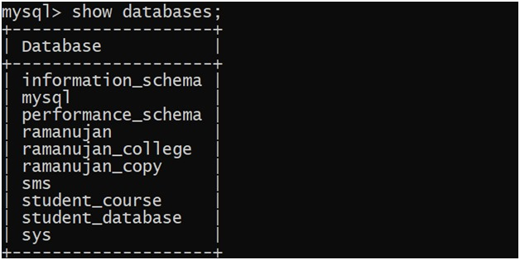

C:\Users\admin\AppData\Local\Packages\5319275A.WhatsAppDesktop_cv1g1gvanyjgm\TempState\7B41BFA5085806DFA24B8C9DE0CE567F\WhatsApp Image 2024-08-28 at 16.44.42_f18cc882.jpg

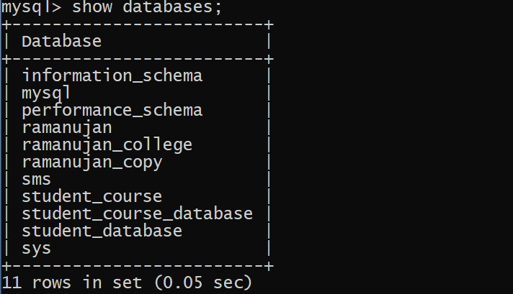









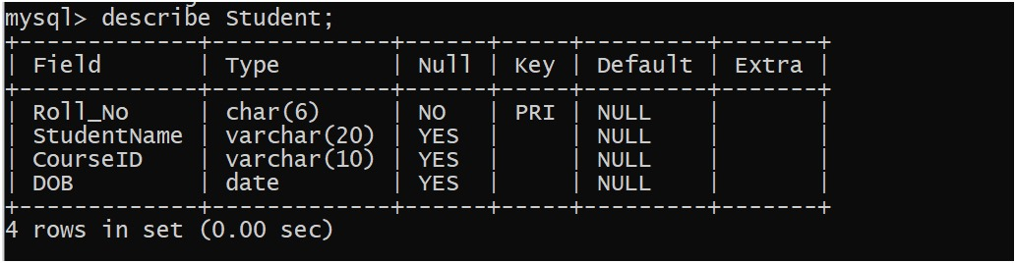





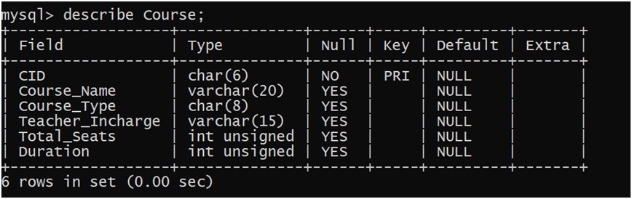



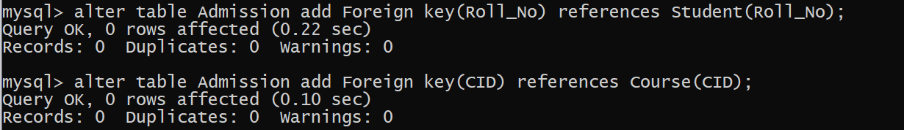

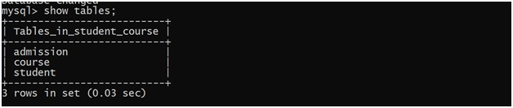

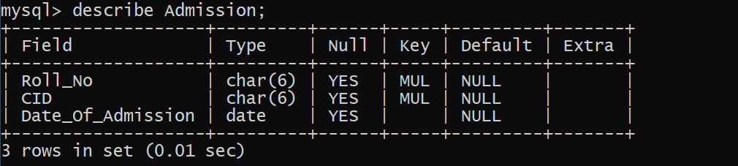

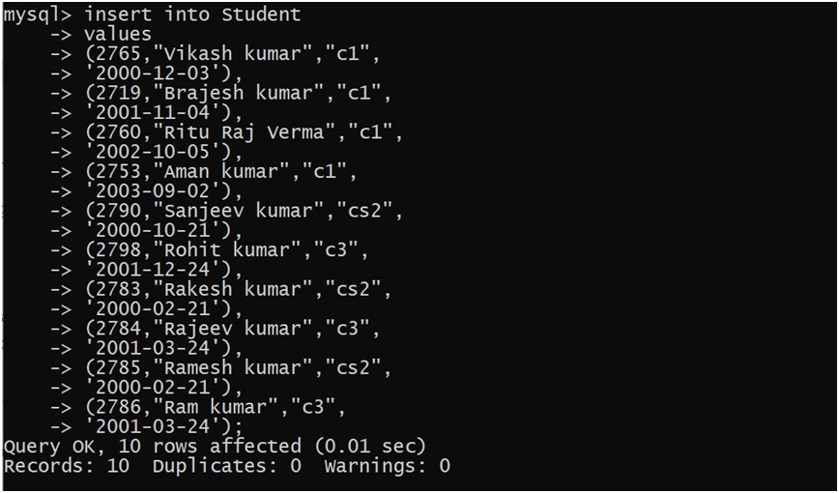

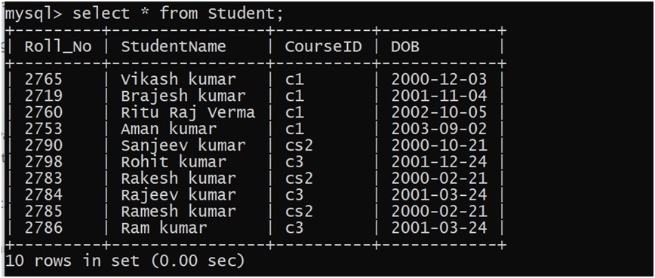

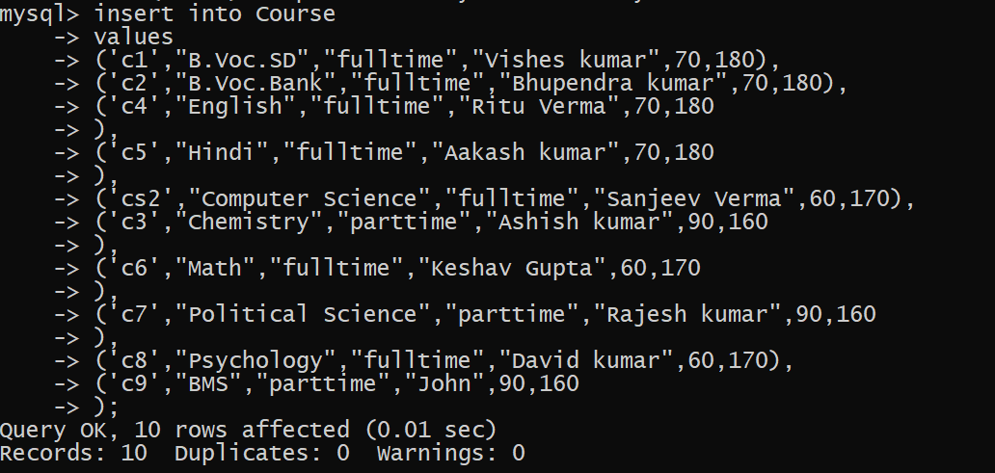

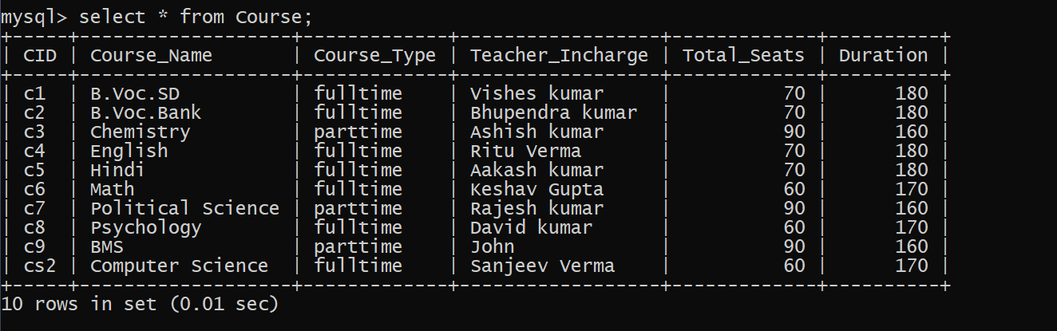

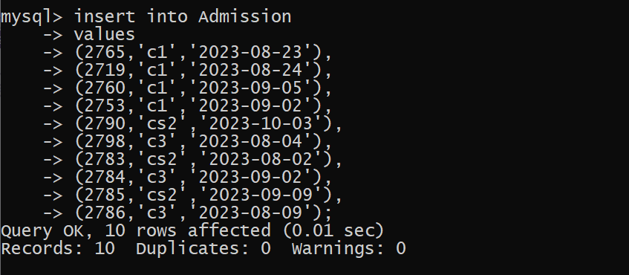

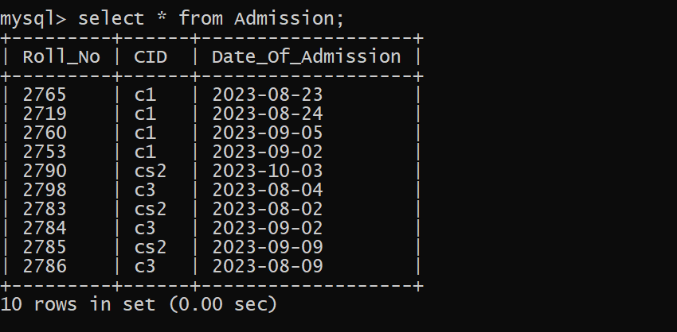

Queries

1.) Retrieve names of students enrolled in any course.

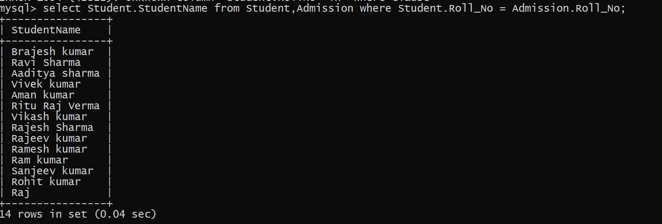

2.) Retrieve names of students enrolled in at least one part time course.

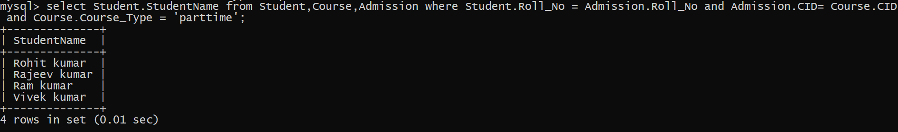

3) Retrieve students' names starting with letter ‘A’.

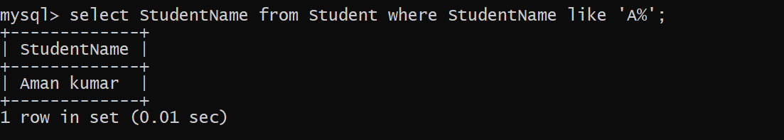

4) Retrieve students' details studying in courses ‘computer science’ or ‘chemistry’.

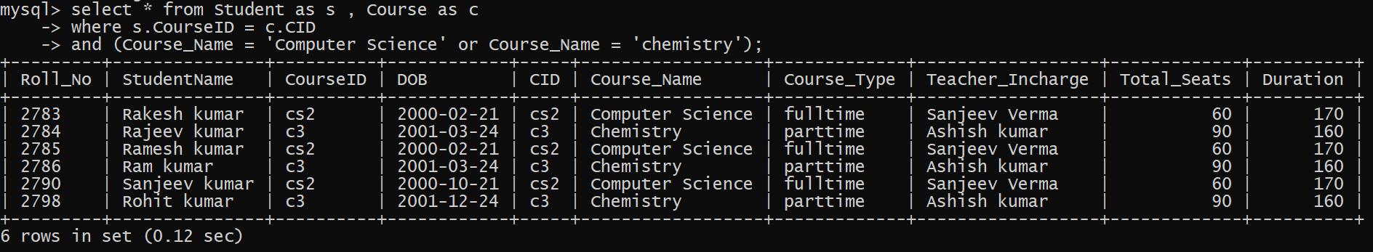

5) Retrieve students’ names whose roll no either starts with ‘X’ or ‘Z’ and ends with ‘9’

Insert one more row in Student table and Admission





Main Query:

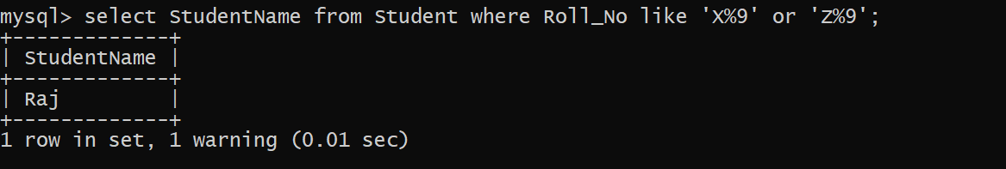

Q 6. Find course details with more than N students enrolled where N is to be input by the user.

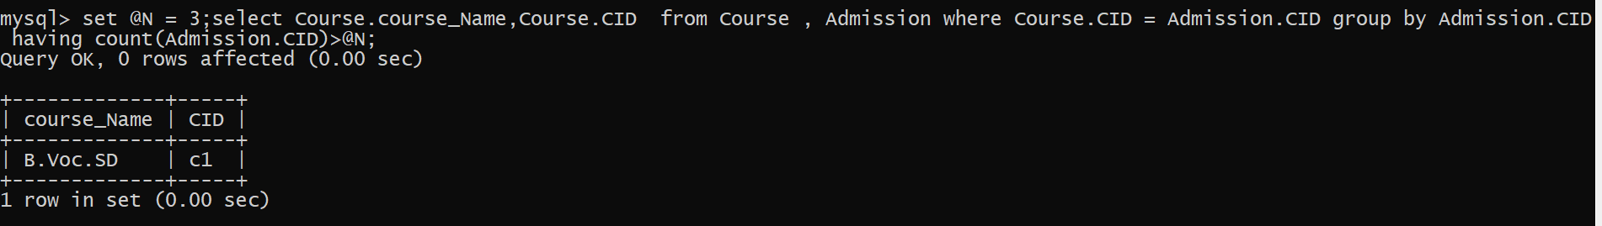

Q 7. Update student table for modifying a student name.

Before Update

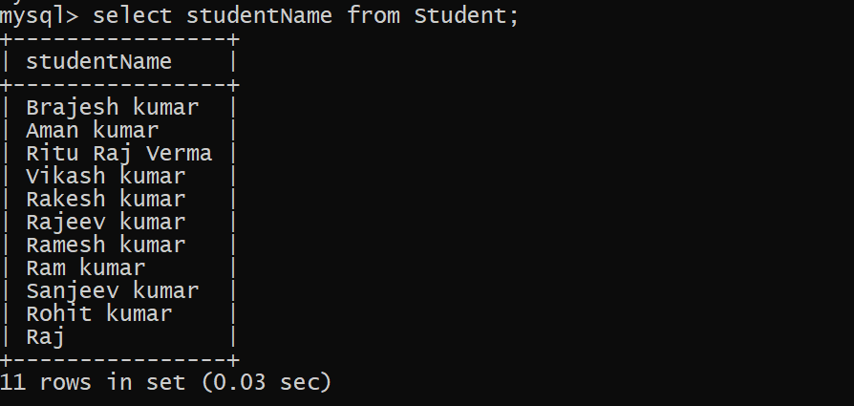

After Main Query :

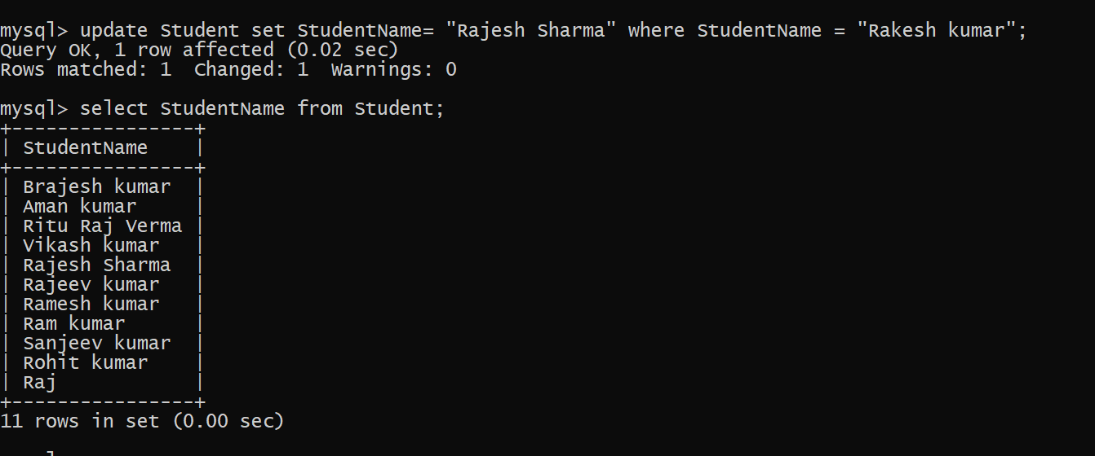

Q 8. Find course names in which more than five students have enrolled

Insert two more rows in student and Admission table.





Main Query :

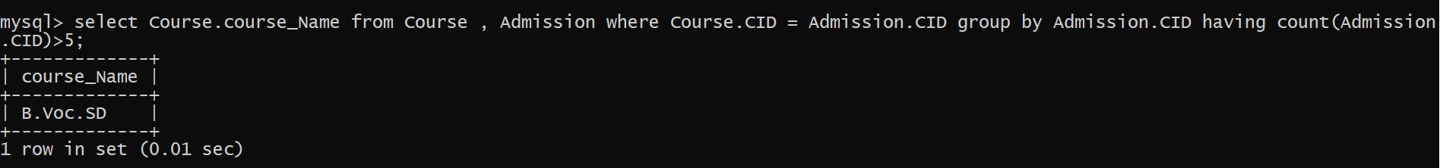

Q 9. Find the name of youngest student enrolled in course ‘BSc(P)CS’

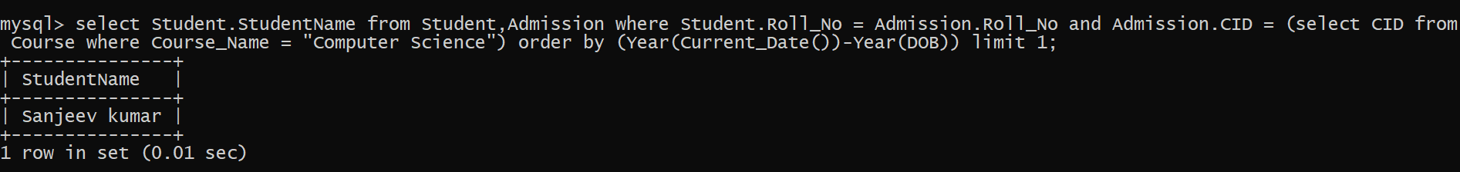

Q 10. Find the name of most popular Course (on the basis of enrolled students)

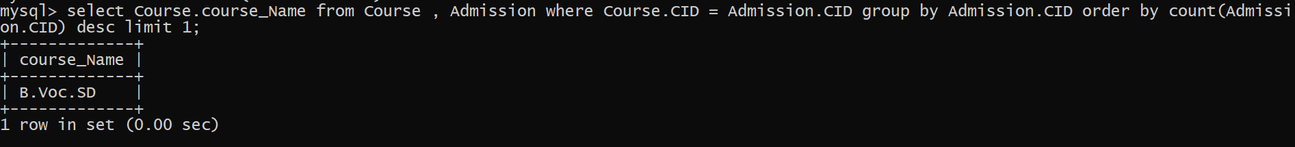

Q 11. Find the name of two popular part time courses (on the basis of enrolled students)

Insert one more rows in student and Admission table.

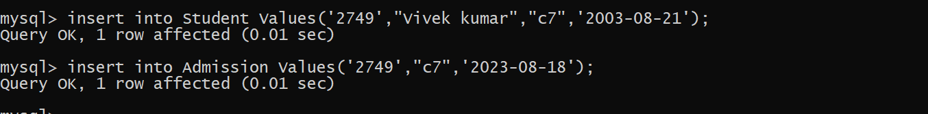

Main Query :

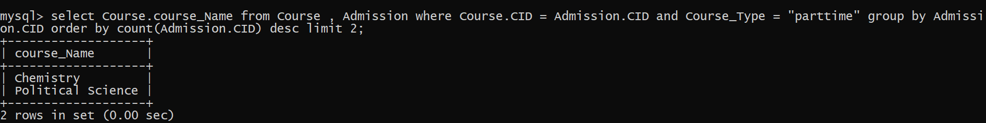

Q 12 . Find the student names who are admitted to full time courses only.

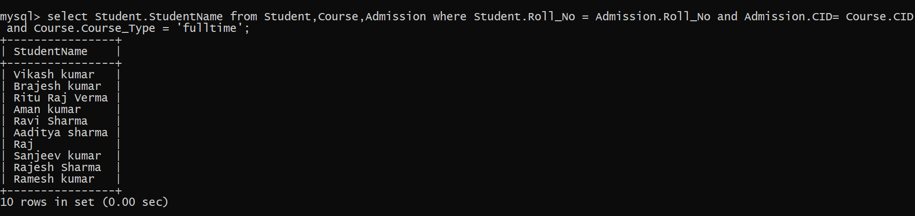

Q 13 . Find course names in which more than 30 students took admission

I have not entered more enteries in student and admission table so in place of 30 , I am assuming 6.

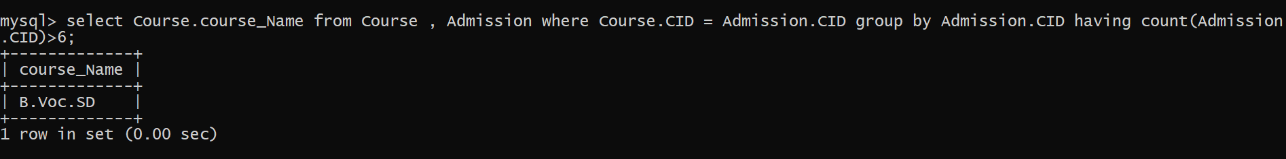

Q 14 . Find names of all students who took admission to any course and course names in which at least one student has enrolled.



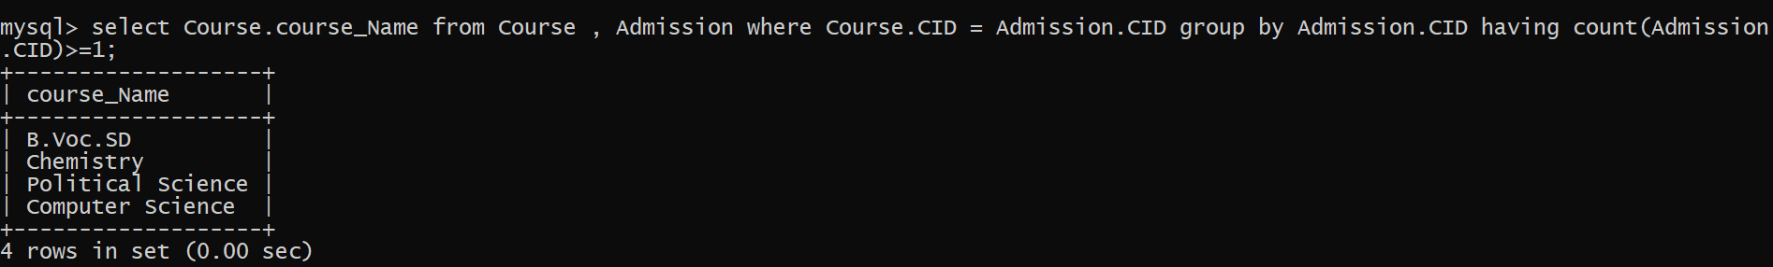

Q 15. Find course names where teacher-in-charge has ‘Gupta’ as surname and the course is full time.

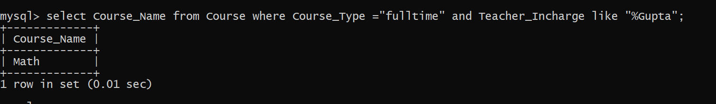

Q 16. Find the course names in which the number of enrolled students is only 10% of its total seats.

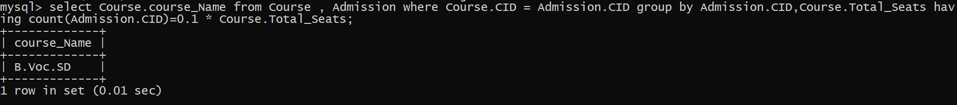

Q 17 . Display the vacant seats for each course .

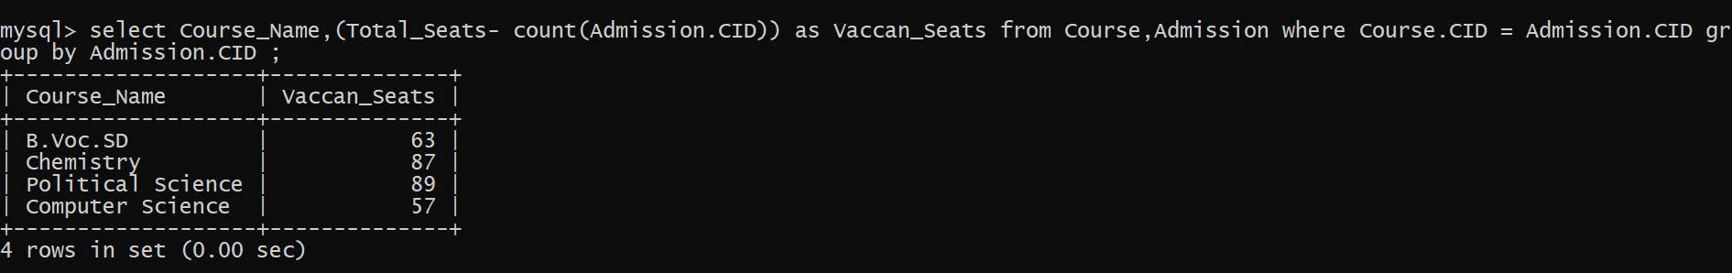

Q 18 . Increment Total Seats of each course by 20%

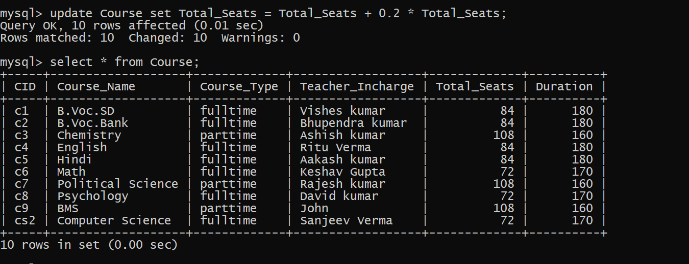

Q 19 . Add Admission fees paid (‘yes’/’No’) field in the Admission table.



After adding new column

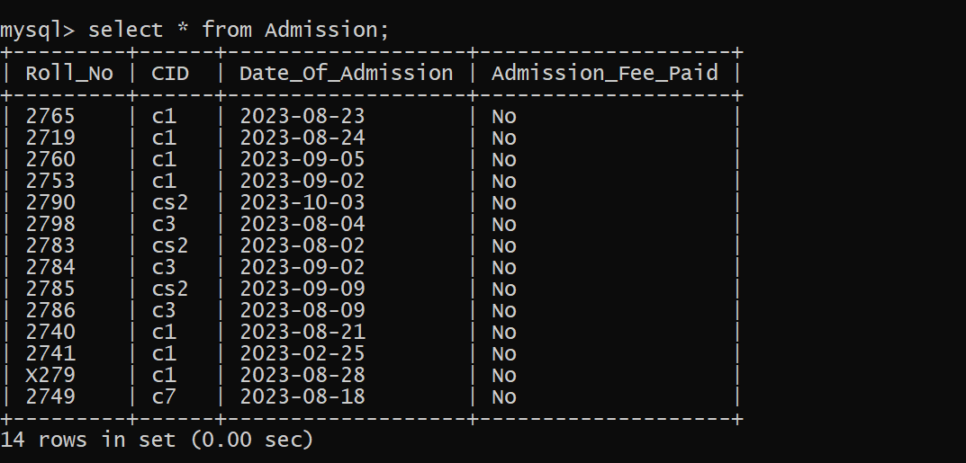

Q 20 . Update the date of admission for all the courses by 1 year.



After update

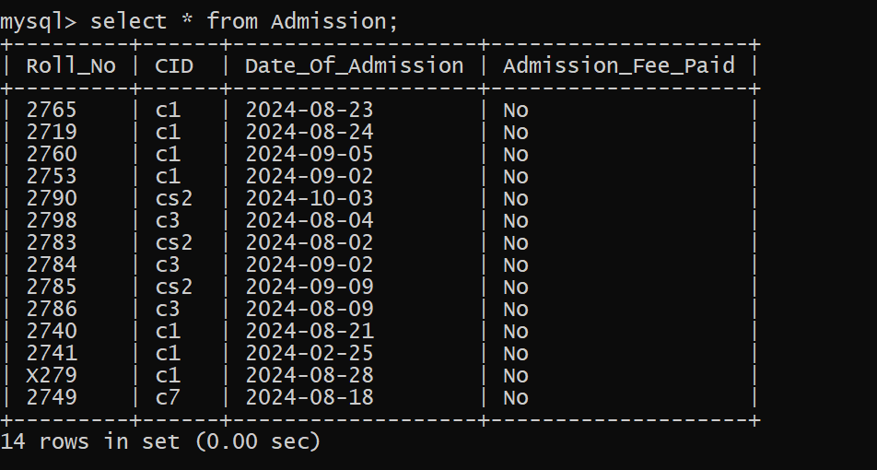

Q 21. Create a view to keep track of course names with total number of students enrolled in it.



After creating view

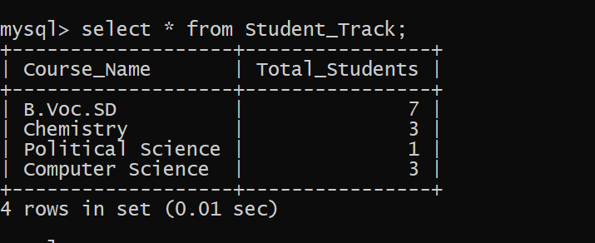

Q 22. Count the number of courses with more than 5 students enrolled for each type of course.

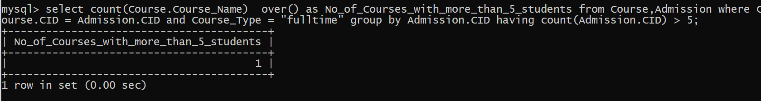



Q 23 . Add column Mobile number in student table with default value ‘9999999999’



After add new column

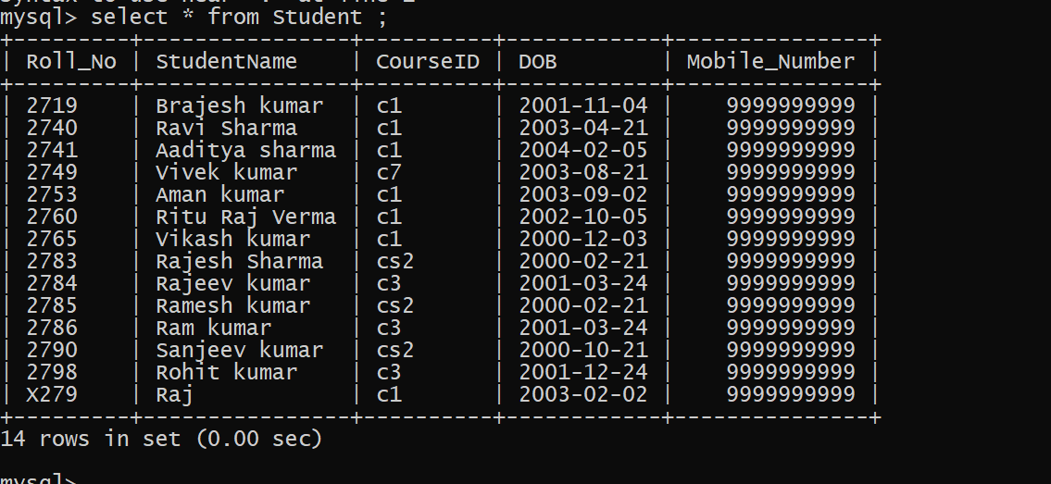

Q 24. Find the total number of students whose age is > 18 years.

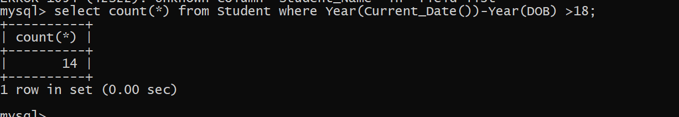

Q 25. Find names of students who are born in 2001 and are admitted to at least one part time course.

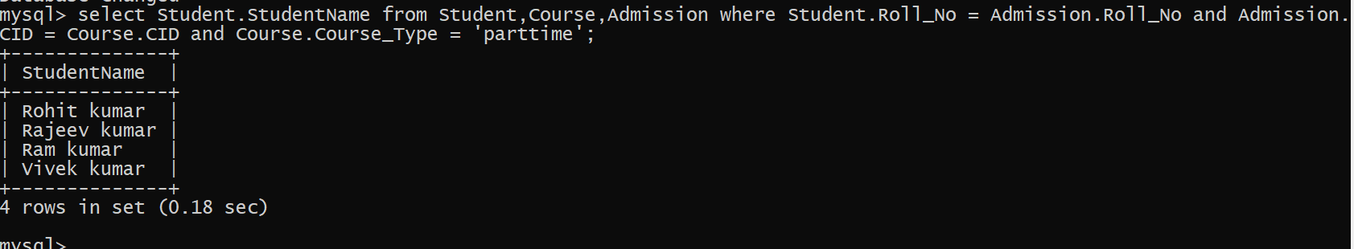

Q 26. Count all courses having ‘science’ in the name and starting with the word ‘B.Sc.’.

Changing the course computer Science to Bsc.Comp Science here.



Main Query :

