Practical 2

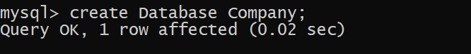





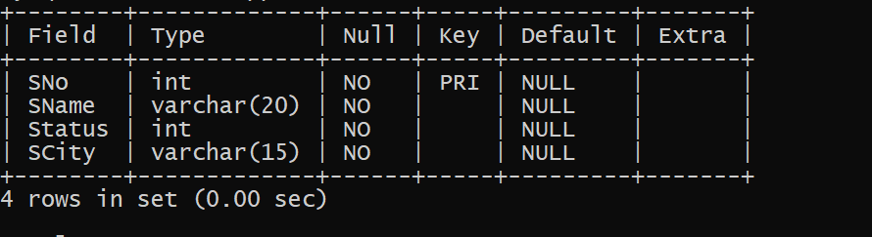



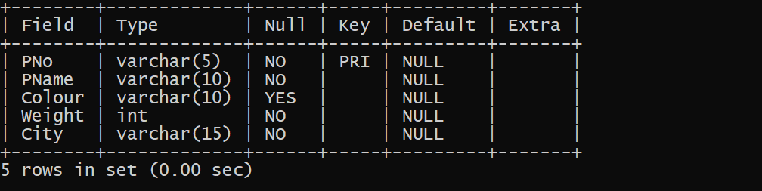

Here we assume weight in Kg.



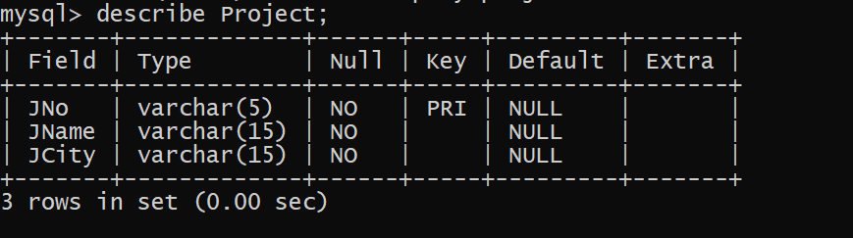





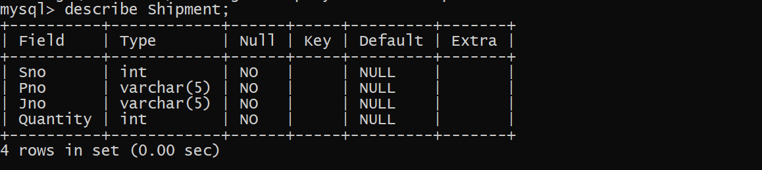



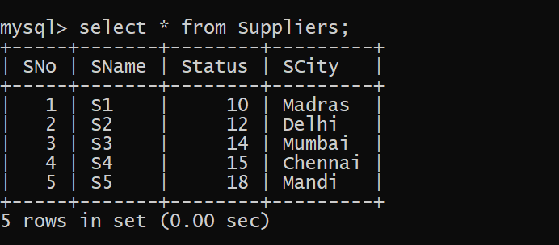



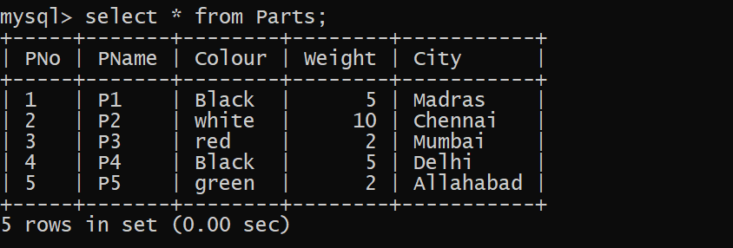



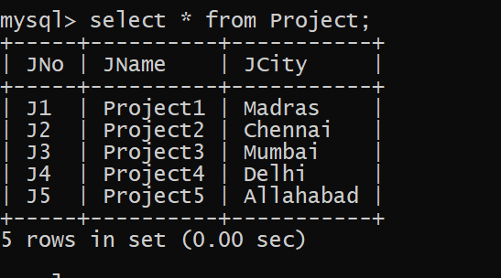



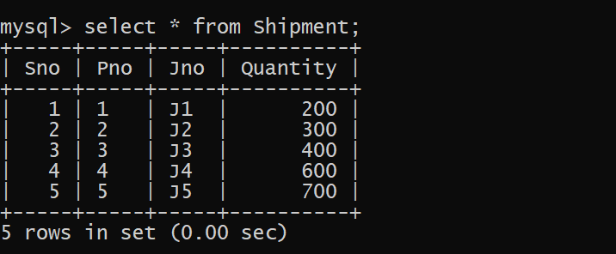

Q 1. Find supplier numbers for suppliers in Mandi with status less than 20.

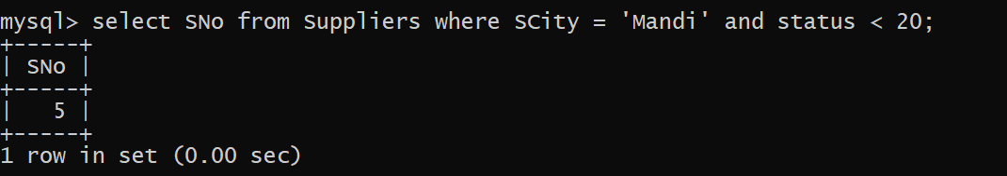

Q 2. Find supplier details for suppliers who supply part P2. Display the supplier list in decreasing order of supplier numbers.

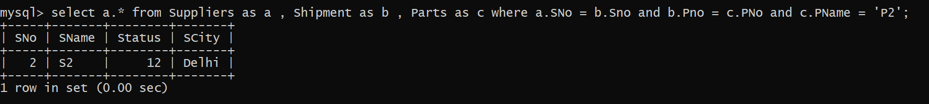

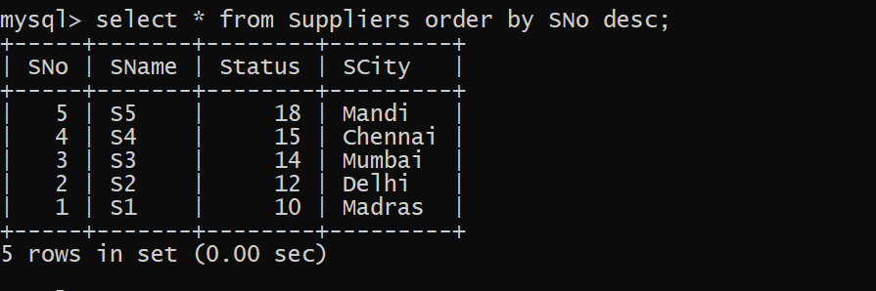

Q 3. Find suppliers names for suppliers who do not supply part P2.

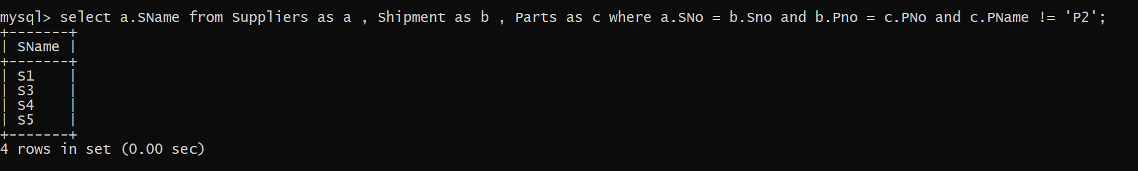

Q 4 . For each shipment get full shipment details, including total shipment weights computed as Weight\*Quantity of corresponding parts.

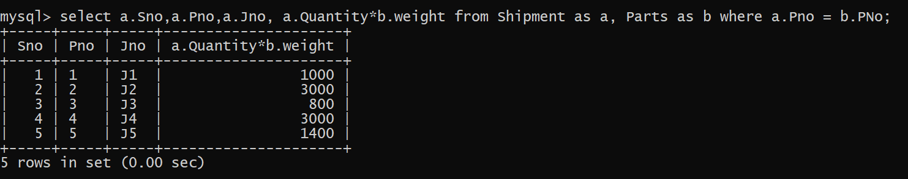

Q 5. Get all the shipments where the quantity is in the range 300 to 750 inclusive.

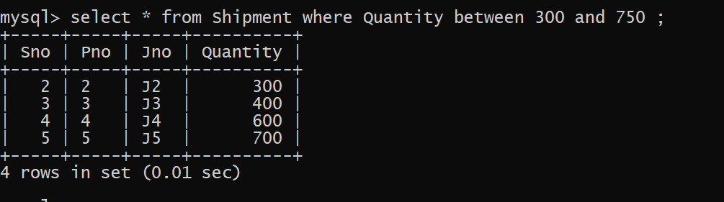

Q 6. Get part numbers for parts that either weigh more than 1Kg or are supplied by suppliers S2 or both.

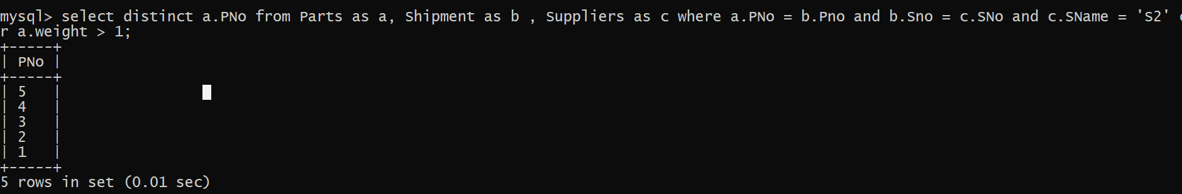

Q 7. Get the names of cities that store more than two red parts. Change the column name in the output to “City-Parts”.

Insert two row into Parts table.



Main Query :

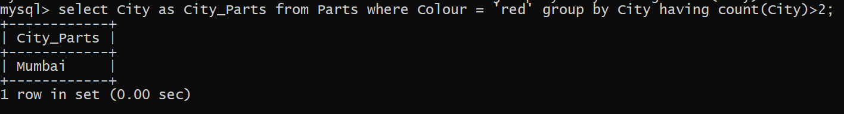

Q 8 . Update the city of supplier S1 to “Delhi”.

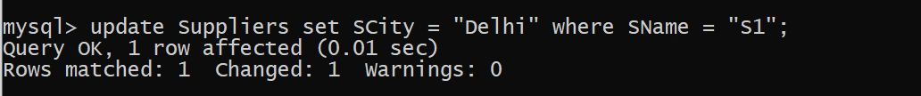

Q 9 . Get part numbers for parts supplied by a supplier in Allahabad to a project in Chennai.

Insert one more row into Suppliers and shipment table.





Main Query

Q 10. Find the names of all parts whose color starts with the letter b.

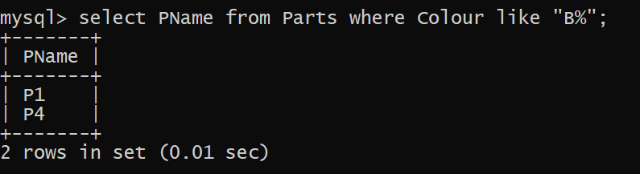

Q 11. Change the datatype of the weight attribute in the Parts table from int to float.

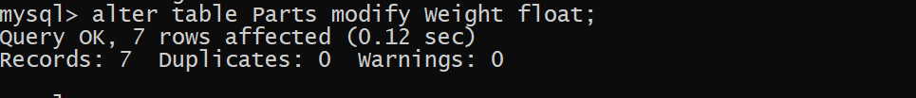

Q 12. Find the number of parts of each color.

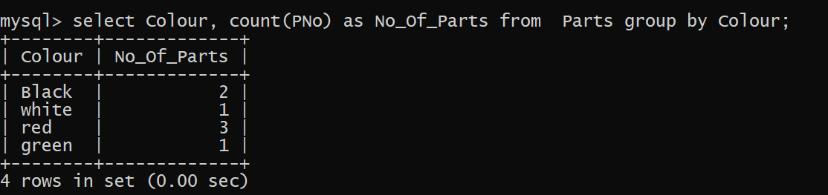

Q 13. Find the names of all the projects which are located in the city Jaipur and in which the part is supplied by supplier S3.

Insert one more row into Project and Shipment table.



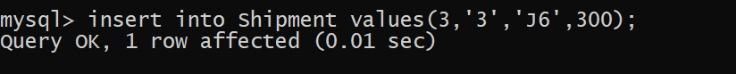

Main Query :

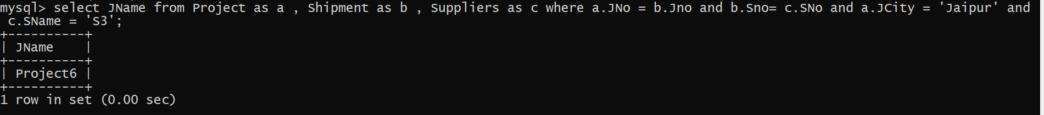

Q 14 . Delete all the projects which are located in Madras.



Q 15. Find all part-details of parts that are shipped to any project carried out in Mumbai.

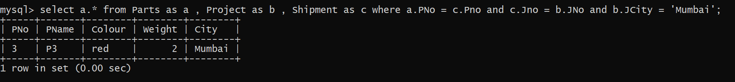

Q 16. Find number of unique projects supplied by supplier S1.

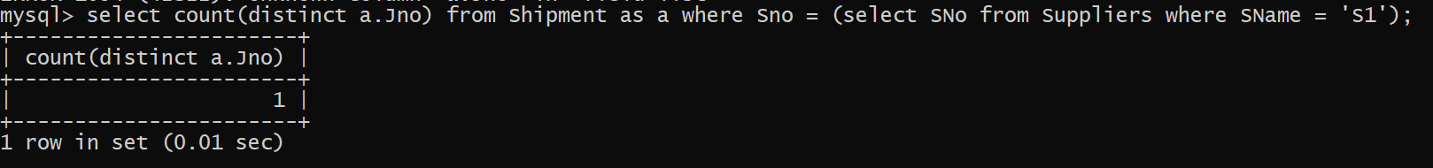

Q 17. Add column SDate in shipment table.

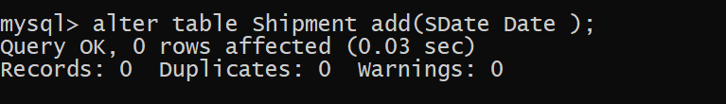

Q 18. For each supplier which supplies parts to a project, find the total no. of parts supplied by the supplier.

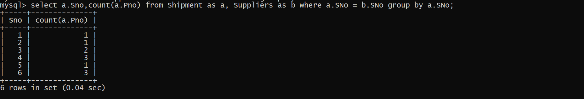

Q 19. Find all supplier name, part name and project name triples such that the indicated supplier, part, and project are all located in the same city. List the name of the city along with the names of suppliers, project and parts.

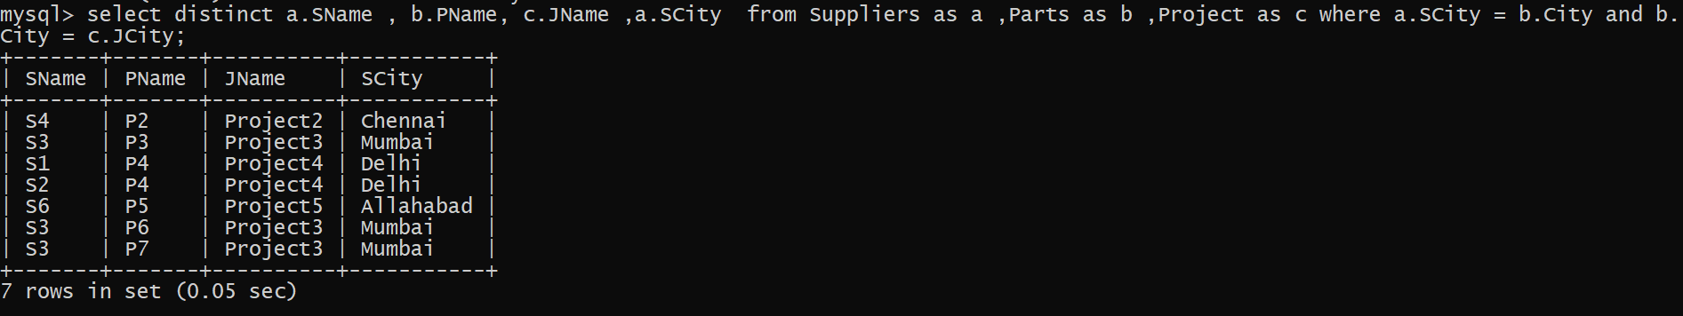

Q 20. Get the names of cities from where more than three yellow parts are supplied.

Insert four rows into Parts and Shipment Table.





Main Query :

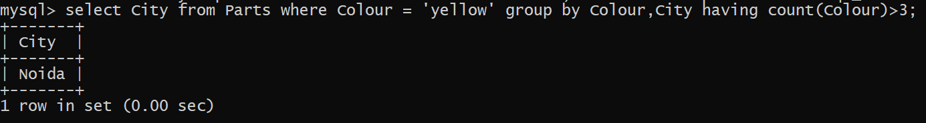

21. Find all distinct cities where either supplier is living or parts are shipped from or projects are carried out. Change the column name in the output to “All-Cities”.

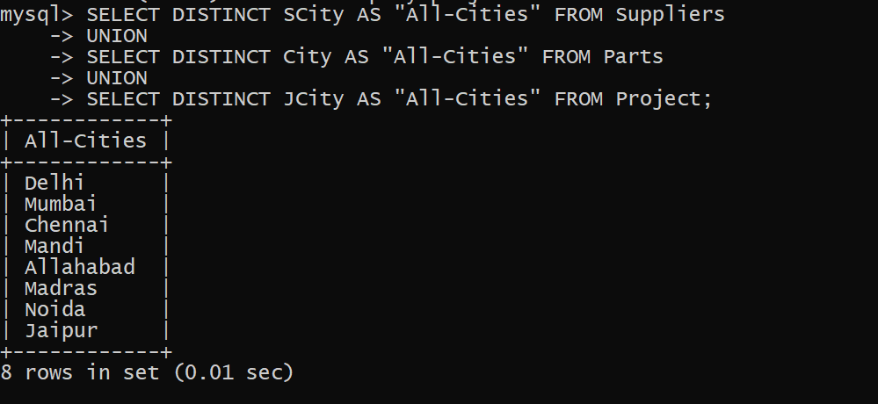

Q 22. Find names of cities such that atleast one supplier is living there and atleast one part is shipped and one project is carried out. Change the column name in the output to “Common-Cities”.

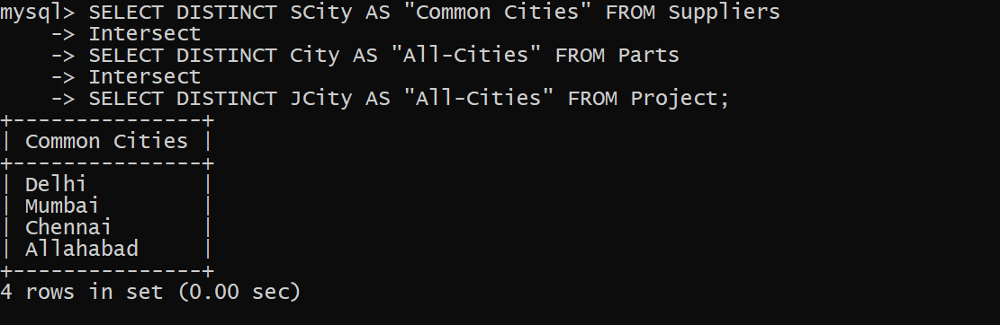

23. Modify data type of any attribute of table shipment.

Before Modify :

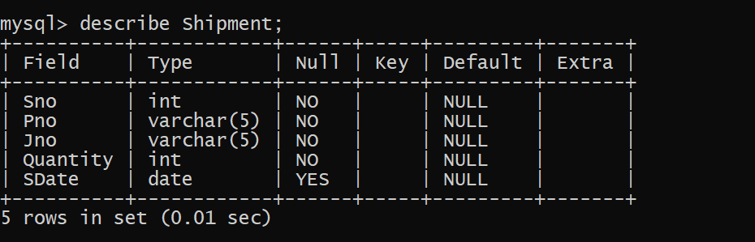

After modify :

