Project Title : Project Management Workspace Hub

Project Overview
In today’s fast-paced and competitive business environment, effective project management is critical for organizations to achieve their goals on time and within scope. With teams increasingly working in distributed and collaborative settings, there is a growing need for centralized digital platforms that streamline planning, coordination, and progress tracking.
WorkspaceHub is a full-stack project management web application designed to help organizations plan, organize, and track projects efficiently. The platform provides a structured workspace where teams can create projects, assign tasks, monitor progress, collaborate in real time, and manage deadlines seamlessly. By centralizing project-related activities, WorkspaceHub enhances transparency, accountability, and overall productivity.
The application focuses on usability, performance, and collaboration, making it suitable for startups, enterprises, project managers, and team members across various domains. WorkspaceHub is developed using modern full-stack technologies including React, Redux Toolkit, Node.js, Express.js, PostgreSQL and Redis ensuring scalability, reliability, and efficient data handling.
With core features such as role-based access, task tracking, status updates, and collaborative workflows, WorkspaceHub reflects real-world project management systems. The platform also demonstrates strong practical knowledge of full-stack development, relational database design, state management, and RESTful API architecture.
WorkspaceHub can be further extended with advanced features such as real-time notifications, analytics dashboards, integrations with third-party tools, and AI-based project insights, highlighting its potential for long-term use and future enhancement.

Project Modules
The system is divided into 4–5 major modules, each performing a crucial role within the application:

1. User Authentication & Authorization Module
This module manages secure user registration, login, and logout functionalities. It implements authentication using JSON Web Tokens (JWT) and supports role-based access control for administrators, project managers, and team members. User credentials are securely stored using encrypted passwords to ensure data protection.
2. Project & Workspace Management Module
This module allows users to create and manage workspaces and projects. Project details such as name, description, timeline, and assigned members can be defined and updated. It serves as the central structure for organizing tasks and team collaboration.

3. Task Assignment & Tracking Module
This module enables project managers to create tasks, assign them to team members, set priorities, and define deadlines. Task statuses such as To Do, In Progress, and Completed help track progress efficiently. Updates are reflected dynamically to keep all users informed.

4. Collaboration & Progress Monitoring Module
This module supports team collaboration by allowing users to comment on tasks, update progress, and view activity logs. It enhances transparency and accountability by providing real-time visibility into project progress and team contributions.

5. Reporting & Deadline Management Module
This module provides an overview of project performance, task completion rates, and upcoming deadlines. It helps teams identify bottlenecks, manage workloads effectively, and ensure timely project delivery.

Technologies Used
WorkspaceHub is built using modern, industry-standard technologies for scalable web application development:

Frontend:
• React.js : for building a dynamic and component-based user interface
• Redux Toolkit : for efficient global state management
• RTK Query : for optimized data fetching and caching
• Tailwind CSS : for responsive and clean UI design

Backend:
• Node.js : server-side runtime environment
• Express.js : backend framework for building RESTful APIs
• JWT based Acesss and Refresh Token : for authentication and secure session handling

Database:
• PostgreSQL : relational database for structured and reliable data storage
• Drizzle(ORM) : for database modeling and query management
• Redis: for caching managment
• Nodemailer: for sending invitation and email

Development & Deployment Tools
• Visual Studio Code
• ThunderClient(API testing)
• Git & GitHub (version control)
• npm (package management)
Deployment Platform:
The application WorkspaceHub is deployed on modern cloud platforms such as Render enabling continuous deployment, environment variable management, scalable hosting, and reliable uptime.

Database Architecture

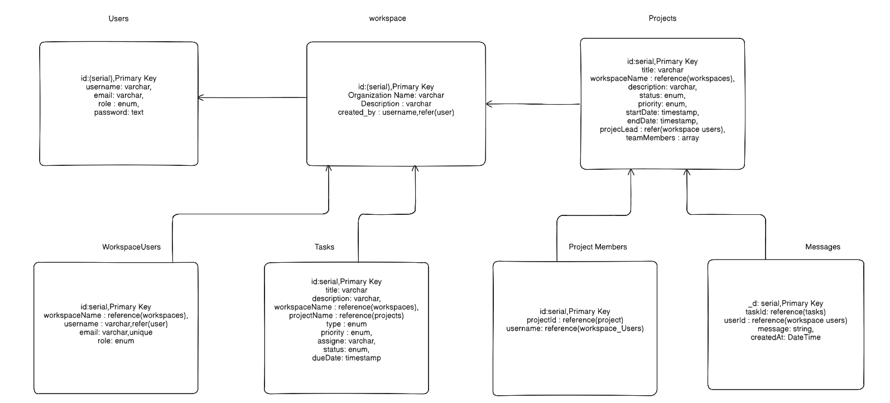

Conclusion
WorkspaceHub demonstrates the development of a practical and efficient project management system using modern full-stack technologies. The application integrates secure authentication, structured project organization, task tracking, and collaborative workflows. This project showcases strong technical expertise in frontend development, backend API design, relational database management, and scalable application architecture.
With potential extensions such as real-time notifications, analytics dashboards, calendar integrations, and AI-driven project insights, WorkspaceHub serves as a strong foundation for enterprise-level project management solutions and future research or development.

References
• Stack Overflow : https://stackoverflow.com
• React : https://react.dev
• Redux Toolkit : https://redux-toolkit.js.org
• Node.js : https://nodejs.org
• PostgreSQL : https://www.postgresql.org

Github Link :

https://github.com/RupeshKumar4511/project-management-workspace-hub

