Self-Pruning Network for CIFAR-10

What I built
I implemented a three-layer MLP for CIFAR-10 where each weight is multiplied by a learnable gate:
effective_weight = weight * sigmoid(gate_scores)
If a gate moves close to zero, that connection is effectively removed. I replaced every fully connected layer with a custom PrunableLinear layer and trained the model with:
total_loss = cross_entropy + lambda * sum(sigmoid(gate_scores))
The goal was not just to get sparsity, but to see how much pruning I could get before accuracy started to fall apart.

Why L1 produces sparsity
The important part is that L1 keeps applying pressure even when a gate is already small. That matters because once a connection becomes weak, the optimizer still has a reason to keep shrinking it toward zero. L2 behaves differently: its gradient gets smaller near zero, so it tends to leave a lot of tiny values instead of creating genuinely sparse structure. For this problem, L1 is the better fit because I want gates to die, not just become small.
Concretely, if I write the positive gate value as g = sigmoid(score), the L1 term contributes sign(g), which is +1 for any positive value regardless of magnitude. L2’s gradient is 2g, so it shrinks toward zero as g does. L1 keeps pushing with the same constant force all the way down. That is why L1 produces genuine zeros while L2 mostly produces very small values.

Experimental setup
- Dataset: CIFAR-10
- Input representation: flattened 32 x 32 x 3 image
- Architecture: 3072 -> 512 -> 256 -> 10
- Optimizer: Adam
- Epochs: 20
- Batch size: 128
- Sparsity threshold: a gate is counted as pruned if sigmoid(gate_score) < 1e-2
- Lambda schedule: 5 warmup epochs, then 10 ramp-up epochs, then constant target lambda
- Sweep: 0.0, 1e-4, 1e-3, 1e-2

Results
Lambda | Peak test acc (%) | Final test acc (%) | Final sparsity (%) | Layer sparsity (fc1/fc2/fc3) | Notes
0.0 | 55.47 | 53.59 | 0.00 | 0.00 / 0.00 / 0.00 | Useful baseline, but it overfit after the mid-point of training
1e-4 | 57.25 | 55.67 | 31.70 | 33.53 / 10.21 / 6.91 | Best peak accuracy and a clean regularization effect
1e-3 | 57.09 | 55.80 | 93.31 | 96.17 / 60.66 / 11.48 | Best trade-off: almost baseline-plus accuracy with very high sparsity
1e-2 | 55.86 | 42.52 | 99.90 | 100.00 / 99.57 / 52.97 | Too aggressive, accuracy collapses once pruning fully kicks in

What I found
The first thing that stood out was that mild pruning actually helped. The baseline model with lambda=0 peaked at 55.47% test accuracy and then drifted down to 53.59% by the end, which looks like straightforward overfitting. With lambda=1e-4, the model reached 57.25% peak test accuracy and still finished at 55.67%, so a small amount of sparsity pressure worked like useful regularization.
The more striking result came from lambda=1e-3: it ended at 55.80% final test accuracy while pruning 93.31% of the gates. That is only slightly below the best peak accuracy in the whole sweep, but with a dramatic reduction in active connections. If I had to defend one configuration as the best overall trade-off, I would pick lambda=1e-3.
The lambda=1e-2 run shows the other end of the spectrum. It reached 99.90% sparsity, but final accuracy dropped to 42.52%. That run is still useful because it confirms the mechanism is working. The model really can delete almost everything, but the classification task becomes too under-parameterized once pruning becomes that aggressive.

Layer-wise observation
The pruning pattern was not uniform across the network. fc1 pruned much more aggressively than fc3 in every nonzero-lambda run:
- lambda=1e-4: fc1=33.53%, fc2=10.21%, fc3=6.91%
- lambda=1e-3: fc1=96.17%, fc2=60.66%, fc3=11.48%
- lambda=1e-2: fc1=100.00%, fc2=99.57%, fc3=52.97%
I think this makes sense. The first layer has a huge number of input-to-hidden connections and therefore more redundancy. The final classifier layer is much smaller and closer to the actual class decision, so it stays denser for longer.

Why the annealing schedule helped
I did not apply the full sparsity penalty from epoch 1. The model trained for five warmup epochs with zero pruning pressure, then lambda increased gradually over the next ten epochs.
That decision mattered. In the lambda=1e-3 run, sparsity stayed near zero through the ramp, and then jumped sharply late in training:
- Epoch 10: 57.09% test accuracy, 0.00% sparsity
- Epoch 15: 55.63% test accuracy, 1.95% sparsity
- Epoch 16: 55.83% test accuracy, 56.57% sparsity
- Epoch 20: 55.80% test accuracy, 93.31% sparsity
This was exactly the behavior I wanted. The network first learned a workable representation, and only then started deleting connections aggressively. If I had used the target lambda from the start, the model would likely have pruned too early and lost accuracy much sooner.
The gate histogram for lambda=1e-3 shows the expected bimodal pattern: a large spike near zero from pruned connections and a smaller cluster of surviving gates spread across higher values.

Figures

Gate distribution for the strongest trade-off run (lambda=1e-3)
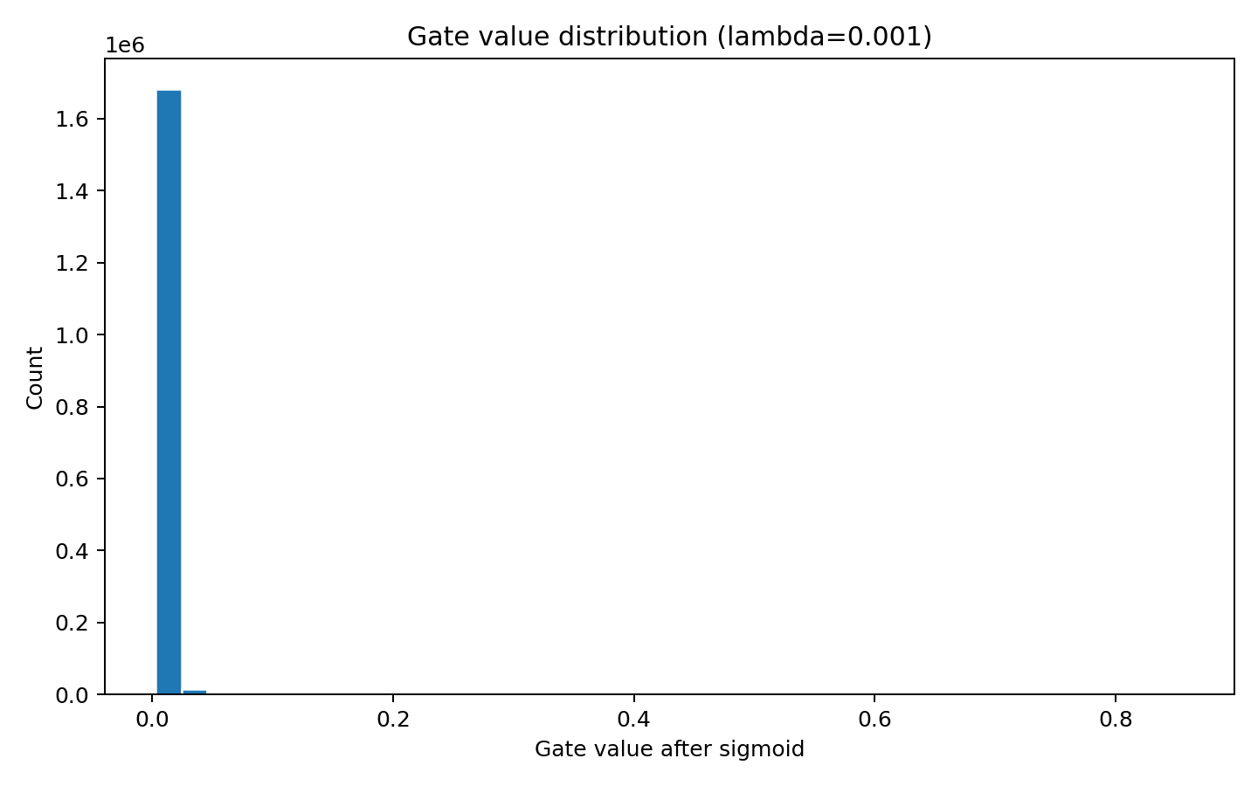
Gate histogram

Accuracy and sparsity over time for lambda=1e-3
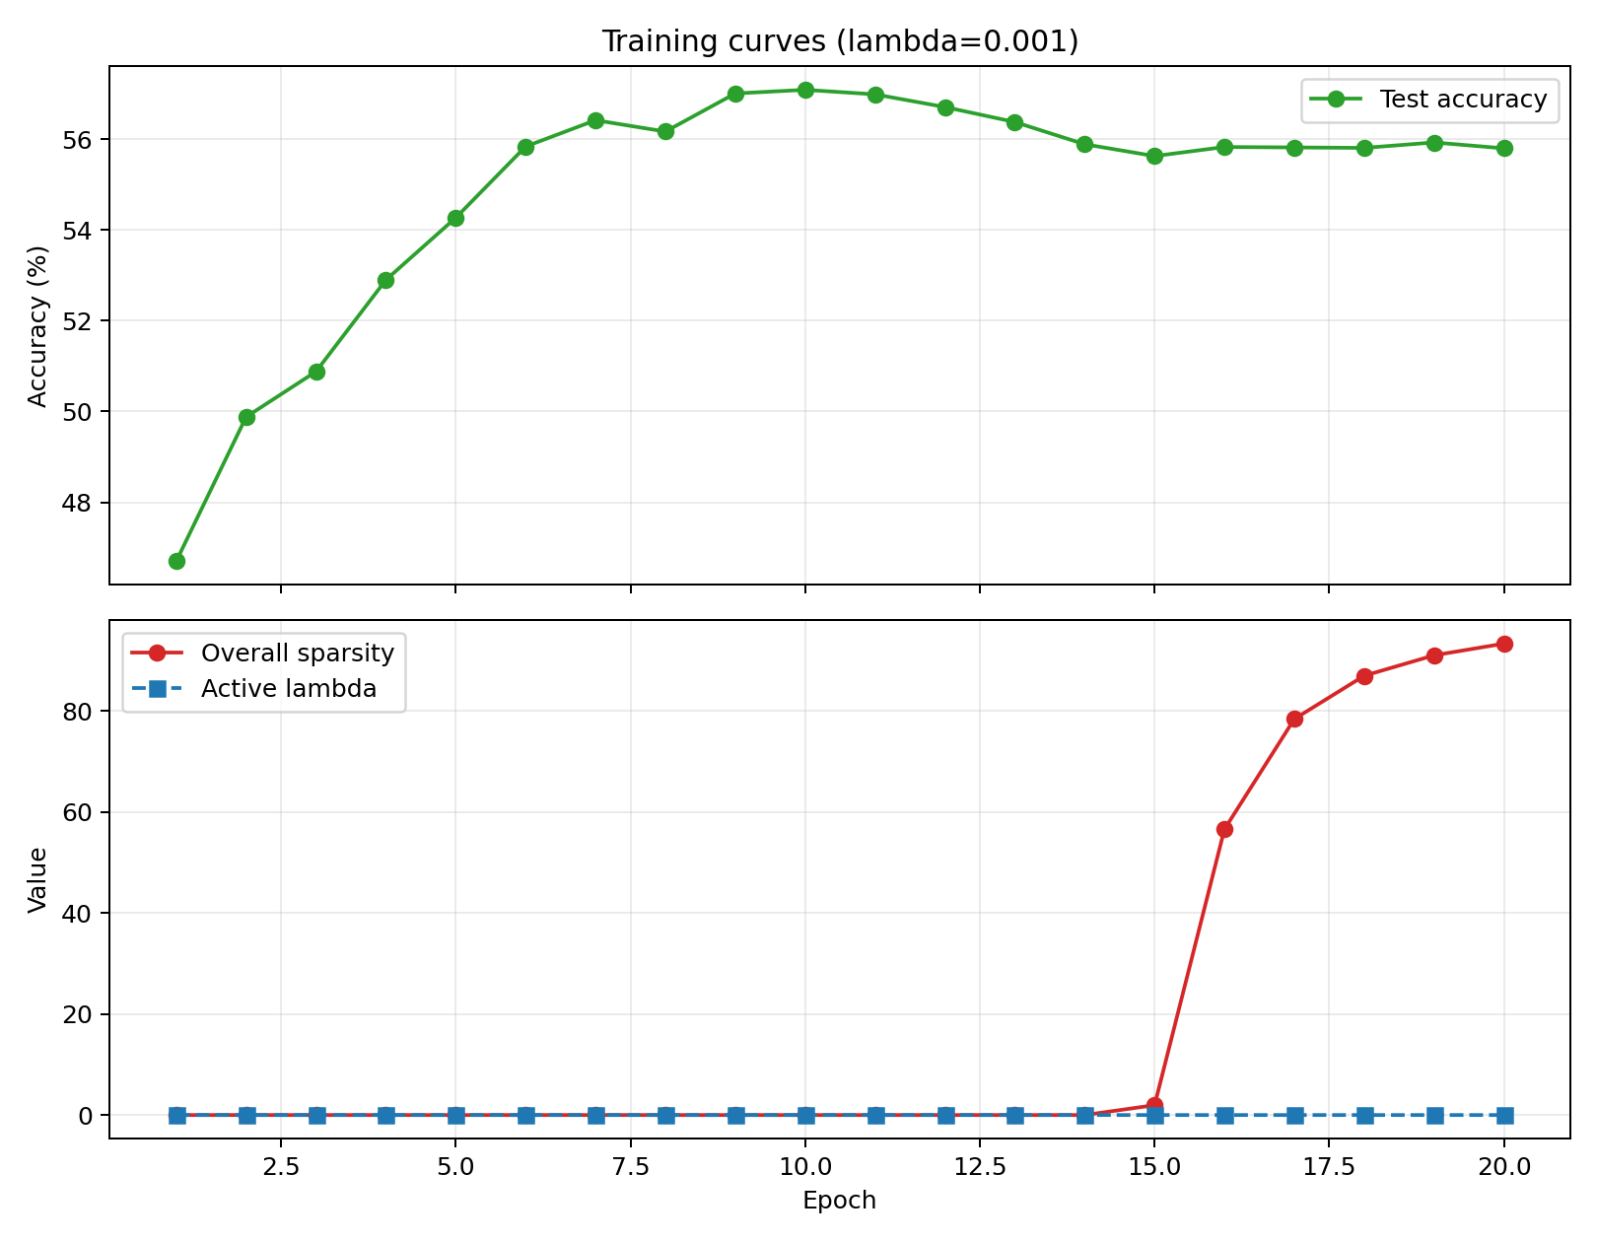
Training curves

Layer-wise sparsity across the full lambda sweep
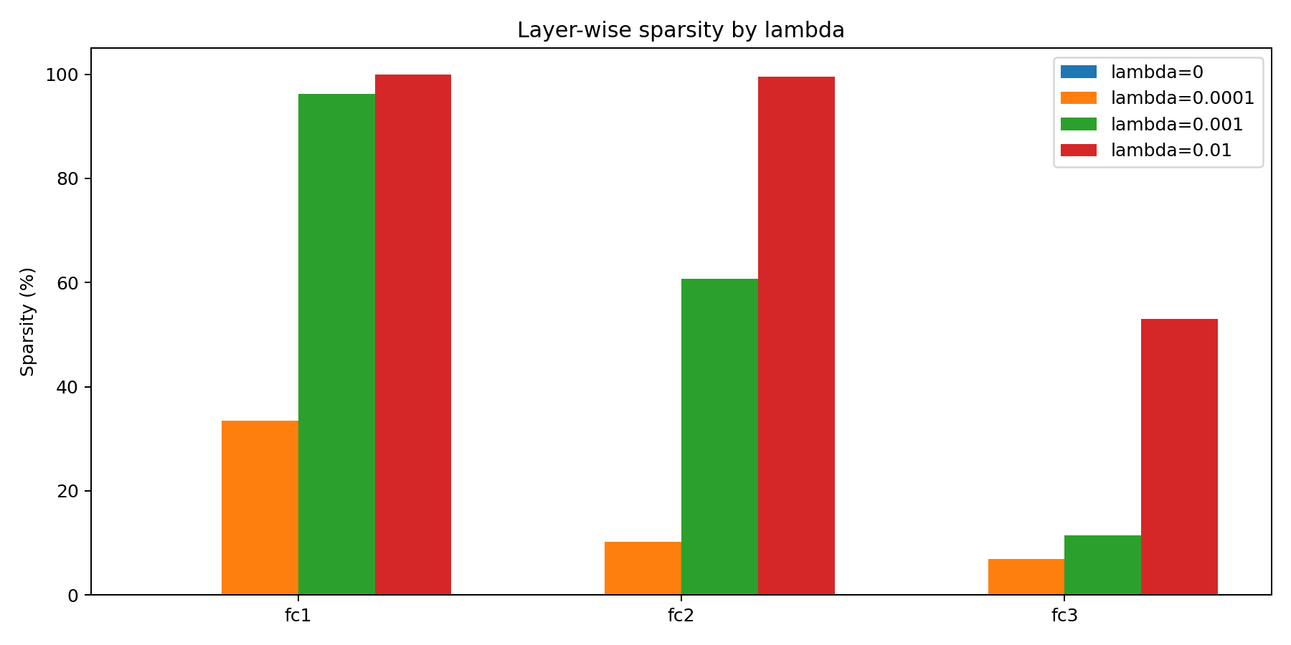
Layer-wise sparsity

One honest limitation
This model is an MLP on flattened CIFAR-10 images, so the absolute accuracy ceiling is limited from the start. A convolutional model would almost certainly perform better on the task itself. I stayed with the MLP because the assignment is really about learning gates, sparsity, and the accuracy-pruning trade-off, but it is still a real limitation of the setup.

Follow-up ResNet baseline
After finishing the sweep, I trained a ResNet18 baseline on the same CIFAR-10 pipeline to answer one question: was 55% accuracy a problem with the training stack, or just the MLP architecture?
It reached:
- 95.04% best test accuracy
- 94.91% final test accuracy
- best epoch: 89
- hardware: NVIDIA GeForce RTX 3050 Ti Laptop GPU
- batch size: 256
- epochs completed: 100
That made the MLP limitation concrete. The pruning mechanism was working fine. The ceiling was the architecture choice, not a bug.

ResNet training curves
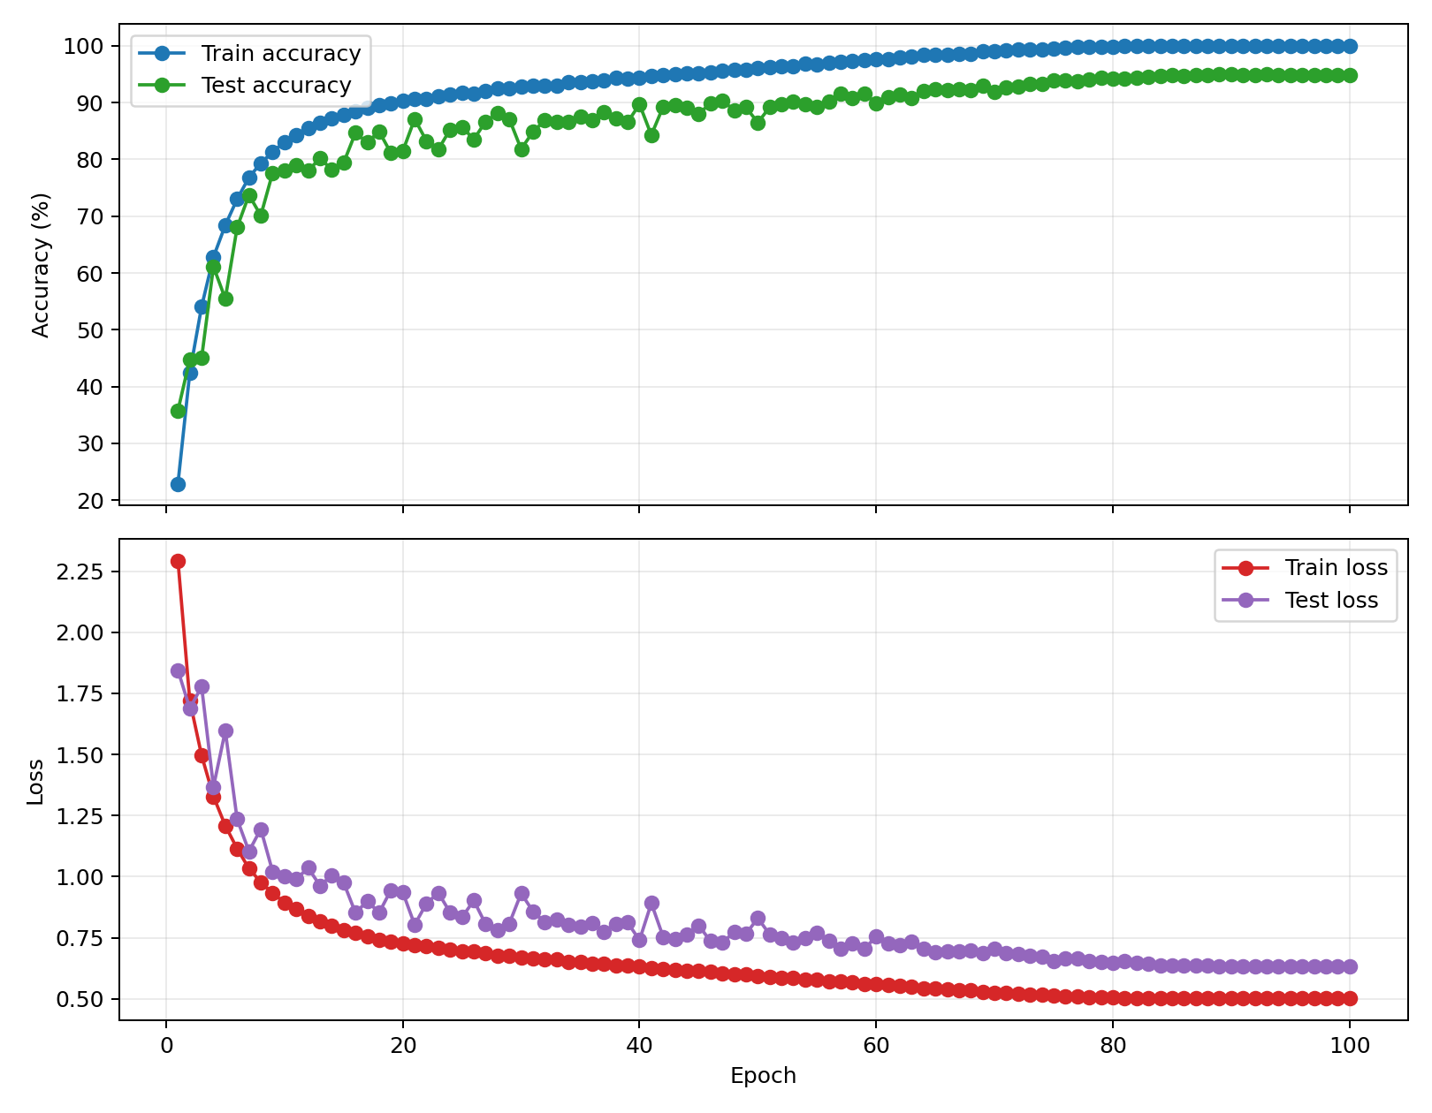
ResNet training curves

Final takeaway
Self-pruning worked best as controlled regularization rather than a hard constraint. The jump from epoch 15 to epoch 16 in the lambda=1e-3 run, where sparsity went from 1.95% to 56.57% in one epoch, was the clearest evidence that the annealing schedule was doing real work.
If I were extending this, I would look at structured pruning next, removing entire neurons rather than individual weights. That would actually reduce inference compute, which soft sigmoid gates do not do by themselves.

