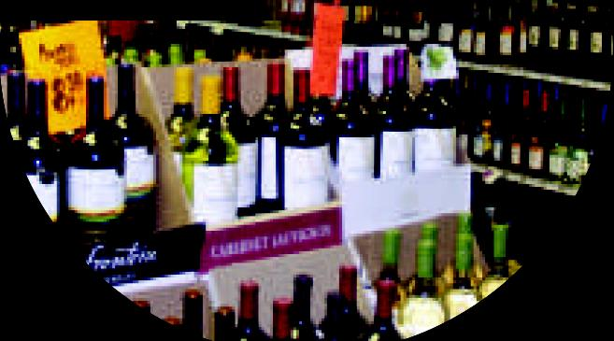**Wines &** Liquors

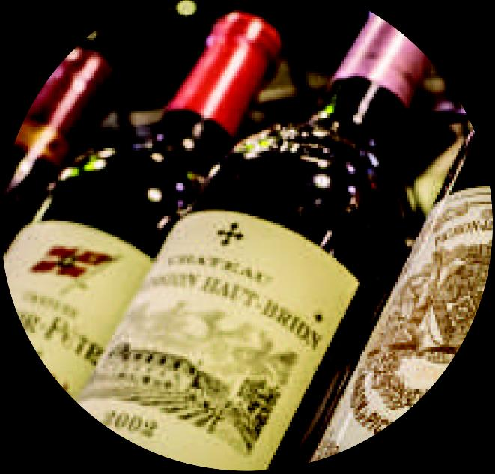

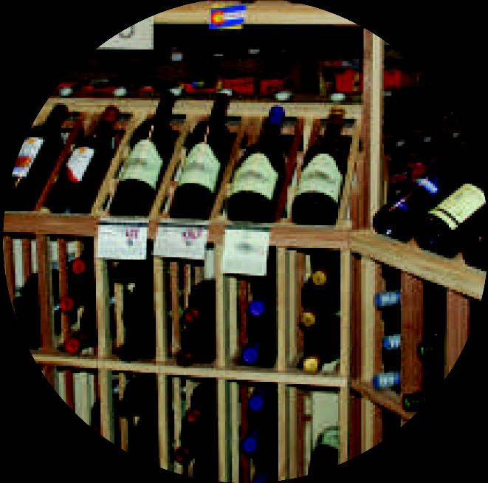

**-..1111111111.-**

**• r - •**

**Immo.**

**I**

-

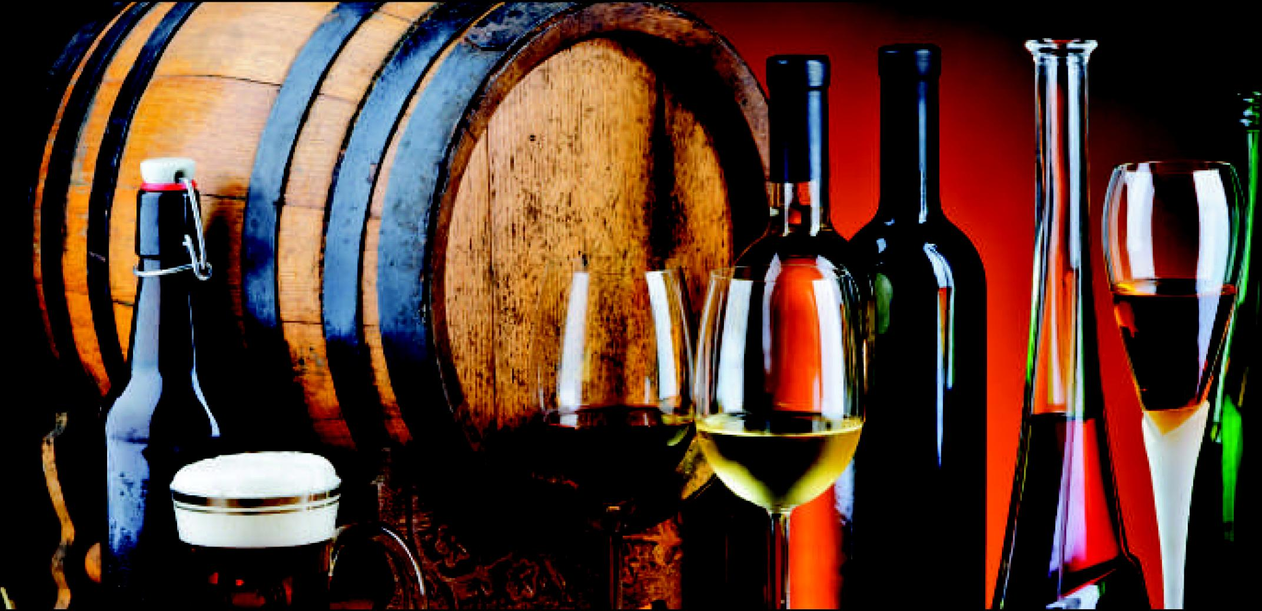

**14.**

**A**

griosa is Canada's Largest Privately Owned Wine Exporter, Bridging The Gap Between Suppliers Of Premium Canadian Wines And Overseas Buyers And Investors. Showcasing Canada's Exceptional Wine Talents, We Represents A Diverse Portfolio

Of Award Winning VQA Wines That Have Consistently Garnered Phenomenal National And International Reviews. Our Company Works Closely With Wineries To Effectively Expand And Strengthen Their Presence Within International Markets While Simultaneously Developing Sales Channels And Investment Opportunities For Foreign Investors Interested In Importing Exceptional Canadian Wines And Wine Products.