nder the leadership of **Mr. K.Bains** (Chairman) our team Mr. Joseph Csaba, Ms. Susan Skemp & Mr. Jerrald Jones collectively has international trade experience and accord careful personal attention for every shipment. We have exceptional procedures in place to facilitate efficient movement of all kinds of product to the end user. Our team can directly take care of your specific requirements and all necessary export documentation. Our business credo is total honesty and full transparency in everything we handle.

**Team**



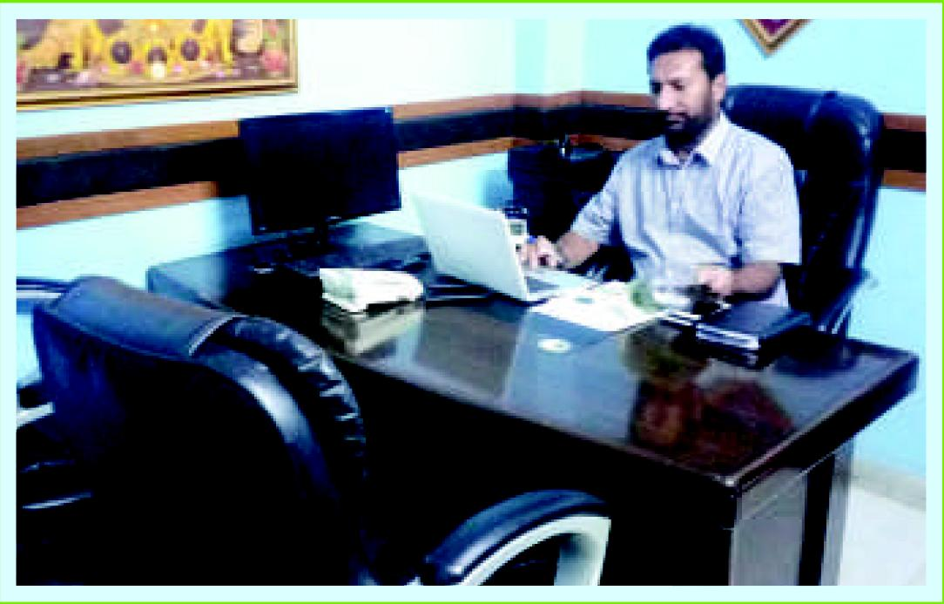

|  |  |  |
| --- | --- | --- |
|  | **• -..Values** |  |

**A**

griosa provides a Honest, Transparent and Clean culture at its work premises. We handle our brands ,employees ,customers , consumers,vendors ,suppliers ,communities with utmost care and affection.

|  |  |
| --- | --- |
|  | **Vision** |

|  |  |
| --- | --- |
| 0 ur Vision is to create Customer delight by helping our valuable customers around the world to eat healthier & live healthier. Our vision is about meeting consumers'  needs and making food an easier choice that is healthier & more enjoyable part of life. Our Vision lets everyone well informed right from our employees to customers, Consumers and communities wherever we manufacture and sell our products and what we care about. It not only captures the essence of wellness and health but it also embodies all the ways we can eat and live better such as the safety and value of the products and the services and the solutions we offer. |  |

**Mission**

**Our**



t Agriosa with thorough research we ensure Superior quality & Product Safety &Value
  
for money to our customers at international and Domestic Markets .Our Mission is to
  
stand by our commitment and provide on long term sustainability on the best of

Quality and product Safety and Value for Money to our Customers that protects the trust of

our customers in the Agriosa Brand.