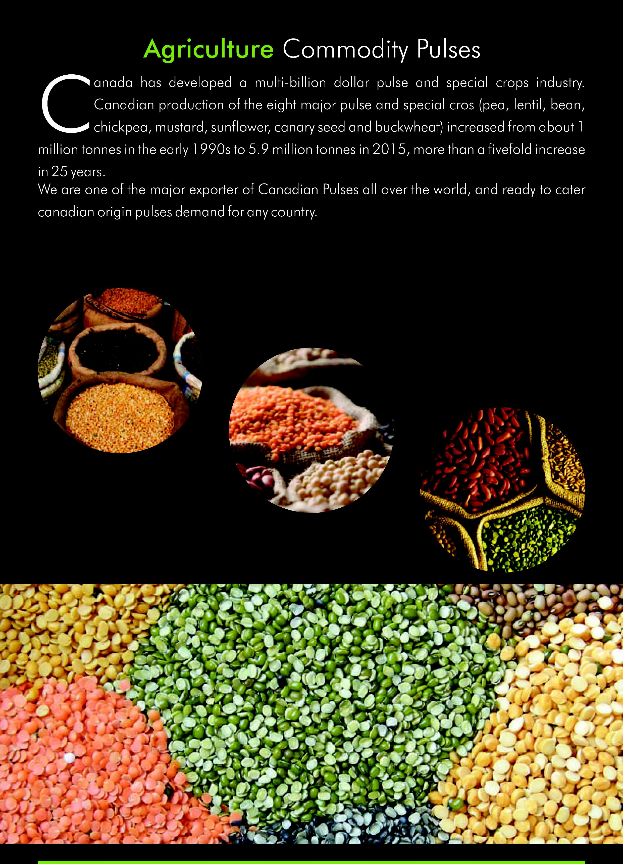

**''::41rdlri--'‘e Alik A**

i

***4*A 11, *j***

**t_r**

**a 4; 411,11r**

***14.***

**w_.**

**Agriculture** Commodity Pulses

Canada has developed a multi-billion dollar pulse and special crops industry. Canadian production of the eight major pulse and special cros (pea, lentil, bean, chickpea, mustard, sunflower, canary seed and buckwheat) increased from about 1 million tonnes in the early 1990s to 5.9 million tonnes in 2015, more than a fivefold increase

in 25 years.

We are one of the major exporter of Canadian Pulses all over the world, and ready to cater

canadian origin pulses demand for any country.