**umen & Energy products**

**A**

griosa is Canada's one o the facilitator of bitumen, through their associates at Canada, Singapore, Malaysia & Iran. The following are our Strength in this Industry: Crude Oil, Dried Distillers Grain with Solubles, Gasoline, Ethanol, Lubricants, Natural Gas Liquids (NGLs), Petroleum Coke, Sulphur.

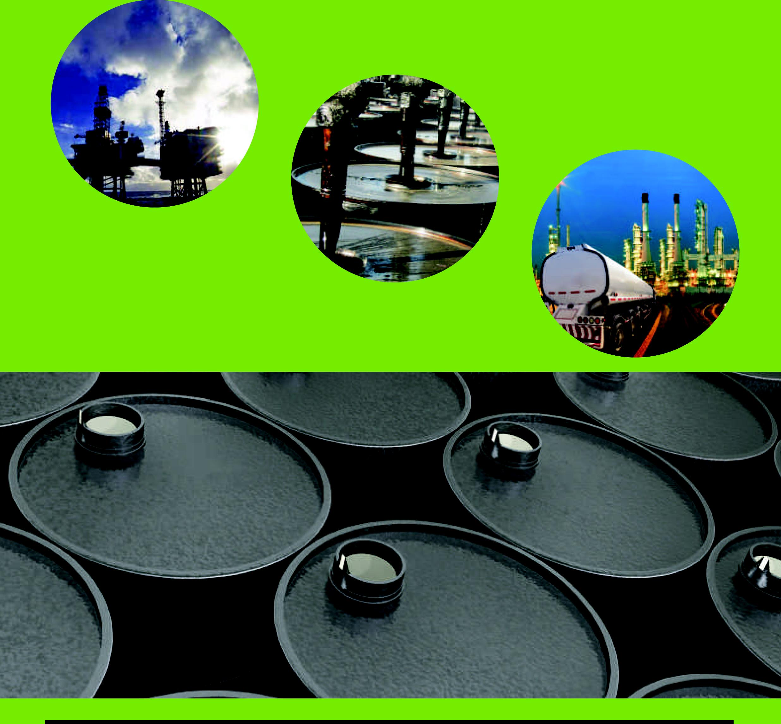

on'