🌍 Global Debt Analysis Project Report
The Global Debt Analysis Project is a professional Data Analytics project created using Python, Excel, Jupyter Notebook, and Power BI. The project focuses on analyzing debt data of different countries from 1995 to 2020 and generating useful insights through data visualization.

1. Project Overview
This project analyzes global debt patterns and financial trends across countries. The analysis helps identify high-risk countries, top debt contributors, and yearly debt growth.
The project combines data cleaning, transformation, analysis, and visualization to convert raw data into meaningful business insights.

2. Dataset Details
Total Rows: 266
Total Columns: 27

Column Names
1. Countary Name
2. 1995
3. 1996
4. 1997
5. 1998
6. 1999
7. 2000
8. 2001
9. 2002
10. 2003
11. 2004
12. 2005
13. 2006
14. 2007
15. 2008
16. 2009
17. 2010
18. 2011
19. 2012
20. 2013
21. 2014
22. 2015
23. 2016
24. 2017
25. 2018
26. 2019
27. 2020

3. Technologies Used
Technology | Purpose
Python | Data Cleaning and Analysis
Pandas | Data Manipulation
Matplotlib | Charts and Visualization
Excel | Dataset Storage
Jupyter Notebook | Interactive Analysis
Power BI | Dashboard Creation

4. Project Files Explanation

4.1 Excel File
The Excel file stores the raw dataset containing country-wise debt data.

4.2 Python File (.py)
The Python script performs data cleaning, transformation, chart generation, trend analysis, and high-risk country detection.
Main Python Libraries Used:
import pandas as pd
import matplotlib.pyplot as plt

4.3 Jupyter Notebook (.ipynb)
The Jupyter Notebook is used for interactive coding, visualization, and testing analysis step-by-step.

4.4 Power BI Dashboard (.pbix)
Power BI is used to create professional dashboards and visual reports.

4.5 Checkpoint File
Checkpoint files are automatic backup files created by Jupyter Notebook to prevent data loss.

5. Difference Between Python and Jupyter Notebook
Python (.py) | Jupyter Notebook (.ipynb)
Runs complete script | Runs code cell-by-cell
Used for automation | Used for analysis
Console output | Interactive output
Best for software development | Best for visualization

6. Analysis Performed
Data Cleaning – Removed missing values and corrected formats.
Data Transformation – Converted wide format into long format using df.melt().
Top Countries Analysis – Identified countries with highest debt.
Debt Trend Analysis – Studied debt growth over years.
High Risk Countries – Identified countries with extremely high debt values.

7. Charts and Visualizations

Python Code Screenshot
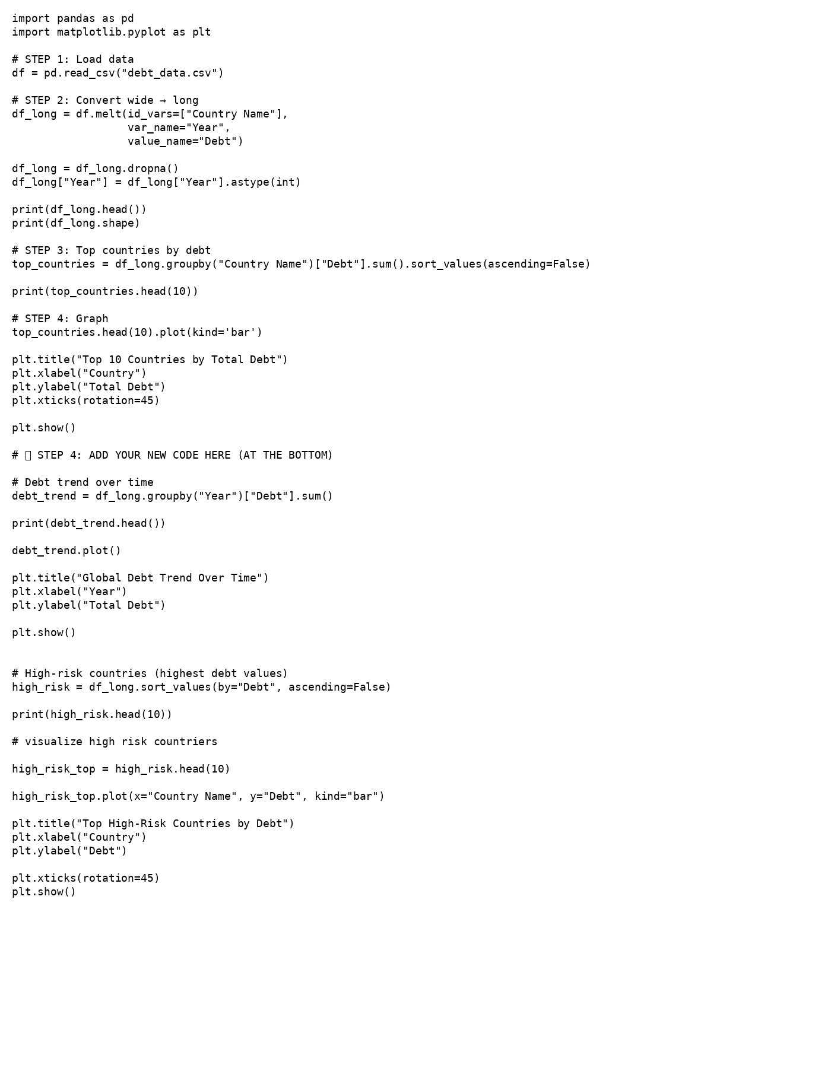

Debt Trend Chart
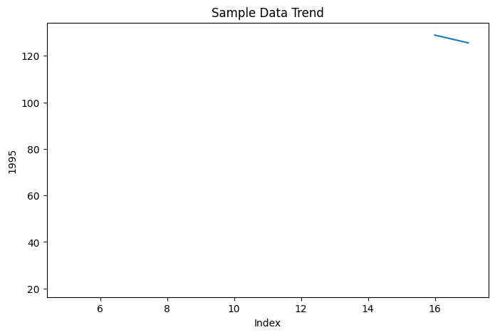

Country Comparison Chart
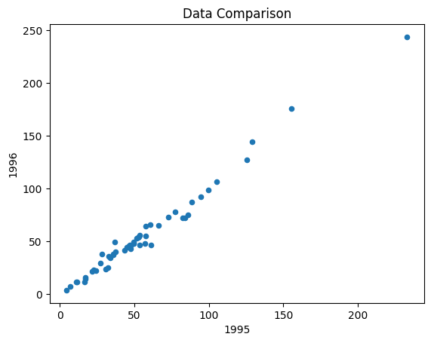

8. Conclusion
The Global Debt Analysis Project successfully demonstrates the use of Python, Power BI, Excel, and Jupyter Notebook for financial data analysis. The project provides valuable insights into global debt conditions, country-wise trends, and high-risk financial indicators.

9. Author
Rupesh Kumar

10. License
MIT License

