Customer Sales Analysis Project Report
Prepared By: Rupesh Kumar

1. Introduction
The Customer Sales Analysis project was developed to analyze customer purchasing behavior, product sales performance, discounts, subscriptions, and customer segmentation. This project uses SQL, Python, Excel, Jupyter Notebook, and Power BI to generate meaningful business insights from customer shopping data.

2. Dataset Information
The dataset used in this project was collected from Kaggle. It is a Customer Shopping Trends dataset containing customer transaction information.
Dataset Information | Details
Dataset Source | Kaggle
Dataset Name | Customer Shopping Trends Dataset
Total Rows | 3900
Total Columns | 18
File Format | .xlsx / CSV
Column Names in Dataset:
- Customer ID
- Age
- Gender
- Item Purchased
- Category
- Purchase Amount (USD)
- Location
- Size
- Color
- Season
- Review Rating
- Subscription Status
- Shipping Type
- Discount Applied
- Promo Code Used
- Previous Purchases
- Payment Method
- Frequency of Purchases

3. Technologies Used
Technology | Purpose
MySQL | Database querying and data analysis
Python | Data preprocessing and visualization
Pandas | Data manipulation
Matplotlib | Data visualization
Excel | Dataset management
Jupyter Notebook | Python execution environment
Power BI | Interactive dashboard creation

4. SQL Analysis
SQL queries were used to perform customer sales analysis, revenue comparison, product analysis, customer segmentation, and subscription analysis.

Revenue by Gender
select gender,SUM(purchase_amount ) as revenue
from customer
group by gender;

Customers Using Discounts but Spending Above Average
select customer_id,purchase_amount
from customer
where discount_applied='Yes'
and purchase_amount >= (
select AVG(purchase_amount)
from customer
);

Top 5 Products with Highest Average Rating
select item_purchased,
avg(review_rating) as Average_Rating
from customer
group by item_purchased
order by avg(review_rating) desc
limit 5;

Average Purchase Amount by Shipping Type
select shipping_type,
round(avg(purchase_amount),2) as avg_purchase
from customer
where shipping_type in ('standard','express')
group by shipping_type;

Subscription Revenue Analysis
select subscription_status ,
count(customer_id) as total_customer,
round(avg(purchase_amount),2) as avg_spend,
round(sum(purchase_amount),2) as total_revenue
from customer
group by subscription_status;

Customer Segmentation
with customer_type as(
select customer_id ,previous_purchases,
case
when previous_purchases= 1 then 'new'
when previous_purchases between 2 and 10 then 'returning'
else 'loyal'
end as customer_segment
from customer
)
select customer_segment,count(*) as number_of_customer
from customer_type
group by customer_segment;

5. Python Analysis Using Jupyter Notebook
Python was used in Jupyter Notebook for data preprocessing, exploratory data analysis (EDA), and visualization. Pandas and Matplotlib libraries were used to analyze customer sales data.
# Import Libraries
import pandas as pd
import numpy as np
import matplotlib.pyplot as plt
# Load Dataset
df = pd.read_csv('customer_sales.csv')
# Display First Five Rows
print(df.head())
# Dataset Information
print(df.info())
# Check Missing Values
print(df.isnull().sum())
# Revenue by Gender
gender_revenue = df.groupby('Gender')['Purchase Amount (USD)'].sum()
print(gender_revenue)
# Top Rated Products
top_products = df.groupby('Item Purchased')['Review Rating'].mean().sort_values(ascending=False).head(5)
print(top_products)
# Visualization
gender_revenue.plot(kind='bar')
plt.title('Revenue by Gender')
plt.xlabel('Gender')
plt.ylabel('Revenue')
plt.show()

6. Power BI Dashboard
Power BI was used to create interactive dashboards and reports. The dashboard contains revenue analysis, customer segmentation, top products, discount analysis, and subscription insights.
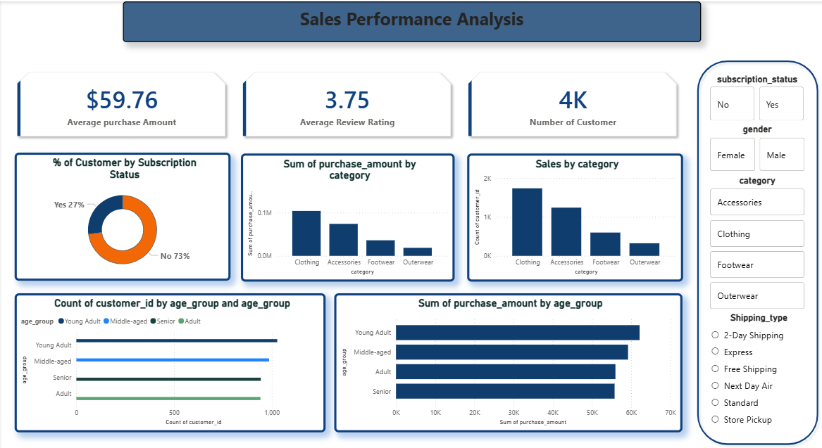

7. Key Insights
- Subscribed customers generated more revenue compared to non-subscribed customers.
- Discount campaigns increased customer purchases.
- Loyal customers contributed significantly to business revenue.
- Top-rated products had higher repeat purchases.
- Shipping type affected average purchase amount.

8. Conclusion
This project demonstrates how SQL, Python, Jupyter Notebook, Excel, and Power BI can be integrated to analyze customer shopping behavior and generate meaningful business insights. The project improves analytical skills and demonstrates practical implementation of data analysis techniques.

9. Future Improvements
- Implement machine learning models for sales prediction
- Create recommendation systems
- Develop real-time dashboards
- Deploy the project online

