Concept: Gallium transitions from solid to liquid at around 30C which is very close to ambient air temperature. Gallium also expands around 3% by volume during the transition from liquid to sold and can produce pressures in range of 145,000 psi (verification needed). As the melting point of gallium is close to ambient temperature, the amount of energy required to phase change gallium from solid to liquid is fairly small. Using the ambient air to then cool the gallium back into a solid producing work. Unfortunately, gallium reacts with aluminum and causes embrittlement destroying the mechanical structure of an aluminum container, thus making gallium difficult to work with. If it's possible to harness the volumetric expansion in a meaningful way, such a device could make use of the abundant cool air as a fuel source for power generation.

This experiment is intended to test the capabilities of harnessing the volumetric phase change of gallium.

Materials:

- Gallium – 50 grams
- 6mm diameter x 50mm 304 stainless steel dowel pin
- 8mm O.D. 304 stainless tube with 6mm I.D.
- 304 stainless steel compression fitting for 8mm tube to ½ inch NPT female pipe fitting
- 304 stainless steel ½ inch mail NPT plug
- Pipe thread tape

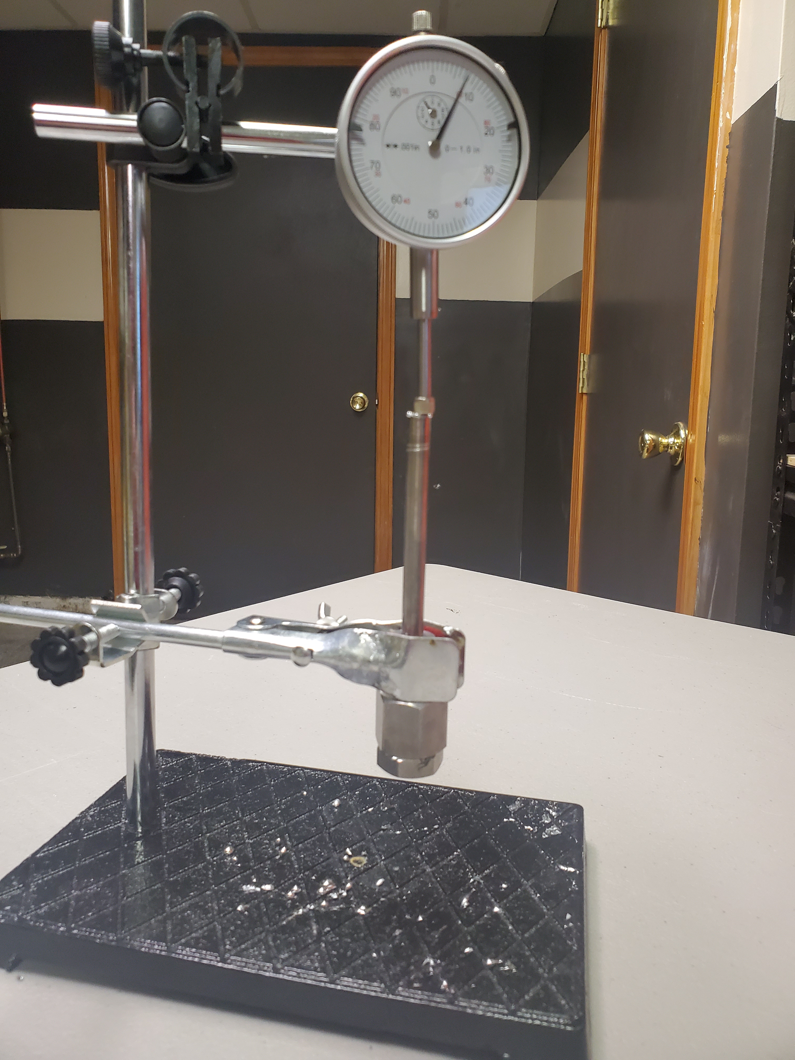
Assembly:

- Cut a piece of stainless steel tube with a pipe cutter, go a little overboard with the cutting pressure to leave a nice bur on the end of the pipe to act as a gasket.
- Insert the dowel pin from the other side of the tube with the factory cut end (no bur) and press out through the other side, should be very tight and difficult to press through.
- Add the compression fitting to the no bur end and thoroughly tighten.
- Set the tube with the compression fitting facing up.
- Melt gallium and fill tube and compression fitting close to the top.
- Apply thread tape to NPT plug, insert into compression fitting and tighten. You should get some liquid gallium and all of the air to squeeze out as you tighten.

Test:

- Mount in test stand with dowel end up.
- Mount and adjust dial indicator to zero.
- Go have a beer and wait for the gallium to cool.

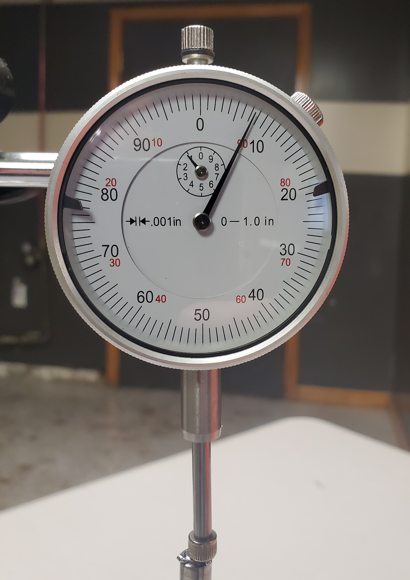
Observation:

- The dowel was forced out of the tube by the expanding gallium about 0.008 in (0.2mm)
- Liquid gallium squirted past the dowel and crimp / bur in the tube
- No visible signs of stress, cracks or any indication that the stainless steel had issues.

Questions:

- Will repeated cycles stress the tube and how long will it last?
- What will it take to seal the gallium piston so that no gallium escapes?
- Is there a way to raise the transition temperature of gallium by alloying with another material such as bismuth?
- Is negative expansion phase change really necessary to draw energy from the air?
- Is there an easier material to work with with a better / higher transition temperature.
- Can we produce enough power for self sustaining thermal cycles?

