

**“ ATTENDANCE SYSTEM BY FACE RECOGNITION AND EYE BLINK”**

**Faculty of T.U , IOST**

**A Project Proposal**

**Submitted to**

**Department of CSIT**

**TEXAS INTERNATIONAL COLLEGE**

**Submitted By:**

**Nishan Kharel**

**Rup Jung Malla**

**Khabindra Tamang**

**Bishal Kunwar**

**Under the Supervision of**

**Kumar Poudyal**

# 1.INTRODUCTION

Imagine a world where attendance marking is automatic, accurate, and secure. No more signing in sheets, swiping cards, or buddy punching. Enter the realm of the **Face Recognition and Eye Blinking Attendance System**, a futuristic solution aiming to revolutionize attendance management.

A facial recognition system is a technology potentially capable of matching a human face from a digital image or a video frame against a database of faces. Such a system is typically employed to authenticate users through ID verification services, and works by pinpointing and measuring facial features from a given image.

Eye is the most vital external organ of human system. Like fingers, eyes have distinctive patterns which caught the eye of innovators of technology.  Recognizing individuals with their iris is the most reliable and accurate biometric identification system in use.

This technology analyses eye movements, specifically blinks, to confirm the presence of a live person. It measures the ratio between the height and width of the eye opening throughout a time frame. When a blink occurs, the ratio drops significantly, indicating a live person.

A facial recognition-based attendance system is considered an effective system in biometric verification based on pattern recognition and computer vision development.

Whether it's an office entrance, a classroom door, or a gym gate, the system is ready to identify you. No awkward poses or specific angles needed. Just a natural glance is enough for the system to capture your face.

Contents

1.INTRODUCTION 2

2**.**Problem Definition**:** 4

3.Objective : 5

4.Scope and Limitation: 5

Features and Operations: 5

Limitations: 5

5.Methodology: 5

Software Development Models: 5

• Study Of existing 6

• Requirement Analysis 6

• Tools Used 6

• Algorithm Used: 7

• Testing: 7

6.Overview of an Enhanced System(DBMS SERVER_USER): 7

OverView Of system: 9

Explanation 9

7.Time Chart(Gantt Chart): 10

Reference: 10

# **2.Problem Definition:**

In traditional attendance systems, issues such as buddy punching (where one person clocks in for another) persist, leading to inaccuracies in tracking attendance. Additionally, some practical challenges arise in implementing an Eye Scanning and Face Recognition Attendance System that need to be addressed:

1. **Hardware Costs: T**raditional attendance systems often involve lower initial costs. The implementation of an Eye Scanning Attendance System and Face recognition may require investing in specialized eye scanning hardware, potentially posing a financial barrier for some organizations.
2. **User Acceptance:** Some individuals may have concerns or reservations about the use of biometric data, such as eye scans, face scanning, raising issues related to privacy and user acceptance. The system should address these concerns and implement robust security measures to protect sensitive biometric information.
3. **Accuracy :** Facial recognition can be affected by lighting, angle, facial expressions, and accessories. The system needs robust algorithms to overcome these limitations and maintain high accuracy. Eye blink detection might struggle with fast blinking, closed eyes due to drowsiness, or individuals wearing contact lenses.
4. **Training Requirements:** Users, especially administrators and staff responsible for managing the attendance system, may require training on the proper use and maintenance of the eye scanning technology. The system should include user-friendly interfaces and comprehensive training materials.

**Key points that the system needs to address:**

1. Accuracy: The system should ensure high accuracy in recognizing face and matching eye patterns ,its movement to guarantee reliable attendance tracking.
2. Cost-effectiveness : Strive for cost-effectiveness in implementing eye scanning technology, balancing the initial investment with the long-term benefits of improved accuracy and security.
3. User-Friendly Interface: Design a user-friendly interface that minimizes the learning curve for users and administrators, fostering widespread acceptance and ease of use.
4. Security and data protection: Implementing robust security measures to prevent unauthorized access to data and ensuring compliance with data protection regulations.

By addressing these real-world challenges and focusing on the key points mentioned, the Eye Scanning Attendance System can provide a solution that not only improves accuracy but also addresses practical considerations for successful implementation in diverse environments.

# 3.Objective :

1. Improved Security and Access Control: Using face recognition and eye blink verification grants access only to authorized personnel. It helps to Gain real-time insights into staff movements within facilities for improved safety and security.
2. **Real-time tracking and reporting : This system** offer immediate insights into attendance data for better workforce management and resource allocation.
3. **Increase accuracy and prevent fraud :** Combine face recognition and eye blink detection to ensure attendance is recorded only for present and conscious individuals.

# 4.Scope and Limitation:

## Features and Operations:

1. User Registration : Users enroll by providing facial images and other relevant information.
2. Automatic Attendance Recording: As users enter or leave a designated area, the system automatically captures their face and detects blinks, registering their attendance in real-time.
3. Real time Monitoring and Reporting: Administrators can access dashboards and reports showing attendance data, including timestamps, individual records, and overall trends.
4. Verification and Authorization : The system verifies captured faces against enrolled identities and ensures live presence through eye blink detection. This prevents proxy attendance attempts.

## Limitations:

1. Technical Accuracy:  While advances are being made, both facial recognition and eye blink detection can be affected by factors like lighting, angles, facial expressions, and accessories.
2. Privacy Concerns : Storing facial and eye data raises privacy concerns. Robust security measures, data anonymization, and clear user consent mechanisms are crucial.
3. User Acceptance : Some individuals might be uncomfortable with facial recognition and eye tracking technology. Building trust and transparency about the system is key.

# 5.Methodology:

## Software Development Models:

* Agile: Since this project involves iterative development and potential changes based on user feedback, an agile model like Scrum or Kanban is more suitable than the Waterfall model.

## Study Of existing

While the technology for facial recognition and eye blink attendance systems is there, and is being used in some places around the world, its adoption in Nepal is still in its early stages. There are not yet many widely used systems implemented across the country. Recently , we have seen such system in Kathmandu University of Management using facial recognition . Nabil Bank too was also the one to pilot this system in various branches all over Nepal.

## Requirement Analysis

Functional Requirement :  Capture facial image, detect blinks, verify identity, record attendance, generate reports, integrate with existing systems.

Non Functional Requirement :  Accuracy, security, privacy, scalability, user-friendliness, accessibility.

## Tools Used

Programming Language: Python with its libraries like OpenCV , NumPy , scipy , glob .

Packages for face recognition and Eye Blink Detection : cmake , dlib , face recognition

Packages for text to Speech : gTTS(Google text to speech) , pygame

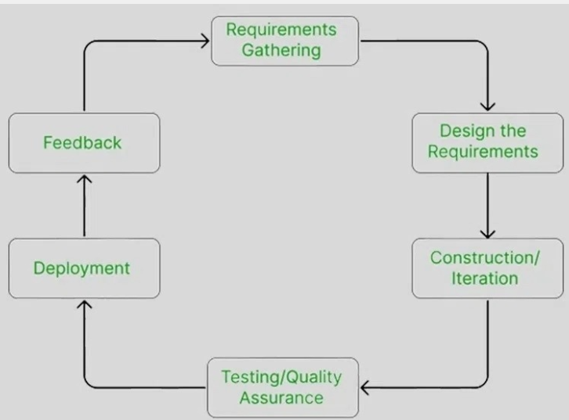

Figure: Agile Model

## Algorithm Used:

FCFS Algorithm (First Come first serve ) is a scheduling algorithm that assigns resources task based on their arrival time . In this system , FCFS can be used to allocate the person recordance according to the time and their arrival first.

## Testing:

Unit Testing :  Individually test each module of the system for functionality and performance.

System Testing : Test the entire system with real users and data to ensure it meets all requirements.

# 6.Overview of an Enhanced System(DBMS SERVER_USER):

Integrating Face Recognition and with Eye Blinking in DBMS server -user Architecture:

1. Database Management System(DBMS) :
   1. Centralized database storing student information, attendance records, and related data.
   2. Tables for students, courses, attendance logs, etc
2. Server : Central processing unit managing communication between the database and user device. Implements face recognition with eye blinking for authentication.
3. User Side**:**
   1. Face Recognition System with Eye Blinking:
      1. Hardware or software component capturing and analyzing facial features, including eye-blinking patterns for heightened security.
      2. Sends the detected face and eye-blinking data to the server for authentication and attendance recording.
   2. User Interface (UI):
      1. Represents the application or system through which users interact.
      2. Displays attendance information, user authentication status, and relevant notifications.
      3. Allows administrators to manage and monitor attendance data
4. Communication Lines:
   1. User-Server Communication:
      1. Network connection between the user side and the server.
      2. Facilitates data exchange, authentication requests, and attendance updates.
   2. Server-DBMS Communication**:**
      1. Connection between the server and the database.
      2. Ensures secure and reliable data transfer.
5. Security Layer:
   1. Ensures the integrity and confidentiality of sensitive information.
   2. Implements protocols for secure user authentication and data transmission.
   3. Includes additional security measures for eye-blinking pattern recognition.
6. Logging and Auditing:
   1. Keeps track of user activities, attendance changes, and system events.
   2. Assists in troubleshooting, monitoring system health, and maintaining accountability.
7. Eye Blinking Recognition Algorithm:
   1. Part of the server-side logic responsible for recognizing patterns in eye-blinking behaviour for enhanced authentication.
   2. Requires the user to blink their eyes a specified number of times for additional security.

## OverView Of system:

| User Side | | DBMS Server |

| | | |

| +---------------------+ | | +---------------------+ |

| | Webcam / Camera | | | | Database | |

| +---------------------+ | | +---------------------+ |

| | Face Recognition | | | | Attendance | |

| | Algorithm | | | | Records | |

| +---------------------+ | | +---------------------+ |

| | Eye-Blinking | | -----> | | User Information | |

| | Detection Algorithm| | | | and IDs | |

| +---------------------+ | | +---------------------+ |

| | | |

+-------------------------+ +-------------------------+

Explanation:  
Here's a concise explanation of the diagram:

Imagine you're using a face recognition and eye-blink system to mark your attendance:

* Your Webcam/Camera: Captures your image and eye movements.
* Face Recognition Algorithm: Analyzes your face to identify you from stored IDs in the Database.
* Eye-Blinking Detection Algorithm: Confirms you're live by analyzing your blinks.
* If both checks pass:
  + Your attendance is recorded in the Attendance Records database.
  + You receive confirmation on your device.

# 7.Time Chart(Gantt Chart):

|  |  |  |  |  |
| --- | --- | --- | --- | --- |
| Task | Duration | Start Date | End Date | Dependencies |
| Project Initiation | 1 week | 2024-01-01 | 2024-01-07 | - |
| Requirement Analysis | 2 week | 2024-01-07 | 2024-01-20 | Project Initiation |
| System Design | 1 week | 2024-01-21 | 2024-01-29 | Requirement Analysis |
| Face and Eye Recognition Module | 4 weeks | 2024-02-08 | 2024-03-10 | System Design and face and eye module |
| Integrating and Testing | 2 weeks | 2024-03-10 | 2024-03-20 | Integration and Testing |
| User Training | 3 days | 2024-03-21 | 2024-03-25 | User training |
| Documentation | 4 days | 2024-04-01 | 2024-04-05 | Documentation |
| Final Testing and QA | 1 week | 2024-04-06 | 2024-04-12 | Testing |
| Launch | 5 day | 2024-04-13 | 2024-04-19 | Launch |
| Project Review | 2 day | 2024-04-20 | 2024-04-23 | Review |

Excepted Outcome: This system will access to individual and overall attendance records for better planning and resource allocation. Mainly , it can be used in colleges and schools as the old system of using pen and register will be removed and country will move towards the age of technologies.

## Reference:

Face Recognition : OpenCV, Dlib, FaceNet, PyTorch, TensorFlow, "FaceNet: A Unified Embedding for Face Recognition and Clustering" by Schroff

Eye _Blink: Research paper such as "Real-time Eye Blink Detection using Facial Features" by Li et al.  "A Survey of Eye Blink Detection Techniques" by Kadoury and Croucher