Exercise 1: Control Structures

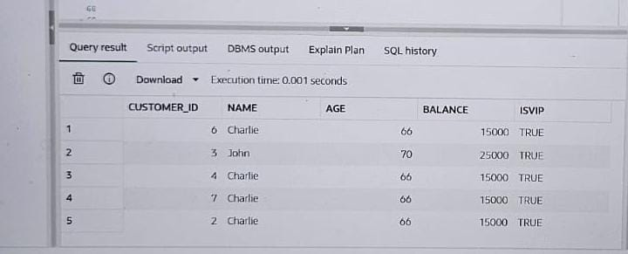

**Scenario 1: Apply 1% Interest Discount for Senior Citizens**

BEGIN

FOR cust_rec IN (SELECT customer_id FROM customers WHERE age > 60) LOOP

UPDATE loans

SET interest_rate = interest_rate - 1

WHERE customer_id = cust_rec.customer_id;

END LOOP;

COMMIT;

END; 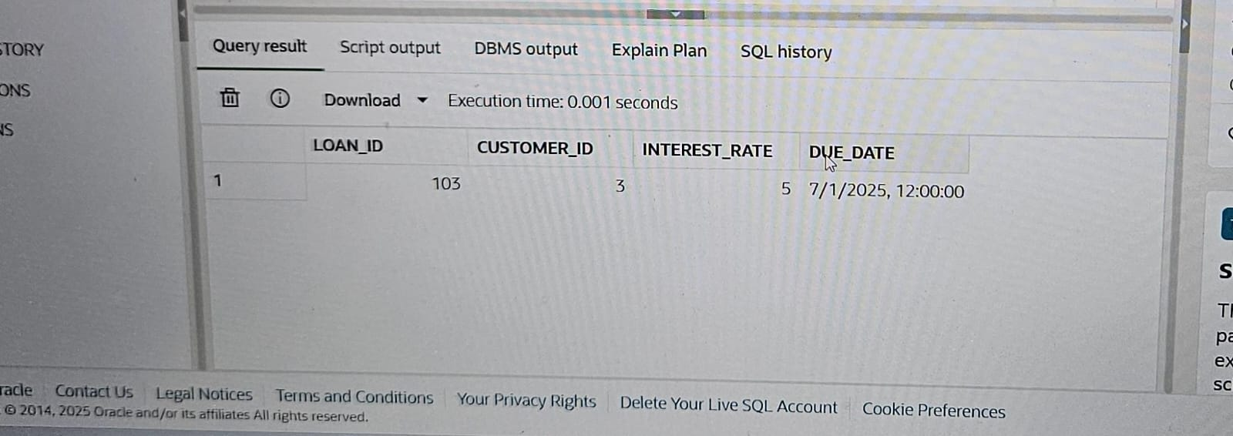

**Scenario 2: Promote Customers to VIP Based on Balance**

BEGIN

FOR cust_rec IN (SELECT customer_id FROM customers WHERE balance > 10000) LOOP

UPDATE customers

SET isvip = 'TRUE'

WHERE customer_id = cust_rec.customer_id;

END LOOP;

COMMIT;

END;

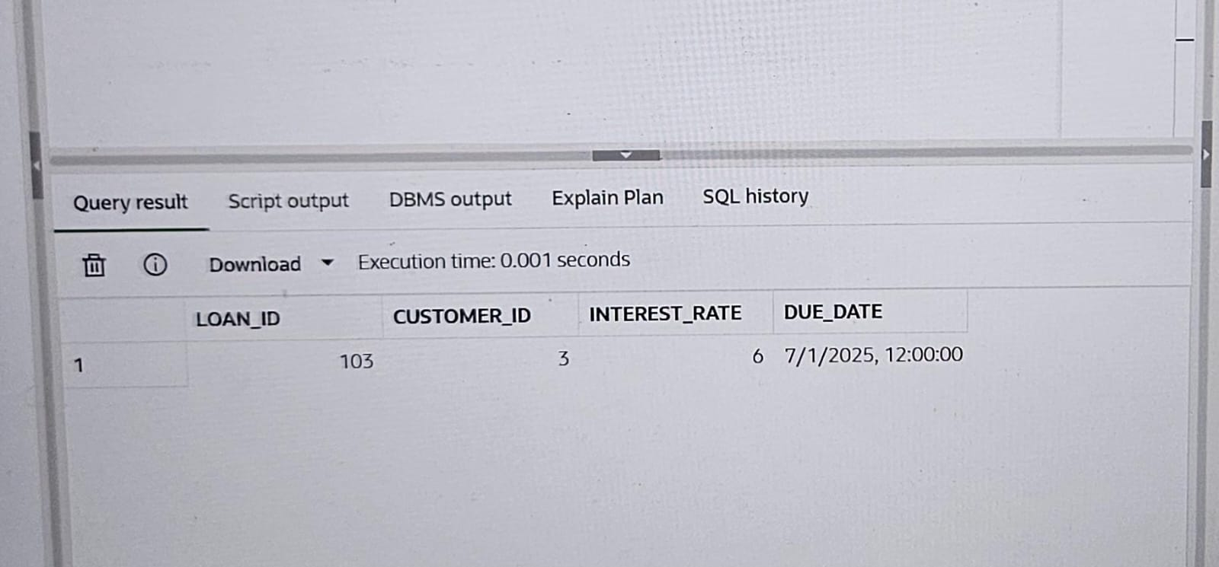

**Scenario 3: Send Reminders for Loans Due in Next 30 Days**

DECLARE

v_due_date DATE;

v_cust_name VARCHAR2(100);

BEGIN

FOR loan_rec IN (

SELECT l.loan_id, l.due_date, c.name

FROM loans l

JOIN customers c ON l.customer_id = c.customer_id

WHERE l.due_date BETWEEN SYSDATE AND SYSDATE + 30

) LOOP

DBMS_OUTPUT.PUT_LINE(

'Reminder: Dear ' || loan_rec.name || ', your loan (ID: ' || loan_rec.loan_id ||

') is due on ' || TO_CHAR(loan_rec.due_date, 'DD-Mon-YYYY') || '.'

);

END LOOP;

END;

