Exercise 3: Stored Procedures

**Scenario 1: Process Monthly Interest (1%) for Savings Accounts**

CREATE OR REPLACE PROCEDURE ProcessMonthlyInterest IS

BEGIN

UPDATE savings_accounts

SET balance = balance + (balance * 0.01);

COMMIT;

END;

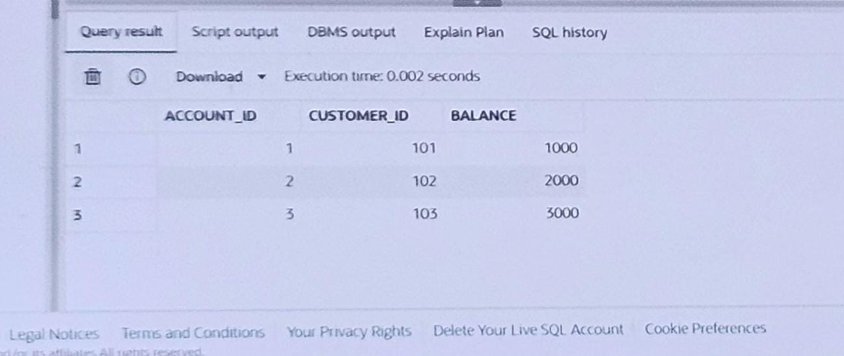

**Scenario 2: Update Bonus for Employees in a Department**

CREATE OR REPLACE PROCEDURE UpdateEmployeeBonus (

dept_id IN NUMBER,

bonus_percent IN NUMBER

) IS

BEGIN

UPDATE employees

SET salary = salary + (salary * bonus_percent / 100)

WHERE department_id = dept_id;

COMMIT;

END;

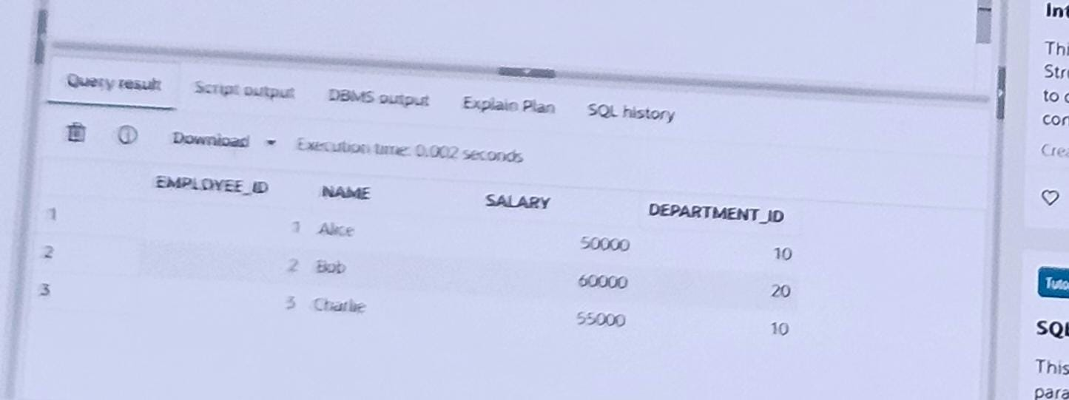

**Scenario 3: Transfer Funds Between Accounts**

CREATE OR REPLACE PROCEDURE TransferFunds (

from_account IN NUMBER,

to_account IN NUMBER,

amount IN NUMBER

) IS

from_balance NUMBER;

BEGIN

SELECT balance INTO from_balance

FROM accounts

WHERE account_id = from_account

FOR UPDATE;

IF from_balance < amount THEN

RAISE_APPLICATION_ERROR(-20001, 'Insufficient balance.');

END IF;

-- Deduct from source

UPDATE accounts

SET balance = balance - amount

WHERE account_id = from_account;

UPDATE accounts

SET balance = balance + amount

WHERE account_id = to_account;

COMMIT;

END;

