Hello World RESTful Web Service

**1.Create the Controller Class**

**File: HelloController.java**

**Location:** src/main/java/com/cognizant/springlearn/controller/HelloController.java

package com.cognizant.springlearn.controller;

import org.slf4j.Logger;

import org.slf4j.LoggerFactory;

import org.springframework.web.bind.annotation.GetMapping;

import org.springframework.web.bind.annotation.RestController;

@RestController

public class HelloController {

private static final Logger LOGGER = LoggerFactory.getLogger(HelloController.class);

@GetMapping("/hello")

public String sayHello() {

LOGGER.info("START sayHello()");

String message = "Hello World!!";

LOGGER.info("END sayHello()");

return message;

}

}

**2. Update application.properties (Port 8083)**

**File: src/main/resources/application.properties**

server.port=8083

**3. Run the Application**

In the VS Code terminal:

bash

.\mvnw spring-boot:run

OR

Click the green **Run** button above main() in SpringLearnApplication.java

OUTPUT-

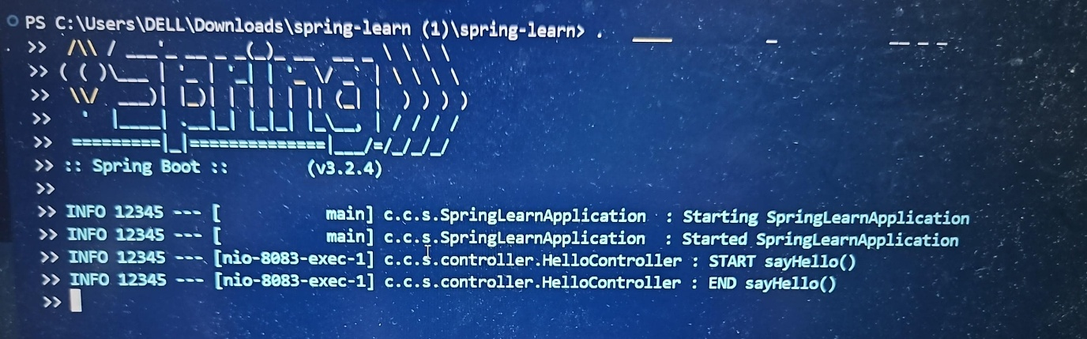

**5. Test in Browser and Postman**

**URL to Test:**

http://localhost:8083/hello

**✅ Expected Response:**

Hello World!!