//Factorial using Recursion

#include<stdio.h>

int fact(int n);

int fact(int n){

if(n==1){

return 1;

}

else{

return n\*fact(n-1);

}

}

int main(){

int n;

printf("Enter the value of n: \n");

scanf("%d",&n);

printf("\nThe factorial is: %d",fact(n));

printf("\nRuqaiyya Mahreen 1BM23EE044");

}

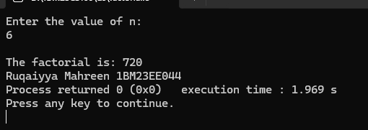

Fibonacci using Recursion

#include <stdio.h>

int fibonacci(int n) {

if (n == 1) {

return 0;

} else if (n == 2) {

return 1;

} else {

return fibonacci(n - 1) + fibonacci(n - 2);

}

}

int main() {

int n;

printf("Ruqaiyya Mahreen 1BM23EE044\n");

printf("Enter the value of n: ");

scanf("%d", &n);

printf("Fibonacci(%d): %d\n", n, fibonacci(n));

return 0;

}

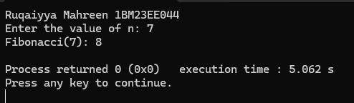

//Tower of Hanoi

#include <stdio.h>

void towerOfHanoi(int n, char source, char dest, char temp) {

if (n == 1) {

printf("Move disk 1 from rod %c to rod %c\n", source, dest);

return;

}

towerOfHanoi(n - 1, source, temp, dest);

printf("Move disk %d from rod %c to rod %c\n", n, source, dest);

towerOfHanoi(n - 1, temp, dest, source);

}

int main() {

int n;

printf("Enter the number of disks: ");

scanf("%d", &n);

towerOfHanoi(n, 'A', 'C', 'B');

printf("Ruqaiyya Mahreen 1BM23EE044");

return 0;

}

