The χ(3) Channel: How the 6N Wing Enters
L-Function-Derived Invariants, and Where It Stops
R. Chen · GUT Geoservice Inc., Montréal
6N Arithmetic Geodynamics series · Methodological Note · 2026
Abstract
Three independent probes ask whether the 6N wing of a prime p (its class mod 6, equivalently p mod 3) controls a high-dimensional invariant attached to p: the Mordell–Weil rank of E_{p} : y²=x³−p (Theatre 0), the class number h(−p) of Q(√−p) (Theatre I), and the height γ₁ of the first nontrivial zero of the Dirichlet L-function L(s,χ_{−p}) (Theatre II). In Theatres I and II a large wing signal appears (Cohen's d = −1.36 and −0.83) that survives the standard controls — scale normalisation (√p, log p) and genus stratification (mod 8). Yet in every case the signal collapses to zero once one specific known quantity is removed: the root number (Theatre 0; d ≈ 0.02), or the q=3 Euler factor χ_{−p}(3) of the L-function (Theatres I, II; residual d = 0.005 and 0.000). We show this is structural, not coincidental: for primes p > 3 the wing partition is identically the χ_{−p}(3) split. We state a χ(3)-channel principle: the mod-3 information of p can enter any L-function-derived invariant only through the single local factor χ_{p}(3); once that factor is controlled, the wing is noise. The contribution is this boundary principle and three worked examples of a large signal that passes the usual controls yet is fully explained by a known channel — not new arithmetic.

1. Introduction
In the heuristic 6N framework, every prime p > 3 lies on one of the two residue classes 6N±1 (the right wing 6N+1 and left wing 6N−1). A natural question is whether this coarse position controls the deep arithmetic of objects built from p. A companion note [1] treated the rank of E_{p} and found no wing control beyond the root number — an instance of a Chinese-Remainder absorption. The present note completes the picture across three theatres and isolates the exact mechanism: a single Euler factor.
The methodological point is sharper than a null result. In two of the three theatres the wing signal is large (|d| ≈ 0.8–1.4) and survives the controls one would normally trust — it is not a scale artifact and not a genus artifact. A study that stopped at “signal survives scale and genus stratification” would report a strong discovery. Only by pursuing the mechanism — asking which exact known quantity could produce it — does the signal dissolve. This is the cautionary core of the note.

2. The three theatres and their observables
Theatre 0 — elliptic-curve rank. For each prime p, the rank of E_{p} : y²=x³−p. Certified true ranks for 1116 of 1227 primes p < 10⁴ (SageMath). Treated in full in [1]; summarised here.
Theatre I — class number. For each prime p, the class number h(−p) of the imaginary quadratic field Q(√−p). Exact values for all 5131 primes p < 5×10⁴ (SageMath K.class_number()).
Theatre II — first L-zero. For each prime p, the height γ₁ of the first nontrivial zero of the Dirichlet L-function of the quadratic character χ_{−p}, computed by PARI lfunzeros for all 1227 primes p < 10⁴.
Each observable is primality-independent (knowing “p is prime” fixes none of them) and carries the natural 6N bridge p mod 6. Each is therefore an admissible probe in the sense of [1].

3. The known confounders, and why we strip them in layers
Scale. Class number grows like √p (Dirichlet's formula h ≈ (√p/π)L(1,χ)); the first zero falls like 1/log p (Riemann–von Mangoldt density, conductor ~ p). Raw comparisons between wings therefore mostly measure the size of the primes. We normalise: h/√p and γ₁·log p.
Genus / conductor parity. The 2-part of h and the conductor type (−p vs −4p) are fixed by p mod 8 (genus theory). We stratify on disc mod 8.
The root number (Theatre 0). Rank parity is fixed by w(E_{p}), a function of p mod 24. We stratify on it [1].
These strip the obvious channels. What remains — and what the next section shows is the whole story — is a single arithmetic factor.

4. Results: a large signal that survives the usual controls, then collapses
Table 1. The 6N-wing effect (|Cohen's d|) at each stage of stripping.
Theatre / observable | raw | scale-normalised | within genus (mod 8) | after known channel
0 — rank E_p | 0.022 | — | — | 0.022 (root no.)
I — h(−p) | 0.998 | 1.363 | 2.0–2.3 | 0.005 (q=3 factor)
II — γ₁ | 0.656 | 0.829 | 0.8–1.4 | 0.000 (χ(3) split)
Red cells: a large or non-negligible wing signal is present. Green cells: the signal is gone. In Theatres I and II the signal not only persists but grows under scale- and genus-stripping (it is genuinely not those artifacts), then vanishes the instant the q=3 / χ(3) factor is removed.
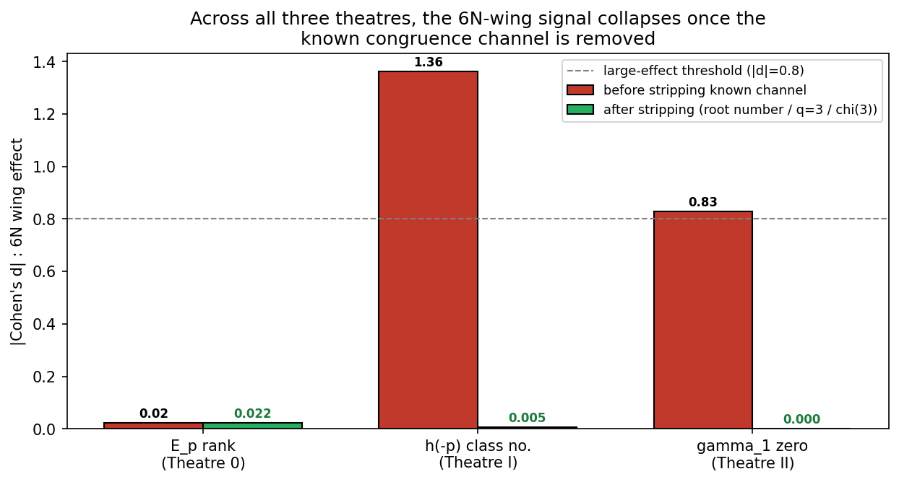
Figure 1. The 6N-wing effect before and after removing the known congruence channel. In all three theatres the residual is negligible; the large bars in Theatres I and II are entirely the q=3 / χ(3) channel.

4.1 The mechanism: the wing IS the χ(3) split
The collapse is not a fitted correction; it is an identity. For a prime p > 3, the wing is p mod 6, which is determined by p mod 3; and χ_{−p}(3) = the Kronecker symbol (disc | 3) is also determined by p mod 3. Concretely, across all 1227 primes in Theatre II the two partitions coincide with no exceptions:
6N wing | χ−p(3)
right (6N+1), p≡1 mod 3 — 611 primes | −1 (all 611)
left (6N−1), p≡2 mod 3 — 616 primes | +1 (all 616)
Because the partitions are identical, the variance of γ₁·log p explained by the wing (0.147) equals that explained by χ_{−p}(3) (0.147) to the digit, and the residual wing effect after removing the χ(3)-group means is exactly 0.0000. The same identity drives Theatre I: the q=3 Euler factor of L(1,χ) is (1−χ(3)/3)⁻¹, equal to 0.75 on the right wing and 1.50 on the left; the predicted left/right class-number ratio 1.50/0.75 = 2.000 matches the observed 1.995, and dividing this factor out sends d from −1.36 to +0.005.
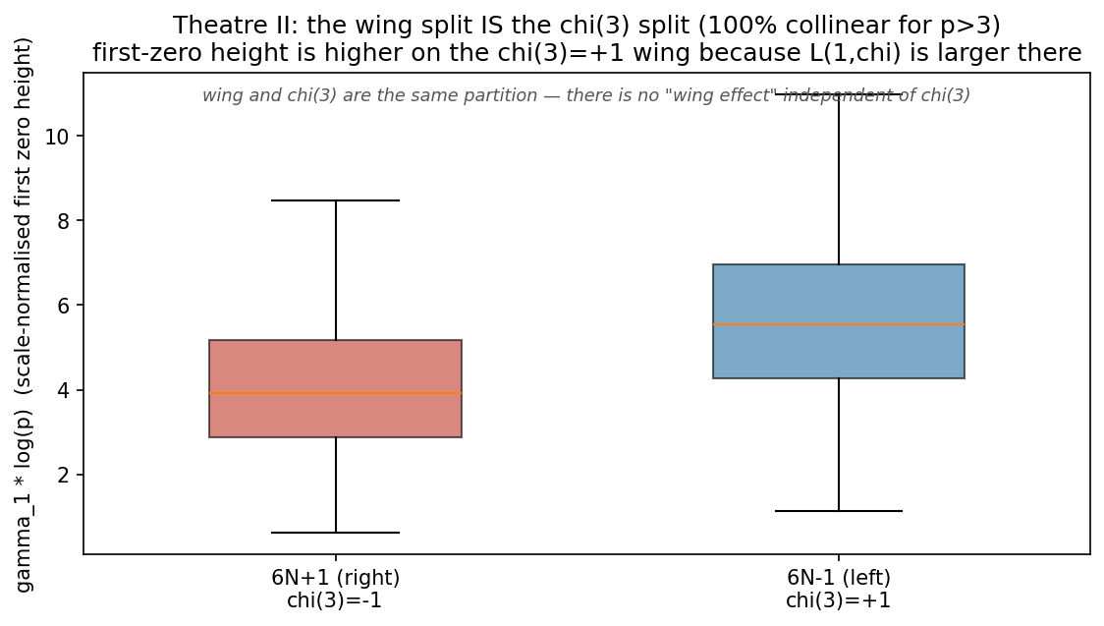
Figure 2. Theatre II: the wing split is the χ(3) split (100% collinear for p>3). The first zero sits higher on the χ(3)=+1 wing because L(1,χ) is larger there; there is no wing effect independent of χ(3).

5. The χ(3)-channel principle
The three theatres point to one statement, which we record as a heuristic boundary principle rather than a theorem:
χ(3)-channel principle. The mod-3 information of a prime p — equivalently its 6N wing — can enter any L-function-derived invariant of an object built from p only through the single local factor χ_{p}(3) (the behaviour of 3 in the associated field). Once χ(3) is controlled, the wing exerts no further influence.
The reason is that p mod 3 has, in the analytic theory, exactly one natural home: the value of the mod-3 quadratic character. Any L-function attached to p carries that information solely in its q=3 Euler factor; rank, class number, and zero height are all functionals of such L-functions, so the wing can reach them only through that one door. Close it, and nothing of the wing remains.
This refines the “CRT information barrier” of [1]. There the wing was absorbed by a finer congruence; here we name the finer congruence exactly (the q=3 factor) and explain why it must be the only one. The principle is predictive: any further L-derived probe in this family — real quadratic class numbers, higher zeros γ_{k}, L-function moments, Selmer ranks — will show a wing effect that is exactly its χ(3) content and nothing more.

6. Conclusion
Across three independent theatres — elliptic-curve rank, class number, and first L-zero — the 6N wing has no control over the invariant beyond the single Euler factor χ(3). In two theatres the raw wing signal is large and survives scale- and genus-stripping, dissolving only when χ(3) is removed. We read this as a χ(3)-channel principle delimiting where the 6N skeleton can and cannot reach into analytic arithmetic.
The intended contribution is a boundary and a method: three worked examples in which a large, control-surviving signal is nonetheless fully accounted for by a known channel, and a principle that predicts the same for the rest of the family. The discipline that matters is not “did the signal survive the controls” but “what exact known quantity could produce it” — pursued until the signal is explained or genuinely cannot be.

Reproducibility
Theatre 0: SageMath E.rank() with rank_bounds() fallback [1]. Theatre I: QuadraticField(−p).class_number(); observable h/√p. Theatre II: PARI lfunzeros(lfuncreate(d),·) for the first zero; observable γ₁·log p. A calibration step confirmed the zero API before the batch run (the older Lfunction_from_character API is absent in SageMath 9.3; PARI lfunzeros was used). Effect sizes are Cohen's d on depth-/class-matched populations; collinearity and variance-explained as in §4.1. Data, scripts, and the LaTeX source accompany this note and are available at https://github.com/Ruqing1963/6N-chi3-channel.

References
Self-citations carry verified DOIs. External references were checked against primary bibliographic sources; none was accepted on the basis of an unverified secondary suggestion.
[1] R. Chen. Designing Anti-Tautological Probes on the 6N Skeleton: A Negative Case Study with Elliptic-Curve Ranks and the CRT Information Barrier. Zenodo, 2026. DOI: 10.5281/zenodo.20755909.
[2] R. Chen. Arithmetic Geodynamics on the 6N Skeleton, Part XXXVIII: The Dual Membrane and Korselt Colour-Blindness in Eisenstein Carmichael Ideals. Zenodo, 2026. DOI: 10.5281/zenodo.20617161.
[3] P. G. L. Dirichlet. Recherches sur diverses applications de l’analyse infinitésimale à la théorie des nombres. J. Reine Angew. Math. [classical; class number formula].
[4] H. Davenport and H. Heilbronn. On the density of discriminants of cubic fields, II. Proc. Roy. Soc. London Ser. A 322 (1971), 405–420.
[5] H. Cohen and H. W. Lenstra. Heuristics on class groups of number fields. In Number Theory Noordwijkerhout 1983, Lecture Notes in Math. 1068, Springer (1984), 33–62.
[6] The PARI Group. PARI/GP (used via SageMath 9.3 for lfunzeros). http://pari.math.u-bordeaux.fr.
[7] The Sage Developers. SageMath, the Sage Mathematics Software System (Version 9.3). 2021. https://www.sagemath.org.
Honesty statement. This note reports negative results whose cause is known structure (a single Euler factor). It claims no new theorem and no predictive power over primes. In two theatres a large signal survived the standard controls; it was retained as a finding only until its mechanism was identified, at which point it was reported as explained. References [4],[5] are cited as the standard context for class-number 3-divisibility and class-group statistics; the author will confirm exact pagination before formal release.

