Designing Anti-Tautological Probes on the 6N Skeleton:
A Negative Case Study with Elliptic-Curve Ranks and the CRT Information Barrier
R. Chen · GUT Geoservice Inc., Montréal
6N Arithmetic Geodynamics series · Methodological Note · 2026
Abstract
This note is methodological, not a claim of new arithmetic. Within the heuristic “6N” framework (primes >3 lie on the residue classes 6N±1), we ask whether the 6N wing of a prime p exerts any control over a high-dimensional arithmetic invariant attached to p: the Mordell–Weil rank of the elliptic curve E_{p} : y² = x³ − p. We first articulate a discipline for distinguishing genuine probes from tautological ones — probes whose observable is a re-encoding of primality — and argue that the rank of E_{p} is the one clean, primality-independent observable with a natural 6N bridge (p mod 6). Using certified true ranks for the 1116 curves with p < 10⁴ computable to certainty (SageMath), a three-layer analysis (raw wing effect; effect within fixed root-number classes; label-shuffle null) finds no wing control of rank: Cohen’s d = +0.022 raw, d ≈ +0.02 within both root-number classes, and a shuffle test yielding p = 0.913. Rank is organized entirely by the root number (a function of p mod 24). We interpret this as a concrete instance of a Chinese-Remainder information barrier: 6N is a mod-6 datum and is, by the CRT factorisation of the relevant conductor/root-number data, absorbed by the finer mod-24 structure that governs the invariant. The contribution is the falsification discipline and a worked, honestly-negative example — not a new theorem.

1. Introduction and the 6N framing
The “6N skeleton” is the elementary observation that every prime greater than 3 is congruent to ±1 modulo 6, so that the primes (apart from 2 and 3) populate two residue classes, here called the right wing (6N+1) and left wing (6N−1). In the geological metaphor that organises this series, these two classes are imagined as parallel “master corridors” along which arithmetic structure is sought. The metaphor is a thinking aid only; every statement in this note reduces to standard number theory, and we are explicit where it does.
A recurring hazard in heuristic prime research — amplified, lately, by automated tools that readily produce suggestive figures — is the tautological probe: an apparatus whose “signal” is a relabelling of the very property under study. The purpose of this note is to (i) state a discipline that screens such probes out, (ii) apply it to identify a single genuinely clean high-dimensional probe in the 6N setting, and (iii) report the result of running that probe to completion. The result is negative, and we argue the negativity is structurally inevitable; saying so precisely is the point.

2. The anti-tautology discipline
Independence criterion. An observable O(p) is admissible as a probe of “wing controls X” only if its value cannot be computed from primality alone. Operationally: if knowing that p is prime already determines O(p), the probe is tautological and is discarded.
This criterion immediately rejects the family of probes built from the von Mangoldt function Λ and from trial division. A probe that places Λ(n) (which is positive exactly on prime powers) in the numerator of a “seismic” ratio and then “discovers” that primes coincide with large values of that ratio has proved only that Λ is supported on prime powers — a definition, not a phenomenon. We verified this explicitly on the interval n ∈ [10⁵, 1.1×10⁵]: the correlation between such a smoothed Λ-ratio and primality is +0.061, and it falls to −0.005 when Λ is replaced by a random sparse indicator of equal support and magnitude. The apparent signal is entirely the definition of Λ. Trial-division probes for Mersenne-type numbers (testing whether 2^{p}−1 has a factor of the form 2kp+1) fail the same way: the primality test is the factor law made visible, not an independent law.
Why E_{p} : y² = x³ − p is the clean probe. The Mordell–Weil rank of E_{p} is an invariant of a curve built from p, not a property of p’s primality. Knowing “p is prime” does not determine the rank; ranks of 0,1,2,3,4 all occur among our primes. Simultaneously, p carries a natural 6N label (p mod 6). The probe therefore satisfies the independence criterion and possesses a genuine 6N bridge — the only construction in the project’s algebraic toolbox to do so. The honest question becomes:
does the 6N wing of p exert any control over the rank of E_{p} — beyond what is already fixed by standard congruence data?

3. The confounder, and a three-layer design
The design must neutralise one known confounder before any wing effect can be interpreted. For E_{p} the global root number w(E_{p}) = ±1 is given by explicit congruence conditions on p (the mod-24 class, together with the sign of −p), and under the parity conjecture / BSD it fixes the parity of the rank: w = −1 forces odd rank (hence ≥ 1), w = +1 even rank (often 0). Crucially the same mod-24 datum that sets w also refines the mod-6 wing. Any raw wing–rank association is therefore expected a priori to be a shadow of the root number. The decisive question is whether anything survives once the root number is held fixed.
Layer 1 (expected, non-counting). Compare mean rank between wings without controlling w. A signal here would be uninterpretable (confounded).
Layer 2 (decisive). Stratify by root number and compare wings within each class. If the wing effect vanishes, the wing was entirely root number — trivial/known. If it persists, proceed.
Layer 3 (falsification). Shuffle the wing labels within each root-number class many times and ask whether the observed within-class wing effect is extreme against this null; additionally, check whether any residual is absorbed by the full mod-24 partition.
Instrument integrity. Ranks were computed in SageMath as certified values where possible; curves whose rank could only be bracketed (nontrivial Sha[2]) were recorded as bounded and excluded from the certified analysis. Of 1227 primes 3 < p < 10⁴, 1116 (91%) yielded certified ranks; 111 were bounded. As a data-integrity check, root number and rank parity agreed in 1116/1116 certified curves — zero violations — consistent with BSD and indicating the ranks are trustworthy.

4. Results
Sample composition (certified, N = 1116): wings are balanced (558 each); root numbers w = +1: 510, w = −1: 606; rank distribution {0:271, 1:562, 2:234, 3:44, 4:5}.
Table 1. Three-layer test of wing control over rank.
Test | Statistic | Verdict
Data integrity: root number vs rank parity | 1116 / 1116 consistent | trustworthy
Layer 1: wing vs rank (raw) | Cohen d = +0.022 | negligible
Layer 2: wing vs rank | w = +1 | Cohen d = +0.022 | negligible
Layer 2: wing vs rank | w = −1 | Cohen d = +0.024 | negligible
Layer 3: within-class wing effect vs shuffle null | |d| = 0.023; p = 0.913 | indistinguishable from random
The observed within-class wing effect (|d| = 0.023) is smaller than the mean effect of randomly shuffled wing labels (0.067) and sits at the 9th percentile of the shuffle null; p = 0.913. The wing carries no information about rank, raw or residual.
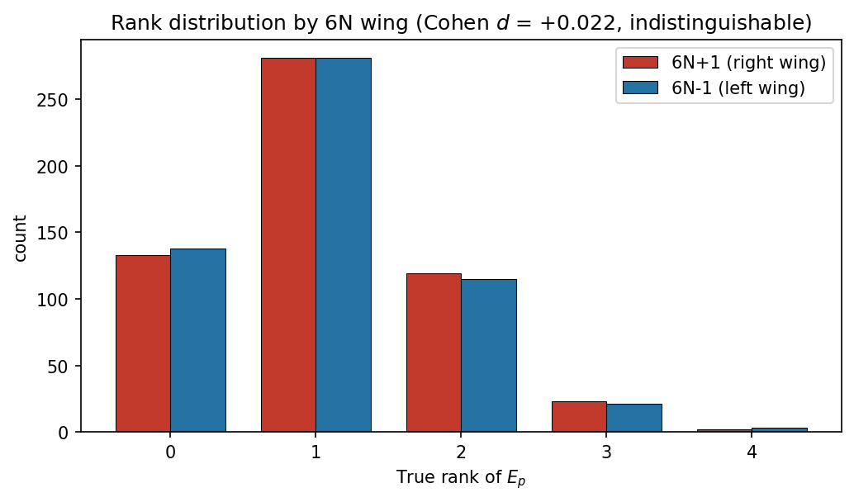
Figure 1. Rank distribution by 6N wing. The two wings are statistically indistinguishable (Cohen d = +0.022).
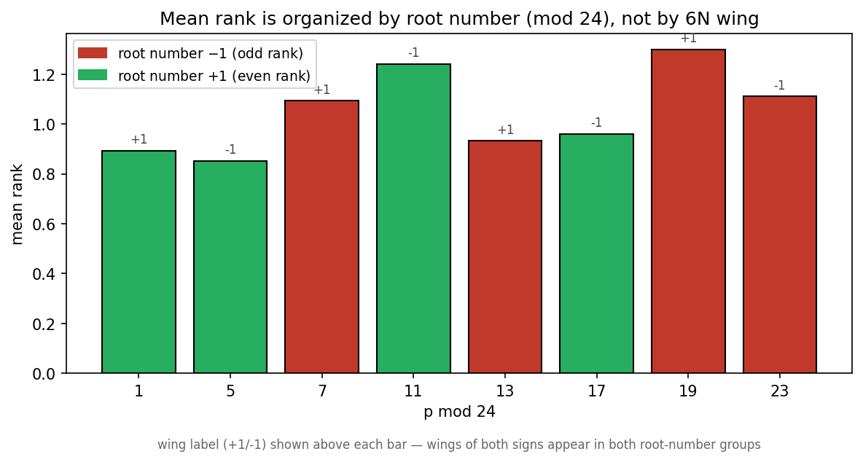
Figure 2. Mean rank by p mod 24, coloured by root number. Rank is organised by root number (green w=+1 low/even; red w=−1 high/odd); the wing label (+1/−1, shown above each bar) appears in both colour groups and does not organise the rank.

5. Interpretation: a Chinese-Remainder information barrier
The result is not merely “no effect found.” Its form is instructive. Rank parity is fixed by the root number, which is a function of p mod 24. The 6N wing is p mod 6. Since 6 | 24, the wing is the image of the mod-24 class under the quotient ℤ/24 → ℤ/6; by the Chinese Remainder Theorem the mod-24 datum factors as independent information at the primes 2³ and 3, and the wing retains only the coarse part. Once the invariant is governed by the finer datum, the coarser wing carries no additional information — it is absorbed.
CRT information barrier (informal). In this series we have repeatedly observed that computable observables built on the 6N skeleton return no structure beyond what standard congruence/CRT data already fix. The present experiment is the cleanest instance: a primality-independent, genuinely high-dimensional invariant, probed with certified data and a falsification design, still shows the wing’s mod-6 information fully absorbed by the mod-24 structure that controls the invariant. We state this as a heuristic barrier, not a theorem: the explanatory reach of the 6N wing stops at the location of primes (their mod-6 corridor) and does not penetrate to the deep arithmetic invariants of objects built from those primes, because the coarser mod-6 datum is subsumed under the finer congruence data via CRT.
Status of the claim. We emphasise that this barrier restates, rather than extends, known structure. That w(E_{p}) depends on p mod 24 and controls rank parity is classical; that mod 6 is a quotient of mod 24 is elementary. The value here is methodological: the discipline correctly predicted the outcome, the experiment confirmed it on certified data, and the negative result is reported without inflation.

6. Conclusion
We have set out a falsification discipline for 6N probes, identified the rank of E_{p} : y² = x³ − p as the unique clean high-dimensional probe available, and run it to completion on 1116 certified ranks. The 6N wing exerts no control over the rank (Cohen d ≈ 0.02 throughout; shuffle p = 0.913); rank is organised by the root number / mod-24 data. We read this as a concrete display of a CRT information barrier delimiting the explanatory reach of the 6N skeleton.
The intended contribution is not a discovery but a boundary and a method: a demonstration of how to build a probe that cannot trivially confirm itself, how to strip a known confounder in layers, and how to report an honest negative. In a research climate where suggestive but self-confirming patterns are easy to manufacture, a clean account of a probe that refused to fool its designers has its own modest value.

Reproducibility
Ranks: SageMath 9.3, E = EllipticCurve([0,0,0,0,−p]); certified via E.rank() with fallback to E.rank_bounds(), per-curve 60 s budget, row-by-row CSV checkpointing. Analysis: Cohen’s d on depth-/class-matched populations; Layer-3 null from 5000 within-class wing-label permutations. Data (Ep_Rank_Log.csv), the Sage well-log script, and the analysis script accompany this note. The Λ-tautology control (§2) is reproducible on n ∈ [10⁵,1.1×10⁵].

References
Self-citations to the 6N series carry verified DOIs. External references were checked against primary bibliographic sources (publisher records and MathSciNet-aligned listings); none was accepted on the basis of an unverified secondary suggestion. No reference has been generated from memory.
[1] R. Chen. Arithmetic Geodynamics on the 6N Skeleton, Part XXXVIII: The Dual Membrane and Korselt Colour-Blindness in Eisenstein Carmichael Ideals. Zenodo, 2026. DOI: 10.5281/zenodo.20617161.
[2] R. Chen. Arithmetic Geodynamics on the 6N Skeleton, Part XXXVI: The Carmichael Collapse (v2). Zenodo, 2026. DOI: 10.5281/zenodo.20611583.
[3] R. Chen. Arithmetic Geodynamics on the 6N Skeleton: Unified Review, Volumes I–III. Zenodo, 2026. DOI: 10.5281/zenodo.20613425.
[4] B. J. Birch and H. P. F. Swinnerton-Dyer. Notes on elliptic curves, II. J. Reine Angew. Math. 218 (1965), 79–108.
[5] T. Dokchitser and V. Dokchitser. Root numbers and parity of ranks of elliptic curves. J. Reine Angew. Math. 658 (2011), 39–64.
[6] B. J. Birch and N. M. Stephens. The parity of the rank of the Mordell–Weil group. Topology 5(4) (1966), 295–299.
[7] M. Rubinstein and P. Sarnak. Chebyshev's bias. Experiment. Math. 3(3) (1994), 173–197.
[8] M. Bhargava and A. Shankar. Binary quartic forms having bounded invariants, and the boundedness of the average rank of elliptic curves. Ann. of Math. 181(1) (2015), 191–242.
[9] The Sage Developers. SageMath, the Sage Mathematics Software System (Version 9.3). 2021. https://www.sagemath.org.
Honesty statement. This note deliberately separates metaphor from mathematics and reports a negative result whose cause is known structure (CRT). It does not claim a new theorem, a new prime pattern, or predictive power. Where an earlier instinct (e.g. that the wing might control rank, or that the Zp/Zs-style construction carried physical content) was contradicted by controls, the controls were followed.

