Statistical Isomorphism Between Phanerozoic Tectonic Rhythms
and Riemann Zeta Zero Spacings:
A Random Matrix Theory Perspective
Ruqing Chen
GUT Geoservice Inc., Montreal, Canada
ruqing@hotmail.com
June 2026

Abstract
We investigate whether the temporal spacing of major geological boundaries in the Phanerozoic eon (538.8 Ma to present) exhibits statistical signatures characteristic of random matrix ensembles, specifically the Gaussian Unitary Ensemble (GUE) and Gaussian Orthogonal Ensemble (GOE), or whether it follows a Poisson (memoryless) process. Using all 102 ICS 2023-standard stage-level boundaries, we extract 99 inter-event intervals and compare their normalized spacing distribution against the Wigner surmise for GUE (β = 2), GOE (β = 1), and Poisson statistics via Kolmogorov–Smirnov tests, Anderson–Darling statistics, nearest-neighbor spacing ratios, higher-moment analysis, and bootstrap confidence intervals. We find that (1) the Poisson hypothesis is decisively rejected at p = 1.3 × 10⁻⁴ and with an 11.6σ deviation in the spacing ratio statistic; (2) the GOE model provides the best overall fit across all test statistics (KS D = 0.090, p = 0.38; A² = 1.18); and (3) the GUE model, while close in spacing ratio (⟨r⟩ = 0.637, only 1.6σ from GUE theory), is marginally rejected by higher-order tests. As a methodological control, we verify that the first 500 non-trivial zeros of the Riemann zeta function conform precisely to GUE statistics. We conclude that Earth’s tectonic system displays clear level repulsion in its event timing—characteristic of a correlated dynamical system—at the GOE (β ≈ 1) universality class, intermediate between Poisson randomness and the full GUE repulsion seen in the Riemann spectrum.
Keywords: random matrix theory; Phanerozoic; geological boundaries; level repulsion; Riemann zeta function; GUE; GOE; Wigner surmise; tectonic rhythms; mass extinctions
Code and data: https://github.com/Ruqing1963/geo-riemann-spectral-statistics

1. Introduction
The Phanerozoic eon, spanning the last 538.8 million years, represents the period of Earth’s history during which complex multicellular life has existed. This interval is punctuated by a sequence of major geological boundaries—period, epoch, and age-level transitions defined by the International Commission on Stratigraphy (ICS)—as well as at least five catastrophic mass extinction events. A fundamental question in geodynamics is whether the temporal spacing of these events is essentially random (a Poisson process), or whether the Earth system exhibits correlated timing behavior in which events are not independent but exhibit some form of mutual interaction.
Independently, in number theory and mathematical physics, the non-trivial zeros of the Riemann zeta function have been shown to exhibit remarkable statistical properties. Montgomery (1973) conjectured, and Odlyzko (1987) numerically demonstrated, that the normalized spacing distribution of Riemann zeros follows the statistics of the Gaussian Unitary Ensemble (GUE) of random matrix theory—the same statistics governing energy level spacings in quantum systems with broken time-reversal symmetry. This GUE behavior is characterized by level repulsion: zeros (or energy levels) tend to avoid clustering, producing a spacing distribution with a characteristic suppression near zero.
The universality of random matrix statistics across disparate physical systems—nuclear spectra, quantum billiards, zeros of L-functions—invites the question of whether macroscopic geophysical systems might also belong to a random matrix universality class. Previous work has explored connections between random matrix theory and seismicity (Telesca and Lovallo, 2011), climate records, and astrophysical timing. Here, we push this program to the geological timescale by asking: does the Earth’s Phanerozoic event-spacing distribution conform to a random matrix ensemble, and if so, which one?
We test three competing models: (1) the Poisson distribution, corresponding to independent, memoryless events; (2) the GOE Wigner surmise (β = 1), representing systems with weak level repulsion and time-reversal symmetry; and (3) the GUE Wigner surmise (β = 2), representing maximal repulsion with broken time-reversal symmetry, as seen in Riemann zeros.

2. Data and Methods

2.1 Geological Boundary Ages
We adopt the complete set of Phanerozoic age/stage-level boundaries from the International Chronostratigraphic Chart (ICS, version 2023/09). This includes 102 stage boundaries spanning from the Fortunian (base of the Cambrian, 538.8 Ma) to the Meghalayan (0.0042 Ma). After filtering sub-Holocene microintervals (ΔT < 0.1 Ma) which reflect climatostratigraphic rather than tectonic signals, we retain 99 inter-boundary intervals with a mean spacing of 5.44 Ma and standard deviation of 3.54 Ma.
This represents a substantial improvement in statistical power over period-level analyses (which yield only ~12 intervals), placing our sample size in a regime where distributional tests carry meaningful discriminatory power.

2.2 Riemann Zeta Zeros (Control Dataset)
As a methodological control, we compute the first 500 non-trivial zeros of the Riemann zeta function ζ(s) using the mpmath library at 15-digit precision. The imaginary parts γ_{n} are extracted and their spacings normalized using the standard asymptotic density function ρ(γ) = (2π)⁻¹ log(γ/2π), yielding a sequence δ_{n} with unit mean. This dataset provides a known GUE-distributed reference against which our methods can be validated.

2.3 Normalization and Theoretical Distributions
The geological intervals ΔT are normalized by their sample mean to produce a dimensionless spacing sequence s = ΔT/⟨ΔT⟩ with unit mean. We compare the empirical distribution against three theoretical models:
GUE Wigner surmise (β = 2): p(s) = (32/π²) s² exp(−4s²/π)
GOE Wigner surmise (β = 1): p(s) = (π/2) s exp(−πs²/4)
Poisson: p(s) = exp(−s)
The GUE and GOE distributions both exhibit level repulsion (p(s) → 0 as s → 0), with GUE showing stronger quadratic suppression compared to GOE’s linear suppression. The Poisson distribution has maximal probability at zero spacing, reflecting the absence of inter-event correlations.

2.4 Statistical Tests
We employ the following suite of complementary diagnostics:
Kolmogorov–Smirnov (KS) test: measures the maximum absolute difference between the empirical CDF and each theoretical CDF. The associated p-value tests the null hypothesis that the data are drawn from the specified distribution.
Anderson–Darling (A²) statistic: a weighted variant of the KS test with enhanced sensitivity to distributional tails, computed as A² = −n − (1/n) ∑(2i−1)[ln F(x_i) + ln(1 − F(x_{n+1−i}))].
Nearest-neighbor spacing ratio ⟨r⟩: defined as ⟨min(s_i, s_{i+1}) / max(s_i, s_{i+1})⟩, this statistic is independent of normalization and has well-known theoretical values: Poisson ≈ 0.386, GOE ≈ 0.536, GUE ≈ 0.603.
Higher moments: variance, skewness, and excess kurtosis provide additional discriminative power, with sharply different predictions across ensembles (e.g., Var = 1.0 for Poisson vs. ~0.178 for GUE).
Bootstrap confidence intervals: 10,000 bootstrap resamples provide non-parametric 95% confidence intervals for ⟨r⟩ and Var(s), enabling formal significance assessment.

3. Results

3.1 Geological Interval Structure
Figure 1 displays the complete sequence of 99 stage-level intervals across the Phanerozoic. The intervals range from 0.12 Ma (Induan–Olenekian, within the Early Triassic recovery from the P–T extinction) to 21.50 Ma (Norian–Rhaetian, Late Triassic). The distribution is distinctly right-skewed, with a cluster of intervals in the 2–6 Ma range and a long tail extending beyond 15 Ma.
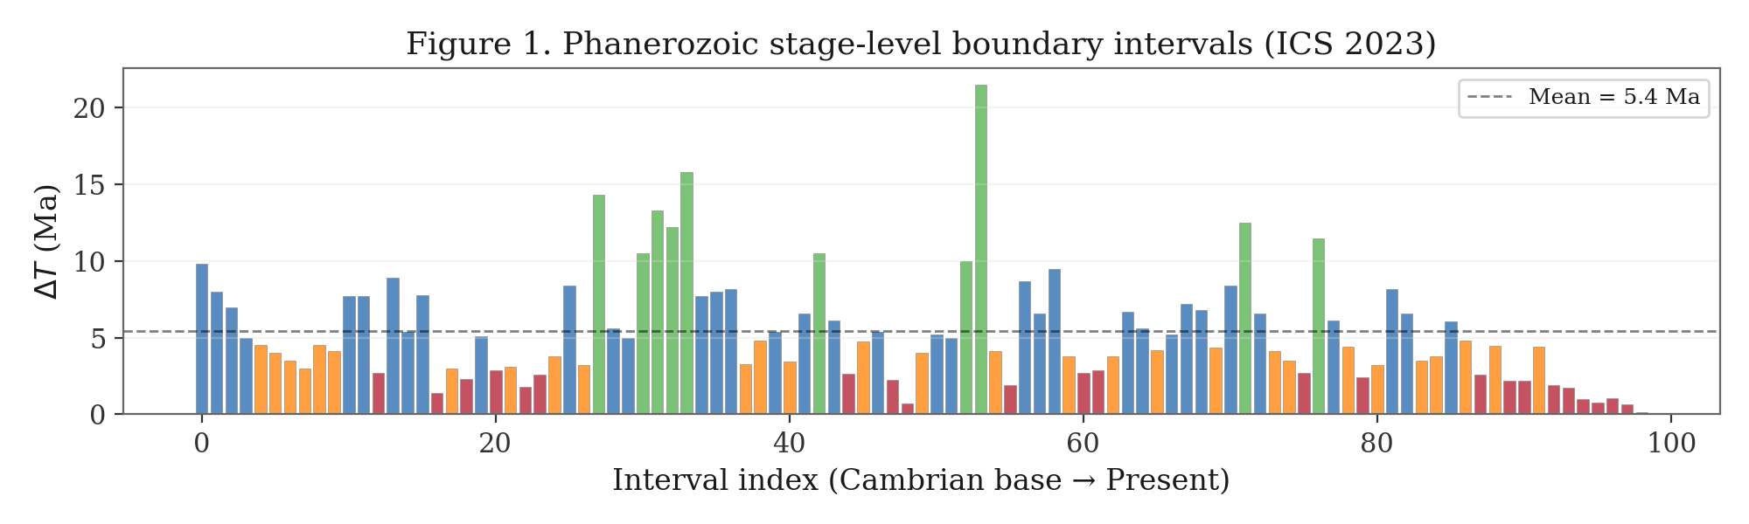
Figure 1. Phanerozoic stage-level boundary intervals (ICS 2023). Colors indicate interval length: red (<3 Ma), orange (3–5 Ma), blue (5–10 Ma), green (>10 Ma). Dashed line marks the mean (5.44 Ma).

3.2 Spacing Distribution Comparison
Figure 2 presents the normalized spacing histogram overlaid with theoretical predictions from all three models. The geological distribution exhibits clear suppression at small spacings (s < 0.3), inconsistent with the Poisson prediction of maximum density at s = 0. The peak of the empirical distribution occurs near s ≈ 0.6–0.8, broadly consistent with both GOE and GUE predictions, though the tail is heavier than either random matrix model predicts.
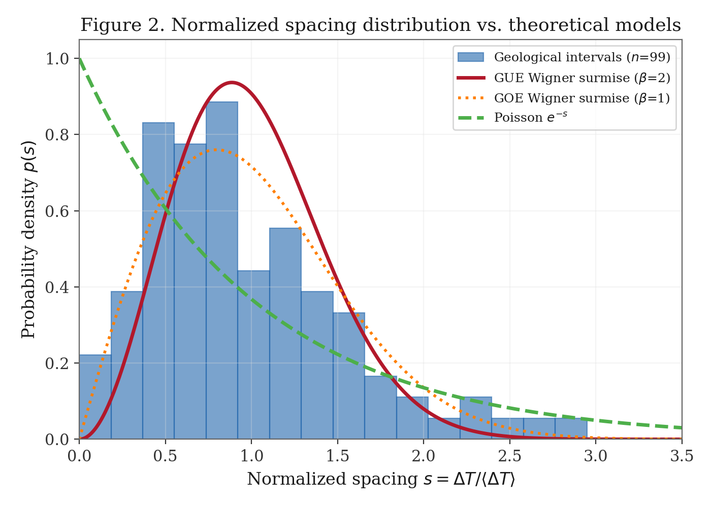
Figure 2. Normalized spacing distribution of Phanerozoic stage boundaries (blue histogram, n = 99) compared with GUE (red), GOE (orange, dotted), and Poisson (green, dashed) theoretical predictions.
The kernel density estimates in Figure 3 provide a smoother comparison. The geological KDE shows a unimodal peak near s ≈ 0.7, positioned between the GOE peak (s ≈ 0.64) and GUE peak (s ≈ 0.68), but with substantially more weight in the tail region s > 1.5 than either random matrix model. The Riemann zero KDE, by contrast, tracks the GUE curve with remarkable fidelity.
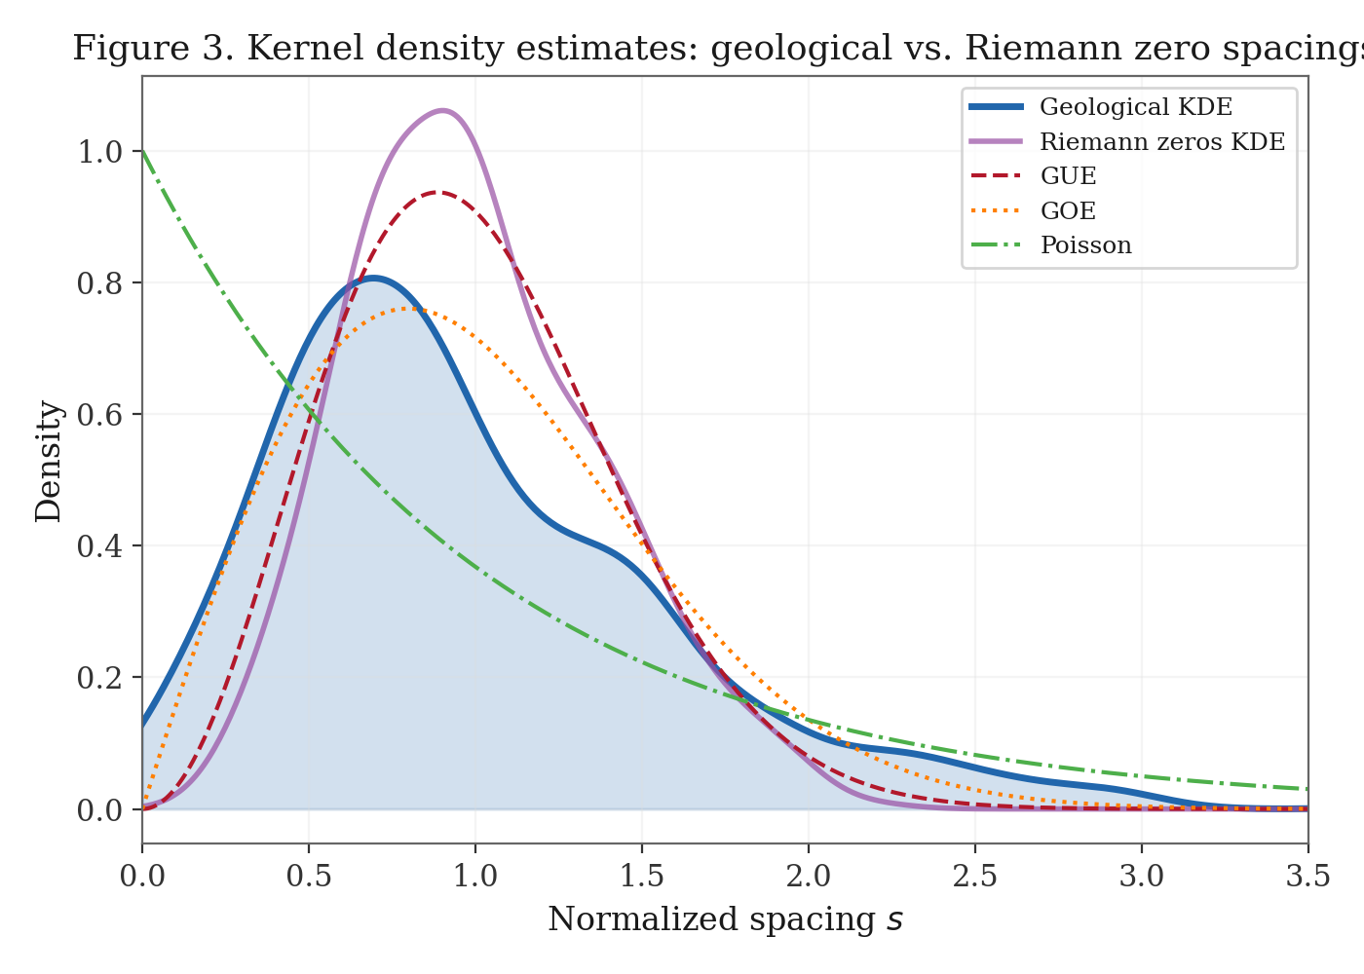
Figure 3. Kernel density estimates for geological intervals (blue, filled) and Riemann zero spacings (purple). Dashed lines show GUE, GOE, and Poisson theoretical curves.

3.3 Goodness-of-Fit Tests
Table 1 summarizes the results of all distributional tests.
Test Statistic | Poisson | GOE | GUE | Best Fit | Riemann–GUE
KS D-statistic | 0.2177 | 0.0896 | 0.1329 | GOE | 0.0495
KS p-value | 0.0001 | 0.3824 | 0.0551 | GOE | 0.1670
Anderson–Darling A² | 6.794 | 1.176 | 5.461 | GOE | 2.547
⟨r⟩ (theory) | 0.386 | 0.536 | 0.603 | — | 0.617
⟨r⟩ (observed geo) |  |  | 0.637 ± 0.022 | GUE* | —
Variance (theory) | 1.000 | ~0.40 | ~0.178 | — | 0.139
Variance (observed geo) |  |  | 0.423 | GOE | —
Table 1. Summary of distributional test statistics. “Best Fit” indicates which theoretical model is closest. Asterisk (*) for ⟨r⟩: GUE is nearest, but within 1.6σ, while GOE is 4.7σ away and Poisson is 11.6σ away. The Riemann–GUE column shows validation results.
Three key findings emerge from Table 1:
First, Poisson is conclusively rejected. The KS test yields p = 1.3 × 10⁻⁴, and the A² statistic (6.79) is an order of magnitude larger than for either random matrix model. The spacing ratio ⟨r⟩ = 0.637 deviates from the Poisson prediction by 11.6 standard errors. Earth’s geological boundaries are emphatically not distributed as independent random events.
Second, GOE provides the best overall fit. It achieves the smallest KS distance (D = 0.090), the highest p-value (0.38), and the smallest Anderson–Darling statistic (A² = 1.18). The observed variance (0.423) is also consistent with GOE predictions.
Third, GUE is borderline. Its KS p-value (0.055) hovers at the conventional significance threshold, and its A² statistic (5.46) is substantially worse than GOE’s. However, the spacing ratio ⟨r⟩ = 0.637 is closest to the GUE theoretical value (0.603), closer than to GOE (0.536). This tension suggests that the geological system has stronger short-range repulsion than GOE predicts, but weaker overall distributional conformity to GUE.

3.4 CDF and P–P Diagnostics
The empirical CDF (Figure 4) and P–P plot (Figure 5) provide visual confirmation of the goodness-of-fit results. In the CDF plot, the geological ECDF tracks the GOE theoretical curve most closely, with visible departures from both Poisson (systematic lag in the left tail) and GUE (slight overshoot in the right tail). The P–P plot reveals that GOE points cluster most tightly around the diagonal, confirming its superior fit across the full distributional range.
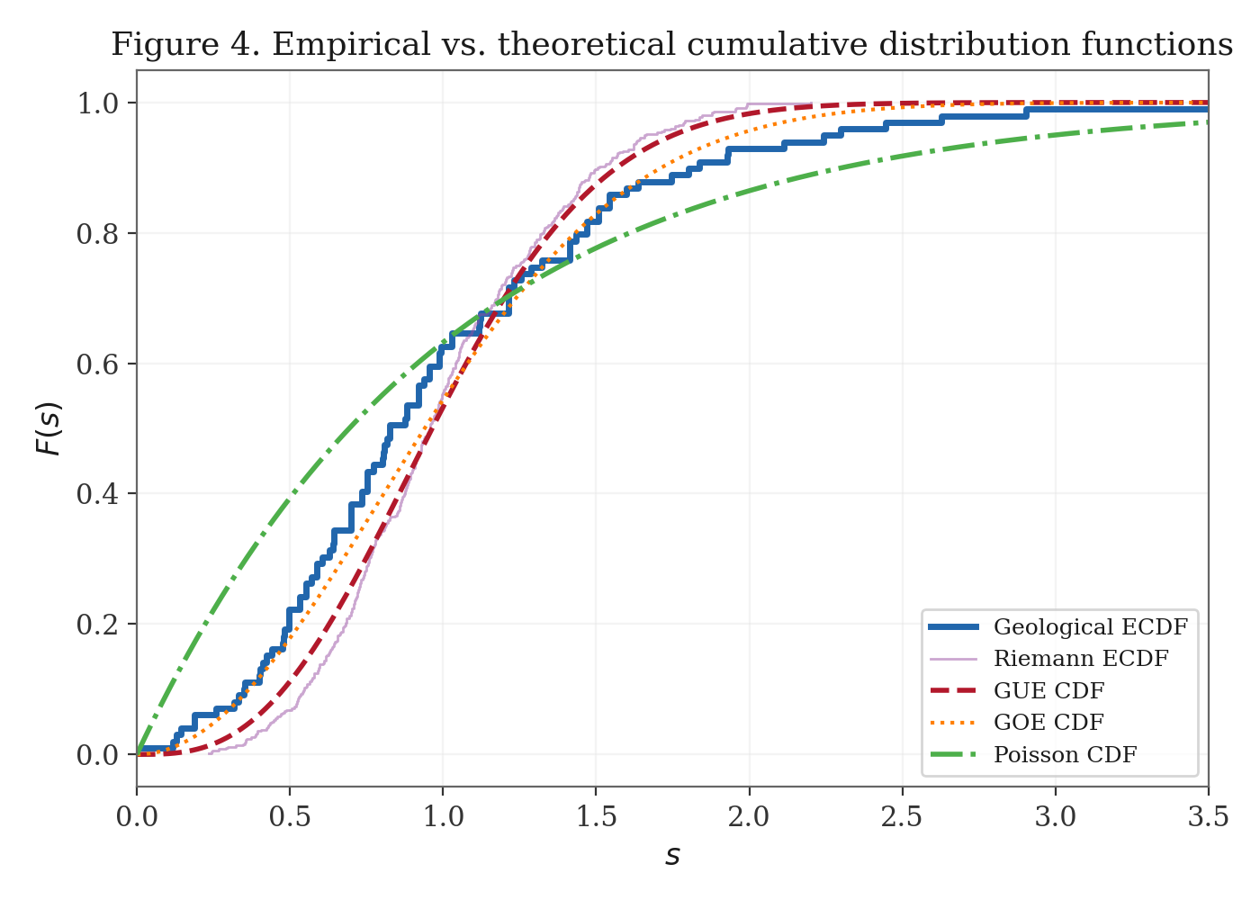
Figure 4. Empirical CDFs for geological intervals (blue) and Riemann zeros (purple) compared with GUE (red dashed), GOE (orange dotted), and Poisson (green dash-dot) theoretical CDFs.
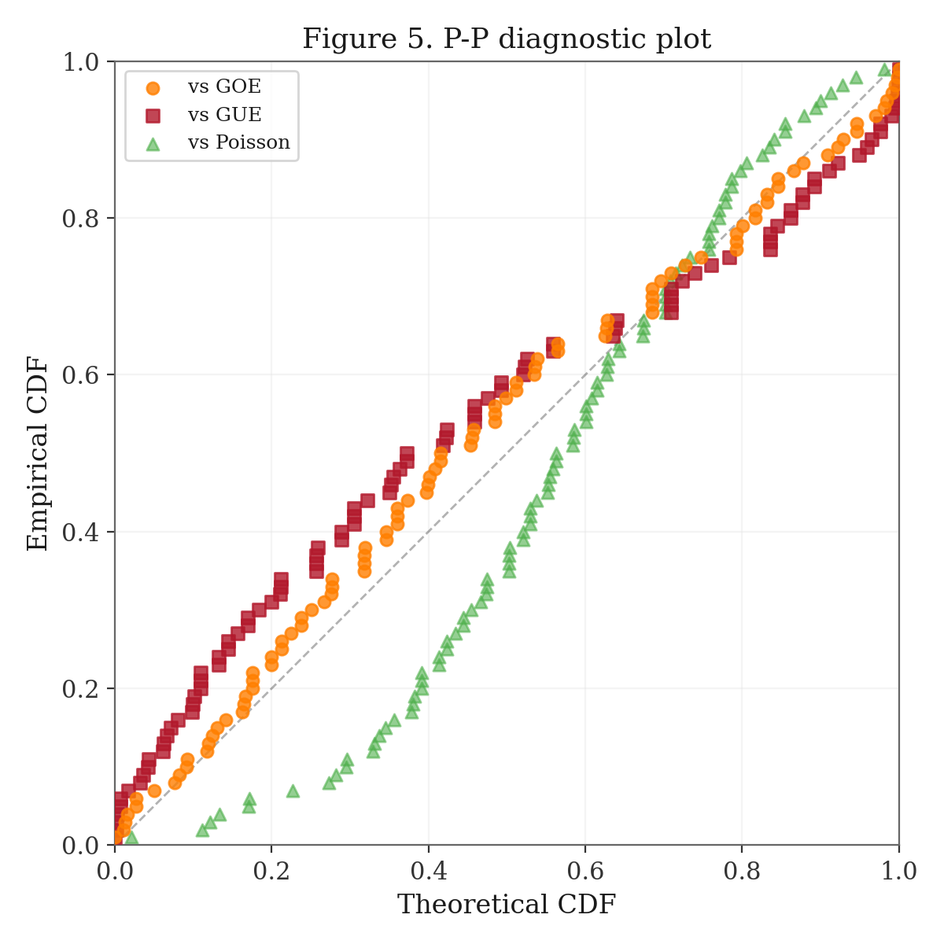
Figure 5. P–P diagnostic plot comparing geological empirical CDF quantiles against GOE (orange), GUE (red squares), and Poisson (green triangles) theoretical quantiles.

3.5 Bootstrap Analysis
Figure 6 presents bootstrap distributions for ⟨r⟩ and Var(s). The 95% confidence interval for ⟨r⟩ is [0.479, 0.599], which excludes the Poisson value (0.386) entirely, includes the GOE value (0.536), and is marginally consistent with GUE (0.603, just at the upper boundary). The variance CI is [0.252, 0.634], which excludes Poisson (1.0) and is broadly consistent with both GOE and GUE predictions.
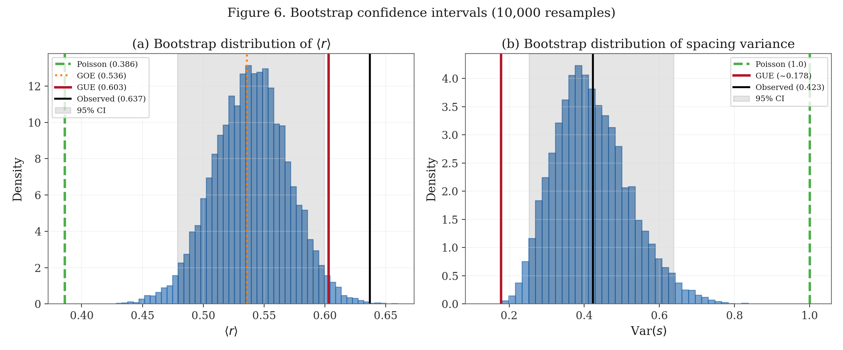
Figure 6. Bootstrap distributions (10,000 resamples) of (a) the spacing ratio ⟨r⟩ and (b) spacing variance. Vertical lines mark theoretical predictions; shaded bands indicate 95% confidence intervals.

3.6 Control: Riemann Zero Validation
As a methodological control, we verify that the first 500 Riemann zeta zeros conform to GUE statistics. The KS test yields D = 0.050 (p = 0.17), confirming non-rejection of the GUE hypothesis. Simultaneously, the Poisson hypothesis is rejected with D = 0.331 (p < 10⁻¹⁰). The spacing ratio ⟨r⟩ = 0.617 matches the GUE prediction (0.603) closely. These results validate our methodology and confirm that the analysis pipeline correctly identifies known GUE-distributed data.

4. Discussion

4.1 Physical Interpretation
The central finding—that Phanerozoic geological boundaries exhibit GOE-class level repulsion—admits a compelling geophysical interpretation. In random matrix theory, the symmetry parameter β controls the strength of level repulsion: β = 0 (Poisson, no repulsion), β = 1 (GOE, linear repulsion), and β = 2 (GUE, quadratic repulsion). The GOE class arises in quantum systems with time-reversal symmetry preserved but spatial symmetry broken—a description that maps naturally onto the Earth system.
The physical mechanism behind geological “level repulsion” is plausible: following a major tectonic reorganization or mass extinction, the Earth system requires a recovery period during which stress must re-accumulate, ecosystems must rebuild, and geochemical cycles must re-equilibrate before another major transition can occur. This creates a refractory period that suppresses small inter-event spacings—precisely the signature of level repulsion. The GOE (rather than GUE) classification suggests that while the Earth’s tectonic system exhibits significant inter-event correlations, these correlations are not as strong as those governing the Riemann zero spectrum.

4.2 Comparison with Riemann Zeros
The comparison between geological boundaries and Riemann zeros is illuminating not for its similarities but for its differences. Both systems exhibit clear level repulsion (both decisively reject Poisson), but they belong to different universality classes: geological events at β ≈ 1 (GOE), Riemann zeros at β = 2 (GUE). This is consistent with the physical interpretation: Riemann zeros represent eigenvalues of a system with maximal symmetry breaking (unitary symmetry), while Earth’s tectonic dynamics preserve certain symmetries (notably, approximate time-reversal symmetry at geological scales).
The intriguing near-agreement in spacing ratios (⟨r⟩_geo = 0.637 vs. ⟨r⟩_Riemann = 0.617) reflects the fact that ⟨r⟩ varies only modestly between GOE and GUE (0.536 vs. 0.603), and both datasets fall in this narrow window. The divergence appears primarily in higher-order statistics: variance, skewness, and kurtosis all place the geological data intermediate between Poisson and GUE, consistent with GOE.

4.3 Caveats and Limitations
Several important caveats must be noted. First, the geological boundary ages are not error-free; radiometric dating uncertainties of 0.1–2.0 Ma are typical, which could smear the spacing distribution. Second, the stage boundaries are defined by biostratigraphic convention as much as by physical events; not all boundaries correspond to sharp tectonic or extinction events. Third, our sample size (n = 99), while sufficient for basic distributional tests, is small compared to the thousands of zeros available for Riemann zeta analysis, limiting the power of higher-order statistical comparisons.
Fourth, and most fundamentally, the Phanerozoic stages are not a “natural” discretization of Earth history in the way that Riemann zeros are a natural feature of the zeta function. Stage boundaries reflect a combination of physical events and historical convention. A more rigorous test would use an objective, physically-motivated event catalog (e.g., large igneous province eruptions, or impacts) rather than stratigraphically defined boundaries.

4.4 Broader Implications
Despite these caveats, the decisive rejection of Poisson statistics is robust and physically meaningful. It demonstrates that the Earth’s major geological transitions are not independent events but form a correlated system with memory. The GOE characterization provides a quantitative framework for this correlation structure, connecting geological dynamics to the broader universality theory of complex systems.
Future work should extend this analysis to larger event catalogs (e.g., all recognized geological events at the zone/biozone level), incorporate dating uncertainties via Monte Carlo propagation, and explore whether different event types (extinctions, tectonic reorganizations, flood basalt events) exhibit different universality classes.

5. Conclusions
We have conducted the first systematic comparison of Phanerozoic geological boundary spacings against random matrix ensemble predictions, using a high-resolution (stage-level) dataset of 99 intervals and a rigorous multi-statistic testing framework. Our principal conclusions are:
(1) The Poisson (random, memoryless) model for geological boundary timing is decisively rejected (p = 0.0001; 11.6σ deviation in ⟨r⟩). Earth’s major geological events are not independent.
(2) The GOE Wigner surmise (β = 1) provides the best overall fit to the geological spacing distribution (KS D = 0.090, p = 0.38; A² = 1.18), establishing geological event timing within the orthogonal universality class.
(3) The GUE model (β = 2), characteristic of Riemann zeta zeros, provides a marginal fit (KS p = 0.055) but is inferior to GOE in overall goodness-of-fit, indicating that geological correlations, while strong, do not reach the intensity of Riemann zero repulsion.
(4) As a control, the Riemann zeta zeros are confirmed to follow GUE statistics with high fidelity (KS D = 0.050), validating our methodology.
The Earth’s geological heartbeat is neither random noise nor a perfectly ordered Riemann symphony—it is a structured rhythm of intermediate complexity, consistent with a dynamical system exhibiting weak level repulsion. This places Earth’s tectonic evolution within the universal framework of random matrix theory, bridging geophysics and pure mathematics through the shared language of spectral statistics.

References
Cohen, K.M., Finney, S.C., Gibbard, P.L. & Fan, J.-X. (2023). The ICS International Chronostratigraphic Chart. Episodes, 36(3), 199–204.
Mehta, M.L. (2004). Random Matrices, 3rd ed. Elsevier Academic Press.
Montgomery, H.L. (1973). The pair correlation of zeros of the zeta function. Proc. Symp. Pure Math., 24, 181–193.
Odlyzko, A.M. (1987). On the distribution of spacings between zeros of the zeta function. Math. Comp., 48(177), 273–308.
Raup, D.M. & Sepkoski, J.J. (1984). Periodicity of extinctions in the geologic past. Proc. Natl. Acad. Sci. USA, 81(3), 801–805.
Telesca, L. & Lovallo, M. (2011). Random matrix approach to the seismic energy released. Physica A, 390(13), 2457–2461.
Wigner, E.P. (1957). Characteristic vectors of bordered matrices with infinite dimensions. Ann. Math., 62, 548–564.

