|  |
| --- |
|  |
| TRAFFIC SQUAD MANAGEMENT SYSTEM |
| **RELATIONAL DATABASE MODEL** |
| **Bcs213072 Mobeen Saeed**  **Bcs213065 Ruquiya Nasir**  **Bcs213053 Laiba Shahzadi** |
|  |
| **12/9/2022** |

|  |
| --- |
|  |

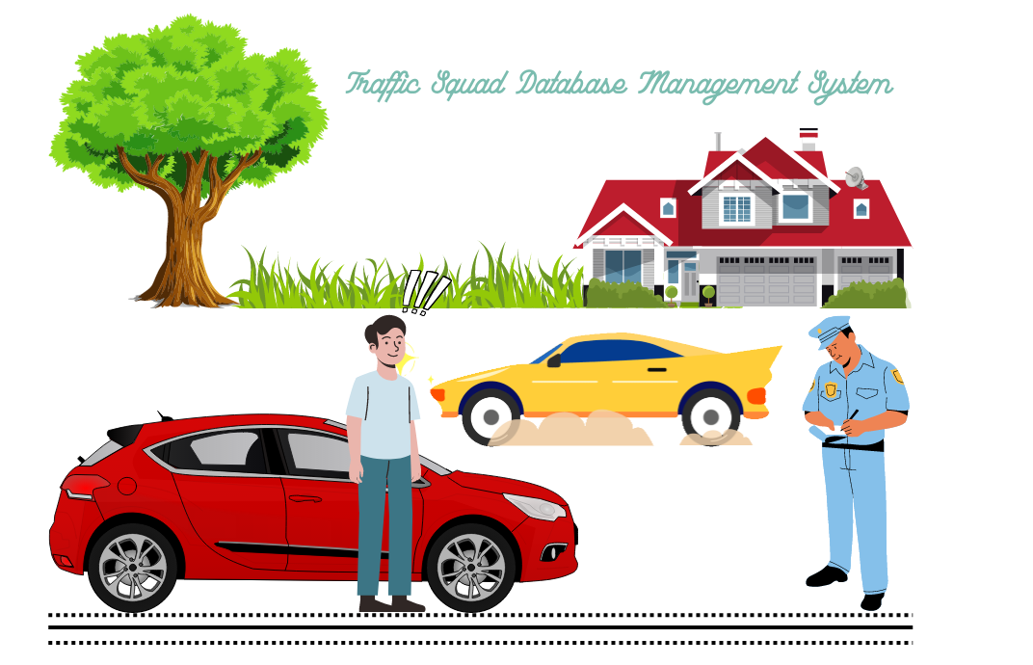

**TRAFFIC SQUAD MANAGEMENT SYSTEM**

**RDM (Relational Database Model)**

Policestation (Pname, code, location)

TrafficPolice (PoliceID, Pname, officername, RANK, CNIC, city, area, street)

Qualification (title, examname)

TrafficPoliceQualification (PoliceID, examname)

TContact_no (c_id, workphone, cellphone)

TrafficPoliceContact_no (PoliceID, c_id)

Te-mail (E-mID)

TrafficPoliceE-mail (E-mID, PoliceID)

Offender (PoliceID, offenderID, Licensetype, licenseNo, address, firstname, lastname, gender, CNIC,)

Ocontactno (c_id, workphone, cellphone)

Offendercontactno (offenderID, c_id)

Oe-mail (oE-mID)

OffenderE-mail (oE-mID, offenderID)

Challan (challanno, PoliceID, offenderID, Sectionact, Noplate, offensedate, city, street, area)

ViolationList (PoliceID, VID, violationname, penalty, Sectionact)

Vehicle (PoliceID, Noplate, vehcileName, type)

**THE END!!**