# Purpose：

Biomedical literature is a rich but also complex source of information. To help researchers summarize literature on a topic in the form of a network, we developed a literature network application for cellular landscape that draws inspiration from two existing applications, agilentliteraturesearch and StringApp. The user query provides a summary of the topics described and selects the organisms for which the network should be generated. The application then queries the weekly database of precomputed text mining results through API to retrieve the list of genes mentioned in the summary, as well as the sentences in the excerpt that refer to any two genes. According to this information, literature network should program to construct a Cytoscape network, in which nodes and edges represent genes and their co-display, respectively. The application allows users to view sentences that support any edge, and all retrieved information is stored as a source in the Cytoscape session file.

# Operation：

## Step 1: the document list

in the form of PMID, for example:

two ways of selecting: 1. retrieve related documents in PubMed with subject words; 2, the user uploads the PMID list file or copies the PMID list content to input box

1. to retrieve the relevant literature PMID with a theme word, such as: breast cancer input breast cancer, click the run button and the app will return the literature-related content with an upper limit of 100 in the result box

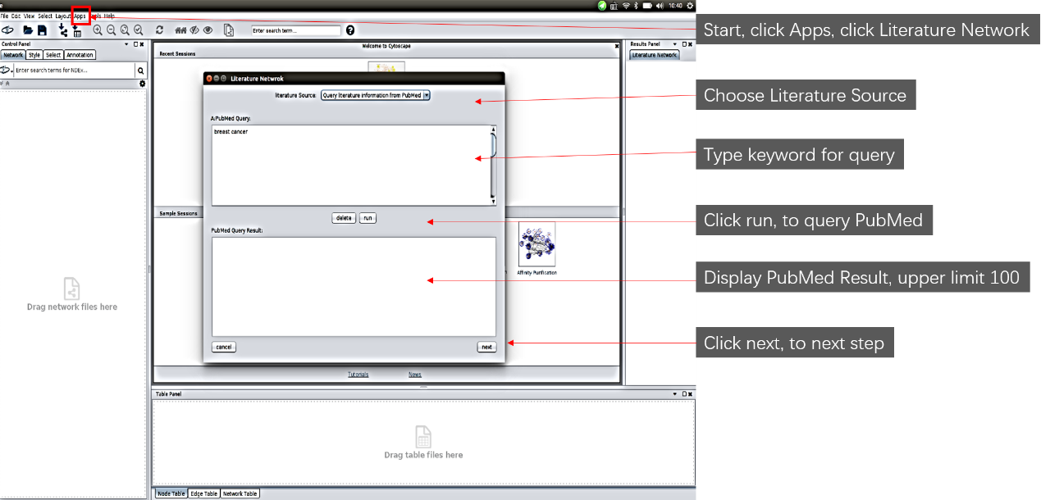

After click run button，the result interface:

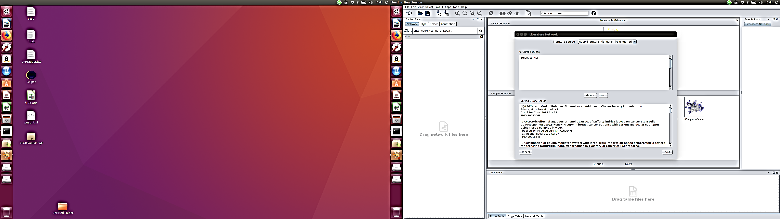

1. User uploads the PMID list file himself or copies the PMID list content to the input box

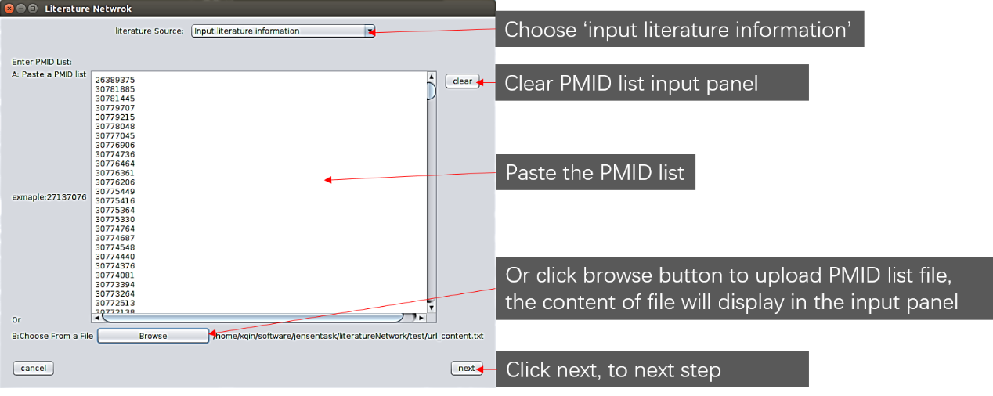

Click next button

## Step 2: the protein list

In form of speciesID.proteinID, for example:

Select species in the species box

two ways of selecting: 1. retrieve related protein in String; 2, the user uploads the protein list file or copies the protein list content to input box

1, retrieve in string, set the maximum number of returned proteins n, The protein list of the top n in PMID was retrieved from string database. Example: the number of proteins is 100.

2, users themselves upload the speciesID.proteinID list file or copy the list content to the input box

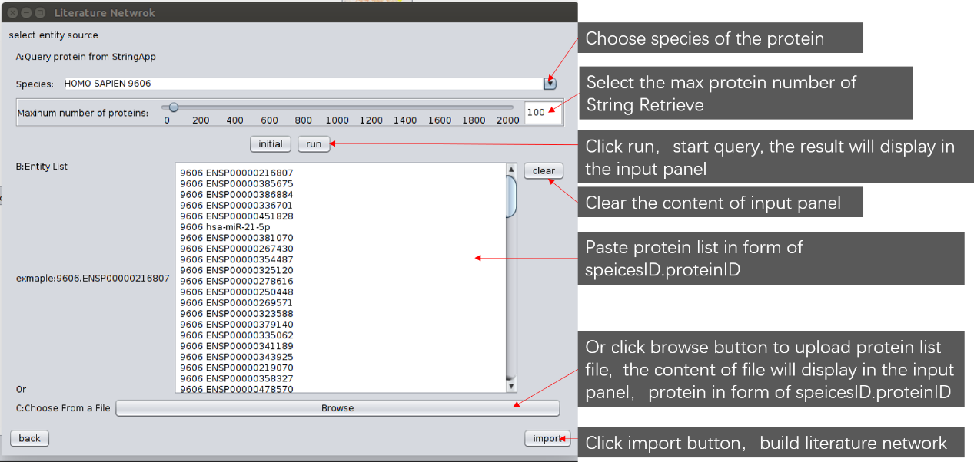

## Step3 click import button to build network

## Step4 click the edge in the network

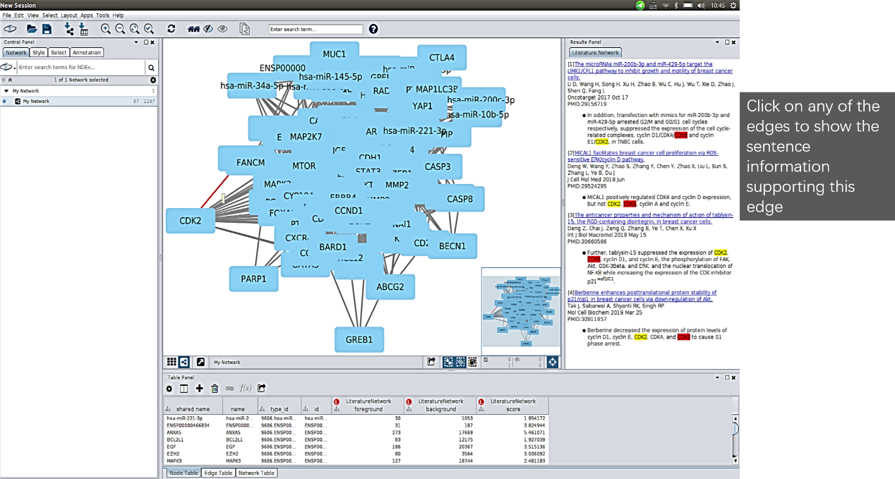

Display sentences that support any edge, and all retrieved information is stored as a source in the Cytoscape session file