**Experiment: 9**

PART A

(PART A: TO BE REFERRED BY STUDENTS)

**Aim: To study the Collection Interfaces and Collection Class**

**Learning Outcomes: Learner would be able to**

1. Implement the Collection Interfaces- List and Set
2. Implement the Collection Class- Array List, The Linked List
3. Understanding how to access a collection- using an Iterator and For-each loop

**Tasks:**

For the following Problem Statements write programs using classes, objects and methods

1. Write a Java program to demonstrate basic CRUD (Create, Read, Update, Delete) operations on a list using the methods provided by the List interface.
2. Write a Java program to demonstrate the usage of the Set interface in the Java Collection Framework.
3. Write a Java program to demonstrate the use of the ArrayList class in the Java Collection Framework and traverse it using an Iterator.
4. Write the above program using for-each loop.
5. Write a Java program to demonstrate the use of the LinkedList class in the Java Collection Framework and traverse it using an Iterator.
6. Write the above program using for-each loop.

PART B

(PART B: TO BE COMPLETED BY STUDENTS)

Students must submit the soft copy as per following segments within two hours of the practical. The soft copy must be uploaded on the portal at the end of the practical. The filename should be **JAVA_batch_rollno_experimentno Example: JAVA_A1_A001_P1**

|  |  |
| --- | --- |
| **Roll No.: C126** | **Name: Rushabh Abhay Shah** |
| **Prog/Yr/Sem: BTI/4/8** | **Batch: d1** |
| **Date of Experiment: 05-04-2025** | **Date of Submission: 05-04-2025** |

Task 1: includes the following

1. Input statement

Q1

import java.util.*;

public class q1 {

public static void main(String[] args) {

// Create a list

List<String> list = new ArrayList<>();

// Create: Add elements to the list

list.add("Apple");

list.add("Banana");

list.add("Orange");

// Read: Display elements

System.out.println("List: " + list);

// Update: Modify an element

list.set(1, "Mango");

System.out.println("Updated List: " + list);

// Delete: Remove an element

list.remove("Orange");

System.out.println("List after deletion: " + list);

}

}

Q2

import java.util.*;

public class q2 {

public static void main(String[] args) {

// Create a Set

Set<String> set = new HashSet<>();

// Add elements to the set

set.add("Apple");

set.add("Banana");

set.add("Orange");

set.add("Apple"); // Duplicate element

// Display elements (duplicates will be ignored)

System.out.println("Set: " + set);

}

}

Q3

import java.util.*;

public class q3 {

public static void main(String[] args) {

// Create an ArrayList

ArrayList<String> arrayList = new ArrayList<>();

arrayList.add("Apple");

arrayList.add("Banana");

arrayList.add("Orange");

// Traverse using Iterator

Iterator<String> iterator = arrayList.iterator();

System.out.println("ArrayList Traversal using Iterator:");

while (iterator.hasNext()) {

System.out.println(iterator.next());

}

}

}

Q4

import java.util.*;

public class q4 {

public static void main(String[] args) {

// Create an ArrayList

ArrayList<String> arrayList = new ArrayList<>();

arrayList.add("Apple");

arrayList.add("Banana");

arrayList.add("Orange");

// Traverse using For-Each Loop

System.out.println("ArrayList Traversal using For-Each Loop:");

for (String item : arrayList) {

System.out.println(item);

}

}

}

Q5

import java.util.*;

public class q5 {

public static void main(String[] args) {

// Create a LinkedList

LinkedList<String> linkedList = new LinkedList<>();

linkedList.add("Apple");

linkedList.add("Banana");

linkedList.add("Orange");

// Traverse using Iterator

Iterator<String> iterator = linkedList.iterator();

System.out.println("LinkedList Traversal using Iterator:");

while (iterator.hasNext()) {

System.out.println(iterator.next());

}

}

}

Q6

import java.util.*;

public class q6 {

public static void main(String[] args) {

// Create a LinkedList

LinkedList<String> linkedList = new LinkedList<>();

linkedList.add("Apple");

linkedList.add("Banana");

linkedList.add("Orange");

// Traverse using For-Each Loop

System.out.println("LinkedList Traversal using For-Each Loop:");

for (String item : linkedList) {

System.out.println(item);

}

}

}

2. Output statement

Q1

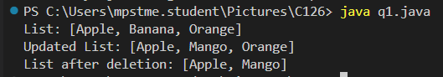

Q2



Q3

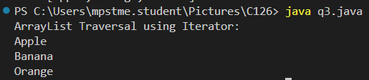

Q4

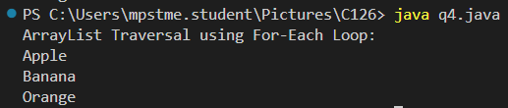

Q5

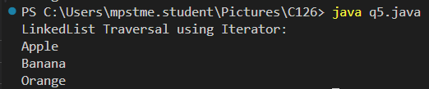

Q6

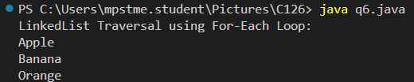

**Conclusion (Learning Outcomes):** Reflect on the questions answered by you jot down your learnings about the Topic:

**Learnt how to implement Collection classes and Collection Interfaces.**