Library Management System
A Data-Driven Java Application with Spring Boot, MongoDB, and a Swing Desktop Client

Student Information
Field | Details
Full Name | [YOUR FULL NAME]
Student ID | [YOUR STUDENT ID]
Course / Module | [COURSE / MODULE NAME]
Instructor | [INSTRUCTOR NAME]
Submission Date | [SUBMISSION DATE]

Project URLs
Resource | Link
GitHub Repository | [PASTE GITHUB REPOSITORY URL HERE]
Video Demonstration | [PASTE VIDEO URL HERE — YouTube / OneDrive]

Note: Replace all bracketed placeholders above before submission. Screenshots in the Results section marked “illustrative mockup” should be replaced with real screenshots captured while running the application, and the video link above must point to a 3–5 minute screen recording demonstrating the system end to end.

1. Introduction

1.1 Overview
Libraries — whether at a school, university, or in a small community — need a reliable way to track which books they own, who is allowed to borrow them, and which copies are currently out on loan. Many small libraries still rely on spreadsheets or paper registers, which do not scale, are error-prone, and provide no automatic enforcement of rules such as loan limits or overdue fines. This project addresses that problem by building a complete, data-driven Library Management System (LMS).
The system is composed of three cooperating parts: a MongoDB database that persistently stores books, members, and loan records; a Spring Boot backend that exposes a RESTful API implementing all business rules and CRUD operations; and a Java Swing desktop application that gives library staff a friendly graphical interface to the API without requiring them to write HTTP requests by hand.

1.2 Objectives
- Design a NoSQL (MongoDB) data model capable of representing books, members, and loan transactions, including referential relationships between collections.
- Implement a Spring Boot backend exposing a full CRUD REST API for each entity, plus higher-level business operations (issuing and returning books).
- Enforce real-world business rules in code: unique ISBNs/emails, copy-availability checks before a loan is issued, and automatic overdue-fine calculation on return.
- Build a desktop GUI (Java Swing) that consumes the REST API and lets a librarian perform every CRUD and loan operation without touching the command line.
- Implement comprehensive, centralised error handling on the backend and resilient, user-friendly error handling on the client, so the system degrades gracefully under failure conditions (e.g. a temporarily unreachable database).
- Document the system's architecture, implementation, and design decisions to support future maintenance and extension.

1.3 Significance of the Chosen Solution
A library management system is a compact but complete example of the kind of data-driven application found throughout industry: a persistent store, a service layer enforcing business rules, an API boundary, and a client. Building it end-to-end demonstrates database schema design for a document store, RESTful API design, layered backend architecture, defensive error handling, and building a GUI client that talks to a remote service over HTTP — all core, transferable software engineering skills.

2. System Architecture
The application follows a classic layered architecture, separating presentation, API, business logic, and persistence concerns. This keeps each layer independently testable and replaceable — for example, the Swing GUI could be swapped for a web frontend without touching the backend at all, because both would talk to the same REST API.
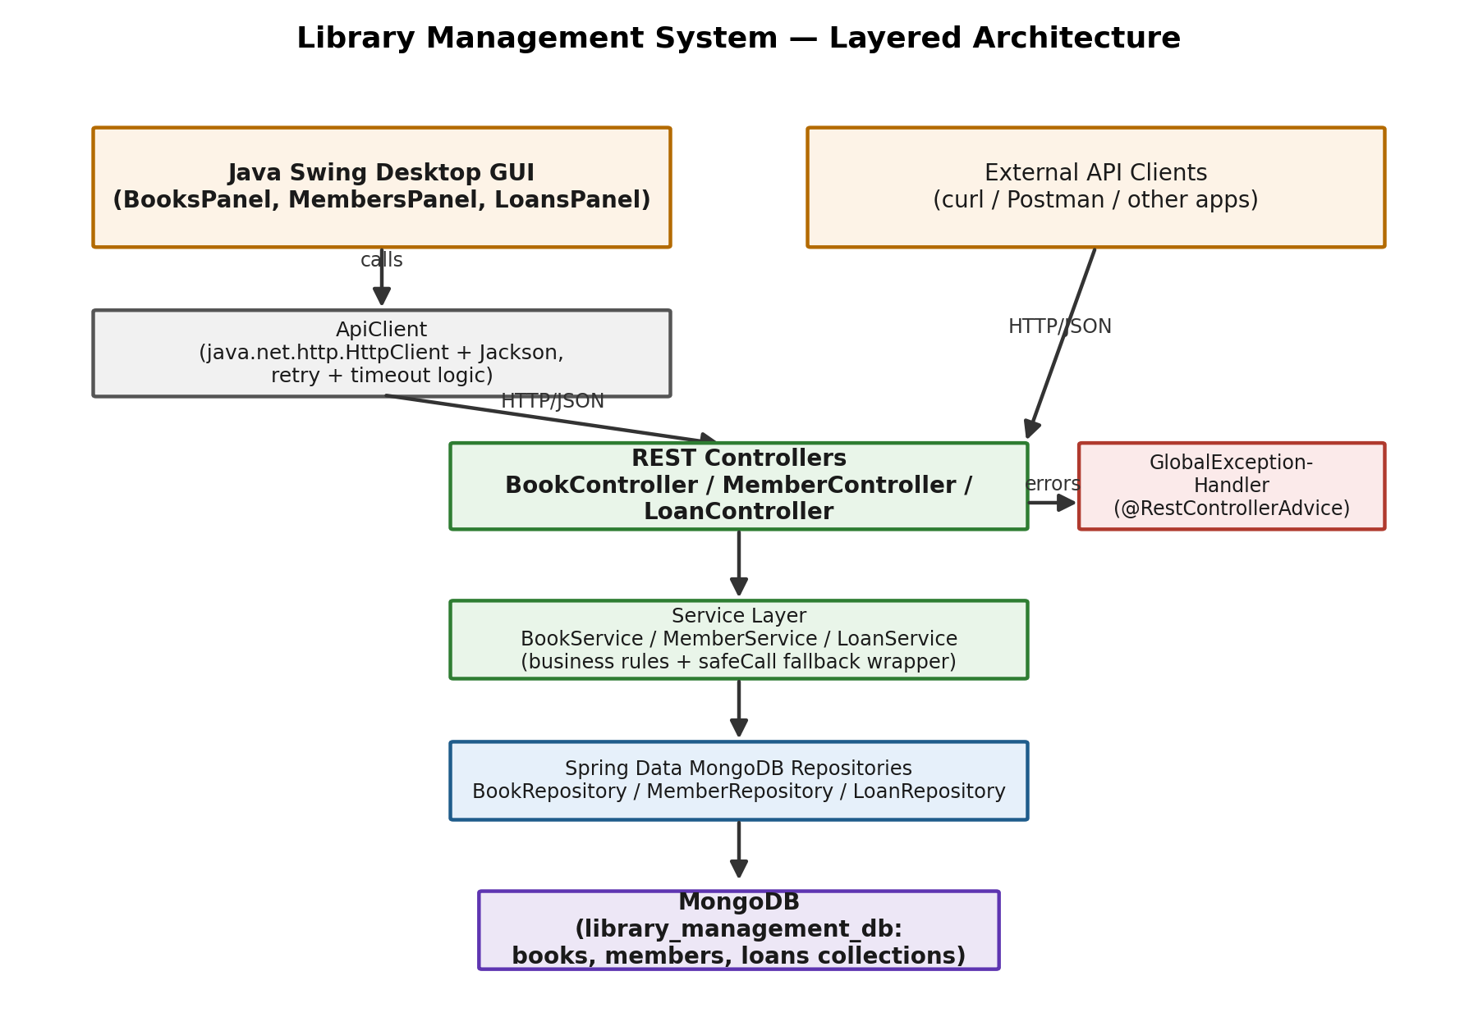
Figure 1. Layered architecture of the Library Management System.

2.1 Component Overview
Component | Responsibility
Java Swing GUI | Desktop client; renders tables/forms for Books, Members, and Loans; calls the REST API via ApiClient; shows errors via dialogs.
ApiClient (GUI) | Wraps java.net.http.HttpClient; adds timeouts, one automatic retry on connectivity failure, and JSON (de)serialisation with Jackson.
REST Controllers | Expose HTTP endpoints under /api/books, /api/members, /api/loans; translate HTTP requests into service calls.
Service Layer | Implements business rules (uniqueness checks, availability checks, fine calculation) and wraps all database access for fallback handling.
Spring Data Repositories | Interfaces extending MongoRepository; Spring Data generates the MongoDB queries at runtime.
MongoDB | NoSQL document database; stores three collections: books, members, loans.
GlobalExceptionHandler | Cross-cutting concern: converts every exception raised anywhere in the request lifecycle into a consistent JSON error response.

2.2 Data Model
Books, members, and loans are each stored as their own MongoDB collection. Rather than embedding books and members inside loan documents (which would duplicate data and make updates inconsistent), a Loan stores lightweight references — bookId and memberId — to documents in the other two collections. This keeps availableCopies on the Book document as the single source of truth for how many copies are on the shelf.
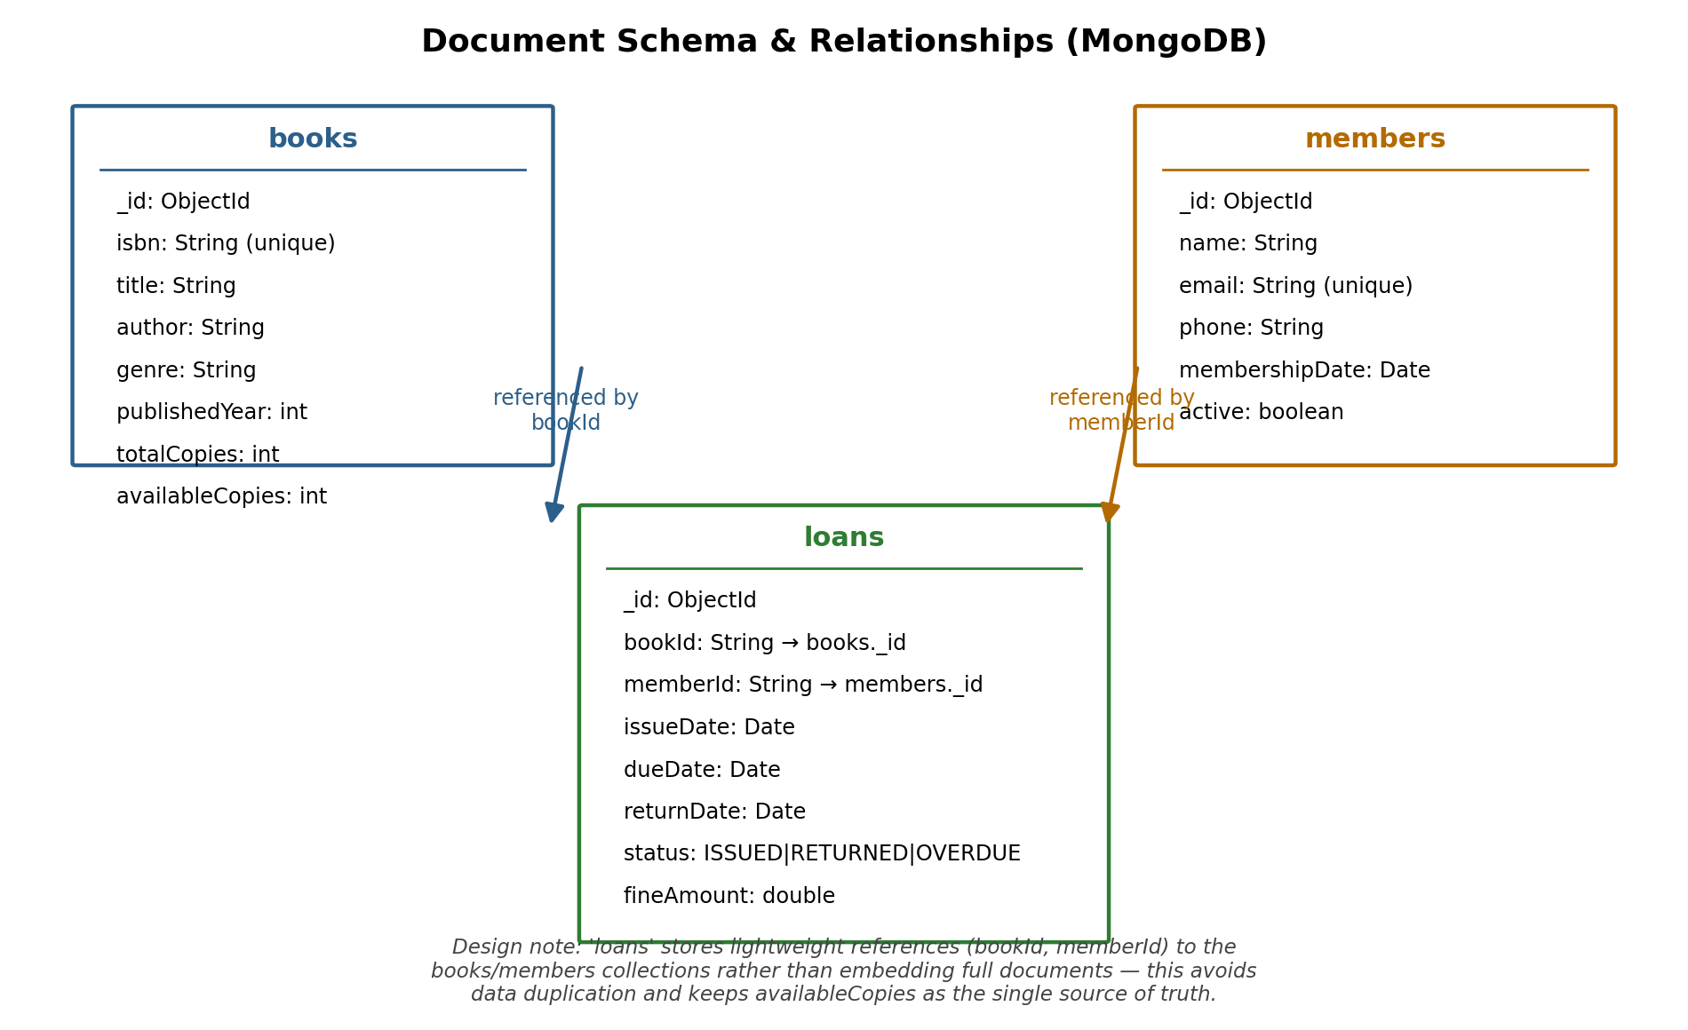
Figure 2. Document schema for the books, members, and loans collections.

2.3 Request Flow Example
To make the interaction between layers concrete, the diagram below traces a single business operation — issuing a book to a member — from the GUI button click through to the database and back, including the two failure paths (no copies available, and a database outage).
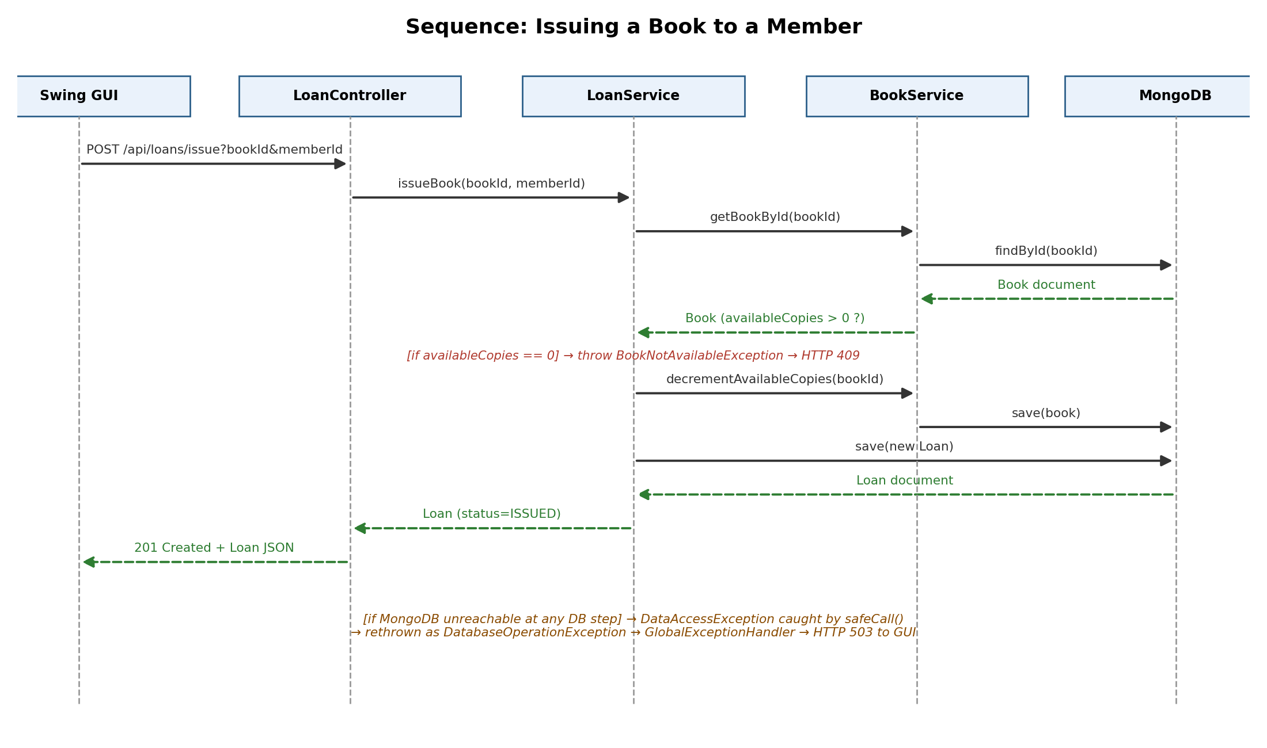
Figure 3. Sequence diagram for POST /api/loans/issue.

3. Implementation

3.1 Backend Development
The backend is a Spring Boot 3.3 application (Java 17) using spring-boot-starter-web for REST, spring-boot-starter-data-mongodb for persistence, and spring-boot-starter-validation for request validation. It is organised into five packages: model, repository, service, controller, and exception (plus a small dto and config package).
Each entity (Book, Member, Loan) has a corresponding @Document-annotated model class, a Spring Data MongoRepository interface providing CRUD plus derived-query methods (e.g. findByTitleContainingIgnoreCase), a service class containing business logic, and a REST controller. Example — the Book document model:
@Document(collection = "books")
@Data @NoArgsConstructor @AllArgsConstructor
public class Book {
@Id
private String id;
@NotBlank(message = "ISBN is required")
@Indexed(unique = true)
private String isbn;
@NotBlank(message = "Title is required")
private String title;
private String author;
private String genre;
private int publishedYear;
private int totalCopies;
private int availableCopies;
}
Business logic for the loan workflow lives in LoanService. Issuing a book validates that the member is active and that copies remain, decrements availableCopies, and creates a Loan with a due date 14 days out (configurable via application.properties). Returning a book computes an overdue fine automatically:
public Loan returnBook(String loanId) {
Loan loan = getLoanById(loanId);
if (loan.getStatus() == LoanStatus.RETURNED)
throw new InvalidRequestException("Loan already returned");
LocalDate today = LocalDate.now();
loan.setReturnDate(today);
loan.setStatus(LoanStatus.RETURNED);
long overdueDays = ChronoUnit.DAYS.between(loan.getDueDate(), today);
loan.setFineAmount(overdueDays > 0 ? overdueDays * finePerDay : 0.0);
bookService.incrementAvailableCopies(loan.getBookId());
return safeCall(() -> loanRepository.save(loan), "update loan on return");
}

3.2 Database Interaction
MongoDB was chosen as the NoSQL database because the domain fits document storage well: each Book, Member, and Loan is a self-contained record with no need for complex joins, and Spring Data MongoDB lets repository interfaces be declared with zero boilerplate. Uniqueness of isbn and email is enforced with @Indexed(unique = true) at the database level, backing up the application-level checks in the service layer (defence in depth).
Sample derived-query methods used throughout the project:
public interface BookRepository extends MongoRepository<Book, String> {
Optional<Book> findByIsbn(String isbn);
List<Book> findByTitleContainingIgnoreCase(String title);
List<Book> findByGenreIgnoreCase(String genre);
boolean existsByIsbn(String isbn);
}
A DataSeeder component (CommandLineRunner) inserts a small set of sample books and members on first startup if the collections are empty, so the API and GUI have data to demonstrate immediately without manual setup.

3.3 API Development
The REST API follows conventional resource-oriented design. Each of the three resources supports the full CRUD set, and two additional business endpoints model the loan workflow explicitly rather than treating it as a generic PUT on a Loan resource, since issuing/returning a book has side effects on a different resource (Book.availableCopies):
Method | Endpoint | Purpose
GET | /api/books, /api/members, /api/loans | List all
GET | .../{id} | Fetch one by id (404 if missing)
GET | /api/books/search?title=&author=&genre= | Search books
POST | /api/books, /api/members | Create (409 on duplicate ISBN/email)
PUT | .../{id} | Update
DELETE | .../{id} | Delete
POST | /api/loans/issue?bookId=&memberId= | Issue a book to a member
PUT | /api/loans/{id}/return | Return a book; computes fine if late
The Swing GUI's ApiClient calls these same endpoints using java.net.http.HttpClient with a 5-second request timeout and Jackson for JSON mapping, so the desktop client and any external tool (curl, Postman) are peers consuming an identical contract.

3.4 Error Handling & Fallback Design
Five custom exceptions model distinct failure categories: ResourceNotFoundException (404), DuplicateResourceException (409), BookNotAvailableException (409), InvalidRequestException (400), and DatabaseOperationException (503, used for the database-outage fallback). A single @RestControllerAdvice class, GlobalExceptionHandler, intercepts every exception thrown anywhere in the controller/service layers and converts it into a uniform JSON body:
@ExceptionHandler(DatabaseOperationException.class)
public ResponseEntity<ErrorResponse> handleDatabaseError(
DatabaseOperationException ex, HttpServletRequest req) {
log.error("Database operation failed: {}", ex.getMessage(), ex.getCause());
return build(HttpStatus.SERVICE_UNAVAILABLE,
"The database is temporarily unavailable. Please try again shortly.", req);
}
@ExceptionHandler(Exception.class) // last-resort safety net
public ResponseEntity<ErrorResponse> handleGeneric(Exception ex, HttpServletRequest req) {
log.error("Unexpected error", ex);
return build(HttpStatus.INTERNAL_SERVER_ERROR,
"An unexpected error occurred. Please contact support if this persists.", req);
}
Every service method routes its MongoDB calls through a small safeCall/safeRun helper that catches Spring's DataAccessException (thrown for connection failures, timeouts, etc.) and rethrows it as a DatabaseOperationException. This means a MongoDB outage anywhere in the call chain surfaces to the client as a clean, predictable 503 response instead of an unhandled 500 error with an internal stack trace — a concrete fallback procedure for unexpected failures.
On the client side, ApiClient retries a request once after a short delay if the initial attempt fails with a connection error or timeout, and every Swing panel wraps its network calls in a SwingWorker with a single catch block that shows the server's real error message (or a friendly connectivity message) via JOptionPane — the GUI never freezes and never crashes on a failed call. A JVM-wide uncaught-exception handler in LibraryGuiApp is a further safety net.

4. Results
The figures below illustrate the application's behaviour. (When you run the application yourself, replace these with real screenshots taken from your terminal and the running Swing window, as required by the assignment.)
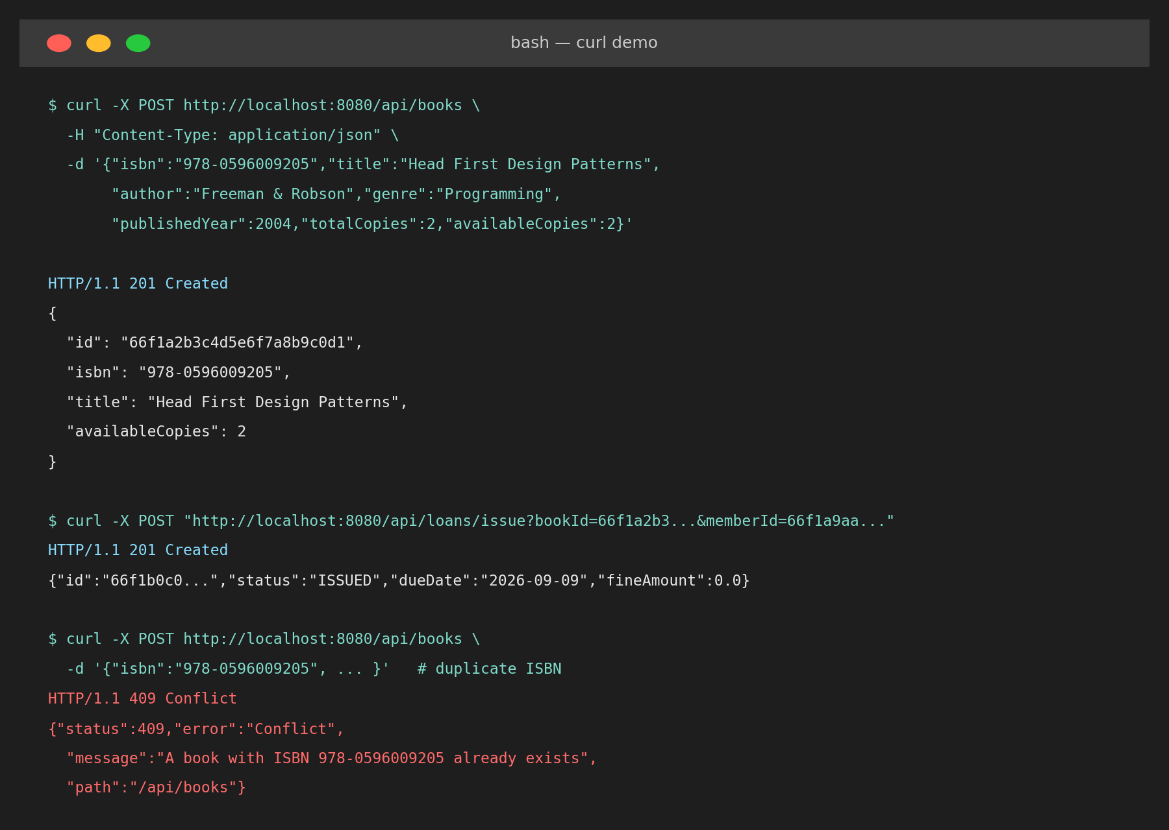
Figure 4 (illustrative mockup). Example curl calls: successful book creation, a successful loan issue, and a 409 Conflict returned for a duplicate ISBN.
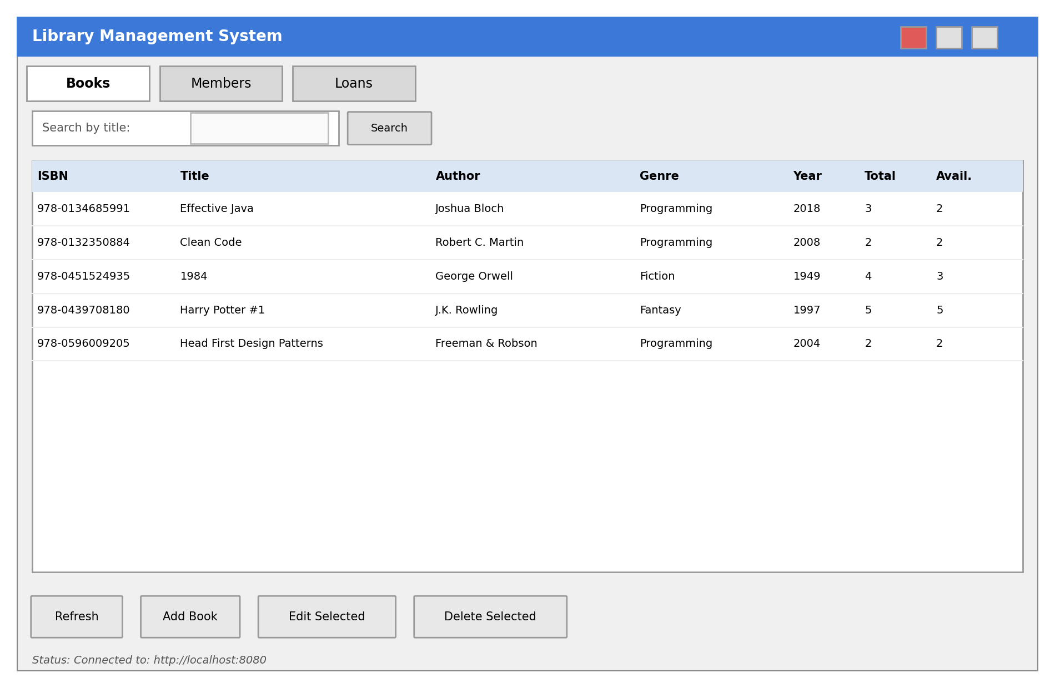
Figure 5 (illustrative mockup). The Swing GUI's Books tab, showing the seeded sample data, search box, and CRUD buttons.
In practice, exercising the running system demonstrates: (1) the DataSeeder populating sample books/members on first launch; (2) creating, editing, and deleting books and members from the GUI, each change reflected immediately via a table refresh; (3) issuing a book reduces its availableCopies by one and appears in the Loans tab with status ISSUED; (4) returning a book after its due date shows a fine calculated at $0.50/day and restores the copy count; (5) attempting to issue a book with zero available copies is rejected with a clear 409 error dialog rather than crashing the client; and (6) stopping the MongoDB service and retrying an operation produces a friendly “temporarily unavailable” message instead of a raw error.

5. Challenges and Solutions

5.1 Keeping availableCopies consistent
Challenge: because Loan only stores a bookId reference, there was a risk of availableCopies drifting out of sync with reality if an issue or return operation partially failed (e.g. the Book update succeeds but the Loan save fails, or vice versa).
Solution: the two writes are ordered so that the availability check happens first (fail fast with BookNotAvailableException before any write occurs), and the Book document is updated before the Loan document is saved, minimising the window in which the two could disagree. For a production system this would be strengthened further with a MongoDB multi-document transaction; this is noted as future work below.

5.2 Returning clean errors instead of raw exceptions
Challenge: by default, an unhandled Spring exception returns a generic 500 response containing an internal stack trace, which is both unhelpful and a potential information leak, and gives GUI clients nothing useful to show the user.
Solution: a small hierarchy of custom exceptions plus a single GlobalExceptionHandler ensures every failure — whether a business-rule violation, a validation error, or a database outage — is translated into the same ErrorResponse JSON shape with an appropriate HTTP status. This let the Swing GUI implement one generic error-handling path (ApiClient.toApiException) that works for every endpoint.

5.3 Keeping the desktop GUI responsive
Challenge: Swing runs all UI updates on a single Event Dispatch Thread; performing an HTTP call directly inside a button handler would freeze the entire window until the response arrived (or until the request timed out).
Solution: every network call in the GUI is wrapped in a SwingWorker, moving the HTTP request to a background thread and only touching Swing components again inside done(), which safely runs back on the EDT. Combined with a 5-second request timeout, this guarantees the UI never hangs indefinitely.

5.4 Testing without a live MongoDB instance
Challenge: unit-testing the service layer's business logic (e.g. duplicate-ISBN rejection, database-fallback wrapping) should not require a running MongoDB server.
Solution: BookServiceTest uses Mockito to mock BookRepository directly, allowing both the happy path and a simulated DataAccessResourceFailureException to be tested in isolation and asserted against the correct custom exception type.

6. Conclusion and Future Work

6.1 Conclusion
This project delivers a complete, working Library Management System covering every required component: a Spring Boot backend with full CRUD and business-rule enforcement; a MongoDB document schema with appropriate uniqueness constraints and cross-collection references; a RESTful API exercised both by a Java Swing desktop client and by direct HTTP tools; and centralised, layered error handling with an explicit fallback strategy for database failures. The layered architecture keeps concerns cleanly separated, and the automated tests demonstrate that the business rules behave correctly even when the database is unavailable.

6.2 Future Work
- Add authentication and role-based authorization (e.g. Spring Security) so only librarians can delete records or issue/return books, while members can only view their own loan history.
- Wrap the issue/return operations in a MongoDB multi-document transaction (available since MongoDB 4.0 with replica sets) to guarantee atomicity between the Book and Loan writes.
- Add a scheduled job that automatically flips ISSUED loans to OVERDUE and sends email/SMS reminders as the due date approaches.
- Add pagination and sorting to the list endpoints so the API remains performant as the catalogue grows beyond a few thousand titles.
- Package the backend and MongoDB together with Docker Compose for one-command startup, and add OpenAPI/Swagger documentation for the REST API.
- Extend the Swing GUI with a dashboard tab summarising key metrics (books on loan, total overdue fines outstanding, most-borrowed titles).

