Lid-Driven Cavity using Vorticity-Streamfunction

~23BME013

Aim: To solve the incompressible cavity problem and analyze the primary recirculation using vorticity and stream function.

Case definition and parameters
Simulations were analyzed on the following parameters.

Parameter | Value
Coordinate system | Cartesian
Grid points, nx | 65
Grid points, ny | 65
Raynold’s number | 100,400
U_lid | 2
CFL | 0.8
Tolerance | 1e-0.8
Max_steps | 2000
SOR | 1.7

Governing Equation:
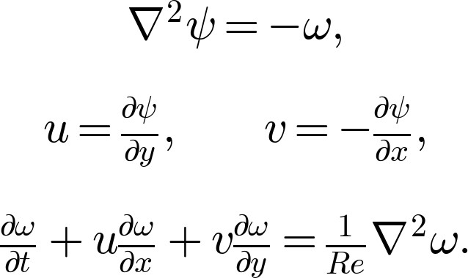
Boundary Conditions: Unit square; stationary side and bottom walls; top wall moving at prescribed lid speed; zero streamfunction on all walls.
Numerical Method: Explicit upwind vorticity transport, red-black SOR solution of the streamfunction Poisson equation, and Thom-type wall-vorticity conditions.
Observations: Primary vortex centre, minimum streamfunction, centreline velocity profiles, vorticity-change norm, Poisson residual, and grid dependence at Reynolds numbers 100 and 400. Compare centreline velocities, primary-vortex position, convergence, and secondary-corner-vortex development.

For Raynolds number 100:
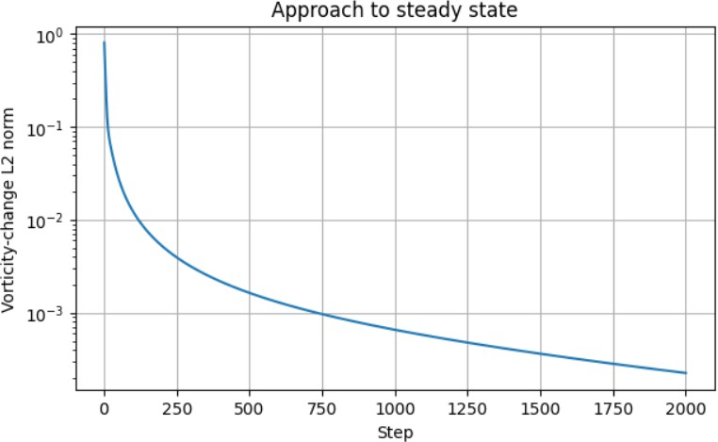
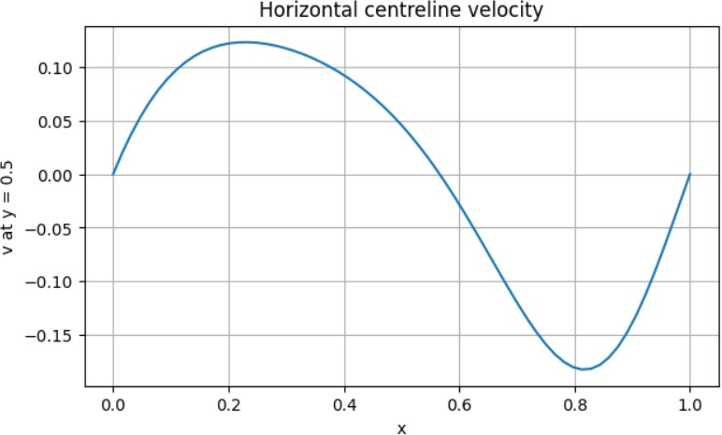
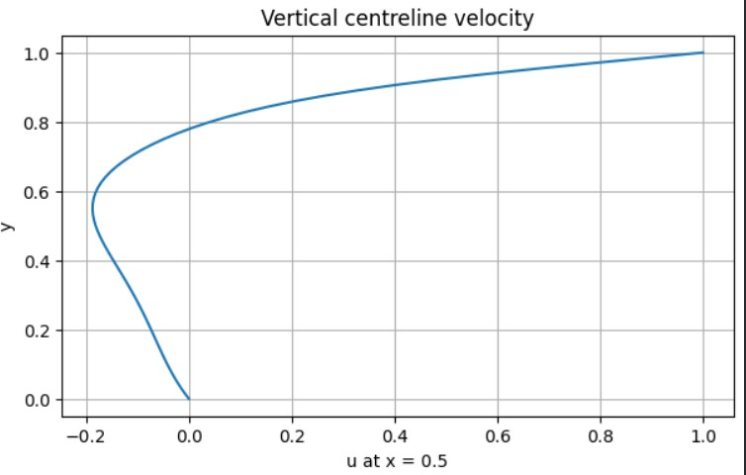
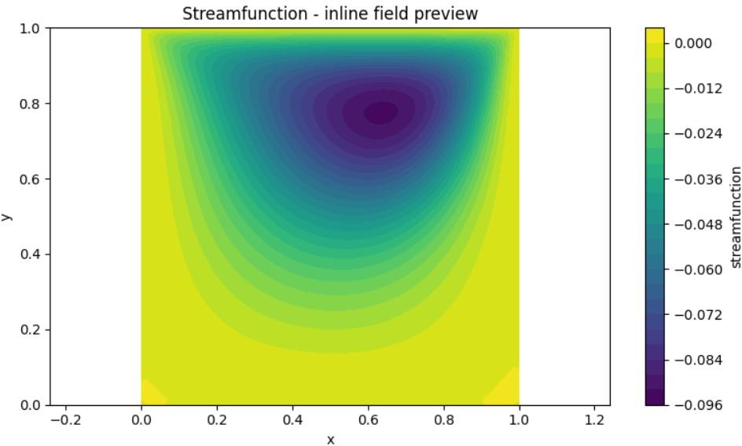

For Raynolds number 400:
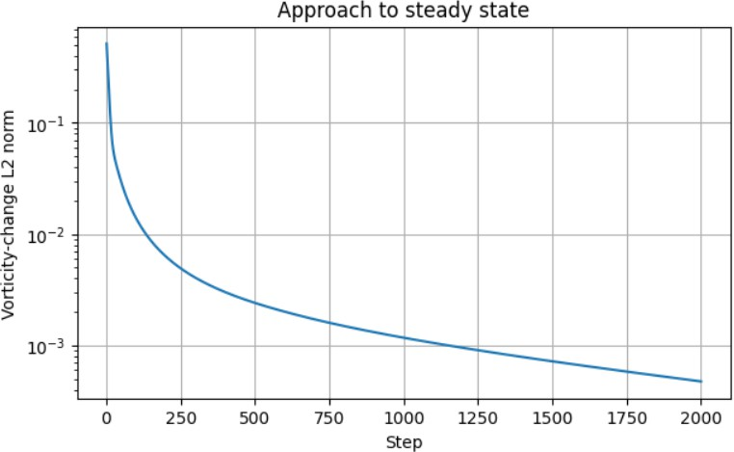
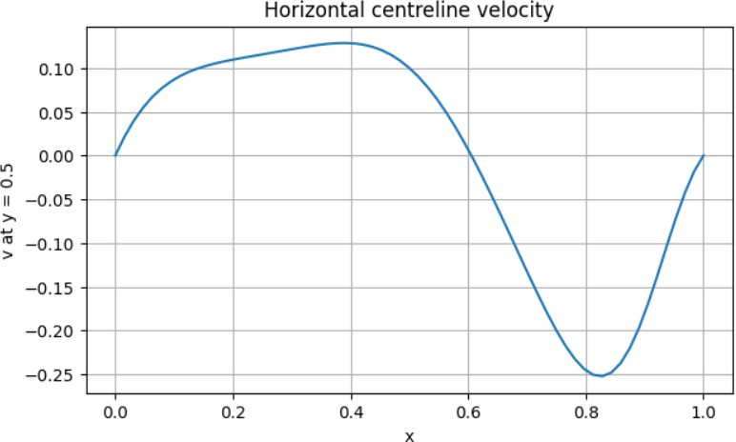
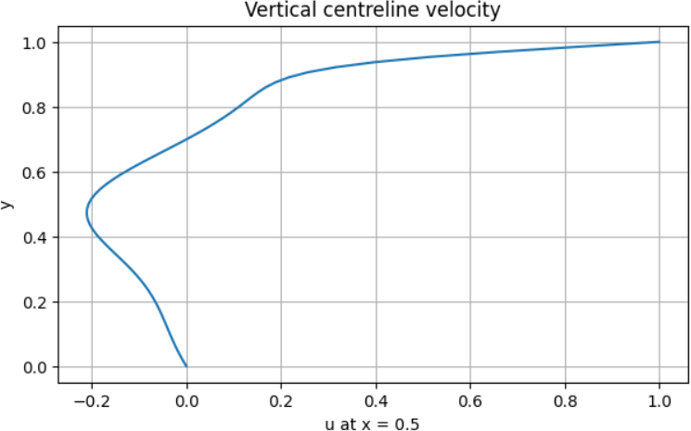
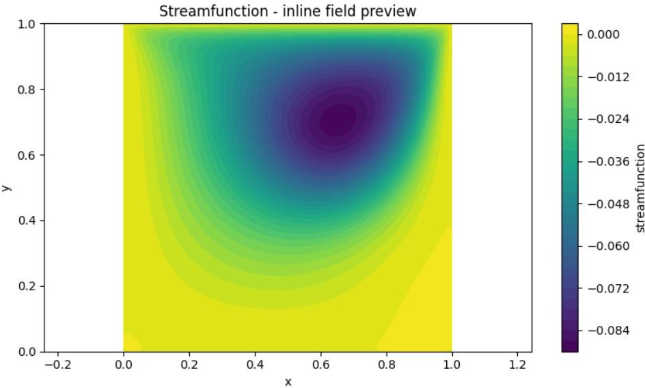

Results:

Parameter | Re = 100 | Re = 400
Grid / steps run | 65 × 65 / 2000 (max) | 65 × 65 / 2000 (max)
Primary vortex centre (x, y) | ≈ (0.63, 0.77) | ≈ (0.66, 0.70)
Minimum streamfunction, ψmin | ≈ −0.096 | ≈ −0.090
Min. u on vertical centreline (x = 0.5) | ≈ −0.185 at y ≈ 0.55 | ≈ −0.205 at y ≈ 0.48
u = 0 crossing on vertical centreline | y ≈ 0.78 | y ≈ 0.70
Max. v on horizontal centreline (y = 0.5) | ≈ +0.123 at x ≈ 0.23 | ≈ +0.129 at x ≈ 0.39
Min. v on horizontal centreline (y = 0.5) | ≈ −0.182 at x ≈ 0.82 | ≈ −0.252 at x ≈ 0.83
v = 0 crossing on horizontal centreline | x ≈ 0.57 | x ≈ 0.60
Vorticity-change norm, step 0 | ≈ 8 × 10−1 | ≈ 5 × 10−1
Vorticity-change norm, step 250 | ≈ 4 × 10−3 | ≈ 5 × 10−3
Vorticity-change norm, step 2000 | ≈ 2.3 × 10−4 | ≈ 4.7 × 10−4
Benchmark ψmin, vortex centre (Ghia et al., ≈) | ≈ −0.103 at (0.62, 0.73) | ≈ −0.114 at (0.55, 0.61)
Benchmark min. u on vertical centreline (≈) | ≈ −0.21 at y ≈ 0.45 | ≈ −0.33 at y ≈ 0.28

Conclusion:
The lid-driven cavity flow in a unit square was solved with the vorticity–streamfunction formulation, using explicit upwind vorticity transport, red-black SOR for the streamfunction Poisson equation and Thom-type wall vorticity, on a 65 × 65 grid at Reynolds numbers of 100 and 400. In both cases a single primary vortex forms below the moving lid, with the streamfunction negative (clockwise circulation) in the vortex core. The primary vortex centre lies at approximately (0.63, 0.77) for Re = 100 and (0.66, 0.70) for Re = 400, with minimum streamfunction of about −0.096 and −0.090 respectively.
Centreline velocities: On the vertical centreline the u-velocity rises from zero at the bottom wall, reaches a reverse-flow minimum of about −0.185 (Re = 100, y ≈ 0.55) and −0.205 (Re = 400, y ≈ 0.48), crosses zero at y ≈ 0.78 and 0.70, and reaches the lid speed of 1 at y = 1. On the horizontal centreline the v-velocity is positive on the left (up to ≈ 0.123 at x ≈ 0.23 for Re = 100 and ≈ 0.129 at x ≈ 0.39 for Re = 400) and negative on the right (down to ≈ −0.182 and ≈ −0.252 at x ≈ 0.82–0.83), which is the expected upward flow near the left wall and downward flow near the right wall for a clockwise vortex. The profiles are less symmetric and the right-hand downward jet is stronger at Re
= 400, and the shear layer under the lid is thinner: u = 0.6 is reached at y ≈ 0.945 for Re = 100 and at y ≈ 0.965 for Re = 400. This is consistent with convection becoming more important relative to viscous diffusion as Re increases.
Convergence: The vorticity-change norm falls quickly from about 0.8 (Re = 100) and 0.5 (Re = 400) to about 4–5 × 10−3 by step 250, but then decays only slowly, reaching about 2.3 × 10−4 and
4.7 × 10−4 at step 2000. The curves are still falling at the end of the run and no plateau is visible, so neither case reached the specified tolerance and both runs stopped at the step limit. The solution is therefore a close-to-steady transient state and not a fully converged steady state. The vorticity-change norm at step 2000 is about twice as high at Re = 400 as at Re = 100, so the higher-Re case is further from steady state. The Poisson residual was not plotted, so the accuracy of the SOR solve cannot be assessed from the results.
Comparison with benchmark data: The well-known benchmark solution of Ghia et al. for the same problem gives a minimum streamfunction of about −0.103 at (0.62, 0.73) for Re = 100 and

about −0.114 at (0.55, 0.61) for Re = 400, and the minimum u on the vertical centreline is about
−0.21 at Re = 100 and about −0.33 at Re = 400. The present results are in qualitative agreement at Re = 100, with the vortex centre and the u-minimum close to the benchmark, but the vortex strength is lower by about 7%, and the velocity extrema are lower. At Re = 400 the differences are larger: the streamfunction minimum is about 20% too weak, the u-minimum of about −0.21 is far from about
−0.33, and the vortex centre at (0.66, 0.70) lies to the right of and above the benchmark position. The benchmark vortex moves towards the cavity centre as Re increases, whereas here it moves right. The velocity extrema are therefore under-predicted at both Reynolds numbers, and more so at Re = 400.
Likely causes of the discrepancy: First-order upwind transport of vorticity introduces numerical diffusion that acts like an increased viscosity, which weakens the vortex and thins the effective Reynolds number, and this effect grows with Re on a coarse 65 × 65 grid. The first-order Thom wall-vorticity boundary condition also limits accuracy near the lid. In addition, the runs were stopped before steady state, so the vortex is still adjusting. Grid dependence was listed in the observations but only the 65 × 65 grid is shown, so the grid effect could not be separated from the scheme effect. Secondary corner vortices were not resolved; the faint patches near the bottom corners of the streamfunction plots are too weak to be identified as vortices, and at Re = 400 they are expected to be very small and need a finer grid and a converged solution to appear.
Overall, the method reproduces the qualitative structure of the lid-driven cavity flow: a single clockwise primary vortex below the lid, reverse flow along the lower part of the vertical centreline, a thinner lid shear layer and stronger asymmetry at higher Re. However, the quantitative accuracy is limited, especially at Re = 400, by first-order upwind diffusion, the coarse grid and incomplete convergence. Running to the specified tolerance, plotting the Poisson residual, refining the grid (e.g. 129 × 129 and above), and using a second-order convective scheme would be needed for results suitable for quantitative comparison with the benchmark. The parameter table also lists a lid speed of 2 whereas the plots show a lid speed of 1.

