### **Introduction**

### **Project Name:** SkillScore

### **Purpose:** Streamlining activity point tracking and approvals

### **Users:** Students, Faculty, Faculty Advisors

### **Key Features:**

### Submission & verification of activity points

### Faculty approval & multi-step verification

### Event creation & management

### Dashboard insights for students & faculty

### Automated notifications & reports

**SkillScore** is an activity points management portal. Skillcore is designed to streamline the process of tracking, verifying, and approving student activity points, ensuring a smooth and transparent system for both students and faculty.

With an intuitive and user-friendly interface, SkillScore allows students to submit requests, track their progress, and stay informed about upcoming events. Faculty members and faculty advisors can efficiently review submissions, approve or reject requests, and manage event participation.

Today, we will walk you through the key features of SkillScore, including the student and faculty dashboards, request and event management systems, and reporting tools that help ensure students meet their activity requirements with ease.

### **Student Dashboard**

The student dashboard provides an overview of key information, including their personal details, upcoming events, and activity points progress. Students can see their total points earned visualized with a circular progress indicator, making it easy to track their status toward completion.

### 

### **Student Profile**

The profile page displays a student’s information, including their semester and faculty advisor.

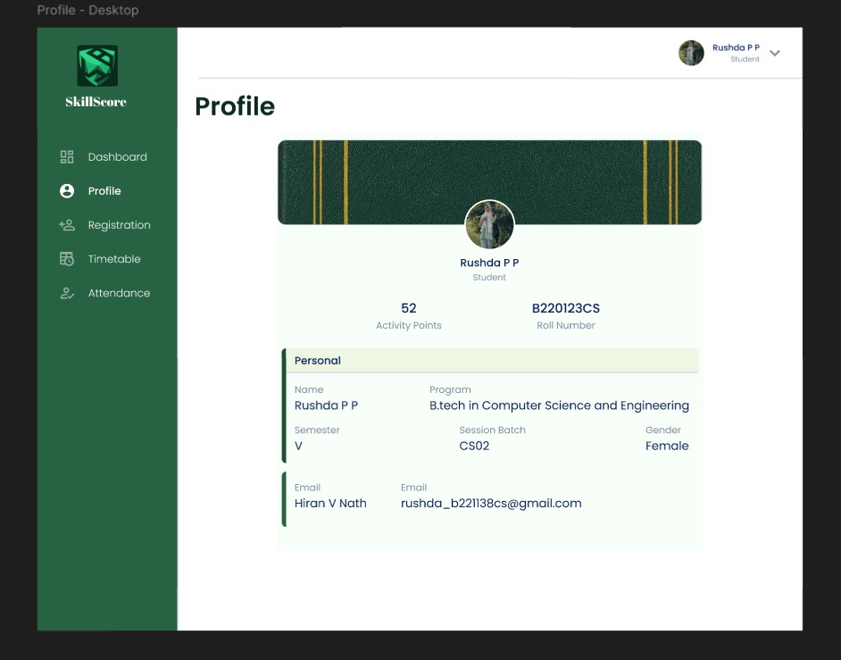

**Request Page**

Students can use the request form to submit activity points for approval. The page categorizes requests into Pending, Approved, and Rejected tabs, allowing students to track their submissions easily. They can also edit requests or provide additional proof if needed for declined requests.

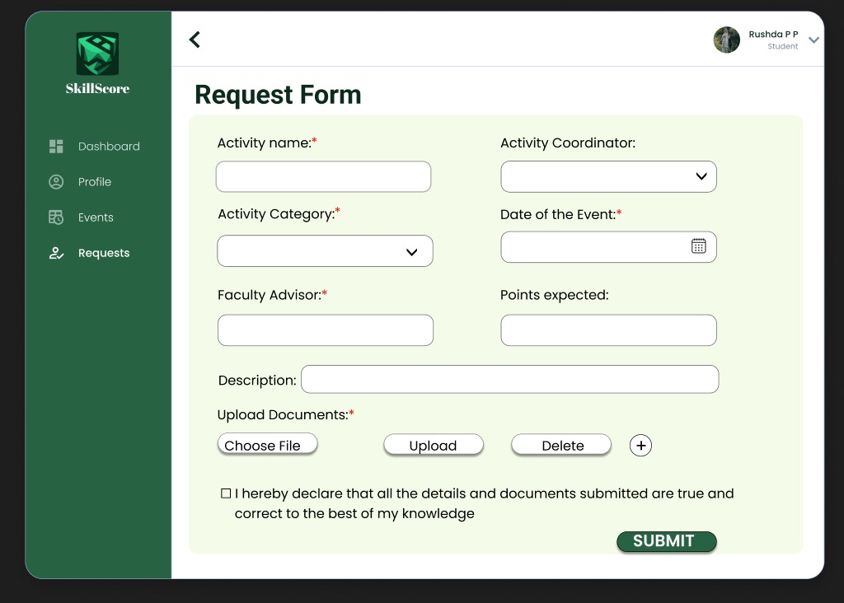

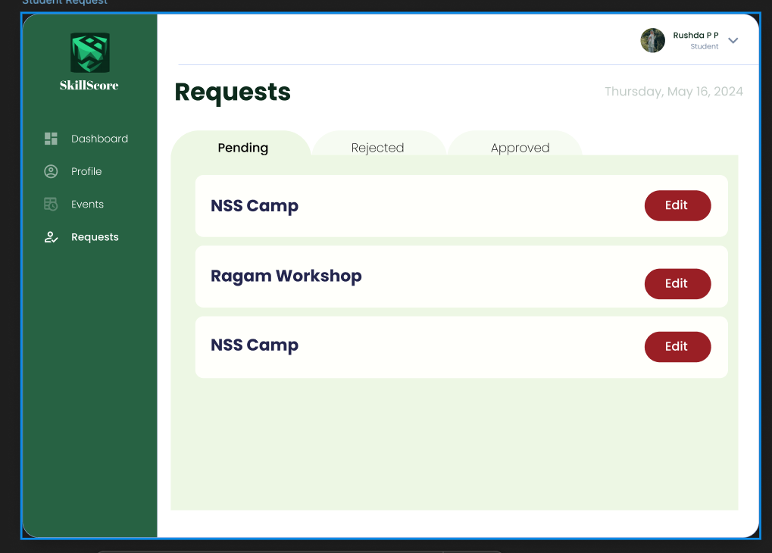

### **Rejected page of Student**

This page shows the rejected requests of the students and shows why the request is rejected and gives an option to edit and resubmit the form again.

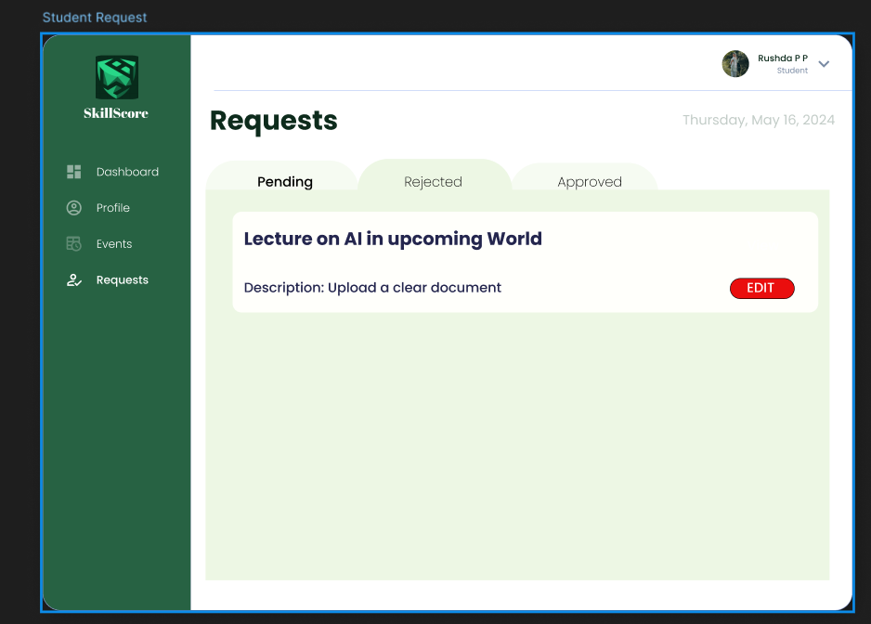

### **Event Page**

The event page lists all upcoming and ongoing events that students can participate in. Students can view event details, including dates, descriptions, and registration links, encouraging active involvement in institute activities.

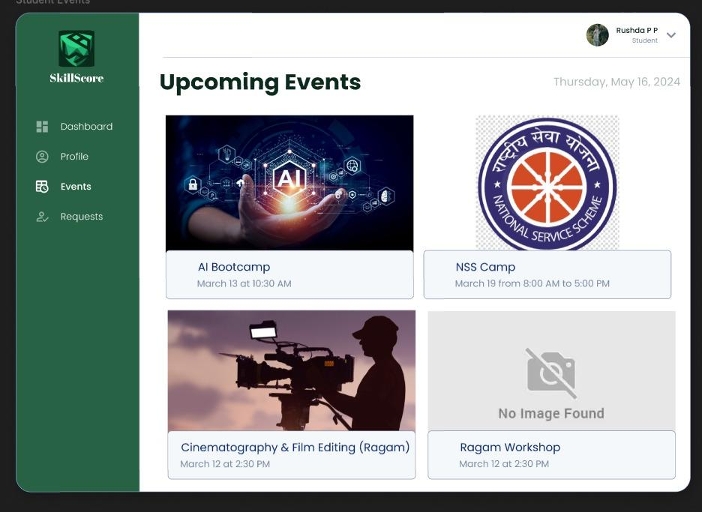

### **Faculty Advisor Dashboard**

The faculty advisor dashboard includes additional metrics tailored for advisors, such as the total number of students they manage, the number of students below the required activity points, and pending requests awaiting their approval. These insights help advisors monitor and assist their students effectively.

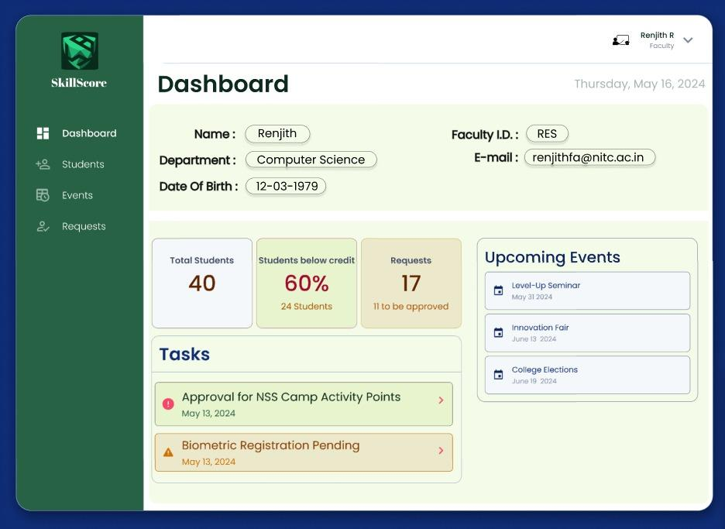

### 

### 

### 

### 

### 

### 

### 

### 

### **Student Reports for Advisors**

Advisors can access detailed reports for each student under their guidance by selecting a student’s name. These reports include the student’s activity points progress and pending requests, allowing advisors to make informed decisions.

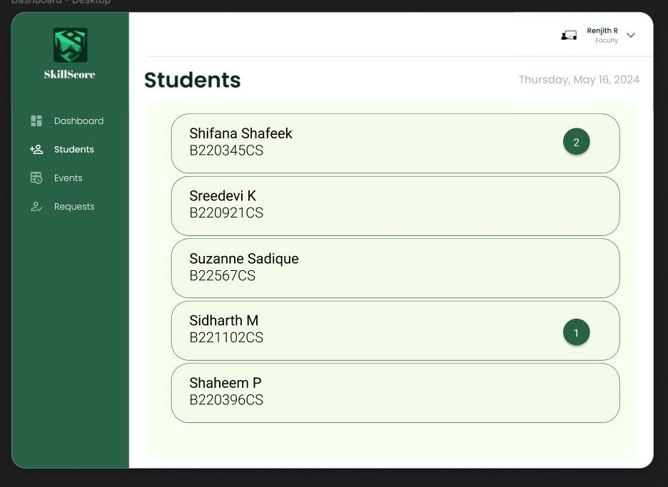

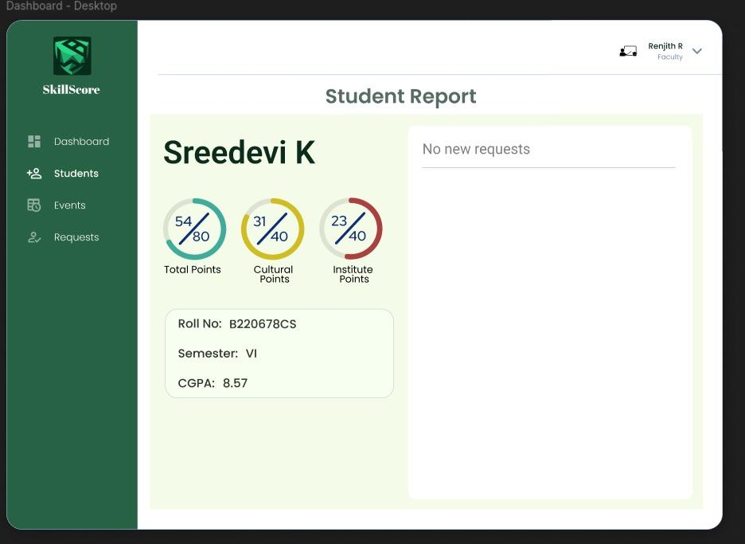

### **Faculty Dashboard**

The faculty dashboard provides a quick summary of personal details, upcoming events, and pending requests. These metrics are prominently displayed to help faculty prioritize tasks efficiently.

### **Requests Management for Faculty**

Faculty members can access all student requests categorized into Pending, Approved, and Rejected statuses. They can review, comment on, and approve or reject requests, ensuring smooth communication and processing.

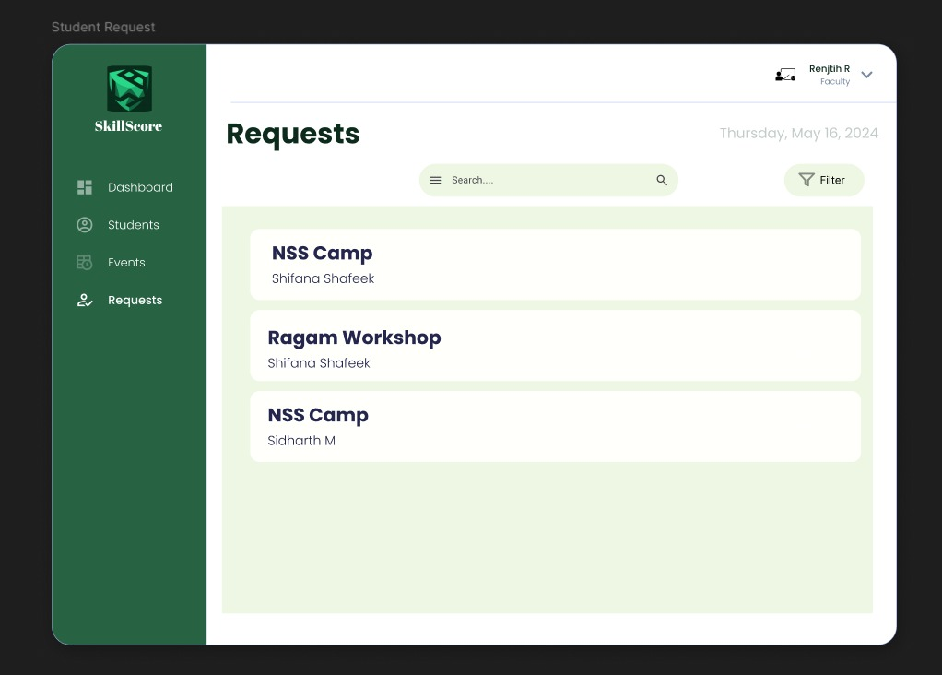

Faculty Rejection page

If the faculty rejects the request then he should show the reason for the rejection which will be shown to the student. Or if he accepts then the accepted message goes to the student.

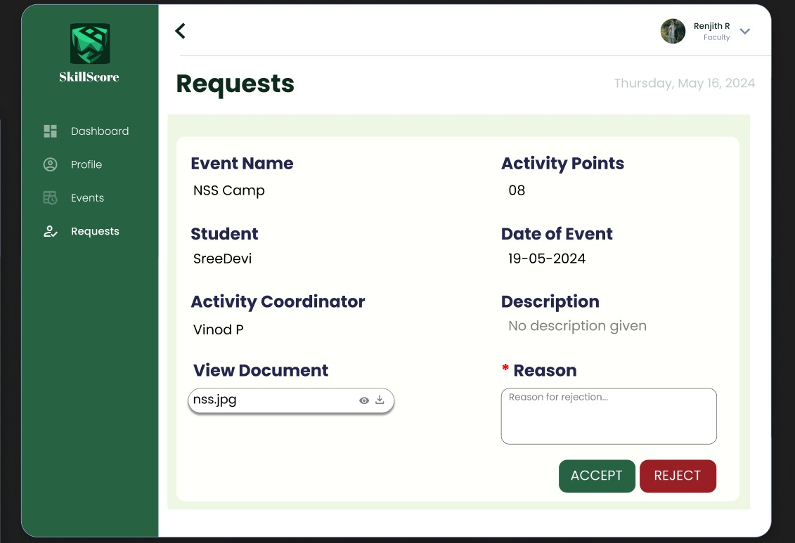

### 

### 

### 

### **Event Management for Faculty**

Faculty can use the event management feature to view existing events or add new ones. This functionality helps streamline the organization of events by providing a simple and accessible interface for inputting event details.

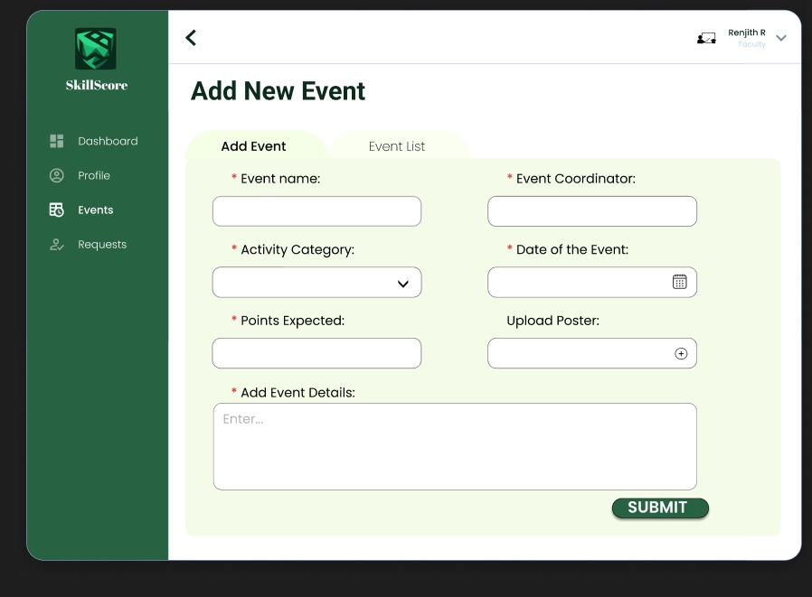

### **Streamlined Workflow**

The portal ensures seamless interaction for all users. Students can monitor their progress and manage requests effortlessly, while faculty and advisors have tools to efficiently manage approvals and events.

### **Key Features in Focus**

* **Circular Progress Indicators**: Displays activity points progress visually for better clarity.
* **Bold Metrics**: Key data like students below credit requirements and pending requests are highlighted for quick access.
* **Clean Navigation**: A user-friendly layout ensures easy navigation for students and faculty alike.