Team Number: 1 Date: 4

Lab Exercise: Java DB, jTable, & Consume REST services

Lab Objectives
- In Lecture 23, we discussed the project AjaxJTableCRUD, which integrates JSP, jTable, and Java DB together. In this lab, we apply those techniques to our web application.
- JSP servlet + jTable + JavaDB
- GlassFish as service container.

Description of the Problem

Use Java DB:
- Create a Java DB database instance called “RosterDB”;
- Create a connection to the RosterDB. You could have different user name and password for the connection, but for grading purpose, please use “app” as the user name and “app” as the password (all lower case).
- Write a sql script file named roster.sql, which should contains statements to create a table with the name roster to the RosterDB database.

- [10 points] [Refactoring] From the last lab, you should have already created a folder “Services” which contains RosterJSP and RosterMVC. Now create one more subfolder under “Services”: RosterJTable.
- [40 points] In NetBean create a web application named “WebRosterJTable” (it should be within the folder RosterJTable). Follow the example project AjaxJTableCRUD to organize source files. Specifically,
  - You should have source folders such as dao, jdbc, model, and servlet.
  - You should create a Java DB named RosterDB, use app for both user name and password.
  - You should create a sql file roster.sql in the folder dao. Running roster.sql against RosterDB should create a roster table with a record created for each student (use the roster information in last lab).
  - The displayed roster table should support pagination, new record creation, delete, and update. Take advantage of the built-in jTable features.
- [10 points] A click on the “RosterJTable” button should lead to a request first sent to the Node server, which then forward the request to the WebRosterJTable service hosted by GlassFish.
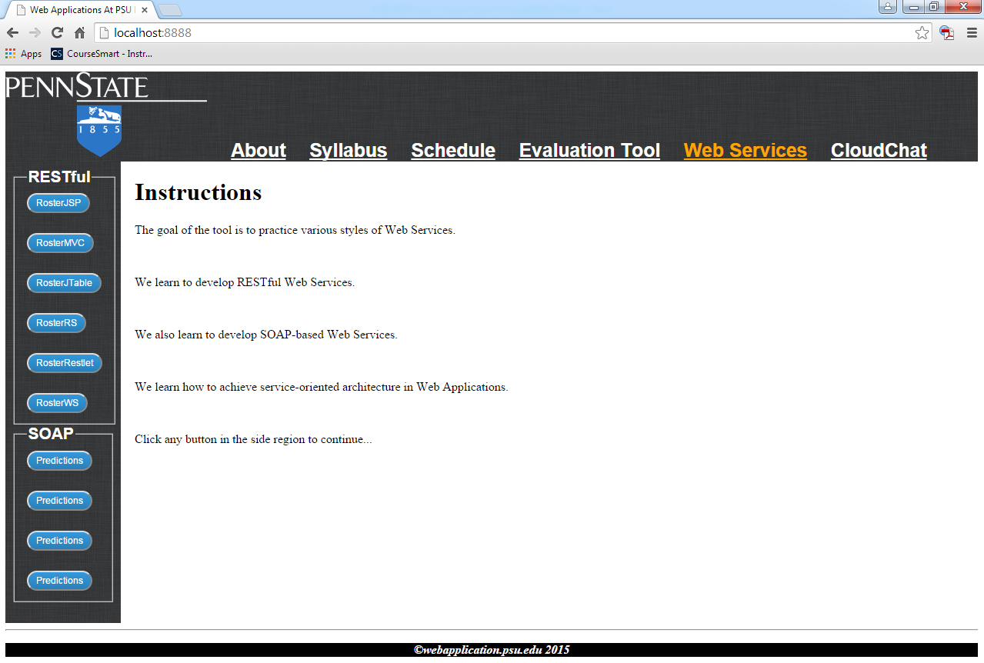

- [40 points] Use the Amazon web service
  - All the resources related to this service should be within the folder AmazonBook;
  - Use the module aws-lib. You can install this module yourself, or simply use the one we used in class (NodeAmazonClient/node_modules).
  - Study prod-adv.js to learn how to invoke this amazon service. Use your own amazon keys.
  - In the side bar for “web services”, add one more option for “AmazonBook”, which should lead a user to a search page.
  - The search page should contain
    - A field for a user to input his/her Amazon access ID
    - A field for a user to input his/her Amazon secret key
    - A few input fields for a user to type in search information such as ItemID, ISBN, etc.
    - A button that sends the current search request to Node. Node then as a client should send a request to the Amazon service. Node may need to format the response from Amazon so that the information can be displayed nicely in the user’s web browser.

Lab Submission:

- Provide individual performance in the table below (performance factor is a real number between 0.0 and 1.0, individual grade is lab grade times his/her performance factor). [Check the “ACM code of ethics, if you do not know it. If you do not honestly record teammates’ performance factor, you are actually encouraging them to be lazy. In doing this, you are NOT helping them, but preparing them to fail in their career.]
Student Name | Performance factor
Caleb Rush | 0.33
Matt DOwney | 0.33
Nick Totolos | 0.33

- Paste a screenshot inside this lab report to demonstrate how it works.
- Save this report to a PDF file with the name CSSE-WEB-Lab-11-Team-X.pdf, where X is your team number;
- Submit to StepStone. Your submission should be one zip file with the name CSSE-WEB-Lab-11-Team-X.zip (where X is your team number) that includes:
  - CSSE-WEB-Lab-11-Team-X.pdf;
  - The Website folder, excluding the sub-folder node_modules generated by npm;

