Team Number: 1 Date: 3/4/2016

Lab Exercise: SVG & Canvas

Lab Objectives

- Practice SVG scripting.
- Practice Animation with canvas scripting

Description of the Problem

- Continue to refine your web application.
  - If your lab6 has bugs, fix it first.
  - You are encouraged to apply creative styles.
- [15 points] Revise your web application such that the current time information as shown on the top-right corner is replaced by a script-based SVG (you can reuse the code used in lecture, but may apply style to make the clock looks more appealing.

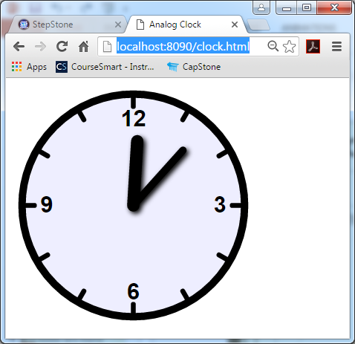

- [15 points] Refer to https://developer.mozilla.org/en-US/docs/Web/API/Canvas_API/Tutorial/Basic_animations and https://developer.mozilla.org/en-US/docs/Web/API/Canvas_API/Tutorial/Advanced_animations to learn how to do animations with canvas elements.
- [5 points] Use a new folder CanvasAnimation for code related to this lab.
- [5 points]Add a new link “Relax” in the top navigation area to trigger the animation page.
- [60 points]As the page loads, your animation code should produce similar animation effect as shown in us_uk_flags.mp4.
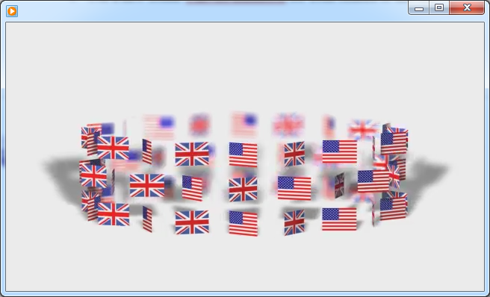

- [Note] If you have some other interesting ideas at the same complexity level as the one described above, you are encouraged to implement it.

Lab Submission:
- Provide individual performance in the table below (performance factor is a real number between 0.0 and 1.0, individual grade is lab grade times his/her performance factor). [Check the “ACM code of ethics, if you do not know it. If you do not honestly record teammates’ performance factor, you are actually encouraging them to be lazy. In doing this, you are NOT helping them, but preparing them to fail in their career.]
Student Name | Performance factor
Name 1
Name 2
Name 3
Add more rows if needed

- Paste a screenshot inside this lab report to demonstrate how it works.
- Save this report to a PDF file with the name CSSE-WEB-Lab-7-Team-X.pdf, where X is your team number;
- Submit to StepStone. Your submission should be one zip file with the name CSSE-WEB-Lab-7-Team-X.zip (where X is your team number) that includes:
  - CSSE-WEB-Lab-7-Team-X.pdf;
  - The Website folder, excluding the sub-folder node_modules generated by npm;

