Team Number: 2 Date: 3/25/2016

Lab Exercise: JSP & JavaBean

Lab Objectives

- JSP servlet
- JavaBeans;
- GlassFish as service container.

Description of the Problem

- [10 points] [Refactoring] For this lab, you should create a folder “Services” to hold resources related to the “Web Services” link.
- Change the port of the Node server to 8888.
- [10 points] A click on the “Web Services” link should lead to the following display.
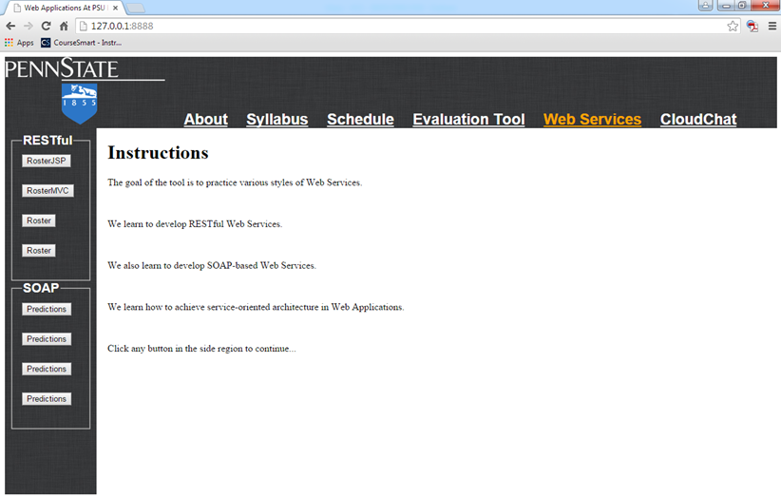

- [40 points] Create a Java web application named “WebRoster” in NetBeans
  - Use JavaBean (roster.java, student.java) to manage roster information. Your javabean needs to read information from roster.txt.
  - You should write a Java server page roster.jsp to handle requests for rosters.
  - Use GlassFish to host roster.jsp (GlassFish uses port 8080)
- [10 points] Client-side javascript: when a user clicks the “RosterJSP” button in the side region, the request is first sent to the Node server. The node server should forward the request to the JSP servlet hosted in GlassFish: use res.redirect("http://localhost:8080/WebRoster/roster.jsp")
- The response should be displayed as the figure below:
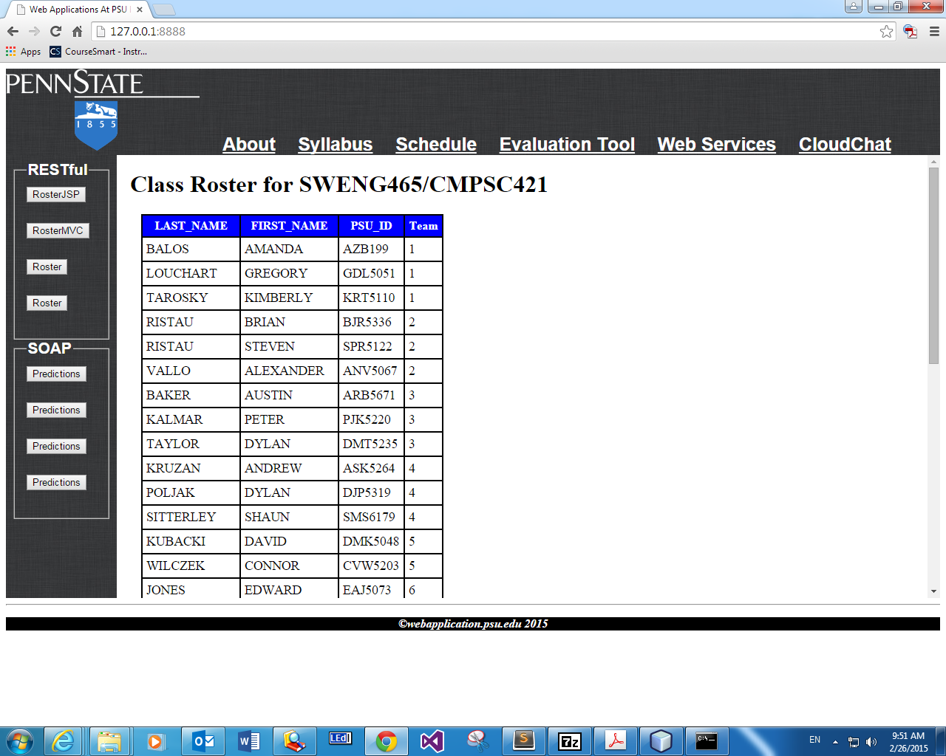
- [30 points] Client-side javascript: the table should be re-ordered whenever a user clicks one of the table headers (maybe toggle between increasing and decreasing orders)

Lab Submission:

- Provide individual performance in the table below (performance factor is a real number between 0.0 and 1.0, individual grade is lab grade times his/her performance factor). [Check the “ACM code of ethics, if you do not know it. If you do not honestly record teammates’ performance factor, you are actually encouraging them to be lazy. In doing this, you are NOT helping them, but preparing them to fail in their career.]
Student Name | Performance factor
Caleb Rush | 0.33
Matt Downey | 0.33
Nick Totolos | 0.33

- Paste a screenshot inside this lab report to demonstrate how it works.
- Save this report to a PDF file with the name CSSE-WEB-Lab-9-Team-X.pdf, where X is your team number;
- Submit to StepStone. Your submission should be one zip file with the name CSSE-WEB-Lab-9-Team-X.zip (where X is your team number) that includes:
  - CSSE-WEB-Lab-9-Team-X.pdf;
  - The Website folder, excluding the sub-folder node_modules generated by npm;

