Q01.

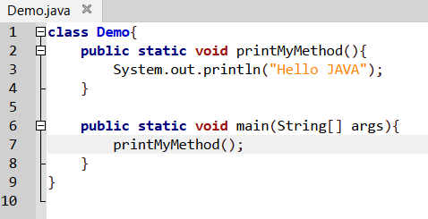

Output>>
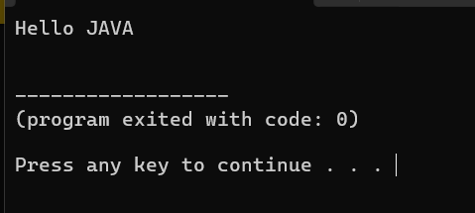

Q02.

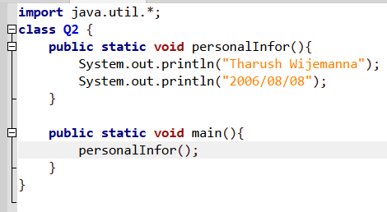

Output>>

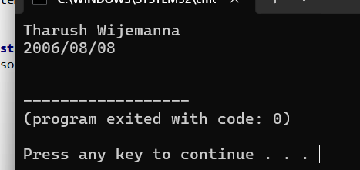

Q03.
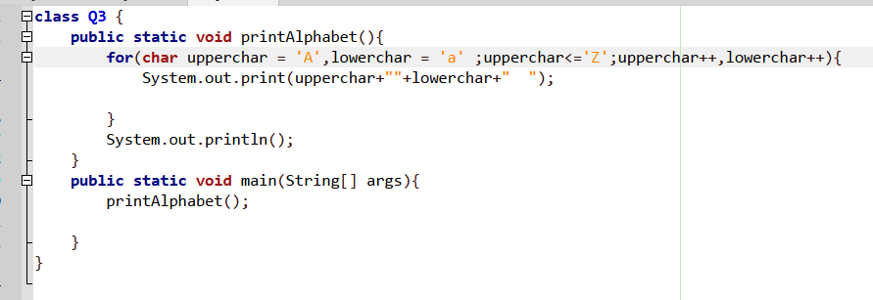

Output>>

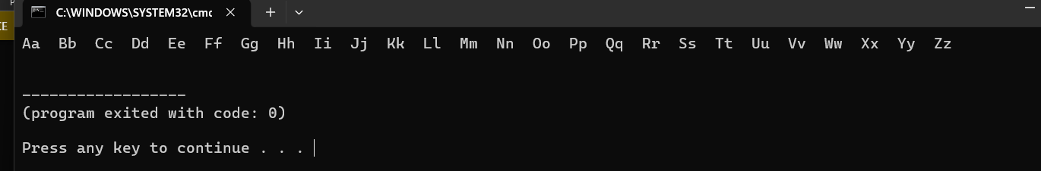

Q04.

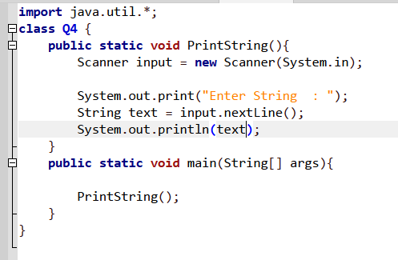

Output>>
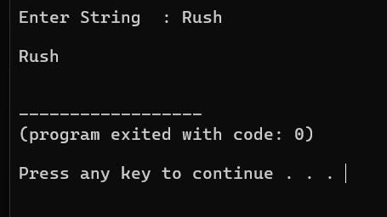

Q05.
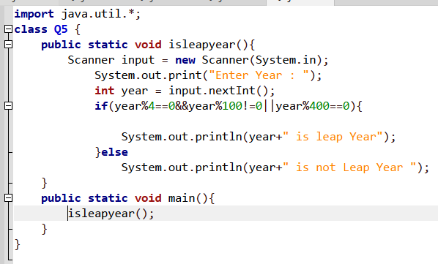

Output>>
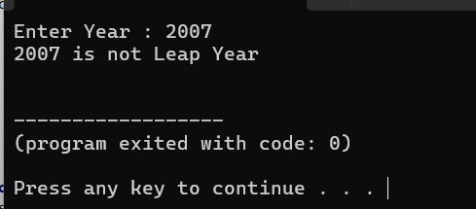
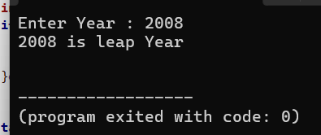

Q06.
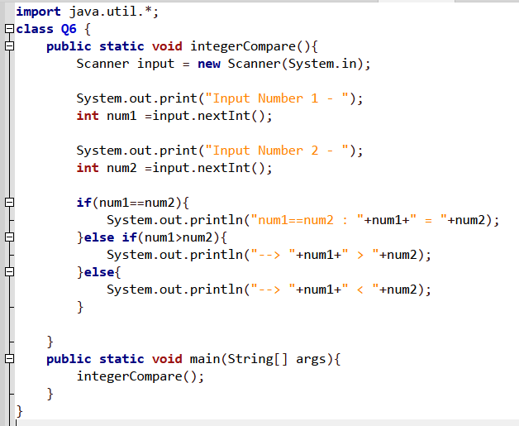
Output>>
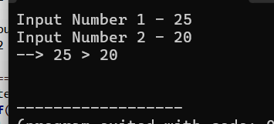
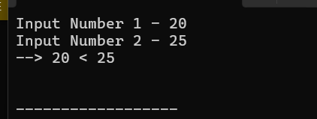

If the user input the same numbers . and output is given below
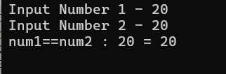

Q07.
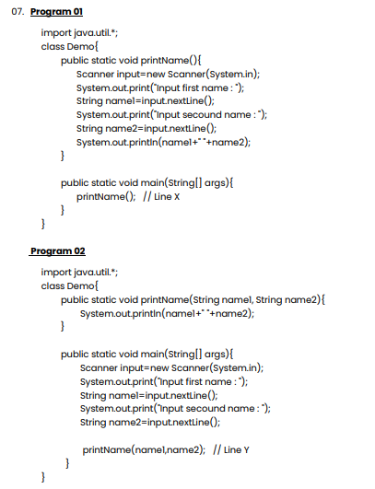

i.
*Program 01
It does not get arguments from the main method instend ,it uses the scanner class inside the sub-method( printName() ) to get user input and print it directly.

* program 02
It receives arguments passed from the main method(name1 and name2) and print them using those parameter values.
And these are the main differences between program 01 and program 02

ii.
Answer is : NO
In program 02 the printName method is defined as public static viod printName(String name1,
String name2) which requires two String parameters calling printName() .without passing
Any argument from main method does not match the method signature defined in program 02

Q08.

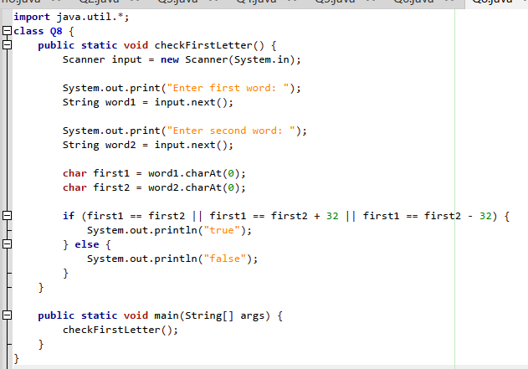
Output>>
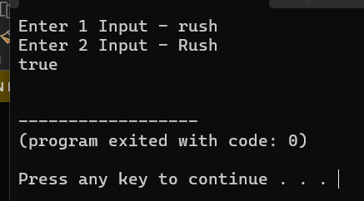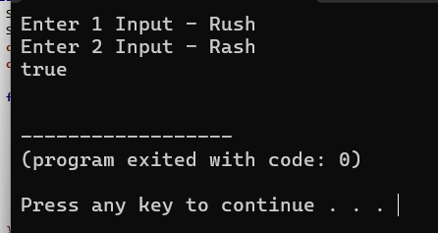
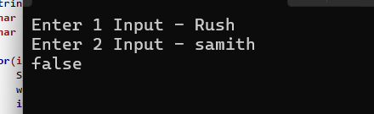

Q09.
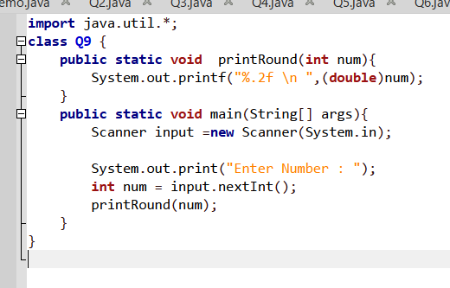

Output>>

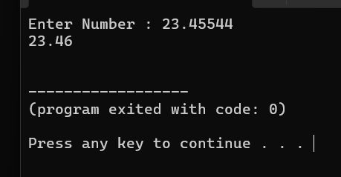

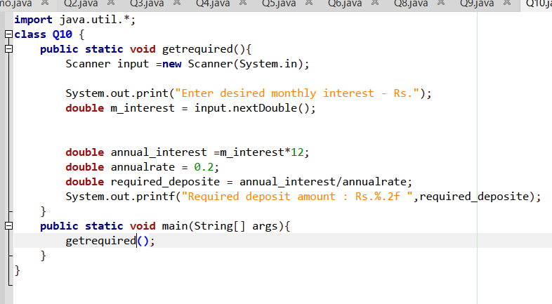
Q10.

Output>>
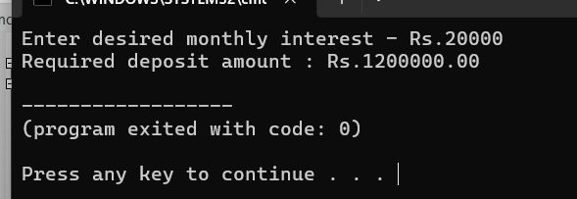

Q11.
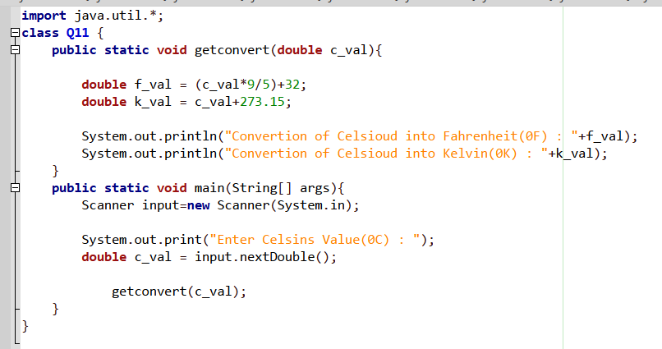

Output>>
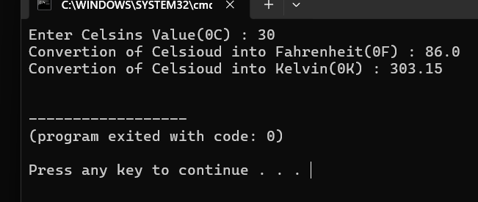

Q12.
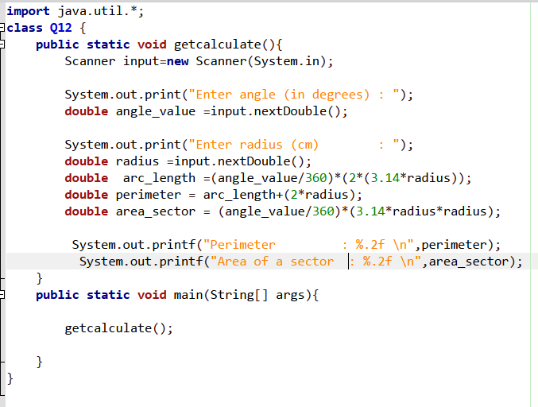
Output>>
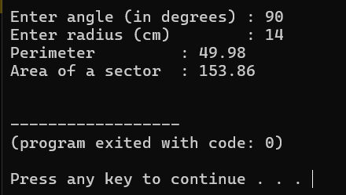

Q13.

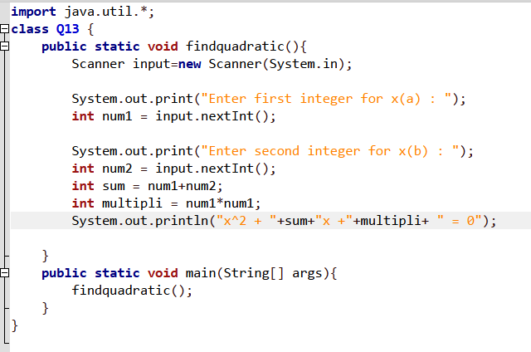
Output>>
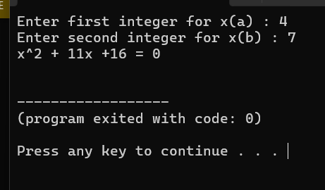

Q14.
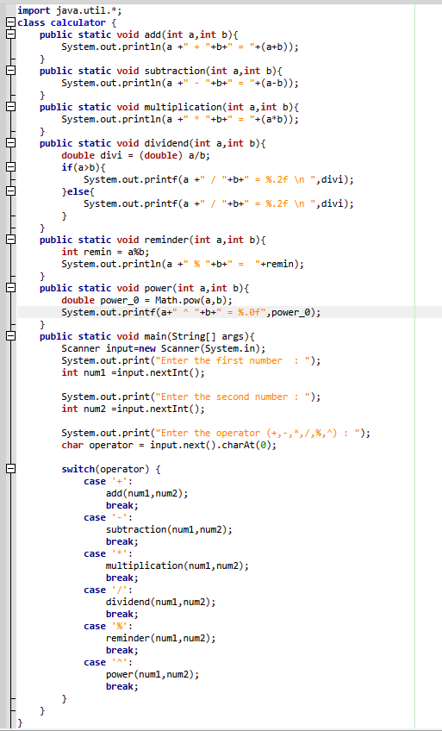

Output>>
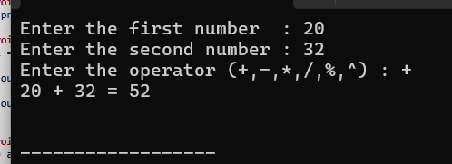
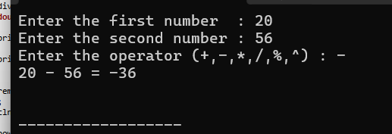
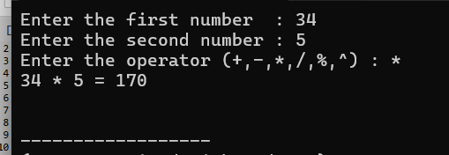
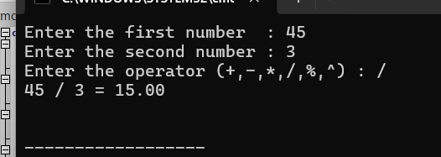
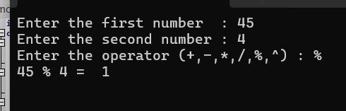
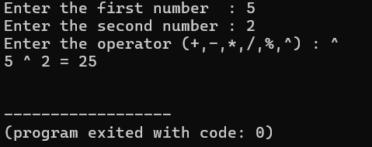

Q15.
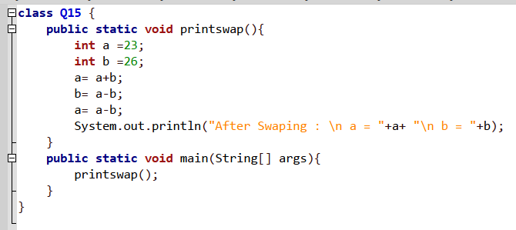

Output>>
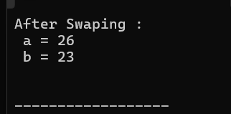

Q16.

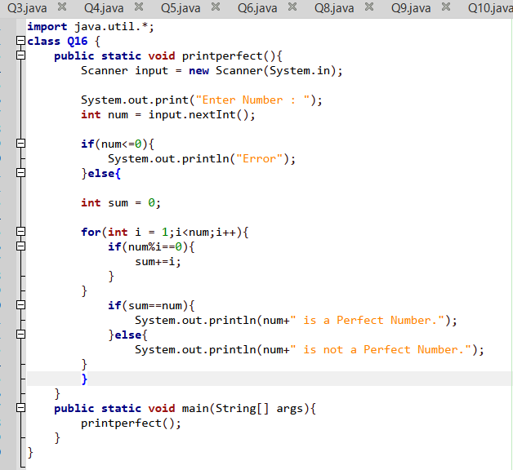
Output>>
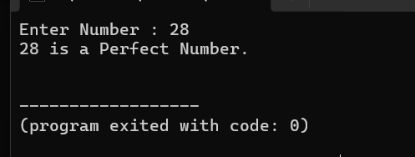

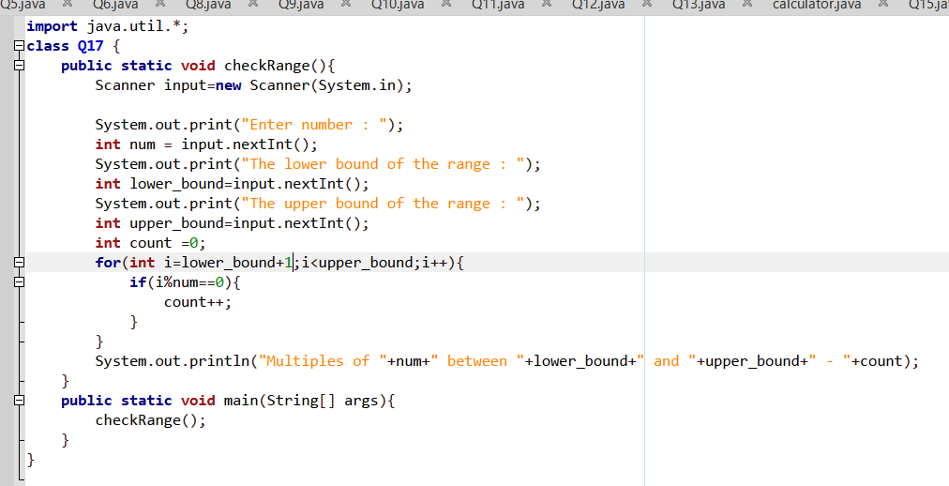
Q17.

Output>>
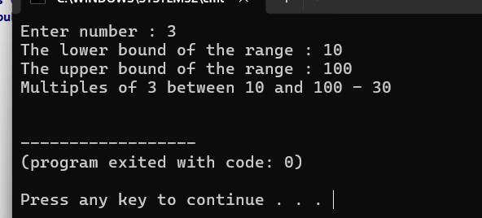

Q18.
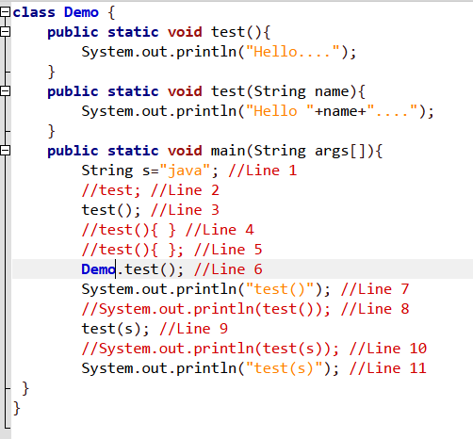
Answers:
line 1 – legal
line 2 – illegal
* curly braces are required when calling a method
line 3 – legal
line 4 – illegal
* We can’t declare a method inside the main method block.
line 5 – illegal
* We can’t declare a method inside the main method block.
line 6 – legal
line 7 – legal
line 8 – illegal
* The test() can’t be used inside System.out.println().
line 9 – legal
line 10 – illegal
* * The test(string name) can’t be used inside System.out.println().
line 11 – legal

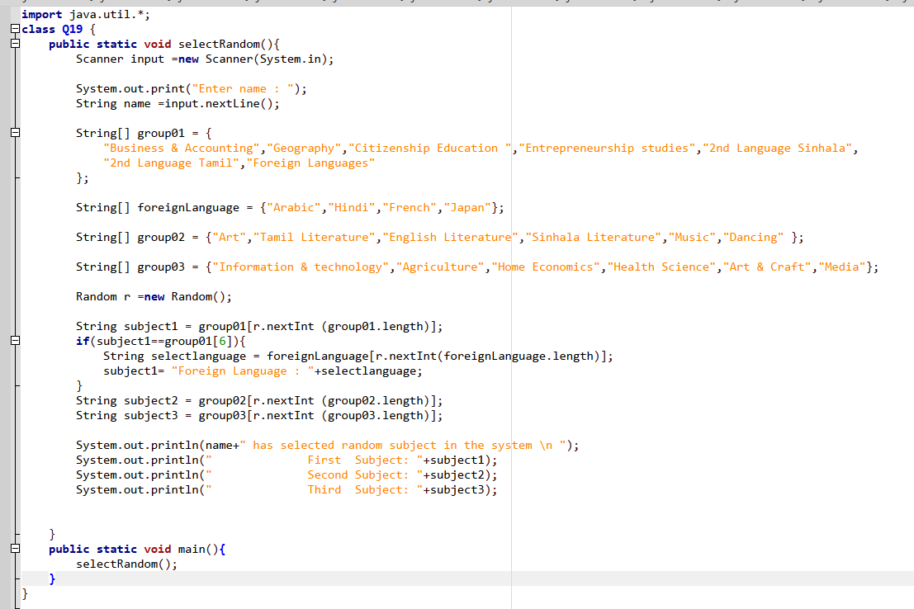
Q19.
Output>>
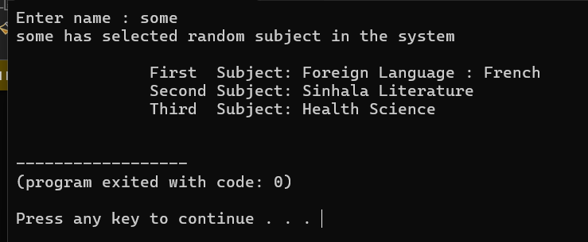

Q20.
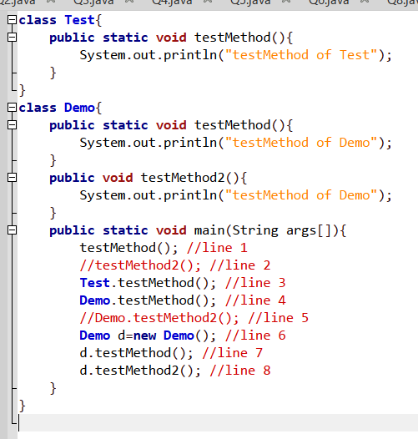
Answers:
Line 2 and Line 5 Shows compile error because testMethod2()/Demo.testMethod2 are non static, and static method can’t be directly call non static methods.

Q21.
Answers
- Legal
- Legal
- Illegal
* method body { } is missing
d. Illegal
* missing method identifier(name)
e. Illegal
* method body { } is missing
f. legal
g. Illegal
* we can’t use semicolons when passing parameters
h. Illegal
* Missing data type for parameter( x )
I. illegal
* Missing data type and variable name
j. illegal
k. illegal
* without condition it was illegal
l. legal

Q22.

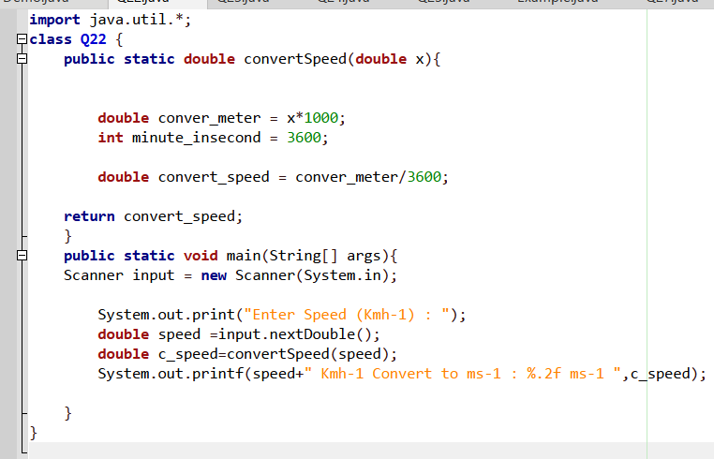
Output>>
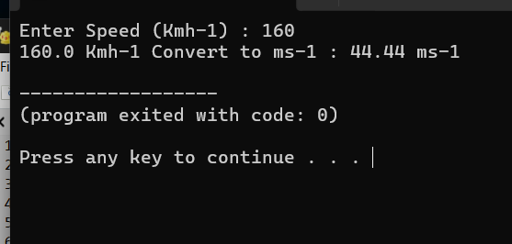

Q23.
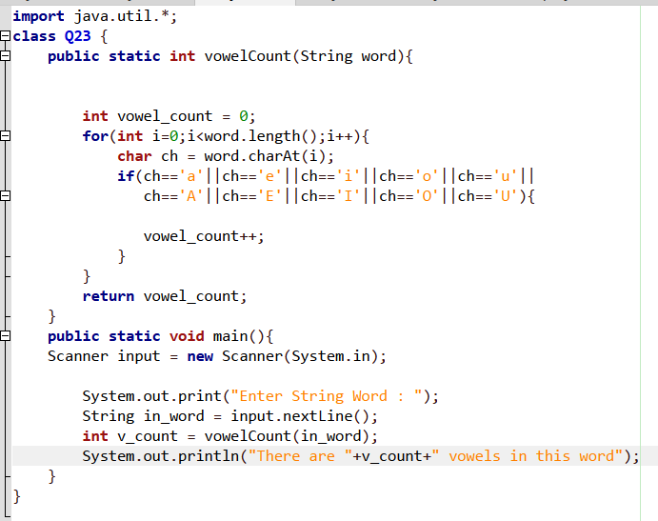
Output>>
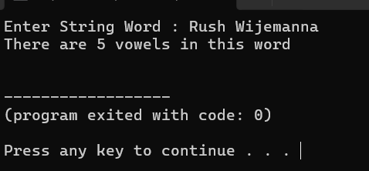

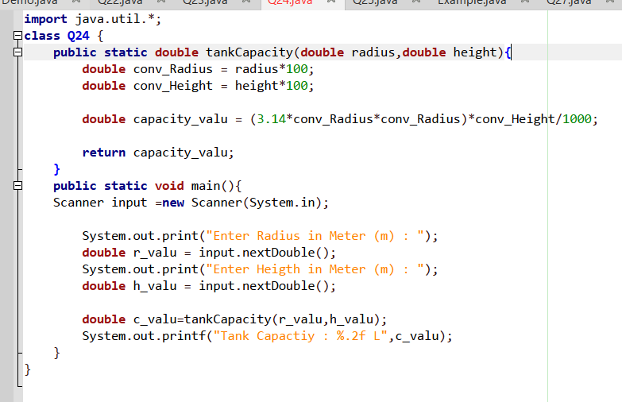
Q24.

Output>>
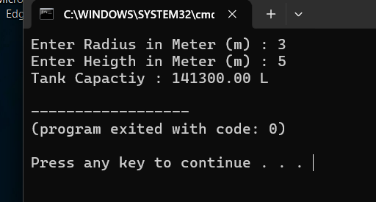

Q25.
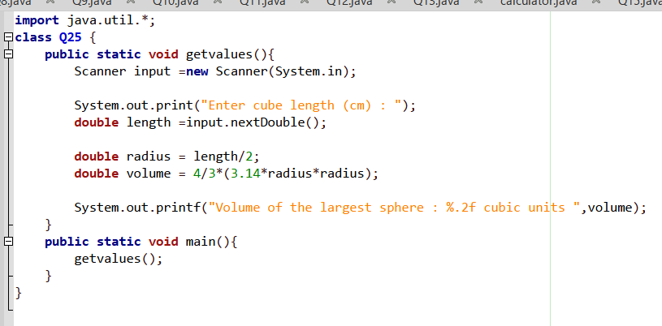

Output>>
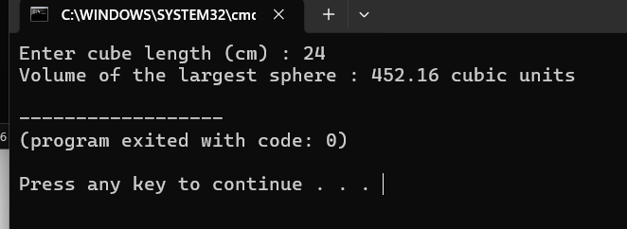

Q26.
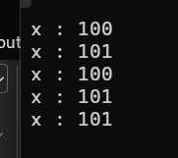
System.out.println("x: " + x); (Line 1)
- In the main method, x is initialized to 100.
- Output: x: 100
increment(x); (Line 2)
- The value of x (100) is passed into the increment method.
- Inside increment, x++ increases the local variable x to 101.
- System.out.println("x: " + x); inside the method executes.
- Output: x: 101
System.out.println("x: " + x); (Line 3)
- In Java, primitive data types are passed by value. Changes made to x inside the increment method do not affect the original variable x in the main method.
- Therefore, x in main remains 100.
- Output: x: 100
x = increment(x); (Line 4)
- The increment(x) method is called again, printing x: 101 from inside the method. (Output: x: 101)
- This time, the returned value (101) is reassigned back to x in the main method (x = ...).
System.out.println("x: " + x); (Line 5)
- Now x in main has been updated to 101.
- Output: x: 101

Q27.
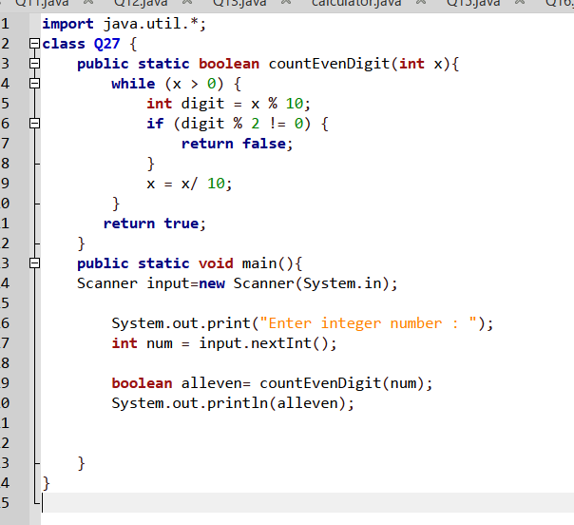
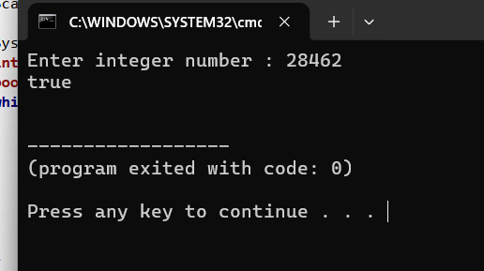
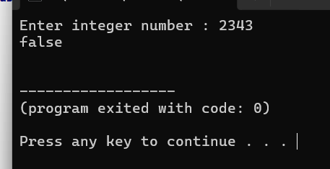
Output>>

Q28.
Answers
B,C,D,G
Q29.
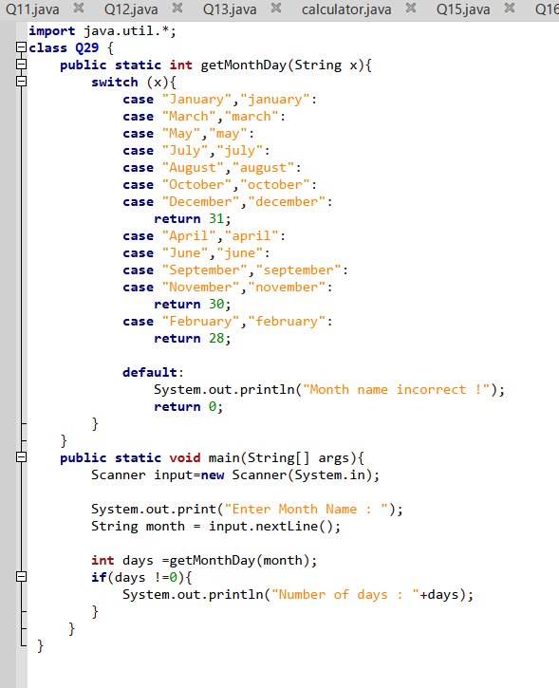
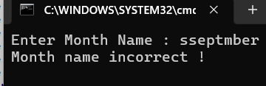
Output>>
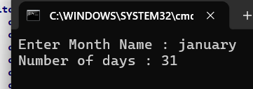

Q30.
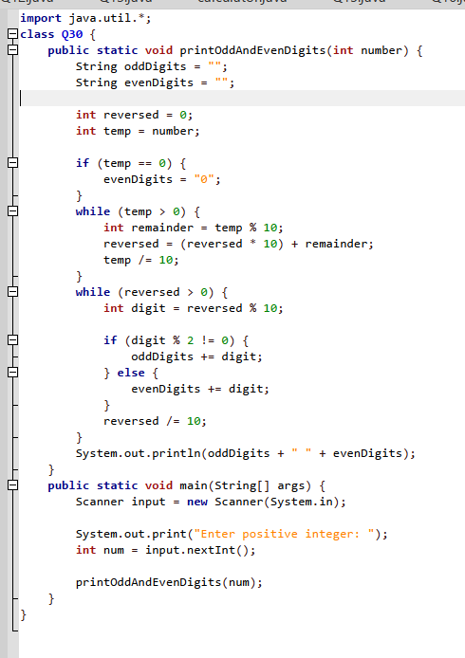
Output>>
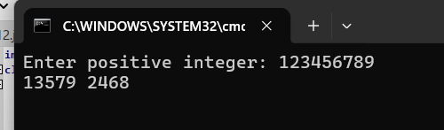

Q31.
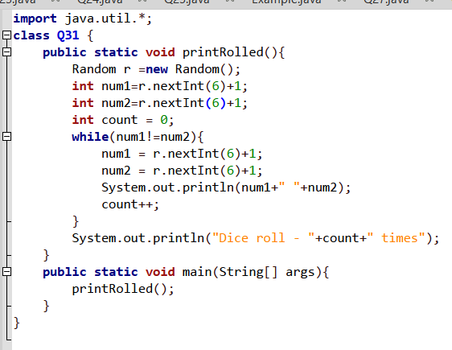

Output>>
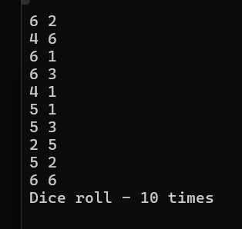

Q32.
Line 1 can inserted A,B,C,G
and line2 can inserted A,B,C,E,G
Q33.
Answers
C,D,E,F,H,K,O

Q34.
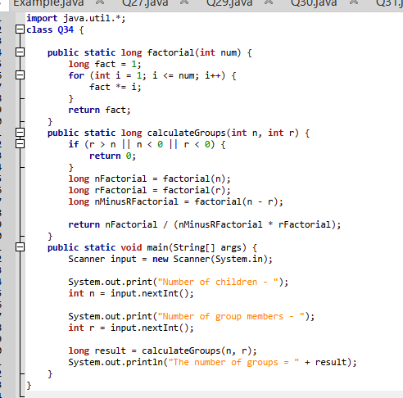
Output>>
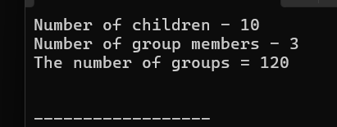

Q35.
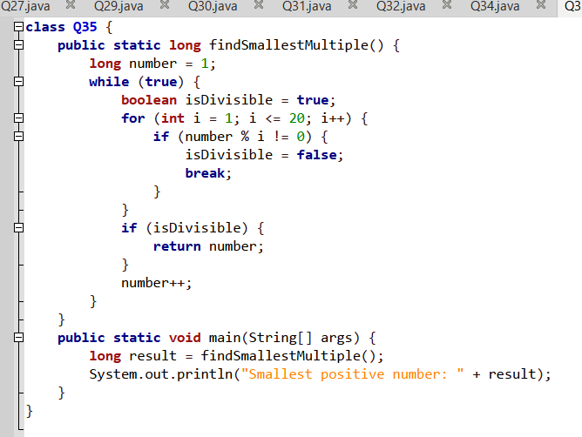
Output>>
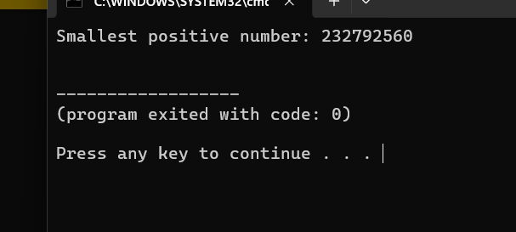

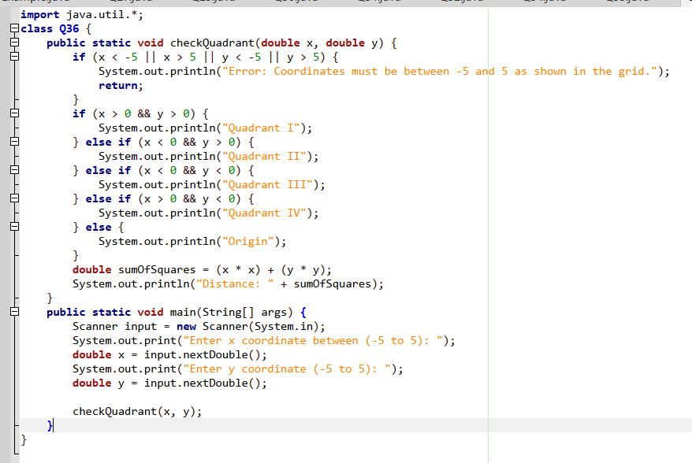
Q36.

Output>>
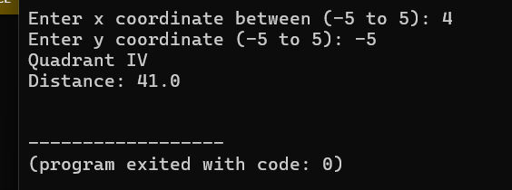

Q37.
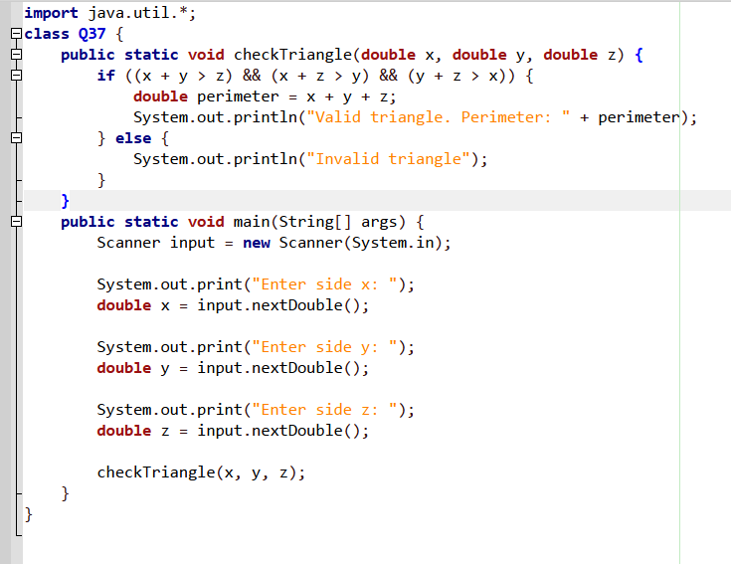
Output>>
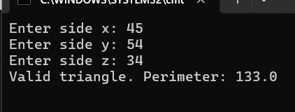

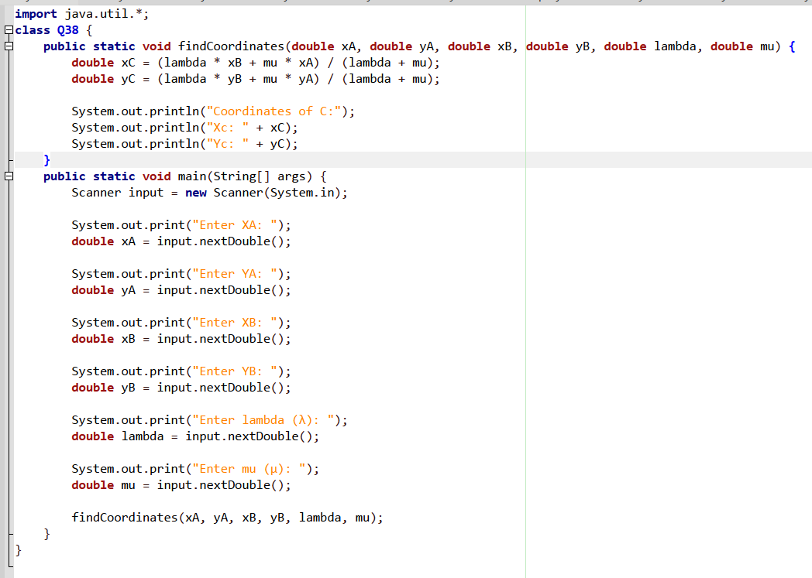
Q38.

Output>>
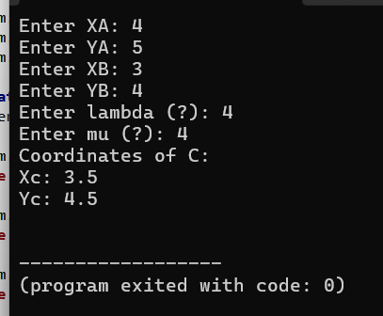

Q39.
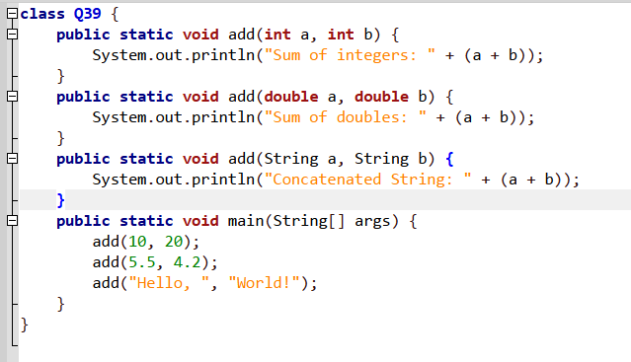

Output>>
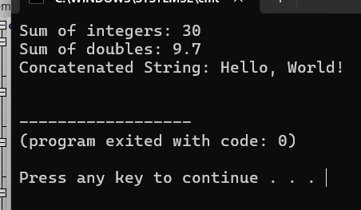

Q40.
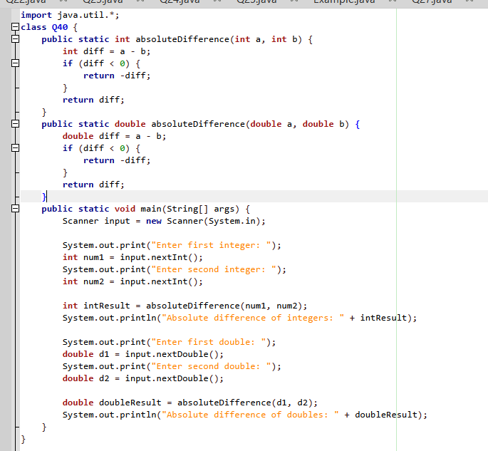
Output>>
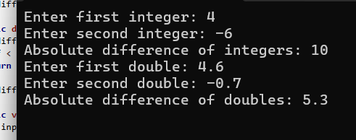

Q41.
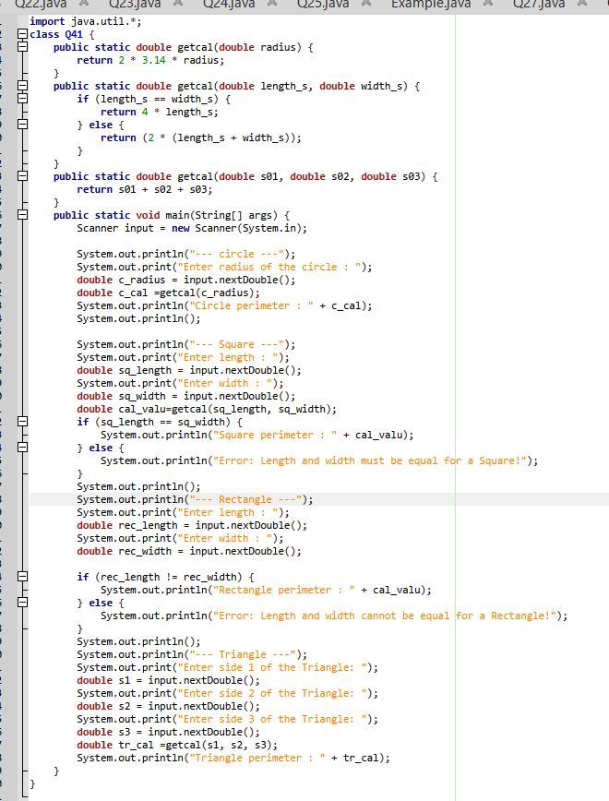
Output>>
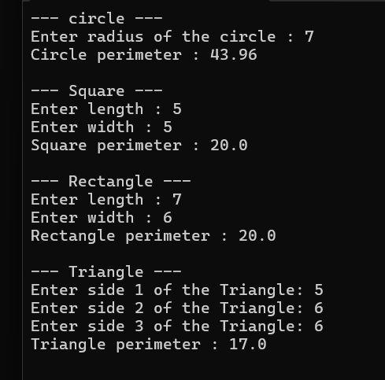

Q42.
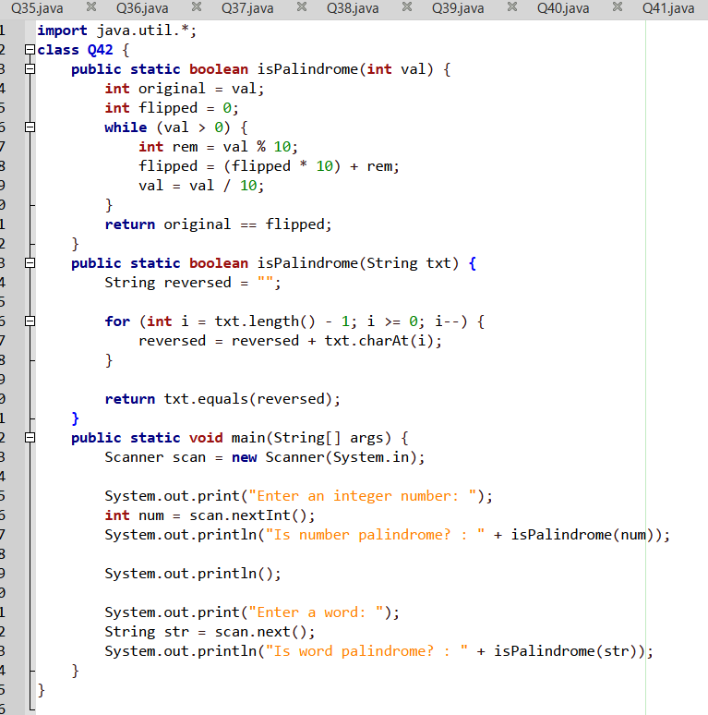
Output>>
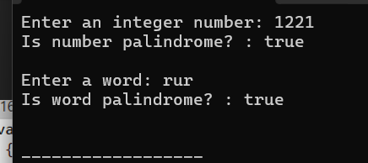
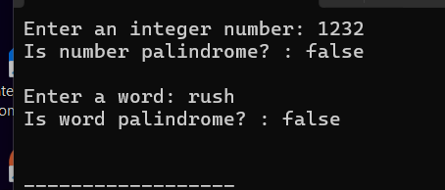

Q43.
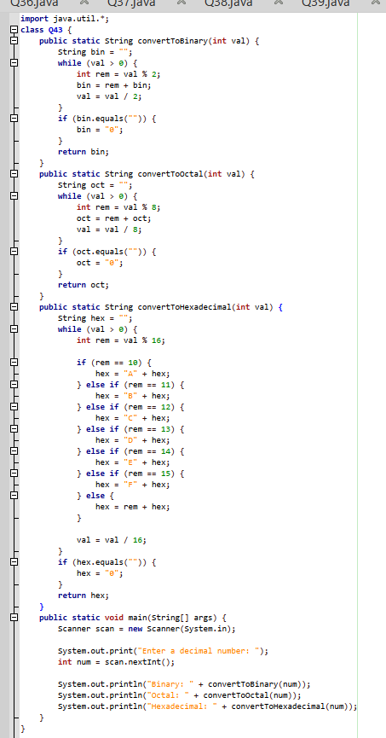
Output>>
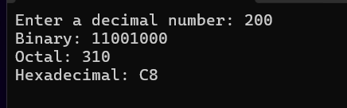

Q44.
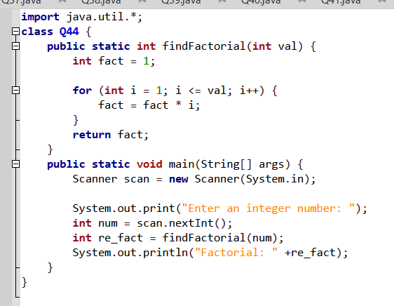
Output>>
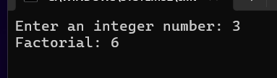

Q45.
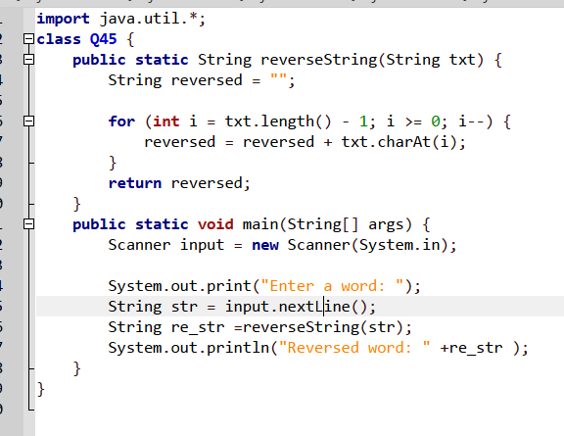
Output>>
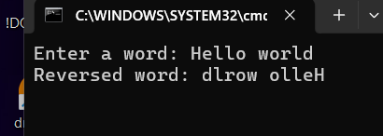

Q46.
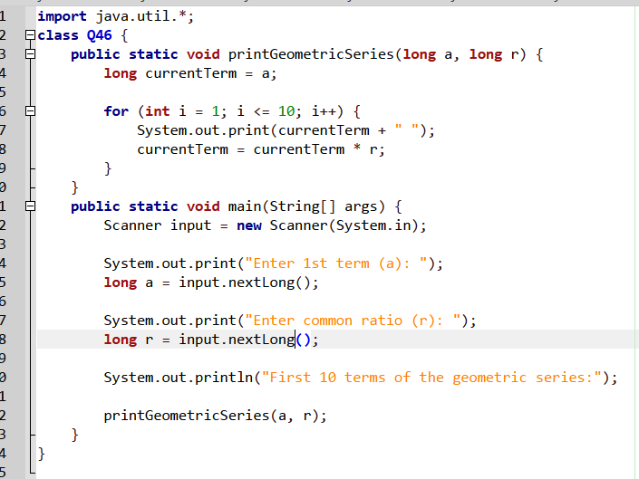
Output>>
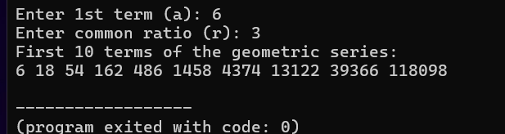

Q47.
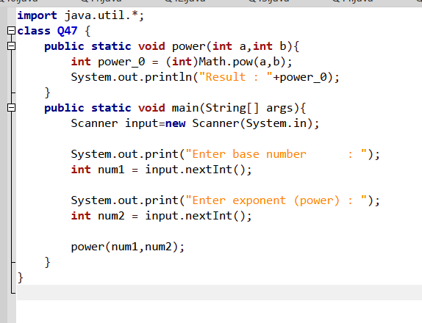
Output>>
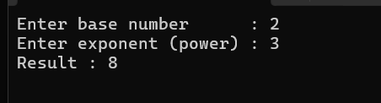

Q48.
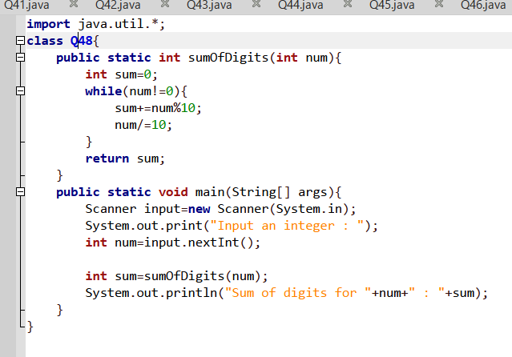
Output>>
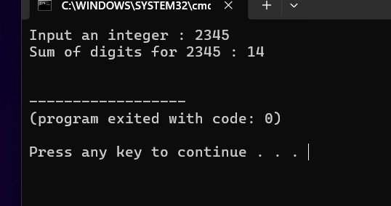

Q49.
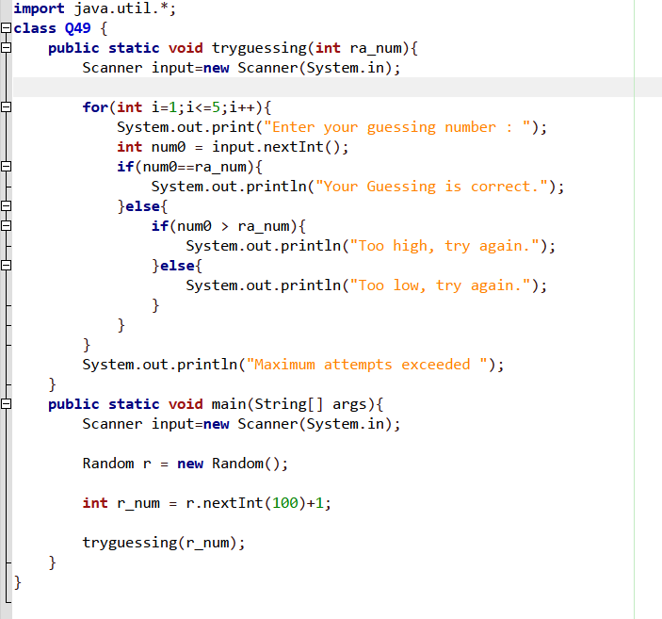
Output>>
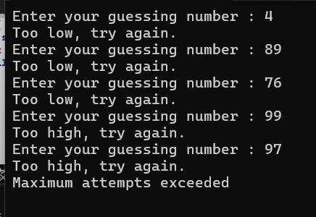

Q50.
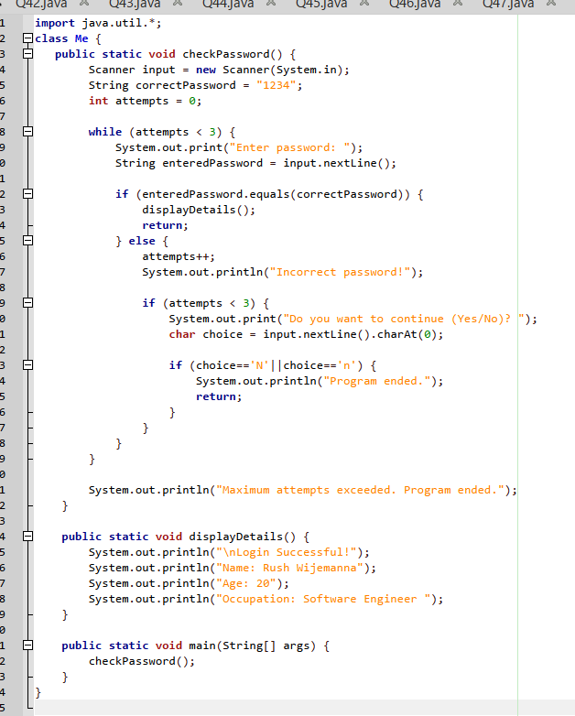
Output>>
