01.
class Example01{
public static void main(String args[]){
System.out.println("Hello Wordl");
}
}
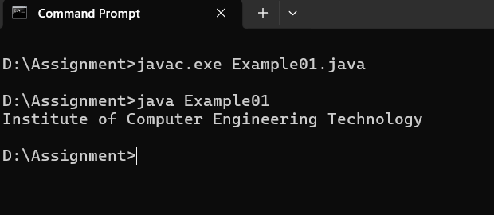
Output>>

02.
class Example02 {
public static void main(String args[]){
System.out.println("Institute of Computer Engineering Technology");
System.out.println("223 A,");
System.out.println("Galle Road,");
System.out.println("Panadura");
}
}
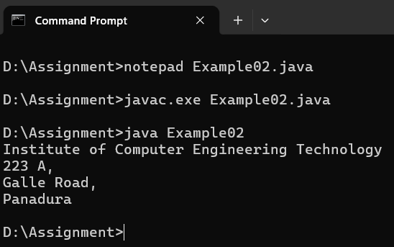
Output>>

03.
class Example03 {
public static void main(String args[]){
System.out.println("J");
System.out.println("A");
System.out.println("V");
System.out.println("A");
}
}
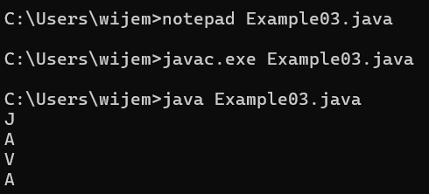
Output>>
04.
class Example04 {
public static void main(String args[]){
System.out.println("1");
System.out.println(1000);
System.out.println(1.23);
}
}
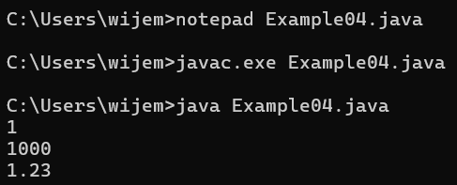
Output>>

05.
class Example05 {
public static void main(String args[]){
System.out.println("Hello");
System.out.println("A");
System.out.println(1234);
System.out.println(-1234);
System.out.println(1.2334);
System.out.println(0.0032);
System.out.println(-0.0023);
System.out.println('A');
System.out.println('6');
System.out.println(true);
System.out.println(false);
}
}
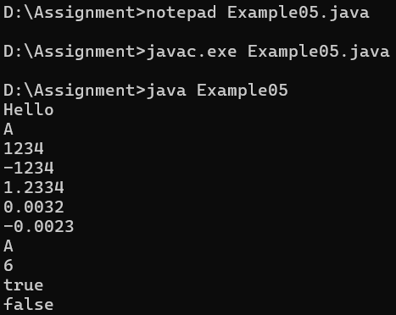
Output>>

06.
class Example06 {
public static void main(String args[]){
System.out.print("A");
System.out.print("B");
System.out.print("C");
System.out.print("D");
}
}
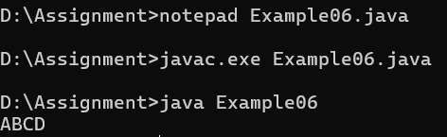
Output>>

07.
class Example07 {
public static void main(String args[]){
System.out.println("1");
System.out.print("2 ");
System.out.println("3 ");
System.out.print("4 ");
System.out.print("5 ");
System.out.println("6 ");
System.out.print("7 ");
System.out.print("8 ");
System.out.print("9 ");
System.out.println("10 ");
}
}

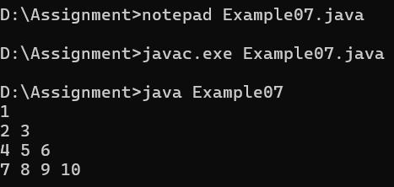
Output>>

08.
class Example08 {
public static void main(String args []){
System.out.print("1");
System.out.println();
System.out.print("2 ");
System.out.print("3 ");
System.out.println();
System.out.print("4 ");
System.out.print("5 ");
System.out.print("6 ");
System.out.println();
System.out.print("7 ");
System.out.print("8 ");
System.out.print("9 ");
System.out.print("10 ");
}
}
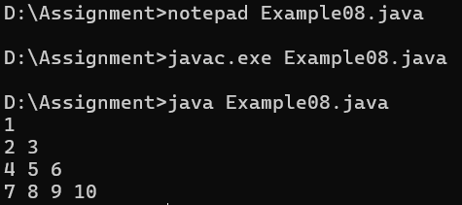
Output>>

09.
class Example09 {
public static void main(String args[]){
System.out.println("A");
System.out.println("B");
System.out.println();
System.out.println("C");
System.out.println("D");
System.out.print("");
}
}
Output>>
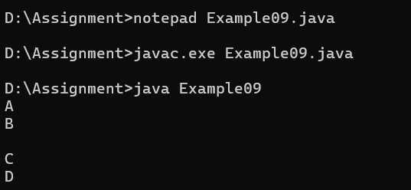
10.
class Example10 {
public static void main(String args[]){
System.out.println("A");
System.out.println("B");
System.out.print();
System.out.println("C");
System.out.println("D");
}
}

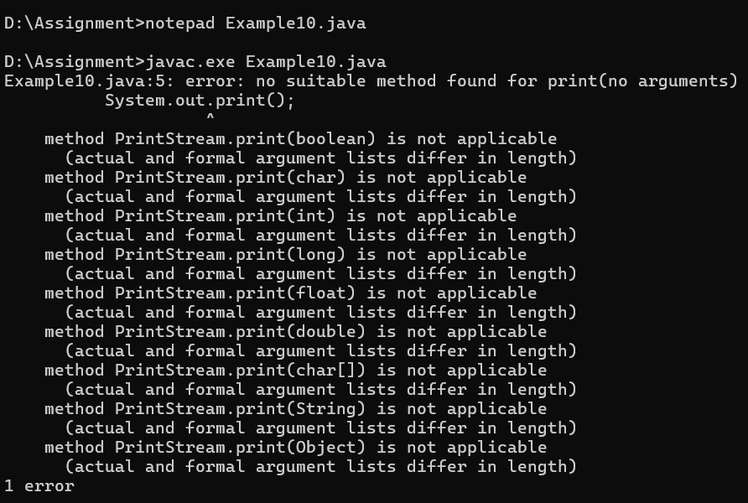
Output>>
*error
11.
class Example11 {
public static void main(String args[]){
int a;
a=100;
System.out.println("a");
System.out.println(a);
}
}
Output>>
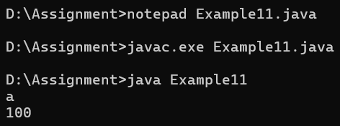

12.
class Example12 {
public static void main(String args[]){
int a;
System.out.println("a");
System.out.println(a);
}
}
Output>>
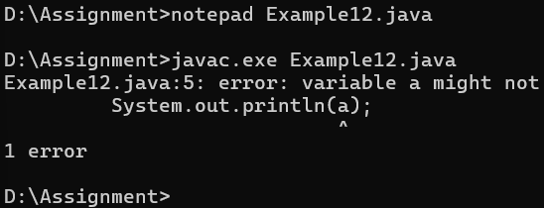
*error
13.
class Example13 {
public static void main(String args[]){
int a=100;
System.out.println(a);
}
}
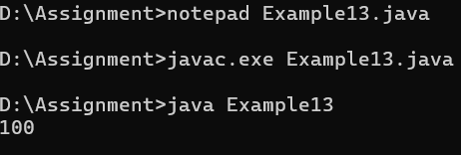
Output>>

14.
class Example14{
public static void main(String args[]){
int a;
System.out.println(a);
a=100;
}
}
Output>>
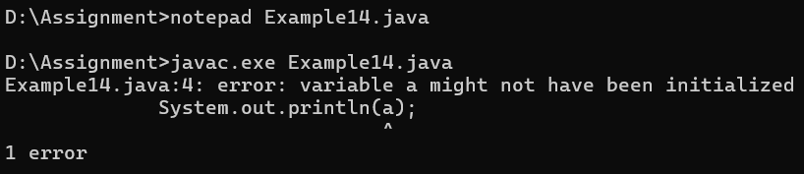
*error
15.
class Example15{
public static void main(String args[]){
int x;
x=100;
x=200;
System.out.println(x);
}
}
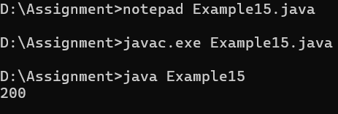
Output>>
16.
class Example16{
public static void main(String args[]){
int x;
x=100;
System.out.println(x);
x=200;
System.out.println(x);
}
}
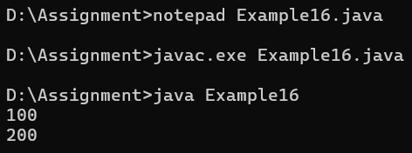
Output>>

17.
class Example17{
public static void main(String args[]){
int x=100;
int y=200;
System.out.println(x);
System.out.println(y);
}
}
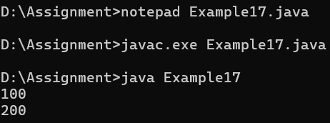
Output>>

18.
class Example18{
public static void main(String args[]){
int x;
x=1000;
System.out.println(x);
var y=2000;
System.out.println(y);
}
}
Output>>
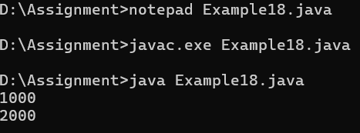

19.
class Example19{
public static void main(String args[]){
int x=100;
int y=200;
int z;
System.out.println(x);
System.out.println(y);
System.out.println(z);
}
}
Output>>
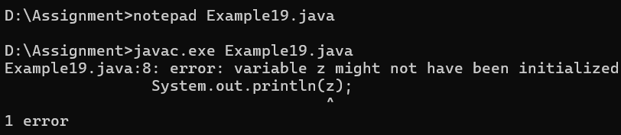
20.
class Example20{
public static void main(String args[]){
int x=100,y,z=200;
System.out.println(x);
y="java";
System.out.println(y);
System.out.println(z);
}
}

Output>>
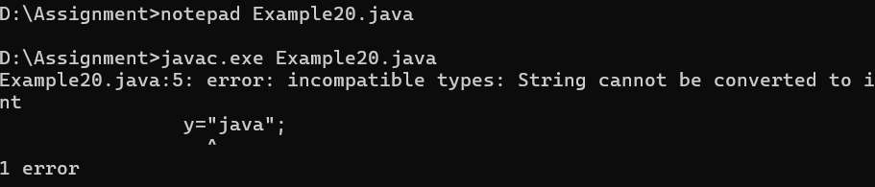
21.
class Example21{
public static void main(String args[]){
System.out.println("A");
//System.out.println("B");
System.out.println("C");
//System.out.println("D");
System.out.println("E");

}
}
Output>>
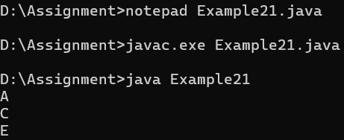

22.
class Example22 {
public static void main(String args[]){
System.out.println("A");
System.out.println("B");
/*System.out.println("C");
System.out.println("D");
System.out.println("E");*/
System.out.println("F");
}
}
Output>>
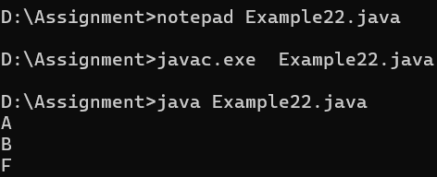
23.
class Example23{
public static void main(String args[]){
int x=100;
int y=200;
System.out.println(x);
System.out.println(y);
x=y;
System.out.println(x);
System.out.println(y);
}
}
Output>>
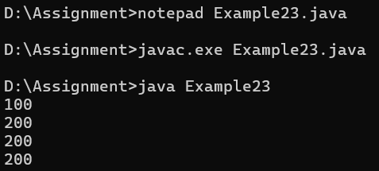
24.
class Example24{
public static void main(String args[]){
System.out.println(true);
System.out.println("true");
}
}
Output>>
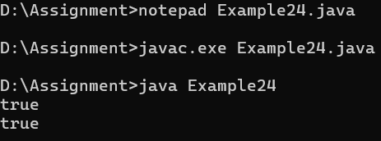

25.
class Example25 {
public static void main(String args[]){
System.out.println(Java);
System.out.println("Java");
}
}
Output>>
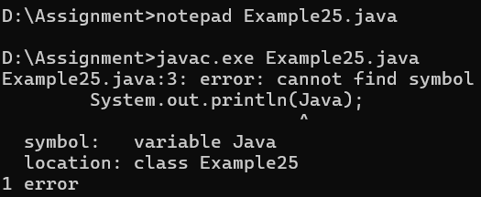
*error
26.
class Example26 {
public static void main(String args[]){
System.out.println('A');
System.out.println("A");
System.out.println('2');
System.out.println("2");
System.out.println('JAVA');
System.out.println("JAVA");
}
}

Output>>
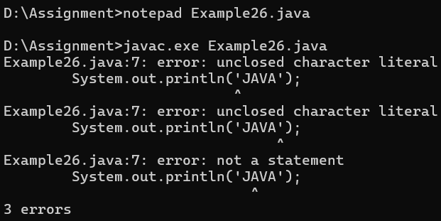
*error
27.
class Example27 {
public static void main(String args[]){
System.out.println("Hellooooo\tJAVA");
System.out.println("Hellooooo\t\t\tJAVA");
}
}
Output>>
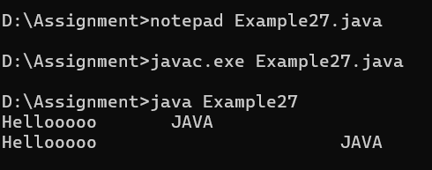

28.
class Example28 {
public static void main(String args[]){
System.out.println("Hi\tJAVA");
System.out.println("Hello\tWorld");
}
}
Output>>
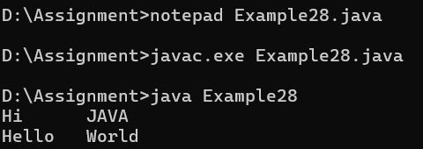

29.
class Example29 {
public static void main(String args[]){
System.out.println("AB\nCD");
System.out.println("");
System.out.println("EF\tGH\n\nIJ\tKL");
}
}
Output>>
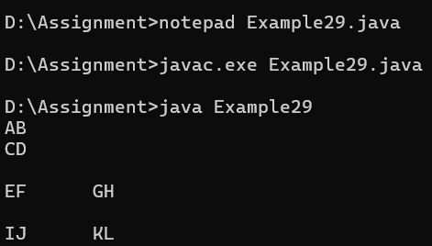
30.
class Example30 {
public static void main(String args[]){
System.out.println("time - "17:56:02"");
}
}
Output>>
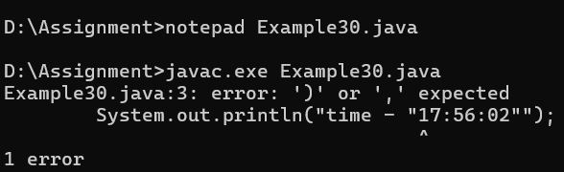
*error

31.
class Example31 {
public static void main(String args[]){
System.out.println("\'iCET\'");
System.out.println("\"Institute of Computer Engineering Technology\"");
}
}
Output>>
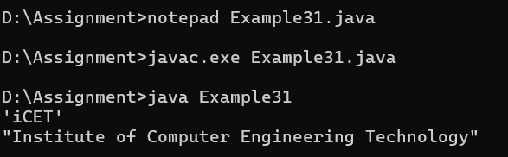

32.
class Example32 {
public static void main(String args[]){
System.out.println("First Line \nSecond Line");
System.out.println("A \tB \tC");
System.out.println("D \tE \tF");
}
}
Output>>
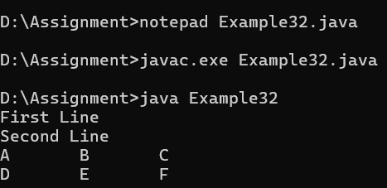

33.
class Example33 {
public static void main(String args[]){
System.out.println("AB\nCD");
System.out.println("AB\tCD");
System.out.println("AB\fCD");
System.out.println("AB\bCD");
System.out.println("AB\rCD");
System.out.println("AB\\CD");
}
}

Output>>
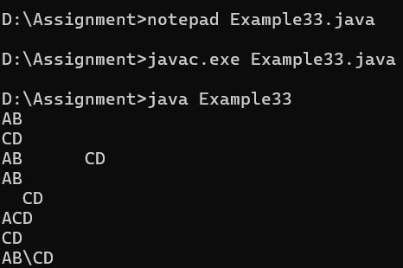

34.
class Example34 {
public static void main(String args[]){
System.out.println(10+20);
System.out.println("10"+"20");
System.out.println("10"+20);
System.out.println(10+"20");
}
}
Output>>
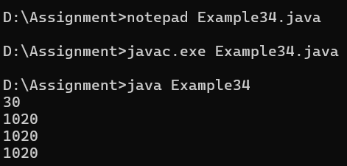
35.
class Example35 {
public static void main(String args[]){
System.out.println(20230326);
System.out.println("2023-03-26");
}
}
Output>>
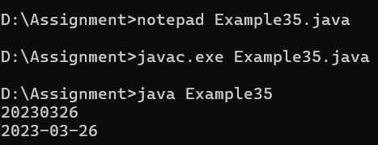
36.
class Example36 {
public static void main(String args[]){
int x,y,z;
x=10;
y=20;
z=x+y;
System.out.println(x+"+"+y+"="+z);
}
}
Output>>
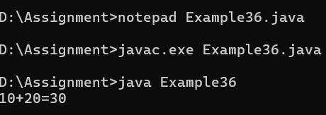
37.
class Example37 {
public static void main(String args[]){
int x=10,y=20;
System.out.println(x+y);
System.out.println("x"+"y");
System.out.println("x+y");
System.out.println("x"+y);
System.out.println(x+"y");
}
}
Output>>
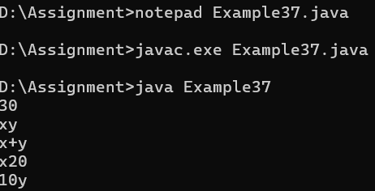

38.
class Example38 {
public static void main(String args[]){
System.out.println(10+20+30);
System.out.println("10+20+30");
System.out.println(10+20+30);
System.out.println("10+20"+30);
System.out.println("10"+"20"+"30");
System.out.println("10"+20+30);
System.out.println(10+20+"30");
System.out.println(10+"20"+30);
}
}
Output>>
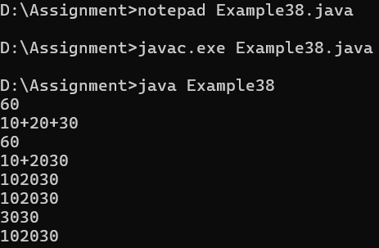

39.
class Example39 {
public static void main(String args[]){
String s1="Hello";
System.out.println(s1);
System.out.println(s1.concat(" JAVA"));
}
}
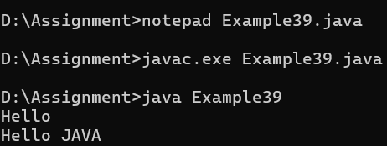
Output>>
40.
class Example40 {
public static void main(String args[]){
int x, y, z;
x=10;
y=20;
z=x+y;
System.out.println(x+" + "+y+" = "+z);
z=x-y;
System.out.println(x+" - "+y+" = "+z);
z=x*y;
System.out.println(x+" * "+y+" = "+z);
}
}
Output>>
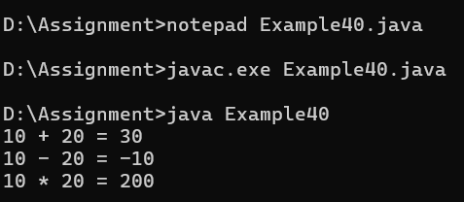
41.
class Example41 {
public static void main(String args[]){
int x, y;
x=10;
y=20;
System.out.println(x+" + "+y+" = "+(x+y));
System.out.println(x+" - "+y+" = "+(x-y));
System.out.println(x+" * "+y+" = "+(x*y));
}
}
Output>>
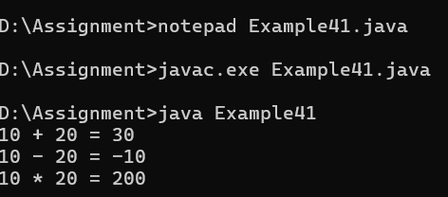

42.
class Example42{
public static void main(String args[]){
int x,y;
x=100;
y=200;

y=x;
System.out.println(x);
System.out.println(y);
}
}
Output>>
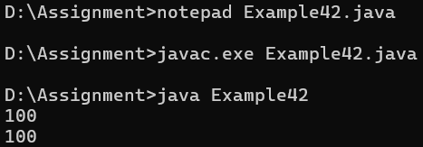

43.
class Example43{
public static void main(String args[]){
int num=103;
if(num>0){
System.out.println(num+"is positive number");
}else if(num<0){
System.out.println(num+"is negative number");
}else{
System.out.println(num+"is 0");
}
}
}
Output>>
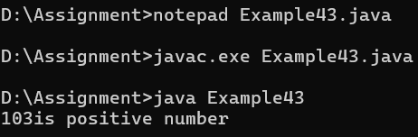
44.
import java.util.*;
class Example44{
public static void main(String args[]){
Scanner input=new Scanner(System.in);
System.out.print("input number -");
int num=input.nextInt();
if(num>0){
System.out.println(num+"is positive number");
}else if (num<0){
System.out.println(num+"is negative number");
}else{
System.out.println(num+"is 0");
}
}
}
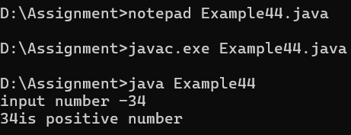
Output>>
45.
import java.util.*;
class Example45 {
public static void main(String args[]){
Scanner input=new Scanner(System.in);
System.out.print("Enter your marks -");
int mark=input.nextInt();
if(mark>=75){
System.out.println("your grade is A");
}else if(mark >=65){
System.out.println("your grade is B");
}else if(mark >=50){
System.out.println("your grade is C");
}else{
System.out.println("your grade is F");
}
}
}
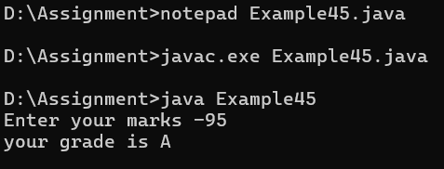
Output>>

46.
import java.util.*;
class Example46 {
public static void main(String args[]){
Scanner input=new Scanner(System.in);
System.out.print("Enter your age -");
int age=input.nextInt();
if(age<18){
System.out.println("age is not valid to vote");
}else{
System.out.println("welcome to vote");
}
}
}
Output>>
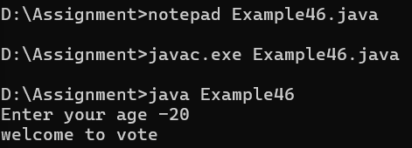

47.
class Example47 {
public static void main(String args[]){
double x, y, z;
x=3;
y=4;
z=Math.sqrt(x*x + y*y);
System.out.println("Hypotenuse is "+z);
}
}
Output>>
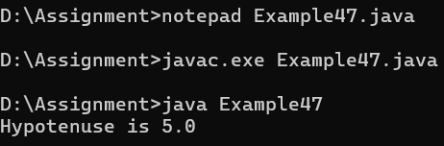

48.
import java.util.*;
class Example48 {
public static void main(String args[]) {
Scanner input=new Scanner(System.in);
System.out.print("Enter any number - ");
int num=input.nextInt();
int fact=1;
for(int i=1;i<num;i++){
fact=fact*i;
}
System.out.println("The factorial of "+num+" is "+fact);
}
}

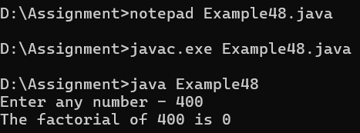
Output>>

49.
import java.util.*;
class Example49 {
public static void main(String args[]) {
Scanner input=new Scanner(System.in);
System.out.print("Input your age - ");
int age=input.nextInt();
if(age < 18){
System.out.println("age is not valid to vote");
}
else {
System.out.println("welcome to vote");
}
}
}
Output>>
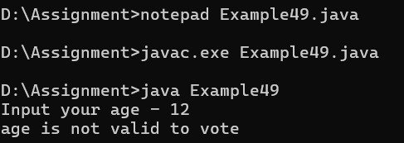
50.
public class Example50 {
public static void main(String args[]) {
for(int i=-5;i<6;i++){
int result = i!=0 ? 100/i : 0 ;
if(i!=0){
System.out.println("100/"+i+" is "+result);
}
}
}
}
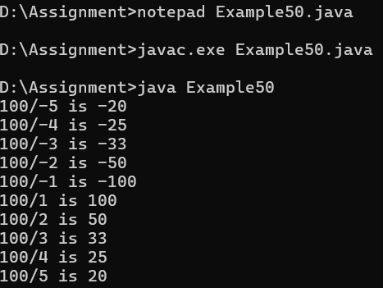
Output>>

