01
class Details {
public static void main(String[] args){
System.out.println("Name : Rush Wijemanna");
System.out.println("Address : 30A Malamulla West Panadura");
System.out.println("Phone Number: 0767260054");
System.out.println("Email : Wijemannatawl@gmail.com");
}
}
Output>>
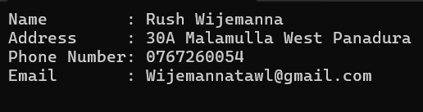
02
class Strangle {
public static void main(String[] args){
System.out.println("*");
System.out.println("* *");
System.out.println("* * *");
System.out.println("* * * *");
System.out.println("* * * * *");
System.out.println("* * * * * *");
System.out.println("* * * * * * *");
}
}
Output>>
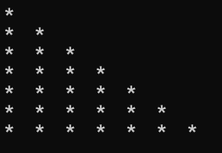
03
class Multiplication{
public static void main(String[] args){
System.out.println(" 299");
System.out.println("+ 800");
System.out.println("------------");
System.out.println(" 1099");
System.out.println("============");
}
}

Output>>
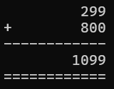
04
class Flag{
public static void main(String[] args){
System.out.println("* * * * * * ==================================");
System.out.println(" * * * * * ==================================");
System.out.println("* * * * * * ==================================");
System.out.println(" * * * * * ==================================");
System.out.println("* * * * * * ==================================");
System.out.println(" * * * * * ==================================");
System.out.println("* * * * * * ==================================");
System.out.println(" * * * * * ==================================");
System.out.println("* * * * * * ==================================");
System.out.println("==============================================");
System.out.println("==============================================");
System.out.println("==============================================");
System.out.println("==============================================");
System.out.println("==============================================");
System.out.println("==============================================");
}
}
Output>>


05
class Program_a{
public static void main(String args[]){
System.out.println("Institute of Computer Engineering Technology");
System.out.println("223 A,");
System.out.println("Galle Road,");
System.out.println("Panadura.");
}
}
Output>>
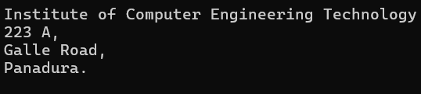

class Program_b{
public static void main(String args[]){
System.out.println("Institute of Computer Engineering Technology");
System.out.print("223 A,");
System.out.print("Galle Road,");
System.out.print("Panadura.");
}
}
Output>>
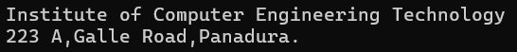
06
class Q6{
public static void main(String[] args){
//This print method always stays on the same line ""Hello and world " are print same line"
System.out.print("Hello");
System.out.print("World");
//below print (Println) method always moves the next line after we print what we need to print
System.out.println();
System.out.println("Hello");
System.out.println("World");
}
}

# Print statement- In this example you guy see this print method we used to always stays on the same line "ex - Hello and world " are print same line
# Println statement- it’s always moves the next line after we print what we need to print

Output>>
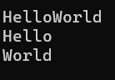
07.
class Q5{
public static void main(String[] args){
System.out.println("a");
System.out.println('a');
}
}
# We always used double quotes to print String (Sequence of character)
# We always used single quotes to print char (single characters)
08.
Class Example {
Public static void main(String[] args){
System.out.println(7);
System.out.println(7.0);
System.out.println(“7”);
System.out.println(‘7’);
}
}
# Number one is Int .It is used to print Decimal
# Number two is Double.It is used to print Float
# Number Three is String.It is used to print Text/Strings
# Number Four is char .It is used to print single characters
09.
There are 5 literals we commonly used and they are
# Integer literals it called int.We use that literal for print Integer Decimal Numbers. We have two types to print Decimal numbers and they are given below
//First Example use for Large Modules
Class Example {
Public static void main(String[] args){
int i = 10;
System.out.println( i );
}
}

Class Example {
Public static void main(String[] args){
System.out.println( 10 ); //this int number print method without creating a variable
}
}

# floating -Point-Literals.It called Double We use that literal for print floats. . We have two types to print Float numbers and they are given below
//First Example use for Large Modules
Class Example {
Public static void main(String[] args){
Double i = 10.00;
System.out.println( i );
}
}

Class Example {
Public static void main(String[] args){
System.out.println( 10.00 ); //this int number print method without creating a variable
}

# String literal . We use that literal for print Text/Strings. .
//First Example use for Large Modules
Class Example {
Public static void main(String[] args){
System.out.println( “Hello World”);
}
}

# character literal. We use that literal for print char (single character)
Class Example{
Public static void main(String[] args){
System.out.println(‘ a ’);
}
}

#boolean literal.this method use to print true or false.there are two methods
Class BooleanExample{
Public static void main(String[] args){
System.out.println(false);//we have to use true or false
}
}
Class BooleanExample{
Public static void main(String[] args){
Boolean isjavafun = false;
System.out.println(isjavafun);
}
}

10

class Example {
public static void main(String args[]){
System.out.println(1100100); //print ->as aDecimal
System.out.println(0B1100100); //print->as a Binary
System.out.println(01100100); //print-> as aoctal
System.out.println(0x1100100); //print-> as Hexadecimal
}
}
Output>>
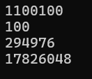

11
class Example{
public static void main(String args[]){
System.out.println(0B11100100);
System.out.println(0b11100100);
System.out.println(0B11100200);
System.out.println(0144);
System.out.println(0148);
System.out.println(0x64);
System.out.println(0xabc);
System.out.println(0xabcg);
System.out.println(0X);
System.out.println(0Xfffffff);
}
}

Explain
# Line 1 (0B11100100) Valid
This is a proper binary literal because it uses the correct 0B prefix and only contains 1s and 0s.
# Line 2 (0b11100100) Valid
This is also a proper binary literal. Java allows both uppercase 0B and lowercase 0b prefixes.
# Line 3 (0B11100200) Invalid (Error)
This line gives a compile error because binary numbers can only have 0 and 1. The number 2 used inside is invalid for binary.
# Line 4 (0144) Valid
This is a valid octal literal because it starts with a 0 and all the numbers (1, 4, 4) are within the allowed 0 to 7 range for octals.
# Line 5 (0148) Invalid (Error)
This throws an error because the starting 0 tells Java it is an octal number. Octal numbers cannot contain the digit 8; they only go up to 7.
# Line 6 (0x64) Valid
This is a correct hexadecimal literal. It starts with 0x and uses valid numbers.
# Line 7 (0xabc) Valid
This is also a valid hexadecimal literal since hex allows letters from a to f.
# Line 8 (0xabcg) Invalid (Error)
This gives an error because hexadecimal literals only allow letters from a to f. The letter g is out of range.
# Line 9 (0X) Invalid (Error)
This is a syntax error because you cannot just leave the hex prefix 0X empty. It must have at least one valid digit or letter after it.
# Line 10 (0Xfffffff) Valid
This is completely valid. It uses the uppercase 0X prefix followed by valid hex letters.

12
This code is not Compile There is a error.line4 missin ”;”
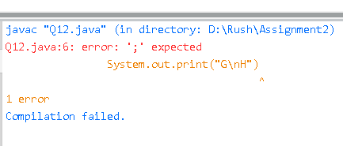

13
class Q13 {
public static void main(String[] args) {
System.out.print("i.\tiCM - iCET CERTIFIED MASTER\n\nii.\tiCM\n\t\n\tiCET\n\tCERTIFIED\n\tMASTER\n\niii.\tiCM\n\t\n\tiCET CERTIFIED MASTER");
}
}

Output>>
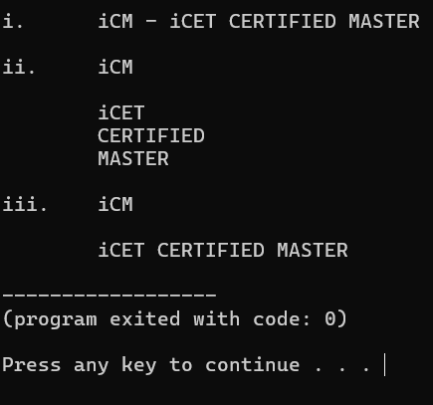

14
class Example {
public static void main(String args[]){
System.out.println("Hello\nJAVA");
System.out.println("Hello\tJAVA");
System.out.println("Hello\bJAVA");
System.out.println("\\Hello JAVA\\");
System.out.println("\"Hello\nJAVA\"");
System.out.println("\'Hello\nJAVA\'");
}
}
Output>>

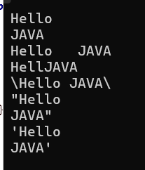

Line 1- this line use \n to move to the next line and print "JAVA"
Line 2- this line use \t to insert tab space between Hello and JAVA
Line 3- this line use \b to insert a backspace (deletes the letter 'o' before JAVA)
Line 4- this line use \\ to print a backslash \ character before and after the text
Line 5- this line use \" to print double quotes " around the text
Line 6- this line use \' to print single quotes ' around the text

15
class Q15{
public static void main(String[] args) {
System.out.println("a. Java is a typed language\nb. AB\"CB\nc. AB\\CD\nd. C:\\Windows\\Program\ne. AB\\\"CD\nf. AB\\\\\\\"\"CD\ng. AB\\nCD\nh. AB\\tCD\ni. AB\\bCD");
}
}
Output>>
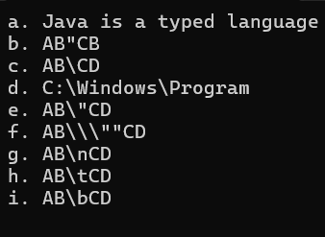

16
class Q16{
public static void main(String[] args){
System.out.println(" _ ______ _______ _________");
System.out.println("(_)/ _____| _____|___ ___|");
System.out.println(" _| | | |___ | |");
System.out.println("| | | | ___| | |");
System.out.println("| | |____ | |_____ | |");
System.out.println("|_|\\______|_______| |_|");

}
}
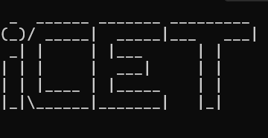
output>>

17
class Q17{
public static void main(String args[]){
System.out.println(" +\"\"\"\"\"+");
System.out.println(" [ | o o | ]");
System.out.println(" | ^ |");
System.out.println(" | '-' |");
System.out.println(" +'''''+");
System.out.println(" |||||||||");
System.out.println(" /\\/\\/|||||||||||\\/\\/\\");
System.out.println(" |||||||||||||");
System.out.println(" |||||||||||||||");
System.out.println(" |||||||||||||");
System.out.println(" |||||||||||");
System.out.println(" |||||||||");
System.out.println(" /\\ /\\");
}

}

Output>>
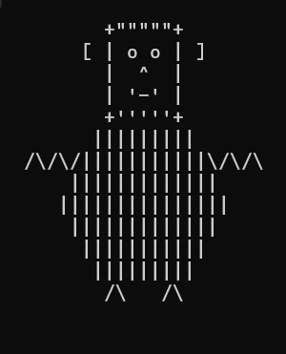

18
class Example{
public static void main(String[] args){
int i; //line 1 i=103; //line 2
System.out.println(i); //line 3
}
}
Line1-create a variable i and assign int literal into i
Line 2-assign 103 into “ i” .like a memory
Line3- this line prints the value stored in the variable i to the console

19
Class Q19{
public static void main(String args[]){
int x;
int y;
x = 102;
y = 103;
System.out.println(x+"\t"+y);
System.out.println(y+"\t"+x);
}
}

Output>>
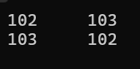

20
class Example{
public static void main(String args[]){
int x;
System.out.println(x);
}
}

Error: Compile time error

21
class Q21{
public static void main(String args[]){
int x=10,y=20,z=30;
System.out.println(x);
System.out.println(y);
System.out.println(z);
int y=200;
System.out.println(y);
}
}

Error: y is declared twice in the same scope

22
class Q22{
public static void main(String args[]){
int x,y;
x=100;
y=200;
System.out.println(x);
System.out.println(y);
y=300;
System.out.println(x);
System.out.println(y);
}
}

# Create x and y int variables
#Assign x = 100 and y = 200. after that print the x and y
#Assign new value into y. it is 300 and after that print x,y agin

23
class Example{
public static void main(String args[]){
int x; //Line 12
System.out.println(x);
}
}

B: x=100 Correct x is a local variable and before it gets printed I must be inisialized a value
24
class Example{
public static void main( String args[] ){
int x,y,z; //line 1
x=y=z=10; //line 2
int a=12,b,c=4; //line 3
int p=10; //line 4
int q=p; //line 5
int i=j=k=10; //line 6
}
}
D. Compile error at line 6

25
class Q25{
public static void main(String args[]){
System.out.println("10"+"20"); //line 1
System.out.println(10+20); //line 2
}
}

Output>>
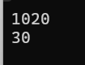

#First: the values are enclosed in double quotes it’s meaning they are strings .that is why “10”+ “20” =1020

#Second the values are not in quotes it's meaning they are integer that is why 10+20=30

26
class Q26{
pubic static void main(String args[]){
System.out.println(10+20+30);
System.out.println("10+20+30");
System.out.println("10+20"+30);
System.out.println("10"+"20"+"30");
System.out.println("10"+20+30);
System.out.println(10+20+"30");
System.out.println(10+"20"+30);
}
}

It was error: it’s not pubic it would be public

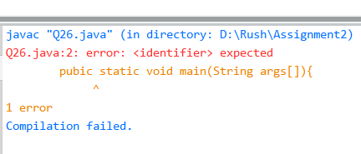

27
class Q27{
public static void main(String[] args){
System.out.println(1+2+3);
System.out.println("1"+"2"+"3");
System.out.println('1'+'2'+'3');
System.out.println('1'+" "+'2'+" "+'3');
System.out.println('A'+'B'+'C');
System.out.println("A"+"B"+"C");
System.out.println('A'+100+200);
System.out.println('A'+" "+'B'+" "+'C');
}
}

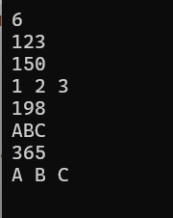

Explain:

#Line 1: it is addition 1+2+3=6
#Line 2: those are Strings “1” + “2” + “3”=123
#Line 3: those are getting values form ascii table and print the output 150
#Line 4: those are Strings “1” + “ ” + “2” + “3”
#Line 5: those are getting values form ascii table and print the output 198
#Line 6: those are Strings
#Line 7: ‘A’ char it is getting value from ascii A=65 in ascii table and after that ‘A” +100+200=365
#Line8: “” becouse that string character in the code and that why those are not getting values from ascii 'A'+" "+'B'+" "+'C'= A B C

28
//this is 28
import java.util.*;
class Example{
public static void main(String[] args){
int i;
i=input.nextInt();
System.out.println(i);
}
}

//this is 20 code

class Example{
public static void main(String args[]){
int x;
System.out.println(x);
}
}

Both are error : Question 20 is print x without assign value to x
:Quection 28 have input.nextInt but it’s not have important code and it is scanner method so that is why it was an error

29
import java.util.*;
class Q29 {
public static void main(String[]args){
Scanner input = new Scanner(System.in);

System.out.print("Enter First Input : ");
int first_Input = input.nextInt();
System.out.println();
System.out.print("Enter Second Input: ");
int second_Input =input.nextInt();
System.out.println();
int final_sum= first_Input + second_Input ;
System.out.print(first_Input +" " + "+" + " " + second_Input +" " + "=" + " "+ final_sum);
}
}
Output>>

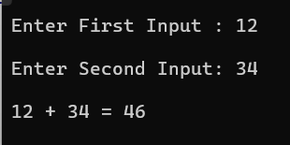

30
import java.util.*;
class Q30 {
public static void main(String[] args){
Scanner input = new Scanner(System.in);

System.out.print("Input Number : ");
int number = input.nextInt();

String s_concat = "" + number + number + number;
System.out.println(s_concat);

int m_number = number + number + number;
System.out.println(m_number);
}
}
Output>>
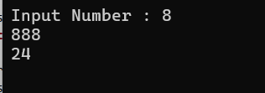

31
import java.util.*;
class Q31 {
public static void main(String[] args){
Scanner input = new Scanner(System.in);

System.out.print("Combined Maths - ");
int c_marks = input.nextInt();
System.out.println();

System.out.print("chemistry - ");
int chem_marks = input.nextInt();
System.out.println();

System.out.print("Physics - ");
int phy_marks = input.nextInt();
System.out.println();

System.out.print("English - ");
int e_marks = input.nextInt();
System.out.println();

int total_sum = c_marks + chem_marks + phy_marks + e_marks;
System.out.println("Total - " + total_sum);
}
}

Output>>
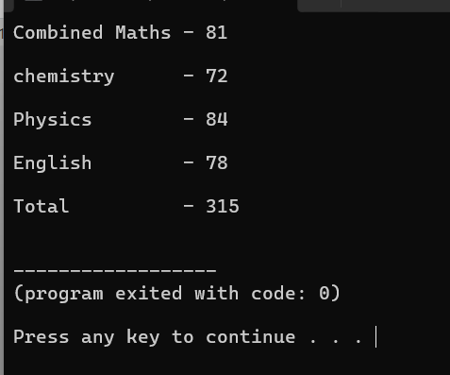

32
import java.util.*;
class Q32 {
public static void main(String[] args){
Scanner input = new Scanner(System.in);

System.out.print("Enter Red value : ");
int red = input.nextInt();
System.out.println();

System.out.print("Enter Green value : ");
int green = input.nextInt();
System.out.println();

System.out.print("Enter Blue value : ");
int blue = input.nextInt();
System.out.println();

int inver_red = 255 - red;
int inver_green = 255 - green;
int inver_blue = 255 - blue;

System.out.println("Inversion of given colour - [" + inver_red +","+ inver_green + "," + inver_blue + "]");

}
}

Output>>
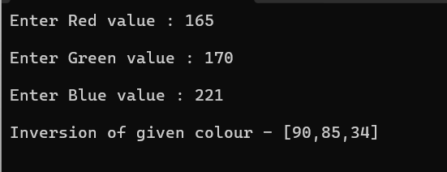

33
Data Type | Size | Description
byte | 1 byte | -128 to 127
short | 2 bytes | -32 768 to 32 767
int | 4 bytes | -2,147,483,648 to 2,147,483,647
long | 8 bytes | 9,223,372,036,854,775,808 to 9,223,372,036,854,775,807
float | 4 bytes | Stores Floating point numbers. Sufficient for storing 6 to 7 decimal digits.
double | 8 bytes | Decimal Numbers
boolean | 1 bit | true or false
char | 2 bytes | Single characters  (Unicode characters)

34
# “ new” in java it was programing reserved keyword. That why it can’t be a variable.
# “My Variable” in java we can’t use spaces in variable name
#”@name” in java we can’t use any special characters in variable name
#”user-input” in java we can’t use hypen in variable name
#”123nume” in java we can’t use to star avariable in numbers
#”java.org”in java we can’t use dot marks in variable name

35
class Q35 {
public static void main(String[] args){
System.out.println("iCET");
String s = "connect intelligents...";
System.out.println(s);
}
}

Exaplain>>

# Line 1 : directly print “iCET” as a String literal
# Line 2 : Create a variable and store “connect intelligenti” as value and print the value using the variable

36

import java.util.*;
class Q36{
public static void main(String args[]){
Scanner input = new Scanner(System.in);
System.out.print("Whats your name : ");
String name = input.next();//i use the next method because i wanted to get first name only
input.nextLine();

System.out.print("Hello "+ name+","+" "+"nice to meet you!");
}
}

Output>>
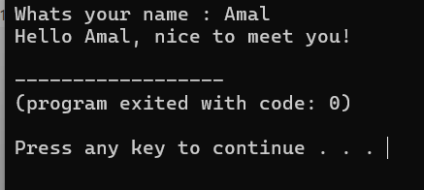

37

class Q37{
public static void main(String args[]){
int x =10;
int y = 5;
String z = x +'y'+"y"+ x + y +'z';
System.out.println("Z is: " +z);
}
}

OutPut>>
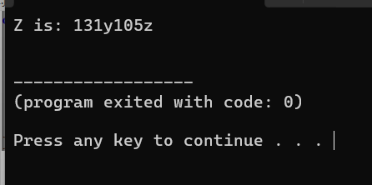

There is a problem because all given answers are incorrect

38
import java.util.*;
class Q38{
public static void main(String args[]){
Scanner input = new Scanner(System.in);
System.out.print("Enter your friends name: ");
String name = input.next();
input.nextLine();
System.out.print("Enter your friend's age: ");
String age = input.nextLine();

System.out.print("Enter your friend's living place: ");
String place = input.nextLine();

System.out.print(name+" is my best friend. He is "+age+" years old and lives in the beautiful town of "+place+".");

}
}

39
import java.util.*;
class Q39{
public static void main(String args[]){
System.out.println("----Subject total calculator----");
System.out.println();
Scanner input = new Scanner(System.in);
System.out.print("Subject 1 name - ");
String subj3 = input.nextLine();

System.out.print(subj1+" marks - ");
int s1M = input.nextInt();
input.nextLine();

System.out.print("Subject 2 name - ");
String subj2 = input.nextLine();

System.out.print(subj2+" marks - ");
int s2M = input.nextInt();
input.nextLine();

System.out.print("Subject 3 name - ");
String subj3 = input.nextLine();

System.out.print(subj3+" marks - ");
int s3M = input.nextInt();
input.nextLine();

System.out.printf("%-11s"+" %16d\n",subj1,s1M);
System.out.printf("%-11s"+" %16d\n",subj2,s2M);
System.out.printf("%-11s"+" %16d\n",subj3,s3M);

}
}

40

import java.util.*;
class Q40{
public static void main(String args[]){
Scanner input = new Scanner(System.in);
System.out.print("Input number 1 : ");
int num1=input.nextInt();
System.out.print("Input number 2 : ");
int num2=input.nextInt();
System.out.println(num1+" "+num2);
int temp1 =num1;
int temp2 =num2;

num1=temp2;
num2=temp1;

System.out.print(num1+" "+num2);

}
}

Output>>
