Q1.
class Demo {
public static void main(String[] args){
int tot = 971;
double avg;
avg = (double)tot/10; /line4 answerr
System.out.println("Average:"+avg);
}
}

Answer: A
Output:
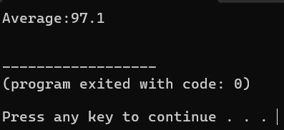

Q2.
class Example {
public static void main(String[] args){
double d;
d = 5/2+5/2;
System.out.println(d);
d = 5/2.0+5/2;
System.out.println(d);
d = 5/2+5.0/2;
System.out.println(d);
d = 5/2.0+5/2.0;
System.out.println(d);

}
}
Answer: B
Output:
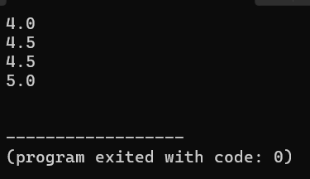

Q3.
class Q3 {
public static void main(String[] args){
int a =10,b =b=7,c=-10,d=-7;
System.out.println(a%b);
System.out.println(-a%b);
System.out.println(a%-b);
System.out.println(-a%-b);
System.out.println(+a%+b);
System.out.println(c%d);
System.out.println(-c%d);

}
}
Output:
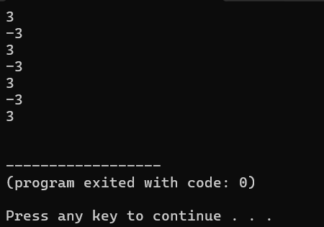

Q4.
class Q4 {
public static void main(String[] args){
int x = 10,y = 7;
System.out.println(x+y);
System.out.println(-x);
System.out.println(-x-y);
System.out.println(-(x-y));
System.out.println(+y);
System.out.println(+y-x);

}
}
Output:
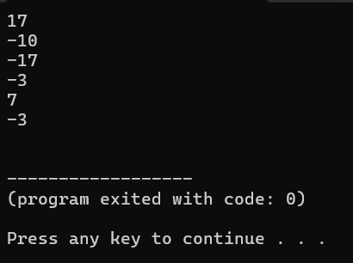

Q5.
class Q5 {
public static void main(String[] args){
int x=-100;
x=+x;
System.out.println(x);
x=-x;
System.out.println(x);
x=-x;
System.out.println(x);
x=x+x;
System.out.println(x);
x=-x-x;
System.out.println(x);
x=x-x;
System.out.println(x);
}
}
Output:
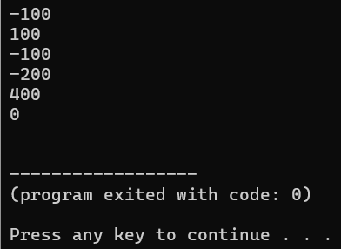

Q6.
class Q6 {
public static void main(String[] args){
int x=100;
System.out.println(x++);
System.out.println(x++);
x++;
System.out.println(++x);
System.out.println(x++);
}
}
Output:
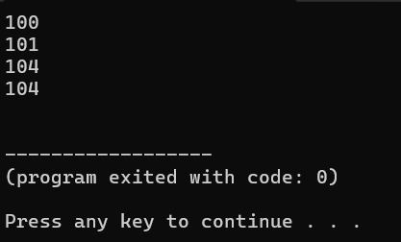

Q7.
class Q7 {
public static void main(String[] args){
int x=100,y;
y=x++;
System.out.println(x+" "+y);
y=x++;
System.out.println(x+" "+y);
y=x++;
System.out.println(x+" "+y);
}
}

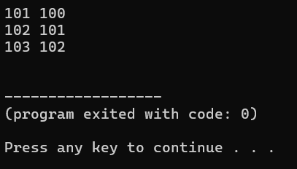
Output:

Q8.
class Q8 {
public static void main(String[] args){
int x=100,y;
y=++x;
System.out.println(x+" "+y);
y=++x;
System.out.println(x+" "+y);
y=++x;
System.out.println(x+" "+y);
}
}
Output:
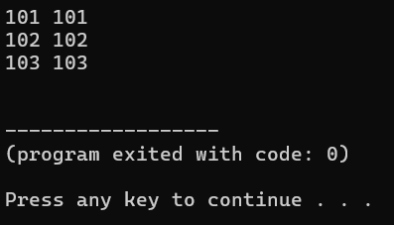

Q9.
class Q9 {
public static void main(String[] args){
int x=100;
x=x++;
System.out.println(x);
x=x++;
System.out.println(x);
x=x++;
System.out.println(x);
x=++x;
System.out.println(x);
x=++x;
System.out.println(x);
x=++x;
System.out.println(x);

}
}
Output:
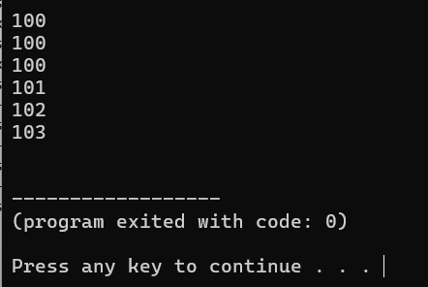

Q10.
class Q10 {
public static void main(String[] args){
int a=10,b=20;
int x;
x= a + b;
System.out.println("A:"+"x"+"="+x); //x=10+20 that is the explain
x= a + -b;
System.out.println("B:"+"x"+"="+x);//x=10+-20 that is the explain
x= ++a + b;
System.out.println("C:"+"x"+"="+x);//x=11+20 that is the explain
x= a + b++;
System.out.println("D:"+"x"+"="+x);//x=11+20 that is the explain
x= ++a + b++;
System.out.println("E:"+"x"+"="+x);//x=12+21 that is the explain
x= a++ + b++;
System.out.println("F:"+"x"+"="+x);//x=12+22 that is the explain
x= ++a + ++b;
System.out.println("G:"+"x"+"="+x);//x=14+24 that is the explain
x= a++ + ++b;
System.out.println("H:"+"x"+"="+x)//;x=14+25 that is the explain
}

}

Output:
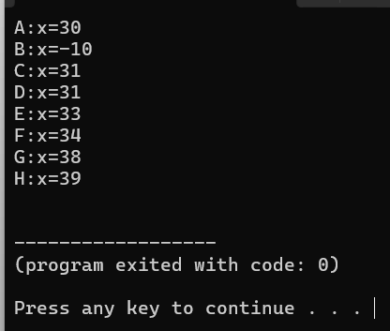

Q11.
class Example {
public static void main(String[] args){
int x;
x=12-4*2;
System.out.println("12-4*2 :"+x);
x=(12-4)*2;
System.out.println("(12-4)*2 :"+x);
x=12-(4*2);
System.out.println("12-(4*2) :"+x);
}
}
Explain:
1. x = 12 - 4 * 2;
Logic: Multiplication (*) has a higher precedence than subtraction (-).
Evaluation:
  - Perform multiplication first: $4×2=8$
  - Perform subtraction next: $12-8=4$
Result: 4
2. x = (12 - 4) * 2;
Logic: Parentheses () have the highest precedence, so the expression inside the brackets is evaluated first.
Evaluation:
  - Perform subtraction inside the parentheses first: $12-4=8$
  - Perform multiplication next: $8×2=16$
Result: 16
3. x = 12 - (4 * 2);
Logic: Expression inside the parentheses () evaluates first.
Evaluation:
  - Perform multiplication inside the parentheses first: $4×2=8$
  - Perform subtraction next: $12-8=4$
Result: 4
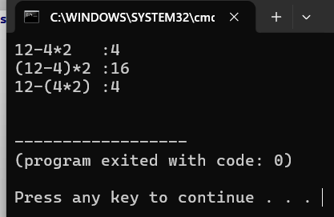
Output:

Q12.
class Q12 {
public static void main(String[] args){
int x;
x=7 % 10 / 2 * 2;
System.out.println("A :"+"x"+"="+x);
x=7 % (10 / 2) * 2;
System.out.println("B :"+"x"+"="+x);
x=7 % 10 / (2 * 2);
System.out.println("C :"+"x"+"="+x);
x=7 % (10 / (2 * 2));
System.out.println("D :"+"x"+"="+x);
x=7 % ((10 / 2) * 2);
System.out.println("A :"+"x"+"="+x);

}
}

Explain:
A. x = 7 % 10 / 2 * 2;
Evaluation:
  - 7 % 10: $7÷10=0$ with a remainder of $7$. $→7$
  - 7 / 2: $7÷2=3.5$ (integer division truncates the decimal). $→3$
  - 3 * 2: $3×2=6$. $→6$
Result: x = 6
B. x = 7 % (10 / 2) * 2;
Evaluation:
  - (10 / 2) evaluate first: $10÷2=5$. $→5$
  - 7 % 5: $7÷5=1$ with a remainder of $2$. $→2$
  - 2 * 2: $2×2=4$. $→4$
Result: x = 4
C. x = 7 % 10 / (2 * 2);
Evaluation:
  - (2 * 2) evaluate first: $2×2=4$. $→4$
  - 7 % 10: $7÷10=0$ with a remainder of $7$. $→7$
  - 7 / 4: $7÷4=1.75$ (truncated). $→1$
Result: x = 1
D. x = 7 % (10 / (2 * 2));
Evaluation:
  - (2 * 2) evaluate first: $2×2=4$. $→4$
  - (10 / 4) evaluate next: $10÷4=2.5$ (truncated). $→2$
  - 7 % 2: $7÷2=3$ with a remainder of $1$. $→1$
Result: x = 1
E. x = 7 % ((10 / 2) * 2);
Evaluation:
  - (10 / 2) evaluate first: $10÷2=5$. $5$
  - (5 * 2) evaluate next: $5×2=10$. 10
  - 7 % 10: $7÷10=0$ with a remainder of $7$. 7
Result: x = 7
Output:
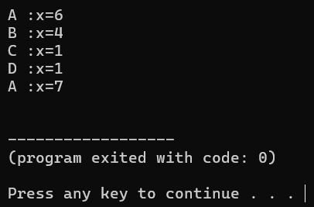

Q13.
import java.util.*;
class Q13 {
public static void main(String[] args){
Scanner input=new Scanner(System.in);

System.out.print("Enter Dividend : ");
double dividend = input.nextDouble();

System.out.println();

System.out.print("Enter Divisor : ");
double divisor =input.nextDouble();

double Quotient = (int) (dividend/divisor);
double remainder = dividend%divisor;
System.out.println("Quotient : "+ Quotient);
System.out.println("Remainder : %.2f\n", remainder);

}
}

Output:
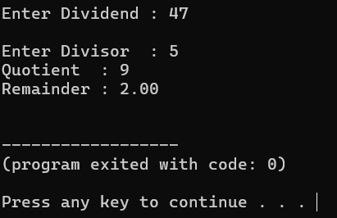

Q14.
import java.util.*;
class Q14 {
public static void main(String[] args){
Scanner input=new Scanner(System.in);

System.out.println(" Enter Numbers ");
System.out.print(" Enter 1st Number: ");
double f_num =input.nextDouble();
System.out.print(" Enter 2nd Number: ");
double s_num =input.nextDouble();

System.out.println();

double addition = f_num + s_num ;
double multi = f_num * s_num ;
double subt = f_num - s_num;
double divi = f_num/s_num ;
double remain =f_num%s_num ;

System.out.printf(" Addition : %.2f\n ",addition);
System.out.printf(" Multiplication : %.2f\n ",multi);
System.out.printf(" Subtraction : %.2f\n ",subt);
System.out.printf(" Division : %.2f\n ",divi);
System.out.printf(" Remainder : %.2f\n ",remain);

}
}
Output:
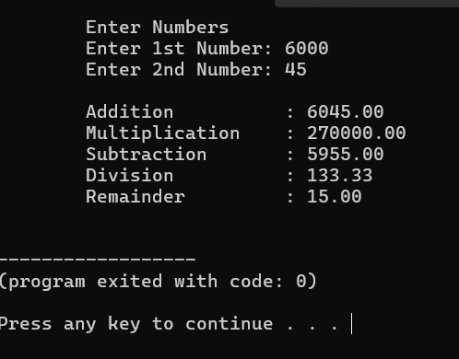

Q15.
import java.util.*;
class Q15 {
public static void main(String[] args){
Scanner input = new Scanner(System.in);

System.out.print("Enter radius: ");
double radius = input.nextDouble();
System.out.println();

double area = 3.14 * radius * radius;
double perimeter = 2 * 3.14 * radius;

System.out.println("Area = "+ area );
System.out.println("Perimeter = "+ perimeter);
}
}

Output:

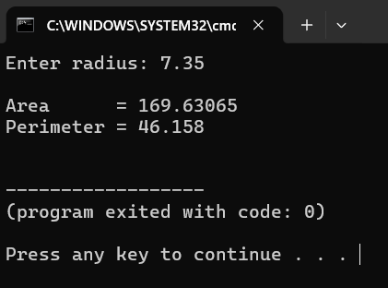

Q16.
import java.util.*;//before get scanner method. use this java library to get methods
class Q16 {
public static void main(String[] args){
//we use scanner method to get input method into our program
Scanner input = new Scanner(System.in);

System.out.print("Enter Product Price : ");
double price = input.nextDouble();

double discount =price * 0.05 ;
double discount_price = price - discount ;
System.out.printf("Price : After Adding 5%% Discount : %.2f\n",discount_price );

}
}
Output:
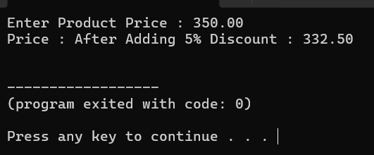

Q17.
import java.util.*;
class Q17 {
public static void main(String[] args){
Scanner input = new Scanner(System.in);

System.out.print("Enter The Total Amount of Purchase : ");
double total = input.nextDouble();

//logic part

double import_tax = total * 0.15 ;
double final_price = total + import_tax ;

System.out.println("Price: After adding Import tax : "+final_price );
}
}
Output:
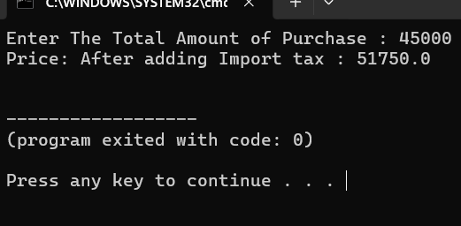

Q18.
import java.util.*;
class Q18 {
public static void main(String[] args){

Scanner input = new Scanner(System.in);

System.out.print("Enter value in byte : ");
double bytes = input.nextDouble();

//calculation part
double kilobytes = bytes / 1024 ;
double megabytes = kilobytes /1024 ;
double gigabytes = megabytes /1024 ;

System.out.printf("Kilobytes : %.2f KB\n",kilobytes);
System.out.printf("Megabytes : %.2f MB\n",megabytes);
System.out.printf("Gigabytes : %.2f GB\n",gigabytes);
}
}
Output:
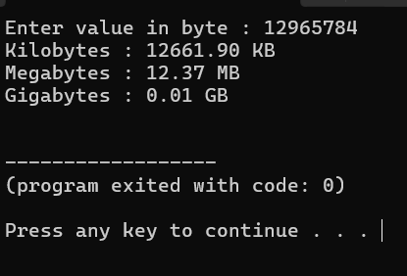

Q19.
import java.util.*;
class Q19 {
public static void main(String[] args){
Scanner input = new Scanner(System.in);

System.out.print("Number of days - ");
int days = input.nextInt();

int day_mo = days/30;
int day_da = days%30;

System.out.println(days+" days"+" ="+" "+day_mo+" and"+" "+ day_da+" days");
}
}

Output:
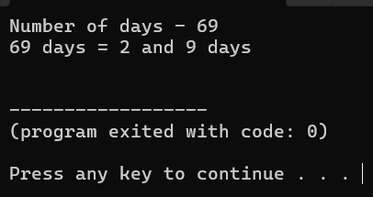

Q20.
import java.util.*;
class Q20 {
public static void main(String[] args){
Scanner input = new Scanner(System.in);

System.out.print("Input seconds : ");
long total_Seconds = input.nextLong();

long hours = total_Seconds /3600 ;
long minutes = (total_Seconds % 3600) / 60;
long seconds = total_Seconds % 60 ;

System.out.println(hours+":"+minutes+":"+seconds);

}
}
Output:
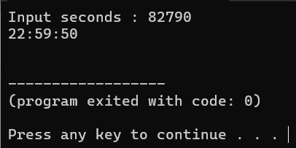

Q21.
import java.util.*;
class Q21 {
public static void main(String[] args){
Scanner input = new Scanner(System.in);

System.out.print("How many eggs do you have : ");
int total_eggs = input.nextInt();

int gross = total_eggs / 144 ;
int remain_gross = total_eggs % 144 ;

int dozen = remain_gross / 12 ;
int extra = remain_gross % 12 ;

System.out.println("Your number of eggs in "+gross+" gross"+" and "+dozen+" dozen, and "+extra);

}
}
Output:
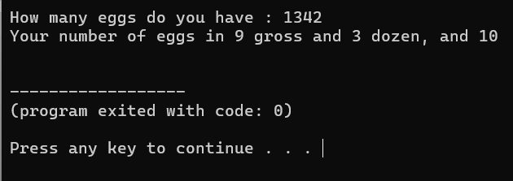

Q22.
import java.util.*;
class Q22 {
public static void main(String[] args) {
Scanner input = new Scanner(System.in);

System.out.print("Enter dividend : ");
int dividend = input.nextInt();

System.out.print("Enter divisor : ");
int divisor = input.nextInt();

int quotient = dividend / divisor ;

int remainder = dividend - ( divisor * quotient );

System.out.println("Remainder is : " + remainder);

}
}
Output:
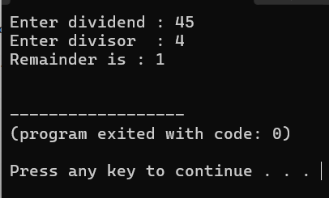

Q23.
import java.util.*;
class Q23 {
public static void main(String[] args) {
Scanner input = new Scanner(System.in);

// Input weight and height
System.out.print("Input weight in kilograms: ");
double weight = input.nextDouble();

System.out.print("Input height in meters: ");
double height = input.nextDouble();

// Calculate BMI
double bmi = weight / (height * height);

System.out.printf("Body Mass Index is %.2f\n", bmi);

}
}
Output:
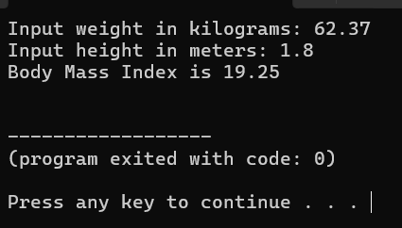

Q24.
import java.util.*;
class Q24 {
public static void main(String[] args) {
Scanner input = new Scanner(System.in);

System.out.print("Enter basic salary: ");
double basic_Salary = input.nextDouble();

double employee_Fund = basic_Salary * 0.120; // 12.0%
double employer_Fund = basic_Salary * 0.035; // 3.5%
double pension_Fund = basic_Salary * 0.083; // 8.3%

System.out.printf("Employee Fund (12.0%%) : %.2f\n", employee_Fund);
System.out.printf("Employer Fund (3.5%%) : %.2f\n", employer_Fund);
System.out.printf("Pension Fund (8.3%%) : %.2f\n", pension_Fund);

}
}
Output:
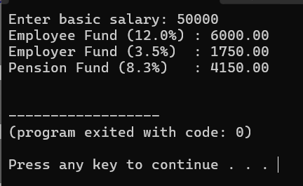

Q25.
import java.util.*;
public class Q25 {
public static void main(String[] args) {
Scanner input = new Scanner(System.in);

System.out.print("Enter the tax-inclusive price in dollars: ");
double inclusive_Price = input.nextDouble();

double actual_Price = inclusive_Price / 1.10;//actual price logic
double sales_Tax = inclusive_Price - actual_Price;//sales tax logic

System.out.printf("Actual Price is: $%.2f\n", actual_Price);
System.out.printf("Sales Tax is: $%.2f\n", sales_Tax);

}
}
Output:
