Q1.
import java.util.*;
class Q1 {
public static void main(String[] args){

Scanner input =new Scanner(System.in);

System.out.print("Input First Number : ");
int f_num = input.nextInt();

System.out.print("Input Second Number : ");
int s_num = input.nextInt();

int add ;

if (f_num>s_num){
add = f_num + s_num ;
System.out.println("Addition of Two Numbers : "+add);
}else{
System.out.println("First Number : "+f_num);
System.out.println("Second Number : "+s_num);
}

}
}

Output>>
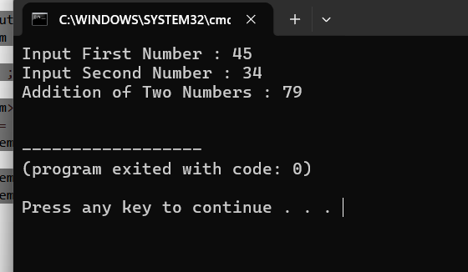

Q2.
import java.util.*;
class Q2 {
public static void main(String[] args){

Scanner input=new Scanner(System.in);

System.out.print("Enter Number : ");
int number =input.nextInt();
int abs;
if (number<0){
abs= -number;
System.out.println("Absolute : "+abs);
}else{
abs = number ;
System.out.println("Absolute : "+abs);

}

}
}

Output>>
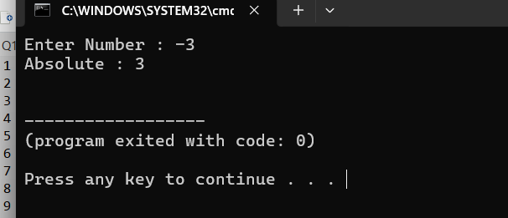

Q3.
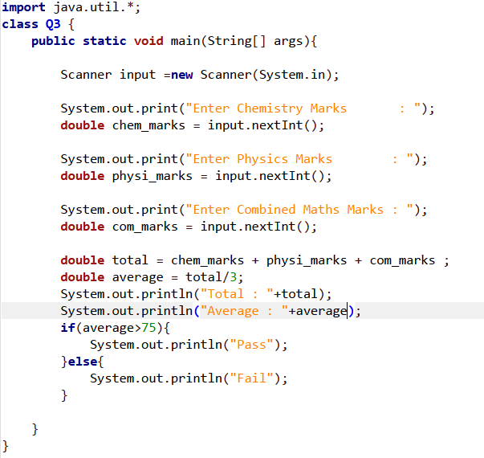
Output>>
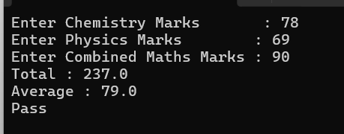 *Pass
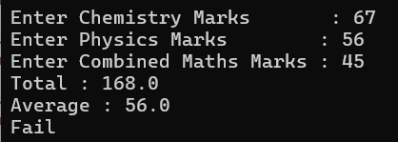*Fail

Q4.
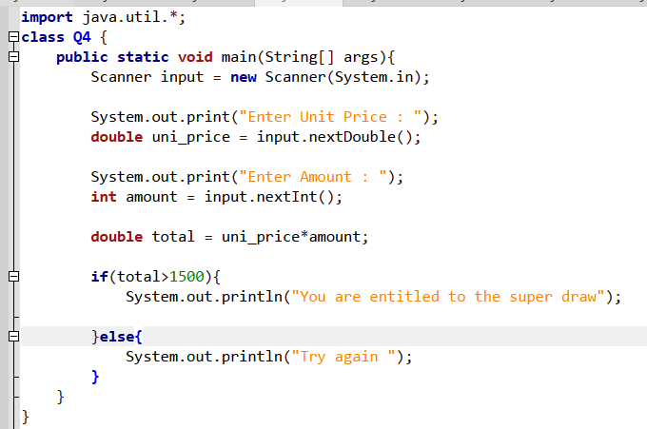
Output>>
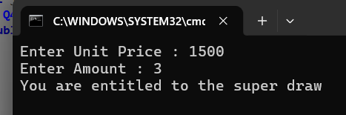
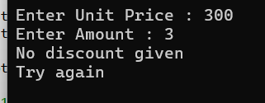

Q5.
import java.util.*;
class Q5 {
public static void main(String[] args){
Scanner input = new Scanner(System.in);

System.out.print("Enter Unit Price : ");
double unit_price = input.nextDouble();

System.out.print("Enter Amount : ");
int amount = input.nextInt();

double total = unit_price*amount;
double discount;
double ne_total;
if(total>500){
discount = total*0.05;
ne_total = total-discount;
System.out.printf("New price (5%%) : %.2f \n",ne_total);

}else{
System.out.println("No discount give");
}

}
}

Output>>
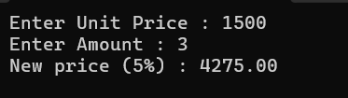

Q6.
import java.util.*;
class Q6 {
public static void main(String[] args){
Scanner input = new Scanner(System.in);

System.out.print("Enter a Random Year : ");
int y_num = input.nextInt();

if(y_num%4 == 0 && y_num % 100 !=0 || (y_num % 400 ==0 )){
System.out.println("It is a leap Year ");

}else{

System.out.println("It is not a leap Year ");
}

}
}

Output>>
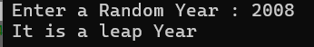*leap year
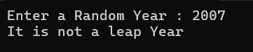not a leap Year

Q7.
import java.util.*;
class Q7 {
public static void main(String[] args){
Scanner input = new Scanner(System.in);

System.out.print("Input number 01 : ");
int num_1 =input.nextInt();

System.out.print("Input number 02 : ");
int num_2 =input.nextInt();

System.out.print("Input number 03 : ");
int num_3 =input.nextInt();

int max_num =num_1;

if(num_2>max_num){
max_num = num_2;

}
if(num_3>max_num){

max_num = num_3;
}
System.out.println("The Maxumum Number is : "+max_num);
}
}

Output>>
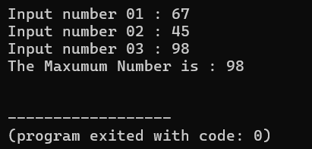

Q8.
class Q8 {
public static void main(String[] args) {
int x = 10;//line3
if(x==10){}
}
}

Answer>> C. if(x==10){}
Output>>
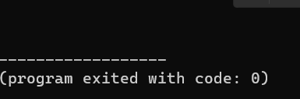*it will not execute any output.

Q9.
class Q9 {
public static void main(String[] args) {
int x = 10;
boolean b=true;
if(){} // A,B,C,E,F are correct
}
}

Answers>>
A -if(b){}
B -if(b=flase){}
C-if (b==false){}
E-if((b==false)==false){}
F-if(b=(false==true)){}

Q10.
import java.util.*;
class Q10 {
public static void main(String[] args){
Scanner input = new Scanner(System.in);

System.out.print("Enter an integer number : ");
int num = input.nextInt();

if(num%2 == 0){
System.out.println("The number is an even number");

}else{
System.out.println("The number is an odd number");
}
}
}

Output>>
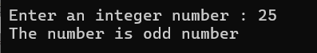*odd number
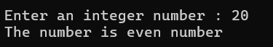*even number

Q11.
class Q11 {
public static void main(String[] args) {
boolean b=true;
System.out.println(b);
System.out.println(b=true);
System.out.println(b==true);
System.out.println(b!=true);
System.out.println(b=true==true);
System.out.println((b=true)==false);
System.out.println(b=(true!=false));
}
}

Output>>
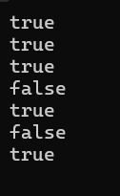

Q12.
class Q12 {
public static void main(String[] args) {
int x=10;
System.out.println(x=9);
System.out.println(x==9);
System.out.println(x=9!=10); //this line is incorrect
System.out.println((x=9)==10);
System.out.println((x=9)<=10);

}
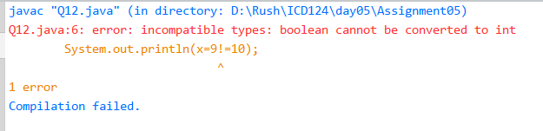
}
Output>>
- Without line 6
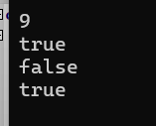

Q13.
class Q13 {
public static void main(String[] args){
int x=20,y=60;
boolean bool;
System.out.println(x=10);
System.out.println(bool=true);
System.out.println(x=10>0); // this is incorrect
System.out.println((x=10)>0);
System.out.println(bool=(x=10)>0);
System.out.println(bool=x+y>100);
}
}

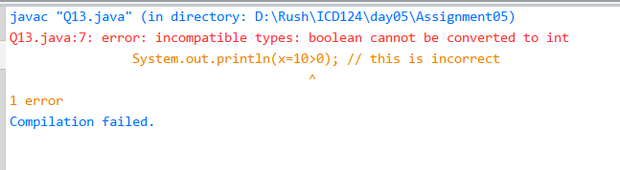
Output without line 7
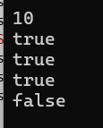

Q14.
class Q14 {
public static void main(String[] args){
byte b = 10;
short s = 100;
int x = 125;
long l = 15000;
float f = 1.5f;
double d = 21.231;
char c = 'c';
boolean bool = 10>9;
System.out.println(b+s+x+""+f+d+c+bool); //Line 1 output
System.out.println(""+b+s+x+f+d+c+bool); //Line 2
System.out.println(b+s+x+f+d+c+""+bool); //Line 3
System.out.println(b+s+x+f+d+c+bool+""); //Line 4
System.out.println(bool+b+f+d+c+""+x+l); //Line 5
}
}

Line4,5 Error
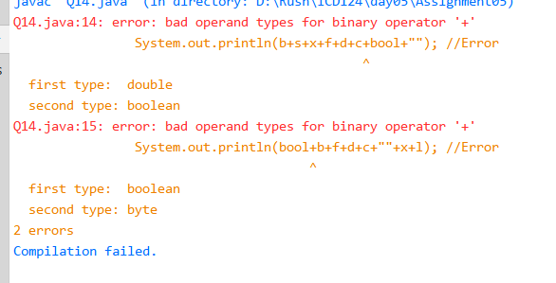
Without line 4,5
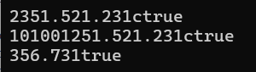

Q15.
class Q15 {
public static void main(String[] args){
int i = 1,j = 2,k =3,m = 2 ;
System.out.println( i ==1); //Line 1
System.out.println( j ==3); //Line 2
System.out.println( ( i >=1) && ( j <4) ); //Line 3
System.out.println( ( m <=99) & ( k < m ) ); //Line 4
System.out.println( ( j >= i ) || ( k == m ) ); //Line 5
System.out.println( ( k + m < j )|(3- j>= k)); //Line 6
System.out.println( !( k > m ) ); //Line 7
}
}

Output>>
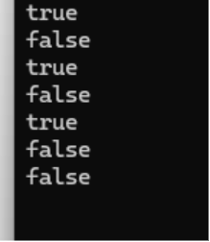

Q16.
- int x =1;
class Q16{
public static void main(String args[]){
int x=1;
switch(x){
default: System.out.print("4 ");
case 1 : System.out.print("1 ");
case 2 : System.out.print("2 ");
case 3 : System.out.print("3 ");

}
}
}
Output:
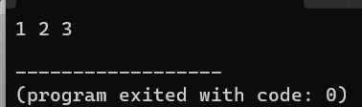
(B.) int x=2;
class Q16{
public static void main(String args[]){
int x=2;
switch(x){
default: System.out.print("4 ");
case 1 : System.out.print("1 ");
case 2 : System.out.print("2 ");
case 3 : System.out.print("3 ");

}
}
}
Output:
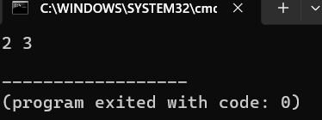

(C.) int x =3;
class Q16{
public static void main(String args[]){
int x=3;
switch(x){
default: System.out.print("4 ");
case 1 : System.out.print("1 ");
case 2 : System.out.print("2 ");
case 3 : System.out.print("3 ");

}
}
}

Output:
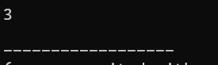

(D.) int x =4;
class Q16{
public static void main(String args[]){
int x=4;
switch(x){
default: System.out.print("4 ");
case 1 : System.out.print("1 ");
case 2 : System.out.print("2 ");
case 3 : System.out.print("3 ");

}
}
}
Output:
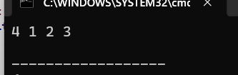

(E.) int x = 0;
class Q16{
public static void main(String args[]){
int x=4;
switch(x){
default: System.out.print("4 ");
case 1 : System.out.print("1 ");
case 2 : System.out.print("2 ");
case 3 : System.out.print("3 ");

}
}
}
Output:
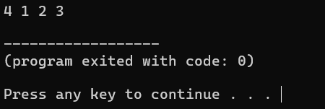
(F.) int x = 5;
class Q16{
public static void main(String args[]){
int x=4;
switch(x){
default: System.out.print("4 ");
case 1 : System.out.print("1 ");
case 2 : System.out.print("2 ");
case 3 : System.out.print("3 ");

}
}
}
Output:

Q17.
class Q17 {
public static void main(String args[]){
int a=-5;
int b=-2;
a%=b;
a/=b;
b=a>0?0:a;
System.out.println(a+" "+b);
}
}

Output:


Q18.
import java.util.*;
class Q18 {
public static void main(String args[]){
int x=100;
System.out.println(x); //Line 1
{
int y=200;
{
int z=300;
System.out.println(x); //Line 2
System.out.println(y); //Line 3
System.out.println(z); //Line 4
}
System.out.println(x); //Line 5
System.out.println(y); //Line 6
//System.out.println(z); //Line 7
}
System.out.println(x); //Line 8
//System.out.println(y); //Line 9
//System.out.println(z); //Line 10
}
}

Answes are: A: line 1, B: line2 ,C:line3 , D:line 4, E:line5 ,
F: line 6, H: line8

Q19.
(A.)
class Q19{
public static void main(String args[]){
int x=1;
switch(x){
default : System.out.print("Wrong ");break;
case 2 : System.out.print("2 ");
case 3 : System.out.print("3 ");
case 1 : System.out.print("1 ");break;
}
}
}
Output>>
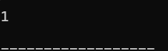

(B.)
class Q19{
public static void main(String args[]){
int x=2;
switch(x){
default : System.out.print("Wrong ");break;
case 2 : System.out.print("2 ");
case 3 : System.out.print("3 ");
case 1 : System.out.print("1 ");break;
}
}
}
Output>>

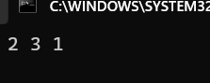

(C)
class Q19{
public static void main(String args[]){
int x=3;
switch(x){
default : System.out.print("Wrong ");break;
case 2 : System.out.print("2 ");
case 3 : System.out.print("3 ");
case 1 : System.out.print("1 ");break;
}
}
}
Output>>



(D)
class Q19{
public static void main(String args[]){
int x=4;
switch(x){
default : System.out.print("Wrong ");break;
case 2 : System.out.print("2 ");
case 3 : System.out.print("3 ");
case 1 : System.out.print("1 ");break;
}
}
}
Output>>
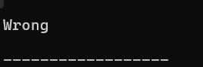

(E)
class Q19{
public static void main(String args[]){
int x=0;
switch(x){
default : System.out.print("Wrong ");break;
case 2 : System.out.print("2 ");
case 3 : System.out.print("3 ");
case 1 : System.out.print("1 ");break;
}
}
}
Output>>
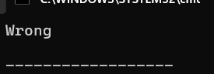

(F)
class Q19{
public static void main(String args[]){
int x=5;
switch(x){
default : System.out.print("Wrong ");break;
case 2 : System.out.print("2 ");
case 3 : System.out.print("3 ");
case 1 : System.out.print("1 ");break;
}
}
}
Output>>
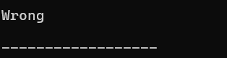

Q20.
import java.util.*;
class Q20 {
public static void main(String[] args){
Scanner input = new Scanner(System.in);

System.out.print("Enter an integer : ");
double num = input.nextInt();

if(num<0){
System.out.println(" Negative integer ");

}else if(num>0){
System.out.println(" Positive integer ");
}else{
System.out.println(" Zero ");
}
}
}

Output:
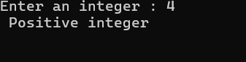
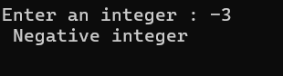
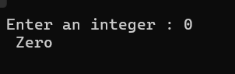

Q21.
import java.util.*;
class Q21 {
public static void main(String[] args){
Scanner input = new Scanner(System.in);

System.out.print("Enter Number 1 : ");
int num_1 = input.nextInt();

System.out.print("Enter Number 2 : ");
int num_2 = input.nextInt();

int absolute_difference ;
if (num_1>num_2){
absolute_difference = num_1 - num_2 ;

}else{
absolute_difference = num_2 - num_1 ;
}
System.out.print("Absolute Difference : "+absolute_difference );
}
}

Output:
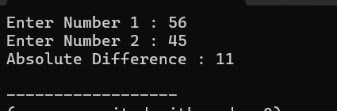

Q22.

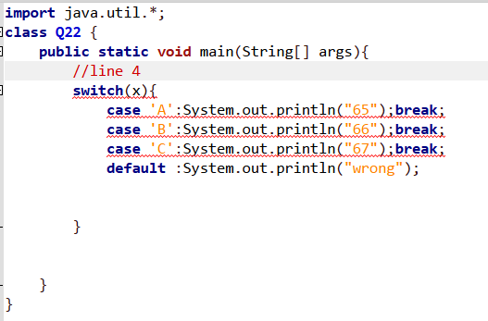

Answer: A,B,C,D,E

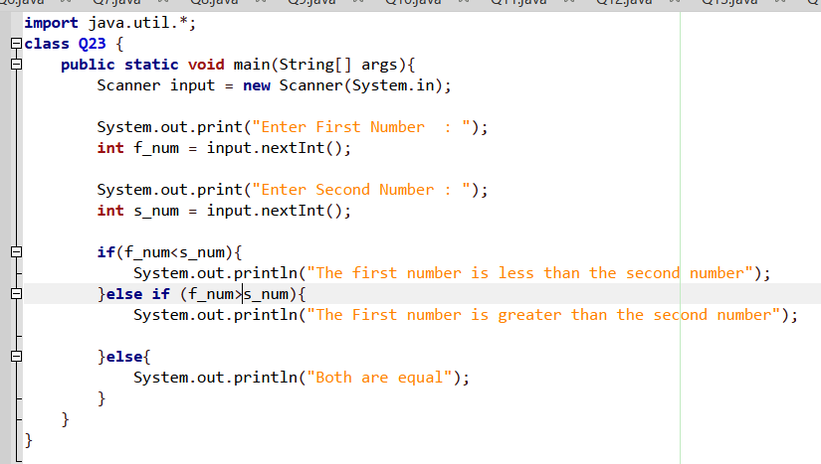
Q23.

Outputs:
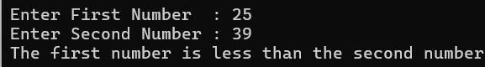
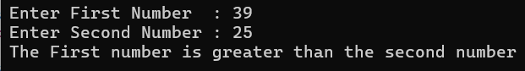
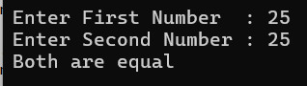

Q24.
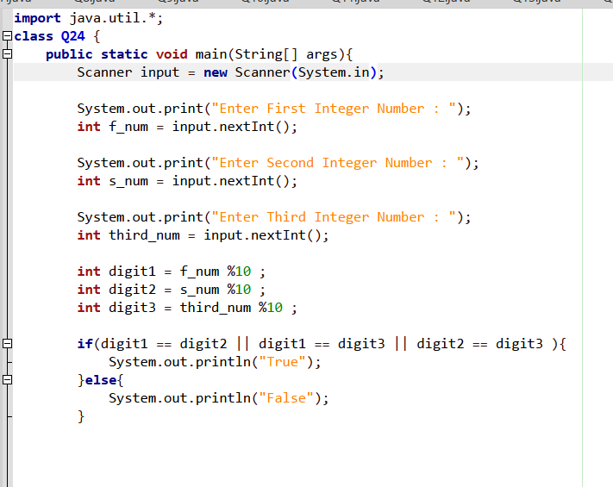
Outputs:
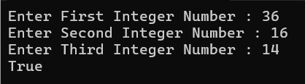
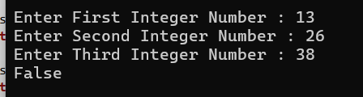

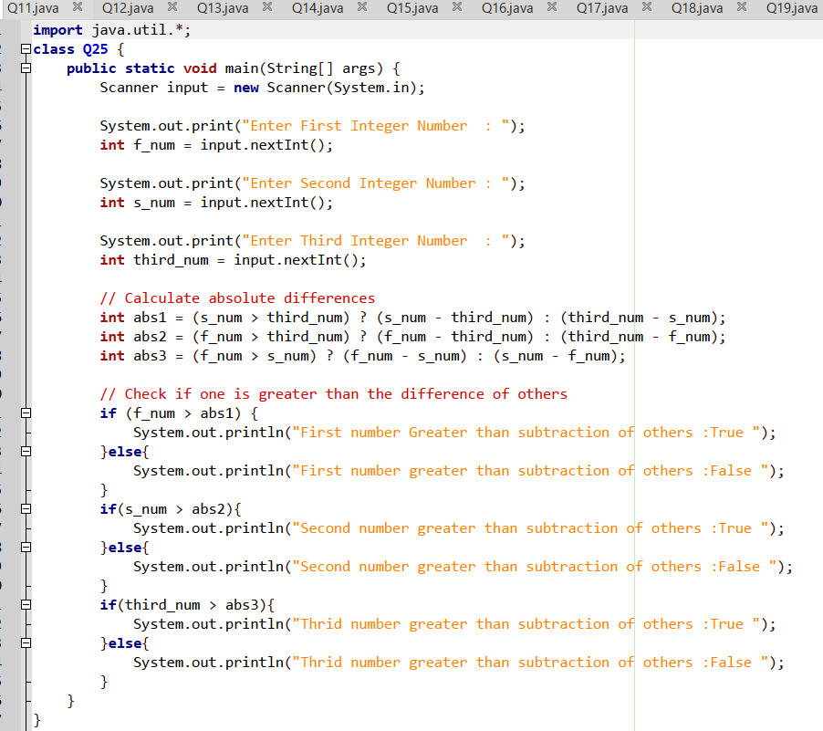
Q25.
Output:
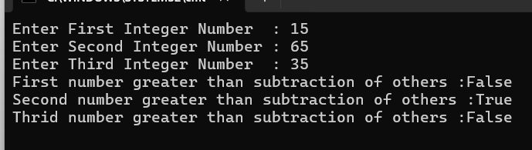

Q26.
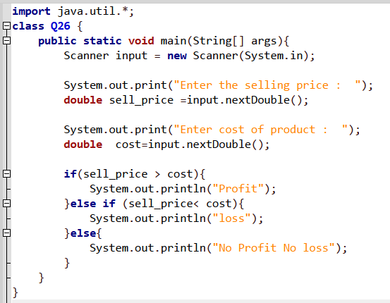

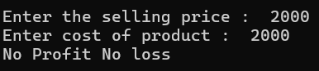
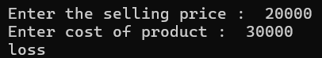
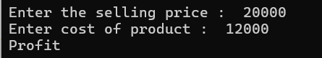
Output:

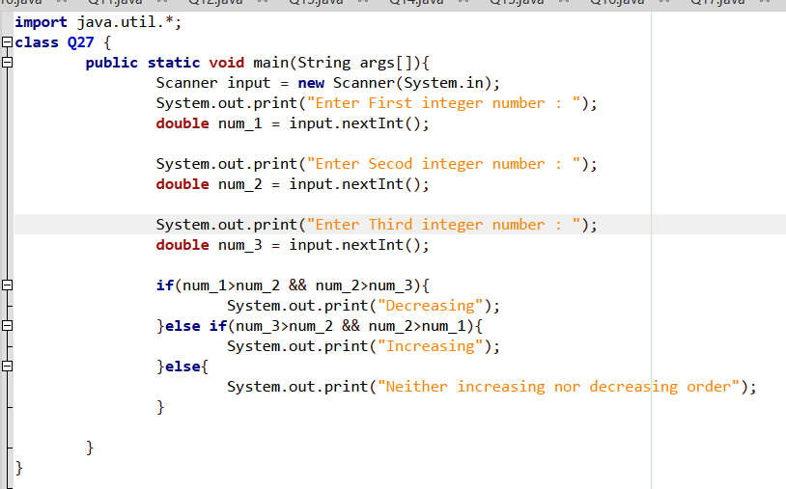
Q27.

Output:
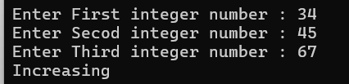
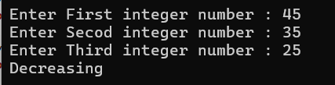
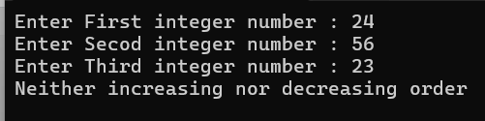

Q28.
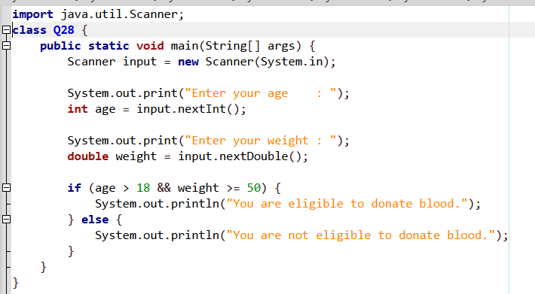

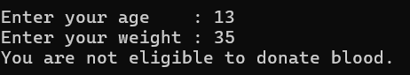
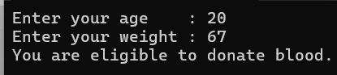
Outputs:

Q29.
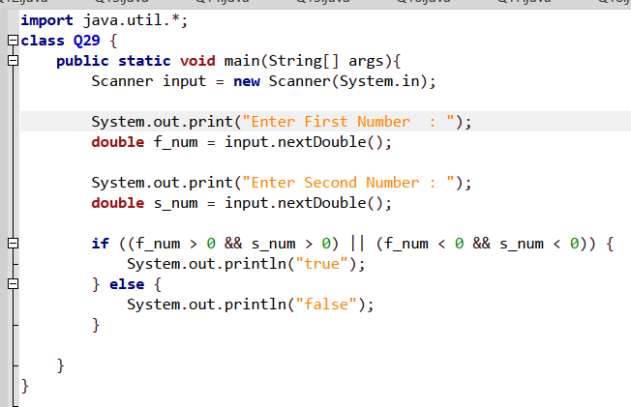

Output:

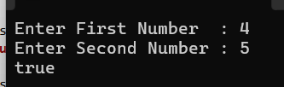
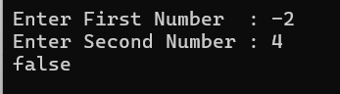

Q30.
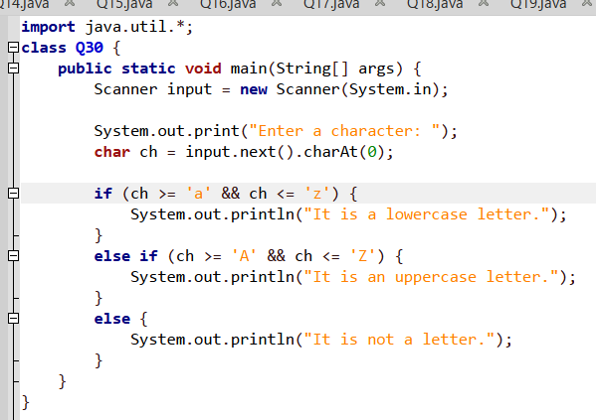

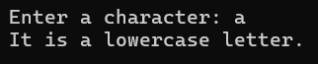
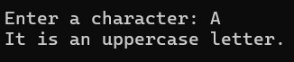
Output:

Q31.
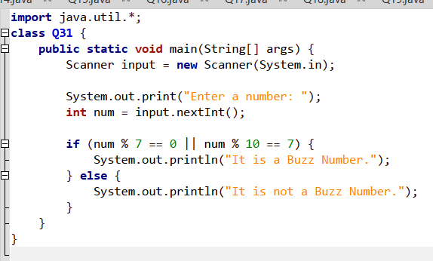

Output:
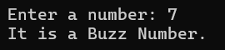
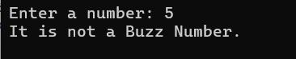

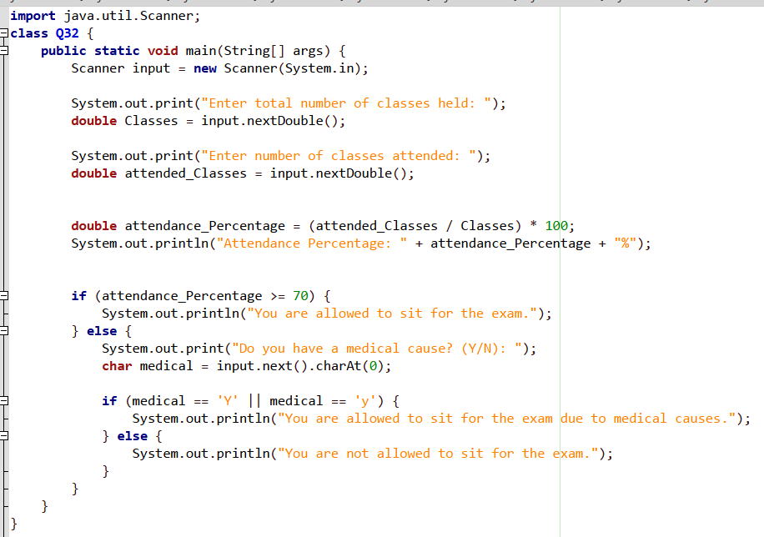
Q32.

Output:
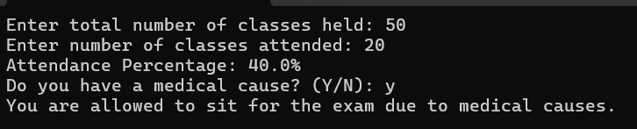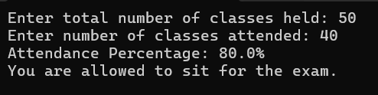

Q33.
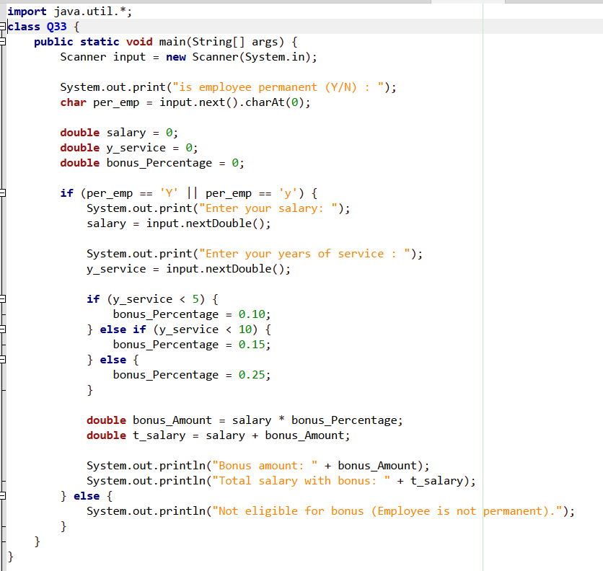
Outputs:
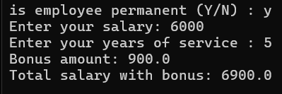
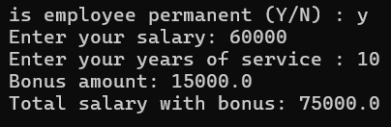
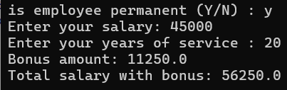
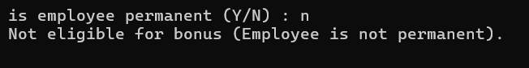

Q34.
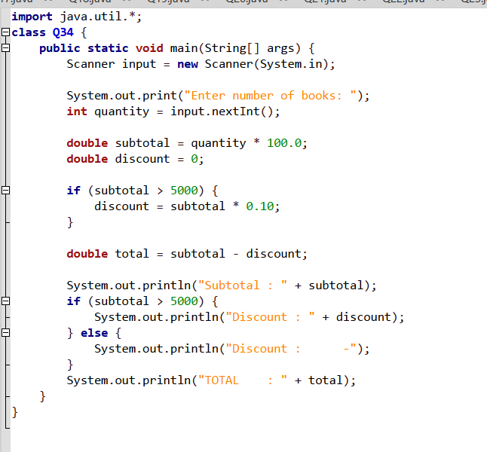
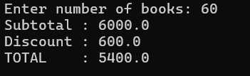
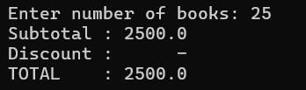
Outputs:

Q35.
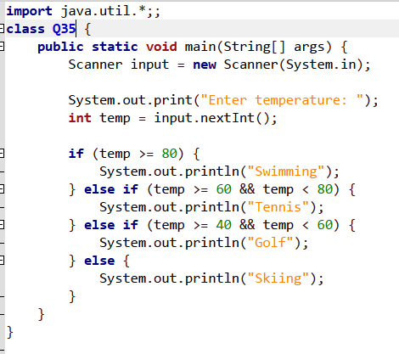

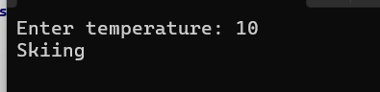
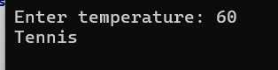
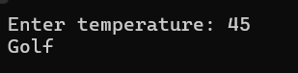
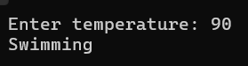
Outputs:

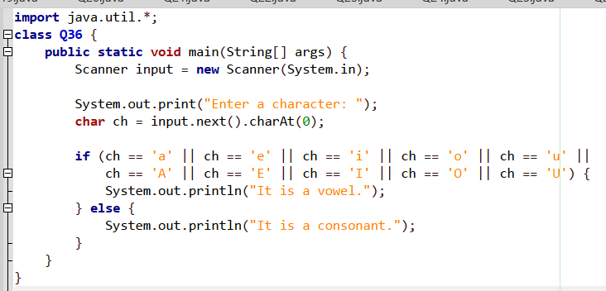
Q36.

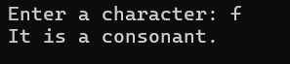
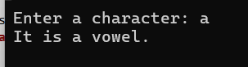
Outputs:

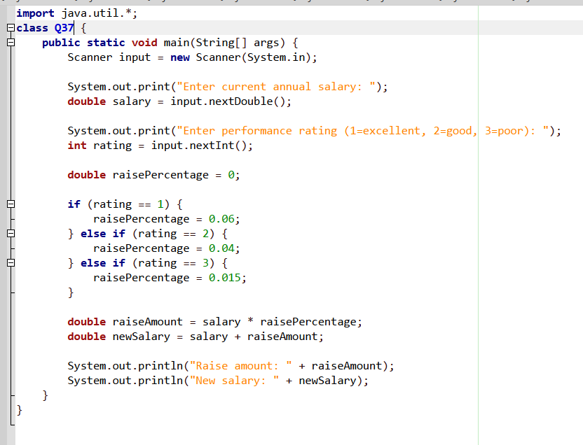
Q37.

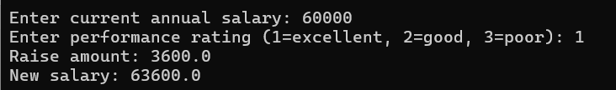
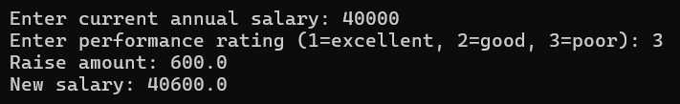
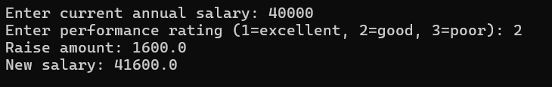
Outputs:

Q38.
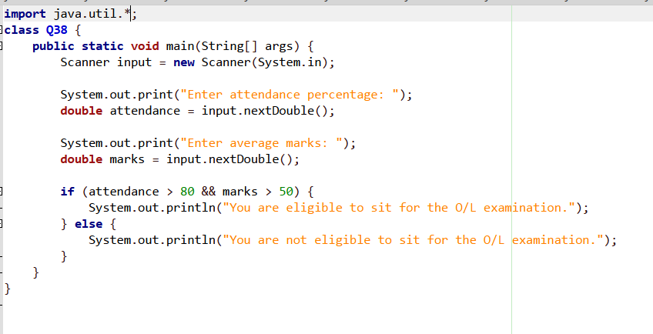

Outputs:
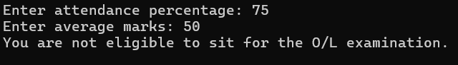
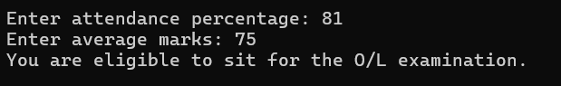

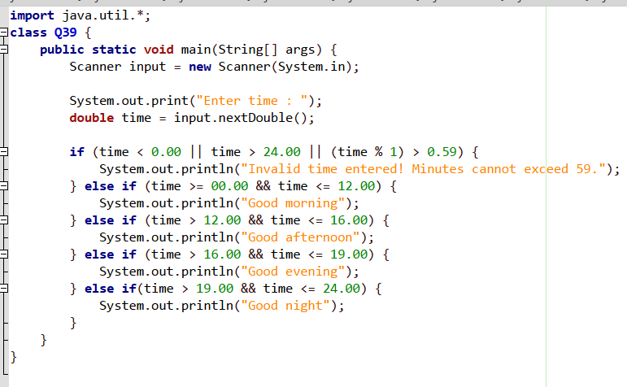
Q39.

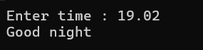
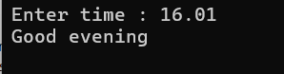
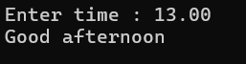
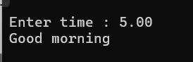
Outputs:

Q40.
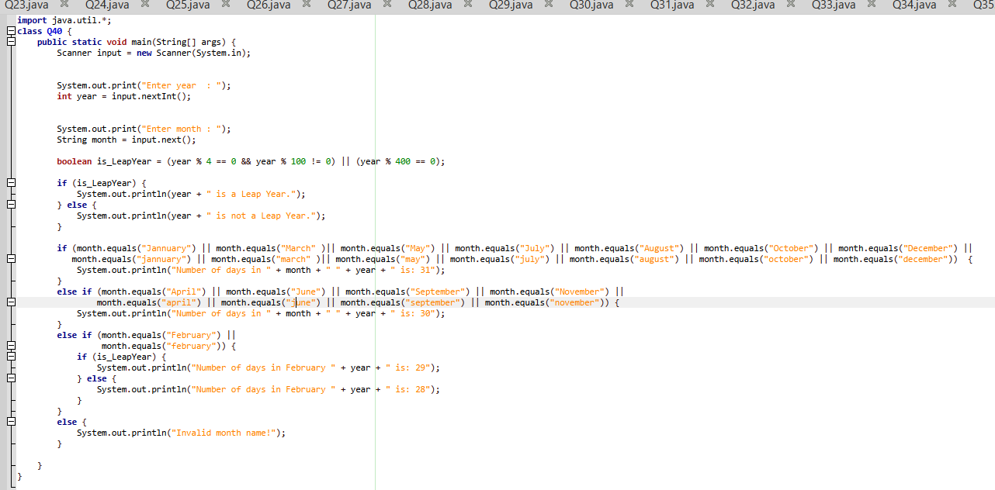

Outputs:
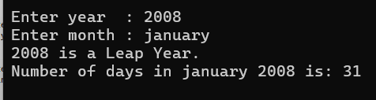

Q41.
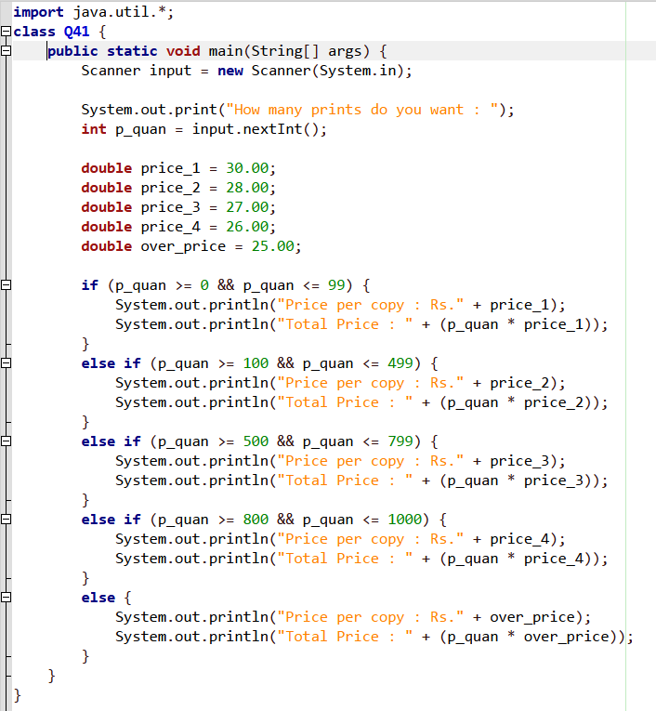
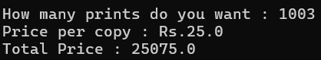
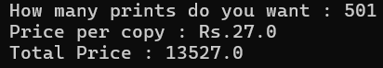
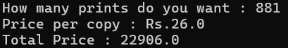
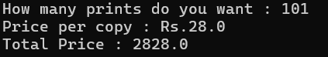
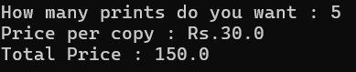
Outputs:

Q42.
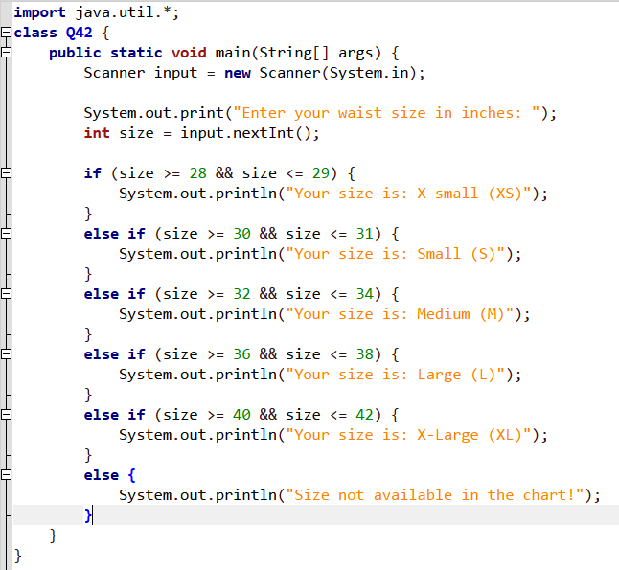

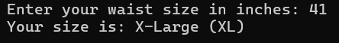
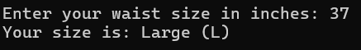
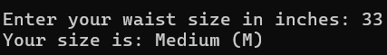
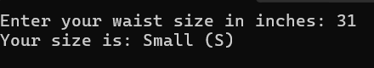
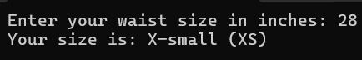
Outputs:

Q43.
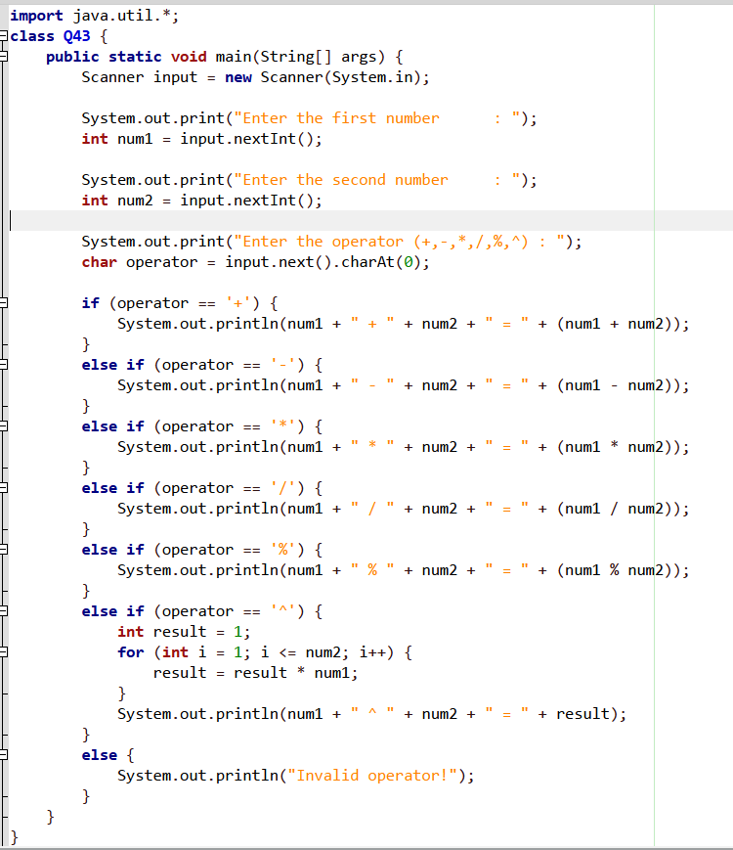
Output:
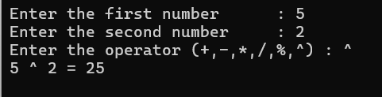

Q44.
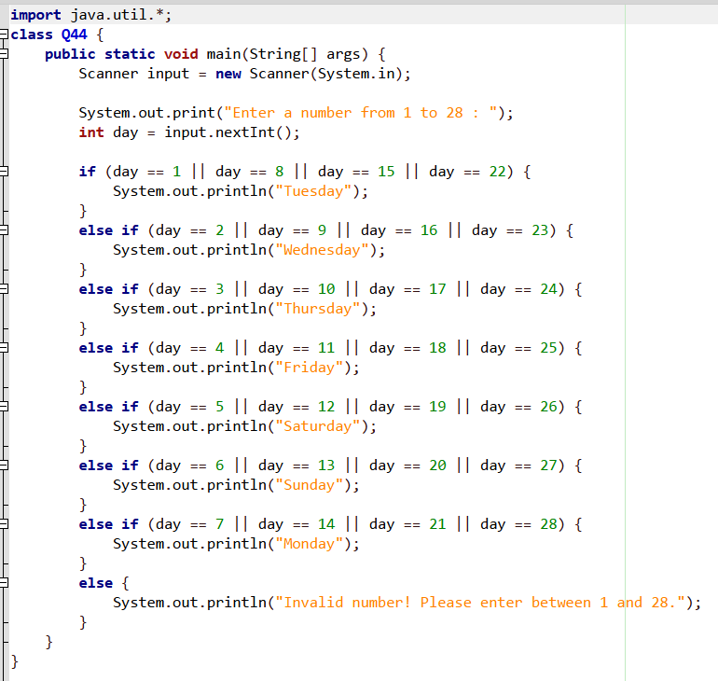
Output:
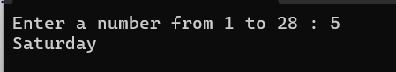

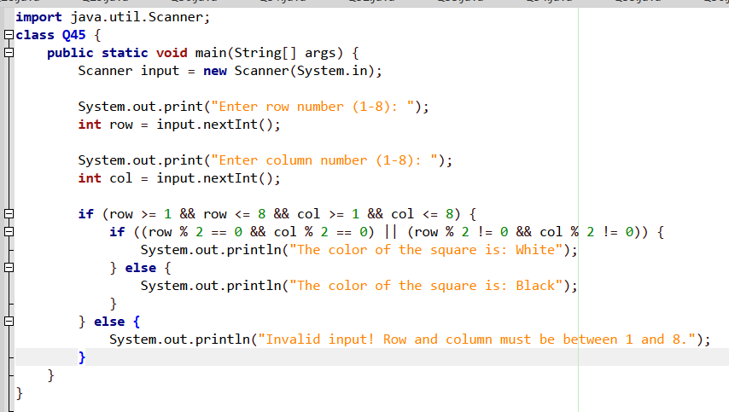
Q45.

Output:
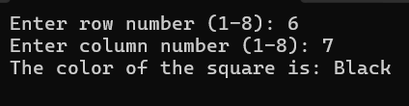
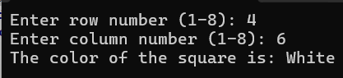

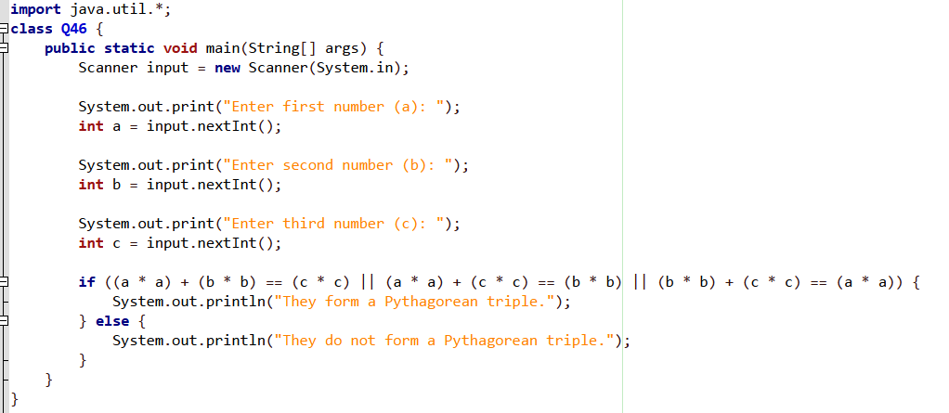
Q46.

Output:
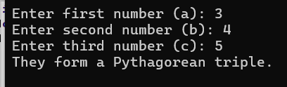

Q47.
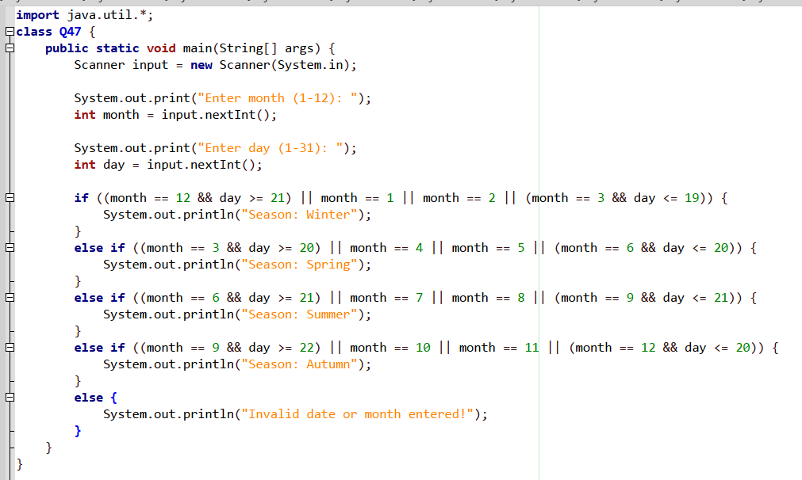

Output:
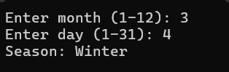

Q48.
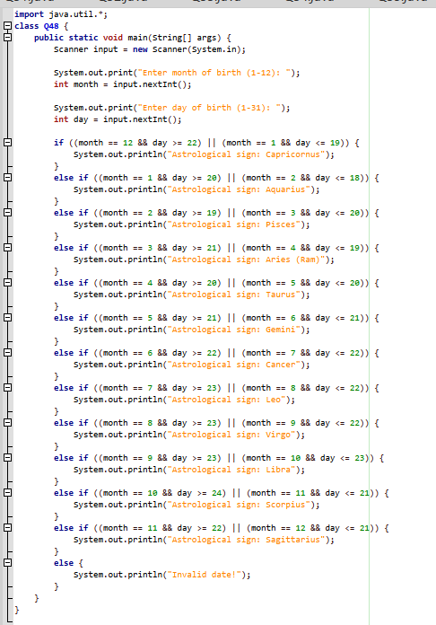
Output:
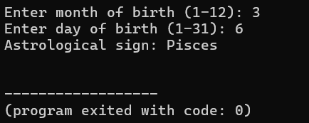

Q49.
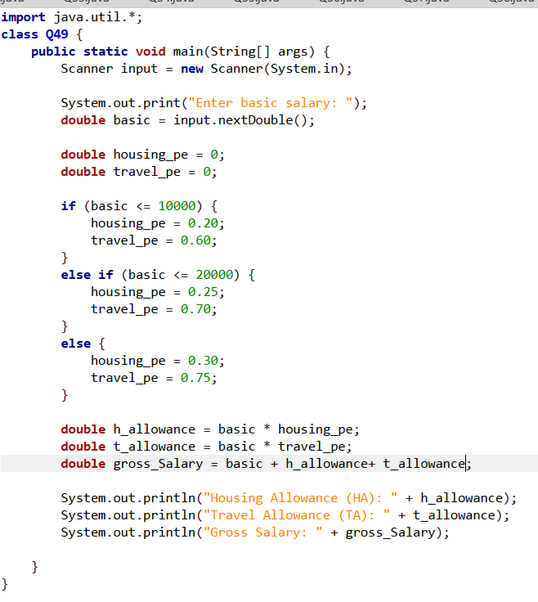
Output:
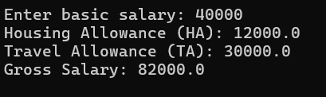

Q50.
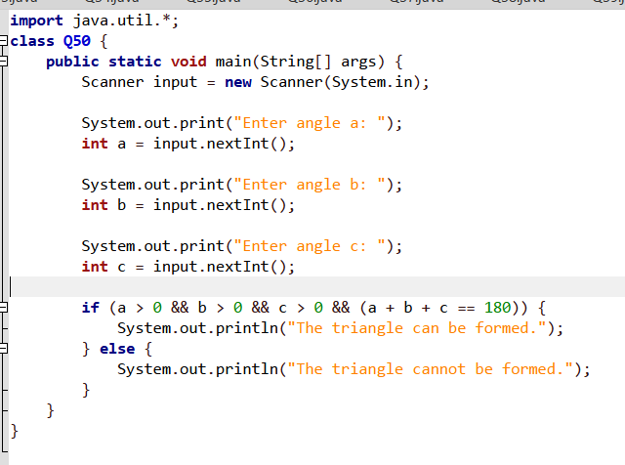
Outputs:
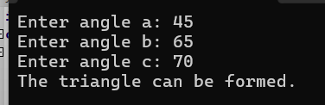
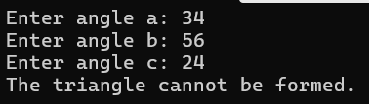

Q51.
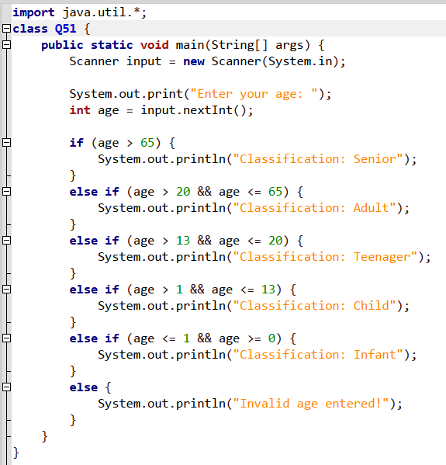
Output:
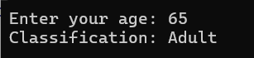
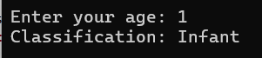

Q52.
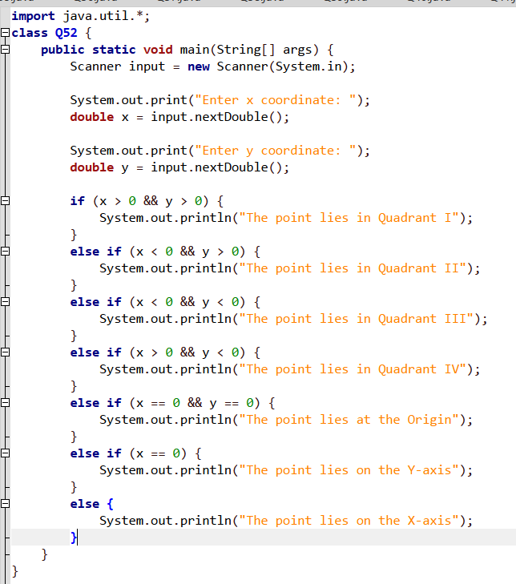
Outputs:
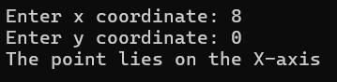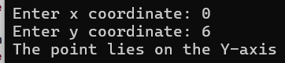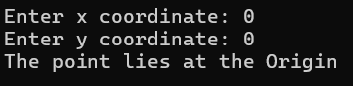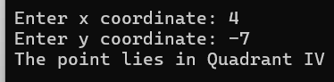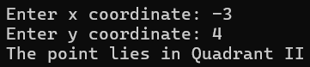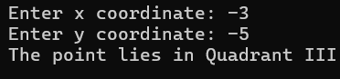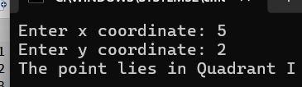

Q53.

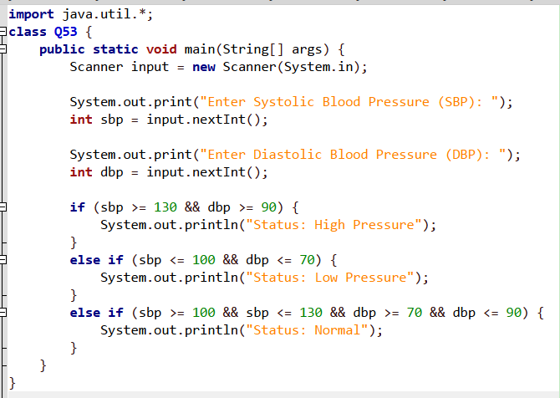
Output:
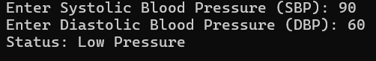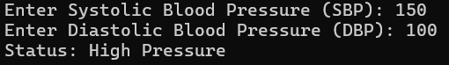
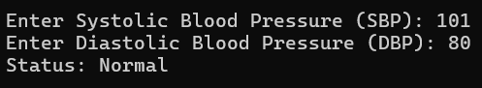

Q54.
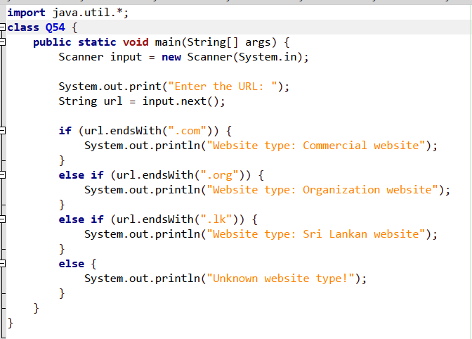
Outputs:
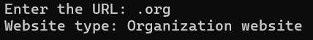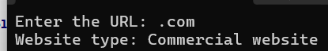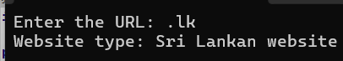

Q55.
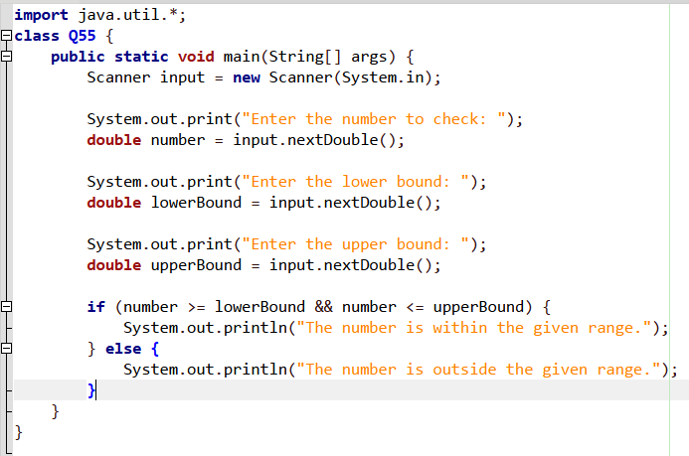
Outputs:
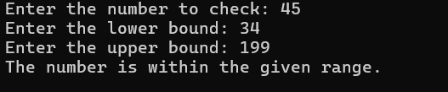
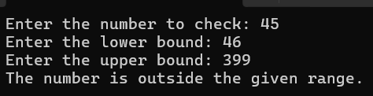

Q56.

Answer: item = (a >= 10) && (b < 50);

Q57.
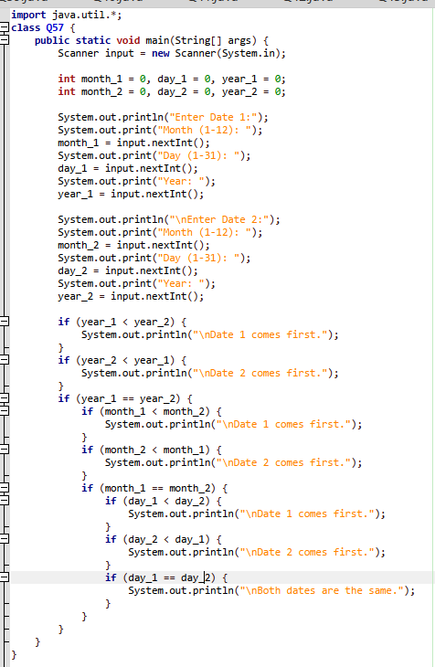
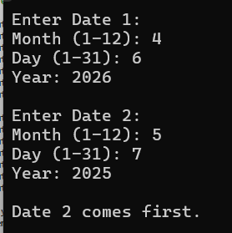
Output:

Q58.
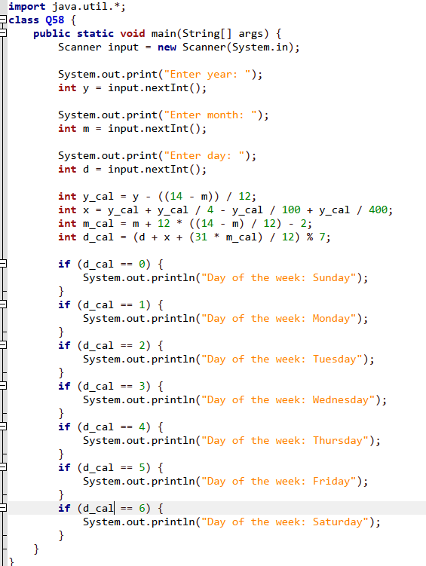
0utput:
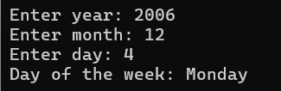

Q59.
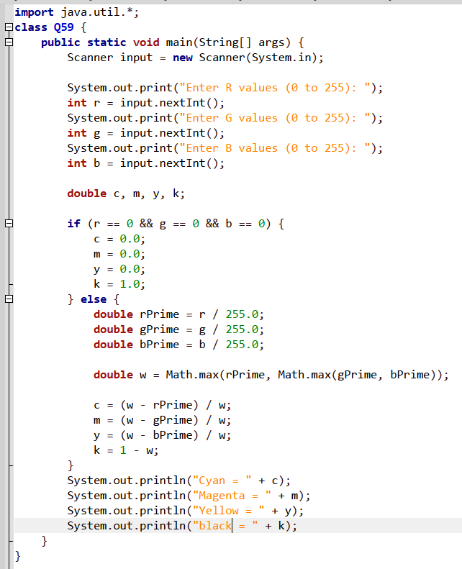
Output:
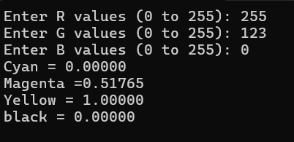

Q60.
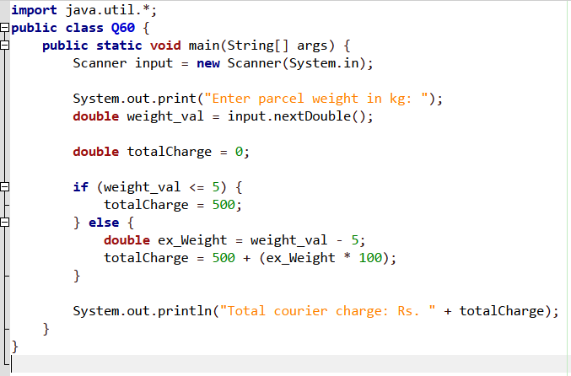

Output:
