Q1.
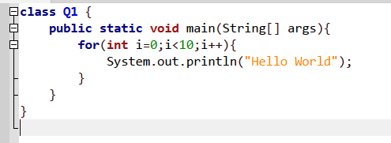

Output>>

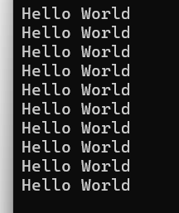

Q2.

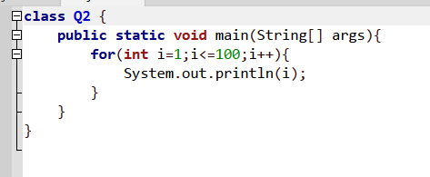
Output>>
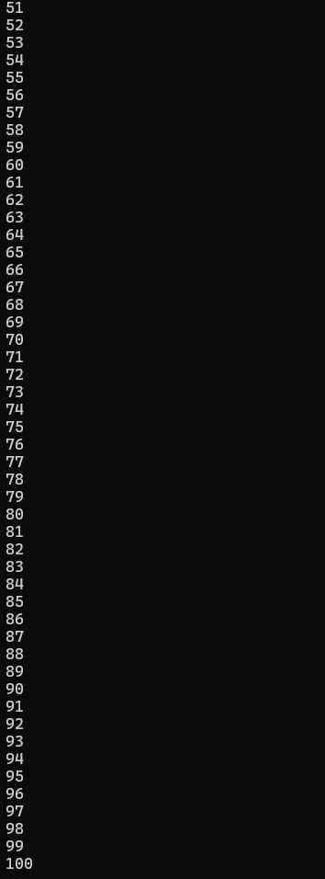
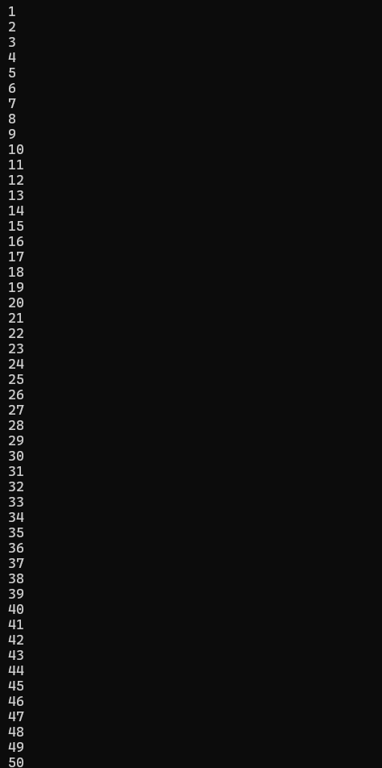

Q3.

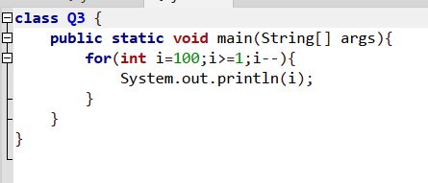

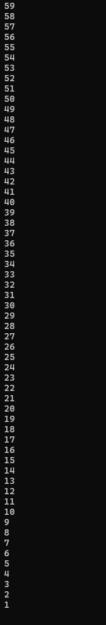
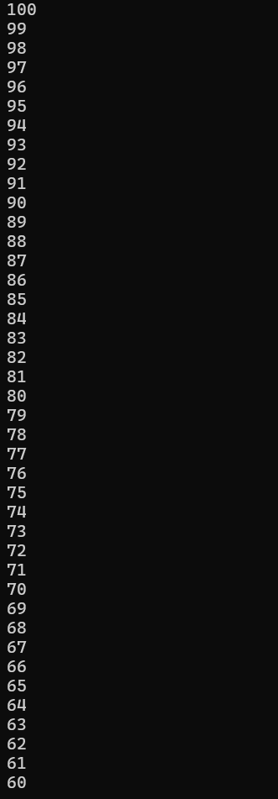
Output>>

Q4.

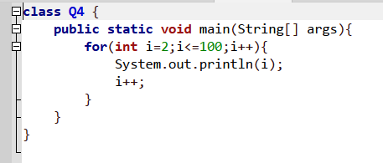

Output>>
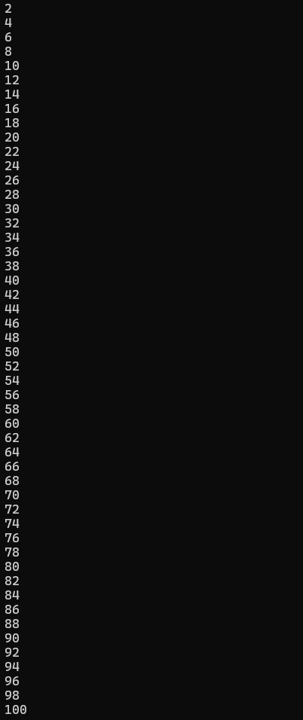

Q5.
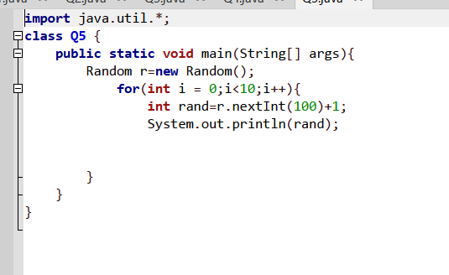

Output>>
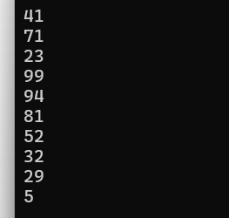

Q6.
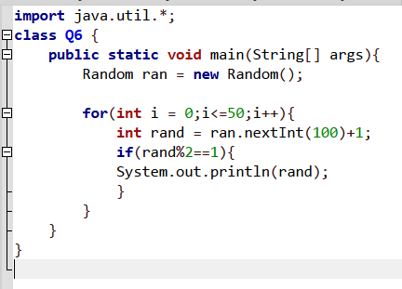

Output>>
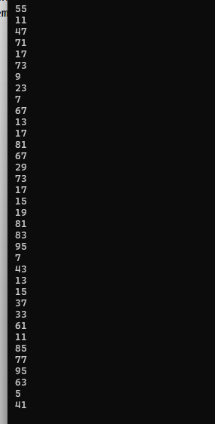

Q7.
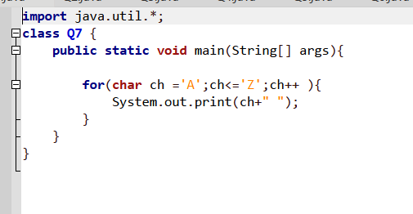

Output>>
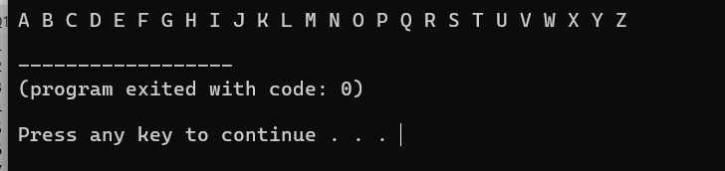

Q8.
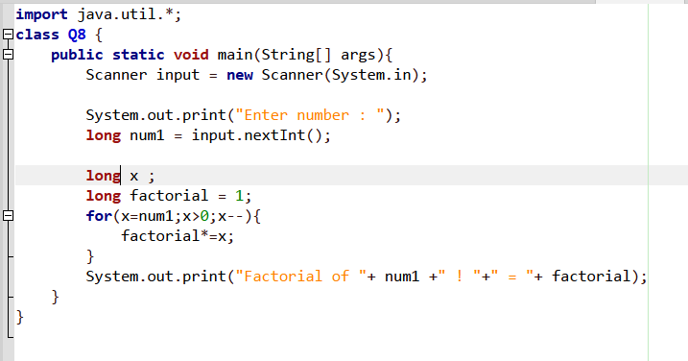

Output>>
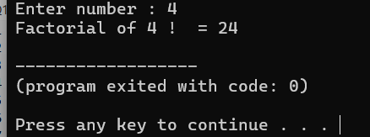

Q9.
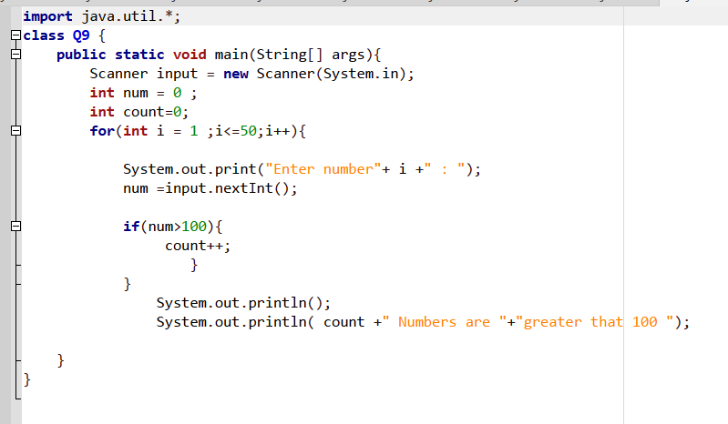
Output>>
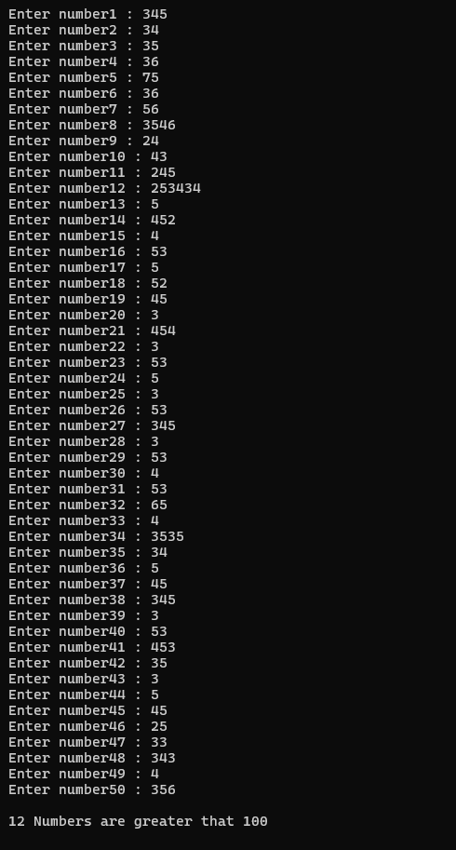

Q10.
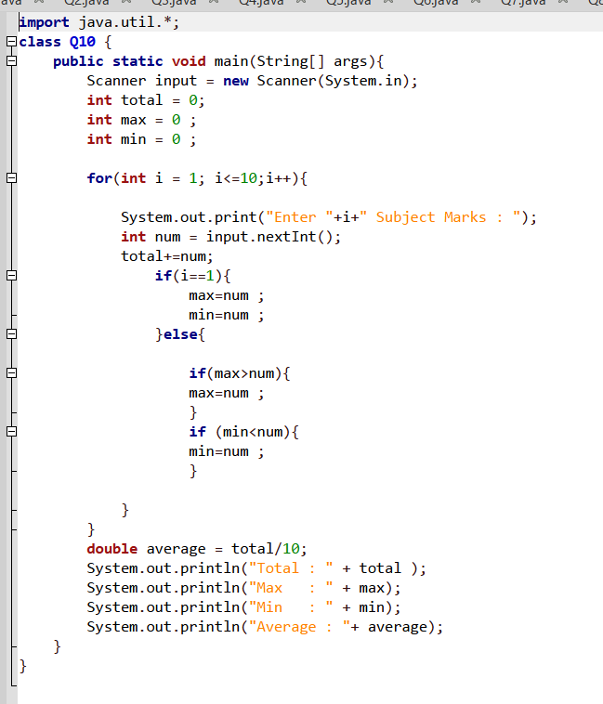
Output>>

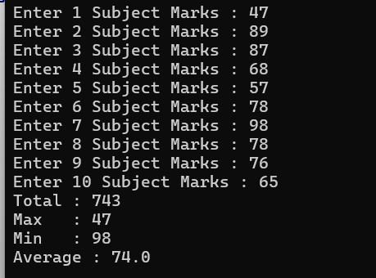

Q11.
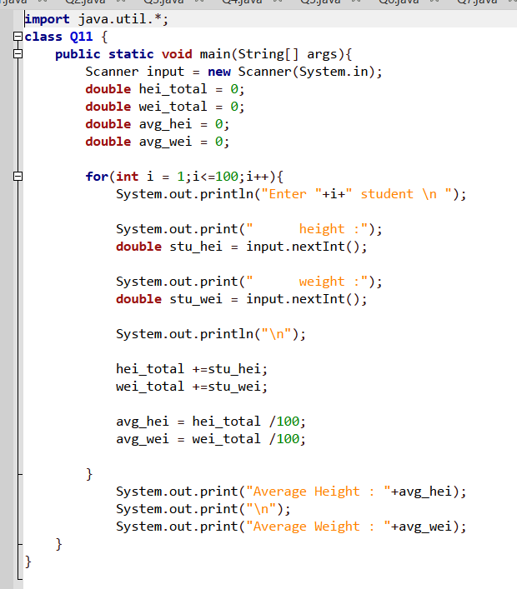
Output>>
After the 100 inputs:
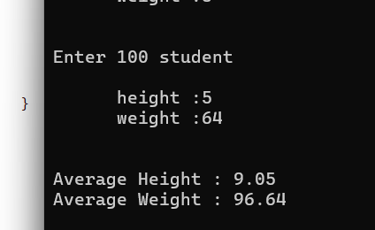

Q12.

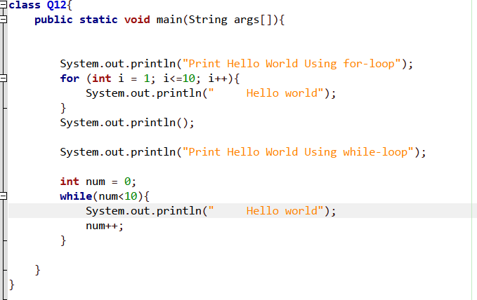
Output>>
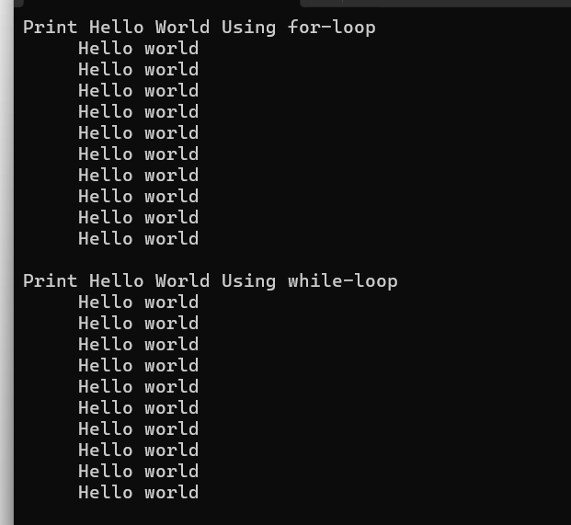

Q13.
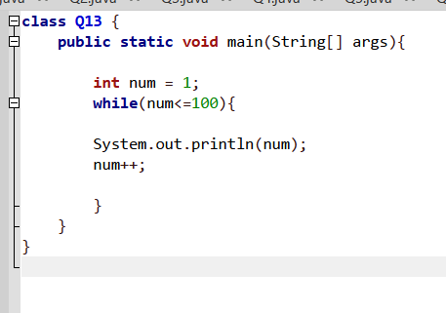
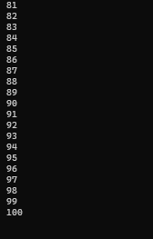
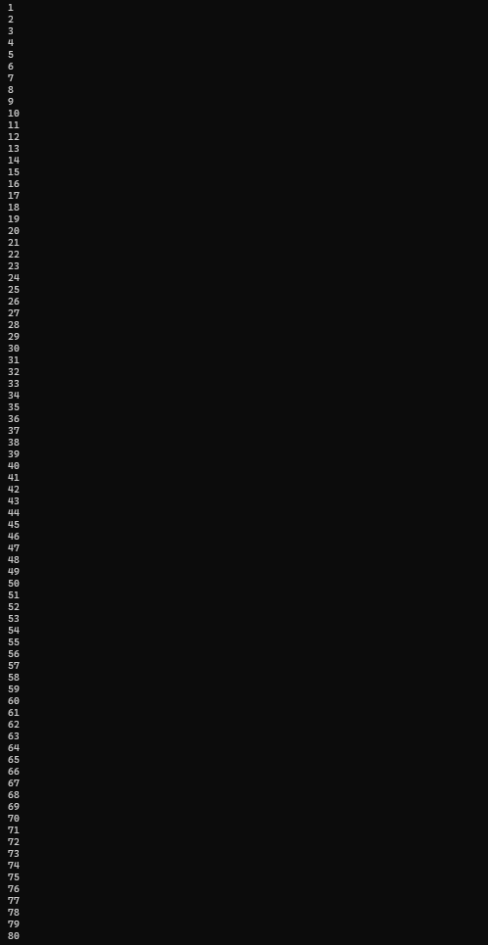
Output>>

Q14.
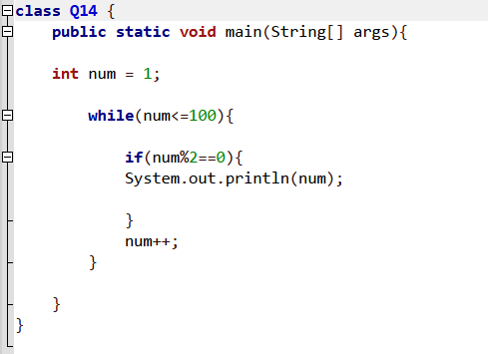
Output>>
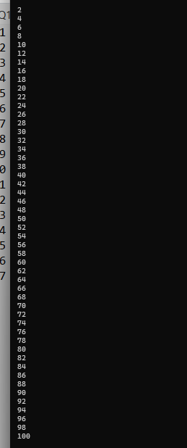

Q15.
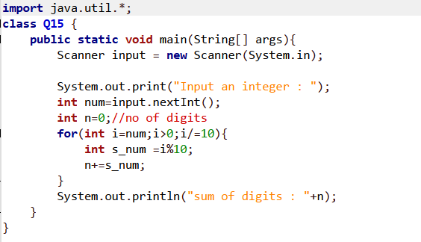
Output>>
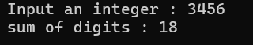

Q16.
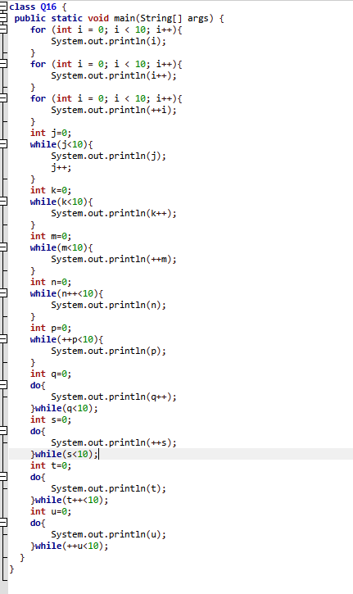

Output>>Explain

1. First For Loop
- Description: Prints numbers from 0 to 9 in the normal order.
- Output: 0, 1, 2, 3, 4, 5, 6, 7, 8, 9
2. Second For Loop
- Description: The value increases inside the print statement and also increases at the loop header, so the value increases by two steps at a time.
- Output: 0, 2, 4, 6, 8
3. Third For Loop
- Description: The value increases before printing and also increases at the loop header, resulting in odd numbers.
- Output: 1, 3, 5, 7, 9
4. First While Loop
- Description: Prints the current value of j first, then increases the value by 1.
- Output: 0, 1, 2, 3, 4, 5, 6, 7, 8, 9
5. Second While Loop
- Description: Prints the value and then increases it immediately, so it prints normally from 0 to 9.
- Output: 0, 1, 2, 3, 4, 5, 6, 7, 8, 9
6. Third While Loop
- Description: Increases the value before printing, so it prints from 1 to 10.
- Output: 1, 2, 3, 4, 5, 6, 7, 8, 9, 10
7. Fourth While Loop
- Description: Increases the value while checking the condition, printing numbers from 1 to 10.
- Output: 1, 2, 3, 4, 5, 6, 7, 8, 9, 10
8. Fifth While Loop
- Description: Increases the value before checking the condition, running from 1 to 9.
- Output: 1, 2, 3, 4, 5, 6, 7, 8, 9
9. First Do-While Loop
- Description: Prints first and then increases the value, looping from 0 to 9.
- Output: 0, 1, 2, 3, 4, 5, 6, 7, 8, 9
10. Second Do-While Loop
- Description: Increases the value first and then prints, running from 1 to 10.
- Output: 1, 2, 3, 4, 5, 6, 7, 8, 9, 10
11. Third Do-While Loop
- Description: Prints the value first, then checks the condition while increasing, executing one extra time up to 10.
- Output: 0, 1, 2, 3, 4, 5, 6, 7, 8, 9, 10
12. Fourth Do-While Loop
- Description: Prints the value and increases it during the condition check, running up to 9.
- Output: 0, 1, 2, 3, 4, 5, 6, 7, 8, 9

Q17.
import java.util.*;
class Q17 {
public static void main(String[] args) {
Scanner scan = new Scanner(System.in);
System.out.print("Input number of Employees: ");
int empCount = scan.nextInt();

for (int i = 1; i <= empCount; i++) {
System.out.print("Input salary " + i + " : ");
double salary = scan.nextDouble();

int n5000 = (int) (salary / 5000);
int rem5000 = (int) (salary % 5000);

int n2000 = rem5000 / 2000;
int rem2000 = rem5000 % 2000;

int n1000 = rem2000 / 1000;
int rem1000 = rem2000 % 1000;

int n500 = rem1000 / 500;
int rem500 = rem1000 % 500;

int n200 = rem500 / 200;
int rem200 = rem500 % 200;

int n100 = rem200 / 100;
int rem100 = rem200 % 100;

int n50 = rem100 / 50;
int rem50 = rem100 % 50;

int n20 = rem50 / 20;
int rem20 = rem50 % 20;

int n10 = rem20 / 10;
int rem10 = rem20 % 10;

int n5 = rem10 / 5;
int rem5 = rem10 % 5;

int n2 = rem5 / 2;
int rem2 = rem5 % 2;
int n1 = rem2 / 1;
System.out.println();
System.out.println("==============");
System.out.println("R5000 notes\t: " + n5000 );
System.out.println("R2000 notes\t: " + n2000);
System.out.println("R1000 notes\t: " + n1000);
System.out.println("R500 notes\t: " + n500);
System.out.println("R200 notes\t: " + n200);
System.out.println("R100 notes\t: " + n100);
System.out.println("R50 notes\t: " + n50);
System.out.println("R20 notes\t: " + n20);
System.out.println("R10 coins\t: " + n10);
System.out.println("R5 coins\t: " + n5);
System.out.println("R2 coins\t: " + n2);
System.out.println("R1 Coins\t: " + n1);

System.out.println();

}

}
}

Output>>
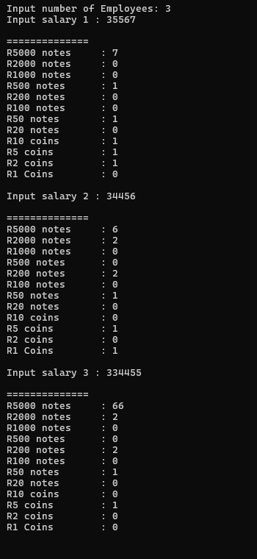

Q18.
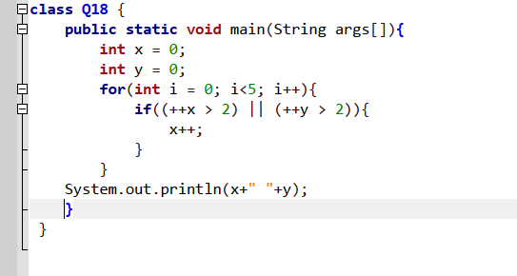

Correct Answer: C
Output>>
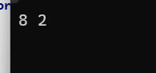

Q19.
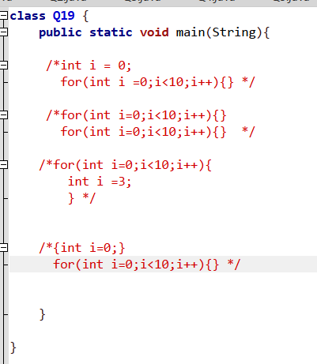
*In this picture I was input that answers as a comment
Don’t think about that i run all answers separately and
Before add the comment signs.*

Answer Explain:
- A. Illegal: we cannot declare a variable named i outside and then declare i again inside the loop header. It causes a duplicate variable error.
- B. Legal: Both loops declare their own i inside their loop brackets. They have separate scopes and do not conflict.
- C. Illegal: we cannot declare int i = 3; inside the loop body because i is already declared in the loop header for that block.
- D. Legal: The first block { int i = 0; } finishes and dies. Then the loop below it can safely create a new int i = 0;.
Correct Answer: B and D

Q20.
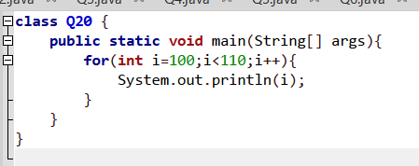
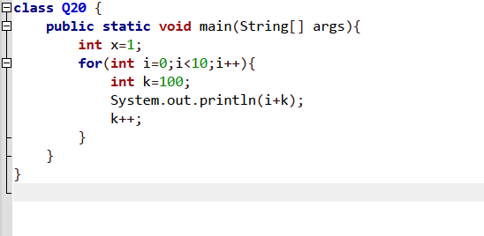
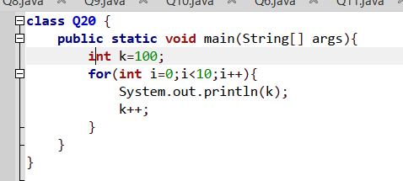
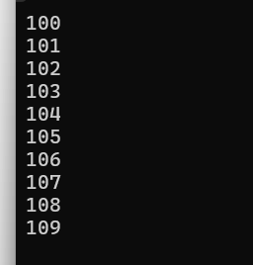
Only Answer A , C ,E give the output of 100 to 109
Output>>

Q21.
A.
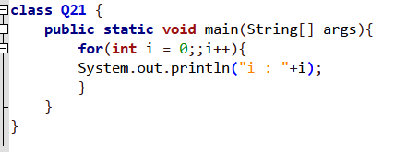
Answer a output is not ending it was
B.
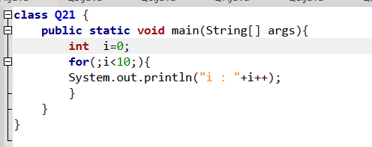
Output>>
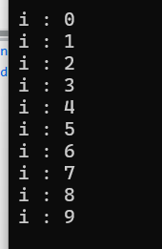

C.
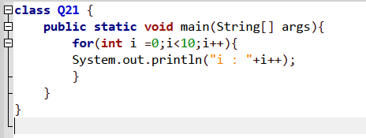
Output>>
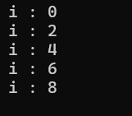
D.
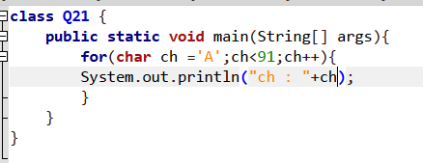
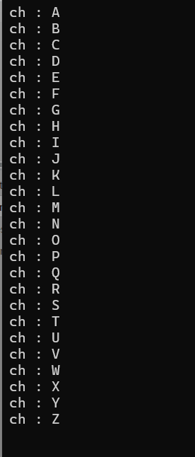
Output>>

E.
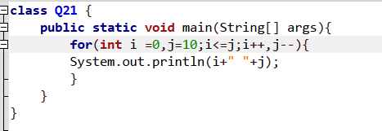
Output>>
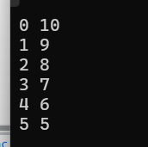
F.
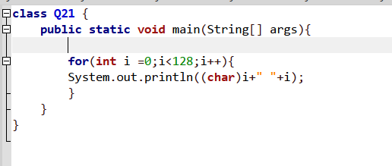
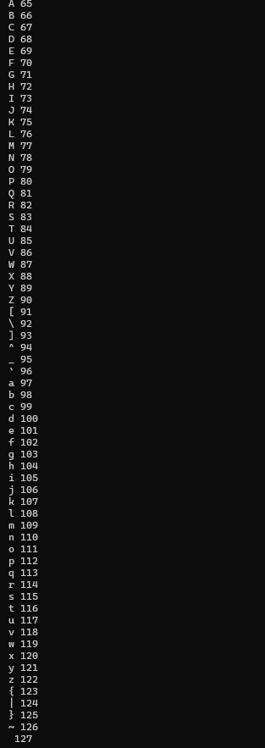
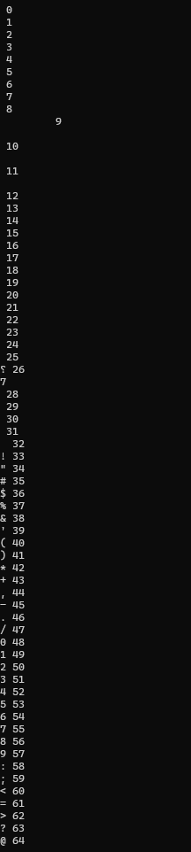
Output>>it ‘s given ascii table.

G.
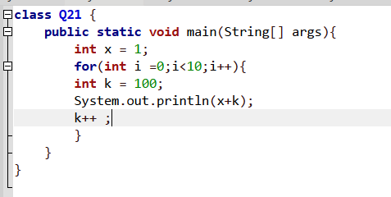
Output>>
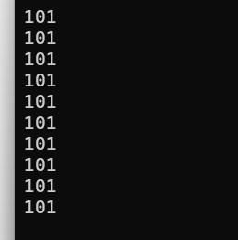

Q22.

A. for(int i=0;i<10;i++){} — Standard and correct loop.
C. for(int i=0;;i++){} — Valid loop with an empty condition (creates an infinite loop).
D. for(int i=0;i<10;){} — Valid loop with an empty update section.
E. for(double d=0;d<10;d++){} — Valid loop using double type.
F. for(;;){} — Valid infinite loop with all sections empty.
G. for(byte b=0;b<10;b++){} — Valid loop using byte type.
J. for(int i=0;;){} — Valid loop with only initialization.
K. for(char ch='A'; ch>92; ch++){} — Valid loop using char type.

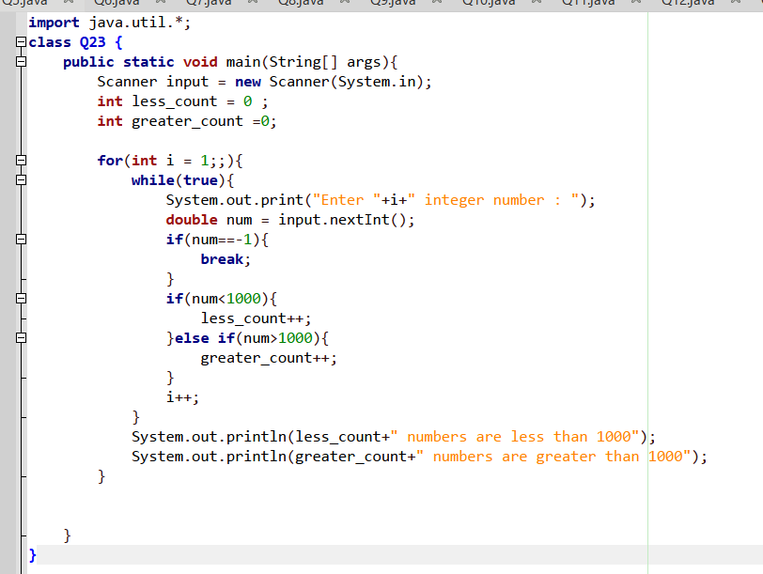
Q23.
Output>>
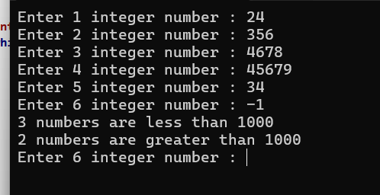

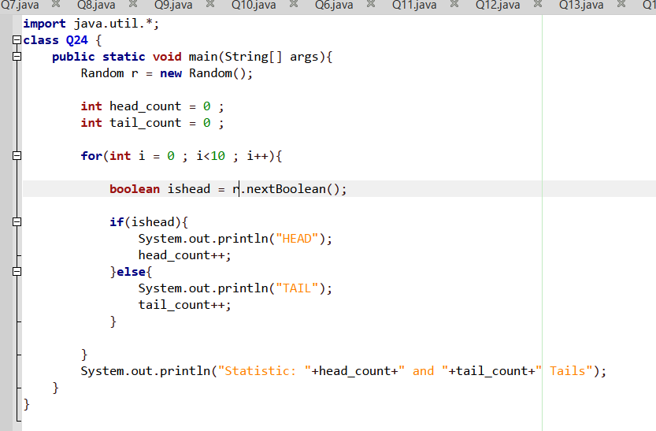
Q24.

Output>>
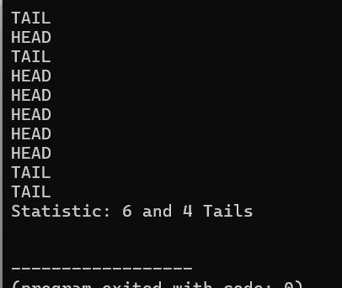

Q25.
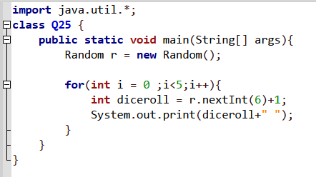
Output>>
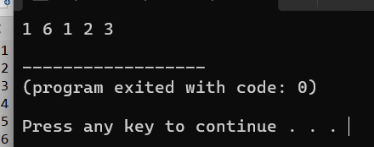

Q26.
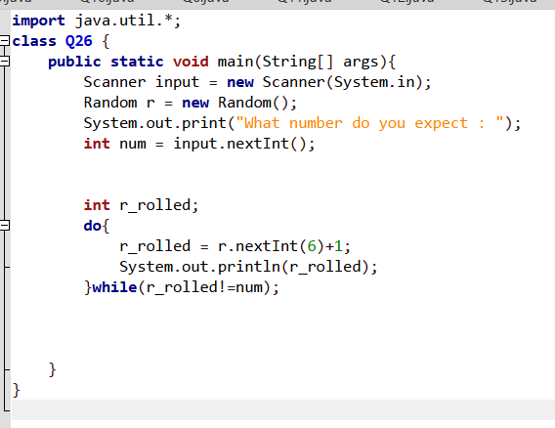

Output>>
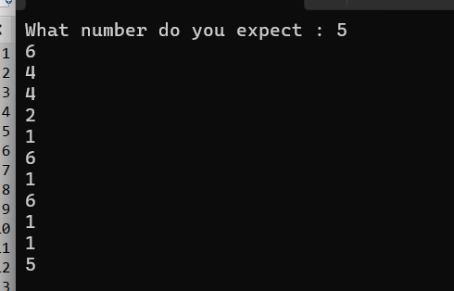

Q27.
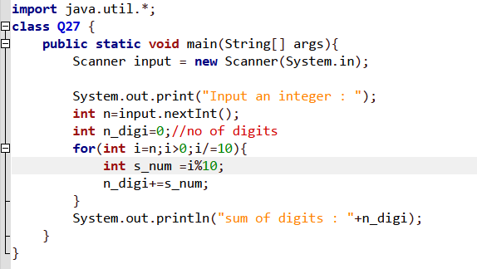

Output>>
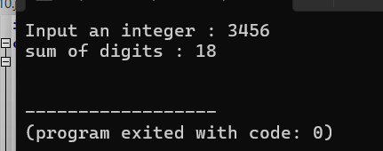

Q28.
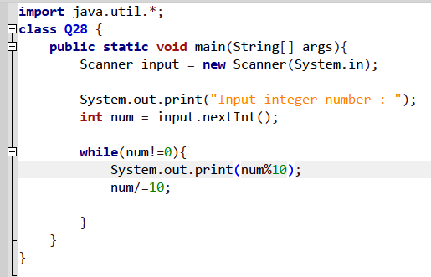

Output>>
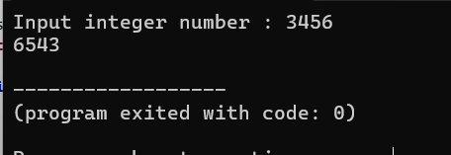

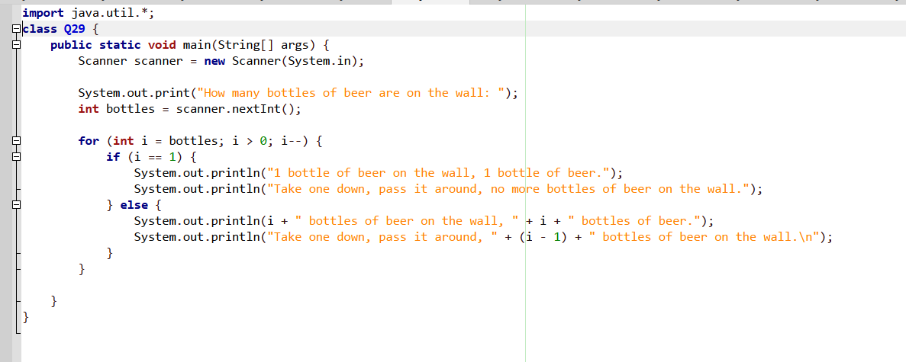
Q29.

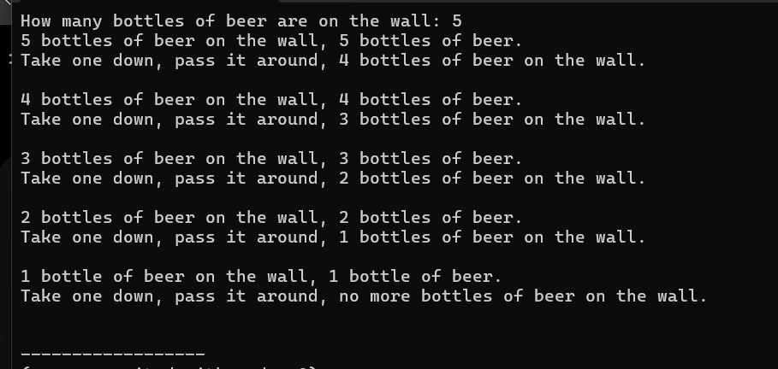
Output>>

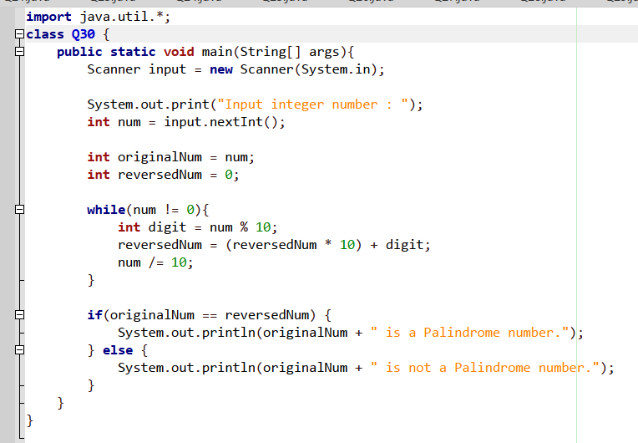
Q30.

Outputs>>
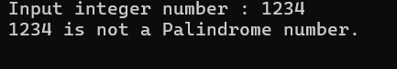
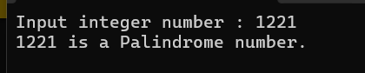

Q31.
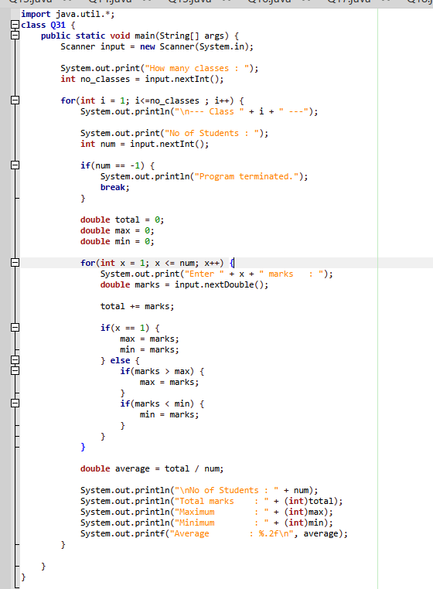
Output>>
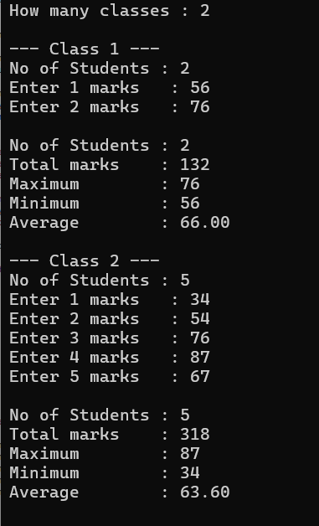

Q32.
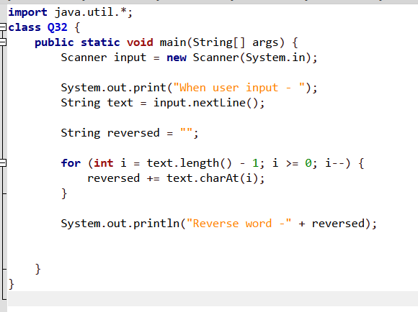

Output>>
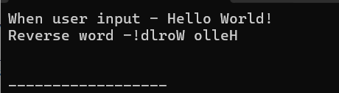

Q33.
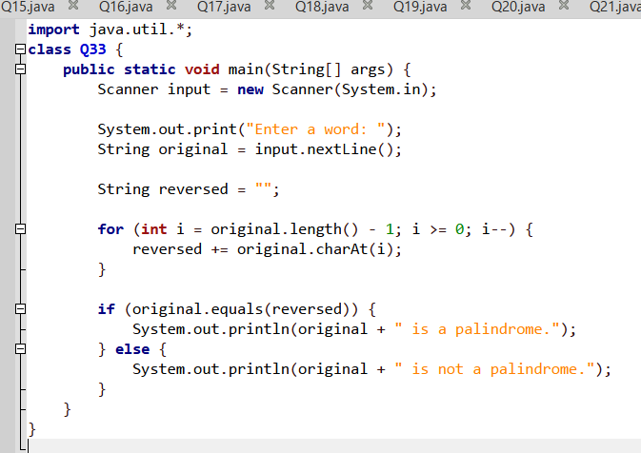

Output>>
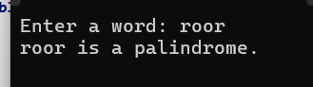
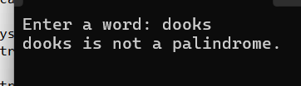

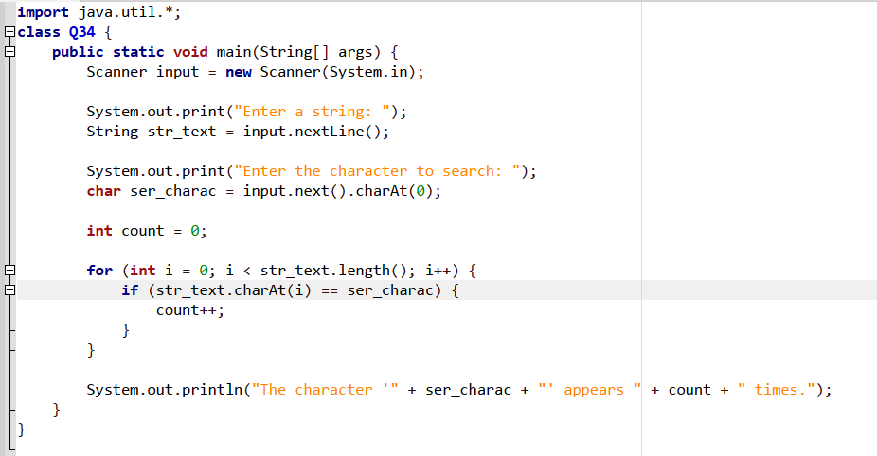
Q34.

Output>>
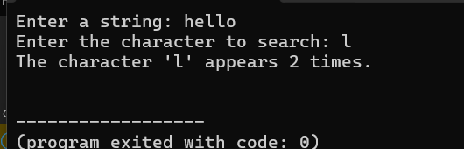

Q35.
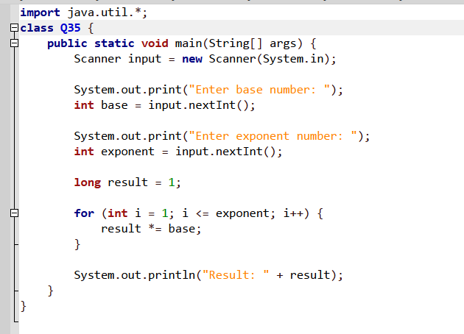
Output>>
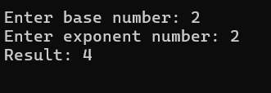

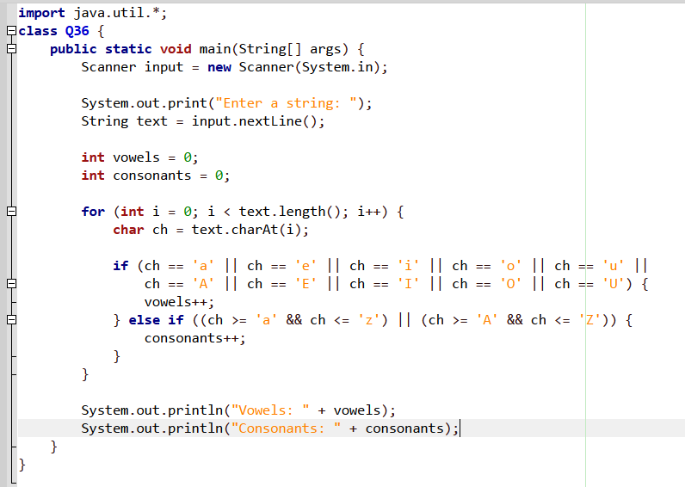
Q36.

Output>>

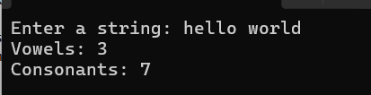

Q37.
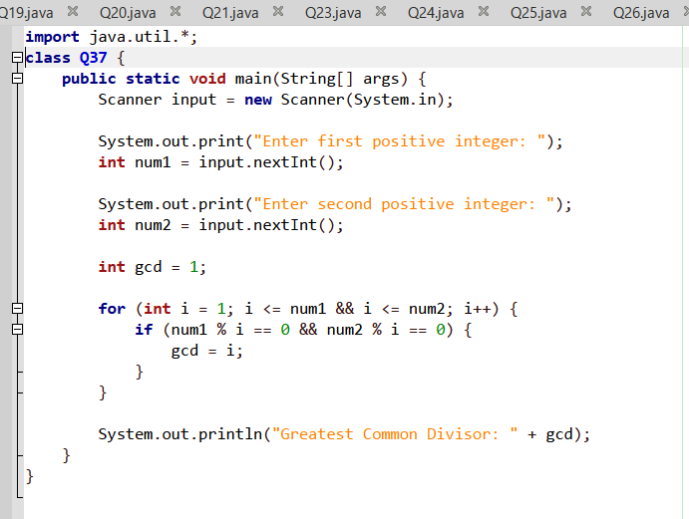

Output>>
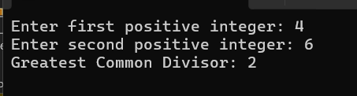

Q38.
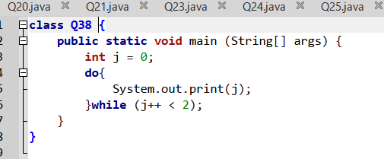
Answer is B
Output>>
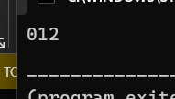

Q39.
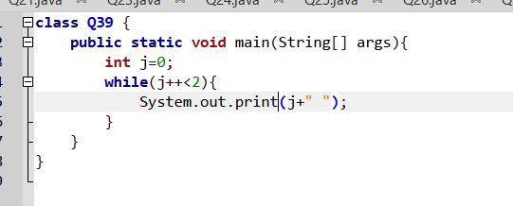

Output>>
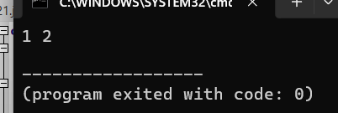

Q40.
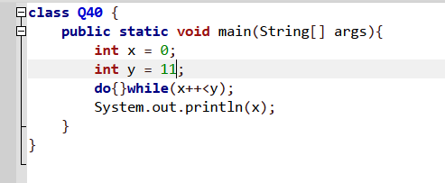

Output>>
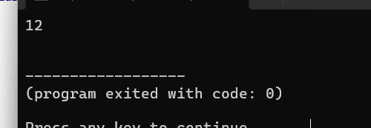

Q41.
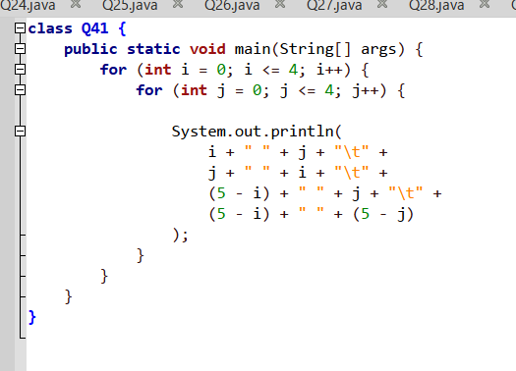
Output>>
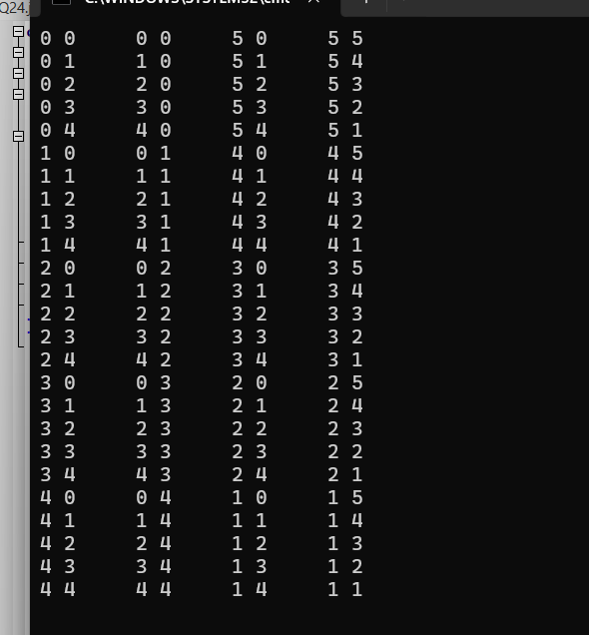

Q42.
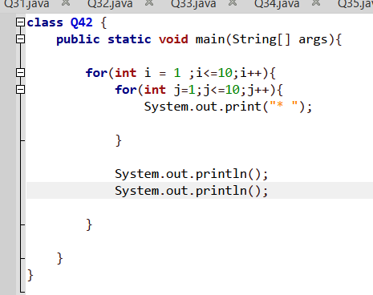

Output>>
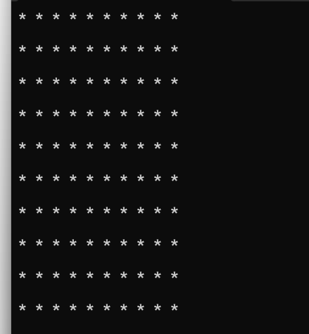

Q43.
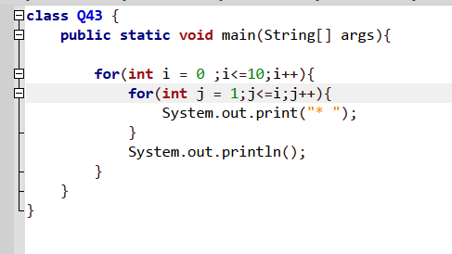
Output>>

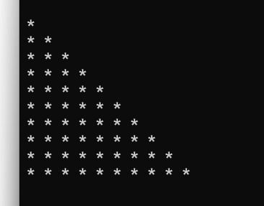

Q44.

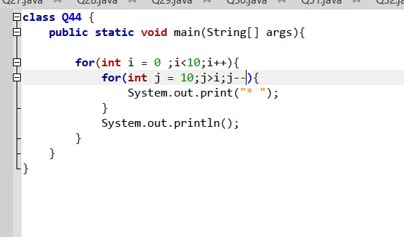
Output>>
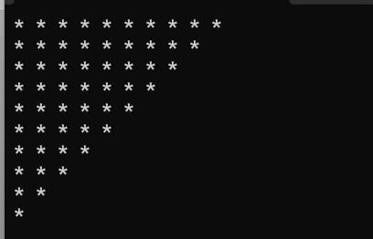

Q45.
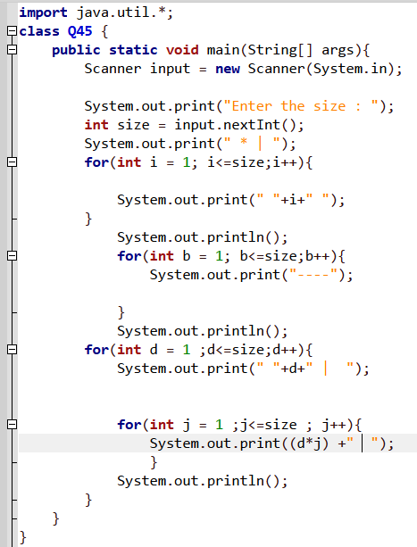
Output>>
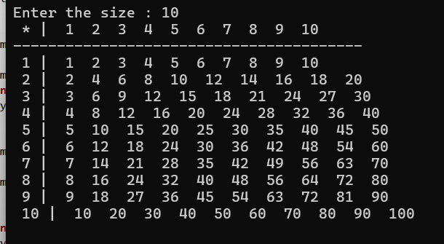

Q46.
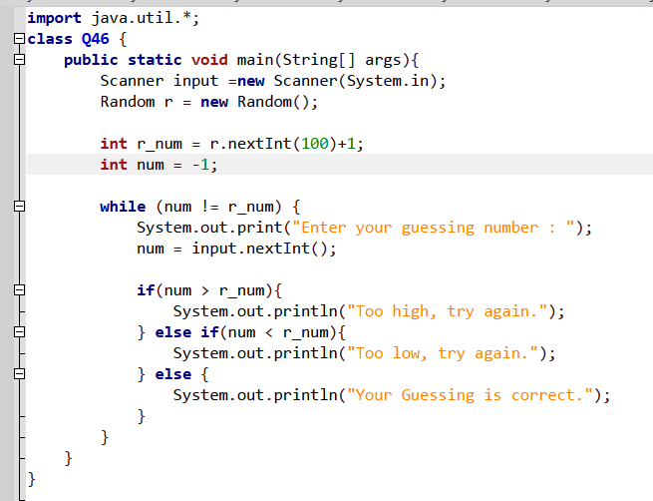
Output>>
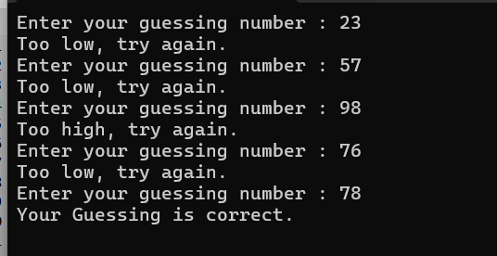

Q47.
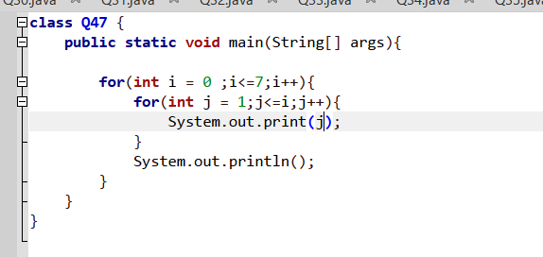

Output>>
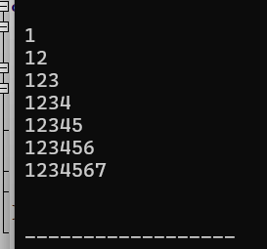

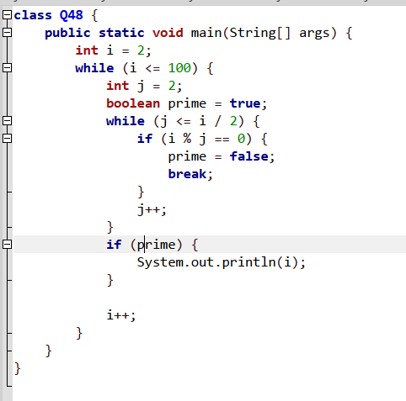
Q48.

Output>>
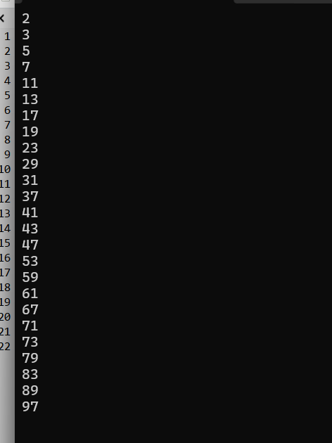

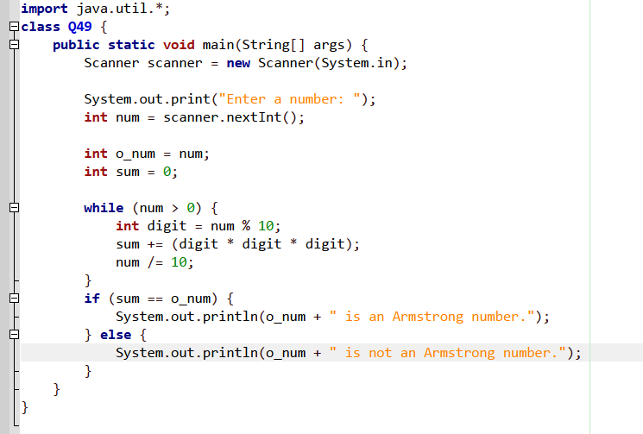
Q49.

Output>>
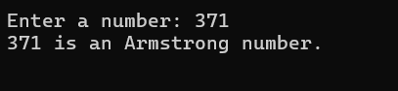
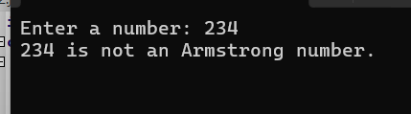

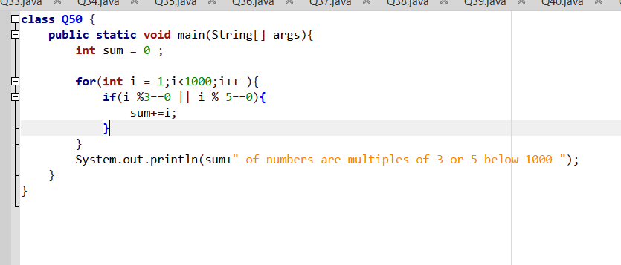
Q50.

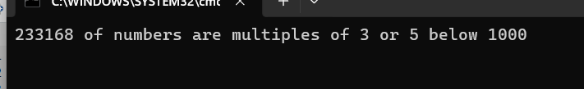
Output>>

Q51.
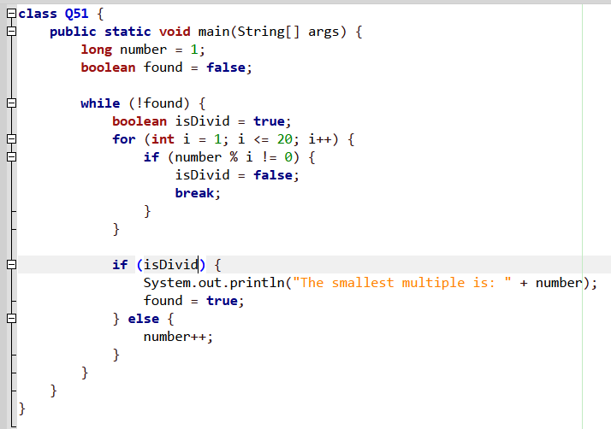

Output>>
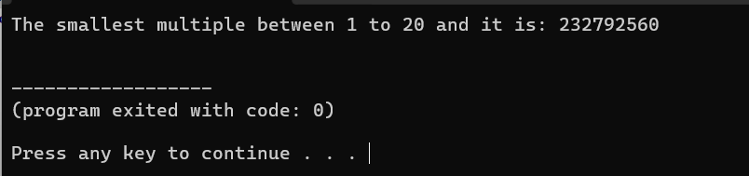

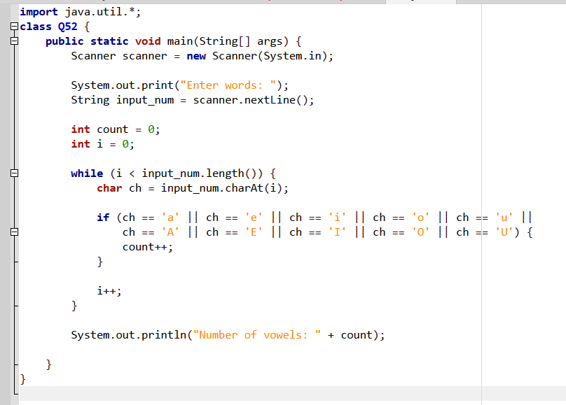
Q52.

Output>>
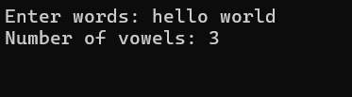

Q53.
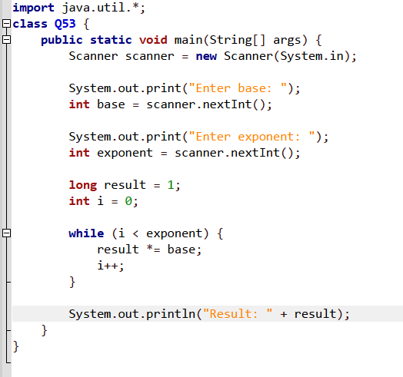

Output>>
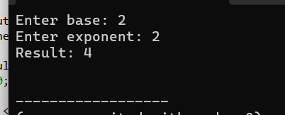

Q54.
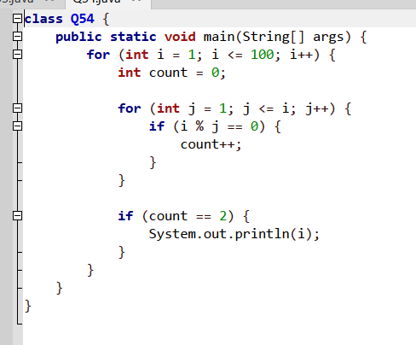
Output>>

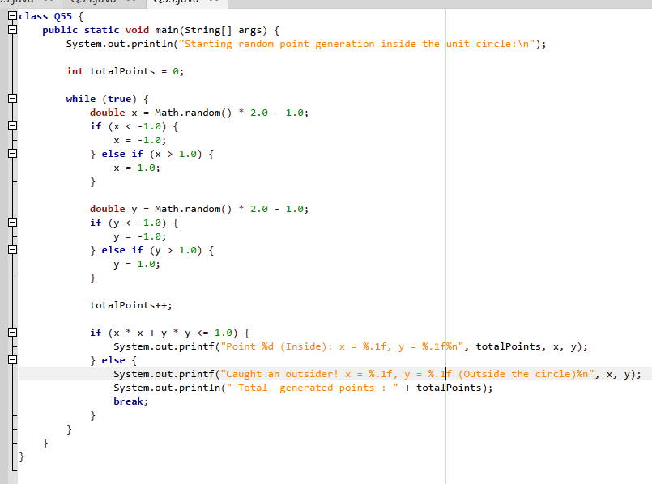
Q55.

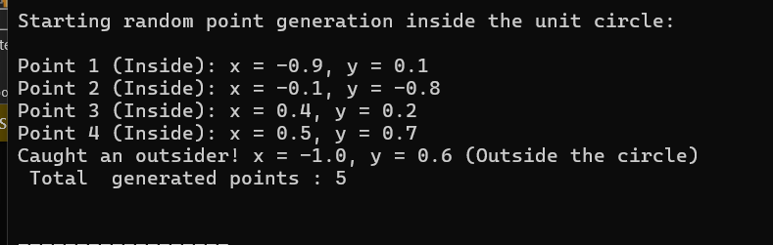
Output>>

Q56.
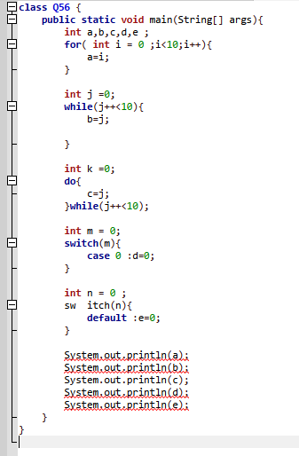
This will show errors .because there is 5 errors are occourred
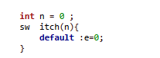
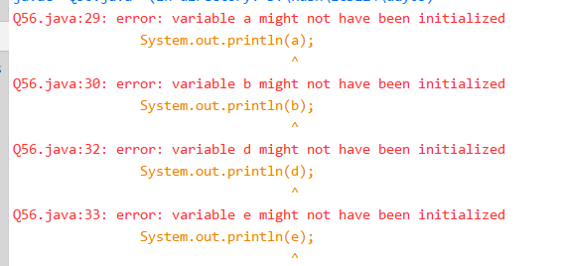
And those 4 errors are given below and other 5 error is switch must be call like switch but In that code .one switch call “sw itch”and that is the other one(error).

Q57.
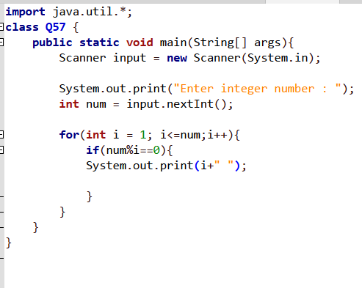

Output>>
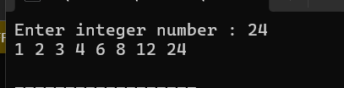

Q58.
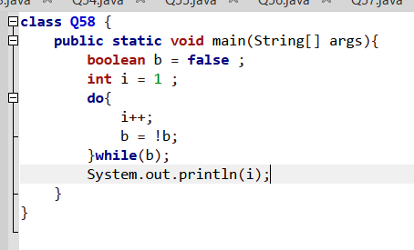
Output>>
Anwer E
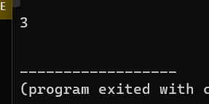

Q59.
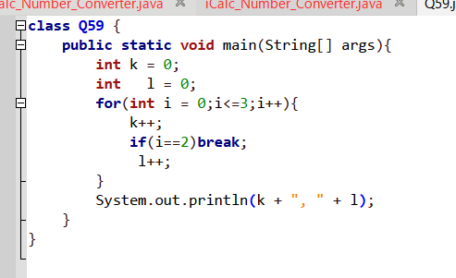
Output>>
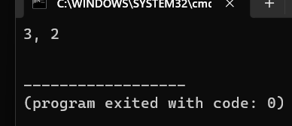
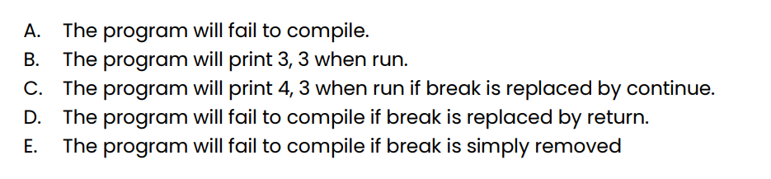

One of these answers are not correct one.

Q60.
Anawers are A and c.

Q61.
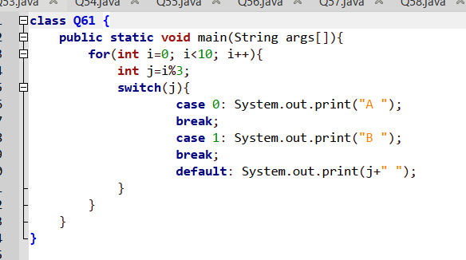
- Answer D
Output>>
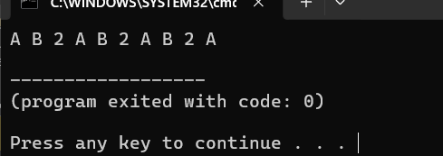

Q62.
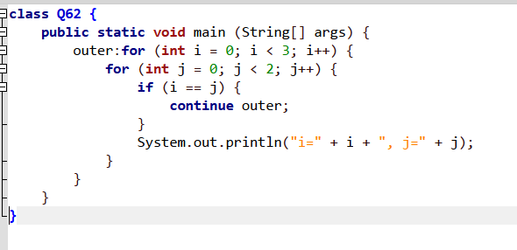

Answers A and D
Output>>
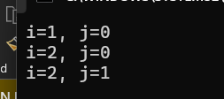

Q63.
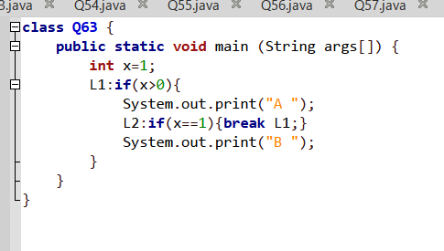

Answer E
Output>>
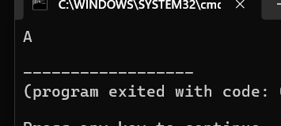

Q64.
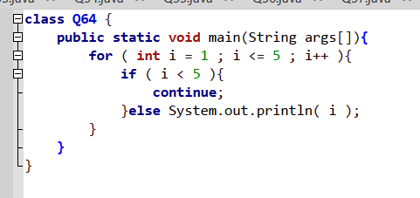
Answer c
Output>>
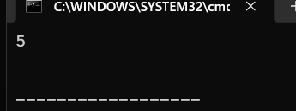

Q65.
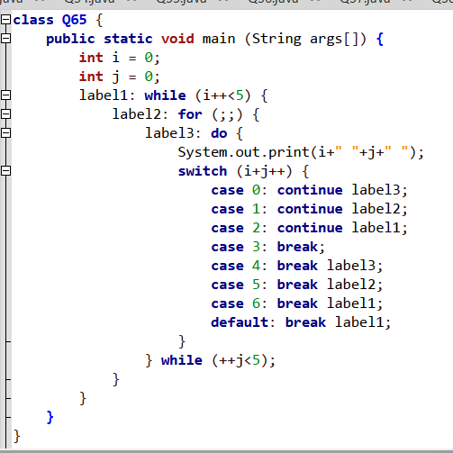

Answer A
Output>>
