Q01.
i.
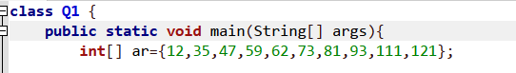
ii,iii.
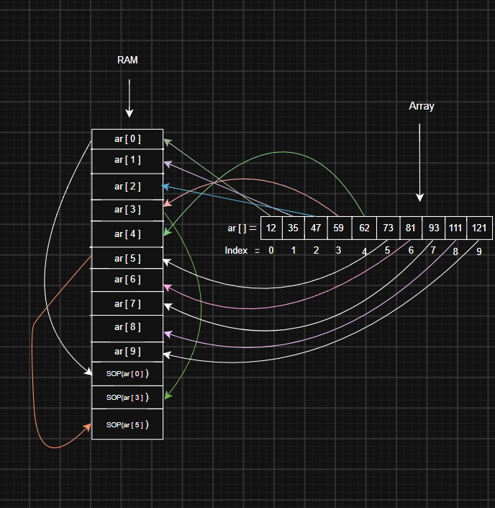
iv.
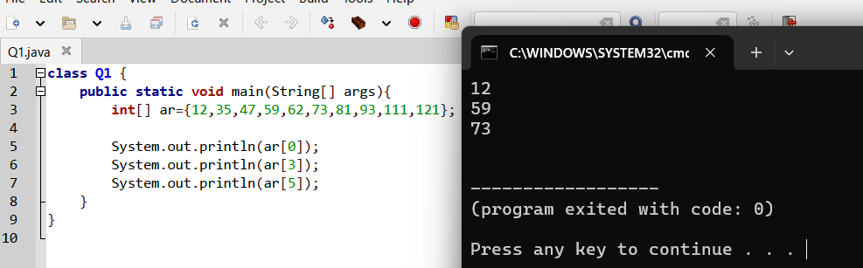

Q02.

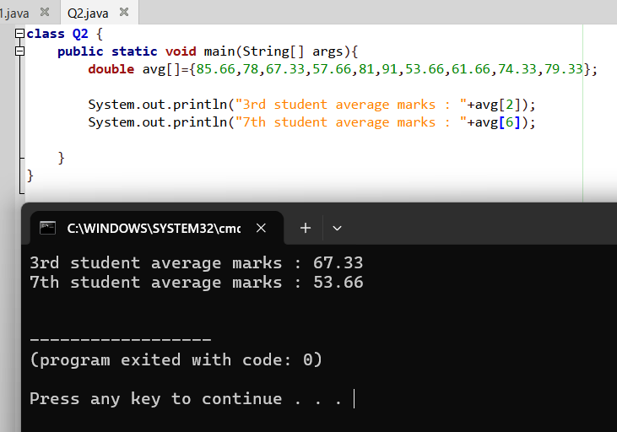

Q03.
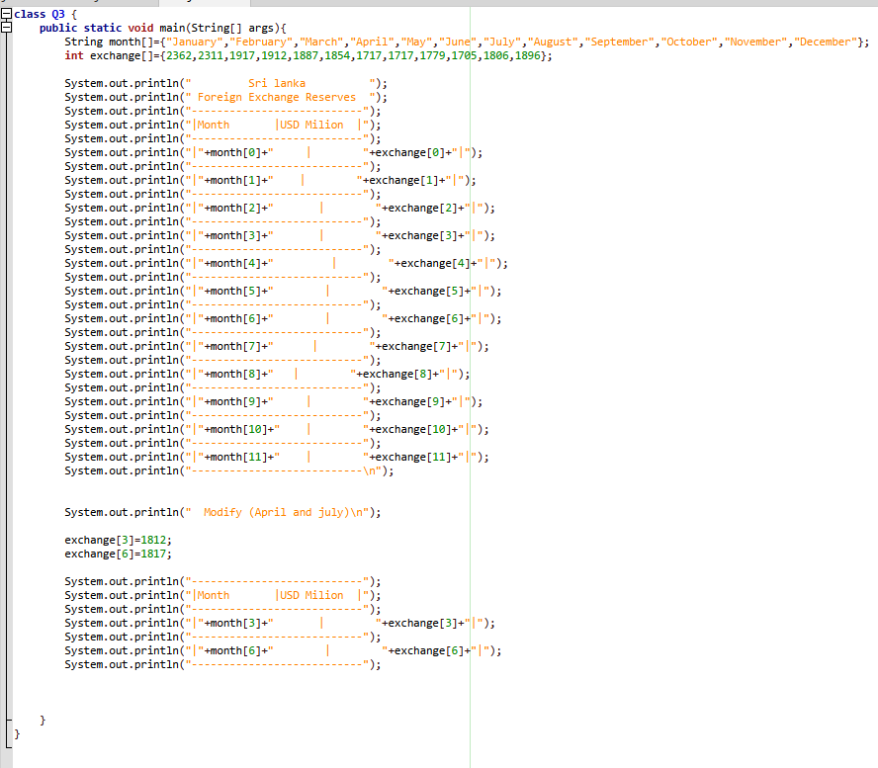
i,ii,iii,iv

Output>>
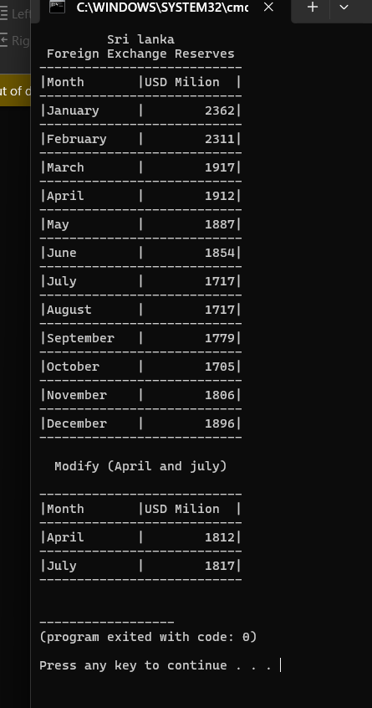

Q04.
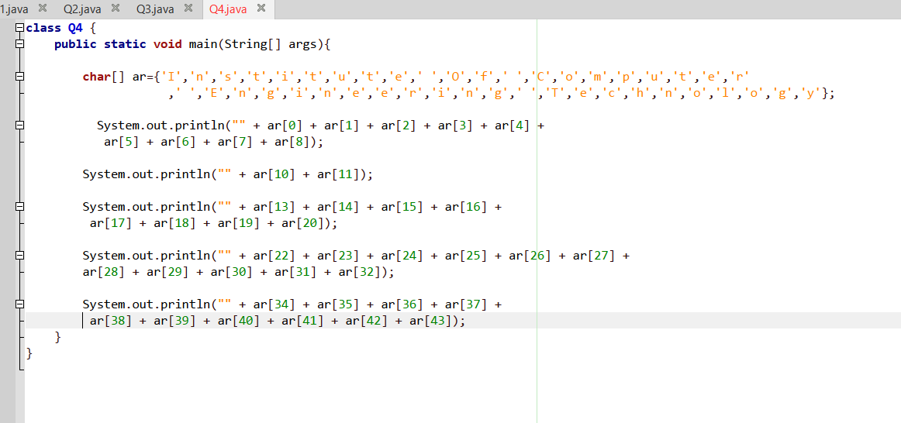
I,ii

Output>>
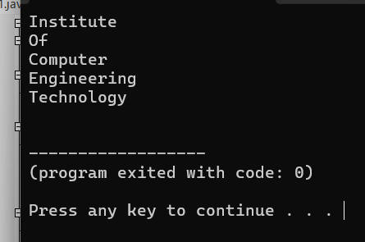

Q05.
i,ii
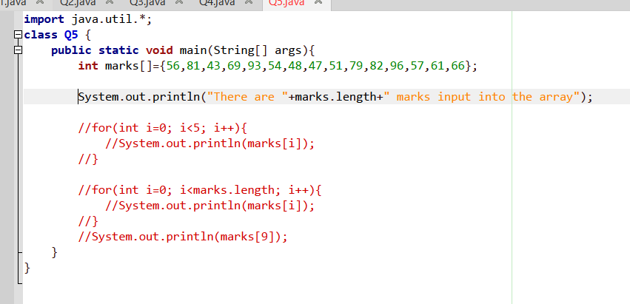
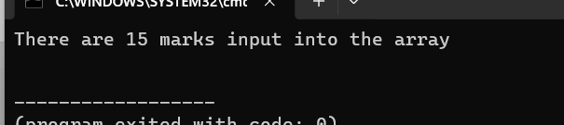
iii.
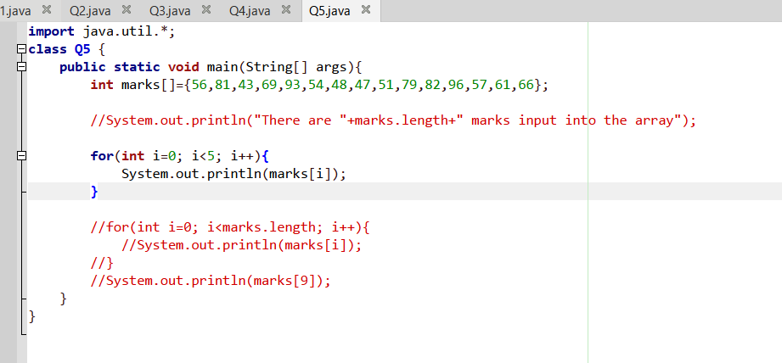
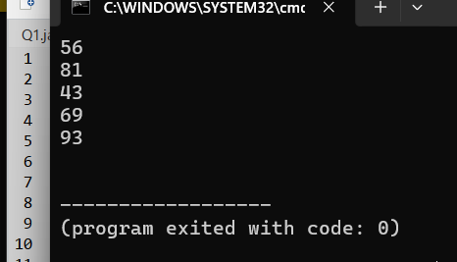
iv.
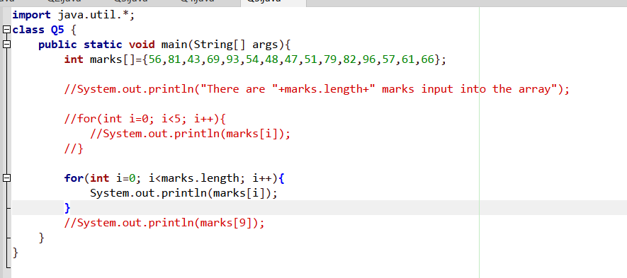
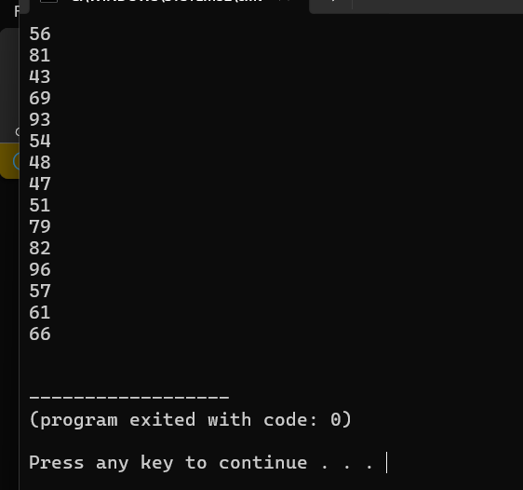
V.
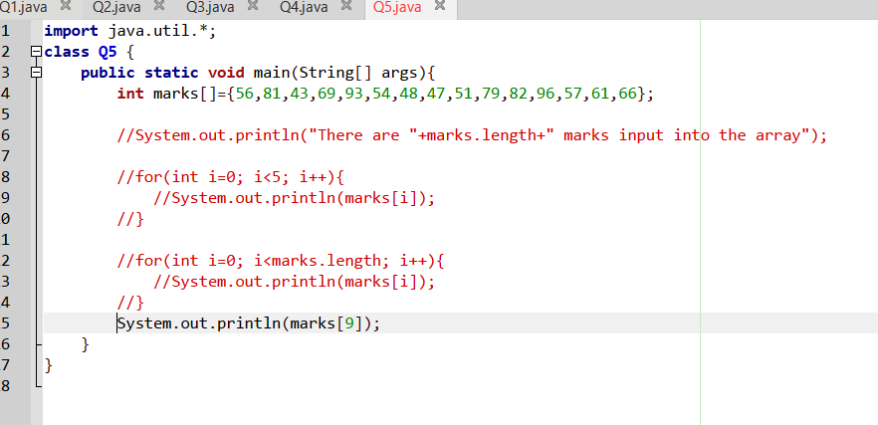


Q06.
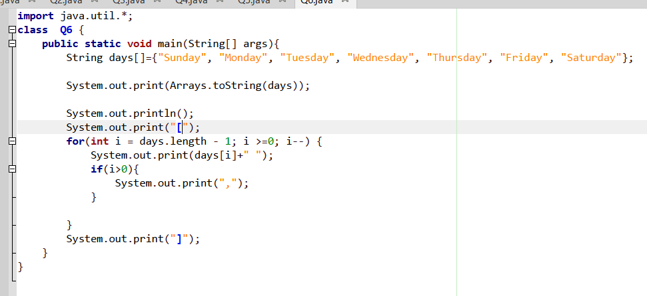

Output>>
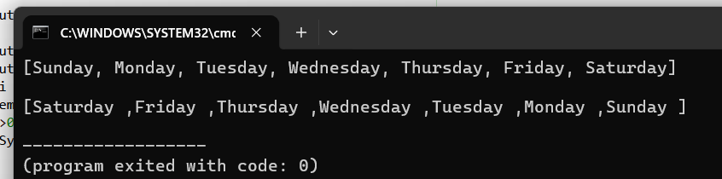

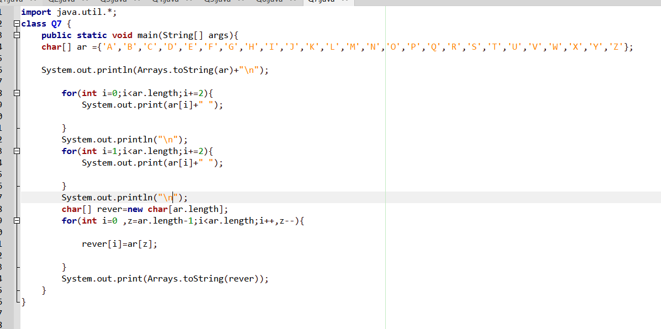
Q07.

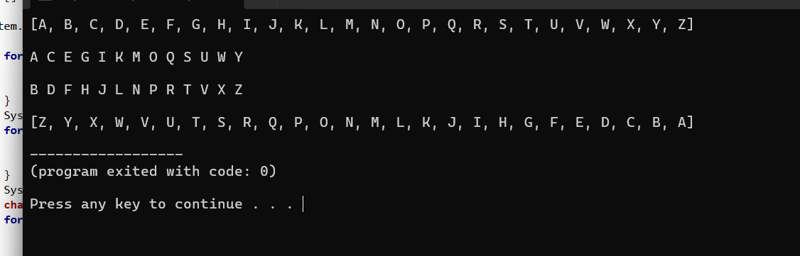
Output>>

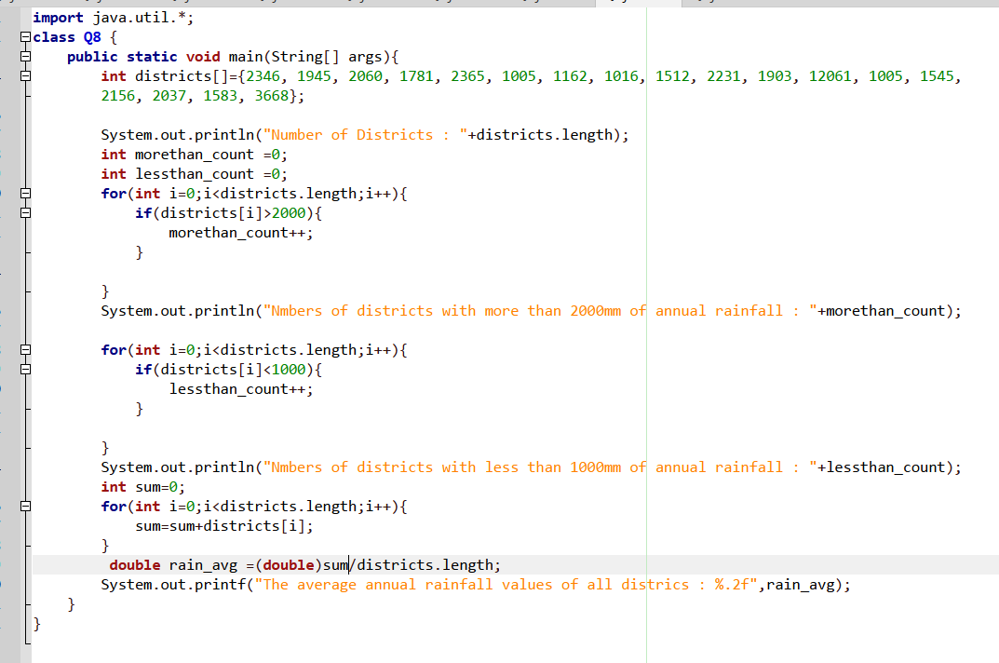
Q08.

Output>>
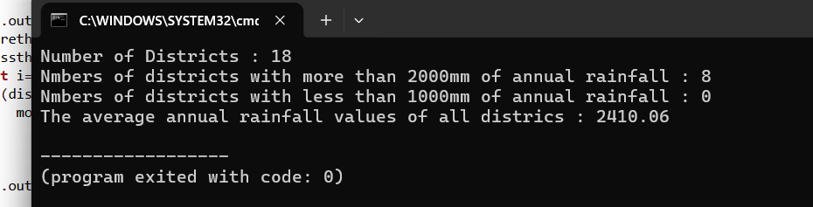

Q09.

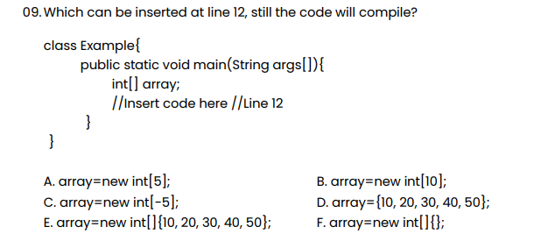

Answers:
A,B,C,E,F

Q10.
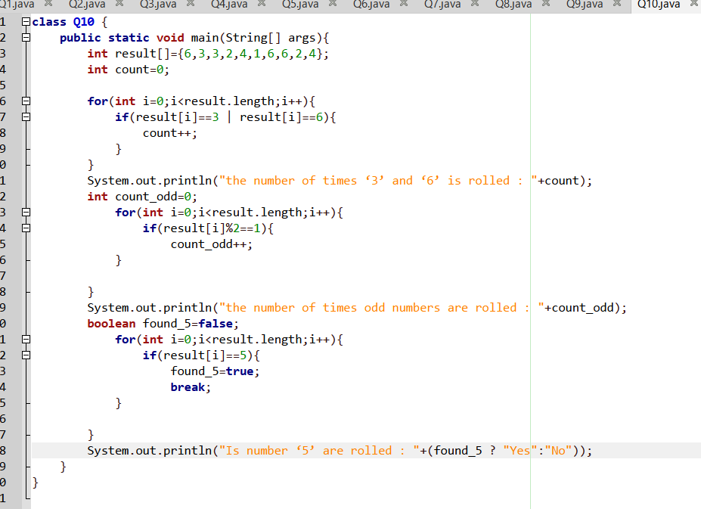
Output>>
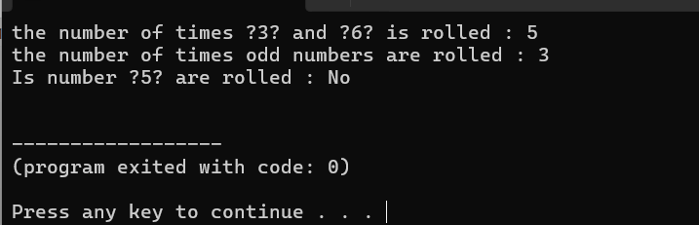

Q11.
i.
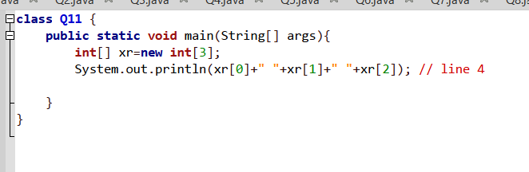
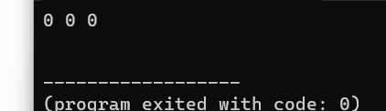
Explain:without array initialization (without values)
It prints default output (0).
ii.
char
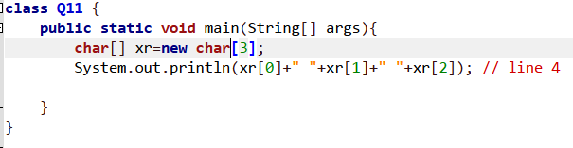
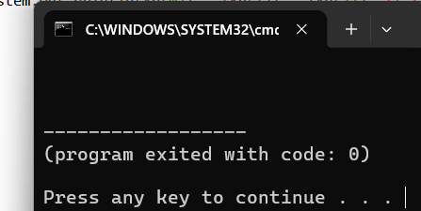

boolean
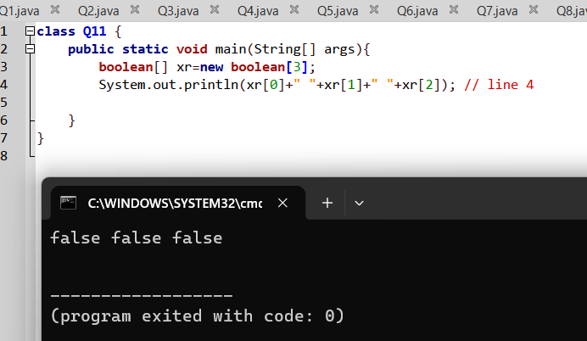
double
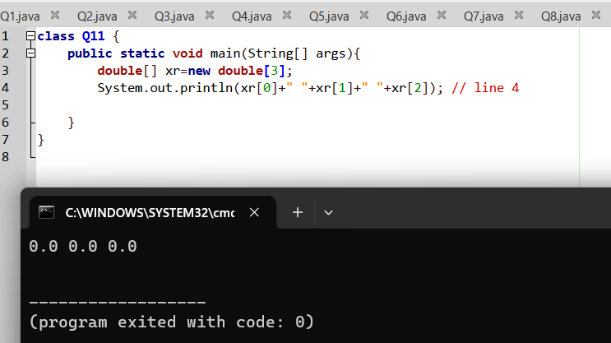

String
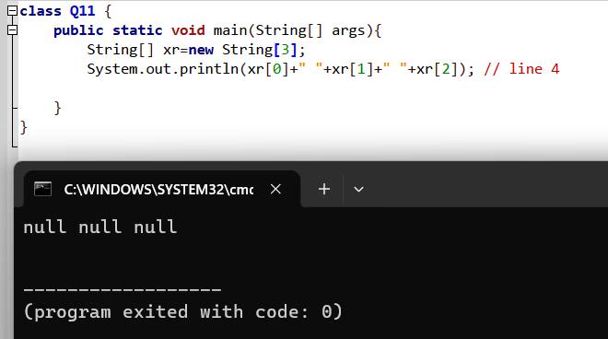

Q12.
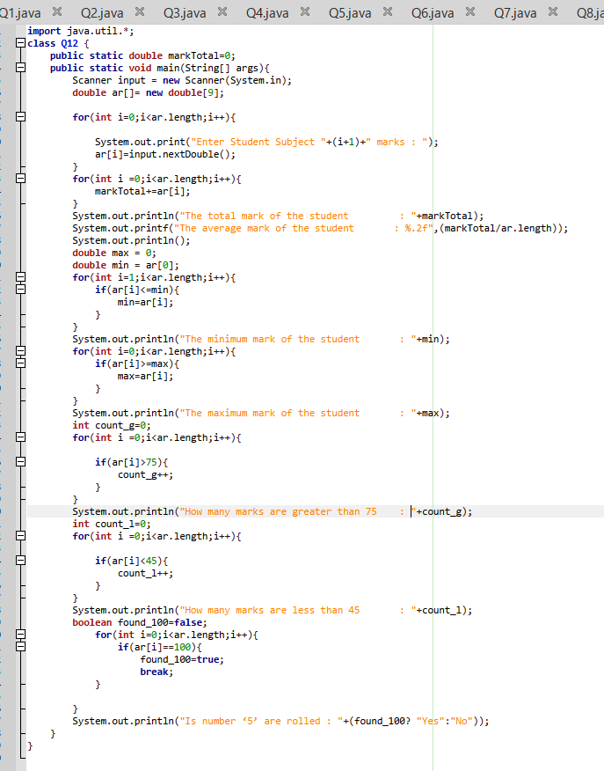
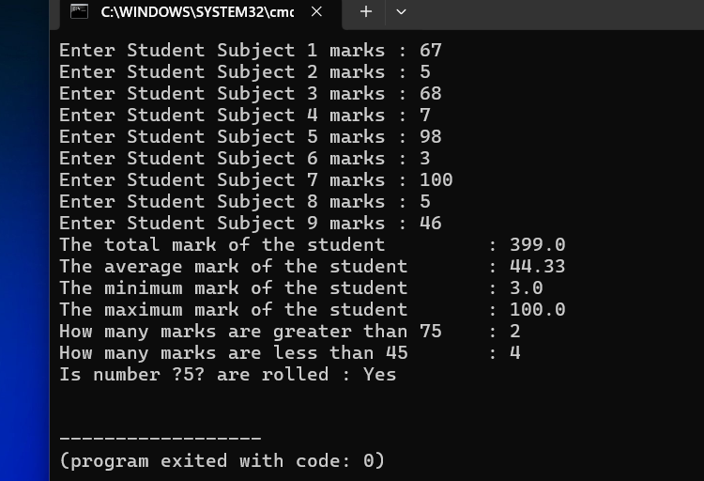

Q13.
i.
A.has Scanner method to get input by user
B.has Random method to get random numbers by System.
ii.
numer[i]=r.nextInt(101);

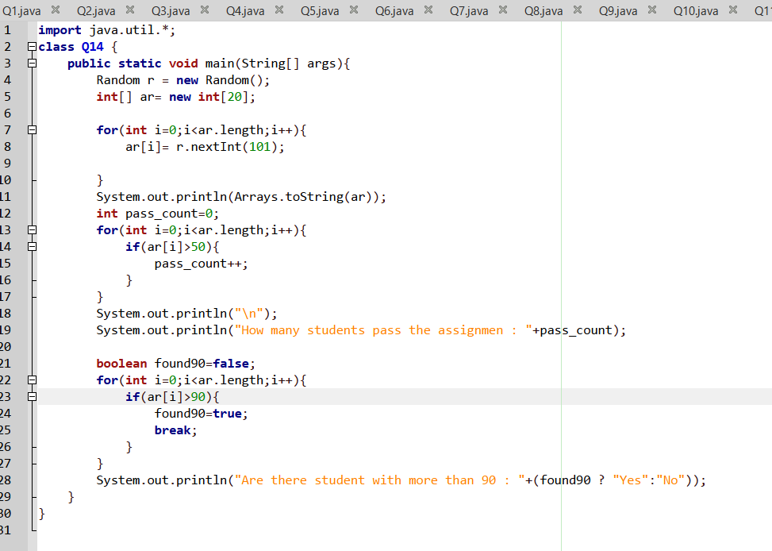
Q14.
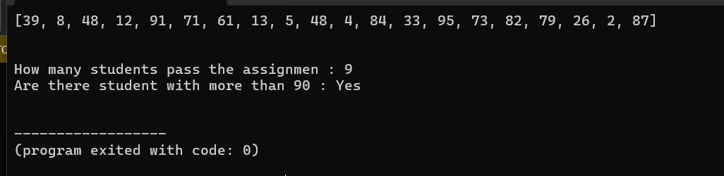
Output>>

Q15.
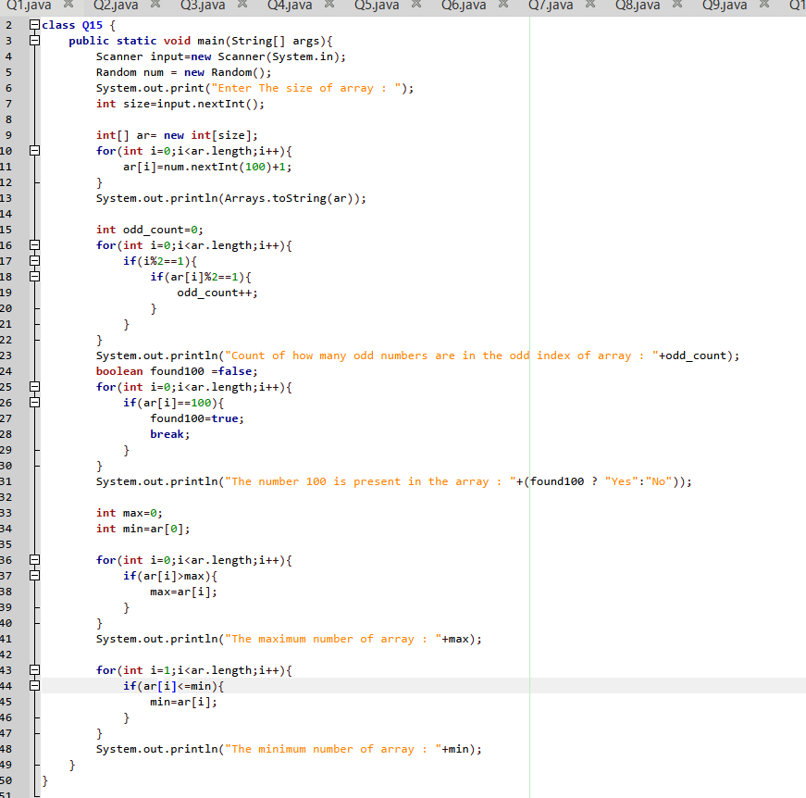
Output>>
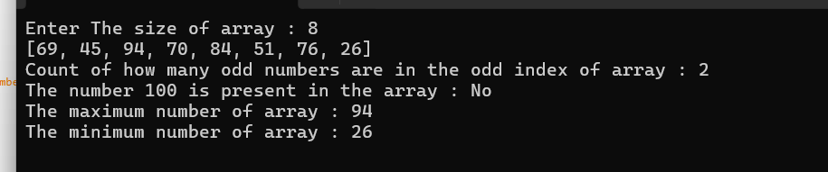

Q16.
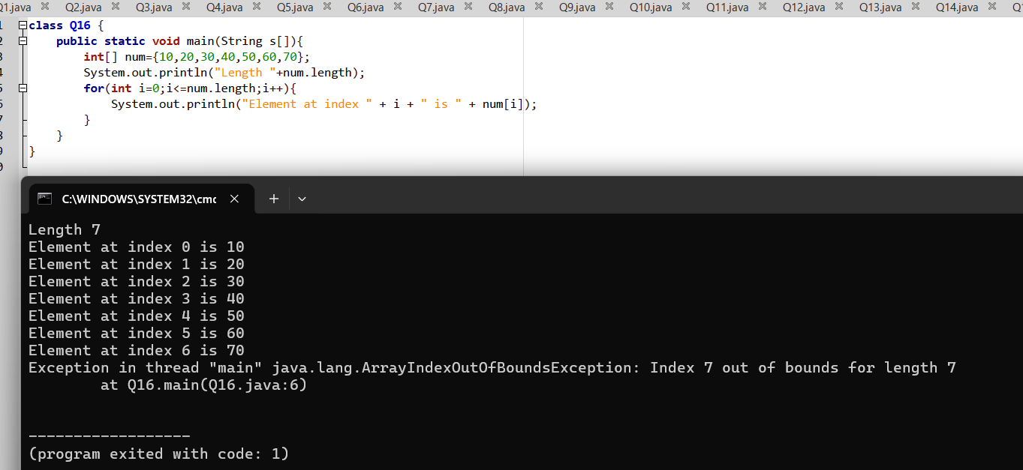
i.

i Explain
We can’t use i<=num.length Because that Array length is 7 so valid indices are only 0 to 6.when i=7 ,accessing num[7] throws an ArrayIndexOutOfBoundsException .
ii.
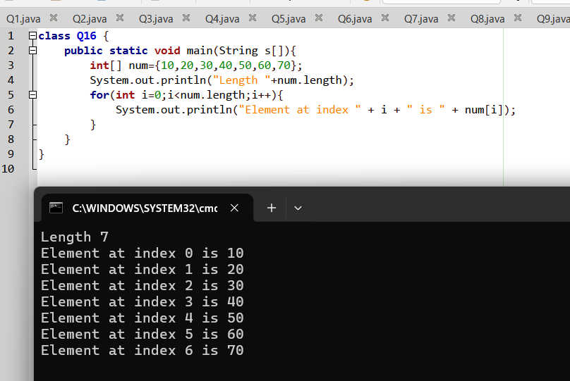

Q17.
i,ii answers
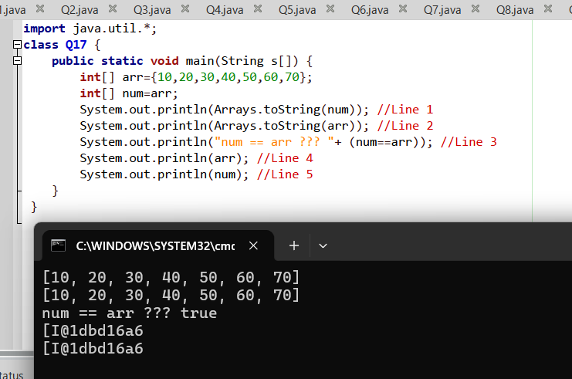
Explain i:
Line3:and after the int num=arr; these are not different these are same now then that is why line 3 boolean logic get output as true

Line4: we already references arr array to num array variables arr array give his ram address as reference and that is why line 4 get output as I@1dbd16a6

Explain ii: after assigned the reference of arr to num that line 5 System.out.println give output as I@1dbd16a6

Q18.
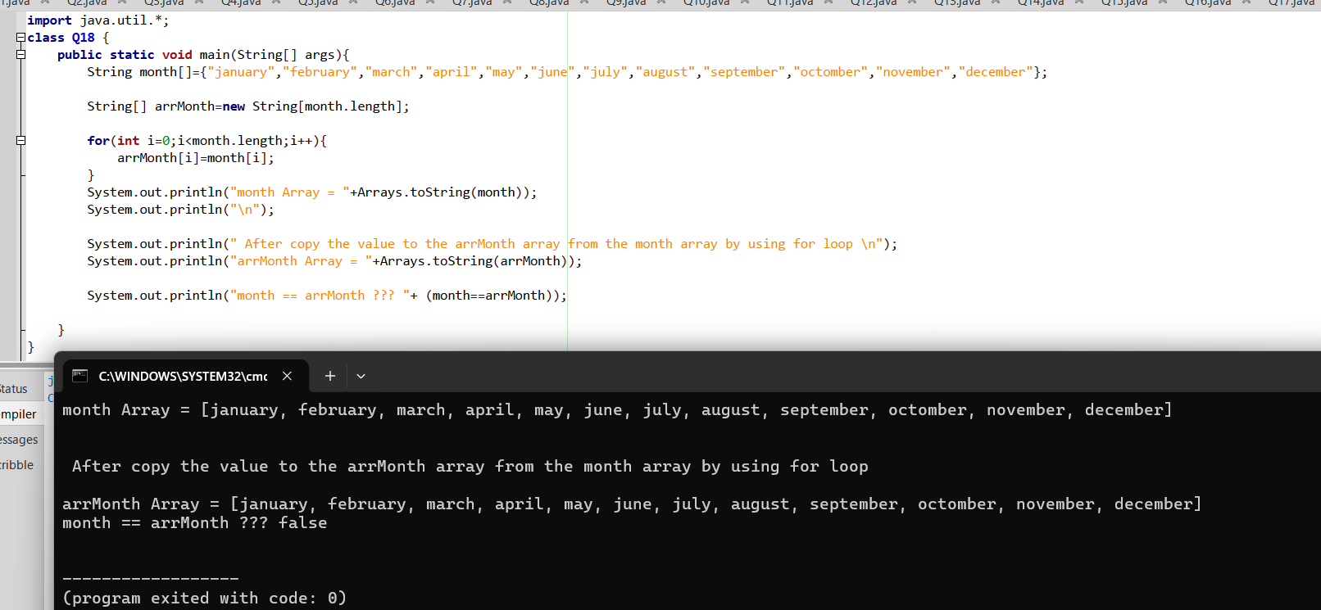
i,ii answers
ii explain: (String[] arrMonth = new String[month.length];): Uses new keyword. Creates a different array object in Heap memory with a new address and I give output as false.

Q19.
i,ii output
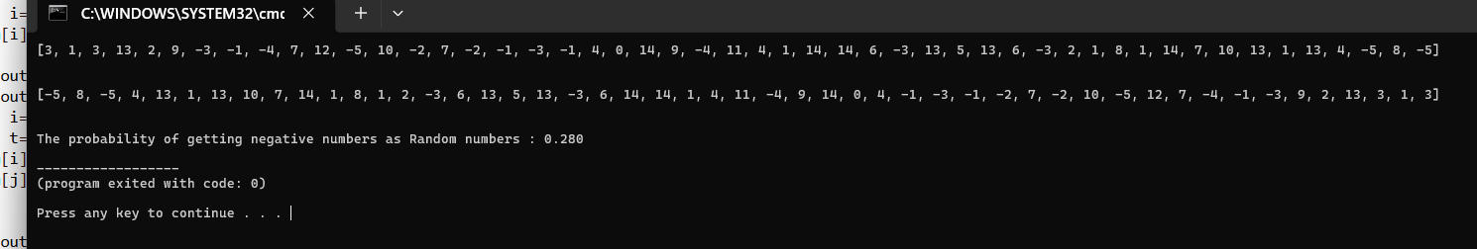

Q20.
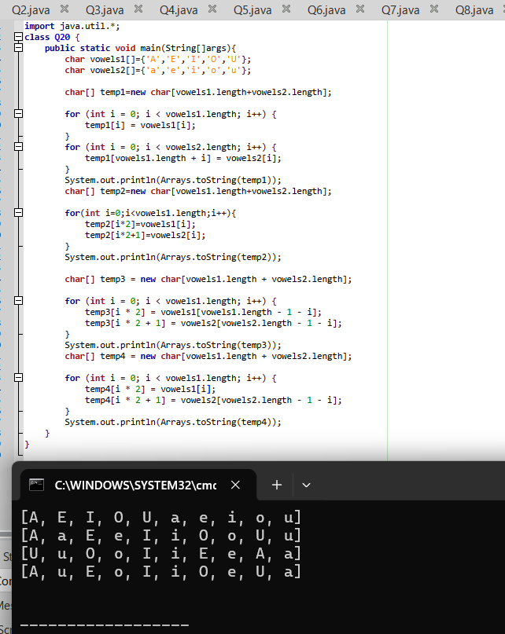

Q21.
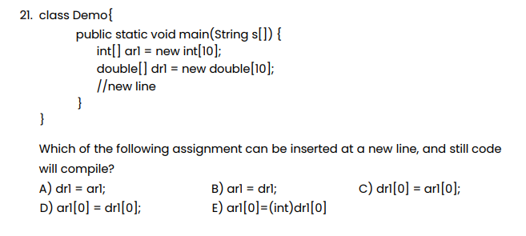
Answers
A,C,D,E

Q22.
Answer A
Q23.
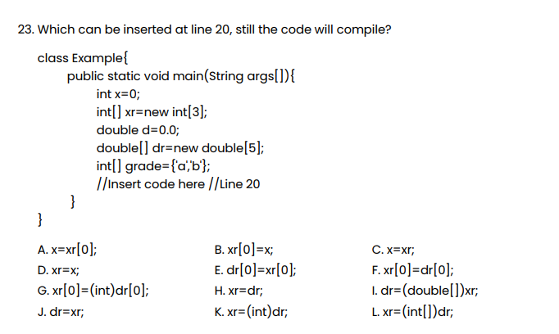
Answers A,B,E,G

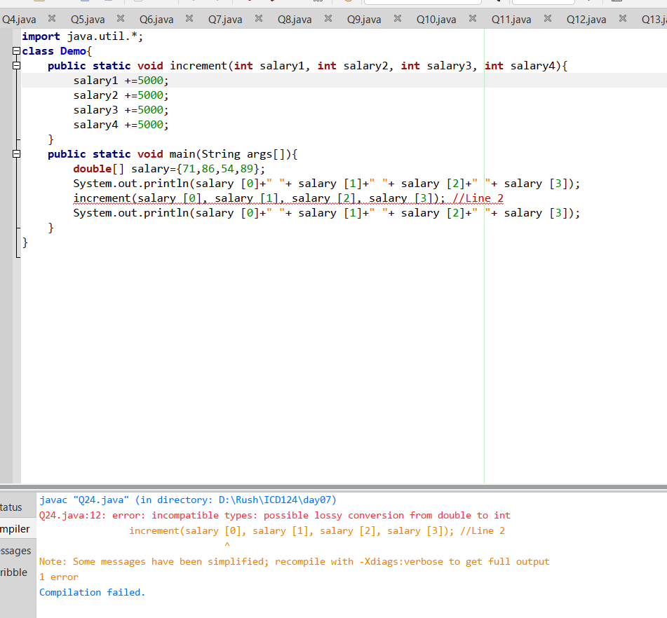
Q24.
- We can’t run this without type casting

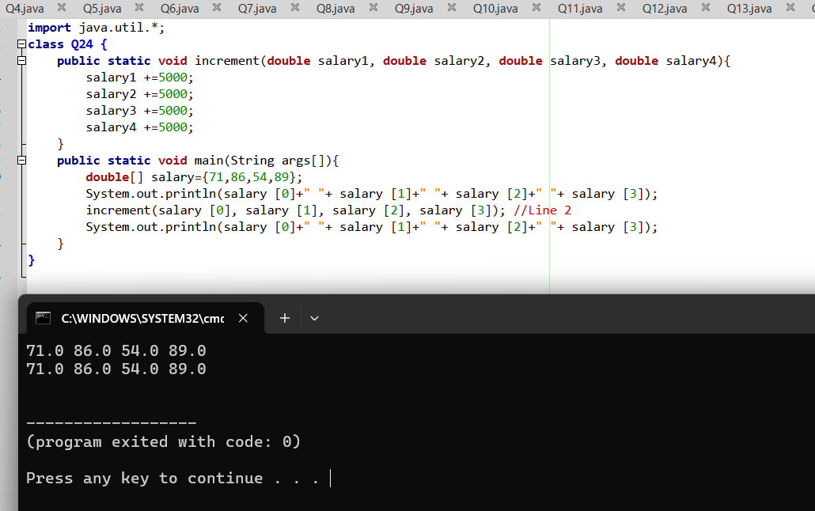
ii.
iii.
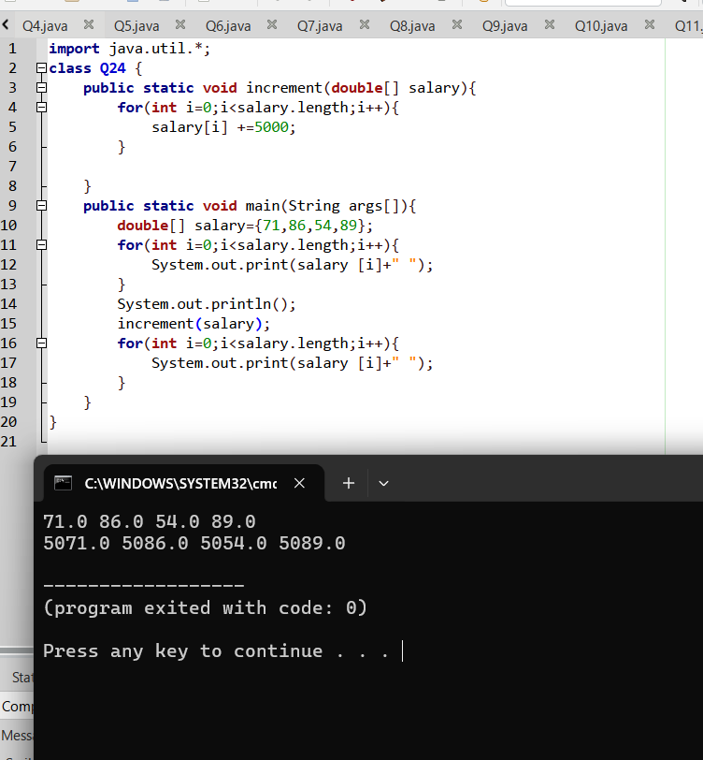

Q25.
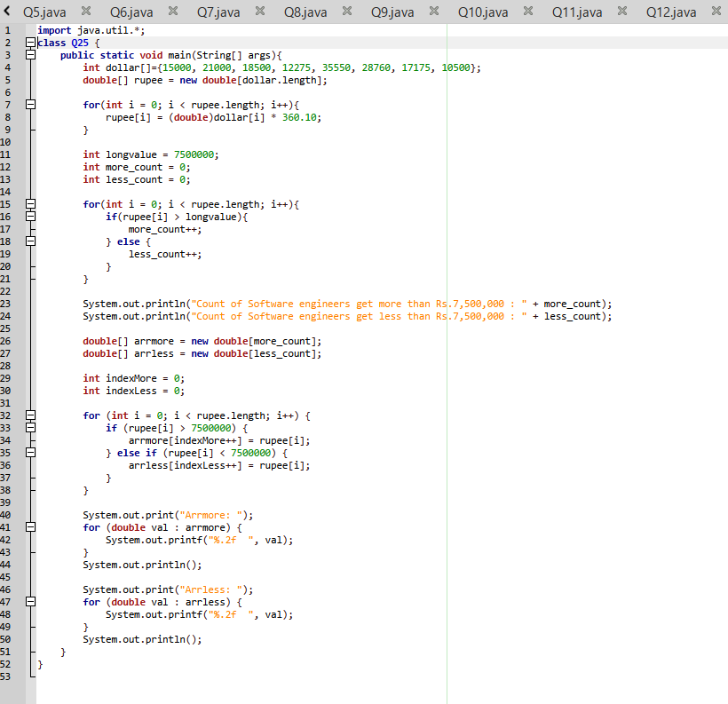
Output>>
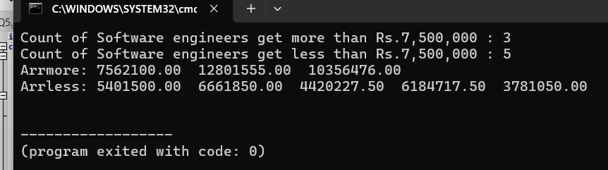

Q26.
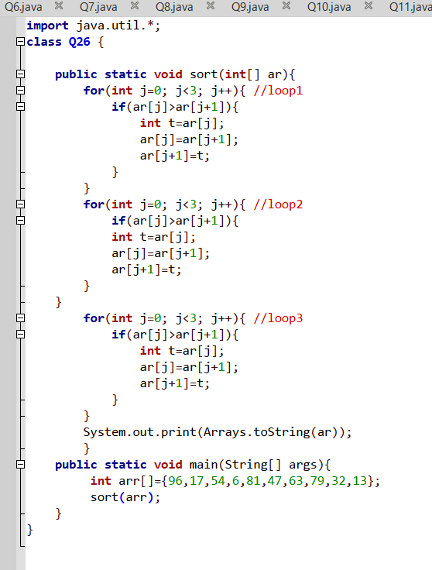
i.
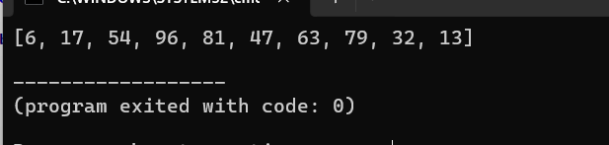
ii.
Loop 1: It compares adjacent pairs among the first 4 elements and pushes the largest value (96) to index 3.
- Result: [17, 54, 6, 96, 81, 47, 63, 79, 32, 13]
Loop 2: It runs again on the first 4 elements and pushes the second largest value (54) to index 2.
- Result: [17, 6, 54, 96, 81, 47, 63, 79, 32, 13]
Loop 3: It runs a final time, moving the smallest value (6) to the front at index 0.
- Result: [6, 17, 54, 96, 81, 47, 63, 79, 32, 13]
iii.
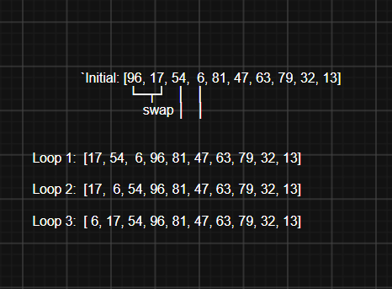
iv.
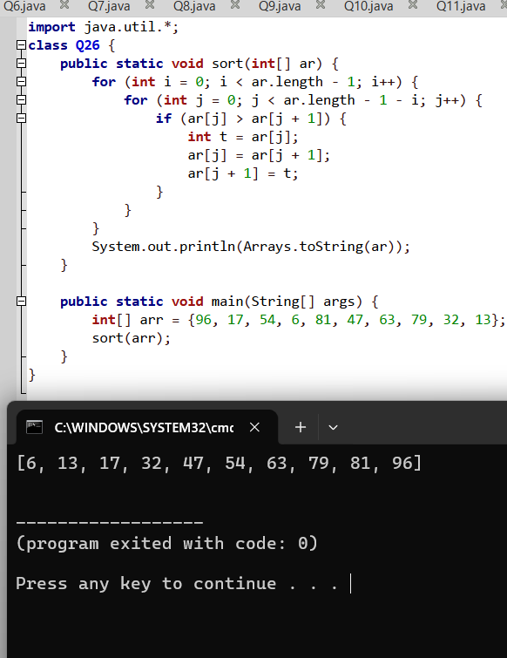

Q27.
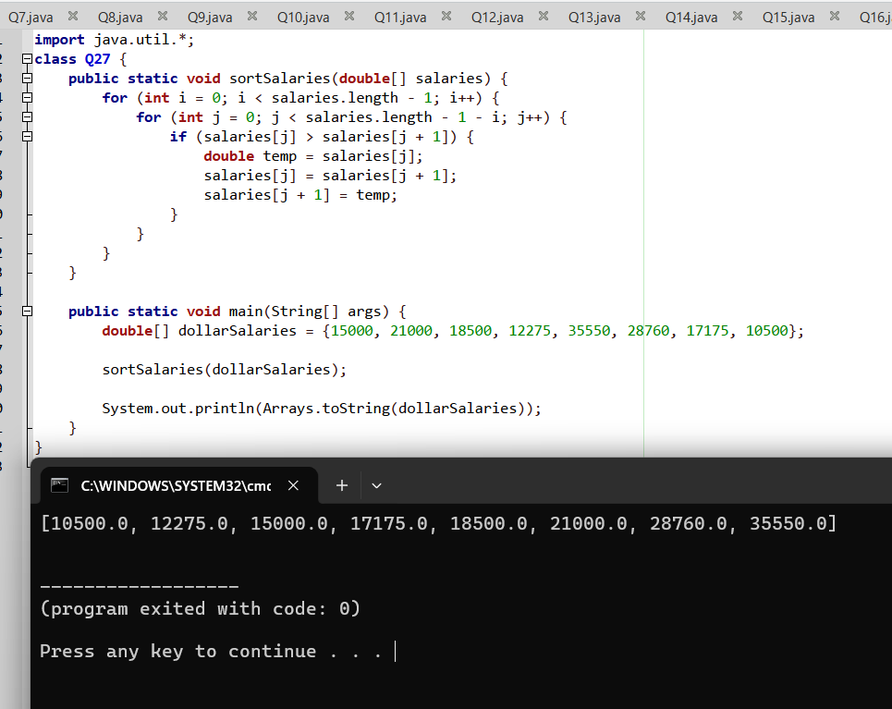

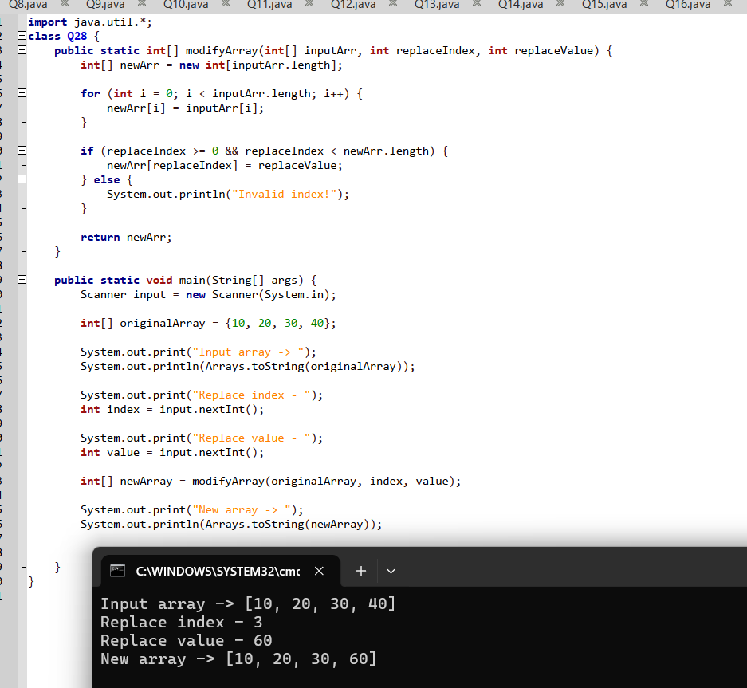
Q28.

Q29.
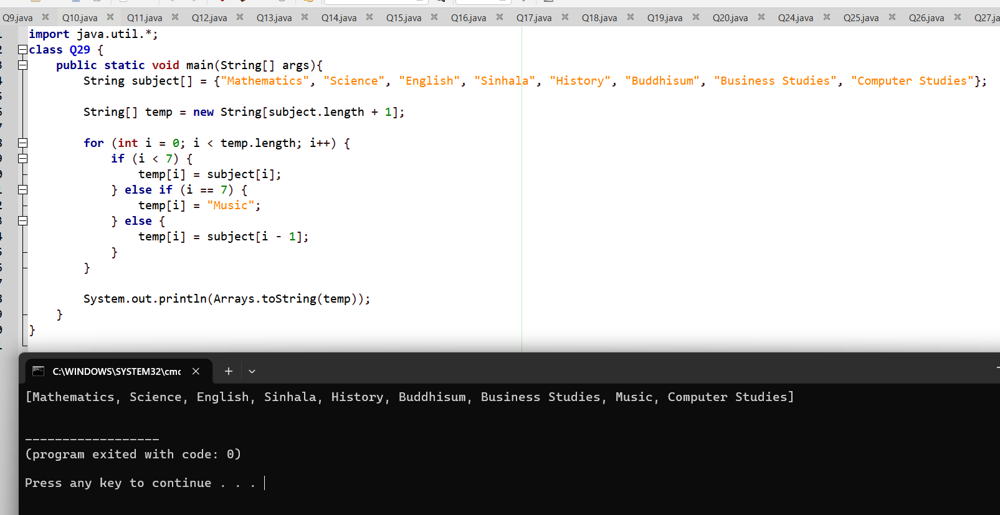

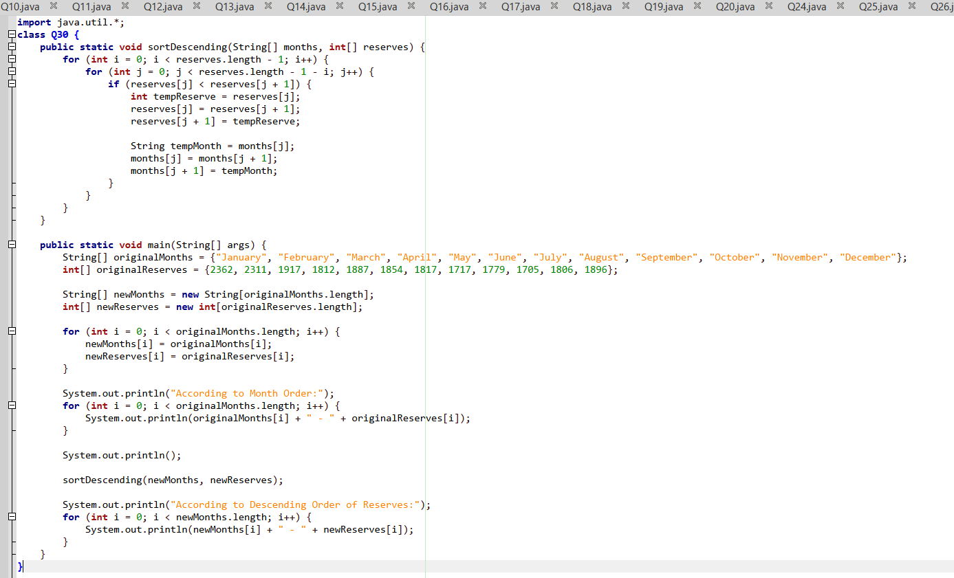
Q30.

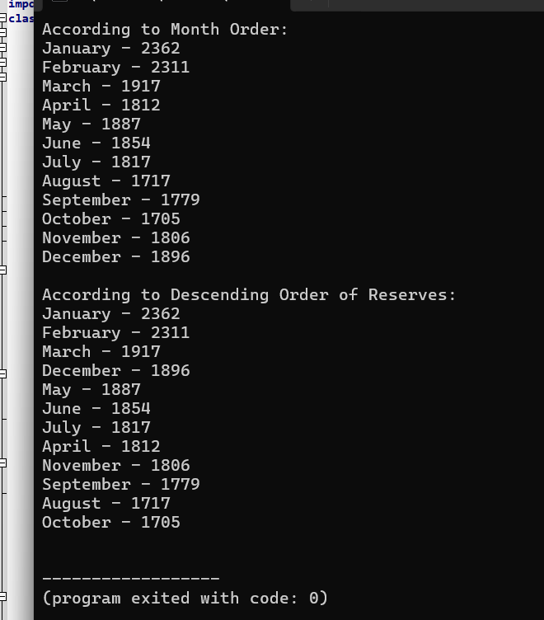

Q31.
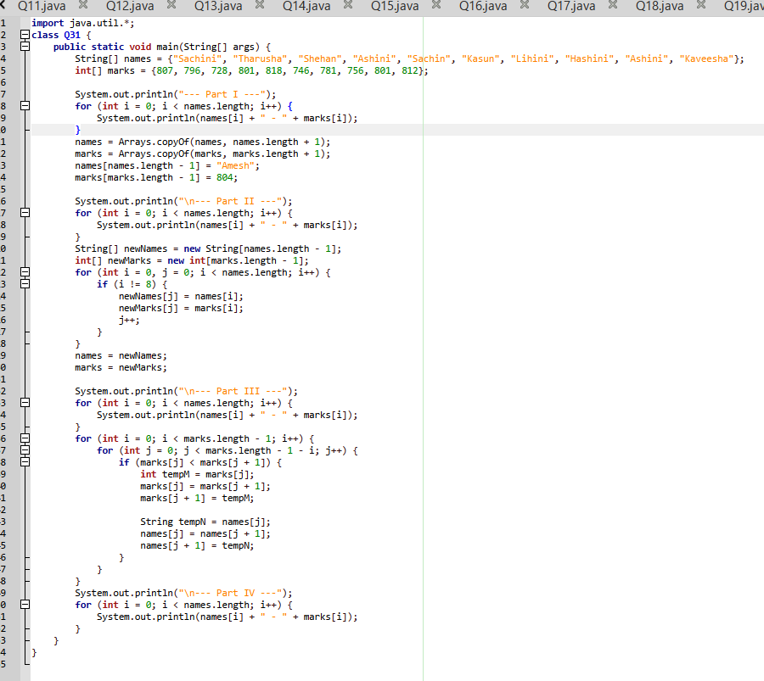

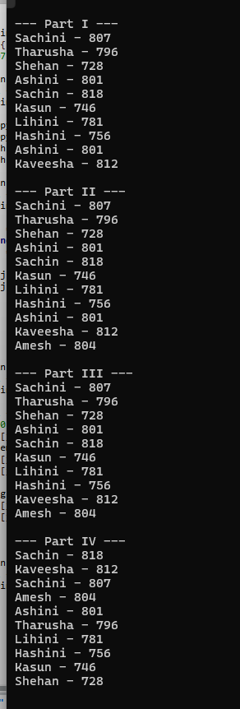

Q32.
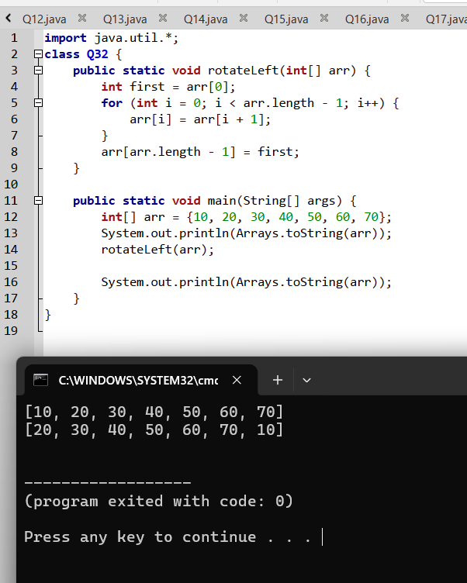

Q33.
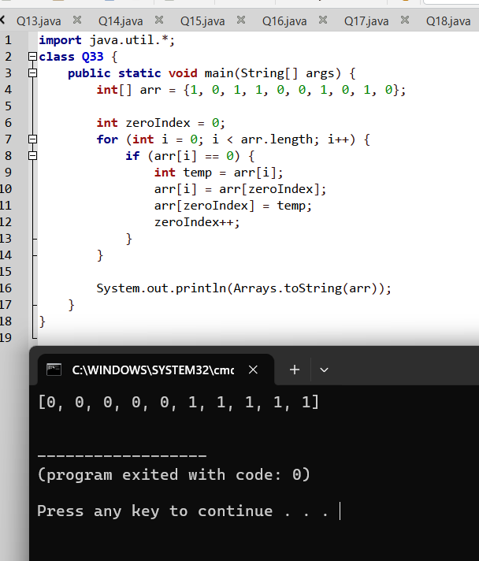

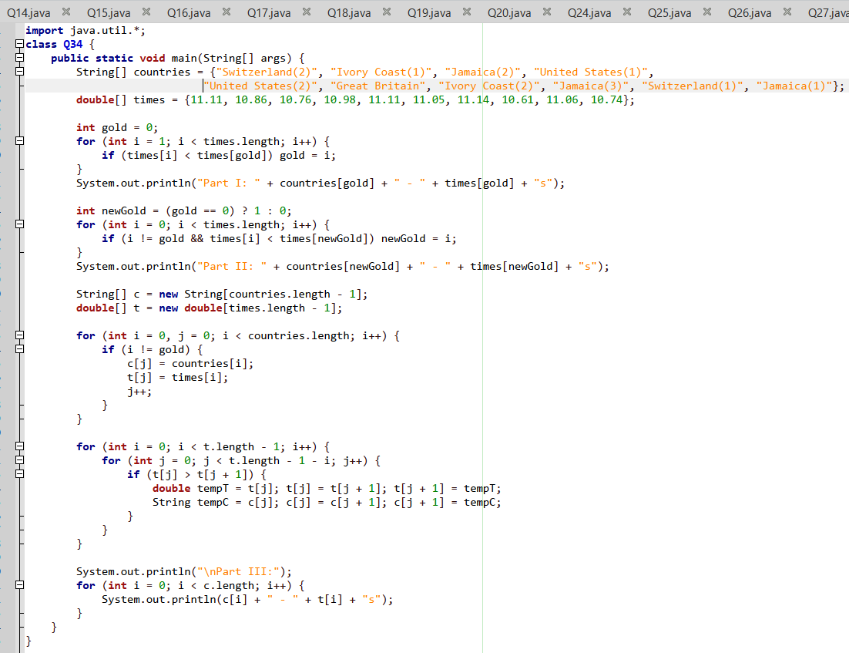
Q34.

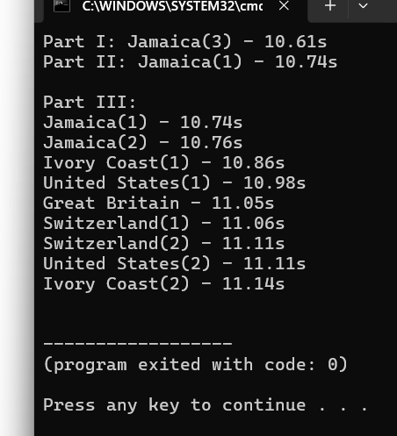

Q35.
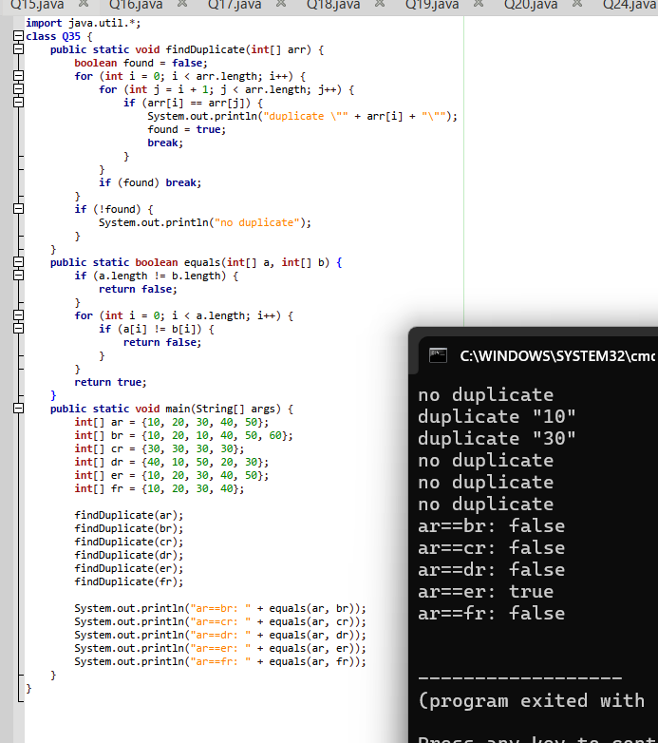

Q36.
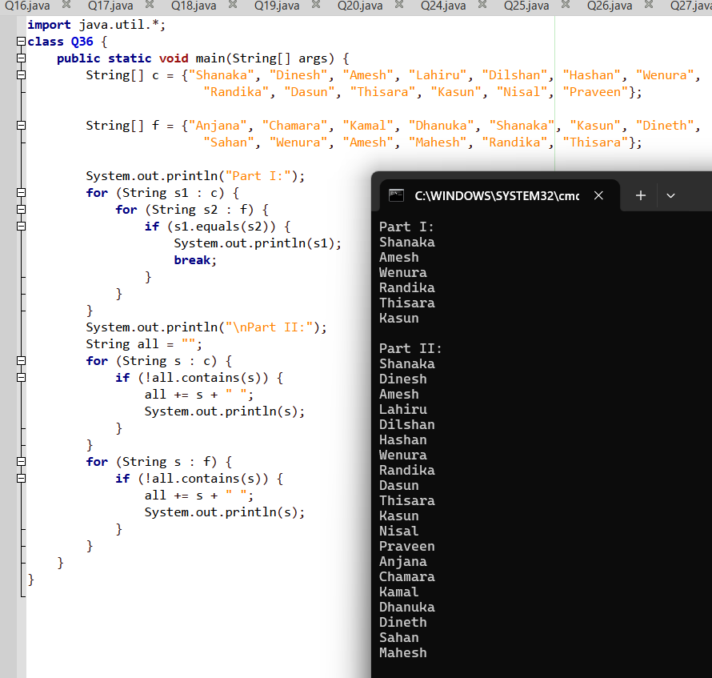

Q37.
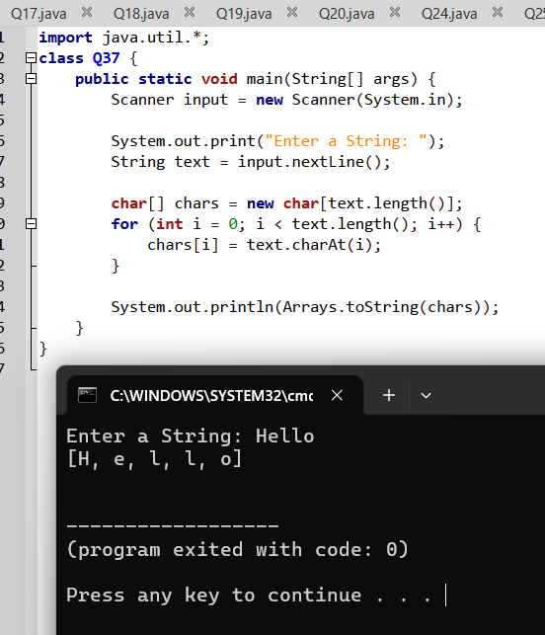

Q38.
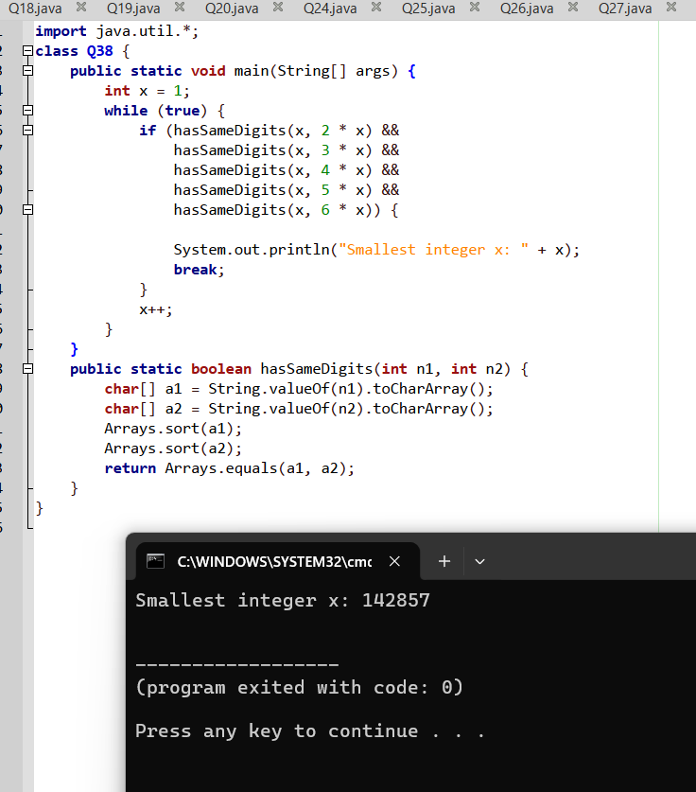

Q39.
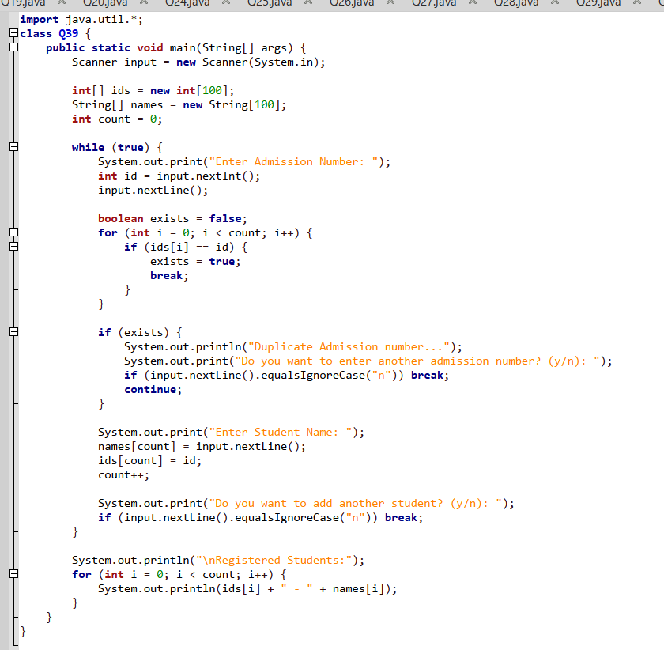

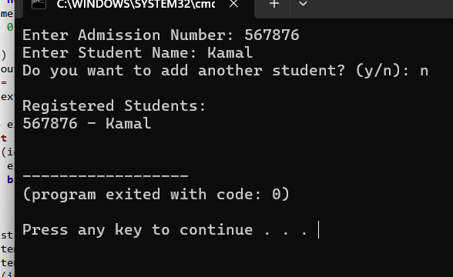
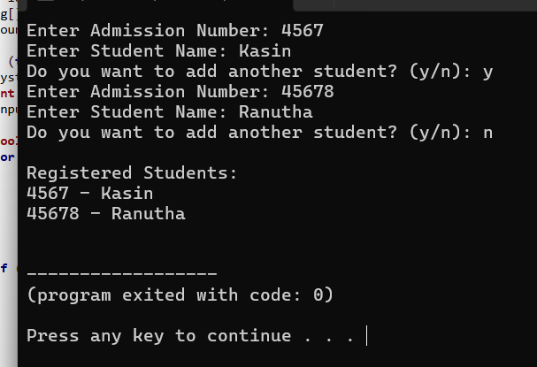

Q40.
