Design and testing of Truck Platooning System

Rushab Jahagirdar (7213829)
FB Informatik
FH Dortmund
Dortmund, Germany
rushab.jahagirdar001@stud.fh-dortmund.de
Suhrut Rajendra Heroorkar (7213761) FB Informatik
FH Dortmund
Dortmund, Germany
suhrut.heroorkar001@stud.fh-dortmund.de
Shifana Rahiman Pattukulangara Mohamed (7213285) FB Informatik
FH Dortmund
Dortmund, Germany
shifana.pattukulangaramohamed003@stud.fh-dortmund.de
Arul Prasath Ramu (7213463)
FB Informatik
FH Dortmund
Dortmund, Germany
arul.ramu002@stud.fh-dortmund.de

Abstract—This document provides the introduction about working of truck platooning system, TPS. The platoon is string formation of trucks where the lead truck is driven by driver and the trailing vehicle follow it. The trail vehicle is assisted using control functions in the lead vehicle. Platooning of vehicle is the need of the hour which helps in the environmental protection where fuel consumption and release of greenhouse gas can be reduced due to its structure. The system is designed and realized using different SysML techniques. Working of one part of the system is demonstrated with timing analysis of the tasks using SimSo tool.
Keywords—TPS: Truck Platooning System, LV: Leading vehicle, TV: Trailing vehicle, PMS: Platoon monitoring station, DAS: Driver assistance system, OBD: On board diagnostics

Introduction
As the dependence between the countries is increasing this is leading to increase in the transportation. The necessary infrastructure is limited and the effects on the environment due to usage of the fuel and emission of greenhouse gas are the bottle necks in this direction. To overcome these constraints, industry is working on “vehicle platooning” concept since long time. Platooning is a concept where two or more trucks are being driven in a single lane with close distance between them. Truck platooning is the use of networking technology and automated driving support systems to join two or more vehicles in a convoy. When these cars are connected for particular stages of a journey, such as on highways, they automatically maintain a predefined, close distance between them.
Platooning, also known as flocking, is a method of transport that involves driving a group of vehicles together. The lead vehicle is driven by a human and the following vehicles are self-driven which are controlled by the functions provided from the lead vehicle. Platoons use electronic and perhaps mechanical linkage to reduce the distance between automobiles or trucks. Truck platooning tries to establish a platoon of trucks along motorway corridors to conserve fuel and boost traffic capacity, however long platoons can cause problems near merges, where cars from the freeway entrance must perform obligatory lane changes.
For platooning to work in the real world, an active platooning strategy that deals with the merging of conventional vehicles is required. When approaching merging zones, the study suggests a novel way to split platoon. The proposed technique intends to provide conventional vehicles with safe and comfortable merging maneuvers while increasing the efficiency of the truck platoon. This is accomplished by determining the truck's position and time in the platoon, with the goal of creating a large gap for merging vehicles.
This provides advantages such as reduction in the fuel consumption due to fact that the close gap between vehicle reduces the air drag acting upon vehicle (Hucho and Ahmed, 1998). Apart from this this provides road safety as the vehicles are controlled by the control function whose reaction time is much faster than that of humans.
In this project, TPS is designed and a part of system is implemented and validated. The designing is done using the SysML modelling technique and implementation is done using tinkerCad simulation environment

Requirement specification (Author: Suhrut Rajendra Heroorkar)

Overview of requirement of the system
Requirement is split into following
- ACTIVATION REQUIREMENT
- COMMUNICATION ESTABLISHMENT
- SENDING INITIAL INFORMATION
- PLATOON START
- PLATOON FEEDBACK SIGNALS
- TRAILING VEHICLE INTRUSION DETECTION
- LOSS OF COMMUNICATION

Activation requirement
The functionality must be activated only after button in leading vehicle and trailing vehicles is pressed. Platooning activation must be indicated to driver. Driver has a provision to start the platooning in the lead vehicle using a button interface provided. Once the button is pressed, the information about activation of platoon in the lead vehicle will be indicated to the driver via the dash board display of the truck.
In order to activate platooning in the trailing vehicle, the dash board display provides information to driver about the available trucks. Driver selects the truck using the dash board interface and the press remote activation button to activate platooning in the trailing vehicle. The radio communication is used to send the activation code to the radio transceiver of the trailing vehicle which activates the platooning. Feedback about the activation is provided back to driver in lead vehicle on the dash board display via the feedback signal from trailing vehicle.

Communication establishment
Communication is established between,
- The lead vehicle and the platoon monitoring station
- Lead vehicle and trailing vehicle.
Communication between lead truck and platooning monitor station is established using the GSM module.
Communication between the lead truck and the trailing truck is established via Wi-Fi network. The communication between the truck should be established within calTvTvInitComm duration.

Sending initial information
Send the information of the platooning to the nearest platoon monitoring station. Trailing vehicle should send the information to leading vehicle. Then leading vehicle should send its information and platooning vehicle information to platoon monitoring station.
- Information can be about vehicle which is necessary for platoon monitoring station to track.
- Information can be related to vehicle state which is necessary to make decision in the platooning system.
Information between the trailing truck and lead truck can be about:
- Vehicle number
    - OBD information
    - Gas level
    - Tire pressure
    - Engine status
    - Brake information
    - Exhaust information
    - Continuously send position information
Information between leading truck and monitoring station can be information about the leading truck and the trailing truck involved in platooning.

Platoon start
Leading vehicle control the trailing vehicle by providing following data,
Vehicle control information
- Cranking signal
- Transmission position
- Acceleration
- Steering
- Braking
- Wheel speed

Platoon feedback signals
Leading vehicle must receive following signals from the trailing truck
- Cranking signal
- Transmission position
- Acceleration
- Steering
- Braking
- Engine torque
- Wheel speed
- Distance between trucks
- DAS function states
- OBD information
Distance between the trucks should be maintained at predefined position calibrated in “distanceBetween” during start of platooning. Maximum dsitanceMax and minimum distanceMin distance between the truck is calibrated which is done based on the signal strength and ease of communication between the trucks.

Trailing vehicle intrusion detection
Trailing vehicle and vehicleDetected flag to leading vehicle when it identifies a vehicle in its vicinity and would increase the gap between the truck to accommodate the vehicle.
Ultrasonic sensor detects the vehicle in the vicinity, along with the camera, the length of the vehicle is calculated. Based on the length calculated, deltaGap is calculated which is the additional gap the vehicle will add between the truck. deltaGap is calculated based on the criticalDistance, distanceMax and minimum gap requirement between the truck.
If the difference between the length of the intruder vehicle and the deltaGap is negative, then blinkingLight will be in GREEN state and the information is passed to leading vehicle that gap will be increased and the same will be done.
If the difference is positive, then the vehicle will not be accommodated and thus the gap will remain as it is and the RED lamp will blink indicating the intrusion vehicle that it cannot be accommodated.
Once the vehicle moves away from the vicinity of the truck, after certain duration resetintrusionTime, the gap will be reset to the default value and light will stop blinking.

Loss of communication
Leading vehicle must monitor the parameter of the trailing vehicle and check if the values are withing the safe working threshold. If the parameter of below the threshold, then a correction signal value is sent out to that truck to adapt to it.
If the distanceBetween value of a truck is equal to or greater than criticalDistance, then this indicate a possible loss of communication between the truck, the value of criticalDistance must be at close proximity to distanceMax. In this case, leading vehicle will monitor the parameter and indicate to driver via the dash board display about the reason for vehicle drifting away from platoon radius, the reduction in the speed can be because of intruder vehicle, decrease in torque or issue in the sensors. In this condition, the lead vehicle will send updated parameter value to trailing truck so that it adapts to it and brings the distanceBetween to desired value.
If the platooning is active and there is a complete communication loss, then after lossCommReconnect time and flag lostCommunication is raised in the leading vehicle indicating a loss in communication. This will indicate the driver to try re-establish the connection. If after numberOfReconnectAttempt, the communication is not established, then the communication loss will be confirmed and the same information will be passed on to PMS.
If the trailing truck, loose the communication to leading vehicle after lostPlatoonCommunication time, then a flag lostPlatoonCommunicationFlag will be raised. This flag would activate the search of the nearest side way track based on the current GPS co-ordinates. The target will be set to that and the trailing vehicle would drive and position itself there. The vehicle should be driven in a limp home mode

Requirement model

Fig: 1 Requirement model

Activation
Fig: 2 Activation model

Connection establishment
Fig: 3 Connection model

Sending initial information
Fig: 4 Connection model

Platoon start
Fig: 5 Connection model

Platoon feedback
Fig: 6 Platoon feedback model

Trailing vehicle intrusion detection
Fig: 7 Trailing vehicle model

Loss of communication
Fig: 8 Loss of communication model

Use case(Author: Suhrut Rajendra Heroorkar)

A vehicle is detected in the vicinity of the truck
- Ultrasonic sensors are installed on the truck that detect object in the vicinity.
- Trailing vehicle via sensor detect the vehicle in the vicinity and raise a vehicleDetected flag
- Send the vehicleDetected and blinkingLight flag to the lead vehicle indicating that vehicle is detected and the gap between the vehicle will be modified
- Trailing vehicle must check if the vehicle can be accommodated in between
    - If the vehicle cannot be accommodated then RED light must blink indicating vehicle to move away.
    - If the vehicle can be accommodated then GREEN light must blink and increase the gap between the truck by deltaGap value.
- The gap should be withing maximum possible gap criticalDistance between the truck in order to be in the platoon radius
- Once the vehicle increases the gap, it should be maintained until the vehicle detected flag is reset
- Once the vehicle detected flag is reset, the trailing vehicle must reduce the gap and bring to default distance value after resetintrusionTime

Communication between leading truck and trailing truck is lost
- If the communication between the leading truck and trailing truck is lost, then after lostCommReconnect time, lostCommunication flag for that particular truck must be raised.
- Information should be provided to the driver to try for reconnection
- If after numberOfReconnectAttempt, the communication was not established then communication lost is confirmed and same information is sent to PMS.
- The leading vehicle must send the information to PMS along with last available information about it such as location, speed, fuel, acceleration, nearest side way track position which is based on GPS co-ordinate
- In trailing vehicle, if the communication is not established after lostPlatoonCommunication, then trailing vehicle should raise lostPlatoonCommunicationFlag and look out for the nearest side way track and should enter into limp home mode and drive and position itself in the target location
(Co-ordinate of the side way track should be fed into system)

If the speed of the truck is less than the requested value of the leading truck
- Leading vehicle should send acceleration, its speed and brake information to trailing vehicle
- Trailing vehicle should adopt to the value sent by leading vehicle and return back the same information to leading vehicle. It should also send the information if any vehicle is detected or any obstruction.
- In leading vehicle, the difference in the value requested and obtained is done and compared if it is greater than a threshold.
- If the difference is greater than threshold and no obstruction is detected, then leading vehicle should send a signal to increase the speed by giving more acceleration, i.e. the reduction is speed in trailing vehicle can be due to some internal process, may be DPF regeneration or increase in the accessory usage etc., in this case trailing vehicle must raise a flag to leading vehicle, based on these two flags (No vehicle and internal process) leading vehicle should provide offset acceleration value until the flags are reset
- Trailing vehicle, on reception of the increase acceleration signal, should monitor again the vehicle or object detection and gap between the truck should be greater than the minimum distance requirement and then it must adopt to the leading vehicle acceleration value.

Block diagram(Author: Suhrut Rajendra Heroorkar)

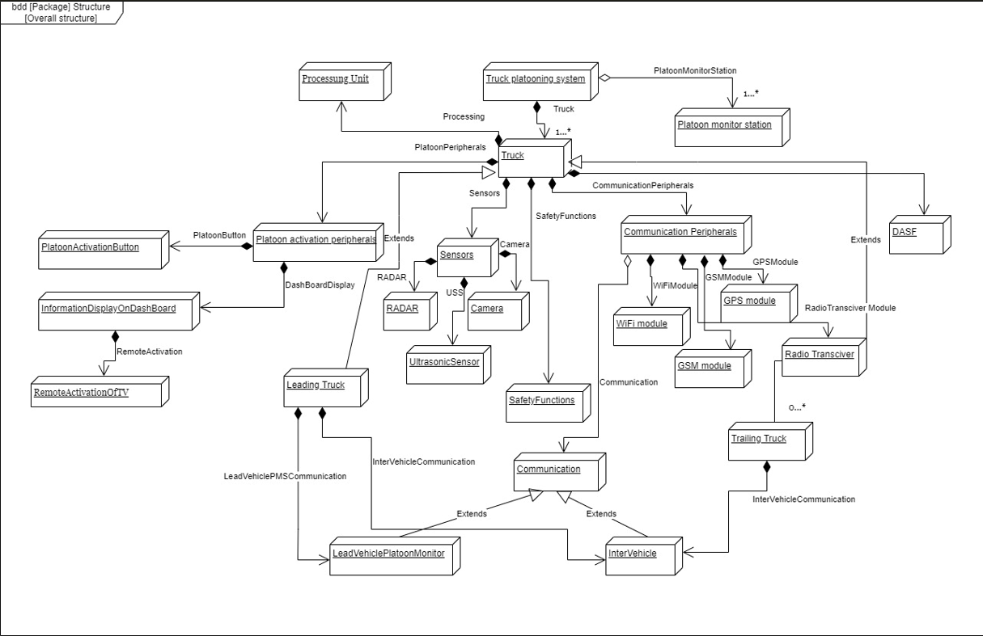
Fig: 9 TPS block diagram
Fig 9 illustrates the block diagram o the truck platooning system.
Truck platooning system consists of Truck blocks.
Truck block is a composite block consisting of following blocks
- Platoon activate peripherals
- Sensors
- Communication peripherals
- DASF (Driver assistance functions)
- Safety functions
- Processing unit
Further Truck block has Leading Truck and Trailing Truck, with a generalization relation.
Communication block which has an aggregation relation with the communication peripherals has two kinds of communication
- LeadVehiclePMS
- InterVehicle.
Platoon activate peripherals is in itself a composite block consisting of
- PlatoonActivateButton: This performs the function of getting platoon activation by driver in lead truck
- InformationDisplayOnDashBoard: This performs the function of displaying the activation information to driver.
- This block has another block RemoteActivationOfTV which performs the functionality to activate platooning in the trailing vehicle.
Sensors block consists of sensor units such as
- RADAR: This is used to measure the distance between the objects using the radio waves
- Camera: This captures the surrounding information about the vehicle which is necessary to detect the objects in the vicinity of the vehicle
- Ultrasonic Sensor: this is used to detect the objects in the close vicinity of the vehicle.
Communication peripherals are subdivided into,
- Wi-Fi Module: This module is used to establish the communication between the leading truck and the trailing truck.
- GPS Module: This module is used to obtain the location of the vehicle which is necessary for tracking
- Radio transceiver: This module is used to transmit and receive the radio signals, especially used in the remote activation of platoon.
- GSM module: this module is used to establish the communication between the lead vehicle and the platoon monitoring station.
Communication module has two communications, in the InterVehicle communication, it uses the communication peripherals i.e., Wi-Fi to establish the communication between the vehicle. LeadVehiclePMS module use the communication peripheral GSM module to establish the communication between the lead vehicle and the PMS.
Processing unit is utilized that performs the necessary manipulation on the data obtained.

internal block diagram (Author: Shifana rahiman pattukulangara mohamed)

LEAD TRUCK
Lead Truck is the most important part of the truck platooning system. It has a driver and controls the entire platooning of the trucks. It is connected to the platooning station as well.
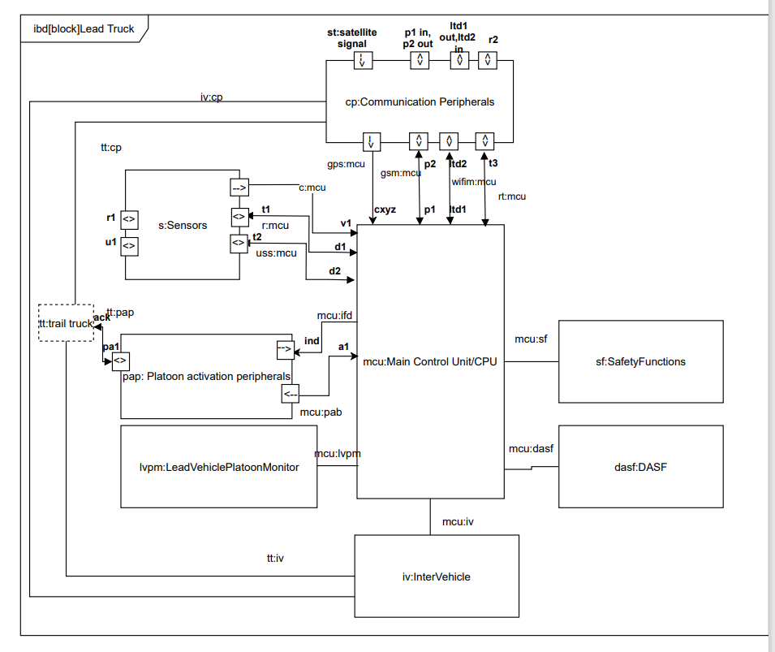
Fig 10: Lead Truck internal block diagram
As shown in Fig 10, the lead truck necessarily contains a sensor block, communication peripherals block cp, platoon activation peripherals block pap, main control unit MCU, safety functions. Driver assistance system, lead vehicle platoon monitor.
The sensor module is used for detecting obstacles and vehicles in vicinity, to calculate their distance and speed as well. This information is passed on to the main control unit for processing and transmitting it to other components for executing the required functionalities like platoon activation, adaptive cruise control, establishment of communication between trucks, detection of obstacles and actions while communication failure occurs.
Lead truck is manually driven but has necessary driver assistance functions. Lead truck is responsible for activating platooning and initiating command signals to the communicate the same with trail trucks and platooning station.
It has radar, ultrasonic sensor that transmits and receives radio signals r1, r2, ultrasonic sound signal u1 respectively through antennas. It has also a camera mounted to it which captures video and send the video signal to the MCU.
Signals:
r1: radio wave radar
u1: ultrasonic sound
t1: timing/control command MCU
t2: timing/control command MCU
v1: video signal
d1: distance output from radar to MCU
d2: distance output from USS to MCU
st: satellite signal
p1/p2: pms truck data (in/out)
ltd1/ltd2:lead truck-trail truck data communication signal(in/out)
r2: radio wave (communication module – radio transceiver)

TRAIL TRUCK
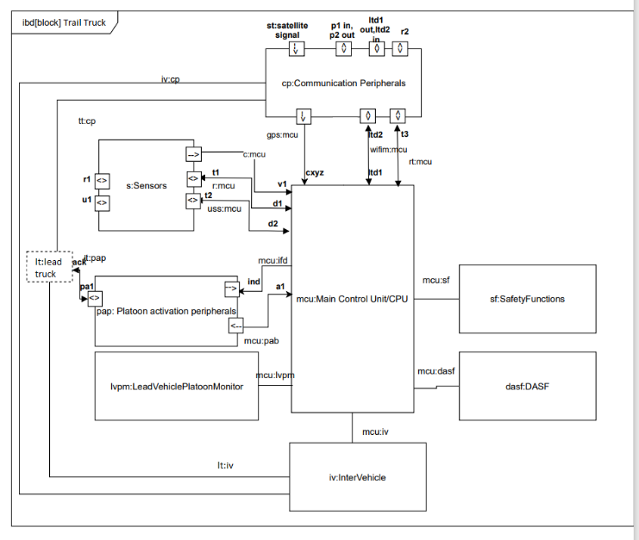
Fig11: Internal block diagram of trail truck
Trail truck is included into platoon, on platoon activation by the driver of the lead truck. It then follows the lead truck at a safe distance within the platoon radius, follows the acceleration, speed, direction of the lead truck automatically. It has no driver and is automatically driven on the signals transferred from the lead truck. It has necessarily all the parts seen inside a lead truck except the GSM module.
The intervehicle communication is established with the help of Wi-Fi Routers and radio transceivers mounted on it. A GPS module is mounted for getting current location coordinates. Radar, camera and ultrasonic sensor mounted in front for obstacle detection as well as for maintaining safe distance from the lead truck.

SENSOR
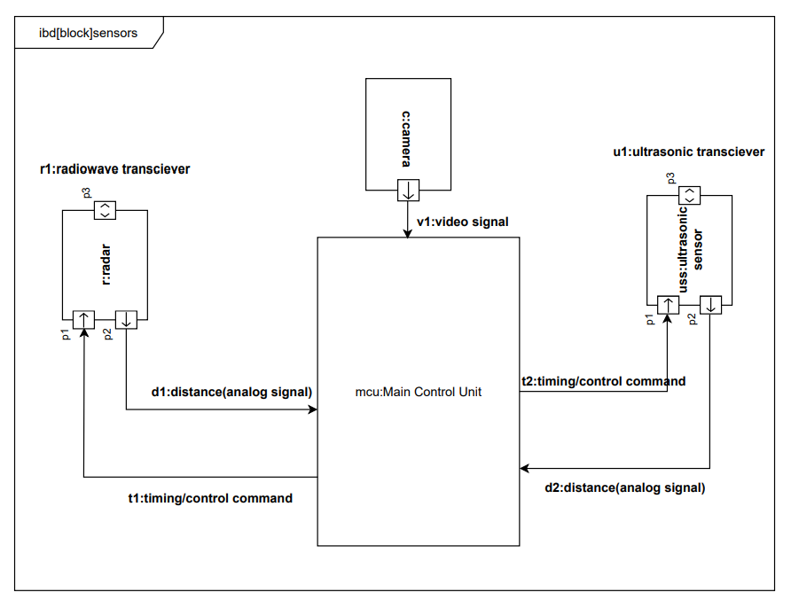
Fig 12: Sensor internal block diagram
The sensor module is the most integral part of a truck platooning system. It has a radar unit for detecting obstacles as well as measuring the distance between the trucks, an ultrasonic sensor which serves the same purpose of detecting obstacles and measuring distance, as well as a camera.
Radar has antennas which act as radio wave transceiver. It emits radio wave generated by a waveform generator which is controlled by the timing and control commands of the main control unit. The transmitted radio wave hits the target/obstacle and rebounds. The returned wave/signal is detected by the receiver in the radar. Time taken for the process corresponds to the distance travelled by the wave, which further corresponds to the distance from/to the obstacle/truck/other vehicle in vicinity. It also helps in detecting the speed of the obstacle/vehicle in vicinity.
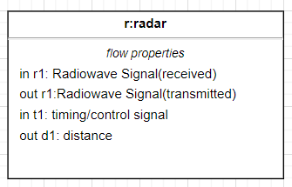
Fig13: flow properties of radar
Fig 13 shows the flow properties of radar. R1 is the transmitted/received radio wave. The antenna is shown as an in&out port. T1 is the timing/control signal received from the Main Control Unit and d1 is the output corresponding to the location and speed of the vehicle/obstacle which is further fed to the MCU for processing.
Ultrasonic sensor USS also works on a similar principle. It emits the ultrasonic sound waves via antenna. This hits the target and rebounds, the time required for which is recorded and thus the speed and location of the obstacle/vehicle is detected.
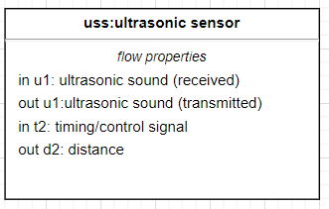
Fig 14: flow properties of ultrasonic sensor
Fig 14 shows the flow properties of ultrasonic sensor. u1 is the transmitted/received ultrasonic sound. The antenna is shown as an in out port. T2 is the timing/control signal received from the Main Control Unit and d2 is the output corresponding to the location and speed of the vehicle/obstacle which is further fed to the MCU for processing.
The sensor module also consists of a camera which capture video in front of the truck and sends it to the MCU for driver assistance systems and platoon monitoring and control.

COMMUNICATION PERIPHERALS
The communication peripherals help in establishing communication between the trucks as well as between the lead truck and the platooning station. This communication is established with the help of Wi-Fi module and GSM module. A GPS module is included in every truck as part of the communication peripherals to get the location coordinates of the truck. A GSM Module is specific to the lead truck alone and is used for establishing communication with the platooning station. Intervehicle communication is established through sending and receiving signals through Wi-Fi router in each truck.
A GPS receiver communicates with satellite via signal st which gets the location of the truck. This is then passed onto the Main Control Unit via a data signal with the x,y and z coordinates of the current position of the truck. This information along with other necessary information including the speed, acceleration etc of the truck is sent to the platoon station for controlling platoon of trucks.
A GSM module helps in sending information from lead truck to platoon station. The information includes location, speed, acceleration, coupling status, and communication status of all trucks including the lead truck. This system comes into use especially in situations where a communication failure occurs, and the decoupled trail truck has to be side-lined to a safe aisle or for safe reestablishment of communication between lead and trail trucks.
A Wi-Fi module receives control signal from MCU which are necessarily the updated and stored data regarding status of each vehicle along with position, speed, distance, acceleration etc which are relevant for platooning. The Wi-Fi module along with Wi-Fi router and a radio transceiver are responsible for sending such data required for platoon activation, safe platooning and continuous communication between the trucks. The signals for this purpose are transmitted and received as radio signals, are detected by the antennas on every truck, decoded with the help of MCU to serve the purpose.
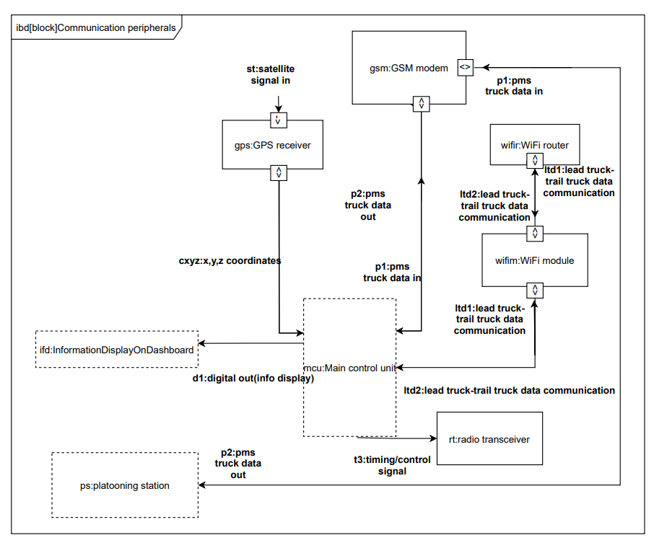

Fig 15: internal block diagram of communication peripherals module
Cxyz is the signal corresponding to the coordinates of the truck sent from GPS module to the MCU.p1,p2 are the truck data in and out transmitted between the GSM module and MCU. The same signals are transmitted between the truck and platoon station as depicted in the figure.
Ltd1 and ltd2 are the communication signals transmitted between lead truck and trail truck via Wi-Fi router.
D1 is the digital input required for displaying the required truck and platooning information on the display dashboard of the truck.

PLATOON ACTIVATION PERIPHERALS
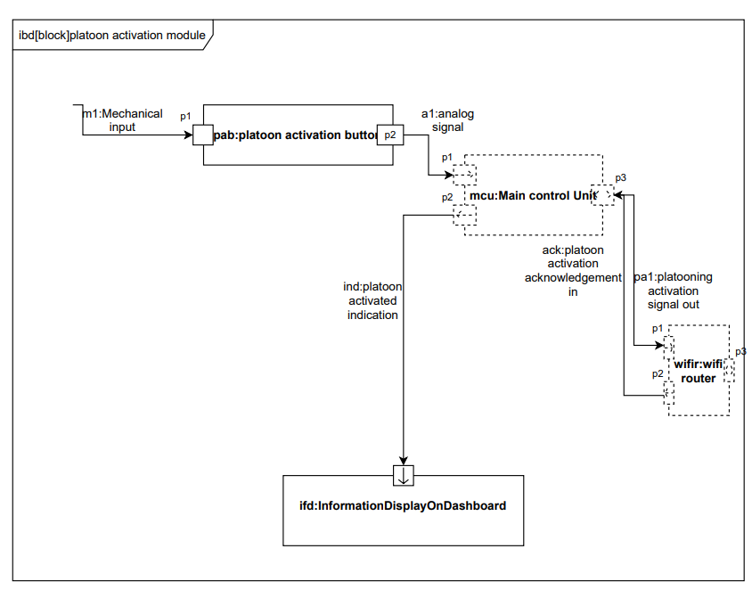
Fig 16: Internal block diagram of platoon activation peripherals
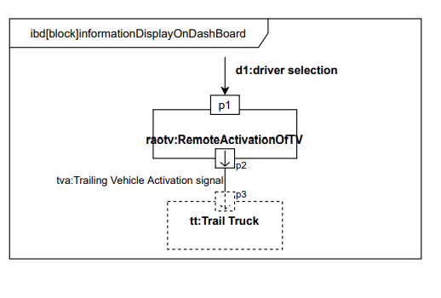
Fig 17: Internal block diagram of Dashboard Display

The Platoon Activation module is responsible for coupling or decoupling of lead and trail vehicles, that is for activating and deactivating the platooning.
It has a platoon activation button directly connected to the Main Control Unit which is further connected to the Information display on dashboard.
Signal M1 which is a mechanical input from the driver of the lead vehicle provides a corresponding analog input to the MCU indicating command for platoon activation.
MCU sends signal in to display necessary information on dashboard display of the lead truck from which the driver can select options out of trail vehicles within the platoon radius and give command for activation of the same.
By selecting the required trail trucks in the display, MCU sends platoon activation signal pa1 to the respective trail trucks via Wi-Fi module. On remote activation of the trail truck, an acknowledgement is sent back to the MCU via Wi-Fi module indicating platooning is activated which is further displayed on the dashboard display.

Activity diagram(Author: Rushab Dinesh jahagirdar)
Activity diagrams are a visual representation of a process or set of processes. Activity diagrams are a powerful tool for showing a set of actions that describe the behaviour of a block or other structural element. Flow of logic is defined via control flow and flow of object is defined by object flow. Activity diagrams are a means of representation in the Unified Modelling Language (UML) used to describe temporal processes in a system. It belongs to the so-called operation diagram group, along with use case diagrams and state diagrams. Individual aspects of the system and run-time changes are visualized in the action diagram.
Activity diagrams are used to model processes such as business processes, workflows, use cases, or processes that occur in algorithms. This allows you to clearly see complex processes, including variants, parallel processes, or iterations. It is easier to understand than textual explanations, which are usually written in natural language.
Taking the use cases into consideration 3 activity diagrams were drawn to show the behaviour of the platoon system.

External vehicle detected in the vicinity
This activity diagram shows the behaviour of the Lead truck and Trail truck when there is intervention of an external vehicle in the vicinity. The truck should detect the external vehicle and it should be able to decide if it can accommodate it and open gap to allow the external vehicle to occupy the space between.
Ultrasonic sensors are installed on the truck that detects objects in the vicinity. Trailing vehicle via sensor detects the vehicle and validates whether accommodation is possible between them. If yes, a green light is blinked indicating that the external vehicle can accommodate between them. If not, a red light should blink indicating accommodation is not possible. Seeing the green light, the trailing vehicle should slow down the speed and continuously monitor the distance between trailing truck and follow truck. By any chance if the distance between trail truck and follow truck is larger than the default calibrated value the trail vehicle should attempt to increase the speed. During this activity if the trail vehicle loses communication with the follow vehicle a counter is set, this helps to reconnect. This reconnection attempt happens 3 times, failure to connect the trailing truck should move to nearest platoon platform in limp home mode. This use case is modelled using sysML activity diagram [Refer Fig. 18].
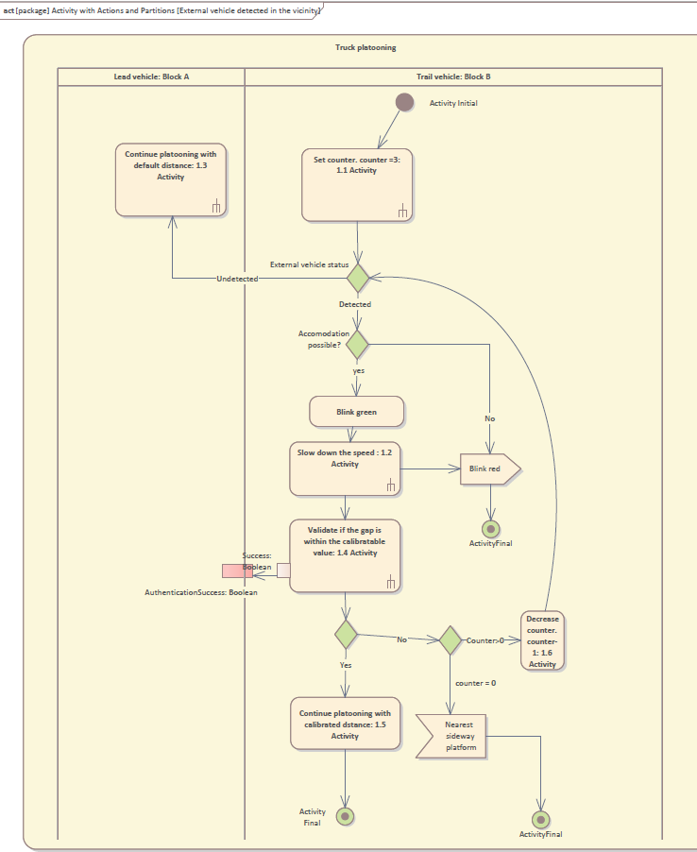
Fig 18: Activity diagram of use case “External vehicle detected in the vicinity”.

Communication between the leading truck and the trailing truck is lost –
If the communication between the vehicle in front and the trailing truck is lost, then the lost flag for that truck should be raised. If the driver can't connect with the machine after trying to reconnect, then details about the vehicle should be provided to the driver. The vehicle's owner should also send details about the vehicle, such as its GPS co-ordinates, fuel consumption, and speed. The vehicle that's trailing should also ask to be reconnected. If the communication between the two parties is not established, then the trailing vehicle should look for the nearest side way platform. The vehicle that's leading should also send details about its driving conditions to the nearest station. This is modelled using activity sysML diagram. [Refer Fig. 19].
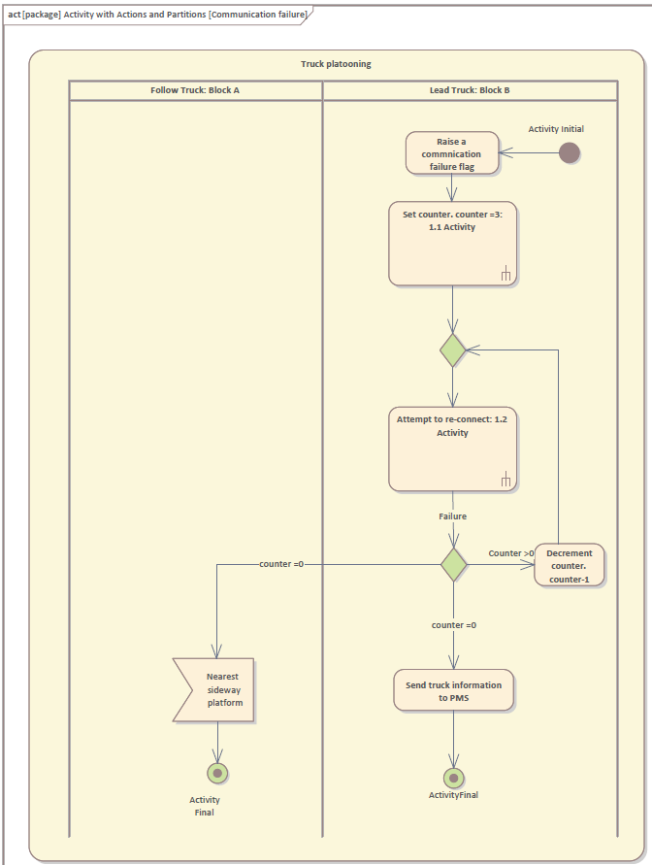
Fig 19: Activity diagram of Communication failure between lead truck and training truck.

Speed of the truck is less than the requested value of the leading truck –
Leading vehicle should send acceleration, its speed and brake information to trailing vehicle. Trailing vehicle should adopt to the value sent by leading vehicle and return the same information to leading vehicle. Trailing vehicle should validate if there is any external vehicle or obstruction because of which it can increase its speed and send the information to the leading truck.
Trailing vehicle, on reception of the increase acceleration signal, should monitor again the vehicle or object detection and gap between the truck should be greater than the minimum distance requirement and then it must adopt to the leading vehicle acceleration value. This use case is modelled using sysML activity diagram [Refer Fig. 20].
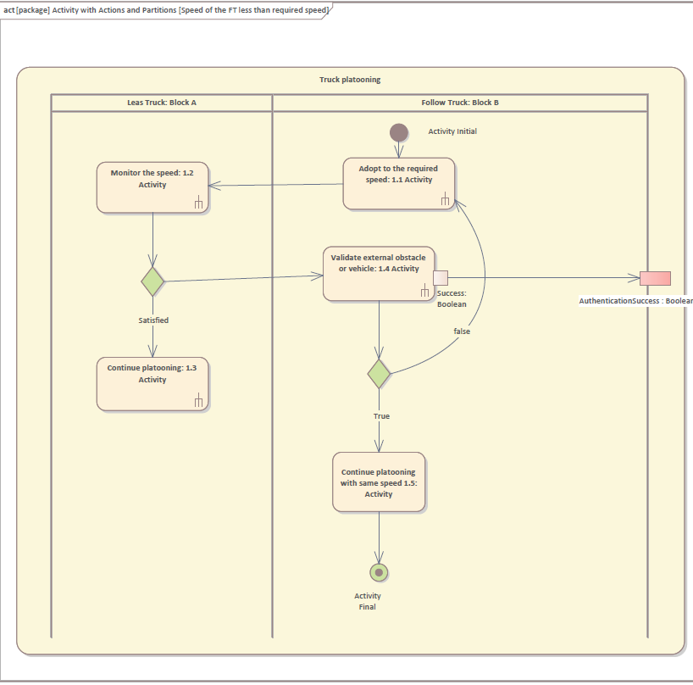
Fig 20: Activity diagram when the speed of the truck is less than the requested value of the leading truck.

Sequence diagram(Author: Arul prasath ramu)
A sequence diagram is a sort of interaction diagram that shows how a group of items interacts and in what order. Software engineers and business experts use these diagrams to understand the requirements for a new system or to describe an existing process.
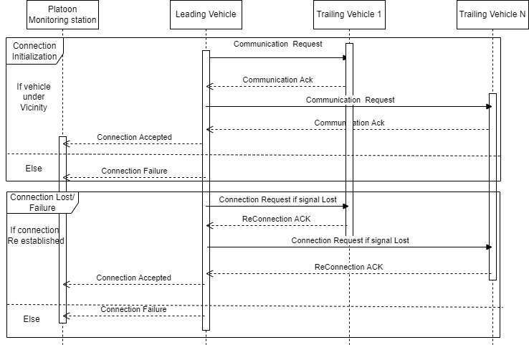
Fig 21: Communication
Fig 21 illustrates the communication sequence of lead and trail trucks. Whenever the connection was initialized. Lead truck tries to connect with trail trucks in nearby vicinity. If the trail trucks accepted the communication request means it will send an ACK to lead truck. Then, lead truck will send the communication accepted message to platooning station. If, the communication was unsuccessful means lead truck will report the communication failure message to platooning station. If the communication failure or lost issue occurs the lead truck will try re-establish the communication. If the connection was successful the above procedure will get repeated. Otherwise, lea truck will report it to platooning station.

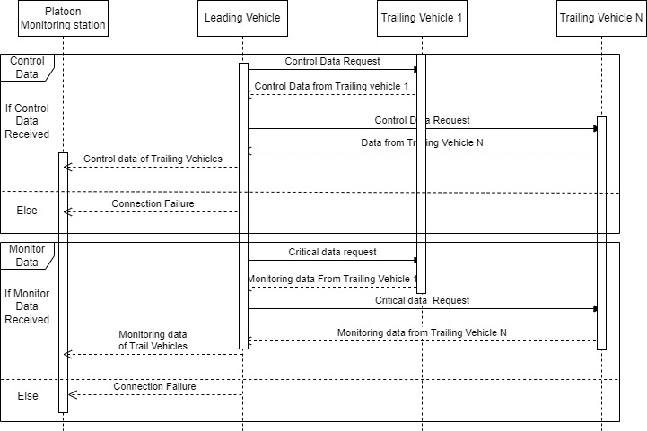
Fig 22: Data
Fig 22 demonstrates how the data transfer happening sequentially. Whenever the lead trucks raise a request for control data and monitor data the trail truck will send those parameters to lead truck in a defined time period. If the lead truck did not receive the parameters on defined time means it will raise a flag to platooning station on communication failure.

allocation diagram(Author: Suhrut Rajendra Heroorkar)

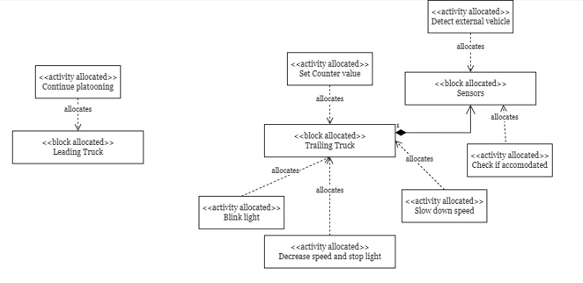
Fig 23 Allocation diagram for intruder detection by trailing vehicle
Fig 23 Indicates the allocation diagram for the trailing truck detecting the intruder vehicle in its vicinity. Leading truck block performs platooning. Trailing truck is allocated with following activities
- Set counter value
- Detect external vehicle via the Sensor block
- Check if the vehicle can be accommodated via Sensor block
- Blink light
- Increase speed and stop light.
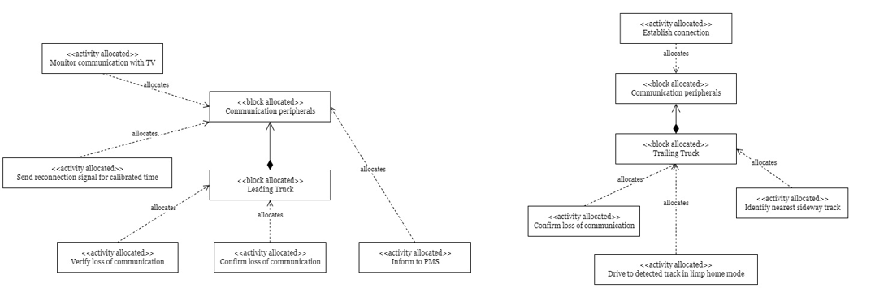
Fig 24 Indicate the allocation diagram for the loss of communication between leading and trailing vehicle

Fig 24 Indicates the allocation diagram for the loss of communication between the leading and trailing vehicle.
Leading truck performs following activities
- Monitor the communication with TV via its communication peripherals
- Send reconnection signal to trailing vehicle if communication is lost via communication peripherals
- Verify the loss of communication
- Confirm the loss of communication
- Inform to PMS via communication peripherals
Trailing vehicle performs following activities
- Establish communication to leading vehicle via the communication peripherals
- Confirm the loss of communication
- Identify the nearest side way track
- Drive to the detected track in limp home mode

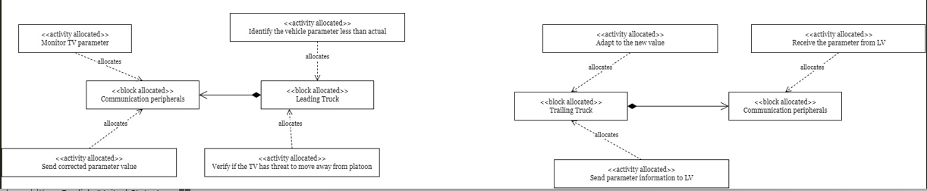
Fig 25 Allocation diagram for reduction in the speed of trailing vehicle
Fig 25 Indicates the allocation diagram for the reduction in the speed of TV and correction signal via LV.
Leading truck perform following activities
- Monitor trailing vehicle parameter via communication peripherals
- Send the correction parameter via communication peripherals
- Verify if the trailing vehicle is moving away from platoon radius
- Identify the vehicle parameter that is less than the actual
Trailing vehicle perform following activities
- Receive the parameters from the leading vehicle via the communication peripherals
- Adapt to the value sent by leading truck
- Send the parameter information to leading vehicle via the communication peripherals

State machine diagram (AUTHOR: RUSHAB DINESH JAHAGIRDAR)
A state machine is a behavioural model that represents a state transition through which a system passes in connection with an external event or trigger. A state machine (also known as an automaton) (finite or infinite) is a way to idealize or program an automated process. Machines are very simple and can only think and act in order. The model starts from the initial state and reaches the state with various results through transition logic and mathematics.
State machine diagrams are used to capture the dynamic aspects of the system. State machine diagrams is used to represent the platoon system behaves when there is an external trigger. Objects go through various states during their lifetime. The lifetime of the object lasts until the end of the program. Objects can be in several states, depending on the events that occur within the object. Each state represents some unique information about the object.
For the system under consideration the following state machine diagrams are modelled -

External vehicle in the vicinity (AUTHOR: RUSHAB DINESH JAHAGIRDAR)
A state machine is modelled considering the event when an external vehicle is in the vicinity. Nested states are a better way to implement this as there are 2 states viz. 1) No external vehicle 2) External vehicle. When an external vehicle is in the vicinity there are again many states involved. So, this state is considered as a sub-state as shown in Fig 9.1. This sub-state moves back to the main state when an external vehicle is moved out of the vicinity. This representation makes it easier to understand the transitions between states if you walk through the transitions to understand the behaviour of the owner element, or if you place the nested states in the same diagram, without clicking on the composite diagram.
When there is no external vehicle, the system should run with the default speed. When an external vehicle is detected the system transits into a sub-system called “external vehicle detected”. The initial state is to validate if the accommodation is possible. In that case, a green light will flash, indicating that an external vehicle can fit between them. If not, a red light should flash to indicate that adjustment is not possible. When the next vehicle sees a green light, it needs to slow down and continuously monitor the distance between the next trucks. If the distance between the follower trucks is greater than the present calibration value, the follower vehicle will randomly try to speed up. During this activity, if the following vehicle loses communication with the following vehicle, a counter will be set to assist in reconnecting. This reconnects attempt occurs three times. If subsequent tracks cannot connect, the trail truck needs to move to the next platform in limp home mode.
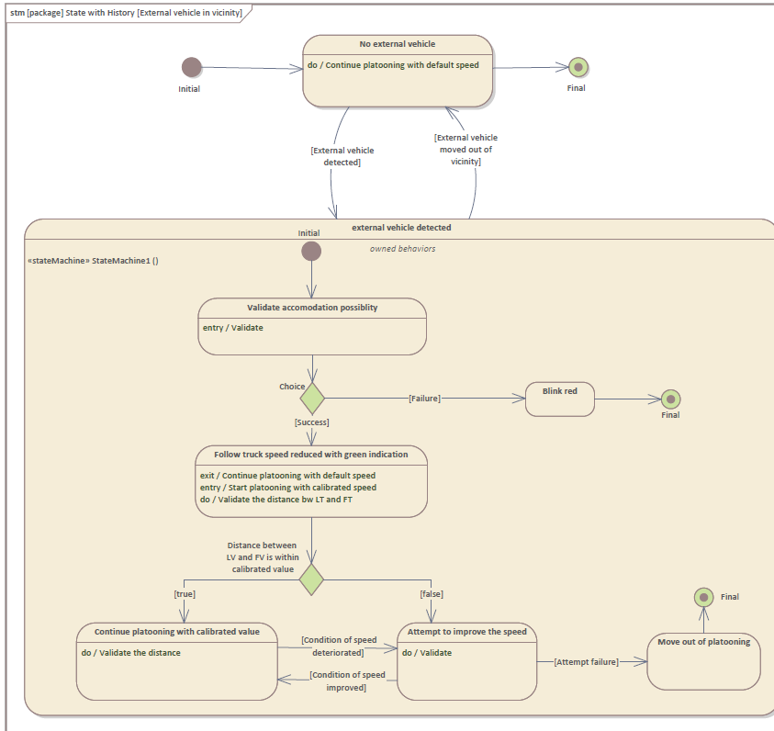
Fig 26 State machine diagram when an external vehicle is in the vicinity.

Communication failure(AUTHOR: RUSHAB DINESH JAHAGIRDAR)

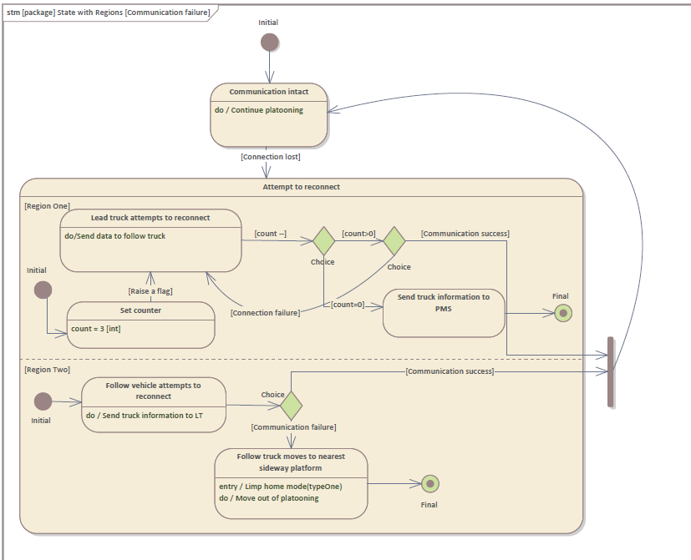
Fig 27 State machine diagram when there is a communication failure.
This state machine is modelled to show how the state transition takes place when there is a communication failure between the lead truck and follow the truck. In this modelling, the “state with region” state diagram is implemented. The Regions State pattern creates elements and diagrams that contain orthogonal composite states, each containing two regions with multiple substates. The area is indicated by a compartment separated by a dotted line. When a complex state transitions to a state, each region has its own independent state, and both regions have their own active state. In case of communication failure, both lead truck and follow truck go through transitions simultaneously, thus this state machine is used.
As shown in figure 27 when there is connection failure the system will transit to “Attempt to connect” state. Region 1 shows the transition lead truck undergoes and region 2 shows the transition follow truck undergoes.
Region 1 (Lead truck) – Sends data to follow truck while attempting to reconnect. Failure to reconnect 3 times results in communication failure. The truck should send follow truck information to platoon monitoring station. If the truck successfully connects inside 3 attempts the truck will move to the main state i.e., communication intact state.
Region 2 (Follow truck) – Follow truck continuously attempts to connect to lead vehicle. Failure to do so, it should enter a limp home mode and move out of platooning and move to nearest sideway platform.

Platoon activation module (AUTHOR: Author: Shifana Rahiman Pattukulangara Mohamed)
The Fig 28 shows the states and transitions of a platoon activation module in the lifecycle. Its initial state is OFF, that is not platooning. On mechanical input m1 from the driver, which is initiated through the platoon activation button press, its state is changed to ON. A corresponding signal is sent to the display on dashboard from the MCU, which leads to the information display from which driver select the trail trucks for platooning and send remote activation signal via radio. Thus, if the selected truck is within 5m to 20m range, then remote activation of trail vehicle is switched ON and an acknowledgement is sent to trail vehicle via radio. Finally, platoon activated indication is displayed on the display dashboard of the lead vehicle.
Rectangles shows the states.
Arrows show the trigger for transition between each state.
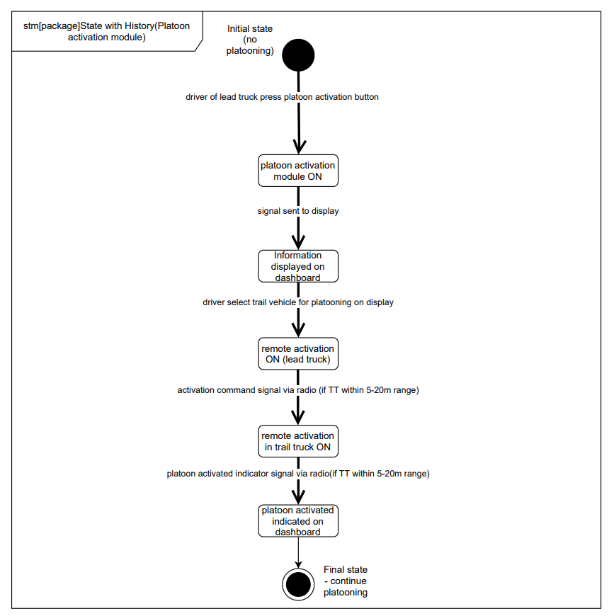
Fig 28 State machine diagram of Platoon activation module

parametric constraint diagram((Author: Arul Prasath Ramu)
The engineering analysis of vital system parameters, including the evaluation of key metrics such as performance, reliability, and other physical qualities, is aided by SysML parametric models. These models combine requirement and system design models by capturing executable constraints based on complex mathematical relationships that can be defined and calculated using the integrated facilities of Math Simulation tools such as MATLAB Simulink, OpenModelica, and Octave, all of which are compliant with the SysML Extension for Physical Interaction and Signal Flow Simulation (SysPhS) standard. The Mathematical Simulations chapter covers the instruments for mathematical simulations. Multiple parametric diagrams can be found in a typical system, each defining a specific engineering study of certain system components.
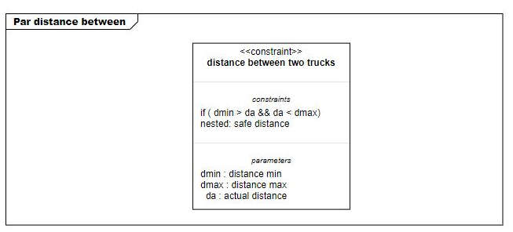
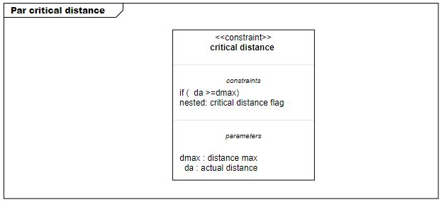
Fig 29: Safe distance and Critical distance
The above figures explain about the constraint of distance. When the actual distance is greater than dmin and less than dmax. It is safe to continue the platooning. Whenever the actual distance is greater than dmax. The lead truck will come to know the critical distance and raise the respective flag.
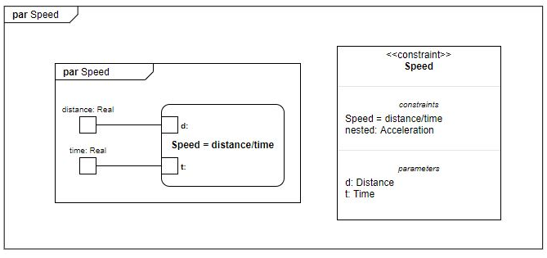
Fig 30 Speed
The rate at which an object travels over a certain distance is known as speed. A fast-moving object travels quickly and covers a large distance in a short amount of time, whereas a slow-moving object travels slowly and covers a little distance in the same length of time.
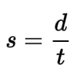
s- Speed
d- Distance travelled
t – Time elapsed
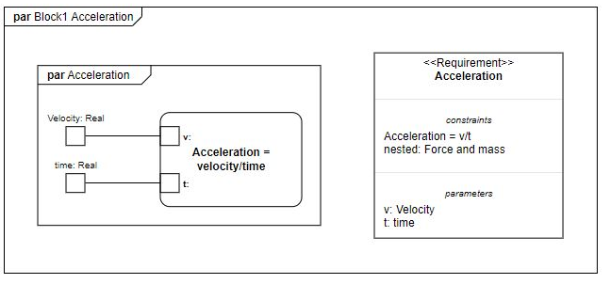
Fig 31 Acceleration
In terms of both speed and direction, acceleration is the rate at which velocity changes with time. If a point or an object moving in a straight path accelerates or slows down, it is said to be accelerated. Acceleration is a vector quantity since it has both a magnitude and a direction. The rate of change of an object's velocity with respect to time is called acceleration in mechanics. Accelerations are quantities that are measured in vectors (in that they have magnitude and direction). The orientation of the net force acting on an object determines the orientation of its acceleration. Newton's Second Law states that the magnitude of an object's acceleration is the combined impact of two causes:
- The size of this net resulting force is precisely proportional to the net balance of all external forces acting on that object.
- that object's mass, which varies based on the materials used in its construction – magnitude is inversely related to mass.

Simulation (Author: Arul Prasath Ramu)
A simulation is a controlled environment in which a real-world process is recreated. It entails developing laws and models that reflect the reality, then putting those models to the test to see what happens. Simulations are utilized in scientific research, safety testing, and the creation of images for video games and films. A simulation is a controlled environment in which a real-world process is recreated. It entails developing laws and models that reflect the reality, then putting those models to the test to see what happens. Simulations are utilized in scientific research, safety testing, and the creation of images for video games and films. We used Tinker cad for circuit simulation. Tinkercad is a web-based 3D modelling program that is completely free to use. It has become a popular platform for producing models for 3D printing as well as an entry-level introduction to constructive solid geometry in schools since its release in 2011.
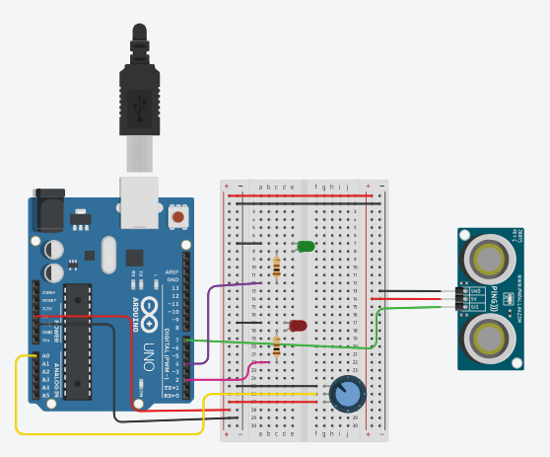
Fig 32 Simulation design
The fig 32 explains the simulation result of a use case – vehicle intervention. We used ultrasonic sensor and a camera for vehicle detection. Here we replaced camera with a pot for simulation purpose. Whenever an ultrasonic sensor detects an extra vehicle, it reports to control unit and the control will compare the length vehicle from camera using image processing. Then the length of vehicle will be compared the calculated accommodation length. If the length is greater than acc_length the trail truck won’t allow the vehicle to pass by blinking RED light and if the length is less than acc_length, trail truck will allow the vehicle to pass by blinking GREEN light and same scenario was reported to lead truck.

scheduling(Author: Suhrut Rajendra Heroorkar)
The requirement “trailing vehicle intrusion detection” is used for the scheduling analysis.
The requirement is divided into the pseudo code as shown
- Step1: Activate ultrasonic sensor: startUltraSonic()
- Step 2: Receive the duration signal and calculate the distance - calcVicObjectDistance
- Step3: Capture the camera image and calculate the length of object - captObjectImag()
- Step4 LOOP: while object is not detected
- Step4.1 Conditional: if distance < object vicinity threshold
- Step4.1.1: Object detected flag is raised objectDetect()
- Step4.1.2: Calculate the delta distance that can be increased
- aDist = deltaGap – lengthOfVehicle – minVehGap - deltaGapCalc()
- Step4.1.3 Condition if aDist > Length
- Step4.1.3.1 Blink green light and increase the distance - blinkLight()
- Step4.1.3.2 Blink red light and keep the vehicle at same position
- Step4.1.3.3 return to Step2
- Step4.1.4 return to Step2
- Step4.2 return to Step2
- Step5: If vehicle is detected - resetParam()
- Step5.1: Monitor the duration pulse and length of the object if less than a threshold value
- Step5.1.1 If the value is less than threshold
- Step5.1.1.1 after certain duration rest the flag light and vehicle detected and reduce the distance between the truck and stop the lamp
- Step5.1.2 return to Step 5.1
Following are the tasks identified
- startUltraSonic()
- calcVicObjectDistance()
- captObjectImag()
- objectDetect()
- deltaGapCalc()
- blinkLight()
- resetParam()
Scheduling analysis of the task is done via SimSo tool.
Earliest deadline first scheduling algorithm is selected.

Task | Execution time (ms) | Period (ms) | Deadline (ms)
startUltraSonic() | 2 | 50 | 10
calcVicObjectDistance() | 1 | 20 | 8
captObjectImag() | 5 | 50 | 20
objectDetect() | 2 | 10 | 8
deltaGapCalc () | 3 | 20 | 8
blinkLight() | 2 | 50 | 10
resetParam() | 5 | 20 | 12

Table 1: Execution, Period and deadline of the task
The overall deadline of the intrusion detection is set to 50ms
The task that are related to sensor are executed in a periodic interval of 50ms
Object detection being an important task to identify object as quickly as possible, so it is scheduled in an interval of 10ms.
Other tasks are executed in 20ms periodic task.
Similarly, deadline of the sensor task is set to higher value as the delay which is in ms would not have hazard situation. Reset parameter task also has high deadline because the major functions done there are the reset of flag to switch off the lamp and reduce the distance, as the delay in ms would not lead hazard situation. Other software tasks have lesser deadline of 8ms.
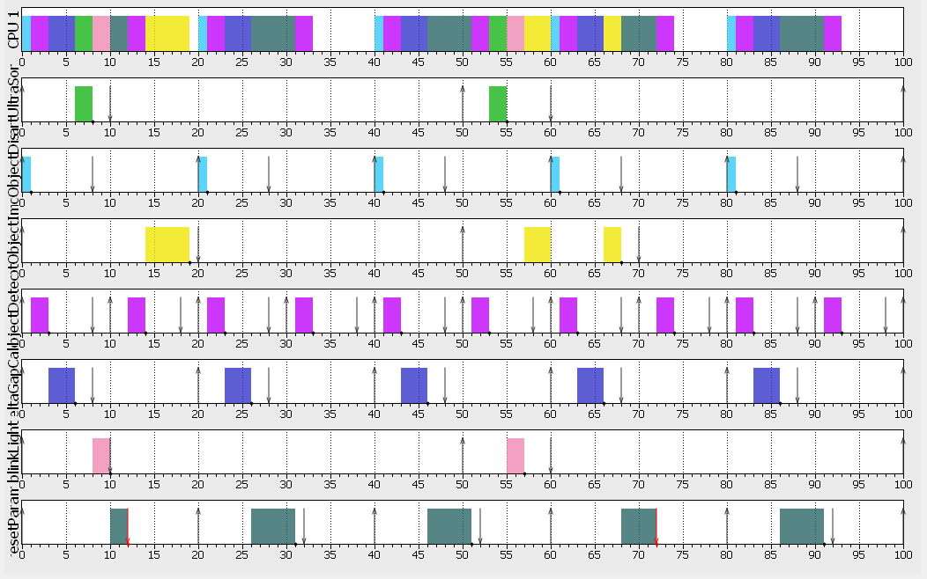
Fig 33: Plot of the scheduled task
Fig 33 indicates that all the tasks are executed by time of 35ms (approx.) which is within the deadline of 50ms requirement of execution of all task. Thus, with this configuration, the tasks are schedulable.
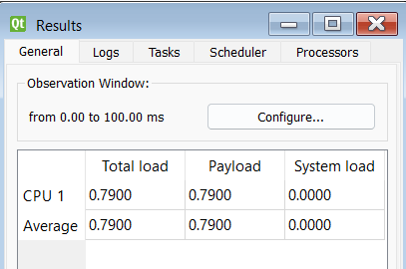
Fig 34 CPU utilization
Fig 34 indicates that 0.79 i.e., 79% of CPU is utilized.
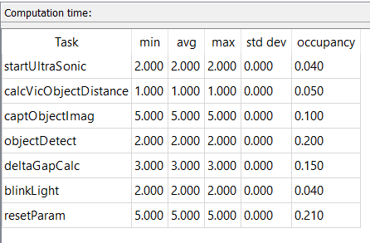
Fig 35: Occupancy of CPU by task
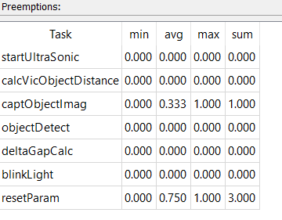
Fig 36: Preemption of task

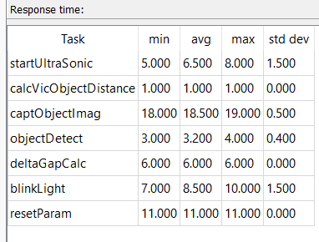
Fig 37: Response time of tasks

Testing(Author : Rushab dinesh jahagirdar)
Simulation models are becoming more prevalent in various industries. They help in solving problems and making decisions. This concern is usually addressed through the validation and model verification process. Model verification refers to the process of ensuring that the computer program that operates the model is correct. Model validation is the process of ensuring that the model is accurate. A model is often referred to as an accredited model. This process helps validate that the model has met the requirements of a certain process. Another aspect of model credibility is developing a level of confidence in the model's correctness.
A good model should be developed to answer a specific scientific question or to provide an answer to a variety of other questions. Its validity should be determined according to the domain where it can be utilized. A model may be valid for a set of experimental tests and invalid for another. The model's accuracy is generally agreed upon by the output variable(s) used to answer the questions that it's being developed to answer. The amount of accuracy that's required should be specified before the model is started. If the variable's properties and functions are of primary interest, then the model should be validated. A number of iterations of a model are then developed before it gets a satisfactory validation. This step is usually performed as part of the model development process.
Software testing is a complex yet rewarding task that involves thoroughly validating and verifying the correctness of the software that is being developed. This step typically takes place during the entire development cycle. Capturing the correctness of the software is the first step in validating its correctness. This step also involves ensuring that the requirements are met. The validation step is carried out to ensure that the system matches the requirements for correctness, completeness, and applicability. It can be performed in various ways, such as by hand, through automation tools, and by performing non-functional tests.
During the implementation of this system, several tests were carried out.
- Validation test – A validation test includes a test of each statement implemented. This process requires a deep understanding of the system to validate the output. Validation tests ensure that the software meets the quality standards set by the customer and that the product meets the customer's requirements.
For this system validation tests are written to ensure that the requirements mentioned in section 2(Requirement specification) are fulfilled. The purpose of programming tests is to quantify the nature of programming in terms of the various malformations found, the number of tests performed, and the framework protected by the tests. While testing when a bug or malformation was found, the bug was logged and fixed. Once the bug is fixed, the tests are repeated to ensure that the bug is safely fixed, and that the system is free of new defects. For this system tests like checkExternalVehicle, checkVicinity, checkConnectivity, etc were implemented to make sure that the system works safely and securely.
Validation testing helped in trying out new strategies specifically analysing the in-intensity functionalities of the system. Below mentioned pre-defined calibrated input values were used for testing

.
Speed of the trailing vehicle | 40 kmph
Maximum distance between lead truck and trail truck | 100 mts
Minimum distance between lead truck and trail truck | 30 mts
Calibrated speed for open gap | 30 kmph
Sensor data receiving | True
Wi-Fi working | True

- Defect test – The bug is an error identified by the tester during testing. Error testing includes testing system malfunctions and whether the system provides well-accepted output in the event of system malfunctions. For this system, test cases have been created to check the operation of the system. Tests cases which check the working of the ultrasonic sensor, Wi-Fi module, blinking light etc were written for in-depth defect testing.
Error-based techniques can be used at any test level but are ideal for system testing. It is necessary to create test cases based on the available error classifications. These defects can be production-related or historical. Root cause analysis can also be used as the basis for test cases.
- Component test – Component testing tests each component of the system. Component tests are run by the tester. Unit tests were performed to test individual features or procedures. Since loss of connectivity is a major requirement for the success of this system. Component testing was done for the feature. This includes test cases for checking the working of sensors, checking the distance between lead vehicle and trail vehicle, and checking if the trail truck is continuously receiving information. Further a test case was also written to check if how the system behaves when there is reconnection of trail vehicle is not possible.
For this system java, junit testing is used. Main code was written taking into consideration of all the uses cases and state machine explained in this document [Figure 30]. A total of 11 test cases were written ensuring 100% coverage [Figure 38].
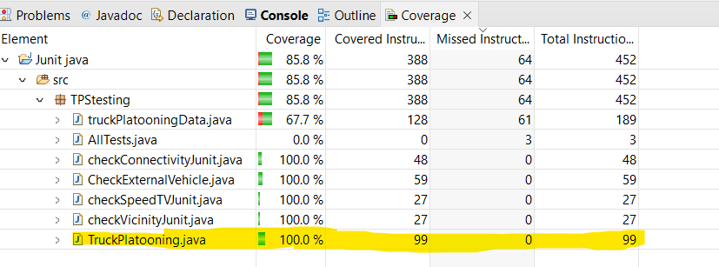
Fig 30: All the test cases ensuring 100% coverage.

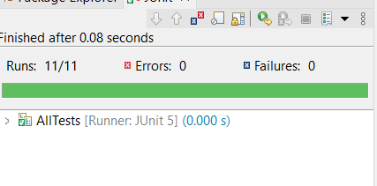
Fig 38: Successful run.

Conculsion
Platooning holds great promise of increasing both road traffic safety as well as efficiency. This paper makes an attempt to model the platoon system, followed by testing it. In this study, we identified the platooning formation is done in at the starting point where leading truck activates the platoon and establish connection with the trailing truck in the vicinity. Sensors like ultrasonic, camera, RADAR are used to learn about surrounding of the truck and activate necessary action during situation for ex intruder detection. Communication between the truck is established via Wi-Fi module and using GPS the positioning of the truck is identified and GSM technology is used to connect to platoon monitor station. Modelling is done considering few critical use cases like external vehicle in the vicinity, Speed of trail vehicle is less than expected value, loss of communication between the trucks. To confirm product (system) meets the functional, performance, design, and implementation necessities, exceptional varieties of checks had been implemented.
Further the implementation can be improved so that the truck can join and leave the platoon dynamically. For this, a cloud service can be implemented that forms and control platoon with lead truck manipulating the necessary data in the cloud while controlling the other trucks.

Acknowledgment
The authors would like to thank Dr. Stefan Henkler for his kind help.
CONTRIBUTION OF EACH TEAM MEMBER

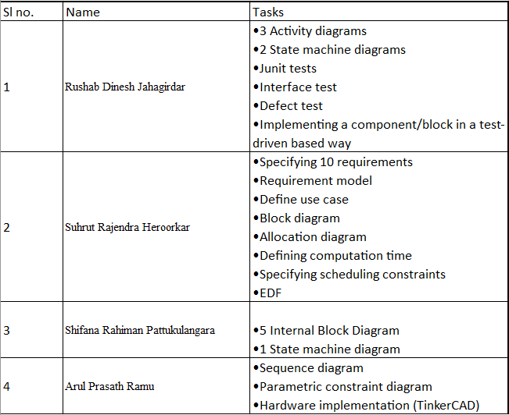

References

- André de Souza, MendesAgenor de Toledo Fleury, Marko Ackermann and Fabrizio Leonardi on "HEAVY-DUTY TRUCK PLATOONING: A REVIEW", COBEM-2017-0843, 24th ABCM International Congress of Mechanical EngineeringDecember 3-8, 2017, Curitiba, PR, Brazil
- S. Ellwanger and E. Wohlfarth, "Truck platooning application," 2017 IEEE Intelligent Vehicles Symposium (IV), 2017, pp. 966-971, doi: 10.1109/IVS.2017.7995840.
- M. Long, G. Tian and H. Cheng, "Longitudinal Control for Truck Platooning," 2020 4th CAA International Conference on Vehicular Control and Intelligence (CVCI), 2020, pp. 418-423, doi: 10.1109/CVCI51460.2020.9338513.
- S. C. Calvert, G. Mecacci, D. D. Heikoop and F. S. de Sio, "Full platoon control in Truck Platooning: A Meaningful Human Control perspective," 2018 21st International Conference on Intelligent Transportation Systems (ITSC), 2018, pp. 3320-3326, doi: 10.1109/ITSC.2018.8570013.
- L. Caltagirone, S. Torabi and M. Wahde, "Truck Platooning Based on Lead Vehicle Speed Profile Optimization and Artificial Physics," 2015 IEEE 18th International Conference on Intelligent Transportation Systems, 2015, pp. 394-399, doi: 10.1109/ITSC.2015.73.
- https://sparxsystems.com/

IEEE conference templates contain guidance text for composing and formatting conference papers. Please ensure that all template text is removed from your conference paper prior to submission to the conference. Failure to remove template text from your paper may result in your paper not being published.

