**BIO DATA**

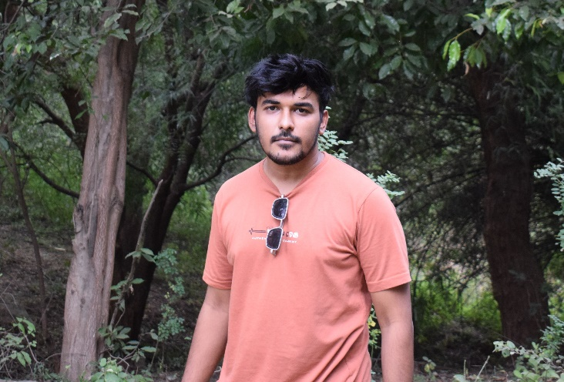**NAME : RUSHABH MUKESH GANDHI**

**FATHER’S NAME : MUKESH MUNILAL GANDHI**

**MOTHER’S NAME : SHARMILA MUKESH GANDHI**

**GRAND FATHER’S NAME : MUNILAL DEVICHAND GANDHI**

**GRAND MOTHER’S NAME : LILADEVI MUNILAL GANDHI**

**PERMANENT ADDRESS : B-201 SANGATH-4 MOTERA ROAD**

**SABARMATI AHMEDABAD**

**PIN CODE : 380005**

**MOBILE NO. : 7990241963**

**FATHER CONTACT NO. : 8200733727**

**DATE OF BIRTH : 23 NOV 1998**

**TIME OF BIRTH : 6:52PM**

**PLACE OF BIRTH : ALIBAUG**

**NATIVE PLACE : TAKHATGARH, DIST: PALI, RAJASTHAN, 306912**

**EDUCATION QUALIFICATION : BTECH WITH SPECALIZATION IN MOBILE**

**APPLICATION (GOLD MEDALIST)**

**CLEARED BTECH WITH 1ST RANK**

**PLANNING TO DO M-TECH**

**GOTRA : RAI GANDHI**

**HEIGHT/WEIGHT : 5.7 ft. / 75**

**COLOUR : FAIR**

**LANGAUAGES KNOWN : MARVADI, GUJARATI, HINDI, ENGLISH**

**CURRENTY WORKING : SOFTWARE ENGINEER, WEB DEVELOPER**

**WORK EXPERIENCE : WORKING AS A FREELANCER, WORKED IN**

**GOVERNMENT COMPANY,**

**FATHER BUISNESS : BARCODE SOLUTION, LADIES RETAIL SHOWROOM**

**& GARMENT MANUFACTURING**