CS107.3 - Object Oriented Programming with C#
Coursework Report - WareHouse Management System
Student Name: ____________________ Student ID: ____________________

1. Problem Statement
Small and medium-sized warehouses frequently manage their inventory, customers and staff using paper records or disconnected spreadsheets. These manual approaches are slow and error-prone: stock counts drift out of sync with reality, there is no reliable audit trail of who moved which goods, and sensitive operations are not protected by any form of access control. As the business grows, the lack of a single source of truth leads to over-ordering, stock-outs and poor decision making.
The WareHouse Management System addresses these problems with a single, interactive desktop application built on a relational database. It centralises inventory, customer and employee records, enforces role-based login so that only authorised users reach sensitive features, and records every stock-in and stock-out movement so the on-hand quantity is always accurate and auditable. By replacing manual records with validated, database-backed operations, the system reduces human error, improves data integrity and gives staff a clear, real-time overview of the warehouse.
2. Requirements
The application is aimed at warehouse administrators and operators. Administrators have full control, including managing employee records, while operators handle day-to-day inventory and customer tasks. This separation reflects how a real warehouse delegates responsibility, so role-based access was a core requirement.
The following functional features were included. Authentication: sign up and login, with passwords stored as SHA-256 hashes and a role (Admin or Operator) assigned to each account. Inventory management: create, read, update and delete materials, with search and category filtering. Customer management and employee management provide the same full CRUD operations, with employee management restricted to administrators. Stock In / Out records movements inside a database transaction and keeps the material quantity synchronised, preventing negative stock. A dashboard summarises record counts and lists the full inventory. These features were chosen because together they cover the complete operational cycle of a warehouse. Non-functional requirements - usability, data validation, exception handling and database integration for every feature - were also targeted throughout.
3. Design
The system follows a layered architecture that separates concerns and keeps the code maintainable. The Presentation layer is built with Windows Forms (a login/sign-up screen and a dashboard shell hosting user controls). The Domain layer holds the entity models and an abstract Person hierarchy. The Data Access layer exposes a generic repository per entity and a single DatabaseManager, and the Database layer is SQL Server LocalDB.
Object-oriented principles are applied throughout. Abstraction and inheritance: the abstract Person class is extended by Admin and ShippingOperator; the generic BaseRepository<T> implements the IRepository<T> interface and is inherited by each concrete repository. Polymorphism: the overridden Role property and the PersonFactory build the correct user type at run time. Encapsulation: fields such as the password are private and exposed through properties. The processes interact predictably: the login form authenticates through UserRepository, PersonFactory creates the role object, the dashboard hosts the management controls, and each control calls its repository, which delegates parameterised SQL to the singleton DatabaseManager. These structures are appropriate because they remove duplication, centralise database access, and use parameterised queries to guard against SQL injection.
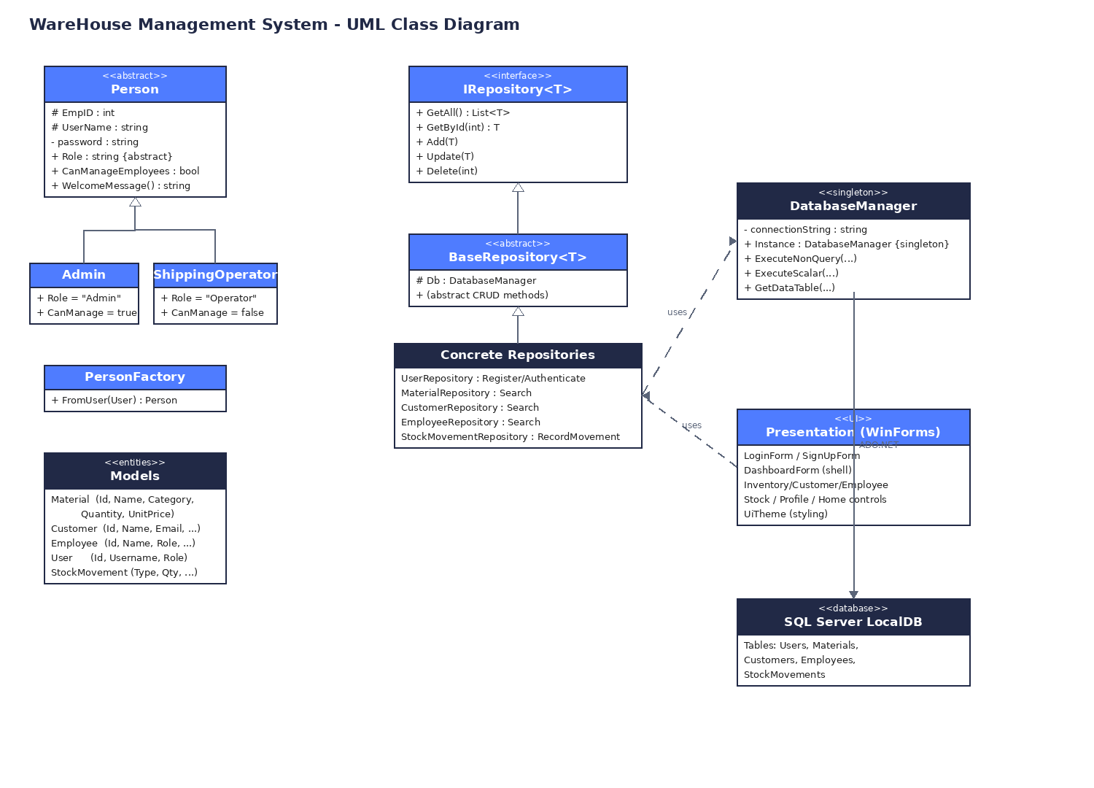
Figure 1: UML class diagram showing the layered, OOP design.
4. Personal Reflection
The layered design worked very well. Once the repository pattern and the shared UiTheme helper were in place, adding later features such as stock movements, the profile screen and the table filters was quick because the structure was already there. Using a generic base repository removed a lot of repeated database code, and SHA-256 hashing with parameterised queries gave a reasonable security baseline.
Some things were harder. The SQL Server LocalDB connection initially copied a fresh database file to the output folder on every build, which wiped saved data between runs; switching the file to "copy if newer" fixed it. Building the Windows Forms interface entirely in code was also verbose. The main lessons I will take into my next project are to decide how data is stored and persisted early, to invest in shared UI helpers from the start, and to commit work in small, well-described steps using version control branches, which made it easy to track and review every change.
5. Future Work
The application could be developed much further. The data layer could move to an ORM such as Entity Framework with asynchronous queries for cleaner, faster data access. New modules - suppliers, purchase orders and reporting with charts - would extend it into a complete inventory suite, and barcode or QR scanning would speed up stock movements. Security could be strengthened with per-user password salts, account lockout and an audit log, and automated unit tests would protect against regressions.
To make the product more sustainable, the database could be hosted in the cloud (for example Azure SQL) so multiple branches share one accurate dataset, reducing local hardware needs and supporting remote work. A paperless, digital-first workflow lowers material waste, while the modular layered design keeps the system easy to maintain and adapt as requirements evolve, extending its useful life.
6. Video Demonstration
Unlisted YouTube demonstration link: ____________________________________________
Replace the line above with your unlisted YouTube video URL before submission.

Appendix A - Application Screenshots
Insert your own screenshots in the placeholders below (run the app, press the Windows key + Shift + S to capture, then paste). Suggested screenshots are listed for each placeholder.
[ Screenshot: Login screen ]
[ Screenshot: Sign up screen ]
[ Screenshot: Dashboard (summary cards + inventory overview) ]
[ Screenshot: Inventory management (with category filter) ]
[ Screenshot: Customer management ]
[ Screenshot: Employee management ]
[ Screenshot: Stock In / Out with movement history ]
[ Screenshot: Profile / change password ]
[ Screenshot: Database tables in SQL Server Object Explorer ]

